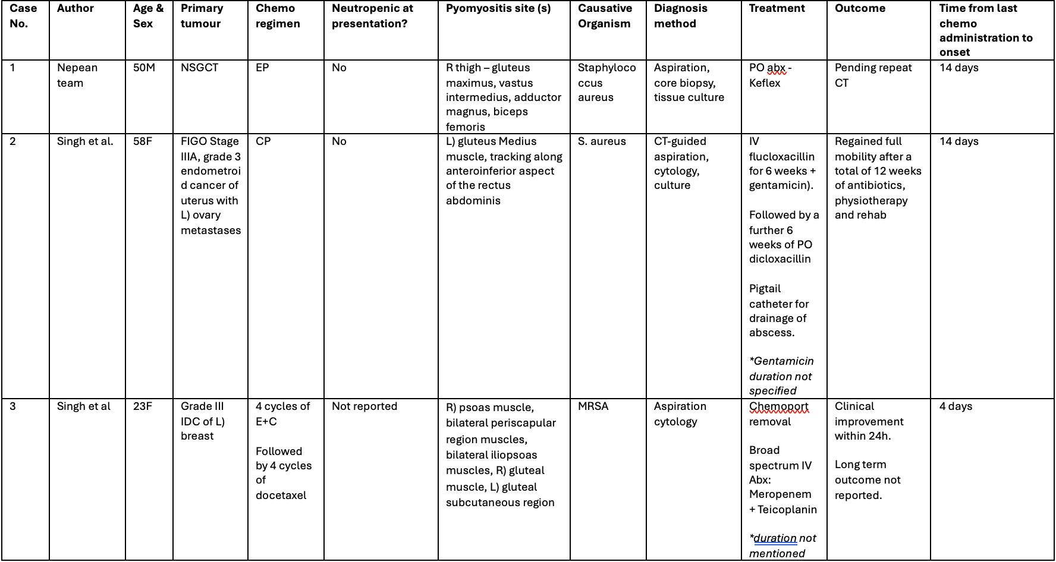
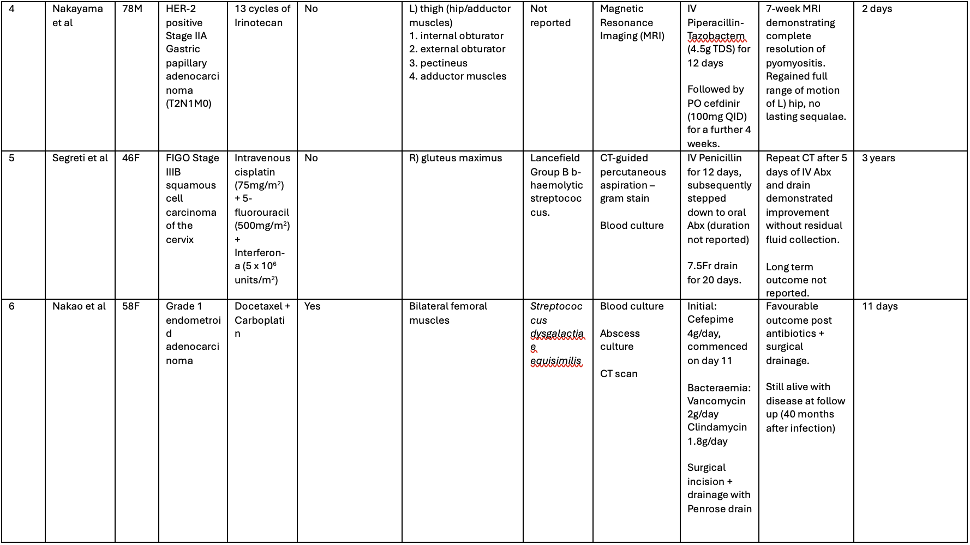
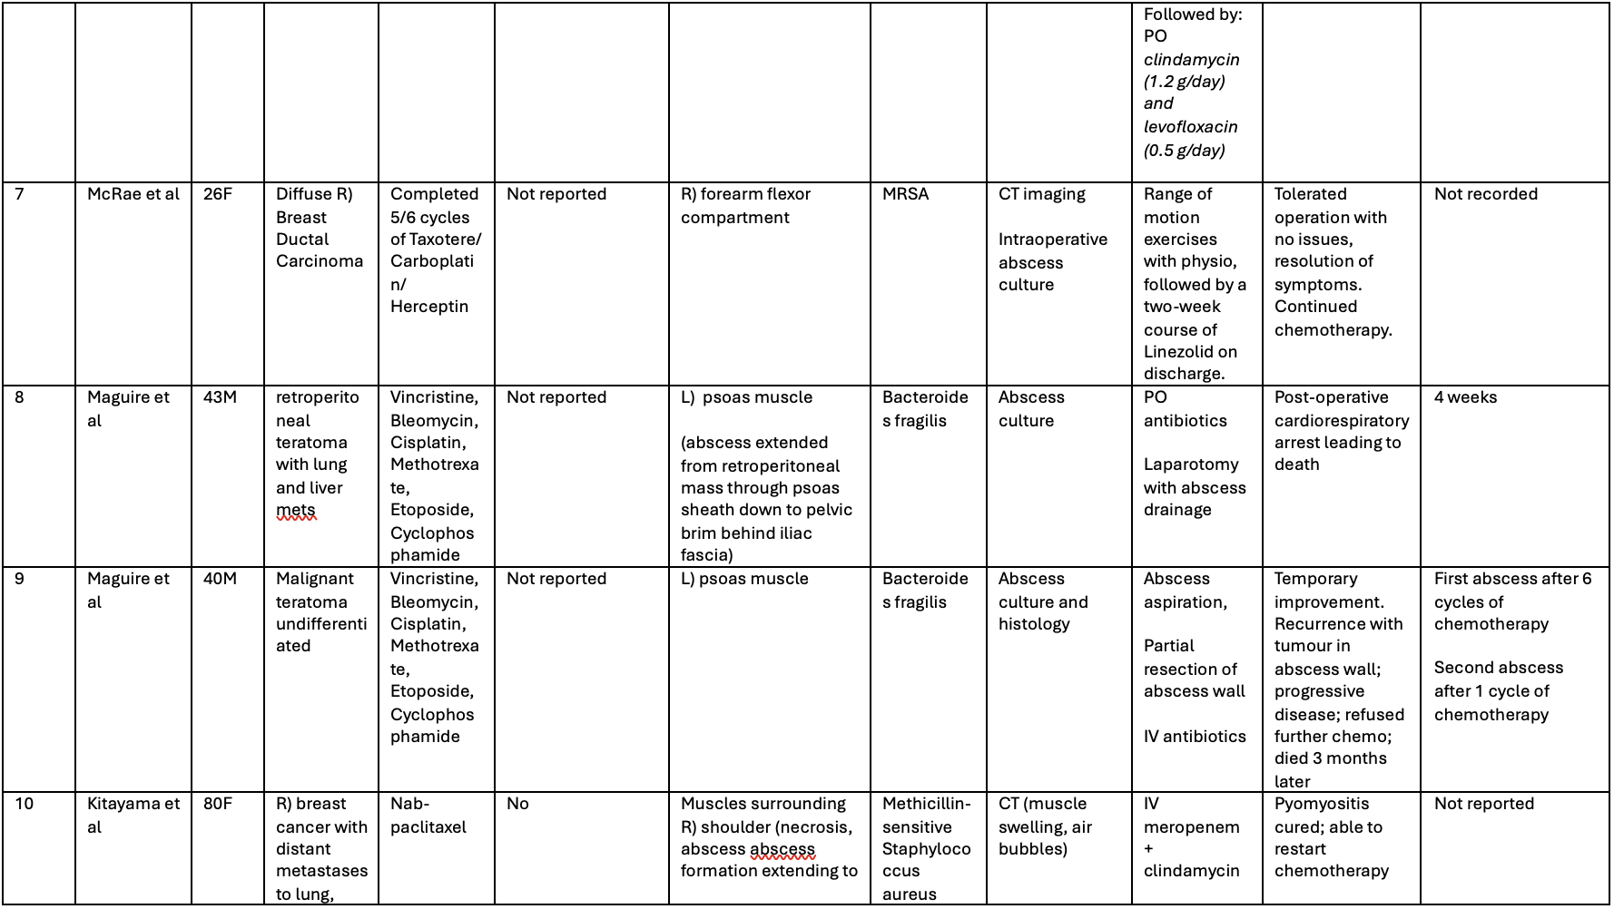
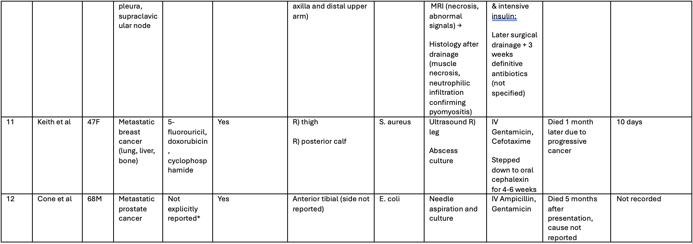
Table 1. Pyomyositis related to chemotherapy for patients with solid organ malignancy
- CT, chemotherapy; PO, per oral; abx, antibiotics; NSGCT, non-seminomatous germ cell tumour; EP, etoposide and cisplatin;
- FIGO, International Federation of Gynecology and Obstetrics; CP, carboplatin and paclitaxel; CT; IV, intravenous; PO, per oral; Abx, antibiotics
- IDC, infiltrating ductal carcinoma; E+C Epirubicin+Cyclophosphamide; MRSA, Methicillin-resistant Staphylococcus aureus;
- HER2, human epidermal growth factor receptor 2; TDS, three times a day; QID, four times a day
- MRSA, Methicillin-resistant Staphylococcus aureus;
*Case series that included solid organ malignancy + haematological malignancies; only 1 case of solid malignancy, chemotherapy regimens were not individually specified

