Supplementary Materials for

Double Electron Spin Resonance of Engineered Atomic Structures on a Surface

Soo-Hyon Phark^{1,2,3†}, Yi Chen^{1,3†}, Christoph Wolf^{1,3}, Hong T. Bui^{1,4}, Yu Wang^{1,3}, Masahiro Haze^{1,5}, Jinkyung Kim^{1,4}, Christopher P. Lutz^{2*}, Andreas J. Heinrich^{1,4*}, Yujeong Bae^{1,4*}

*Correspondence to: cplutz@us.ibm.com, heinrich.andreas@qns.science, bae.yujeong@qns.science

This PDF file includes:

Materials and Methods
Supplementary Text
Figs. S1 to S20

Materials and Methods

Measurements were performed in three ultrahigh-vacuum (< ${10}^{-9}$ Torr) scanning tunneling microscopes (STMs). The data presented in the main figures and Figs. S1, S2, S4-S8, S18, and S20 were measured in a commercial ³He-cooled STM (Unisoku, USM1300) at T = 0.4 K equipped with two-axis superconducting magnets. The data presented in Figs. S9-S13 were measured in a home-built STM based on a commercial cryostat (Janis Research, JDR-250) equipped with two-axis superconducting magnets, which was kept at 0.9 K during the measurement by Joule-Thomson cooling with a small amount of ³He-⁴He gas. The data presented in Fig. S19 were measured in a home-built ³He-cooled STM at T = 1.1 K equipped with a single-axis superconducting magnet. In this work, we chose field directions mostly along the sample plane with details labelled in the corresponding figures.
High-frequency transmission cables were installed on the STM systems as described in detail elsewhere (11). The single electron spin resonance (ESR) spectra were acquired by sweeping the frequency of an RF voltage $V_{RF}$ generated by an RF generator (Agilent E8257D) across the tunneling junction and monitoring changes in the tunneling current. To drive double resonance, the output signals of two RF generators (Agilent E8257D and E8267D) were combined using a power combiner/splitter (Mini-circuits, ZC2PD-K0244+) before combining with a DC bias voltage through a bias tee (SigaTek, SB15D2). Different lock-in detection schemes were designed to emphasize the desired signals in different measurements as described in Fig. S3.
Bilayer MgO was epitaxially grown on atomically clean Ag(001) single crystals by thermal evaporation of Mg in an O₂ pressure of ${1×10}^{-6}$ Torr (7, 11). In one STM system (Unisoku), Ti and Fe atoms were deposited onto a sample at approximately 100K, in the other two systems at ~10 K using standard e-beam evaporators. The Ti atoms on bilayer MgO are spin-$1/2$ and are most likely hydrogenated (20). All measurements were performed on Ti atoms bound to a bridge site of the MgO (that is, in the middle of two oxygen sites). Before measurements, the STM tip made by Pt/It wire was poked into the Ag(001) surface until satisfactory topographic and spectroscopic features were observed on atoms on MgO, after which Fe atoms were picked up by the STM tip from MgO (by applying a DC voltage pulse of 0.6 V) to create a spin-polarized tip. The tip’s spin polarization was calibrated with the asymmetry around zero bias in the dI/dV spectra of Ti on MgO (20).

Supplementary Text

Section 1. Single ESR spectra of an isolated Ti atom and Ti in the Ti-Ti-Fe structure in Fig. 1

To characterize effects of the tip used in collecting the main figures, we used the same tip to obtain a set of ESR spectra of an isolated Ti at different tunnel conductance (Fig. S1A). This allows us to extrapolate the ESR resonance frequency using a linear fit (Fig. S1B) considering the exchange interaction between tip and Ti, and to estimate the Ti resonance frequency in the absence of the tip magnetic field ($f_{res,0}$). The obtained $f_{res,0}$ is 0.28 GHz higher than that under the tunneling conditions (20 pA, 50 mV) used for collecting the data in the main text. We also noticed that the ESR peak heights showed a monotonic decrease with deceasing tunnel conductance which vanished at zero conductance (Fig. S1C). This supports the theoretical claim (16) that the magnetic field gradient from the tip magnetic moment drives the ESR of an isolated Ti spin.

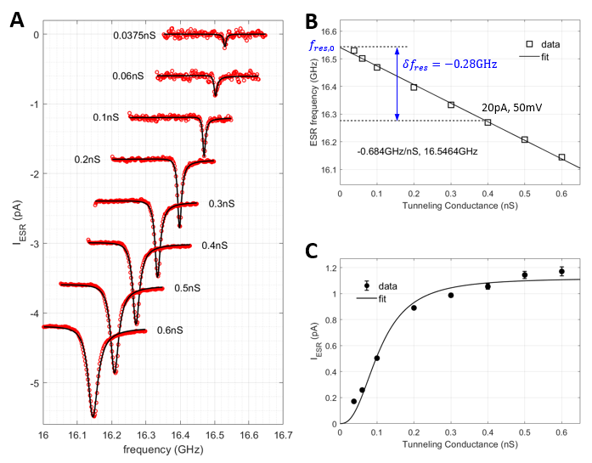

Fig. S1. Single frequency ESR on an isolated Ti with the same tip used for Figs. 1–3. (A) ESR spectra of an isolated Ti at different DC tunneling conductance. This Ti atom is at a bridge site of bilayer MgO/Ag(100). Black solid curves: Lorentzian curve fits to the ESR spectra. (B) Extracted ESR peak frequencies as a function of tunneling conductance, showing a linear dependence on the tunneling conductance. This allows us to estimate the resonance frequency in the absence of the tip magnetic field to be 280 MHz higher than that under the tunneling conditions ($I_{DC}=20 pA$, $V_{DC}=50 mV$, used in Figs. 1–3). (C) Extracted ESR peak height from A showed a monotonic change with the tunneling conductance, which vanishes at zero conductance. Black curve: guide to the eye ($V_{RF}=30 mV$, $T=0.4 K$, $B_{ext}$ as shown in Fig. 1A).

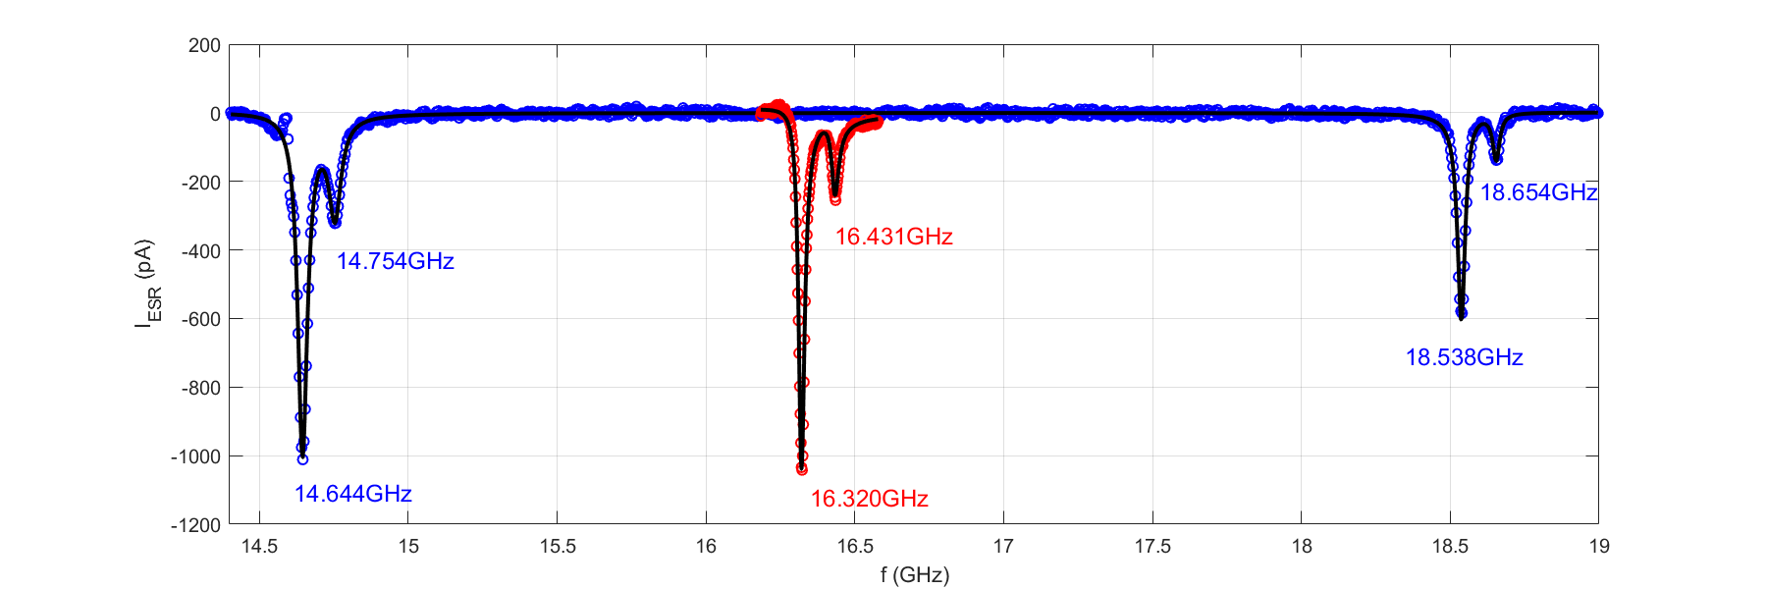

Fig. S2. Single frequency ESR on both Ti atoms (same as Fig. 1C). Black curves are fits to the spectra using two Lorentzian curves on Ti-1 (red) and 4-Lorentzian curves on Ti-2 (blue), which yield the resonance frequencies labelled in the figure ($I_{DC}=20 pA$, $V_{DC}=50 mV$, $V_{RF2}=30 mV$, $0.4<T<0.5 K$).

Section 2. Lock-in detection schemes used in double electron resonance experiments

We carefully designed the lock-in detection schemes in double electron resonance measurements to reveal the desired spectral information. We first consider the lock-in detection scheme used in the traditional single ESR-STM measurement of Ti-1 (Fig. 1C and Fig. S3A). Here the spin polarization signal was the difference between a driven state (lock-in A cycle) and the thermal state (lock-in B cycle). The measured ESR signal then revealed the effect of RF driving from the thermal equilibrium state (35).
The measurements performed in Fig. 1D can be similarly understood as the effect of RF driving of Ti-1 but from a non-thermal-equilibrium state. This non-equilibrium state was created by continuous driving of the remote spin Ti-2 with a second RF generator in both the lock-in A and B cycles (Fig. S3B). At zero Ti-2 driving ($V_{RF2}=0$ mV), the measurement was identical to the single ESR measurement of Ti-1. With increasing $V_{RF2}$, a non-thermal-equilibrium state was realized by driving Ti-2 transitions, and, on top of which, the Ti-1 ESR peak strengths were altered as shown in Fig. 1D and Fig. S4. In Fig. 1D, for example, we set $V_{RF2}$ at $f_{RF2}=f_{0↕}$, which induces population transfers from state $|\left.00\right\rangle$ to $|\left.01\right\rangle$. As a result, the Ti-1 transition at $f_{RF1}=f_{↕0}$ (i.e., between states $|\left.00\right\rangle$ and $|\left.10\right\rangle$) becomes weaker (because the population of state $|\left.00\right\rangle$ is reduced by $V_{RF2}$), whereas the Ti-1 transition at $f_{RF1}=f_{↕1}$ (i.e., between states $|\left.01\right\rangle$ and $|\left.11\right\rangle$) becomes stronger (because the population of state $|\left.01\right\rangle$ is increased by $V_{RF2}$).
The measurements performed in Figs. 2 and 3 are different from the above measurement in that we perform a frequency sweep across the range of the Ti-2 resonances (i.e., the remote spin) rather than those of Ti-1 (Fig. S3C). These measurements can be thought of as spectroscopically revealing the frequencies at which $f_{RF2}$ reaches Ti-2 resonances. Due to the absence of the tip magnetic field, these resonance frequencies were significantly different from ESR spectra collected with the tip above Ti-2. To detect the remote spin resonance, we kept monitoring the Ti-1 ESR strength (by driving it in both lock-in A and B cycles) but drove Ti-2 in the A cycle only. When the Ti-2 driving was off resonance, little change was induced in the Ti-1 ESR signal between the A and B cycles, which resulted in a null signal in the double resonance spectrum.
When the Ti-2 driving reached its resonances in Fig. 2, population was transferred and the Ti-1 ESR strength became different between the A and B cycles, thus resulting in a nonzero signal as shown in Fig. 2. More explicitly, consider the case where we monitor the Ti-1 transition at $f_{RF1}=f_{↕0}$ (i.e., between states $|\left.00\right\rangle$ and $|\left.10\right\rangle$). When we additionally drive the Ti-2 resonance at $f_{0↕}$ (lower frequency peak in Fig. 2A), population is further transferred from state $|\left.00\right\rangle$ to $|\left.01\right\rangle$, which results in less population at state $|\left.00\right\rangle$ and reduces the Ti-1 ESR signal in the lock-in A cycle (compared to the B cycle). Since the Ti-1 ESR signals in the single frequency sweep are negative in our setup (Fig. 1), a reduction of the negative single-frequency ESR signal leads to a positive double resonance peak as seen in Fig. 2A. Similarly, when we monitored a different Ti-1 transition at $f_{RF1}=f_{↕1}$ whilst still driving the Ti-2 resonance at $f_{0↕}$ (lower frequency peak in Fig. 2B), the population transfer from state $|\left.00\right\rangle$ to $|\left.01\right\rangle$ (from Ti-2 driving) resulted in more population at state $|\left.01\right\rangle$ and therefore enhanced the Ti-1 ESR signal in the lock-in A cycle (compared to the B cycle). This leads to an enhancement of the negative single Ti-1 ESR signal and thus a negative double resonance peak (i.e., a dip) as seen in Fig. 2B.
The Ti-2 driving at the higher resonance frequency $f_{1↕}$ (higher frequency peaks in Fig. 2A and B) connects two excited states and involves more complicated interplay between driving and relaxation, which can yield a peak, a dip, or more intricate lineshapes depending on the parameters. This, however, is captured by our Lindblad simulations explained below (Sections 5.1-5.3) and shown in the main figures. We note that the Lindblad simulations can be simplified into a simpler rate-equation model (Sections 5.4 and 5.5), which serves as the basis for the population-transfer-based explanations provided above and in the main text.

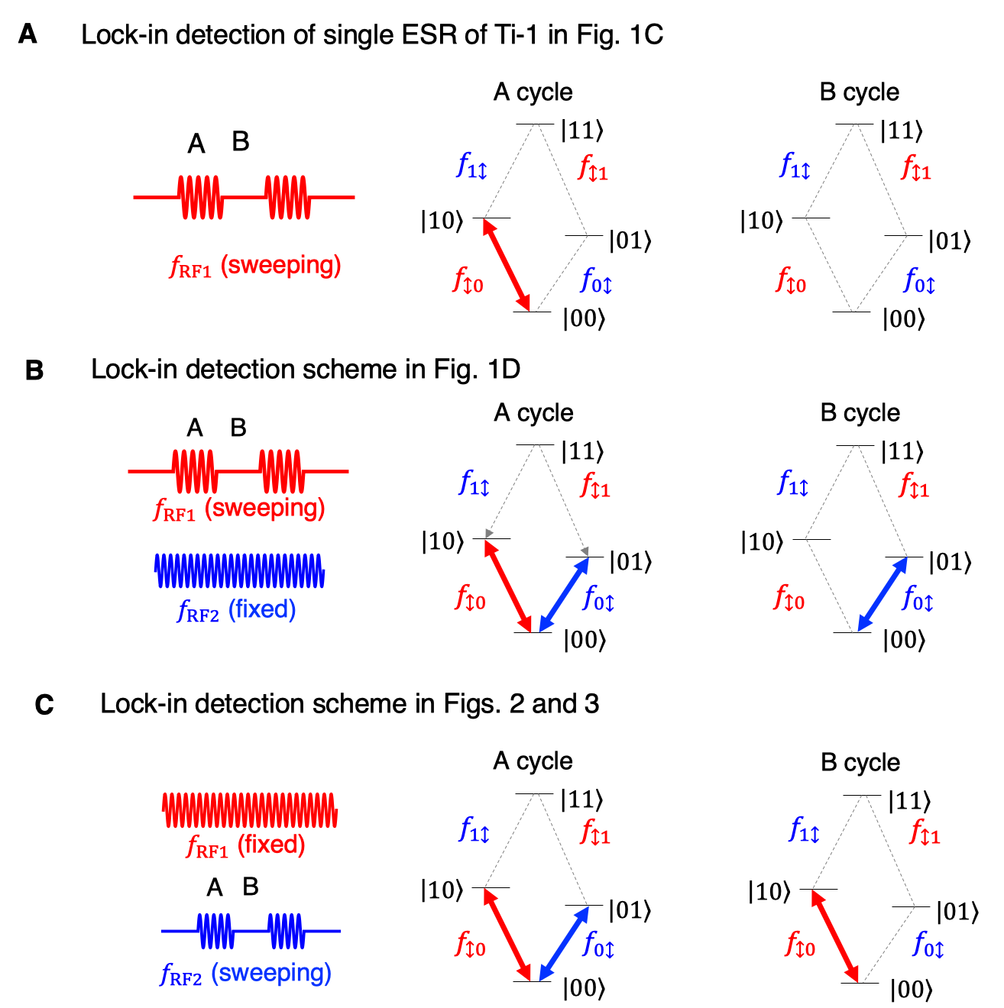
Fig. S3. Lock-in detection schemes. (A) Lock-in detection scheme of single ESR-STM measurement of Ti-1 in Fig. 1C. The spin polarization signal was contrasted between a driven state (lock-in A cycle) and the thermal state (lock-in B cycle) while the RF frequency $f_{RF1}$ was swept. (B) Lock-in detection scheme of the double resonance experiment in Fig. 1D. This scheme is similar to A but based on a non-thermal-equilibrium state created by a continuous second driving at a fixed frequency $f_{RF2}$ at a Ti-2 resonance. (C) Lock-in detection scheme of the double resonance experiment in Figs. 2 and 3. In this scheme, $f_{RF2}$ was swept across the range of Ti-2 resonances. Through monitoring the amplitude change of a Ti-1 spin resonance, we could remotely detect the frequency at which $f_{RF2}$ reaches Ti-2 resonances.

Section 3. Supplementary data to the Ti-Ti-Fe structure presented in the main text

Section 3.1. ESR peak height in double resonances with fixed RF2 frequency (Fig. 1D)

In addition to the double resonance spectra at $f_{RF2}=f_{0↕}$ shown in Fig. 1D, we also acquired the double resonance spectra at $f_{RF2}=f_{1↕}$ and an off-resonance frequency of Ti-2, as shown in Figs. S4B and C. To extract the ESR peak heights in these spectra, we performed a 2-Lorentzian curve fit to each spectrum (black curve). The extracted peak height ratios (${I_{↕0}}/{I_{↕1}}$) were plotted as a function of $V_{RF2}$ (the RF driving voltage of Ti-2) in Figs. S4A-C and summarized in Fig. S4D.
The change of ${I_{↕0}}/{I_{↕1}}$ is noticeably smaller at $f_{RF2}=f_{1↕}$ than at $f_{RF2}=f_{0↕}$ for the same driving amplitude due to the more significant relaxation effects when driven at $f_{1↕}$ (this complicated interplay between driving and relaxation is included in our Lindblad simulations, see below).
When driving the Ti-2 spin at an off-resonance frequency (which does not alter the populations), the double resonance spectrum should be equivalent to single-frequency ESR of Ti-1, and one expects a constant ${I_{↕0}}/{I_{↕1}}$ ratio independent of $V_{RF2}$. However, in this data set, we observed a slight monotonic decrease of ${I_{↕0}}/{I_{↕1}}$ shown in Fig. S4C. This stems from the RF power heating of the spin system. To capture these RF heating effects in Figs. 1D and S4, we recorded the sample temperature at each RF power and frequency and used this temperature reading for the simulation of each ESR curve (Fig. S5). A minor overall up-shift of temperature (0.04 K) was included in the simulations to capture the effective spin temperature (which is reflected in the correct intercept for the peak ratio at V_{RF2} = 0 in Figs. 1E and S4D).
When performing the same experiment as Fig. 1D using another STM at 0.9 K (Fig. S10), the temperature variations were much reduced due to the higher thermal stability at this temperature of this STM as evidenced by the near-constant peak ratio at off resonance. In that case, only a fixed temperature was used in the theoretical simulations to match with the experiments, highlighting the consistence between the experiment and the simulation.

Section 3.2. AC Stark effect in double resonance spectra in Fig. 3

In this work, we utilized the AC start effect to directly obtain the Rabi rates of both Ti-1 and Ti-2 spins. An elegant approach to understand the AC Stark effect is the “dressed atom” theory as follows. Consider a quantum system of two atom levels, $|\left.a\right\rangle$ and $|\left.b\right\rangle$ ($E_{|\left.a\right\rangle }<E_{|\left.b\right\rangle }$), in a near-resonant electromagnetic field with photon energy $ℏω$, so that $E_{|\left.b\right\rangle }-E_{|\left.a\right\rangle }≈ℏω$. If photons do not interact with the atom states, the total Hamiltonian is ${\hat{H}}_{0}={\hat{H}}_{atom}+{\hat{H}}_{field}$, and the eigenstates of ${\hat{H}}_{0}$ are $|\left.a,n\right\rangle$ and $|\left.b,n\right\rangle$ where $n$ labels the photon occupation. We notice that the state of the atom level $b$ with the photon number $n-1$ ($|\left.b,n-1\right\rangle$) is almost degenerate with the state $|\left.a,n\right\rangle$, and so are $|\left.b,n\right\rangle$ and $|\left.a,n+1\right\rangle$. We define the detuning as $Δ=E_{|\left.b\right\rangle }-E_{|\left.a\right\rangle }$, and the two states $|\left.a,n\right\rangle$ and $|\left.b,n-1\right\rangle$ become fully degenerate at $Δ=0$.
Now if we turn on an interaction ${\hat{H}}_{int}$ between atom and field, the states $|\left.a,n\right\rangle$ and $|\left.b,n-1\right\rangle$ become hybridized and their degeneracy lifted. Then, the eigenstates of the system can be described by a linear combination of the two nearly degenerate states of the non-interacting Hamiltonian
$|\left.D\right\rangle =C_{a}|\left.a,n\right\rangle +C_{b}|\left.b,n-1\right\rangle$, | (Eq. S1)
where the coefficients are obtained from the Schrodinger equation,
$({\hat{H}}_{atom}+{\hat{H}}_{field}+{\hat{H}}_{int})|\left.D\right\rangle =E_{D}|\left.D\right\rangle$. | (Eq. S2)
Defining the Rabi rate as $ℏΩ≡\left\langle b,n-1|\right.{\hat{H}}_{int}\left.|a,n\right\rangle$, we can solve the secular equation and obtain the eigenenergies,
$E_{D}=\left(n-1/2\right)ℏω±{ℏΩ_{R}}/2, Ω_{R}=\sqrt{Δ^{2}+Ω^{2}}$, | (Eq. S3)
and the corresponding eigenstates,
${|\left.D(n)\right\rangle }_{+}=\sin{θ}\left.|a,n\right\rangle +\cos{θ}\left.|b,n-1\right\rangle$,  ${|\left.D(n)\right\rangle }_{-}=\cos{θ}\left.|a,n\right\rangle -\sin{θ}\left.|b,n-1\right\rangle$, | (Eq. S4)  (Eq. S5)
where $\cos{2θ}≡Δ/{Ω_{R}}$ and $\sin{2θ}≡Ω/{Ω_{R}}$. At resonance ($Δ=0$), $\sin{θ=}\cos{θ}=1/{\sqrt{2}}$, and the new eigenstates are split by the Rabi rate $Ω$ due to the atom-field interaction ${\hat{H}}_{int}$.
In our double resonance experiment, four spin states are involved. However, in each experiment, only one ESR transition was strongly driven. For example, only the transition $f_{↕0}$ between states $|\left.00\right\rangle$ and $|\left.10\right\rangle$ as shown in Fig. 3A. As a result, the ESR transition between the states $|\left.00\right\rangle$ and $|\left.01\right\rangle$ occurs at two distinct frequencies $f_{0↕}^{(±)}=f_{0↕}±{Ω^{(1)}}/2$ when probed by another weak electromagnetic field that was swept across the Ti-2 resonance $f_{0↕}$. The splitting allows us to determine the Rabi rate of Ti-1 as $Ω^{\left(1\right)}/\left(2πV_{RF1}\right)=0.160±0.015 MHz/mV$. The ESR peak heights at $f_{0↕}^{(±)}$ are sensitive to the detuning $Δ$ due to its influence on the coefficients $\sin{θ}$ and $\cos{θ}$ in Eqs. S4 and S5, which is also seen in our simulations in Fig. S16. We omit the quantum numbers of the photon states for convenience in the main figures and text.

Section 3.3. AC Stark effect in double resonance with the measurement scheme in Fig. 1D

To extract the Rabi rate of Ti-2 (the remote spin), we need to probe a Ti-1 ESR transition while strongly driving a Ti-2 transition, similarly to the scheme in Fig. 1D but with higher $V_{RF2}$. These data are presented Fig. S8 where we observed ESR peak splitting at $V_{RF2}$ above 50 mV. Such splitting is due to the dressing by photons at frequency $f_{0↕}$, which split the spin states $|\left.00\right\rangle$ and $|\left.01\right\rangle$, as depicted in Fig. S8C. The peak splitting $Δf$ showed a linear dependence on $V_{RF2}$ (Fig. S8B). A linear fit to $Δf(V_{RF2})$ for the lower (higher) frequency peak gave the Rabi rate of the Ti-2 spin, ${Ω^{(2)}}/{\left(2πV_{RF2}\right)}=0.262±0.011{MHz}/{mV}$ ($0.225±0.016{MHz}/{mV}$). We used the average of the two ${Ω^{(2)}}/{\left(2πV_{RF2}\right)}$ values in the simulations of the double resonance spectra.
We also obtained an additional data set with the same tip but at a slightly different magnetic field with a smaller out-of-plane component, resulting in a slightly smaller Rabi rate of Ti-2 (Figs. S8D and F). This observation indicates that the interaction between Ti-2 and Fe decreases with smaller z-component of the magnetic field, leading to a weaker driving of the Ti-2 spin and smaller AC Stark splitting.

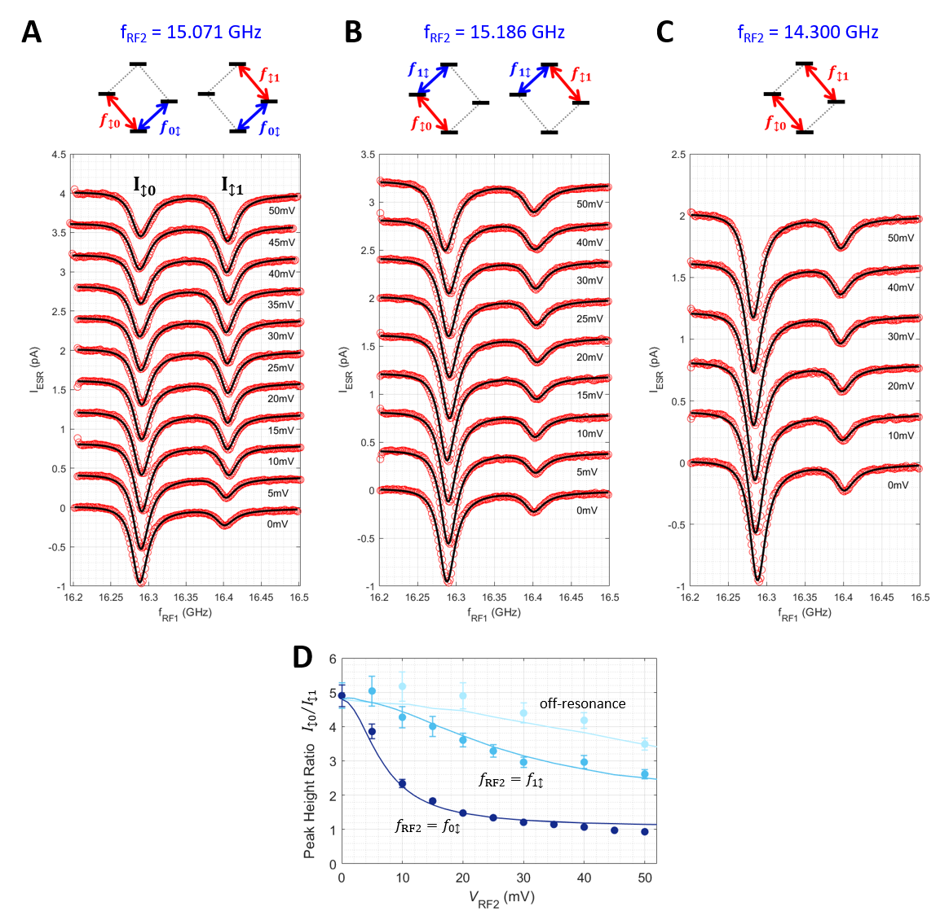

Fig. S4. Complete set of dual-frequency-driven ESR spectra in Fig. 1D. (A-C) $V_{RF2}$dependence of Ti-1 ESR spectra with $f_{RF2}$ fixed at $f_{0↕}=15.071 GHz$ (A), $f_{1↕}=15.186 GHz$ (B), and off-resonance at $14.300 GHz$ (C). Successive spectra are shifted by 0.4 pA for clarity. Black solid curves: 2-Lorentzian curve fits to the ESR spectra. Insets depict the ESR transitions involved in each panel ($I_{DC}=20 pA$, $V_{DC}=50 mV$, $V_{RF1}=30 mV$, $0.4<T<0.5 K$). (D) $V_{RF2}$-dependence of peak height ratio ${I_{↕0}}/{I_{↕1}}$ extracted from the fits in A-C. Solid curves are from simulations (see section 5; parameters: $T_{1}^{(1)}=8 ns$, ${Ω^{(1)}}/{\left(2πV_{RF1}\right)}=0.16{MHz}/{mV}$, $T_{1}^{(2)}=150 ns$, ${Ω^{(2)}}/{\left(2πV_{RF2}\right)}=0.24{MHz}/{mV}$,$0.4<T<0.5 K$).

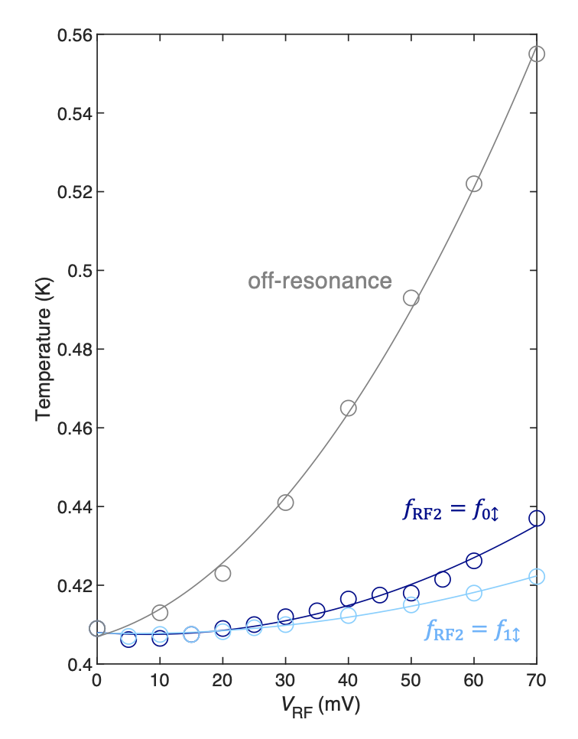
Fig. S5. Temperature as functions of RF power at different frequencies used in Figs. 1D and S4. Circles are experimental temperature readings from a thermometer mounted near the sample. Solid lines are 2nd-order polynomial fits to the temperature readings. In the Lindblad simulations, an additional overall 0.04 K upshift was added to all curves to correctly capture the effective spin temperatures.

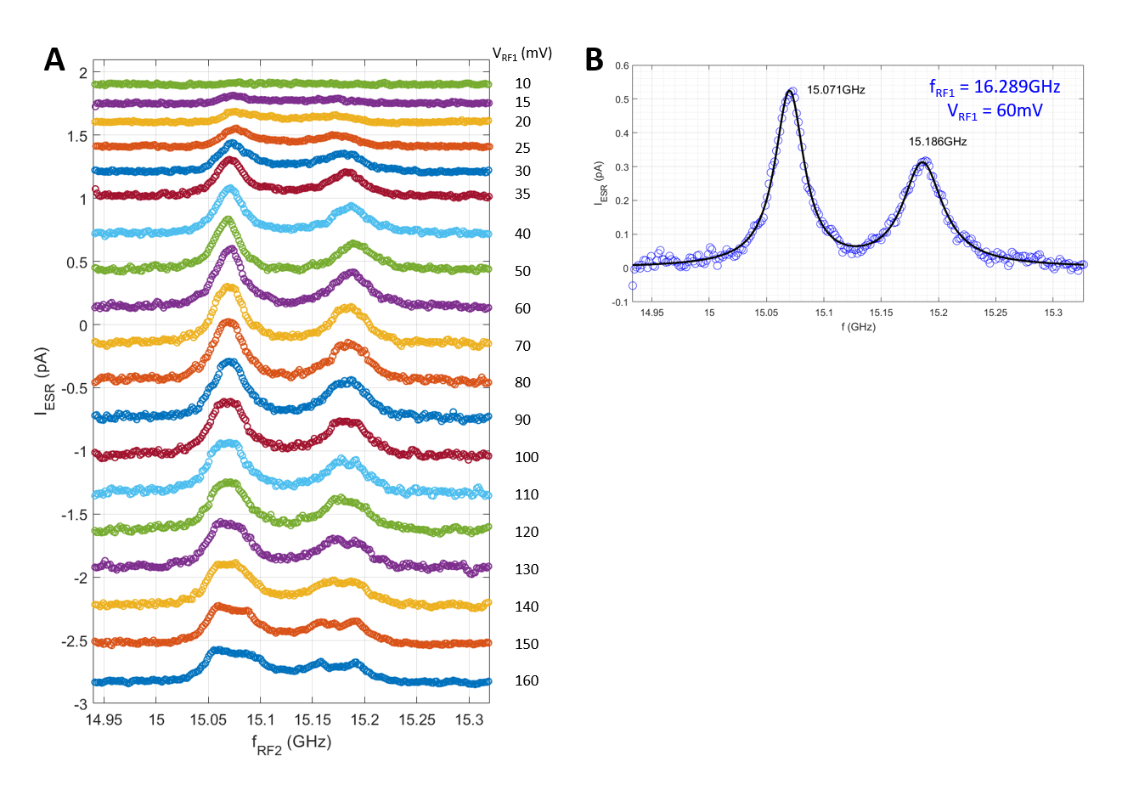
Fig. S6. Complete set of double resonance spectra in Fig. 2A. (A) double resonance spectra measured with $f_{RF1}$ fixed at $f_{↕0}=16.289 GHz$ over a wide range of $V_{RF1}$ ($I_{DC}=20 pA$, $V_{DC}=50 mV$, $V_{RF2}=30 mV$, $0.4<T<0.5 K$). (B) 2-Lorentzian curve fit to double resonance spectrum at $V_{RF1}=60 mV$, yielding the resonance frequencies of Ti-2 spin in the absence of the tip magnetic field.

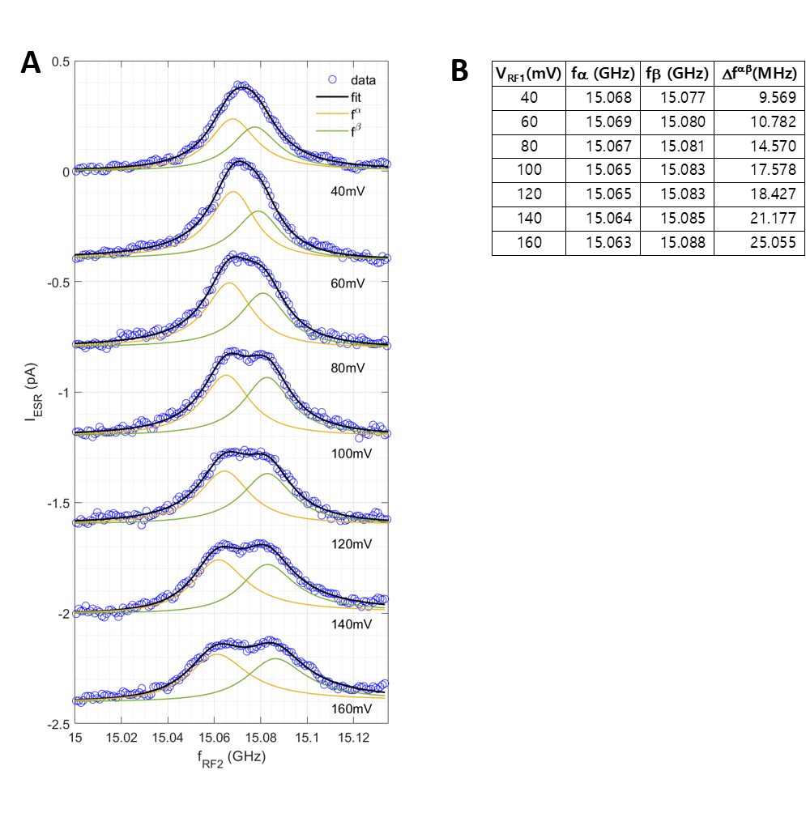
Fig. S7. Fitting of double resonance peak splitting in Fig. 3. (A) 2-Lorentzian curve fits to double resonance spectra in Fig. 3. For each curve, the two peaks were fitted with one common peak width and two independent peak heights. (B) Peak frequencies ($f_{1↕}^{α}$, $f_{1↕}^{β}$) and splitting ${Δf}^{αβ}=f_{1↕}^{β}-f_{1↕}^{α}$, extracted from the fits in A.

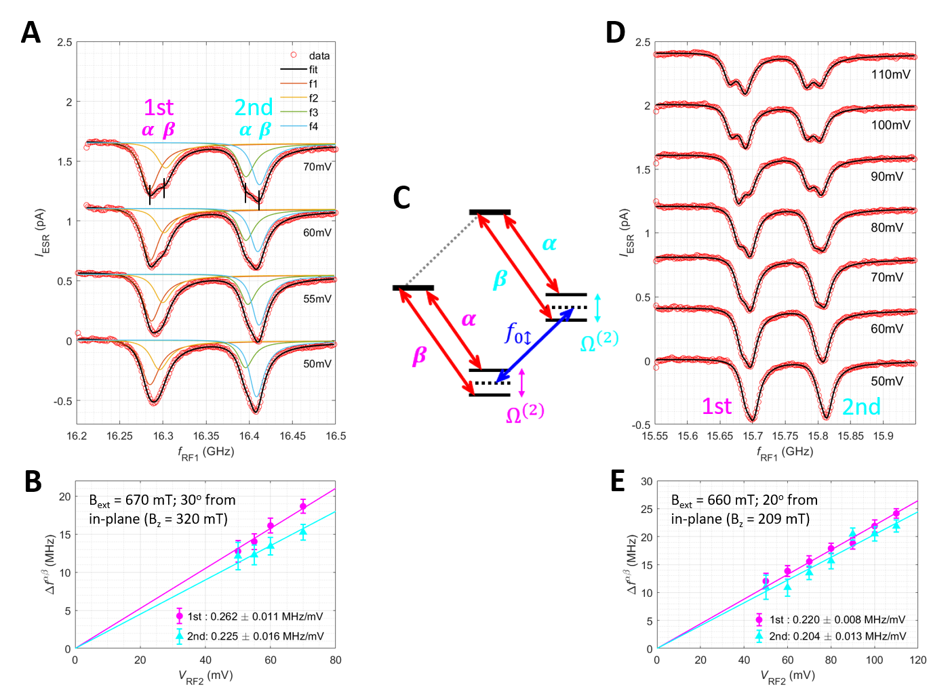

Fig. S8. Dual-frequency-driven ESR spectra at high driving amplitudes. (A) Ti-1 ESR spectra with $f_{RF2}$ fixed at $f_{0↕}=15.071 GHz$ by varying $V_{RF2}$ from $50$ to $70 mV$. Note the splitting of each ESR peak. Solid curves: 4-Lorentzian curve fits to each spectrum. For each curve, the two subpeaks were fitted with one common peak width and two independent peak heights ($I_{DC}=20 pA$, $V_{DC}=50 mV$, $V_{RF1}=30 mV$, $0.4<T<0.5 K$). (B) Splitting of ESR peaks, extracted from the fits in A, as a function of $V_{RF2}$. Solid lines: linear fits to the splitting of the '1st' (magenta) and '2nd' (cyan) ESR peaks that yielded the labelled Rabi rates. (C) Energy diagram of the dressed spin states and possible ESR transitions. (D, E) Same as (A, B) but at a slightly different magnetic field (labelled in E).

Section 4. Double resonance measurements of a second Ti-Ti-Fe structure

To verify the universality of remote spin driving, we performed double resonance measurements of a second Ti-Ti-Fe structure using a different STM kept at 0.9 K as shown in Figs. S10-S13. The magnetic field was kept at 0.85 T with a ~12° angle off the sample plane (i.e., the magnetic field was mostly along the sample plane). Fig. S9 shows the structure and single ESR spectroscopic characterization of the structure. Figures S10 and S11 present the results measured on the second structure using the measurement scheme of Figs. 1D and S4. Here, due to the higher data acquisition temperature (0.9 K) and the thermal stability of this STM, the sample temperature did not vary as much with increasing RF power (as shown by the near-constant off-resonance peak ratio in Fig. S10D), and thus only a fixed spin temperature was needed in the simulations to match the experimental data (see the discussion in Section 3). This further highlights the agreement between the experiments and the simulations.
Figure S12 plots the double resonance spectroscopy results (similar to Fig. 2) at different tip locations on Ti-1. Despite significant shifts of the single ESR peaks of Ti-1 due to the variations of the local tip magnetic field, the frequency of the double resonance peak/dip features stay mostly unaltered, indicating the absence of the tip’s magnetic field on the remote spin. Figure S13 illustrates the reverse double resonance spectroscopy measurement, where the STM tip was placed on Ti-2. We attempted to drive the Ti-1 ESR transitions remotely, but failed as expected, which indicates that Ti-1 cannot be remotely driven due to its negligible coupling to Fe (i.e., absence of a single magnet for remote driving).
Lindblad simulations of this data set show $T_{1}^{(1)}=5$ ns, ${Ω^{(1)}}/{\left(2πV_{RF1}\right)}=0.080{MHz}/{mV}$, $T_{1}^{(2)}=50$ ns, ${Ω^{(2)}}/{\left(2πV_{RF2}\right)}=0.0644{MHz}/{mV}$, and spin temperature$T=0.96 K$. The remote Rabi rate is smaller in this structure due to the slightly larger distance between Fe and Ti-2 (0.72 nm) compared to the structure studied in the main text (0.59 nm). The shorter $T_{1}^{(2)}$ is likely due to the higher measurement temperature and/or differences in the local magnetic environment.
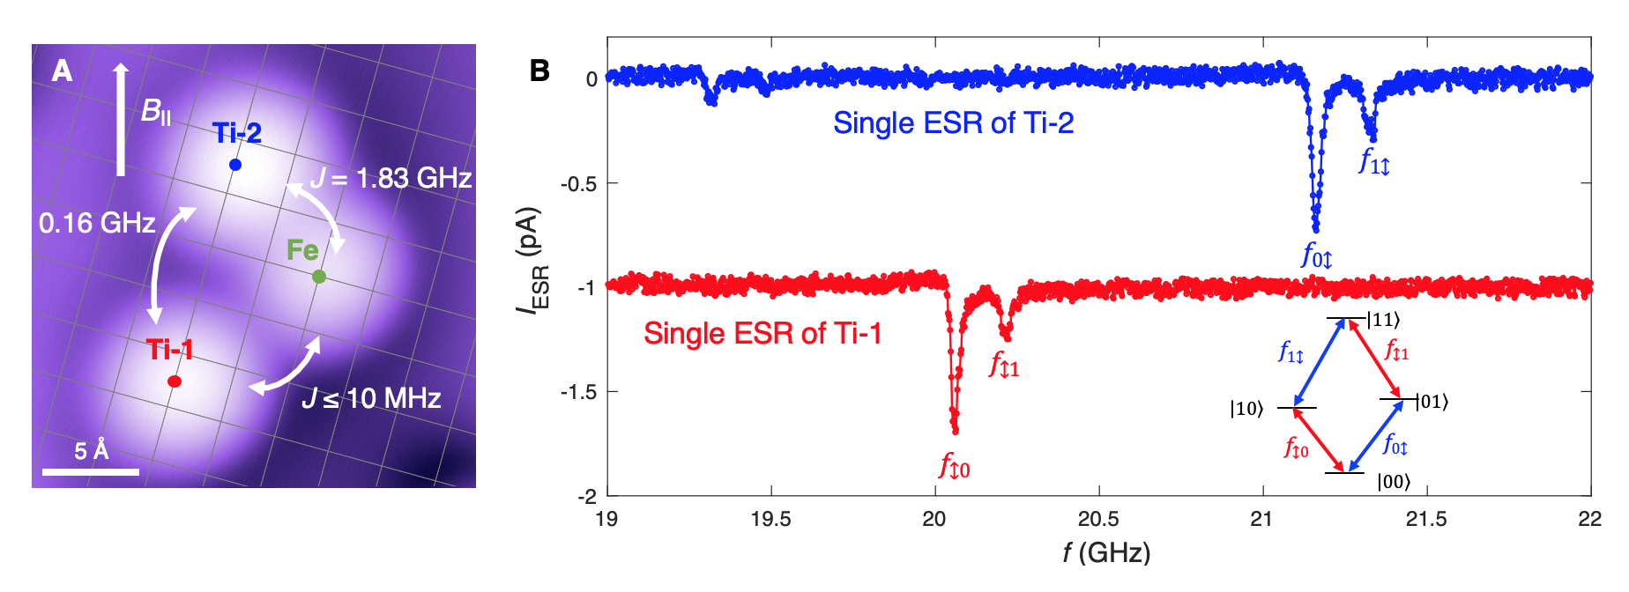

Fig. S9. Single frequency ESR spectra of Ti-Ti-Fe structure #2. (A) STM topograph of Ti-Ti-Fe structure #2. The interactions involved were determined from the ESR spectra in B. (B) Single-frequency ESR spectra of Ti-1 and Ti-2 allowing the determination of coupling involved in this structure. The red curve was shifted down by 1 pA for clarity. Inset: an energy diagram of two weakly coupled Ti spins with four spin states labelled according to $\left|S_{z}\right.$(Ti-1), $S_{z}$(Ti-2$\left.)\right\rangle$ and possible ESR transitions at four frequencies (I = 20 pA, V_{DC} = 40 mV, V_{RF2} = 30 mV, T = 0.9 K).

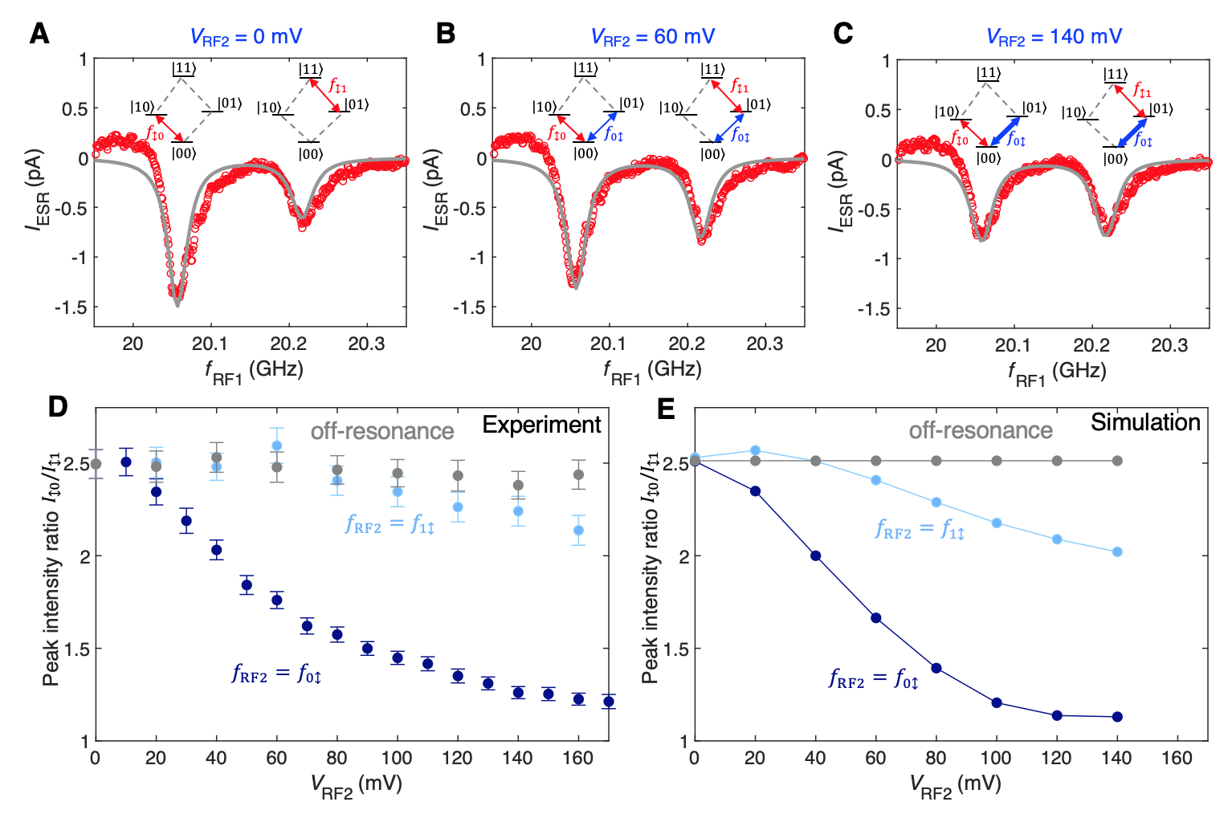

Fig. S10. Dual-frequency ESR driving of Ti-Ti-Fe structure #2 using the same scheme as Fig. 1D. (A to C) With increasing V_{RF2}, the ESR peak height of Ti-1 at $f_{↕0}$ rapidly decreases relative to transition $f_{↕1}$, indicating that population transfer occurs from state $|00⟩$ to $|01⟩$ due to the driving of the remote spin Ti-2 (I = 20 pA, V_{DC} = 40 mV, V_{RF1} = 60 mV, f_{RF2} = 21.212 GHz, T = 0.9 K). Grey lines are simulations (with parameters listed below). (D) The peak height ratio ${I_{↕0}}/{I_{↕1}}$ as a function of V_{RF2}. The peak height ratio decreases with increasing resonant driving of Ti-2 but stays nearly constant at off resonance (the full data is shown in fig. S11) (I = 20 pA, V_{DC} = 40 mV, T = 0.9 K, V_{RF1} = 60 mV, $f_{1↕}$ = 21.212 GHz, $f_{0↕}$ = 21.369 GHz, $f_{RF2}$ = 17.81 GHz at off resonance). (E) Simulations of the peak height ratio (Simulation parameters: $T_{1}^{(1)}=5$ ns, ${Ω^{(1)}}/{\left(2πV_{RF1}\right)}=0.080{MHz}/{mV}$, $T_{1}^{(2)}=50$ ns, ${Ω^{(2)}}/{\left(2πV_{RF2}\right)}=0.0644{MHz}/{mV}$, $T=0.96 K$).

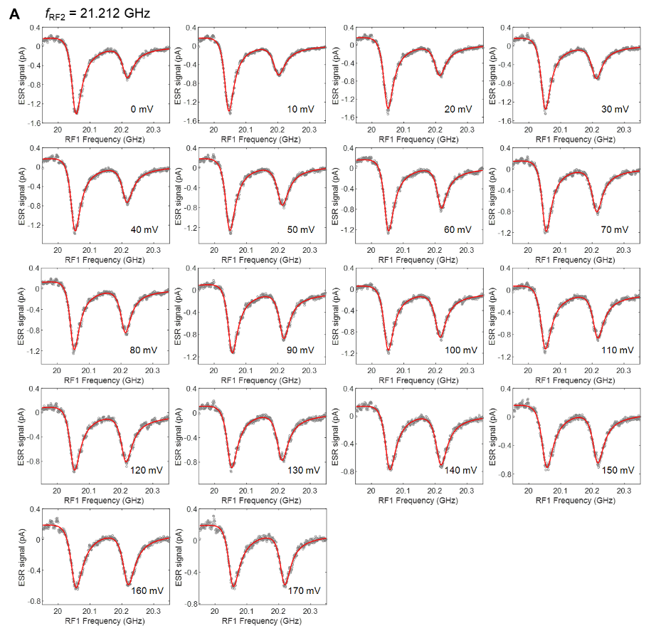
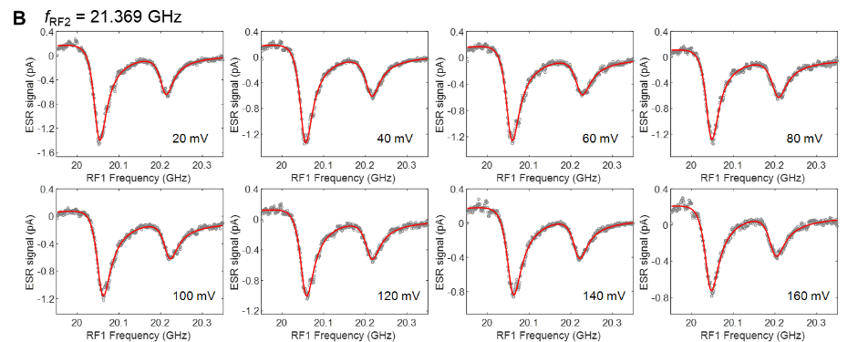
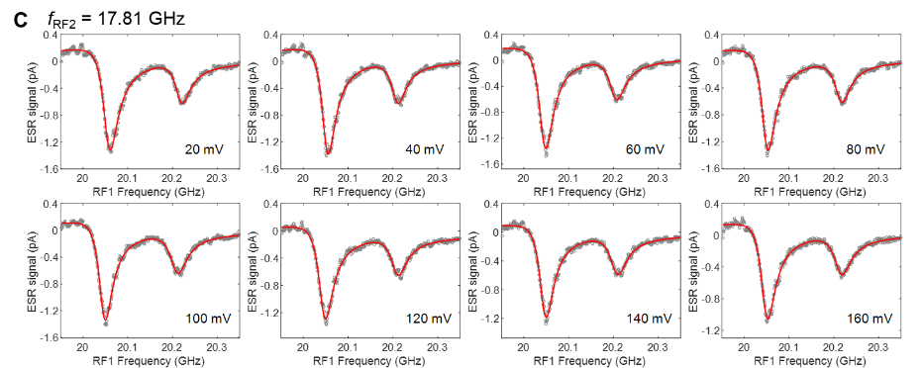

Fig. S11. Full ESR data set of Fig. S10. ESR spectra were measured on Ti-1 at the fixed V_{RF1} = 60 mV while V_{RF2} was varied from 0 to 170 mV at three different frequencies (A) f_{RF2} = 21.212 GHz, (B) f_{RF2} = 21.369 GHz, and (C) f_{RF2} = 17.81 GHz. T = 0.9 K. Red curves are Lorentzian fits that give the peak heights used for plotting Fig. S10D.

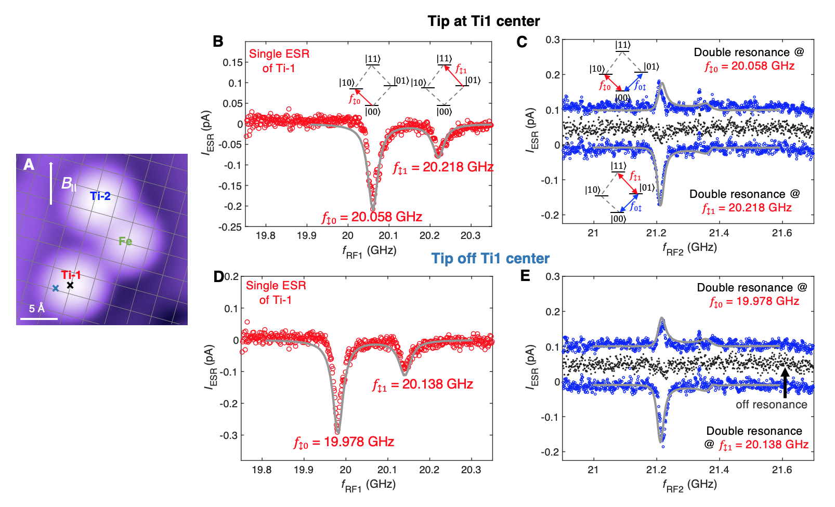
Fig. S12. Double resonance spectroscopy of Ti-Ti-Fe structure #2 using the same scheme as Fig. 2. (A) STM topograph illustrating two tip positions during this measurement. (B) Single ESR spectrum of Ti-1 with the tip at its center (I = 20 pA, V_{DC} = 80 mV, V_{RF} = 30 mV, T = 0.9 K). Grey lines are the simulation results (with parameters listed above in section 4). (C) Double resonance spectrum with the tip at the Ti-1 center (black cross in A). The strongest peak/dip feature originates from the transition $f_{0↕}$ of the remote spin. No significant features can be found off resonance (black) (I = 20 pA, V_{DC} = 80 mV, V_{RF1} = 100 mV, V_{RF2} = 60 mV, T = 0.9 K). Grey lines are the simulation results. (D, E) Same measurements as B to C but with the tip placed off the Ti-1 center (blue cross in A). Despite significant shifts of the single ESR peaks of Ti-1 due to the variations of the tip’s magnetic field, the frequency of the double resonance peak/dip feature stays mostly unaltered, further confirming its origin from the remote spin.

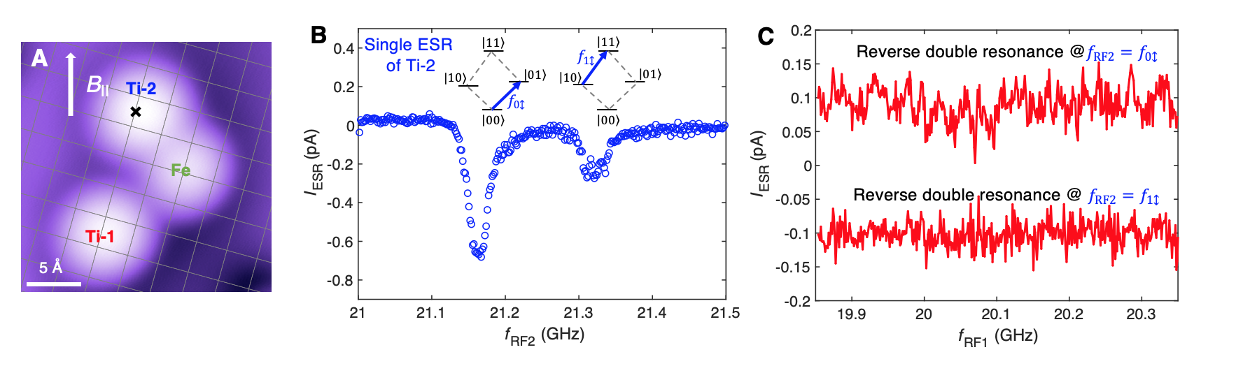

Fig. S13. Reverse double resonance spectroscopy showing that Ti-1 cannot be remotely driven in this structure. (A) STM topograph illustrating that the tip stayed at Ti-2 during the reverse double resonance measurements. (B) Single ESR spectrum of Ti-2 (I = 20 pA, V_{DC} = 40 mV, V_{RF} = 30 mV, T = 0.9 K). (C) Reverse double resonance spectra with the tip placed at Ti-2. No double resonance features were detected, which shows that Ti-1 cannot be remotely driven due to its very weak coupling to Fe (I = 20 pA, V_{DC} = 40 mV, V_{RF2} = 100 mV, V_{RF1} = 60 mV, T = 0.9 K).

Section 5. Simulations of double electron resonance using the Lindblad formalism

Section 5.1. Introduction to the Lindblad master equation

The unitary time evolution of a closed quantum system is described by the von Neumann equation
$$\frac{dρ}{dt}=-\frac{i}{ℏ}\left[H,ρ\right],$$ | (Eq. S6)
where $ρ$ is the density matrix and $H$ is the Hamiltonian of the closed system. A real-world quantum system, on the other hand, is always coupled to an environment. To include decoherence effects induced by the environment, a commonly used method is to invoke the Lindblad master equation. The Lindblad formalism assumes a Markovian interaction between the system and the environment and introduces a series of Lindblad operators $L_{k}$ that describe such interactions and the resultant non-unitary evolution of the system (29). With the unitary and non-unitary evolution combined, the celebrated Lindblad master equation reads
$$\frac{dρ}{dt}=-\frac{i}{ℏ}\left[H,ρ\right]+\sum_{k}{\left(L_{k}ρL_{k}^{†}-\frac{1}{2}L_{k}^{†}L_{k}ρ-\frac{1}{2}ρL_{k}^{†}L_{k}\right)}.$$ | (Eq. S7)
As a simple example, consider the Lindblad formalism of a single spin-1/2 coupled to a thermal bath at temperature $T$. Three relaxation paths can be represented by three Lindblad operators:
- Pure dephasing is represented by $L_{ϕ}=\sqrt{\frac{Γ_{ϕ}}{2}}σ_{z}$, which yields
$$L_{ϕ}ρL_{ϕ}^{†}-\frac{1}{2}L_{ϕ}^{†}L_{ϕ}ρ-\frac{1}{2}ρL_{ϕ}^{†}L_{ϕ}=-Γ_{ϕ}\left[\begin{matrix}0 & ρ_{01} \\ ρ_{10} & 0\end{matrix}\right].$$ | (Eq. S8)
The effect is that off-diagonal terms exponentially decay towards zero at the rate of $Γ_{ϕ}$ in the absence of the drive, as expected.
- Energy relaxation from $\left.\left|0\right.\right\rangle$ to $\left.\left|1\right.\right\rangle$ is represented by $L_{-}=\sqrt{Γ_{-}}σ_{-}$, which yields
$$L_{-}ρL_{-}^{†}-\frac{1}{2}L_{-}^{†}L_{-}ρ-\frac{1}{2}ρL_{-}^{†}L_{-}=-Γ_{-}\left[\begin{matrix}ρ_{00} & {\frac{1}{2}ρ}_{01} \\ {\frac{1}{2}ρ}_{10} & -ρ_{00}\end{matrix}\right].$$ | (Eq. S9)
The effect is that $ρ_{00}$ exponentially decays towards zero at the rate of $Γ_{-}$, and a dephasing process also occurs at the rate of $Γ_{-}/2$.
- Energy relaxation from $\left.\left|1\right.\right\rangle$ to $\left.\left|0\right.\right\rangle$ is represented by $L_{+}=\sqrt{Γ_{+}}σ_{+}$, which yields
$$L_{+}ρL_{+}^{†}-\frac{1}{2}L_{+}^{†}L_{+}ρ-\frac{1}{2}ρL_{+}^{†}L_{+}=-Γ_{+}\left[\begin{matrix}-ρ_{11} & {\frac{1}{2}ρ}_{01} \\ {\frac{1}{2}ρ}_{10} & ρ_{11}\end{matrix}\right].$$ | (Eq. S10)
The effect is that $ρ_{11}$ exponentially decays towards zero at the rate of $Γ_{+}$, and a dephasing process also occurs at the rate of $Γ_{+}/2$.

Combining all three terms together, the Lindblad equation for a single spin becomes
$$\frac{dρ}{dt}=-\frac{i}{ℏ}\left[H,ρ\right]-Γ_{+}\left[\begin{matrix}-ρ_{11} & 0 \\ 0 & ρ_{11}\end{matrix}\right]-Γ_{-}\left[\begin{matrix}ρ_{00} & 0 \\ 0 & -ρ_{00}\end{matrix}\right]-\left(Γ_{ϕ}+\frac{Γ_{+}}{2}+\frac{Γ_{-}}{2}\right)\left[\begin{matrix}0 & ρ_{01} \\ ρ_{10} & 0\end{matrix}\right].$$ | (Eq. S11)
Here we grouped all the off-diagonal decay terms together, which defines a total dephasing rate $1/T_{2}≡Γ_{ϕ}^{tot}≡Γ_{ϕ}+\frac{Γ_{+}}{2}+\frac{Γ_{-}}{2}$.
The ratio between $Γ_{+}$ and $Γ_{-}$ is not arbitrary but fixed by the thermal Boltzmann distribution. To see this, consider the steady-state value of $ρ_{00}$ in the absence of drive:
$$\frac{dρ_{00}}{dt}=Γ_{+}ρ_{11}-Γ_{-}ρ_{00}=Γ_{+}-\left(Γ_{+}+Γ_{-}\right)ρ_{00}.$$ | (Eq. S12)
This means that the steady state in the absence of the drive is given by
$$ρ_{00}^{0}=\frac{Γ_{+}}{Γ_{+}+Γ_{-}} , ρ_{11}^{0}=1-ρ_{00}^{0}=\frac{Γ_{-}}{Γ_{+}+Γ_{-}} ,$$ | (Eq. S13)
which should be equal to the thermal population
$$\frac{Γ_{+}}{Γ_{+}+Γ_{-}}=\frac{1}{1+exp\left(ℏω_{0}/k_{B}T\right)}, \frac{Γ_{-}}{Γ_{+}+Γ_{-}}=\frac{exp\left(ℏω_{0}/k_{B}T\right)}{1+exp\left(ℏω_{0}/k_{B}T\right)},$$ | (Eq. S14)
where $ℏω_{0}$ is the energy difference between states $\left.\left|1\right.\right\rangle$ and $\left.\left|0\right.\right\rangle$. We are thus motivated to define a total energy relaxation rate
$$\frac{1}{T_{1}}≡Γ_{1}≡Γ_{+}+Γ_{-},$$ | (Eq. S15)
which allows us to rewrite Eq. S6 in a commonly used form
$$\frac{dρ}{dt}=-\frac{i}{ℏ}\left[H,ρ\right]-\frac{1}{T_{1}}\left(\left[\begin{matrix}ρ_{00} & 0 \\ 0 & ρ_{11}\end{matrix}\right]-\left[\begin{matrix}ρ_{00}^{0} & 0 \\ 0 & ρ_{11}^{0}\end{matrix}\right]\right)-\frac{1}{T_{2}}\left[\begin{matrix}0 & ρ_{01} \\ ρ_{10} & 0\end{matrix}\right].$$ | (Eq. S16)
Using the single-spin Hamiltonian in the rotating frame $H=\frac{ℏ}{2}\left[\begin{matrix}-∆ω & Ω \\ Ω & ∆ω\end{matrix}\right]$, where $∆ω$ is the detuning frequency and $Ω$ is the Rabi frequency on resonance, the master equation becomes
$$\frac{d}{dt}\left[\begin{aligned}\begin{matrix}ρ_{00} \\ ρ_{01}\end{matrix} \\ ρ_{10} \\ ρ_{11}\end{aligned}\right]=L\left[\begin{aligned}\begin{matrix}ρ_{00} \\ ρ_{01}\end{matrix} \\ ρ_{10} \\ ρ_{11}\end{aligned}\right]=\left[\begin{matrix}{-Γ}_{-} & iΩ/2 & -iΩ/2 & Γ_{+} \\ iΩ/2 & i∆ω-Γ_{ϕ}^{tot} & 0 & -iΩ/2 \\ -iΩ/2 & 0 & i∆ω-Γ_{ϕ}^{tot} & iΩ/2 \\ Γ_{-} & -iΩ/2 & iΩ/2 & {-Γ}_{+}\end{matrix}\right]\left[\begin{aligned}\begin{matrix}ρ_{00} \\ ρ_{01}\end{matrix} \\ ρ_{10} \\ ρ_{11}\end{aligned}\right].$$ | (Eq. S17)

This is the expression of the master equation in the Fock-Liouville space and can be shown to be equivalent to the Bloch equations that governs the single spin dynamics.

Section 5.2. Simulation of two coupled spins using the Lindblad formalism

In the lab frame, the Hamiltonian describing a coupled spin-1/2 system is given by
$$H_{lab}=-ω_{01}S_{1z}⨂I-ω_{02}I⨂S_{2z}+\frac{J}{ℏ}\left(S_{1}⨂I\right)∙\left(I⨂S_{2}\right)$$  $+\left[Ω^{(1)}\cos{ω_{RF1}t}+Ω^{(2)}\cos{ω_{RF2}t}\right](S_{1x}⨂I+I⨂S_{2x})$, | (Eq. S18)
where $⨂$ represents the tensor product, $I$ is the identity operator, $ω_{01}=-γ_{1}B_{0}$ and $ω_{02}=-γ_{2}B_{0}$ are the Larmor frequencies of the spin 1 and 2, $Ω^{(1)}=-γ_{1}B_{1}^{1}$ and $Ω^{(2)}=-γ_{2}B_{1}^{2}$ are the on-resonance Rabi frequencies that represent the strengths of the RF waves, and $ω_{RF1}$ and $ω_{RF2}$ are the applied RF frequencies. In our weakly-coupled spin pair, $J$ is small compared to the energy scale of $ω_{01}-ω_{02}$. The prefactor of $J$ ensures that the resulting ESR splitting is $J$. The two RF waves are assumed to be applied in $x$ direction.
To construct the Lindblad formalism for two coupled spins, we need to consider different relaxation paths. The processes that originate from single-spin relaxation can be formulated similar to the single-spin case shown in the last section:
- Pure dephasing of the first spin is described by $L_{ϕ1}=\sqrt{\frac{Γ_{ϕ1}}{2}}σ_{1z}⨂I$, which yields
$$L_{ϕ1}ρL_{ϕ1}^{†}-\frac{1}{2}L_{ϕ1}^{†}L_{ϕ1}ρ-\frac{1}{2}ρL_{ϕ1}^{†}L_{ϕ1}=-Γ_{ϕ1}\left[\begin{aligned}\begin{matrix}0 & 0 & ρ_{02} & ρ_{03} \\ 0 & 0 & ρ_{12} & ρ_{13} \\ ρ_{20} & ρ_{21} & 0 & 0 \\ ρ_{30} & ρ_{31} & 0 & 0\end{matrix}\end{aligned}\right].$$ | (Eq. S19)
The four rows and columns are labelled according to $\left.\left|00\right.\right\rangle$, $\left.\left|01\right.\right\rangle$, $\left.\left|10\right.\right\rangle$, and $\left.\left|11\right.\right\rangle$.
- Pure dephasing of the second spin is described by $L_{ϕ2}=\sqrt{\frac{Γ_{ϕ2}}{2}}I⨂σ_{2z}$, which yields
$$L_{ϕ2}ρL_{ϕ2}^{†}-\frac{1}{2}L_{ϕ2}^{†}L_{ϕ2}ρ-\frac{1}{2}ρL_{ϕ2}^{†}L_{ϕ2}=-Γ_{ϕ2}\left[\begin{aligned}\begin{matrix}0 & ρ_{01} & 0 & ρ_{03} \\ ρ_{10} & 0 & ρ_{12} & 0 \\ 0 & ρ_{21} & 0 & ρ_{23} \\ ρ_{30} & 0 & ρ_{32} & 0\end{matrix}\end{aligned}\right].$$ | (Eq. S20)
- Energy relaxation by the first spin flipping from $\left.\left|0\right.\right\rangle$ to $\left.\left|1\right.\right\rangle$ is represented by $L_{1-}=\sqrt{Γ_{1-}}σ_{1-}⨂I$, which yields
$$L_{1-}ρL_{1-}^{†}-\frac{1}{2}L_{1-}^{†}L_{1-}ρ-\frac{1}{2}ρL_{1-}^{†}L_{1-}=-Γ_{1-}\left[\begin{aligned}\begin{matrix}ρ_{00} & ρ_{01} & \frac{ρ_{02}}{2} & \frac{ρ_{03}}{2} \\ ρ_{10} & ρ_{11} & \frac{ρ_{12}}{2} & \frac{ρ_{13}}{2} \\ \frac{ρ_{20}}{2} & \frac{ρ_{21}}{2} & -ρ_{00} & 0 \\ \frac{ρ_{30}}{2} & \frac{ρ_{31}}{2} & 0 & -ρ_{11}\end{matrix}\end{aligned}\right].$$ | (Eq. S21)
Here we ignored the dependence of the first spin relaxation rate on the second spin state, which should not be important unless $J$ becomes the dominant energy scale.
- Energy relaxation by the first spin flipping from $\left.\left|1\right.\right\rangle$ to $\left.\left|0\right.\right\rangle$ is represented by $L_{1+}=\sqrt{Γ_{1+}}σ_{1+}⨂I$, which yields
$$L_{1+}ρL_{1+}^{†}-\frac{1}{2}L_{1+}^{†}L_{1+}ρ-\frac{1}{2}ρL_{1+}^{†}L_{1+}=-Γ_{1+}\left[\begin{aligned}\begin{matrix}-ρ_{22} & 0 & \frac{ρ_{02}}{2} & \frac{ρ_{03}}{2} \\ 0 & -ρ_{33} & \frac{ρ_{12}}{2} & \frac{ρ_{13}}{2} \\ \frac{ρ_{20}}{2} & \frac{ρ_{21}}{2} & ρ_{22} & ρ_{23} \\ \frac{ρ_{30}}{2} & \frac{ρ_{31}}{2} & ρ_{32} & ρ_{33}\end{matrix}\end{aligned}\right].$$ | (Eq. S22)
- Energy relaxation by the second spin flipping from $\left.\left|0\right.\right\rangle$ to $\left.\left|1\right.\right\rangle$ is represented by $L_{2-}=\sqrt{Γ_{2-}}I⨂σ_{2-}$, which yields
$$L_{2-}ρL_{2-}^{†}-\frac{1}{2}L_{2-}^{†}L_{2-}ρ-\frac{1}{2}ρL_{2-}^{†}L_{2-}=-Γ_{2-}\left[\begin{aligned}\begin{matrix}ρ_{00} & \frac{ρ_{01}}{2} & ρ_{02} & \frac{ρ_{03}}{2} \\ \frac{ρ_{10}}{2} & -ρ_{00} & \frac{ρ_{12}}{2} & 0 \\ ρ_{20} & \frac{ρ_{21}}{2} & ρ_{22} & \frac{ρ_{23}}{2} \\ \frac{ρ_{30}}{2} & 0 & \frac{ρ_{32}}{2} & -ρ_{22}\end{matrix}\end{aligned}\right].$$ | (Eq. S23)
- Energy relaxation by the second spin flipping from $\left.\left|1\right.\right\rangle$ to $\left.\left|0\right.\right\rangle$ is represented by $L_{2+}=\sqrt{Γ_{2+}}I⨂σ_{2+}$, which yields
$$L_{2+}ρL_{2+}^{†}-\frac{1}{2}L_{2+}^{†}L_{2+}ρ-\frac{1}{2}ρL_{2+}^{†}L_{2+}=-Γ_{2+}\left[\begin{aligned}\begin{matrix}-ρ_{11} & \frac{ρ_{01}}{2} & 0 & \frac{ρ_{03}}{2} \\ \frac{ρ_{10}}{2} & ρ_{11} & \frac{ρ_{12}}{2} & ρ_{13} \\ 0 & \frac{ρ_{21}}{2} & -ρ_{33} & \frac{ρ_{23}}{2} \\ \frac{ρ_{30}}{2} & ρ_{31} & \frac{ρ_{32}}{2} & ρ_{33}\end{matrix}\end{aligned}\right].$$ | (Eq. S24)
- There are four more energy relaxation paths that correspond to the cross-relaxation processes of the two spins. However, our main experimental results are well captured without considering these cross-relaxation processes. The unimportant role of the flip-flop processes can be justified by the very different Larmor frequencies of the two spins in the experiment.
Similar to the single-spin case, $Γ_{1-}/Γ_{1+}$ and $Γ_{2-}/Γ_{2+}$ are determined by the thermal population. In the absence of the drive, the steady thermal populations of $\left.\left|00\right.\right\rangle$, $\left.\left|01\right.\right\rangle$, $\left.\left|10\right.\right\rangle$, and $\left.\left|11\right.\right\rangle$ are given by
$$ρ_{00}^{0}=\frac{Γ_{1+}}{Γ_{1+}+Γ_{1-}}×\frac{Γ_{2+}}{Γ_{2+}+Γ_{2-}}, ρ_{11}^{0}=\frac{Γ_{1+}}{Γ_{1+}+Γ_{1-}}×\frac{Γ_{2-}}{Γ_{2+}+Γ_{2-}} ,$$  $$ρ_{22}^{0}=\frac{Γ_{1-}}{Γ_{1+}+Γ_{1-}}×\frac{Γ_{2+}}{Γ_{2+}+Γ_{2-}}, ρ_{33}^{0}=\frac{Γ_{1-}}{Γ_{1+}+Γ_{1-}}×\frac{Γ_{2-}}{Γ_{2+}+Γ_{2-}} ,$$ | (Eq. S25)
and the relaxation rate ratios are thus determined to be
$$\frac{Γ_{1+}}{Γ_{1+}+Γ_{1-}}=\frac{1}{1+exp\left(ℏω_{01}/k_{B}T\right)},$$  $$\frac{Γ_{2+}}{Γ_{2+}+Γ_{2-}}=\frac{1}{1+exp\left(ℏω_{02}/k_{B}T\right)},$$ | (Eq. S26)
Here we ignored the change of the Zeeman splitting induced by the exchange interaction $J$, which would only induce a negligible difference (less than 1%) of the Boltzmann factors in our parameter regime. We then define a total energy relaxation rate for each spin as
$$Γ_{1}≡\frac{1}{T_{1}^{\left(1\right)}}=Γ_{1+}+Γ_{1-}, Γ_{2}≡\frac{1}{T_{1}^{\left(2\right)}}=Γ_{2+}+Γ_{2-},$$ | (Eq. S27)
which are used as tuning parameters in the simulations.

Section 5.3. Numerical solution to the Lindblad master equation in the lab frame
Inserting Eq. S19-S25 into the Lindblad equation
$$\frac{dρ}{dt}=-\frac{i}{ℏ}\left[H_{lab},ρ\right]+\sum_{k}{\left(L_{k}ρL_{k}^{†}-\frac{1}{2}L_{k}^{†}L_{k}ρ-\frac{1}{2}ρL_{k}^{†}L_{k}\right)}.$$ | (Eq. S28)
yields the master equation for the two-coupled-spin density matrix in the lab frame. The time evolution of the coupled two-spin density matrix was simulated using the Lindblad master equation solver as implemented in QuTip (28). In our setup, the time-evolution is performed by integration of the time-dependent Hamiltonian (Eq. S18) for 2000 ns using a step-size of 0.02 ns. To obtain the steady-state populations, the density matrix was averaged for the last 10% of the simulation time to remove residual oscillations from the calculation and the ESR signal was calculated according to Eq. S29 below. The frequency resolution was 2 MHz corresponding to 150 discrete frequency steps for all spectra shown in the main text.
To reproduce the double resonance spectra, we notice that the observable in our double resonance experiment is the steady-state spin polarization of the spin 1 (the sensor spin under the STM tip), which is given by
$$SP1= ρ_{00}^{SS}+ρ_{11}^{SS}-ρ_{22}^{SS}-ρ_{33}^{SS}.$$ | (Eq. S29)
The double resonance spectra shown in the main text were then obtained by calculating the difference of $SP1$ between the lock-in A and B cycles (as discussed in the Section 2 above).
We note that our simulations has 8 parameters to describe the driven two spin-system: the two Larmor frequencies, the coupling strength between spin-1 and spin-2 (J₁₂), the Rabi rates of spin-1 and spin-2 (Ω⁽¹⁾ and Ω⁽²⁾), and T₁ times of spin-1 and spin-2 (T₁⁽¹⁾, T₁⁽²⁾ ) as well as an effective spin temperature T.
The Larmor frequencies and the coupling strength were determined from the double resonance experiments. For the simulations of the data presented in the main text, the dependence of the Rabi rates on the RF voltages was determined from the AC Stark splitting (Fig. 3, Fig. S7, and Fig. S8). Analytical temperature functions were implemented according to Fig. S5, and an additional, constant temperature offset of ~40 mK was added to match the peak-height ratio of double resonance spectra in thermal equilibrium.
The remaining two parameters were determined as follows: T₁⁽²⁾ can be determined with a high accuracy from the peak-height ratios of the double resonance experiments when driving the remote spin at $f_{0↕}=15.071$ GHz (Figs. 1D and E). By a series of calculations in the intermediate RF voltage regime ($0<V_{RF2}<40$ mV) we found that a value of T₁⁽²⁾ = 150 ± 10 ns minimizes the deviations between experiment and simulation (Fig. S14B). T₁⁽¹⁾ was determined by comparing simulated and experimental spectra obtained at $V_{RF2}=$40 mV (Fig. S14A) to be T₁⁽¹⁾ = 8 ± 1 ns.
The excellent agreement between experiment and calculations confirms that we are indeed observing an electron-electron double resonance experiment with a narrowly determined set of parameters. The simulations also allow us not to consider pure dephasing ($Γ_{ϕ}$, see Eqs. S19 and S20) as additional relaxation channels, since all experimental observations can be reproduced with T₁ relaxation processes only. The effects of additional pure dephasing on Ti-2 and Ti-1 on the spectra are shown in Fig. S15.
For the second data set of double resonance experiments (section 4) the driving strength could not be obtained from the splitting. In this case we used both the T₁⁽¹⁾, T₁⁽²⁾ as well as Ω⁽¹⁾ and Ω⁽²⁾ as free parameter and optimized them in a similar manner as discussed above.
We note that a small detuning ($∆f$< 10 MHz) can change the relative peak heights of the Autler-Townes doublet as shown in Fig. S16 (compared to Figs. S8A and D). Such detuning can occur in the experiment due to imperfect RF generator or magnet settings.

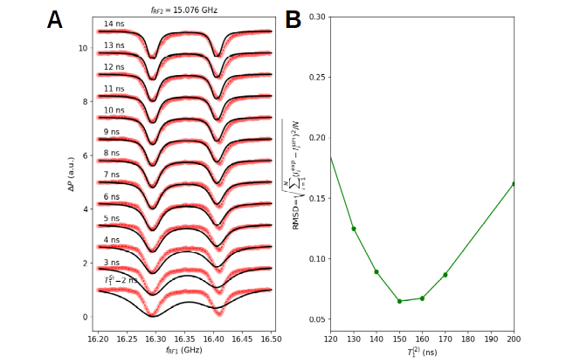
Fig. S14. Estimation of T₁ times used in the simulation. (A) Comparison between experimental data (red) and simulations (black) for a range of T₁⁽¹⁾ between 2 and 14 ns. Experiment: f_{RF2} = 15.076 GHz, V_{RF2} = 40 mV. (B) Deviation of the peak-height ratio as shown in Fig. 1E between simulation (${I_{↕0}}/{I_{↕1}}$: = I^{sim}) and experiment (I^{exp}) expressed as the root mean square deviation (RMSD) for the intermediate voltage range ($0<V_{RF2}<40$ mV) as function of T₁⁽²⁾ giving 150 ± 10 ns as the best estimate.

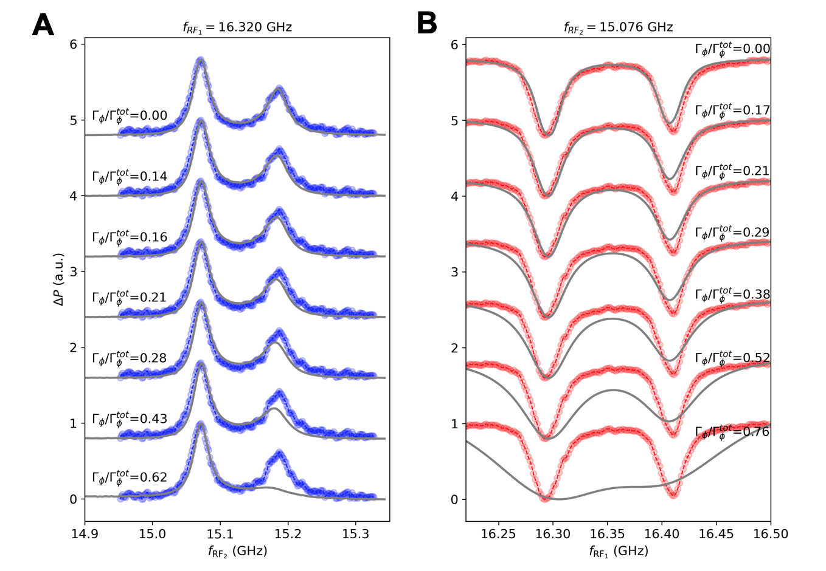
Fig. S15. Influence of additional pure dephasing on Ti-2 and Ti-1 on the simulated spectra. (A) Broadening of the simulated spectra (grey) as a function of pure dephasing rate on Ti-2. The ratio of pure dephasing compared to the total dephasing is labeled on the left. The top spectrum corresponds to no pure dephasing (only T₁ relaxation). Blue curves (experiment): double resonance spectrum measured using the scheme in Fig. 2 $(f_{RF1}=16.320 GHz$, $V_{RF1}=40 mV$, $f_{RF2}=15.076 GHz, V_{RF2}=40 mV)$. (B) Same as in (A) but with pure dephasing added to Ti-1. Red curves: experimental ESR spectrum using the scheme in Fig. 1D $(f_{RF1}=16.320 GHz,{ V}_{RF1}=40 mV,$ $f_{RF2}=15.076 GHz,$ and $V_{RF2}=40 mV)$. Simulation parameters: T₁⁽¹⁾ = 8 ns, T₁⁽²⁾ = 150 ns. $f_{RF1}=16.320 GHz, V_{RF1}=40 mV.$

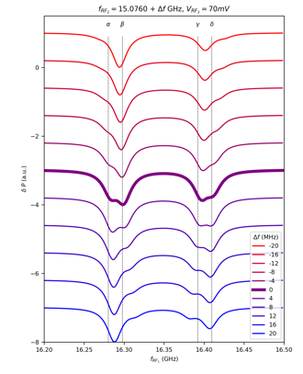

Fig. S16. Effect of detuning of the ESR driving on simulated spectra. Simulated Ti-1 double resonance spectra for varying detuning $∆f$ of $f_{RF2}$ for $V_{RF2}=70 mV$, T₁⁽¹⁾ = 8 ns, T₁⁽²⁾ = 150 ns. Vertical lines correspond to the sub-peaks of the spectrum.

Section 5.4. Rate equation of a single spin
To obtain an intuitive understanding of the competition between driving and relaxation in our system, in this and the next subsections we derive a rate equation that involves only population terms. Before diving into the two-coupled-spin case, in this subsection we first consider how to derive a rate equation for a single spin from its master equation (Eq. S17).
To obtain a rate equation involving only population terms, we take the adiabatic approximation (36) where the coherence terms are assumed to respond so fast to changes in populations that the coherences remain in the instantaneous steady states set by the populations, or, $dρ_{10}/dt=dρ_{01}/dt=0$ (this approximation is fully satisfied at the real steady states). Using the second and third lines of Eq. S17, this approximation allows us to express coherences with populations as
$$ρ_{01}\left(t\right)=-\frac{Ω\left[ρ_{00}\left(t\right)-ρ_{11}\left(t\right)\right]}{2\left(∆ω-iΓ_{ϕ}^{tot}\right)}, ρ_{10}\left(t\right)=ρ_{01}^{*}\left(t\right),$$ | (Eq. S29)
where $Γ_{ϕ}^{tot}=1/T_{2}=Γ_{+}/2+Γ_{+}/2+Γ_{ϕ}$. Inserting Eq. S29 to the first and fourth lines of Eq. S17 yields the rate equations for a single spin
$$\frac{dρ_{00}\left(t\right)}{dt}=-\left(W+Γ_{-}\right)ρ_{00}\left(t\right)+\left(W+Γ_{+}\right)ρ_{11}\left(t\right),$$  $$\frac{dρ_{11}\left(t\right)}{dt}=\left(W+Γ_{-}\right)ρ_{00}\left(t\right)-\left(W+Γ_{+}\right)ρ_{11}\left(t\right),$$ | (Eq. S30)  (Eq. S31)
where the effective driving is given by
$$W=\frac{Ω^{2}}{2}\frac{Γ_{+}/2+Γ_{+}/2+Γ_{ϕ}}{{\left(Γ_{+}/2+Γ_{+}/2+Γ_{ϕ}\right)}^{2}+{\left(∆ω\right)}^{2}} ,$$ | (Eq. S32)
The driving is strongest at zero detuning $∆ω=0$ and weakens when $∆ω$ becomes comparable to the relaxation rate $Γ_{+}/2+Γ_{+}/2+Γ_{ϕ}$.
This rate equation has a straightforward interpretation by simply considering all possible paths of population transfers as shown in Fig. S17A. For example, the population of state $\left.\left|0\right.\right\rangle$, $ρ_{00}$, can be decreased by transferring populations from state $\left.\left|0\right.\right\rangle$ to $\left.\left|1\right.\right\rangle$ via either driving $W$ or relaxation $Γ_{-}$ (yielding the negative rate $-\left(W+Γ_{-}\right)ρ_{00}$ in Eq. S30), and $ρ_{00}$ can be increased by transferring populations from state $\left.\left|1\right.\right\rangle$ to $\left.\left|0\right.\right\rangle$ via either driving $W$ or relaxation $Γ_{+}$ (yielding the positive rate $\left(W+Γ_{+}\right)ρ_{11}$ in Eq. S30). The balance of driving and relaxation yields the steady state solution at $dρ_{00}/dt=dρ_{11}/dt =0$.

Section 5.5. Rate equation of two coupled spins
To obtain a rate equation for our coupled-spin system, we first cast its master equation time-independent by a rotating frame transformation and then focus on the population terms.
To remove the time dependence of the Hamiltonian, we first took the rotating wave approximation for each spin and then ignored the flip-flop terms of the exchange interaction (which are valid for our weakly-coupled spin pair because their Larmor frequency difference is much larger than their interaction energy $J$). Under these approximations, we can introduce a combined rotating frame transformation of the coupled-spin system
$$U\left(t\right)=exp\left(-iω_{RF1}tσ_{1z}/2\right) ⨂ exp\left(-iω_{RF2}tσ_{2z}/2\right),$$ | (Eq. S33)
which rotates each spin at the corresponding RF frequency, similar to the single spin case. The wavefunction is then transformed according to $\left.\left|ψ\right.\right\rangle →U\left(t\right)\left.\left|ψ\right.\right\rangle .$ This transformation yields a time-independent Hamiltonian in the rotating frame as
$$H_{rot}= U\left(t\right)H_{lab}U^{†}\left(t\right)+iℏ\frac{dU\left(t\right)}{dt}U^{†}\left(t\right)=\frac{ℏ}{2}\left[\begin{aligned}\begin{matrix}∆ω_{1}+∆ω_{2}+\frac{J}{2} & \frac{Ω^{(2)}}{2} & \frac{Ω^{(1)}}{2} & 0 \\ \frac{Ω^{(2)}}{2} & ∆ω_{1}-∆ω_{2}-\frac{J}{2} & 0 & \frac{Ω^{(1)}}{2} \\ \frac{Ω^{(1)}}{2} & 0 & -∆ω_{1}+∆ω_{2}-\frac{J}{2} & \frac{Ω^{(2)}}{2} \\ 0 & \frac{Ω^{(1)}}{2} & \frac{Ω^{(2)}}{2} & -∆ω_{1}-∆ω_{2}+\frac{J}{2}\end{matrix}\end{aligned}\right] ,$$ | (Eq. S34)
where $∆ω_{1}=ω_{RF1}-ω_{01}$ and $∆ω_{2}=ω_{RF2}-ω_{02}$ are the detuning frequencies for the two spins. By constructing the Lindblad operators in the same fashion as Eqs. S19-S24 but in the rotating frame, we can arrive at a time-independent Lindblad master equation in the form of
$${\frac{d}{dt}{\left[ρ_{00},ρ_{01},ρ_{02},ρ_{03},ρ_{10},ρ_{11},ρ_{12},ρ_{13},ρ_{20},ρ_{21},ρ_{22},ρ_{23},ρ_{30},ρ_{31},ρ_{32},ρ_{33}\right]}^{T}=L\left[ρ_{00},ρ_{01},ρ_{02},ρ_{03},ρ_{10},ρ_{11},ρ_{12},ρ_{13},ρ_{20},ρ_{21},ρ_{22},ρ_{23},ρ_{30},ρ_{31},ρ_{32},ρ_{33}\right]}^{T},$$ | (Eq. S35)
where $L$ is the superoperator represented by a time-independent 16-by-16 matrix. As an example of the time derivatives of populations, $dρ_{00}/dt$ is given by
$$\frac{dρ_{00}}{dt}=-\left(Γ_{1-}+Γ_{2-}\right)ρ_{00}+Γ_{2+}ρ_{11}+Γ_{1+}ρ_{22}-\frac{Ω^{\left(2\right)}}{2}Im\left[ρ_{01}\right]-\frac{Ω^{\left(1\right)}}{2}Im\left[ρ_{02}\right].$$ | (Eq. S36)
For coherences, $dρ_{01}/dt$, for example, is given by
$$\frac{dIm\left[ρ_{01}\right]}{dt}=\frac{Ω^{\left(2\right)}}{4}\left(ρ_{00}-ρ_{11}\right)-\left(∆ω_{2}+\frac{J}{2}\right)Re\left[ρ_{01}\right]-\left(Γ_{1-}+\frac{Γ_{2-}}{2}+\frac{Γ_{2+}}{2}+Γ_{ϕ2}\right)Im\left[ρ_{01}\right]+\frac{Ω^{\left(1\right)}}{4}Re\left[ρ_{03}\right]-\frac{Ω^{\left(1\right)}}{4}Re\left[ρ_{12}\right],$$ | (Eq. S37)
$$\frac{dRe\left[ρ_{01}\right]}{dt}=-\left(Γ_{1-}+\frac{Γ_{2-}}{2}+\frac{Γ_{2+}}{2}+Γ_{ϕ2}\right)Re\left[ρ_{01}\right]+\left(∆ω_{2}+\frac{J}{2}\right)Im\left[ρ_{01}\right]-\frac{Ω^{\left(1\right)}}{4}Im\left[ρ_{03}\right]-\frac{Ω^{\left(1\right)}}{4}Im\left[ρ_{12}\right],$$ | (Eq. S38)
where $Im\left[ρ_{01}\right]$ and $Re\left[ρ_{01}\right]$ are the imaginary and real parts of $ρ_{01}$, respectively. The steady state can then be obtained by setting all time derivatives to zero and solving the resultant linear equation array (or equivalently, by finding the eigenvector corresponding to the zero eigenvalue of the 16-by-16 superoperator matrix $L$). This approach yields similar results of steady states to the numerical solutions using QuTip.
The analytical model further allows us to obtain an intuitive rate equation for our coupled-spin system. For this purpose we first ignore the second-order coherence terms $ρ_{03}$ (between states $\left.\left|00\right.\right\rangle$ and $\left.\left|11\right.\right\rangle$) and the zeroth-order $ρ_{12}$ coherence terms (between states $\left.\left|01\right.\right\rangle$ and $\left.\left|10\right.\right\rangle$) because these coherences correspond to forbidden transitions in our model and remain small in our parameter regime. We then take the adiabatic approximation of the other coherence terms by treating their instantaneous time derivative as zero, similar to the single spin case, which allows us to express coherences with populations. For example, from Eqs. S37 and S38, we can obtain
$$Im\left[ρ_{01}\right]=\frac{Ω^{(2)}}{4}\frac{Γ_{1-}+Γ_{2-}/2 +Γ_{2+}/2+Γ_{ϕ2}}{{\left(Γ_{1-}+Γ_{2-}/2 +Γ_{2+}/2+Γ_{ϕ2}\right)}^{2}+{\left(∆ω_{2}+J/2\right)}^{2}}\left(ρ_{00}-ρ_{11}\right),$$ | (Eq. S39)
Inserting Eq. S39 back to Eq. S36 then yields an effective driving term that involves only populations. Repeating similar processes leads to the rate equations of our coupled-spin system as
$$\frac{dρ_{00}}{dt}=-\left(W_{1}+Γ_{1-}\right)ρ_{00}-\left(W_{3}+Γ_{2-}\right)ρ_{00}+\left(W_{3}+Γ_{2+}\right)ρ_{11}+\left(W_{1}+Γ_{1+}\right)ρ_{22},$$ | (Eq. S40)
$$\frac{dρ_{11}}{dt}=\left(W_{3}+Γ_{2-}\right)ρ_{00}-\left(W_{3}+Γ_{2+}\right)ρ_{11}-\left(W_{2}+Γ_{1-}\right)ρ_{11}+\left(W_{2}+Γ_{1+}\right)ρ_{33},$$ | (Eq. S41)
$$\frac{dρ_{22}}{dt}=\left(W_{1}+Γ_{1-}\right)ρ_{00}-\left(W_{1}+Γ_{1+}\right)ρ_{22}-\left(W_{4}+Γ_{2-}\right)ρ_{22}+\left(W_{4}+Γ_{2+}\right)ρ_{33},$$ | (Eq. S42)
$$\frac{dρ_{33}}{dt}=\left(W_{2}+Γ_{1-}\right)ρ_{11}+\left(W_{4}+Γ_{2-}\right)ρ_{22}-\left(W_{2}+Γ_{1+}\right)ρ_{33}-\left(W_{4}+Γ_{2+}\right)ρ_{33},$$ | (Eq. S43)
where the effective driving terms have analogous forms to the single spin case (Eq. S32) as
$$W_{1}=\frac{{\left(Ω^{(1)}\right)}^{2}}{8}\frac{Γ_{1-}/2 +Γ_{1+}/2+Γ_{2-}+Γ_{ϕ1}}{{\left(Γ_{1-}/2 +Γ_{1+}/2+Γ_{2-}+Γ_{ϕ1}\right)}^{2}+{\left(∆ω_{1}+J/2\right)}^{2}},$$ | (Eq. S44)
$$W_{2}=\frac{{\left(Ω^{(1)}\right)}^{2}}{8}\frac{Γ_{1-}/2 +Γ_{1+}/2+Γ_{2+}+Γ_{ϕ1}}{{\left(Γ_{1-}/2 +Γ_{1+}/2+Γ_{2+}+Γ_{ϕ1}\right)}^{2}+{\left(∆ω_{1}-J/2\right)}^{2}},$$ | (Eq. S45)
$$W_{3}=\frac{{\left(Ω^{(2)}\right)}^{2}}{8}\frac{Γ_{1-}+Γ_{2-}/2 +Γ_{2+}/2+Γ_{ϕ2}}{{\left(Γ_{1-}+Γ_{2-}/2 +Γ_{2+}/2+Γ_{ϕ2}\right)}^{2}+{\left(∆ω_{2}+J/2\right)}^{2}},$$ | (Eq. S46)
$$W_{4}=\frac{{\left(Ω^{(2)}\right)}^{2}}{8}\frac{Γ_{1-}+Γ_{2-}/2 +Γ_{2+}/2+Γ_{ϕ2}}{{\left(Γ_{1+}+Γ_{2-}/2 +Γ_{2+}/2+Γ_{ϕ2}\right)}^{2}+{\left(∆ω_{2}-J/2\right)}^{2}},$$ | (Eq. S47)
The rate equations Eqs. S40-S43 can be easily understood when considering all possible paths of population transfers of the coupled-spin states as illustrated in Fig. S17B. The driving strength can be understood in a similar way to the single spin case. $W_{1}$, for example, corresponds to the effective driving between states $\left.\left|00\right.\right\rangle$ and $\left.\left|10\right.\right\rangle$, which is proportional to the square of RF1 field strength and becomes reduced when its detuning with respect to the $\left.\left|00\right.\right\rangle$-$\left.\left|10\right.\right\rangle$ transition ($∆ω_{1}+J/2$) becomes comparable to a combined relaxation rate $Γ_{1-}/2 +Γ_{1+}/2+Γ_{2-}+Γ_{ϕ1}$ (which originates from all relaxation paths from states $\left.\left|00\right.\right\rangle$ and $\left.\left|10\right.\right\rangle$).
The obtained rate equations provide an intuitive way to further understand our observations. The peak widths of the double resonance peaks, for example, were not much narrower than single frequency STM-ESR peaks in our data. This is because the detuning of the remote spin Ti-2 in Eqs. S46 and S47 needs to be compared to a combined relaxation rate that involves not only the remote spin relaxation rate $Γ_{2±}$ (which is small) but also the sensor spin relaxation rate $Γ_{1±}$ (which is large and comparable to the single STM-ESR relaxation rates).
In our continuous-wave experiments presented in this manuscript, the steady states rely on an intricate interplay between relaxation rates $Γ$’s and the effective driving rates $W$’s. Consider, for example, the double resonance scheme in Fig. 2 where we monitor the sensor spin Ti-1 transition $f_{↕0}$ between states $|\left.00\right\rangle$ and $|\left.10\right\rangle$. If we strongly drive the remote spin Ti-2 transition $f_{0↕}$, $W_{3}$ becomes dominant over the relaxation rates $Γ_{2±}$, which tends to make the populations of $|\left.00\right\rangle$ and $|\left.01\right\rangle$ equal, i.e., causing a population transfer from state $|\left.00\right\rangle$ to $|\left.01\right\rangle$. This further causes a transfer of population from state $|\left.10\right\rangle$ to $|\left.00\right\rangle$ due to $Γ_{1-}$ relaxation and drive $W_{3}.$ As a result, we expect to have a smaller spin polarization signal on Ti-1 ($SP1= ρ_{00}^{SS}+ρ_{11}^{SS}-ρ_{22}^{SS}-ρ_{33}^{SS}$), mostly because the population of $|\left.10\right\rangle$ ($ρ_{22}^{SS}$) is reduced. This results in the experimental contrast we show in Fig. 2. This type of population-based analysis scheme was used throughout the manuscript.

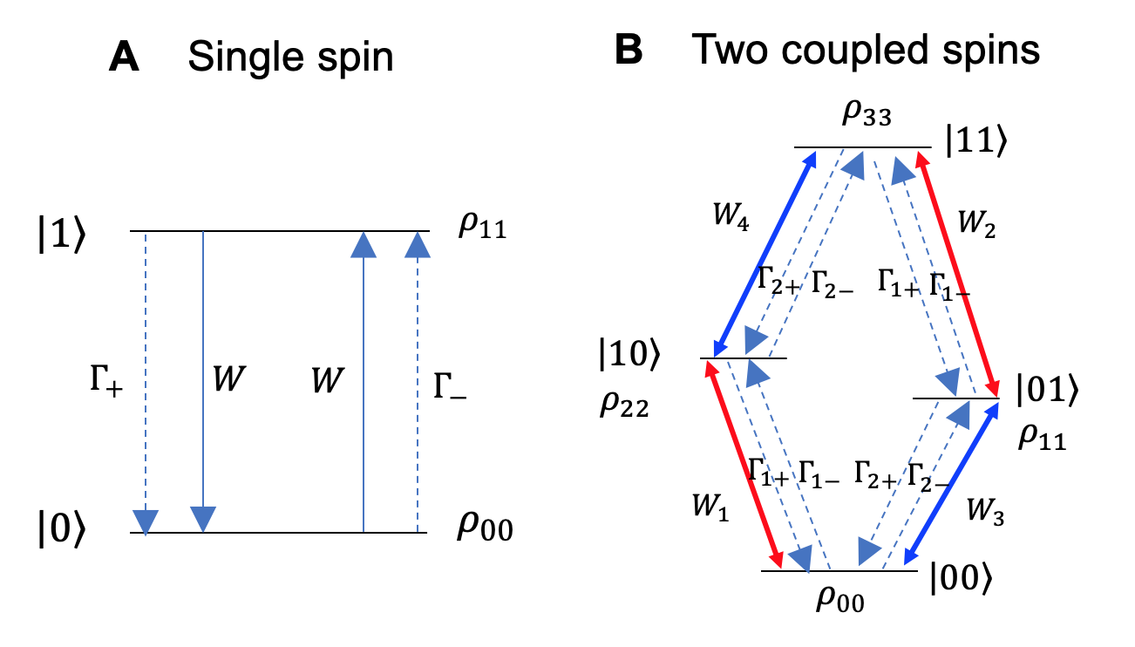
Fig. S17. Relaxation and driving rates in single and coupled spin systems. $W$’s label the effective driving and $Γ$’s label the energy relaxation rates.

Section 6. Single frequency ESR on a Ti-Fe pair

The evolution of the ESR peak heights of a Ti-Fe pair at different tunnel conductance allows us to separate the contributions of ESR driving due to the tip, from driving due to the neighboring Fe, as discussed in Fig. 4. To obtain the ESR peak heights at each tunnel conductance (Fig. 4C), we performed Lorentzian fits to the lower ($f_{⇑}$) and higher ($f_{⇓}$) frequency resonances, as shown in Figs. S18A and B, respectively. The intensity of peak $f_{⇑}$ showed a monotonic decrease as the tunnel conductance was reduced, reflecting a decreasing tip-driven ESR transition as the tip was moved away from the atom. In contrast, the intensity of peak $f_{⇓}$ vanished between 0.6 and 0.8 nS and reappeared as the tip was withdrawn further from the atom. We observed a similar behavior from Ti-Fe pair having a larger Ti-Fe distance (0.72 nm) (Fig. S19). This behavior differs markedly from ESR of isolated Ti atoms (Fig. S1) or pairs of identical coupled spins (20, 21), where the peak intensities decreased monotonically as the tip was moved away.
Drawing from these observations, we developed a simple model for the ESR of the Ti spin in the presence of the Fe: the Ti spin is driven by two transverse RF fields, one induced by the tip ($B_{RF,tip}^{(⊥)}$) and the other by Fe ($B_{RF,Fe}^{(⊥)}$). In the case of Fig. 4, we take the angle between two driving field vectors to be approximately 0 (180º) for $f_{⇑}$ ($f_{⇓}$), based the vanishing peak height for $f_{⇓}$ at a certain tip-atom distance (in Fig. 4, observed at a junction conductance of ~ 0.7 nS). Within this model, the two driving fields are parallel (antiparallel) to each other for the Fe spin state $|\left.⇑\right\rangle$ ($|\left.⇓\right\rangle$), as depicted in the insets of Fig. 4C. In this picture, the Rabi rate of the Ti spin is the sum of two contributions, $Ω_{±}={gμ_{B}m_{S}\left|B_{RF,tip}^{(⊥)}+B_{RF,Fe±}^{(⊥)}\right|}/ℏ$ , which can be rewritten as $\left|Ω_{tip}±Ω_{Fe}\right|$, where the $+$ ($-$) sign represents the parallel (antiparallel) case. We assume that the Rabi rate is approximately proportional to the junction conductance (20), and $B_{RF,Fe}^{(⊥)}$ is assumed to be constant, for a given Ti-Fe distance. For the resonance $f_{⇓}$, the two contributions cancel each other at a critical tip-atom distance. At larger tip-sample distances, $B_{RF,Fe}^{(⊥)}$ becomes dominant, leading to a reappearance of the ESR signal.
The contribution of the Rabi rate to the STM ESR peak height here is described by ${Ω^{2}T_{1}T_{2}}/{\left(1+Ω^{2}T_{1}T_{2}\right)}$, where $T_{1}$ and $T_{2}$ are the energy relaxation time and dephasing times, respectively (2). Using a unitless Rabi rate $Ω_{±}^{'}≡Ω_{±}\sqrt{T_{1}T_{2}}$ as our fitting parameter, we fit the peak heights to this model. The result excellently reproduced the tunnel conductance dependence of the experimental peak height, using the same fit values $Ω_{tip}^{'}$ and $Ω_{Fe}^{'}$ for both $f_{⇑}$ and $f_{⇓}$ cases, as shown by the solid curves in Fig. 4C. The extrapolation of the fit curves to zero conductance leads to a finite intercept of $\sim 0.64$, a ratio that is mostly determined by the thermal occupations of the two Fe states.
We note that tips showing a nearly complete cancellation of ESR peak intensity were not common, and only occurred for occasional tips such as the ones shown in Fig. 4 and Fig. S19. In general, $B_{RF,tip}^{(⊥)}$ and $B_{RF,Fe}^{(⊥)}$ do not have to be parallel or antiparallel, resulting in an incomplete cancellation of the ESR signal. This was observed with several other tips, as shown in Fig. S20. For these tips, the transition to Fe-driven ESR is nonetheless visible as a leveling-off of the Rabi rate as the tip is withdrawn, rather than a disappearance of either peak.

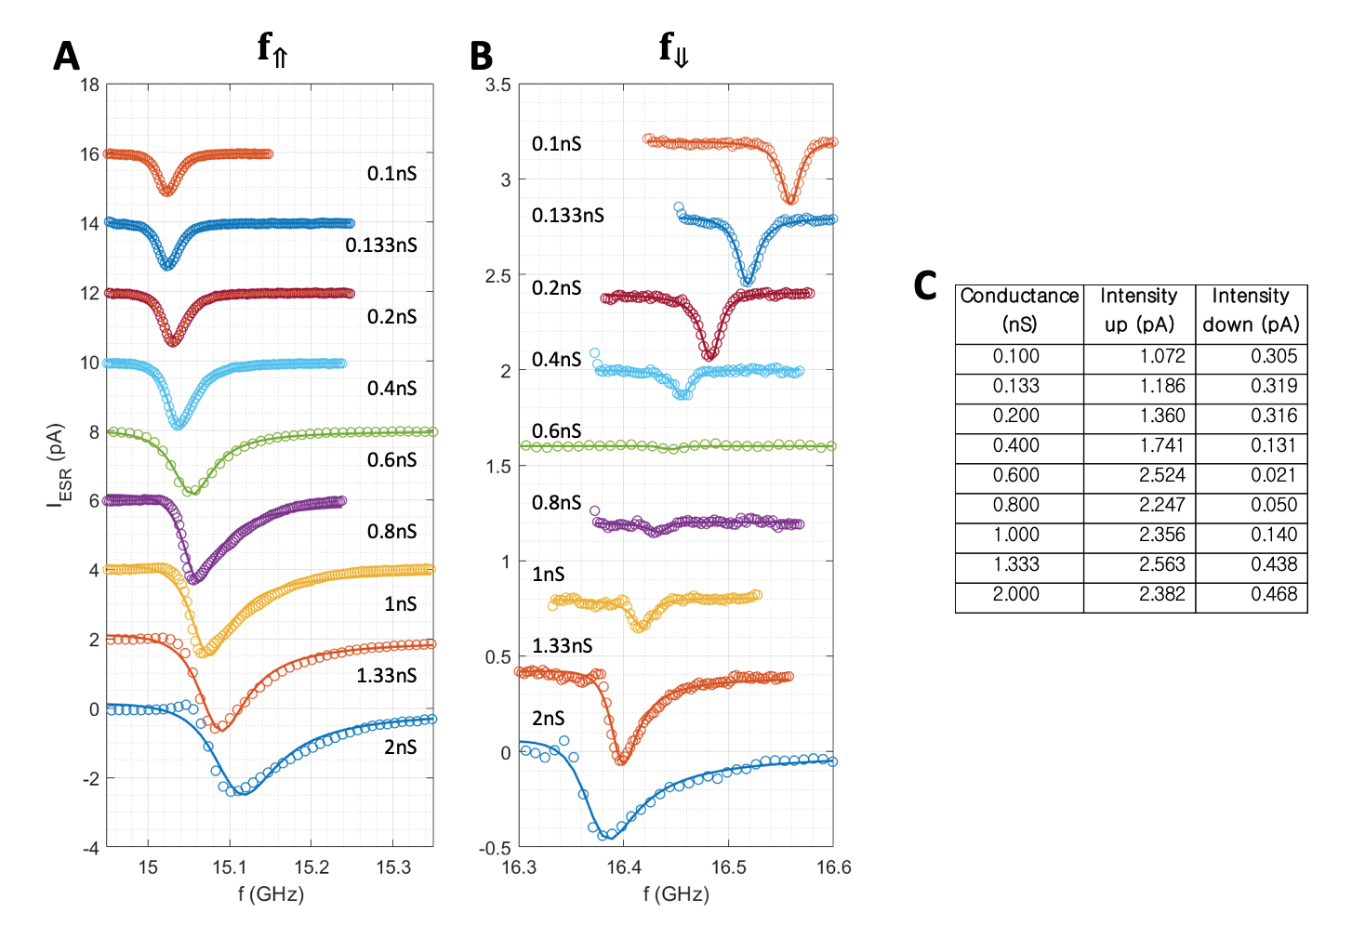
Fig. S18. Fitting to extract the peak heights of ESR spectra on Ti of the TiFe pair in Fig. 4. (A, B) Lorentzian curve fits to ESR peaks at lower ($f_{⇑}$; A) and higher ($f_{⇓}$; B) resonances at different tunnel conductance. For each spectrum, peak width, peak height, and asymmetry factor were used as free fitting parameters. (C) Peak heights extracted from the fits in A and B.

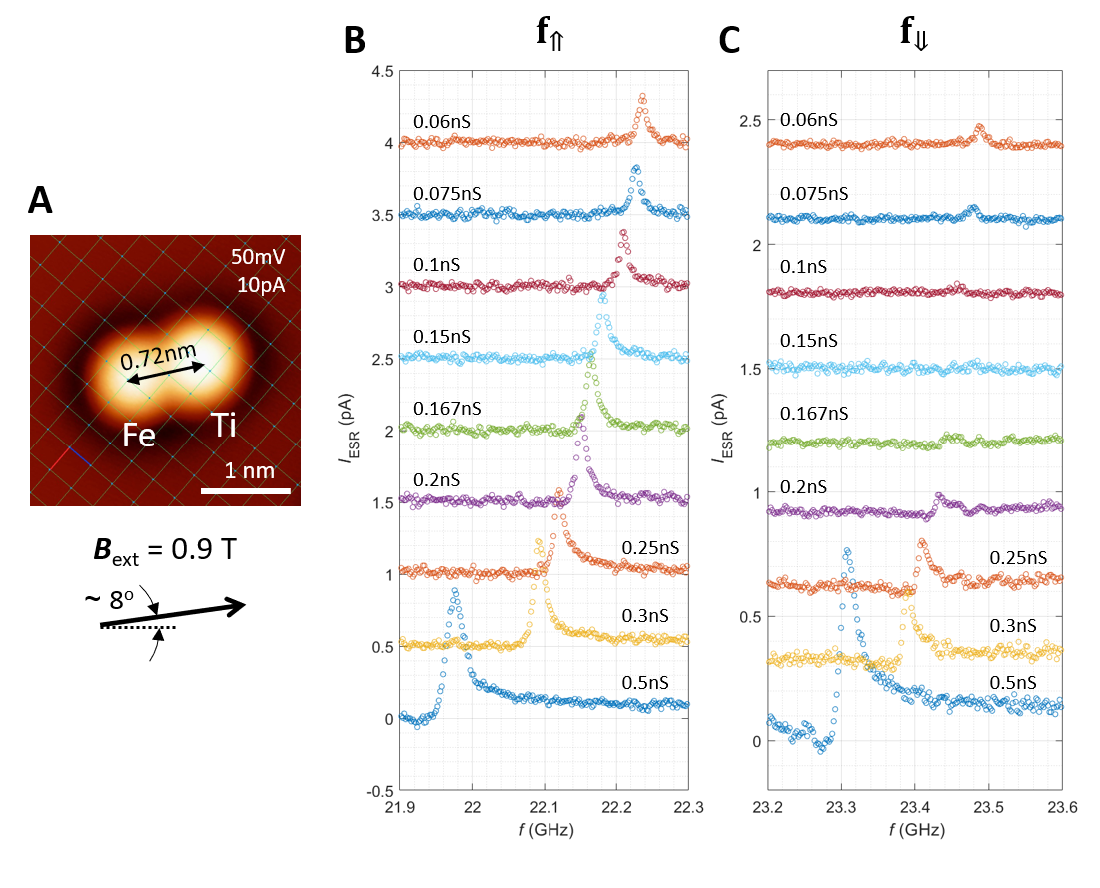
Fig. S19. Tunnel conductance dependence of ESR spectra measured from a Ti-Fe pair of inter-atomic distance 0.72 nm. (A) STM topographic image of a Ti-Fe pair and scheme of applied magnetic field. (B, C) ESR spectra at lower ($f_{⇑}$; B) and higher ($f_{⇓}$; C) resonances. The higher-frequency peak vanished at ~ 0.15 nS ($V_{DC}=50 mV, T=1.1 K$).

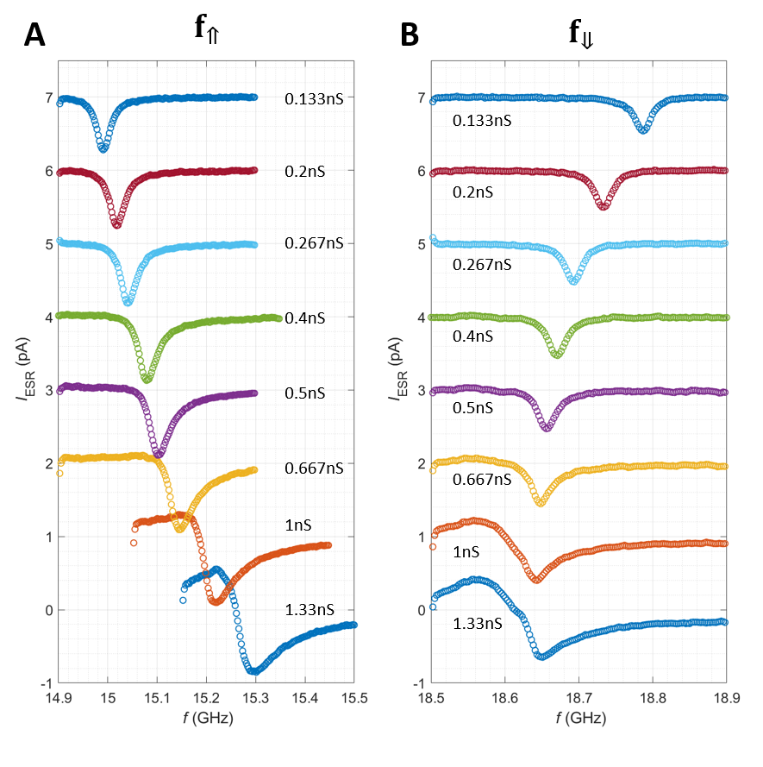
Fig. S20. Tunnel conductance dependence of ESR spectra of the Ti-Fe pair in Fig. 4 measured using a different tip. (A, B) ESR spectra at lower ($f_{⇑}$; A) and higher ($f_{⇓}$; B) resonances. Neither peak vanished in a tunnel conductance regime comparable to that in Fig. 4 ($V_{DC}=50 mV, T=0.4 K$).

