The promotion effect of π-π interactions in Pd NPs catalysed selective hydrogenation
Miao Guo^{2#}, Sanjeevi Jayakumar^{2#}, Xiangtao Kong³, Chunzhi Li^{2,4}, He Li², Jian Chen¹, Mengfei Luo^{1*} & Qihua Yang^{1, 2*}
¹ Key Laboratory of the Ministry of Education for Advanced Catalysis Materials, Zhejiang Key Laboratory for Reactive Chemistry on Solid Surfaces, Institute of Physical Chemistry, Zhejiang Normal University, Jinhua 321004, China.
² State Key Laboratory of Catalysis, Dalian Institute of Chemical Physics, Chinese Academy of Sciences, Dalian 116023, China.
³ College of Chemistry and Chemical Engineering, Anyang Normal University, Anyang 455000, China.
⁴ University of Chinese Academy of Sciences, Beijing 100039, China.
# These authors contributed equally to this work.
KEYWORDS: Heterogeneous hydrogenation, COFs, Pd NPs, Acetophenone, Pyrene, Weak interactions.

- Supplementary methods
We derive the kinetic expressions for the proposed mechanisms of AP hydrogenation in the main text based on the conventional Langmuir–Hinshelwood model with the following assumptions:
- The AP molecules and hydrogen are adsorbed on different sites;
- AP or intermediates concentration change results a negligible change in reaction rate.
In the following, the hydrogenation kinetic models of AP hydrogenation to phenyl ethanol involve adsorption, surface reaction and desorption as follows:
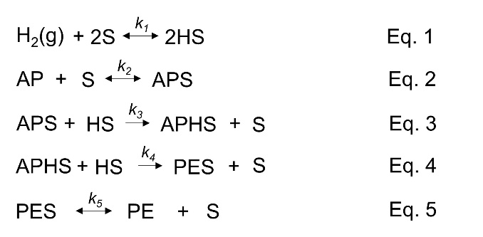
Where k_{i} is rate constant, and S represents empty Pd sites.
Assuming adsorption and desorption steps to be rate-determining does not lead to rate expressions consistent with the observed reaction orders.
When the first hydrogenation of AP is the RDS:
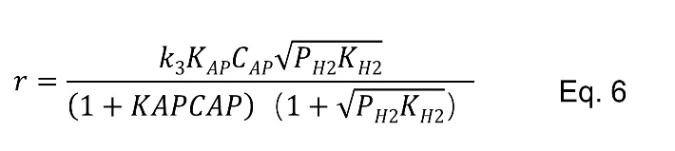
When the second hydrogenation of AP is the RDS:
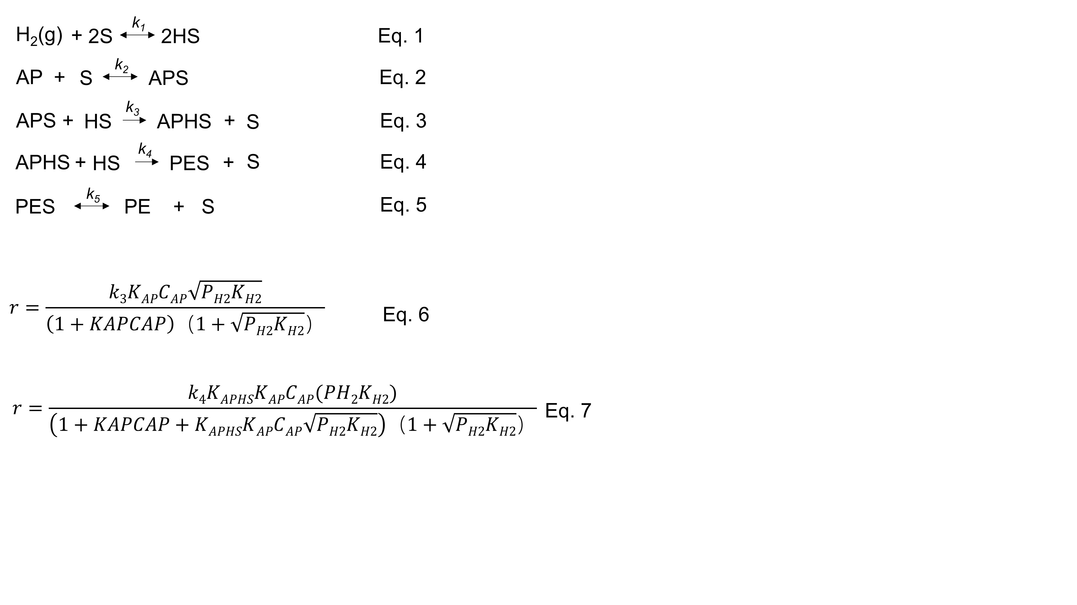
Where K_{i} is adsorption constant.
When the reactions are carried out under low H₂ pressure, the 1+ term in the denominator is approximate to 1. Therefore, the reaction order based on H₂ at low H₂ pressure is half order for Eq. 6 and first order for Eq. 7, respectively.

- Computational methods
We have employed the Vienna Ab Initio Package (VASP)^{[1,2]} to perform all the density functional theory (DFT) calculations within the generalized gradient approximation (GGA) using the PBE^{[3]} formulation. We have chosen the projected augmented wave (PAW) potentials^{[4,5]} to describe the ionic cores and take valence electrons into account using a plane wave basis set with a kinetic energy cutoff of 400 eV. Partial occupancies of the Kohn−Sham orbitals were allowed using the Gaussian smearing method and a width of 0.05 eV. The electronic energy was considered self-consistent when the energy change was smaller than 10⁻⁵ eV. A geometry optimization was considered convergent when the force change was smaller than 0.02 eV/Å. Grimme’s DFT-D3 methodology^{[6]} was used to describe the dispersion interactions.
The equilibrium lattice constants of hexagonal JDL P-6 unit cell were optimized, when using a 1×1×7 Monkhorst-Pack k-point grid for Brillouin zone sampling, to be a=37.617 Å, c=3.740 Å. We then use it to construct a (001) monolayer model with p(1×1) periodicity in the x and y directions and 1 stoichiometric layer in the z direction separated by a vacuum layer in the depth of 20 Å in order to separate the surface slab from its periodic duplicates. During structural optimizations, the gamma point in the Brillouin zone was used for k-point sampling, and all atoms were allowed to relax.
The equilibrium lattice constants of monoclinic CM COF unit cell were optimized, when using a 1×1×7 Monkhorst-Pack k-point grid for Brillouin zone sampling, to be a=35.503 Å, b=33.392 Å, c=4.034 Å, α=90°, β=75.6°, γ=90°. We then use it to construct a (001) monolayer model with p(1×1) periodicity in the x and y directions and 1 stoichiometric layer in the z direction separated by a vacuum layer in the depth of 20 Å in order to separate the surface slab from its periodic duplicates. During structural optimizations, the gamma point in the Brillouin zone was used for k-point sampling, and all atoms were allowed to relax.
The adsorption energy (E_{ads}) of adsorbate A was defined as
E_{ads} = E_{A/surf} – E_{surf} - E_{A(g)}
where E_{A/surf}, E_{surf} and E_{A(g)} are the energy of adsorbate A adsorbed on the surface, the energy of clean surface, and the energy of isolated A molecule in a cubic periodic box with a side length of 20 Å and a 1×1×1 Monkhorst-Pack k-point grid for Brillouin zone sampling, respectively.
Finally, transition states for elementary reaction steps were determined by a combination of the nudged elastic band (NEB) method^{[7]} and the dimer method^{[8-10]}. In the NEB method, the path between the reactant and product is discretized into a series of structural images. The image that is closest to a likely transition state structure was then employed as an initial guess structure for the dimer method.
The interaction energies between Py-COF/Be-COF and AP/CHO were carried out by using Gaussian 09 program suite.^{[11]} All structures were optimized at the PBE0 level with Grimme’s dispersion correction at the D3 level (PBE0-D3) by employing the def2-SVP basis set for all atoms (C, H, O, N). The interaction energies were calculated at the M06-2X/def2-SVP level by including basis set superposition errors at the PBE0-D3/def2-SVP optimized structures.

- Additional catalytic results and characterization information

Table S1. Physical parameters and Pd 3d binding energies of Pd/COFs and commercial Pd/C.
Cat. | BET surface area (m² g⁻¹) | Pd dispersion (%)ª | Pd 3d_{5/2} (eV)^{b} | Pd⁰/Pd²⁺ (%)^{b} | L/B ratio^{c}
Pd/Py-COF | 567 | 26.2 | 335.3 | 68/32 | 0.14
Pd/Be-COF | 1139 | 26.1 | 335.3 | 68/32 | 0.15
Pd/TB-COF | 396 | 24.2 | 335.3 | 67/33 | 0.15
Pd/C | 959 | 17.8 | 335.4 | 58/42 | --
ªData obtained from CO chemisorption results. ^{b}Data obtained from XPS results. ^{c}Calculated based on in situ FT-IR of CO adsorption.

Table S2. The AP hydrogenation with Pd/COFs and commercial Pd/C.
Cat. | Conv. (%) | Sel. (%)
Cat. | Conv. (%) | phenyl ethanol | ethylbenzene | ethylcyclohexane
Pd/Py-COF | >99 | >99 | 0 | 0
Pd/Be-COF | 30 | >99 | 0 | 0
Pd/TB-COF | 22 | >99 | 0 | 0
Pd/C | >99 | 0 | 99 | 1
Reaction conditions: 40 ºC, 10 bar of H₂, 2 mL of EtOH, 0.3 mmol of substrates, Pd catalysts 0.25 mol%, 3h.

Table S3. The catalytic results of H₂-D₂ exchange reaction over Pd NPs.
Cat. | Conv. (%) | TOF (h⁻¹) | Normalized Activity
Pd/Py-COF | 14.1 | 6.5*10⁶ | 57
Pd/Be-COF | 8.0 | 3.7*10⁶ | 55
Pd/C | 7.7 | 3.6*10⁶ | 100
The reaction conditions see experimental section.

Table S4. Synthesis of Py-COF under different conditions.ª
Sample | Solvent (V: V: V) | State
1 | O-dichlorobenzene: n-butanol: CH₃COOH = 10: 5: 1 | Crystalline solid
2 | O-dichlorobenzene: mesitylene: CH₃COOH: 5: 5: 1 | Amorphous solid
3 | THF: mesitylene: CH₃COOH: 5: 5: 1 | Amorphous solid
4 | 1,4-dioxane: mesitylene: CH₃COOH: 5: 5: 1 | Amorphous solid
5^{b} | O-dichlorobenzene: n-butanol: CH₃COOH = 10: 5: 1 | Crystalline solid
ªConditions: Py (57 mg), DMTA (40 mg), solvent (3.2 mL), 6 M CH₃COOH (0.2 mL), N₂ atmosphere, 85 ºC, 3 d. ^{b}Py (285 mg), DMTA (200 mg), solvent (16 mL), 5 d.

Table S5. Pd/Py-COF catalysed AP hydrogenation with different solvent.ª
Solvent | Conv. (%) | Sel. (%)
EtOH | 92 | 99
Isopropyl alcohol | 69 | 99
H₂O | 87 | 99
CH₂Cl₂ | 50 | 99
Ethyl acetate | 29 | 99
n-hexane | 49 | 99
1,4-Dioxane | 20 | 99
ªReaction Conditions: 40 ºC, 10 bar of H₂, 2 mL of solvent, 0.3 mmol of AP, Pd catalysts 0.833mol%, 2h.

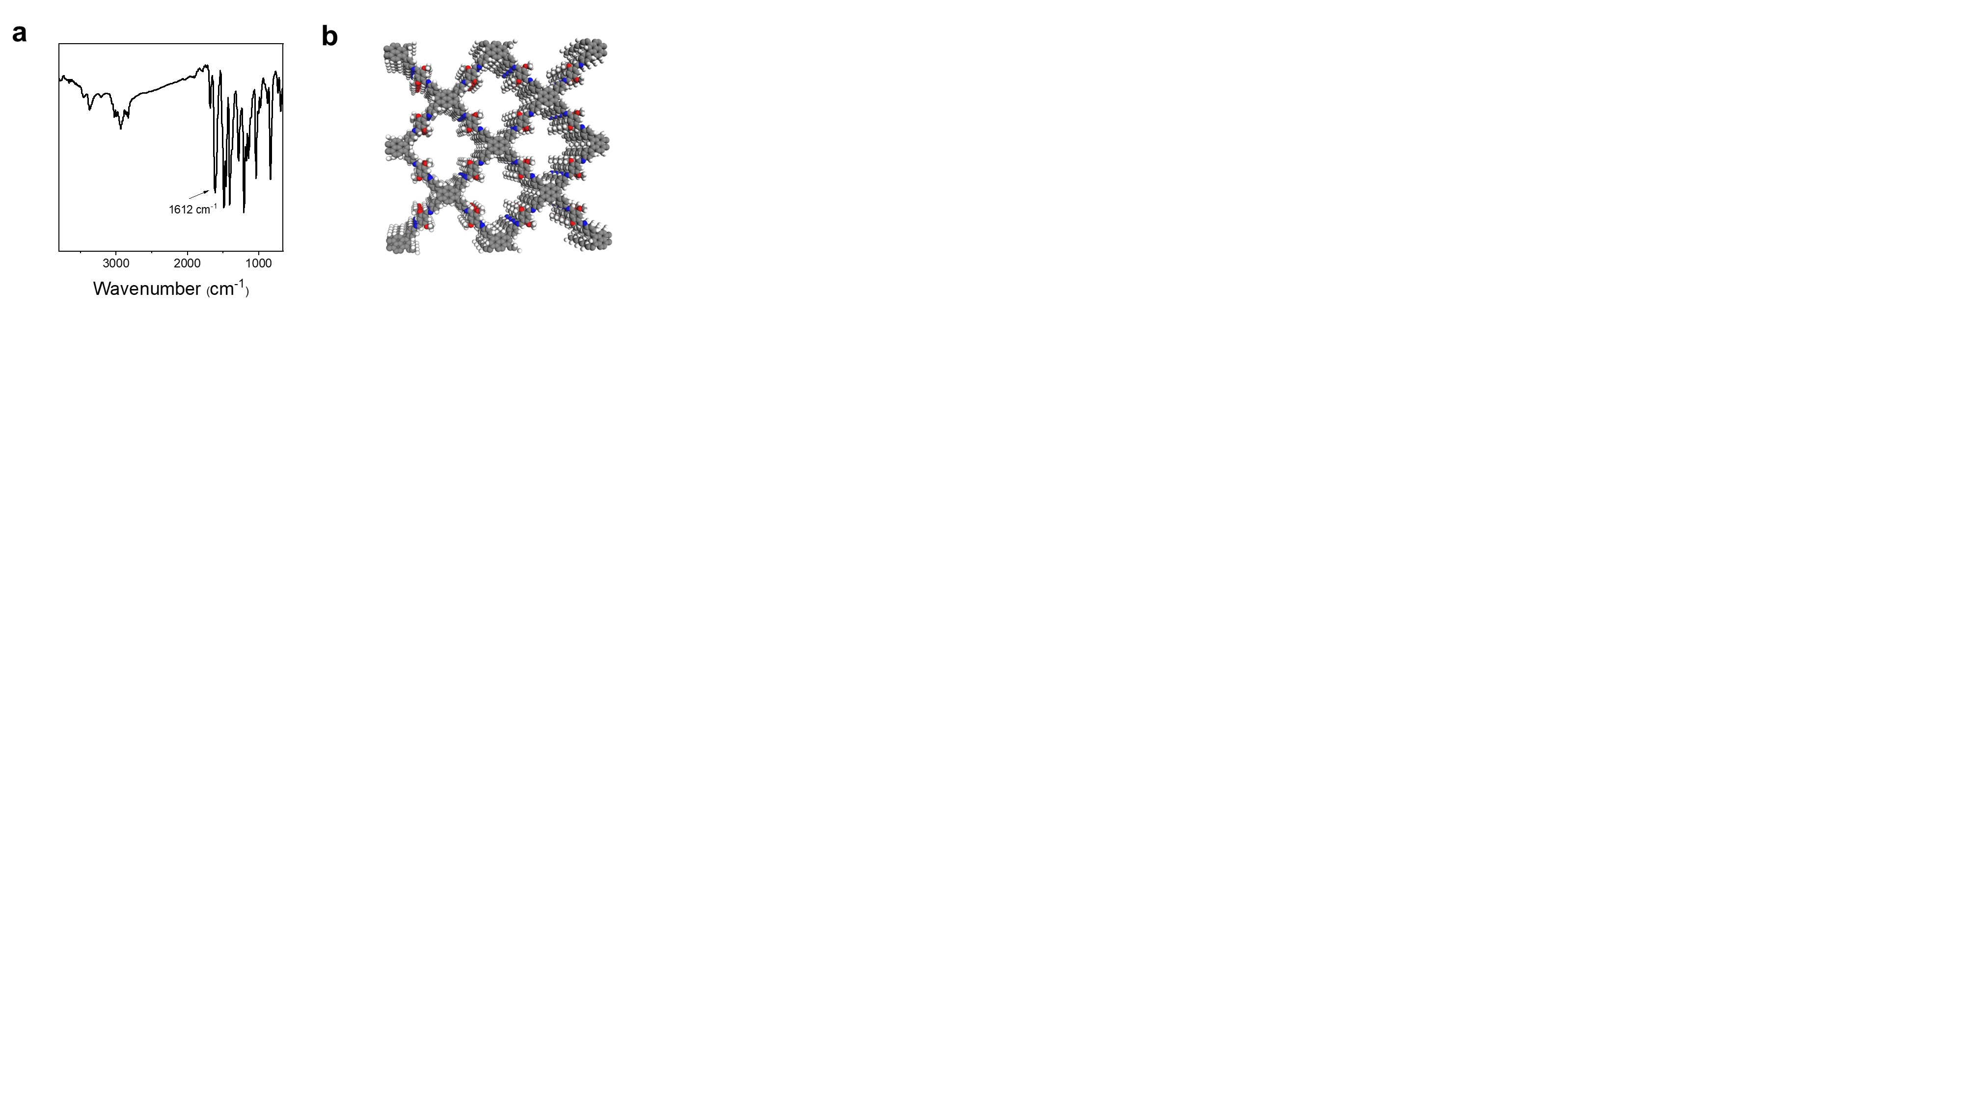
Figure S1. a FTIR spectrum and b top view of Py-COF.

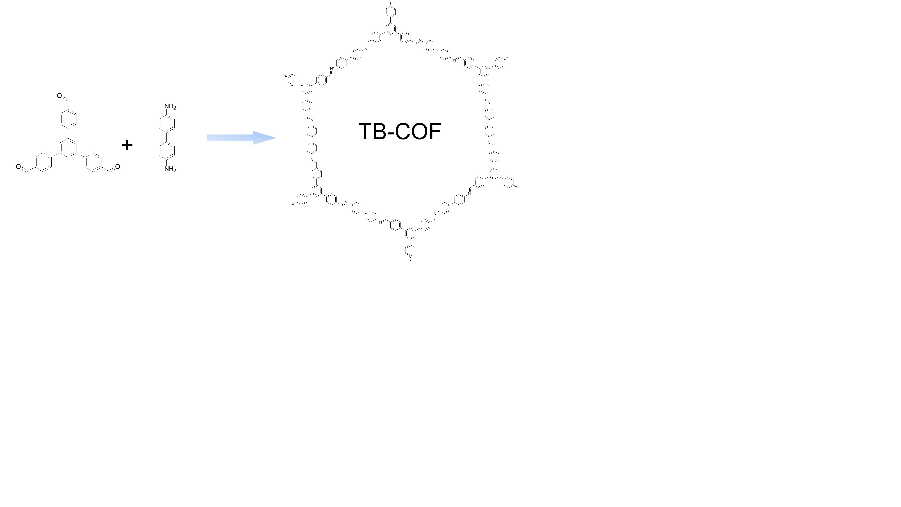
Figure S2. Synthesis of TB-COF

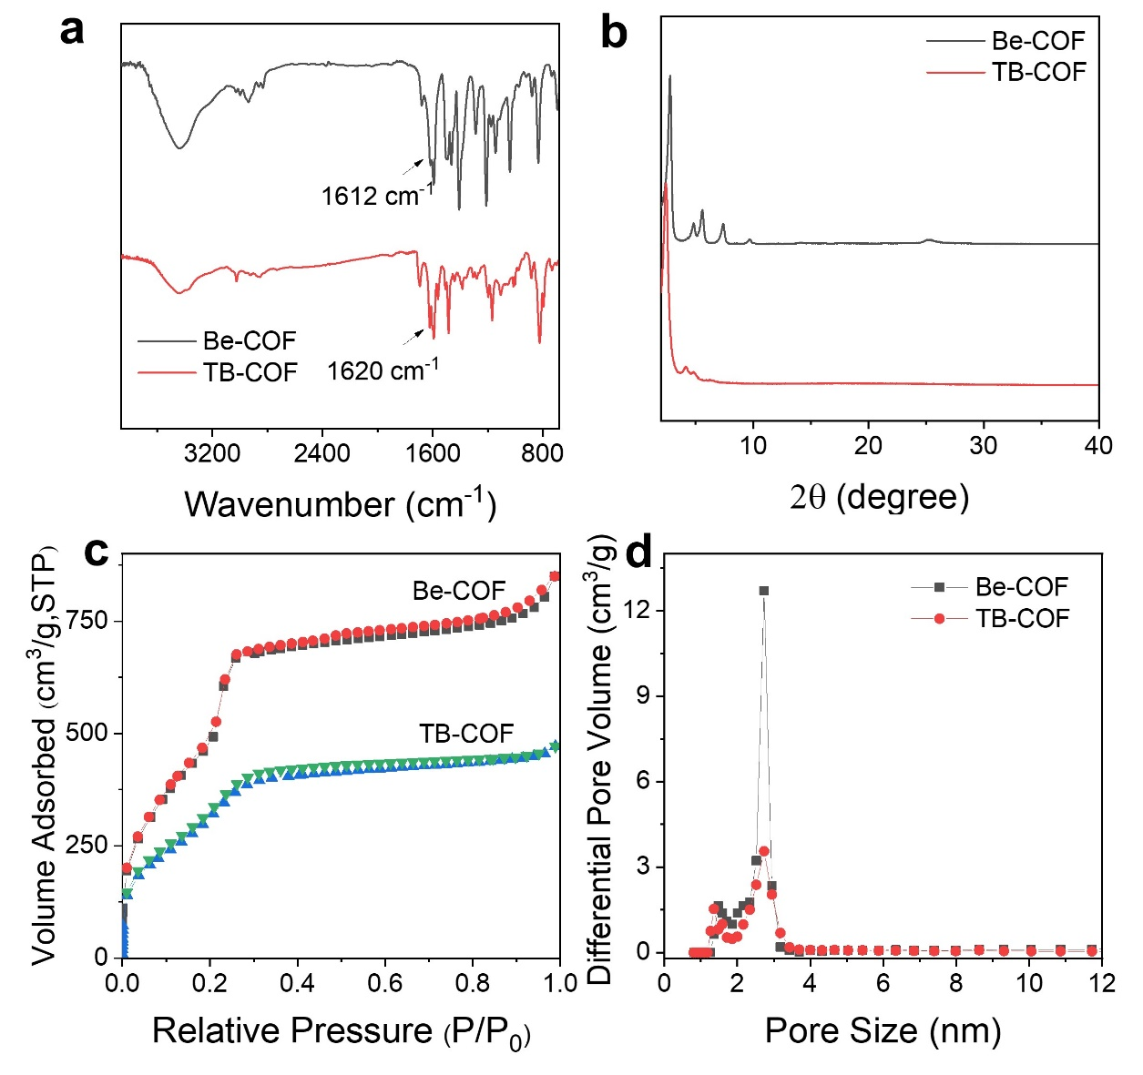
Figure S3. a FT-IR spectra, b PXRD patterns, c N₂ adsorption isotherms and d pore size distribution of Be-COF and TB-COF.

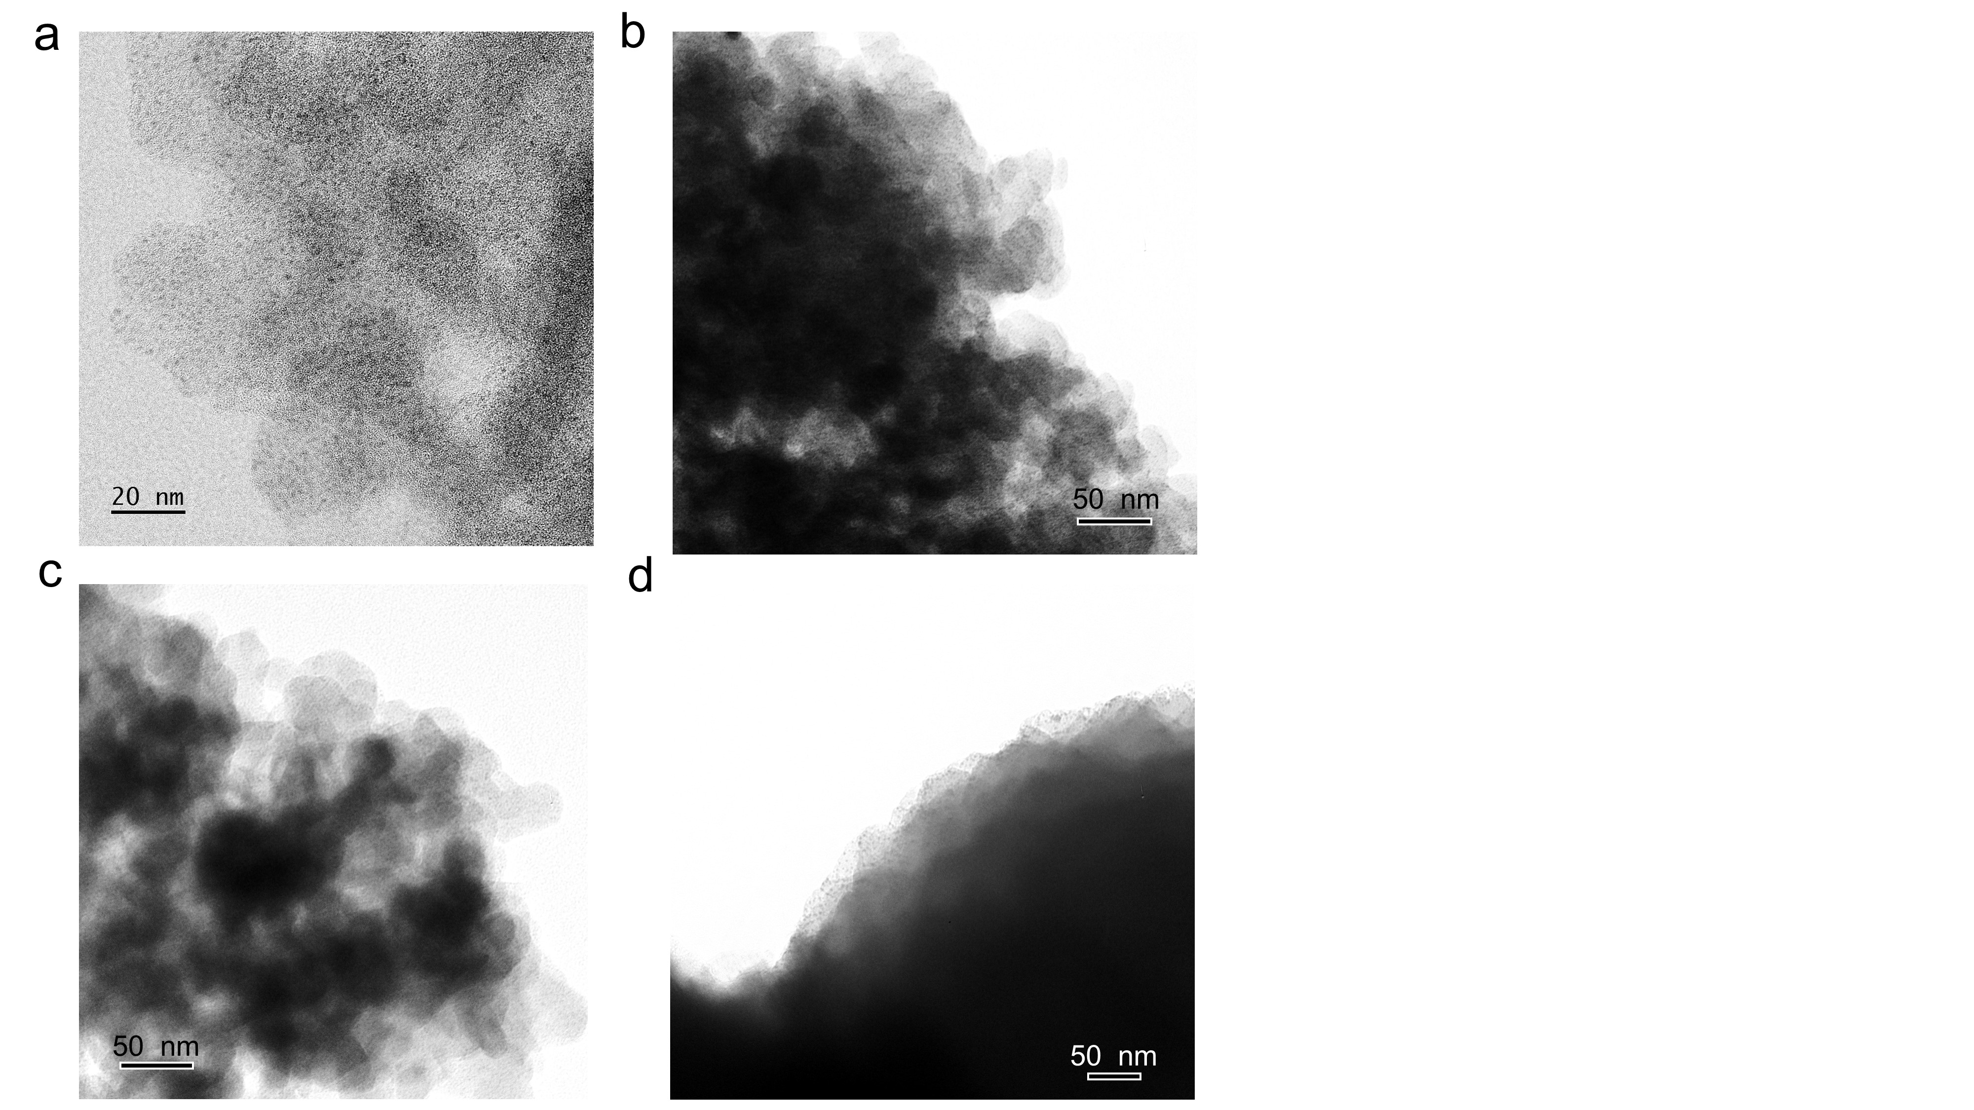
Figure S4. a HRTEM image of Pd/Py-COF, and TEM images of b Pd/Py-COF (10 wt%), c Pd/Be-COF and d Pd/TB-COF.

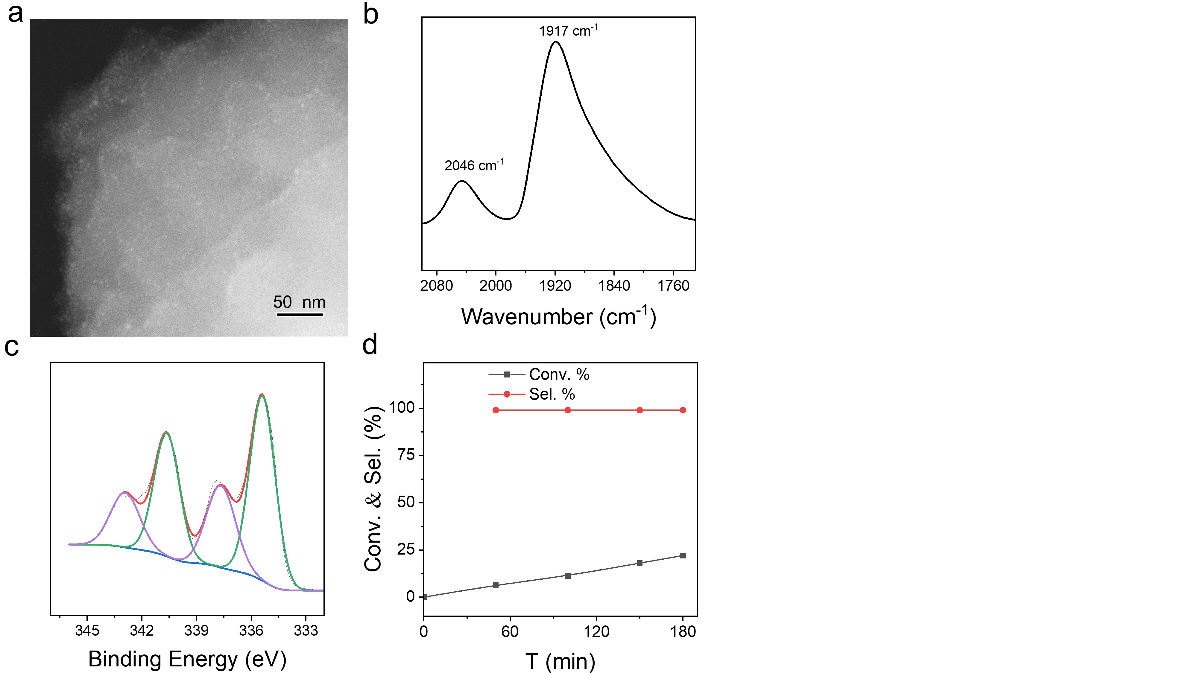
Figure S5. a HAADF-STEM image, b in situ FTIR of CO adsorption, c XPS and d AP hydrogenation results on Pd/TB-COF (40 ºC, 10 bar H₂).

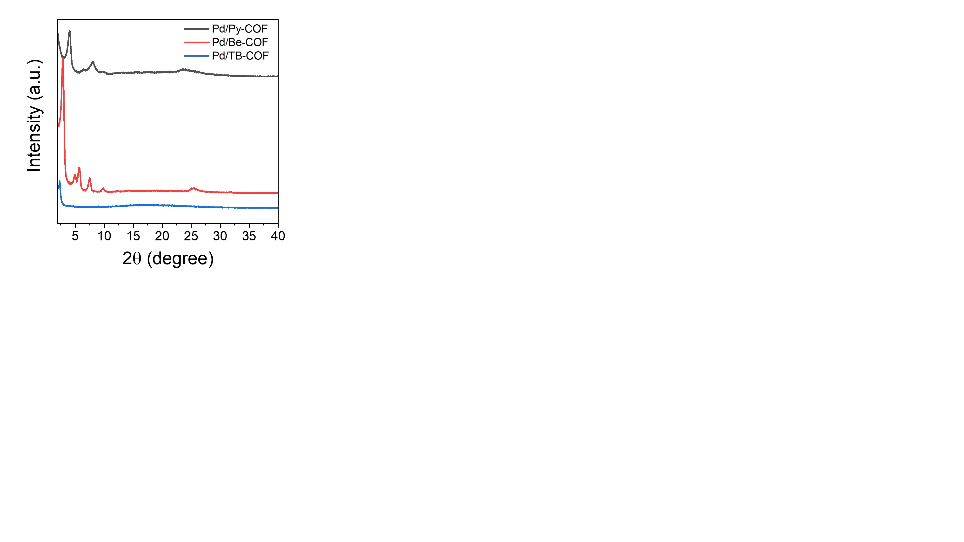
Figure S6. PXRD patterns of Pd/Py-COF, Pd/Be-COF and Pd/TB-COF.

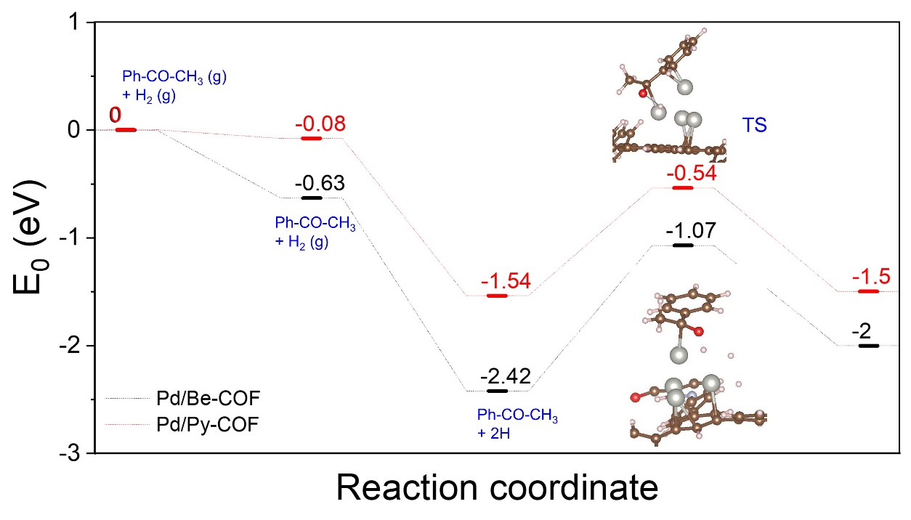
Figure S7. Calculated energy profile of the O hydrogenation step of AP hydrogenation on Pd/Be-COF (black) and Pd/Py-COF (red).

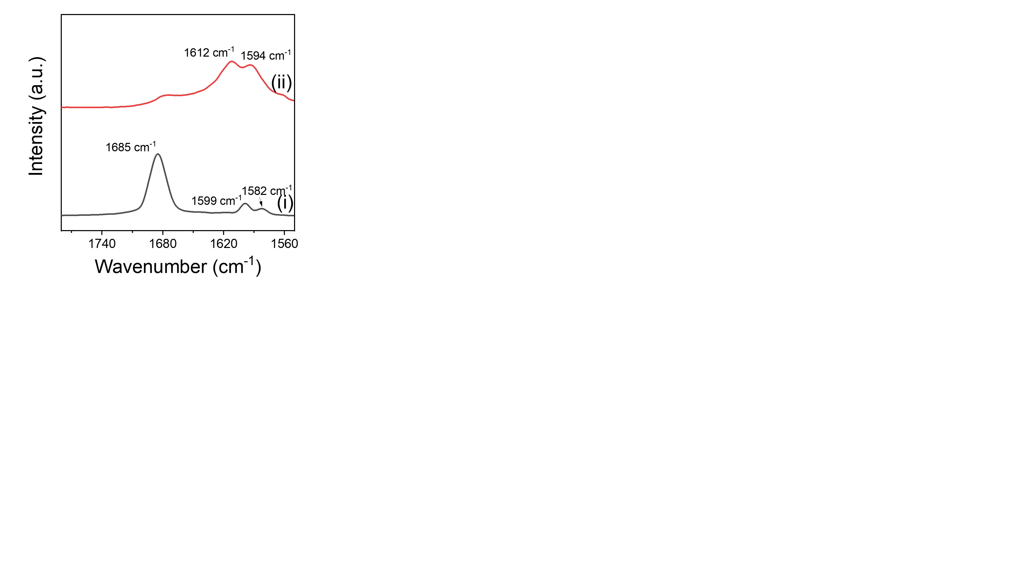
Figure S8. FT-IR spectra of (i) AP and (ii) Pd/Be-COF.

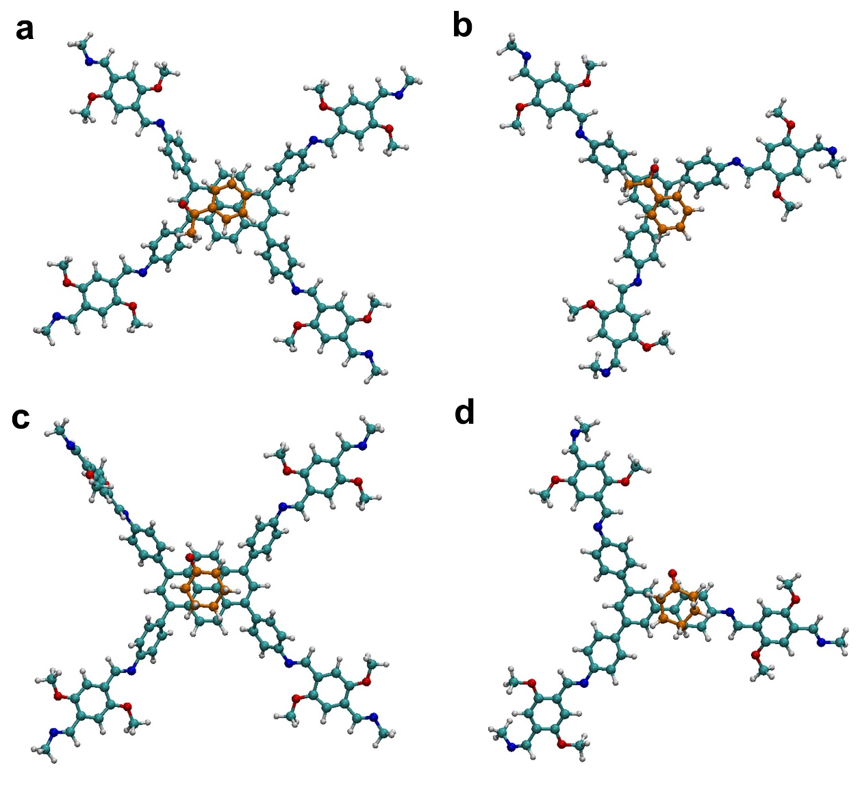
Figure S9. The models for the calculated interactions energies by DFT. a Py-COF/AP
b Be-COF/AP, c Py-COF/CHO and d Be-COF/CHO.

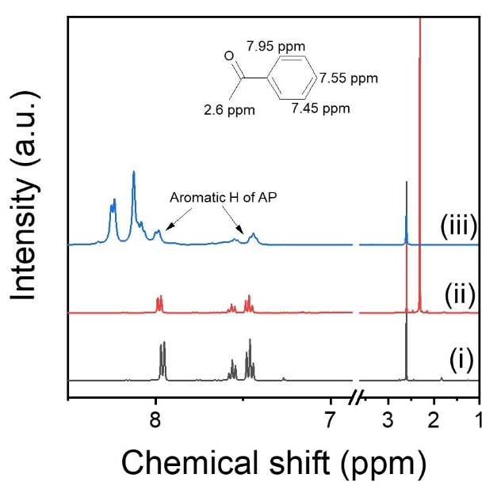
Figure S10. ¹H-NMR spectra of (i) AP, (ii) AP + mesitylene (molar ratio: 1:2) and (iii) AP + pyrene (molar ratio: 1:2).

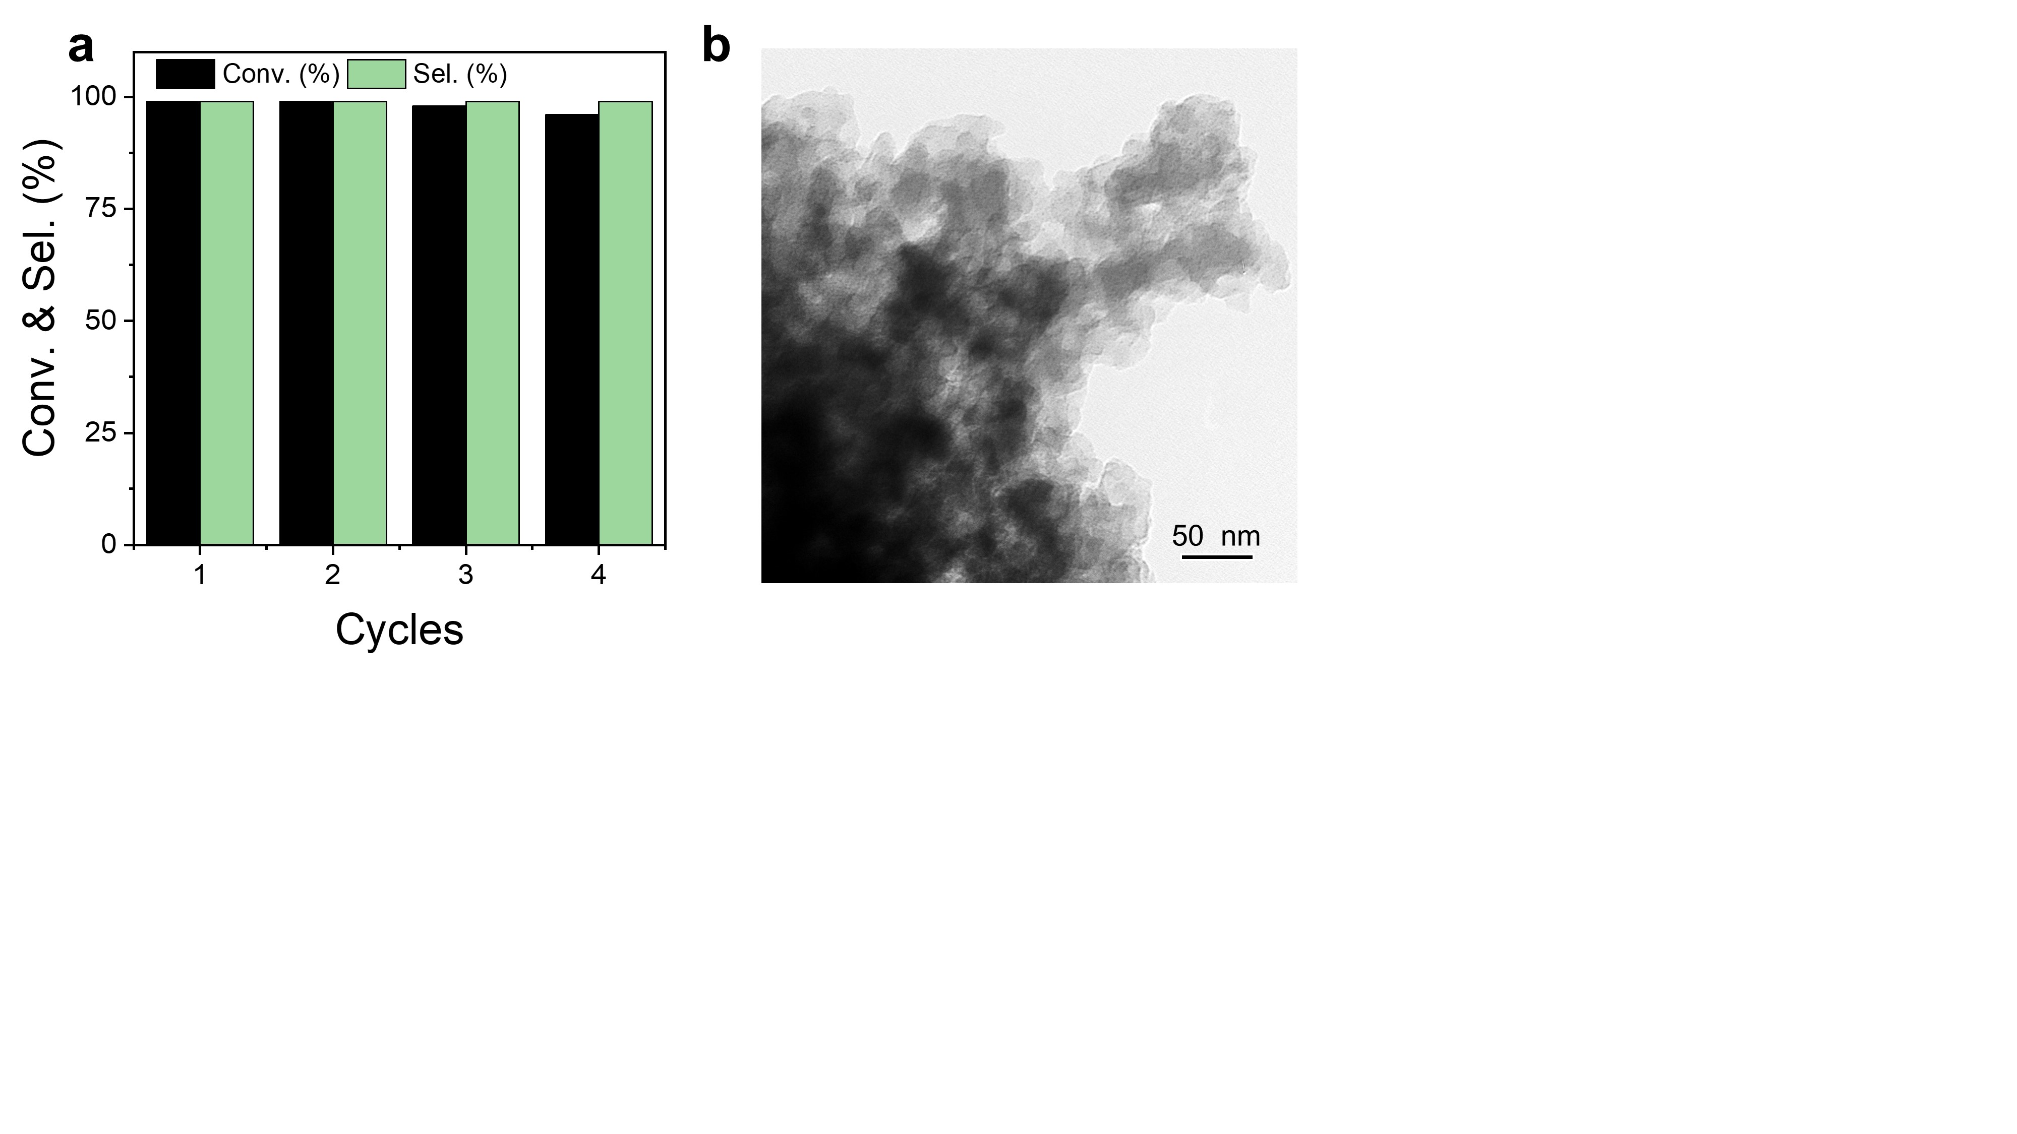
Figure S11. a Recycling stability of Pd/Py-COF in AP hydrogenation, b TEM image of Pd/Py-COF after the fourth cycle.
References
- Kresse, G. & Furthmüller, J. Efficiency of Ab-initio total energy calculations for metals and semiconductors using a plane-wave basis set. Comput. Mater. Sci. 6, 15−50 (1996).
- Kresse, G. & Furthmüller, J. Efficient lterative schemes for Ab initio total-energy calculations using a plane-wave basis set. Phys. Rev. B 54, 11169−11186 (1996).
- Perdew, J. P., Burke, K. & Ernzerhof, M. Generalized gradient approximation made simple. Phys. Rev. Lett. 77, 3865−3868 (1996).
- Kresse, G. & Joubert, D. From ultrasoft pseudopotentials to the projector augmented-wave method. Phys. Rev. B 59, 1758-1775 (1999).
- Blöchl, P. E. Projector augmented-wave method. Phys. Rev. B 50, 17953−17979 (1994).
- Grimme, S., Antony, J., Ehrlich, S. & Krieg, H. J. Chem. Phys. 132, 154104 (2010).
- Henkelman, G., Uberuaga, B. P. & Jonsson, H. J. Chem. Phys. 113, 9901 (2000).
- Henkelman, G. & Jonsson, H. J. Chem. Phys. 111, 7010–7022 (1999).
- Olsen, R. A., Kroes, G. J., Henkelman, G., Arnaldsson, A. & Jonsson, H. J. Chem. Phys. 121 9776–9792 (2004).
- Heyden, A., Bell, A. T. & Keil, F. J. J. Chem. Phys. 123, 224101 (2005).
- Frisch, M. J.; Trucks, G. W.; Schlegel, H. B.; Scuseria, G. E.; Robb, M. A.; Cheeseman, J. R.; Scalmani, G.; Barone, V.; Mennucci, B.; Petersson, G. A.; Nakatsuji, H.; Caricato, M.; Li, X.; Hratchian, H. P.; Izmaylov, A. F.; Bloino, J.; Zheng, G.; Sonnenberg, J. L.; Hada, M.; Ehara, M.; Toyota, K.; Fukuda, R.; Hasegawa, J.; Ishida, M.; Nakajima, T.; Honda, Y.; Kitao, O.; Nakai, H.; Vreven, T.; Montgomery, J. A.; Peralta, Jr, J. E.; Ogliaro, F.; Bearpark, M.; Heyd, J. J.; Brothers, E.; Kudin, K. N.; Staroverov, V. N.; Keith, T.; Kobayashi, R.; Normand, J.; Raghavachari, K.; Rendell, A.; Burant, J. C.; Iyengar, S. S.; Tomasi, J.;. Cossi, M; Rega, N.; Millam, J. M.; Klene, M.; Knox, J. E.; Cross, J. B.; Bakken, V.; Adamo, C.; Jaramillo, J.; Gomperts, R.; Stratmann, R. E.; Yazyev, O.; Austin, A. J.; Cammi, R.; Pomelli, C.; Ochterski, J. W.; Martin, R. L.; Morokuma, K.; Zakrzewski, G. A. Voth, P. Salvador, J. J. Dannenberg, S. Dapprich, A. D. Daniels, O. Farkas, J. B. Foresman, V. G.; Ortiz, J. V.; Cioslowski, J.; Fox, D. J. Revision A. 02; 2009.

