Figure S1
Exposure Chamber Layout
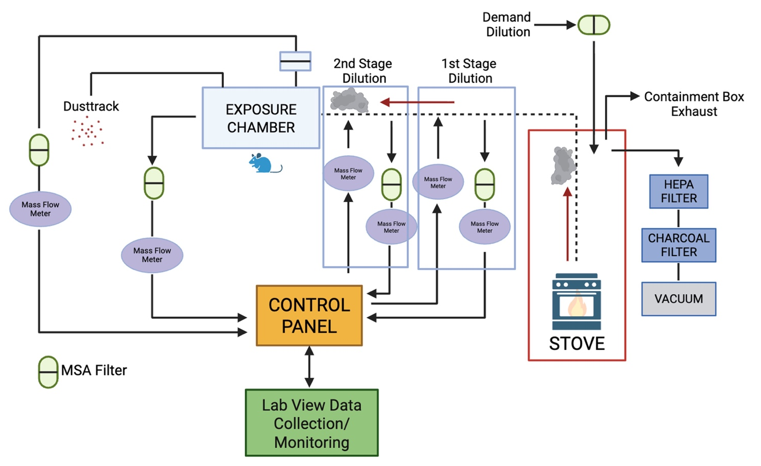

Figure S2
Flow Cytometry Analysis Gating Strategy
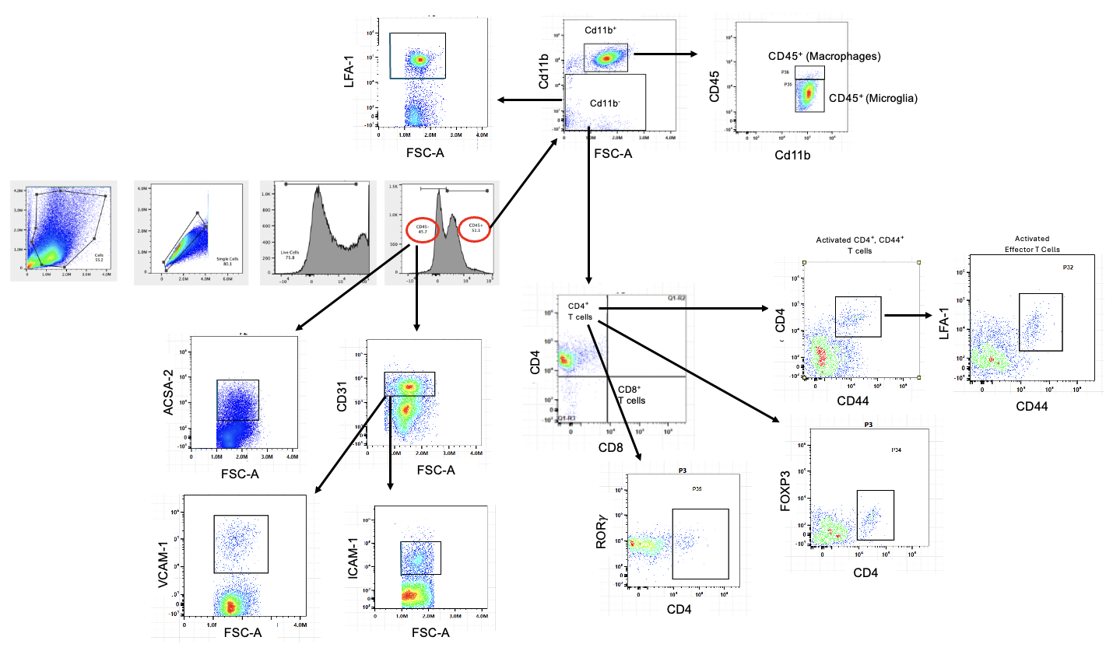

Figure S3
Flow Cytometry Staining Markers
Cellular Marker | Fluorophore
CD45 | PerCP
CD44 | Super Bright 780
CD3 | eFluor 506
CD4 | eFluor 450
CD25 | APC Fire 810
FOXP3 | eFluor 660
RORy | PE-Cyanine 7
CD11b | Brilliant Violet 480
CD31 | Super Bright 645
ICAM | PE Dazzle 594
VCAM | Brilliant Violet 750
LFA-1 (CD11a) | Brilliant Violet 605
ACSA-2 | APC

Figure S4
Gating Strategy for CD45⁺ Peripheral Immune Cells
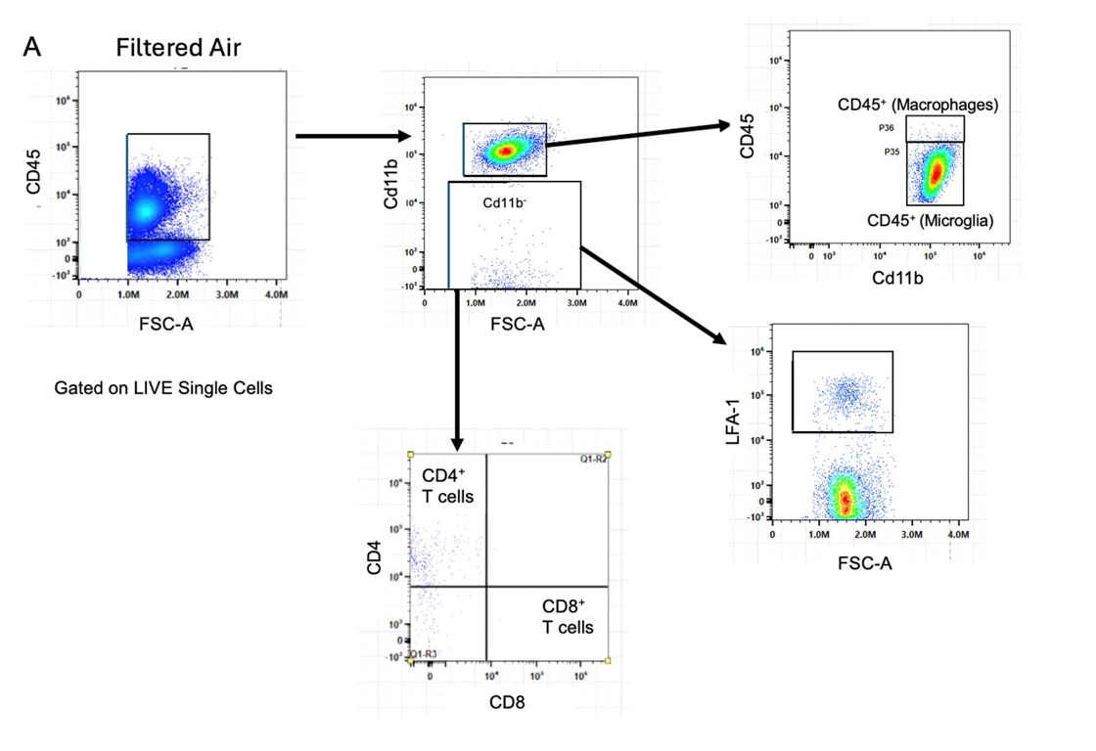
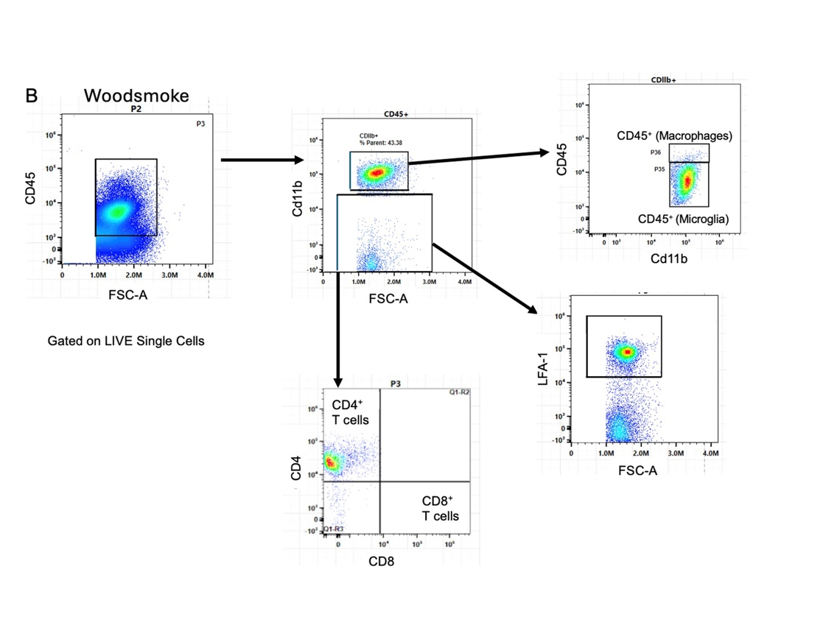

Figure S5
Gating Strategy for CD45⁻ Resident Glial Cells and Peripheral Immune Cells
Filtered Air
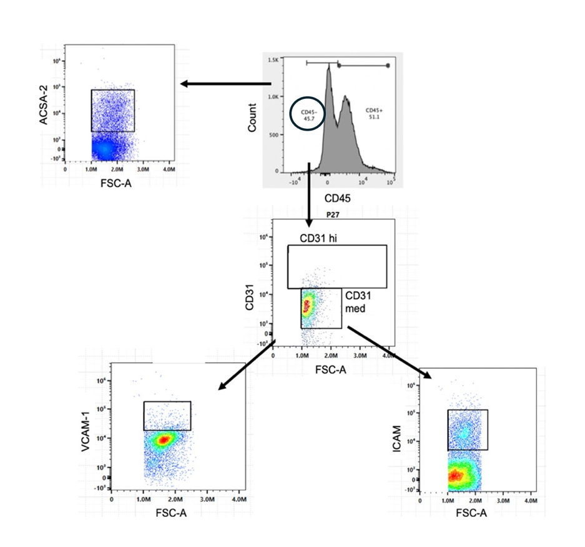
Woodsmoke
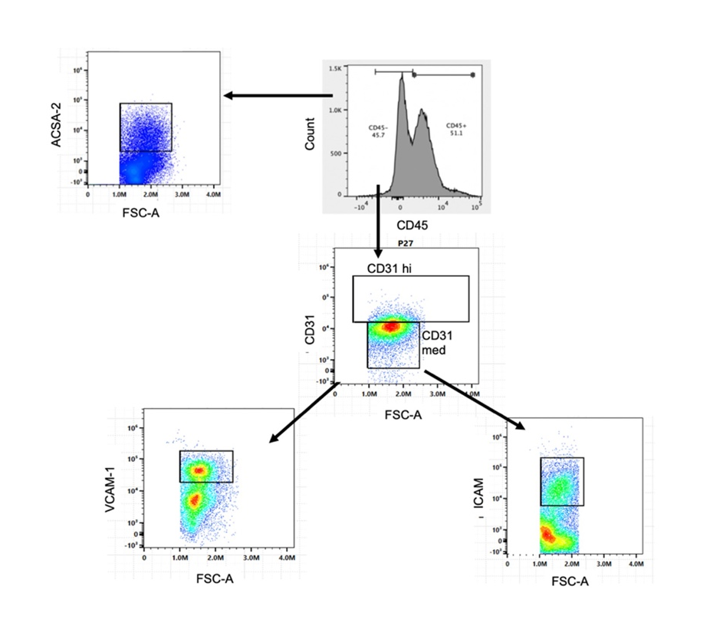

Figure S6
ANOVA Interaction Tables 1, 14, and 28 Days Post Exposure

1 Day Post Exposure
CD4 T cells
Source of Variation | P Value | Significant? | P Value Summary
Interaction (Diet vs Exposure) | 0.004323 | Yes | **
Row Factor (WS vs FA) | 0.032117 | Yes | *
Column Factor (SC vs CO) | 0.088433 | No
LFA-1
Source of Variation | P Value | Significant?
Interaction (Diet vs Exposure) | 0.000089 | Yes | ****
Row Factor (WS vs FA) | 0.000457 | Yes | ***
Column Factor (SC vs CO) | 0.005788 | Yes | **
Macrophages
Source of Variation | P Value | Significant?
Interaction (Diet vs Exposure) | 0.097122 | No
Row Factor (WS vs FA) | 0.000089 | Yes | ****
Column Factor (SC vs CO) | 0.006124 | Yes | **
CD31
Source of Variation
Interaction (Diet vs Exposure) | 0.073221 | No
Row Factor (WS vs FA) | 0.004469 | Yes | **
Column Factor (SC vs CO) | 0.238966 | No
VCAM
Source of Variation | P Value | Significant?
Interaction (Diet vs Exposure) | 0.077821 | Yes | *
Row Factor (WS vs FA) | 0.029674 | Yes | *
Column Factor (SC vs CO) | 0.120023 | No
ICAM
Source of Variation | P Value | Significant?
Interaction (Diet vs Exposure) | 0.088237 | Yes | ***
Row Factor (WS vs FA) | 0.004351 | Yes | **
Column Factor (SC vs CO) | 0.103499 | No

B
14 Days Post Exposure
CD4 T cells
Source of Variation | P Value | Significant? | P Value Summary
Interaction (Diet vs Exposure) | 0.007659 | Yes | **
Row Factor (WS vs FA) | 0.032112 | Yes | **
Column Factor (SC vs CO) | 0.088433 | No
LFA-1
Source of Variation | P Value | Significant?
Interaction (Diet vs Exposure) | 0.297761 | No
Row Factor (WS vs FA) | 0.488076 | No
Column Factor (SC vs CO) | 0.061198 | No
Macrophages
Source of Variation | P Value | Significant?
Interaction (Diet vs Exposure) | 0.229011 | No
Row Factor (WS vs FA) | 0.005892 | Yes | **
Column Factor (SC vs CO) | 0.002980 | Yes | **
CD31
Source of Variation
Interaction (Diet vs Exposure) | 0.673221 | No
Row Factor (WS vs FA) | 0.034690 | Yes | *
Column Factor (SC vs CO) | 0.203885 | No
VCAM
Source of Variation | P Value | Significant?
Interaction (Diet vs Exposure) | 0.000089 | Yes | ****
Row Factor (WS vs FA) | 0.000099 | Yes | ****
Column Factor (SC vs CO) | 0.005590 | No | **
ICAM
Source of Variation | P Value | Significant?
Interaction (Diet vs Exposure) | 0.608237 | No
Row Factor (WS vs FA) | 0.344353 | No
Column Factor (SC vs CO) | 0.445091 | No

C

28 Days Post Exposure
CD4 T cells
Source of Variation | P Value | Significant? | P Value Summary
Interaction (Diet vs Exposure) | 0.000056 | Yes | ****
Row Factor (WS vs FA) | 0.000042 | Yes | ****
Column Factor (SC vs CO) | 0.030983 | Yes | *
LFA-1
Source of Variation | P Value | Significant?
Interaction (Diet vs Exposure) | 0.176437 | No
Row Factor (WS vs FA) | 0.118964 | No
Column Factor (SC vs CO) | 0.097861 | No
Macrophages
Source of Variation | P Value | Significant?
Interaction (Diet vs Exposure) | 0.229011 | No
Row Factor (WS vs FA) | 0.005892 | Yes | **
Column Factor (SC vs CO) | 0.002980 | Yes | **
CD31
Source of Variation
Interaction (Diet vs Exposure) | 0.131498 | No
Row Factor (WS vs FA) | 0.448297 | No
Column Factor (SC vs CO) | 0.824743 | No
VCAM
Source of Variation | P Value | Significant?
Interaction (Diet vs Exposure) | 0.138277 | No
Row Factor (WS vs FA) | 0.219387 | No
Column Factor (SC vs CO) | 0.078498 | No
ICAM
Source of Variation | P Value | Significant?
Interaction (Diet vs Exposure) | 0.608237 | No
Row Factor (WS vs FA) | 0.004123 | Yes | **
Column Factor (SC vs CO) | 0.007781 | Yes | **

Figure S7
Heatmaps of top 100 significant metabolites
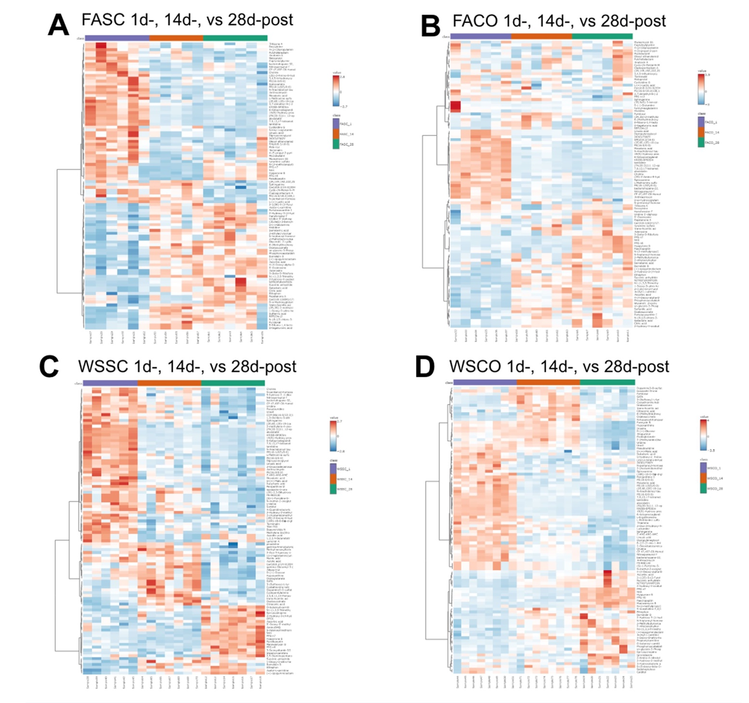
Heatmaps of top 100 significant metabolites by comparing FASC (A), FACO (B), WSSC (C), and WSCO (D) mice that were sacrificed 1-day, 14-days, and 28-days post-exposure.

Figure S8
Significant metabolites with opposite effects between coconut oil diet (CO) and woodsmoke exposure (WS)

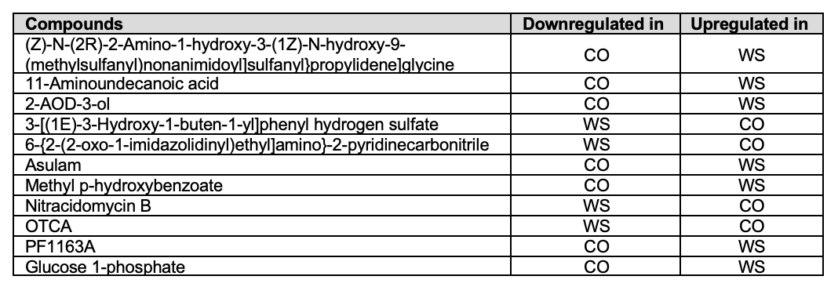

Figure S9
Significant metabolites between CO and WS in the PFC

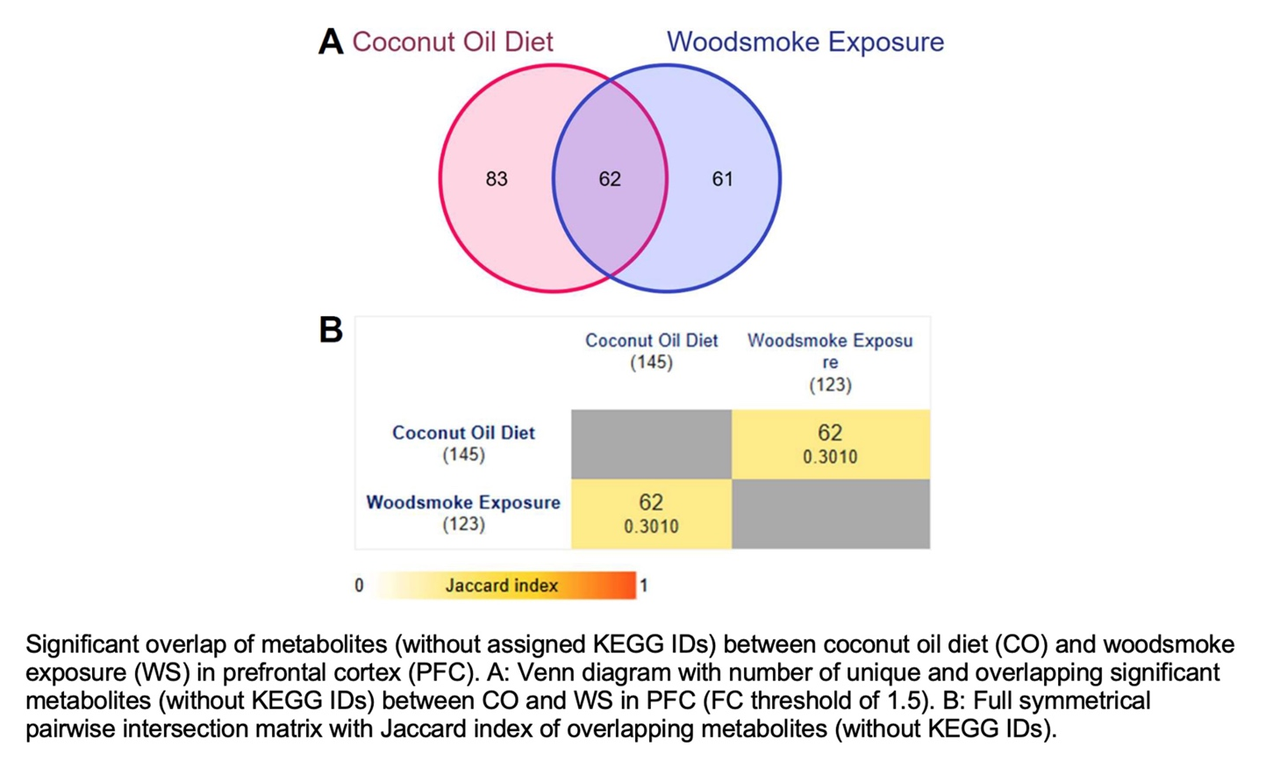

Figure S10
List of unique and overlapping metabolites between CO and WS
(blue, ↓ = downregulation; pink, ↑ = upregulation)
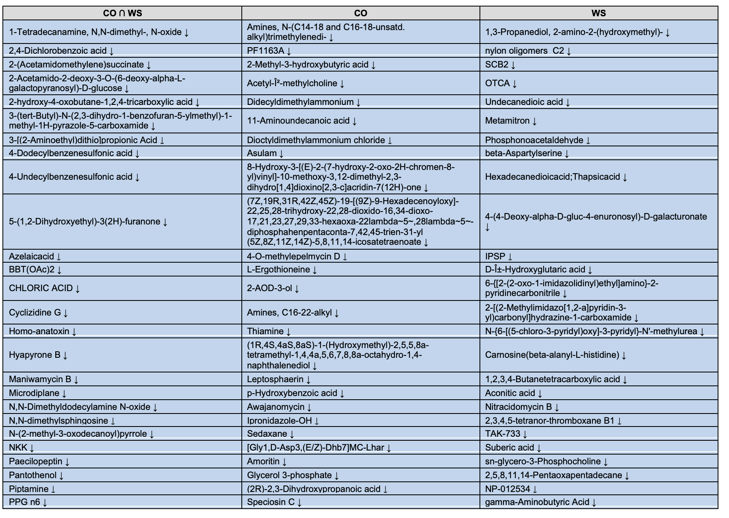
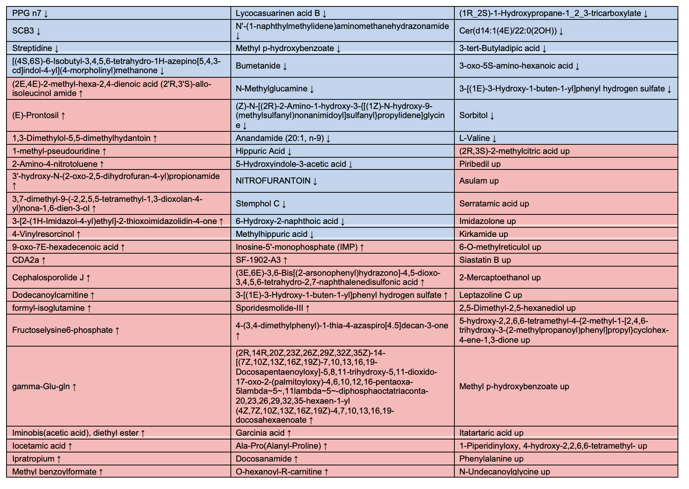

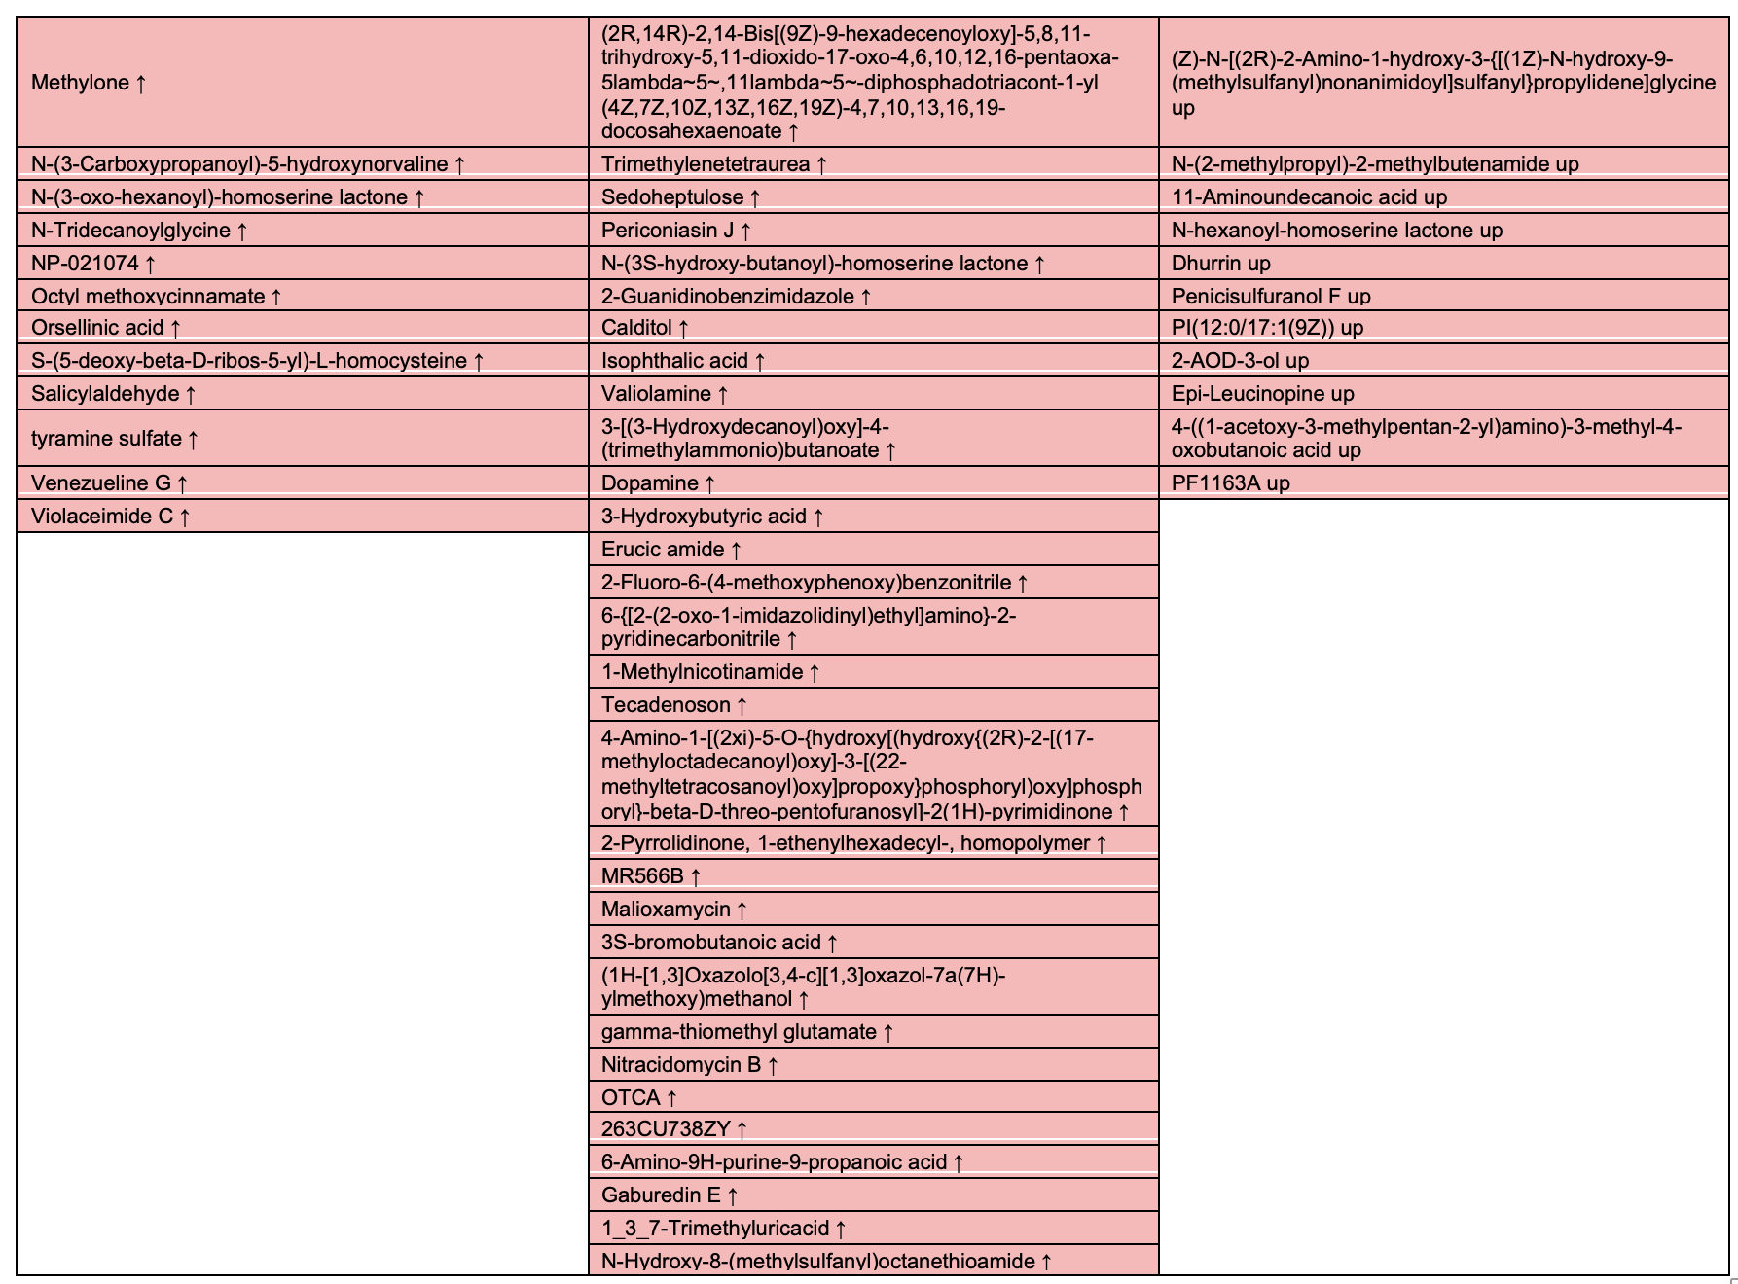

Figure S11
Full list of significant metabolites (without assigned KEGG IDs) altered by coconut oil diet (CO) and woodsmoke exposure (WS) (FC threshold of 1.5).

