SUPPLEMENTARY INFORMATION

Click-Engineered Magnetic Cell-Derived Fusogenic Nanocarriers for Enhanced Magnetic-Field-Assisted Drug Delivery
Manuel Rodríguez-Pérez,§ Sajid Fazal,§ Martina Migliavacca, Ramón Iglesias-Rey, Ester Polo,* Pablo del Pino,* Beatriz Pelaz*

Glycometabolic labeling of A549 cells
Cells effectively incorporated ManNAz translocating N₃ groups in the external layer of the cytoplasmatic membrane. The incorporation of the N₃ groups in A549 cells was assessed by the addition of a DBCO-fluorophore (DBCO-fluor 545). It was observed that untreated cells with ManNAz did not react to the fluorophore (left panel) while the azide-expressing A549 could selectively bind this fluorophore (right panel).
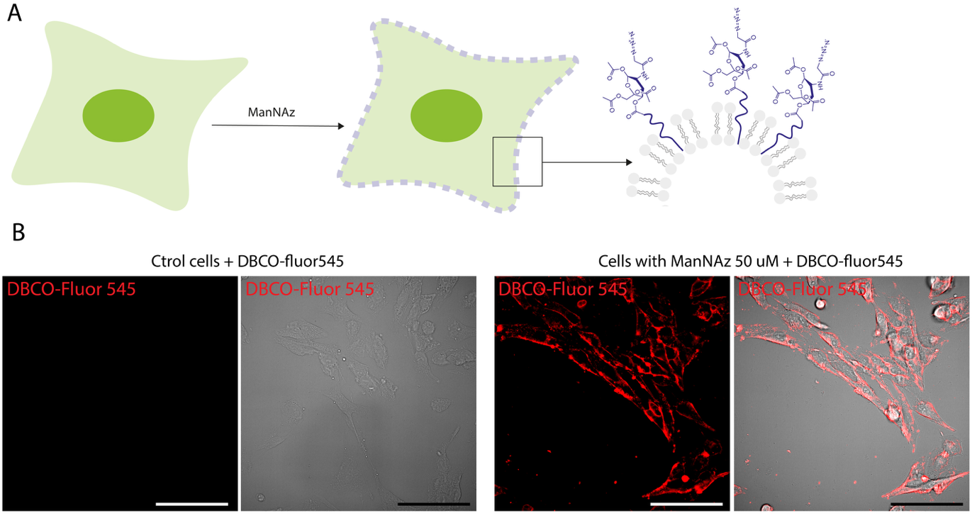
Figure S1: Glycometabolic labeling. A) Schematic representation of cells incorporating ManNAz and the subsequent translocation of N₃ groups in the external layer of the cytoplasmatic membrane. B) Glycometabolically labelled A549 cells with functional azide-groups incorporated on their membranes labeled with DBCO-545-azide (right panel) as compared to unlabelled control cells (left panel) Scale bar: 20 µm.

Preparation of oleic-acid capped iron-oxide nanoparticles (IO NPs)
IO NPs were prepared through the classical thermal-decomposition using an iron-oleate complex precursor [1]. Typically, the iron oleate complex was first prepared by reacting 4 mmoles of iron (III) chloride (FeCl₃, 97%, Sigma-Aldrich, 157740), 2 mmoles iron (II) chloride (FeCl₂, 98%, Sigma-Aldrich, 372870), and 16 mmoles of sodium oleate (> 97%, TCI, O0057) in a mixture of 10 mL ethanol (EtOH, absolute, VWR chemicals, 437433T), 10 mL H₂0 and 20 mL n-hexane (96%, Scharlab, HE02271000) in a 250 mL round bottom flask. The temperature of this reaction mixture was set at 72 ºC under reflux conditions with stirring for 4 h. Following this, the upper organic phase was collected in a separatory funnel and washed twice with water. The synthesized iron oleate complex was then heated in a round bottom flask at 85ºC for 2 hours to facilitate water removal. To further facilitate the complete removal of water, the complex was heated to 113 ºC under vacuum for 2 more hours. The completely dried complex was finally redispersed in hexane. To synthesize iron-oxide nanoparticles, 5 mmol iron-oleate complex and 2.5 mmol oleic acid (90%, Sigma-Aldrich, 364525) were dissolved in 25 mL of 1-octadecene (90%, Sigma-Aldrich, O806) in a 50 mL two-neck round bottom flask. The reaction temperature was initially set at 65 ºC under vacuum conditions with continuous stirring for 30 minutes which was then increased to 210 ºC under N₂ flow. With a temperature controller, it was slowly increased to 310ºC at 1ºC/minute and maintained further at that temperature for 1 hour. After reaction completion, the flask was opened to the atmosphere once the temperature reached below 80ºC. To this, 26 μL of oleylamine and oleic acid were added at 1:1 ratio and the flask temperature was set at 160 ºC under continuous stirring for 3 days to facilitate complete oxidation of the prepared IO NPs.

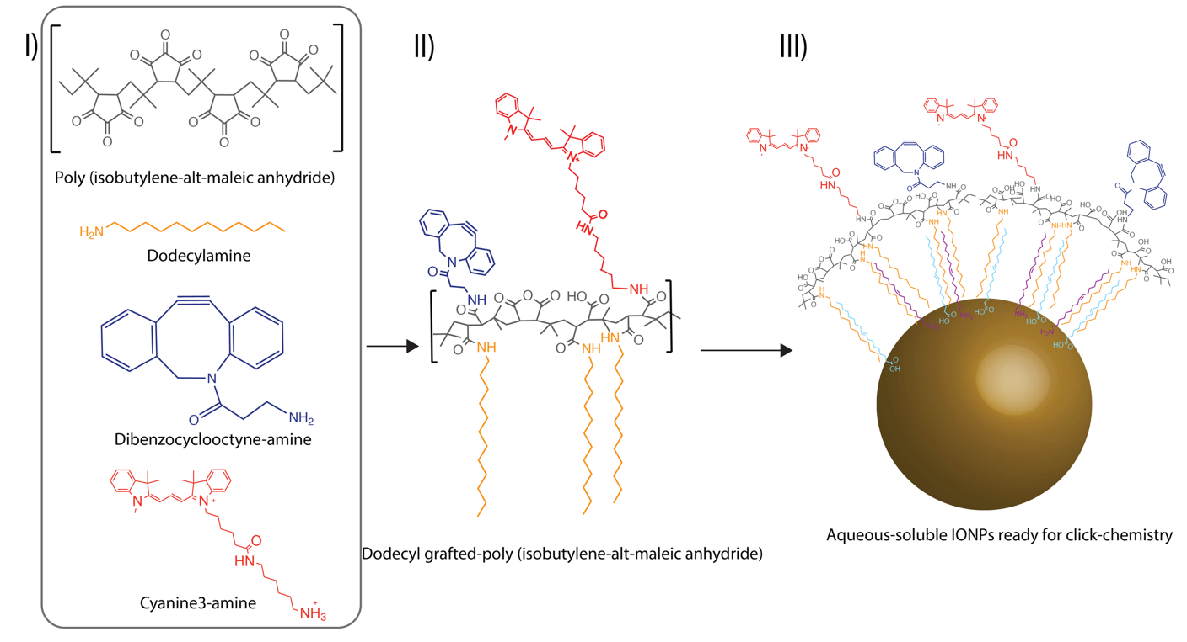
Figure S2. Preparation of oleic-acid capped iron-oxide nanoparticles (IO NPs). I) Chemical components of PMA amphiphilic polymer. II) PMA polymer backbone once synthetized. III) IO NPs coated with PMA polymer.
The IO NPs were then recovered through redispersion and sonication sequentially twice in 5 ml of toluene and 5 ml of ethanol. For separation and purification, 3 centrifugation steps were followed which included centrifugation at 7200 rcf for 10 minutes with dispersion of pellet in 10 mL of toluene and 5 mL of ethanol, followed by further centrifugation twice at 7200 rcf for 10 minutes to recover the pellet which was then dispersed in 5 mL of toluene. Finally, they were centrifuged at 5000 rcf for 5 minutes in which the supernatant containing the purified IO NPs were recovered and stored in a glass vial.

Preparation of DBCO and dodecylamine-grafted poly (isobutylene-alt-maleic anhydride) polymer (DPMA)
To prepare this polymer, typically 750 mg of poly(isobutylene-alt-maleic anhydride), 676.3 mg of dodecylamine, and 53.7 mg of Dibenzocyclooctyne-amine (DBCO-amine) were dissolved in anhydrous tetrahydrofuran in a 250 mL round-bottom flask, followed by brief sonication (20 s) and heating under reflux at 80 °C overnight. To prepare a fluorochrome-NH₂ functionalized polymer, Cyanine3-NH₂ was also added to this reaction mixture such that 5% of total anhydride rings react with the amine-modified fluorescent dye (Figure S2). After reaction completion, the tetrahydrofuran solvent was completely evaporated in a rotavapor and the remaining thin polymer film is dissolved in 9.73 mL of CHCl₃, in order to obtain a 0.5 M monomer concentration (isobutylene-alt-maleic anhydride).

Preparation of DBCO- and dodecylamine-grafted poly (isobutylene-alt-maleic anhydride) polymer-coated- IO NPs (IO@DPMA NPs)
To enable the transfer of previously synthesized hydrophobic IO NPs (see synthesis details in the supplementary information [1]) to an aqueous buffer, an amphiphilic polymer dibenzocyclooctine (DBCO)- and dodecylamine-grafted PMA (DPMA), that was prepared in-house was employed.
The IO NPs were coated with this polymer based on a previously reported coating protocol [2]. The ratio, R, of monomers of polymer per nanoparticle surface area (nm²) was optimized to 600 monomers/nm². Typically for a 50 μL suspension of 18 nm IO NP of 27.2 ppm Fe (3.95 µM), 309 μL of 0.5 M polymer solution was used to coat the IO NPs (See calculations below). For this, the NPs and the polymer solution were dispersed in 1 mL of CHCl₃ in a round-bottom flask and sonicated gently for 10 minutes in a bath sonicator followed by evaporation of solvent in a rotavapor. This was repeated twice, and the modified particles were re-dispersed in 3.7 mL of 0.1 N NaOH. To separate the modified particles, they were centrifuged thrice at 30,000 RCF for 20 minutes and finally re-dispersed in 25 mM HEPES (pH=7.4).

Calculations to determine the volume of polymer needed:

IO NP core diameter (d): 18 nm
IO NP diameter with oleic acid ligand (D): 20.4 nm
Volume of IO NP = (4/3)*(22/7)*(D/2)³ = 3054.857143 nm³
Mass of one IO NP = Volume * Density = 3054.857143 nm³ * 5.17mg/nm³ = 1.57936⁻¹⁴ mg
Fe concentration (ICP) = 27.2 µg/mL; this implies Fe₃O₄ concentration = 37.59 µg/mL
Total IO NPs/mL = Fe₃O₄ concentration/Mass of one IO NP = 2.3744¹⁵ NPs/mL
Surface area of one IO NP = 4 * (22/7) * (D/2)² = 1307.41 nm²
Total surface area of IO NPs/mL= Surface area of one IO NP * Total IO NPs/mL = 1307.41 nm² * 2.3744¹⁵ NPs/mL = 3.1043¹⁸ nm²/mL
monomer coating on IO NP surface, R = 600 /nm²
Volume of IO NPs used for surface coating = 0.05 mL
Stock polymer concentration = 0.5 M
Amount of polymer required for IO NP surface coating
= (IO NP volume) * (surface area of IO NPs/mL) * (600 / nm2) / (0.5 * 6.023²⁰ monomer chains/mL)
=0.05 mL * 3.1043¹⁸ nm²/mL * (600 /nm2) / (0.5 * 6.023²⁰ monomers/mL)
= 0.309 mL

Preparation of drug loaded magFSMs
To prepare drug loaded magFSMs, either doxorubicin (DOX) or carboplatin (CbPt) was initially loaded into the azide-labelled FSMs which were then used for click-conjugation with IO@DPMA NPs. For DOX loaded FSMs, 50 µL of 10 mg/mL DOX prepared in PBS (containing 0.5 mg of drug) was mixed with one batch of cell derived membranes (final volume of 1 mL) and then subsequently subjected to sonication and physical extrusion. Eventually the mixture was subjected to a 30000 RCF centrifugation for 60 minutes at RT to separate out magFSM@DOX. To evaluate drug encapsulation and concentration, absorbance at 480 nm was measured (Table S1). In case of CbPt-loaded magFSMs, a 50 mM solution of CbPt was initially mixed with one batch of cell derived membranes (final volume of 1 mL) and subsequentially extruded as previously described. After purification through centrifugation, ICP-OES analysis was undertaken to determine the Pt content in the obtained magFSM@CbPt (Figure S3). Eventually, dose-response studies were performed included a concentration range of 0-10 µM and 0-200 µM for DOX and CbPt respectively.
Sample | g • L / Pt | g • L / CbPt | M / CbPt | mM /CbPt | μM /CbPt
magFSM1 | 0.185 | 0.353 | 9.50 • 10⁻⁴ | 0.95 | 950
magFSM2 | 0.454 | 0.864 | 2.33 • 10⁻³ | 2.33 | 2330
magFSM3 | 0.244 | 0.465 | 1.25 • 10⁻³ | 1.25 | 1250
magFSM4 | 0.283 | 0.539 | 1.45 • 10⁻³ | 1.45 | 1450
Mean ± Std | 0.29±0.12 | 0.55±0.22 | 1.50 ±0.6 • 10⁻³ | 1.50±0.6 | 1500±590

Table S1. Table representing the ICP-OES values obtained in different batches of MagFSMs@CbPt. The bottom row includes the mean and standard deviation values for Pt and CbPt concentrations (1500 ± 590 μM of CbPt, corresponding to 3% of encapsulation).

Figure S3. Representative chart of DOX absorbances calibration for the evaluation of the DOX content of synthetized magFSMs@DOX (70.7 μg DOX /mL (30 μM) corresponding to 14 % of encapsulation).
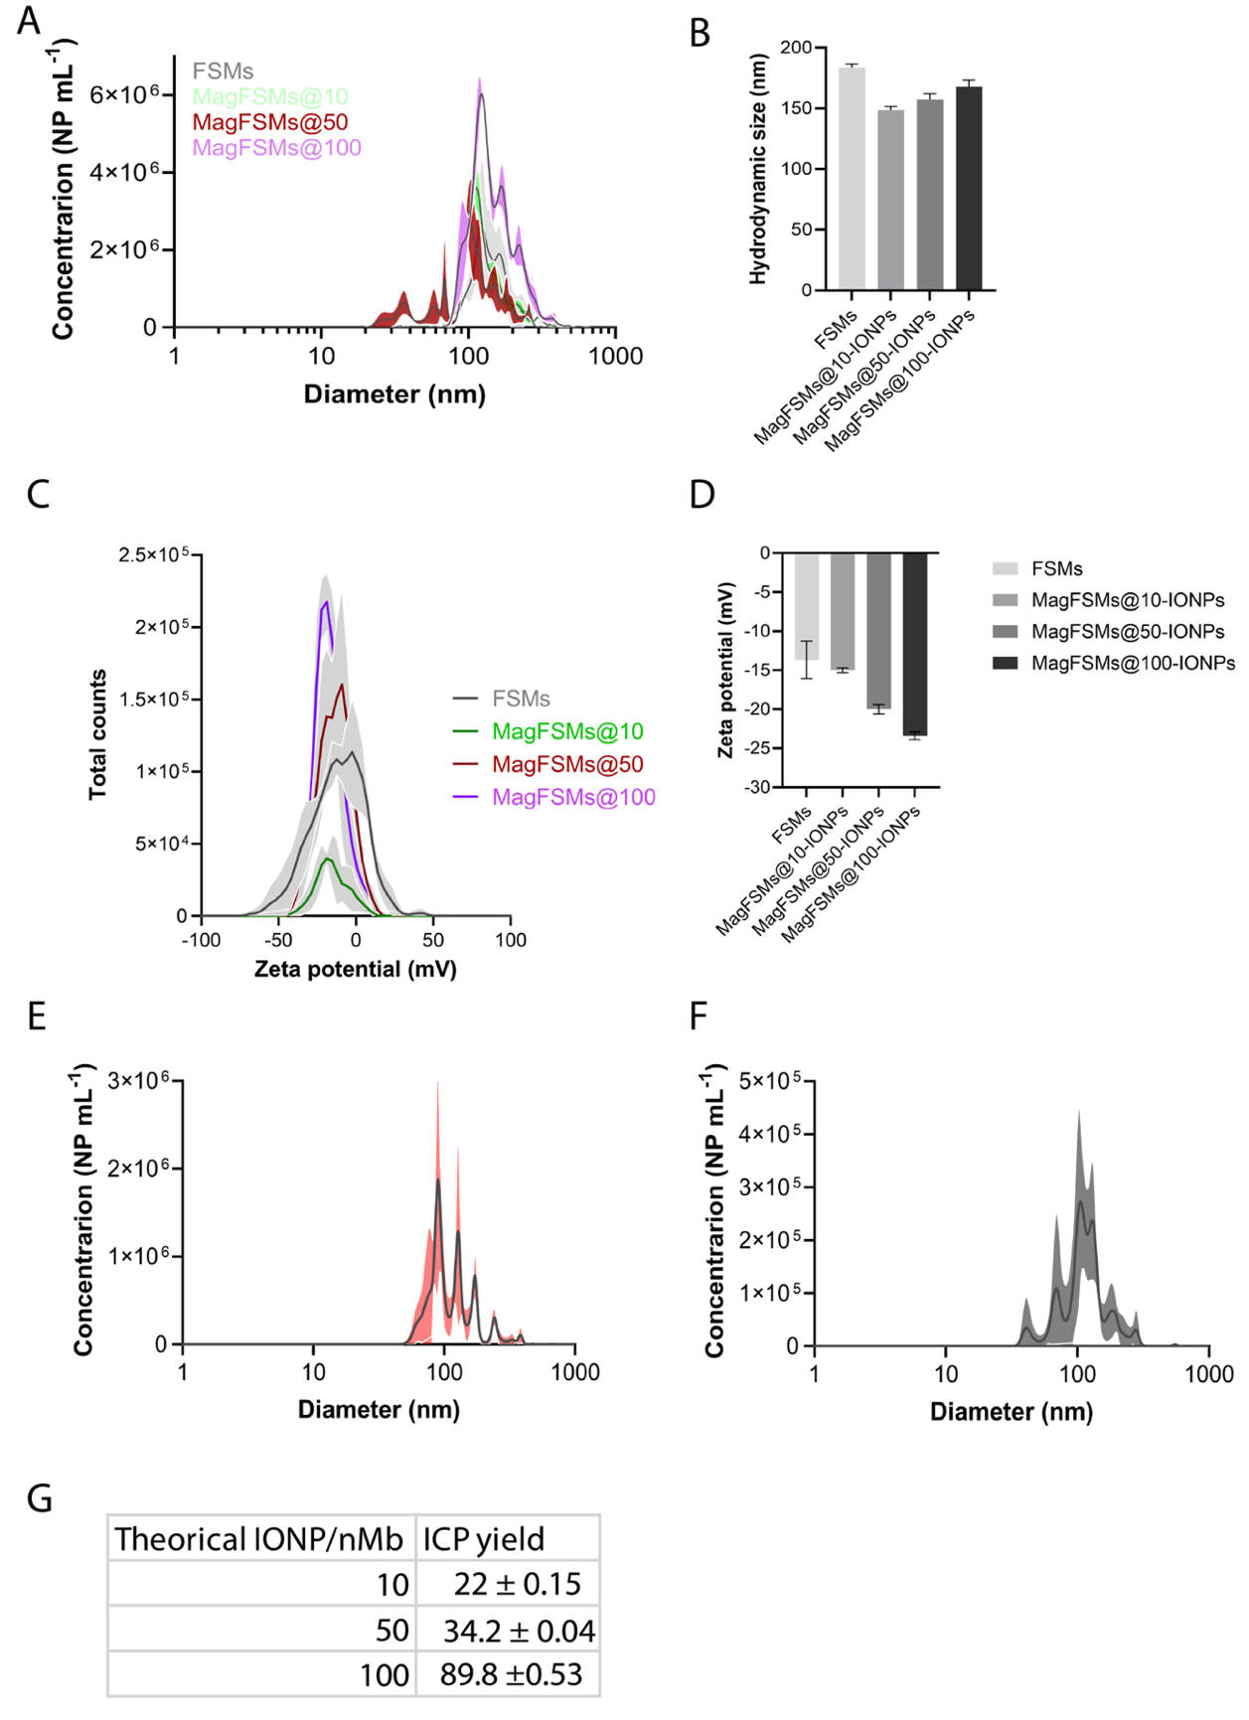
Figure S4. Characterization of magFSMs. A-B) Size distribution and hydrodynamic sizes of FSMs, and magFSMs with different IONPs:FSM ratios obtained by means of nanoparticle tracking analysis. C-D) Zeta potential distribution and values of FSMs and magFSMs. E-F) Size distributionof DOX-loaded (left) CbPt-loaded (right) magFSMs. G) Theorical IONPs:FSM ratios included during magFSMs preparation and the actual values obtained after synthesis as revealed by ICP OES analysis.

Sample | d_{h,N} (nm) (DLS) | Z-Pot (mV) | d_{h} (nm) (NTA) | [NP] (NP/mL)
FCSM | 102.2 ± 11.6 | -13.7 ± 2.4 | 183.5 ± 3 | 1.11e+09 ± 5.52e+07
mag FCSM 10 | 117.5 ± 22.1 | -15 ± 3e-1 | 148.4 ± 3.1 | 1.38e+08 ± 2.60e+07
mag FCSM 50 | 94.0 ± 16.3 | -20 ± 0.6 | 157.2 ± 4.9 | 1.53e+08 ± 2.92e+07
mag FCSM 100 | 111.9 ± 29.1 | -23.4 ± 0.5 | 167.8 ± 5.4 | 1.27e+09 ± 2.34e+07
mag FCSM DOX | 137.7 ± 29.7 | -21.6 ± 2.7 | 116.2 ±10.4 | 6.33e+07 ± 5.80e+06
mag FCSM CbPt | 141 ± 51.2 | -19.4 ± 1.3 | 141.1 ± 1.9 | 2.32e+07 ± 2.63e+06
magCSM | 130.4 ± 22.5 | -26.8 ± 1.9 | 168.1 ± 2.4 | 6.54e+08 ± 1.08e+07
Table S2. Characterization of the nanomaterials used within this study. d_{h} refers o hydrodynamic diameter. d_{h,N} refers to the hydrodynamic diameter in number as obtained by DLS.
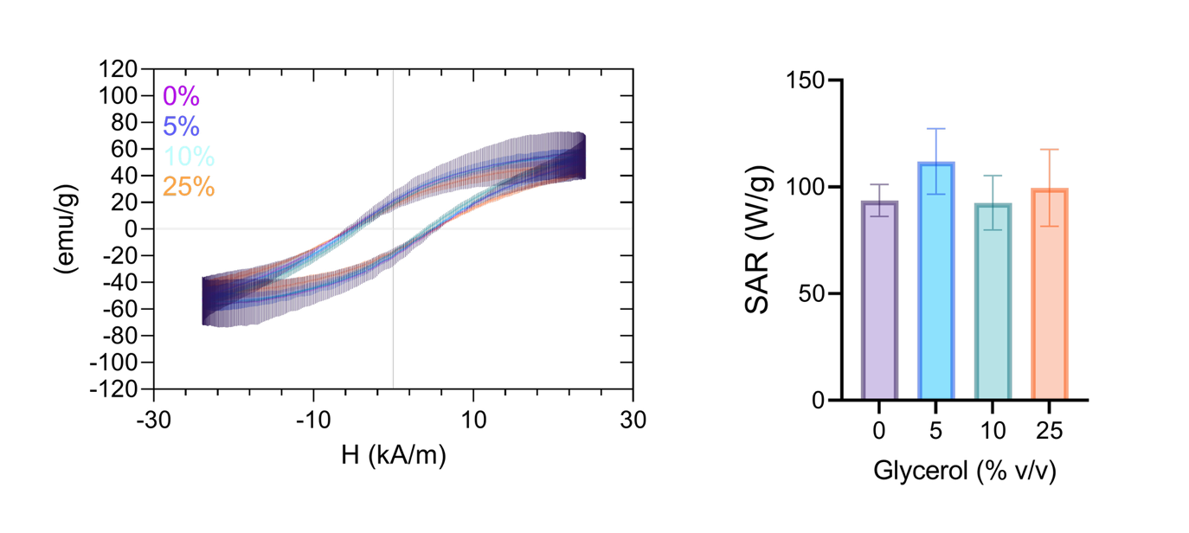
Figure S5. Magnetic properties of magFSMs. A) Magnetization curves of magFSMs in solvents with differential viscosity (0-25% of glycerol in water). B) Specific absorption rate of magFSMs in different glycerol gradients.

Preparation of liposomes
Liposomes were prepared following a protocol widely used in literature [3] with some modifications. Our aim was to obtain NP sharing the same structure and the same synthetic lipids with our FSMs in order have a negative control for assessing the protein components specifically incorporated in FSMs obtained from cell membranes. Briefly, 90 and 100 µg of DOPE and DOTAP (from 10 mg ml⁻¹ stock solutions) were dissolved in 10 ml of chloroform and the solvent was then dried under vacuum in a rotating evaporator. Dried film was rehydrated with HEPES buffer and resultant mixture was then subjected to several freeze/thaw cycles. Liposomes were eventually extruded through 800 nm polycarbonate membranes.

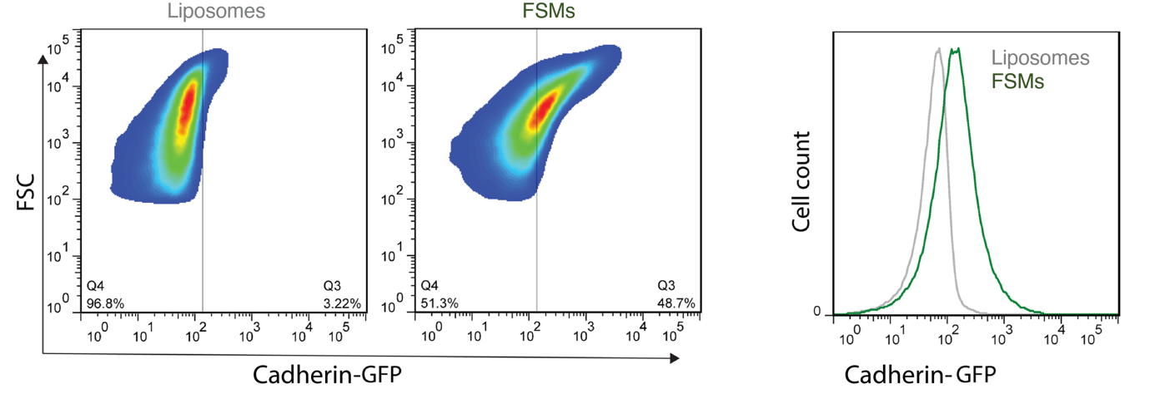
Figure S6. Membrane protein characterization of FSMs by flow cytometry. Flow cytometry analysis of E-cadherin expression on FSMs derived from tumor cell membranes, using an anti–E-cadherin antibody.
FSMs show a clear fluorescence signal associated with E-cadherin labeling, whereas synthetic control liposomes lacking membrane proteins display only background fluorescence..

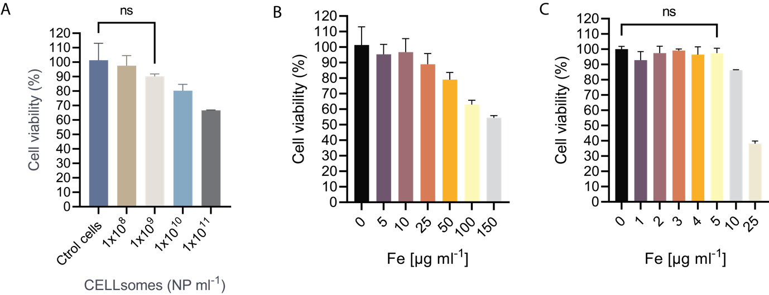
Figure S7. In vitro studies of NP biocompatibility in A549 cells after 24h of NP exposure. A) FSMs. B) IO@DMPA NPs and C) magFSMs, in which 5 μg mL⁻¹ of Fe corresponding to ~ 10¹⁰ FSMs/mL.
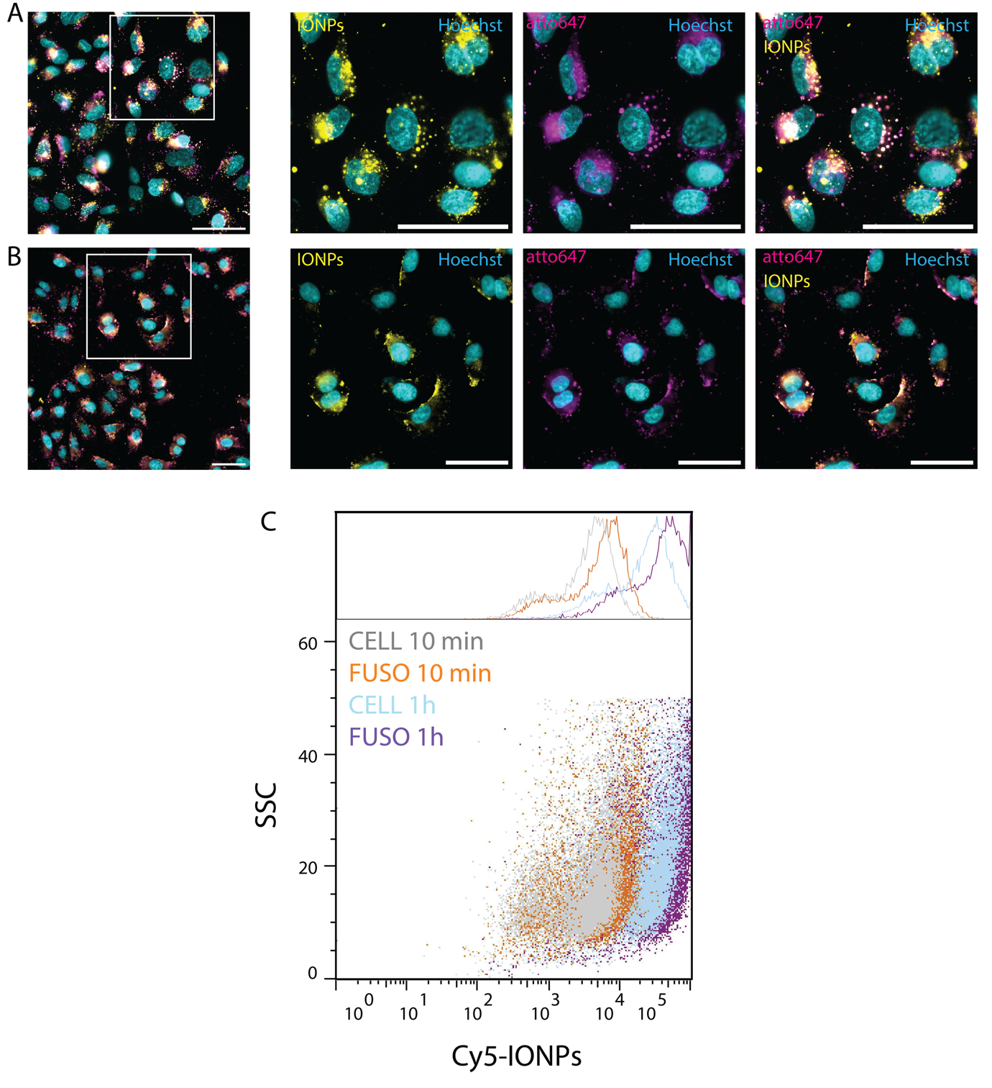
Figure S8. Comparison of fusogenic vs non fusogenic NPs. A) A549 cells exposed to magCSMs (non fusogenic). B) Cells exposed to magFSMs (fusogenic). Magenta signal stands for cell derived nanovesicles while yellow signal stands for IONPS coupled to those nanovesicles (scale bars = 50 µm). C) Flow cytometry analysis of NPs uptake by a549 cells. The study compares the uptake dynamics of fusogenic and non fusogenic nanomembranes at two different timepoints (10 minutes and 1 hour).
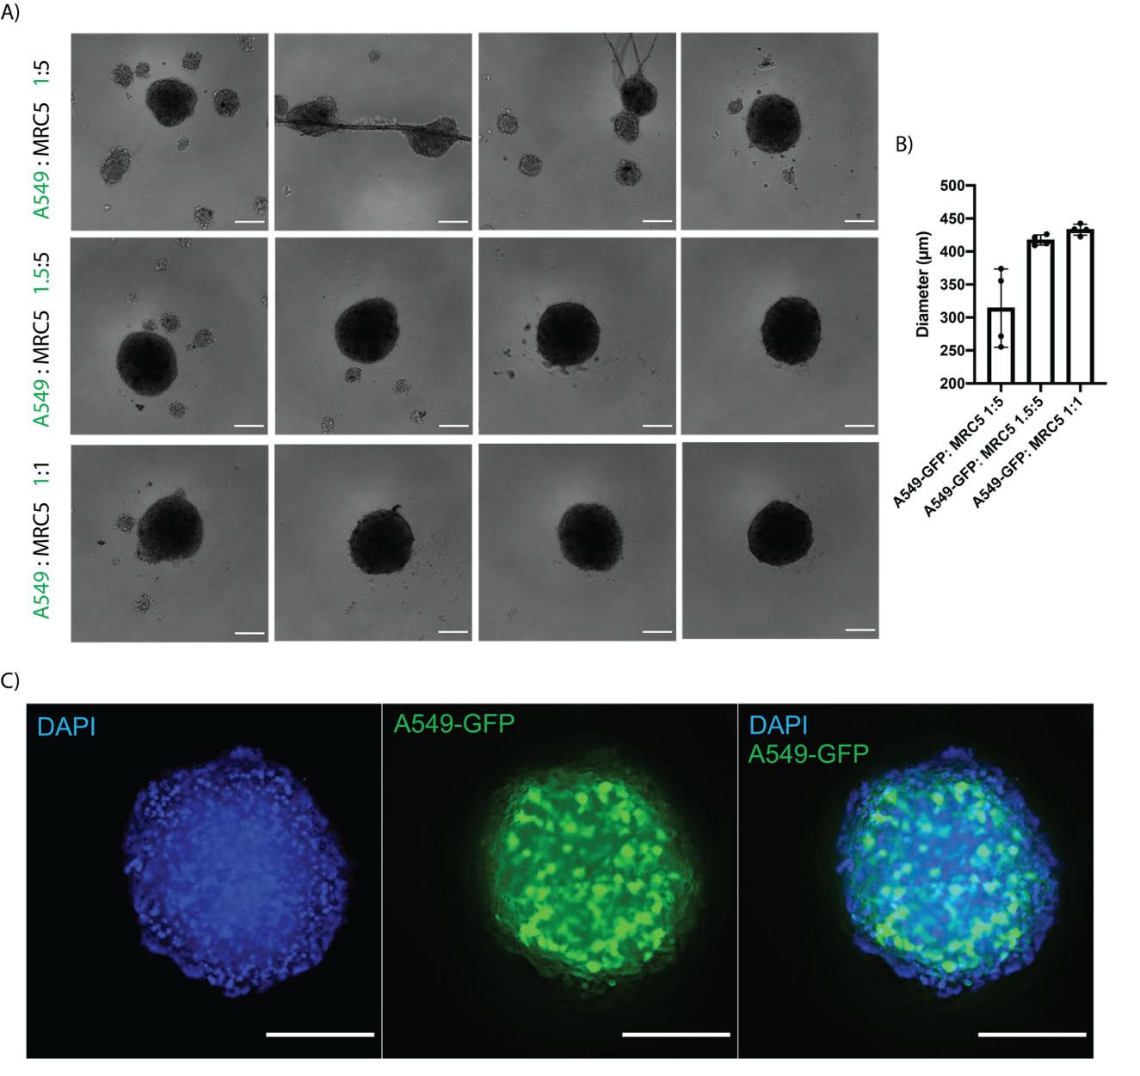
Figure S9. Establishment of heterotypic spheroids composed by A549 (lung cancer) and MRC5 (lung fibroblasts) cells. A) different ratios tested during establishment optimization. B) Diameter of the spheroids obtained. C) Fluorescence microscopy image of a heterotypic spheroid. Blue channel stands for DAPI (nuclei) and green channel for A549-GFP (cancer cells). Scale bars correspond to 200 µm.

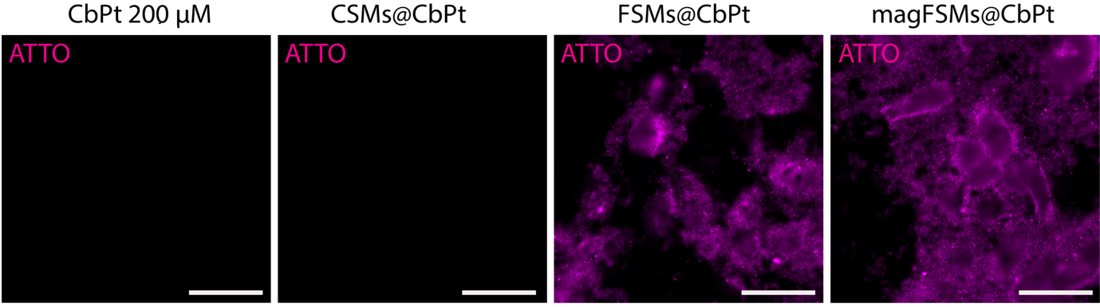
Figure S10. Fluorescence microscopy images of A549 cells exposed for 1h to 200 µM of CbPt and the drug-loaded nanoformulations at an equivalent dose (panel includes non-fusogenic CSMs, FSMs and magFSMs). Magenta signal stands for Atto647 present in FSMs. Scale bars: 50 µm.

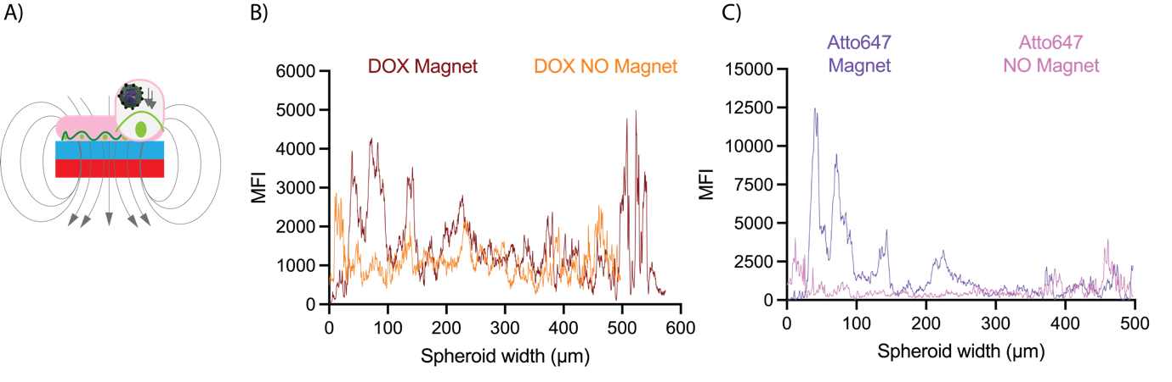
Figure S11. Magnetically driven drug delivery mediated by magFSMs. A) Schematic representation of the experimental setup employed where cell culture plates are placed on top of a neodymium magnet. B) and C) Fluorescence intensity profiles extracted from confocal z-plane sections of spheroids treated with Atto647-labeled magFSMs loaded with DOX, in the presence or absence of an external magnetic field. Profiles show enhanced penetration of both FSM and DOX signals under magnetic-field exposure.

REFERENCES:
1. Cai J, Miao YQ, Yu BZ, Ma P, Li L, Fan HM: Large-Scale, Facile Transfer of Oleic Acid-Stabilized Iron Oxide Nanoparticles to the Aqueous Phase for Biological Applications. Langmuir 2017, 33:1662-1669.
2. Kreyling WG, Abdelmonem AM, Ali Z, Alves F, Geiser M, Haberl N, Hartmann R, Hirn S, de Aberasturi DJ, Kantner K, et al: In vivo integrity of polymer-coated gold nanoparticles. Nat Nanotechnol 2015, 10:619-623.
3. Ciani L, Ristori S, Salvati A, Calamai L, Martini G: DOTAP/DOPE and DC-Chol/DOPE lipoplexes for gene delivery: zeta potential measurements and electron spin resonance spectra. Biochim Biophys Acta Biomembr 2004, 1664:70-79.

