Supplementary Materials

S1. Supplementary Methods

S1.1 Data & Preprocessing
We analyzed a corpus of 1,117 de-identified obstetric discharge notes from a tertiary women’s hospital in Brazil. A comprehensive statistical summary of the corpus is provided in Table S1. The distribution of note lengths is detailed in Figure S1, with notes containing a median of 222 tokens (IQR 178–292) and an average of 251.1 ± 124.8 tokens.
For the purpose of this descriptive analysis, tokenization was performed using a regular expression (\w+) to count sequences of alphanumeric characters, with Unicode support. This method effectively defines a token as a word or number, while excluding punctuation.
A critical preprocessing step involved the normalization of the ICD-10 codes to ensure label consistency. This process included: (i) converting all codes to uppercase; (ii) standardizing separators by replacing hyphens and commas with periods; and The resulting frequency distribution of the top 20 most common 3-character ICD-10 categories is shown in Figure S2.

Figure S1. Distribution of note lengths (tokens per discharge note).
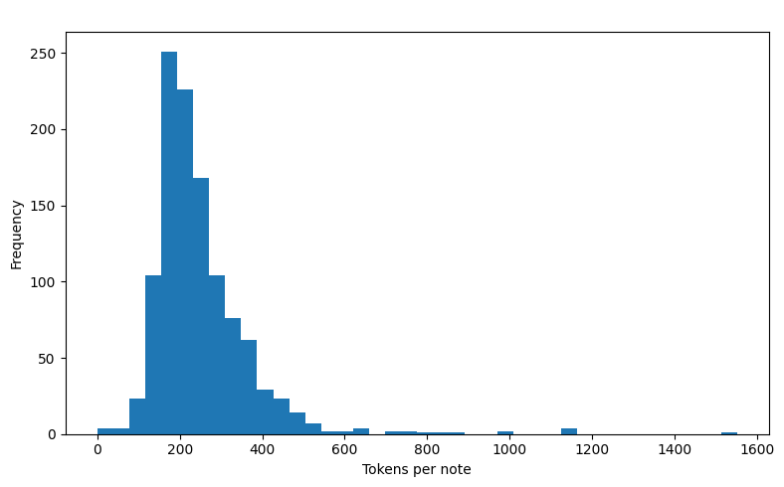

Figure S2. Frequency distribution of the top 20 Three-character category ICD-10
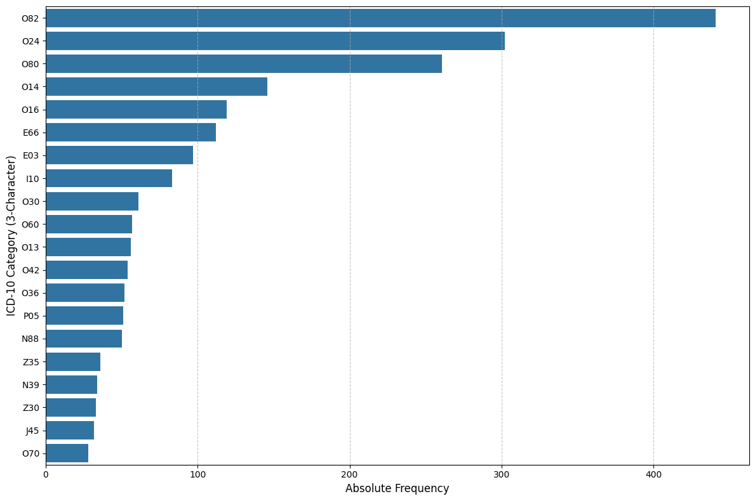

Table S1. Corpus summary.
Metric | Value
Notes (n) | 1117
Tokens per note — mean ± SD | 251.1 ± 124.8
Tokens per note — median [IQR] ] | 222 [178–292]
Codes per note (leaf) — mean ± SD | 2.58 ± 1.39
Codes per note (leaf) — median [IQR] | 2 [2–3]
Codes per note (3-character) — mean ± SD | 2.58 ± 1.38
Codes per note (3-character) — median [IQR] | 2 [2–3]
Distinct 3-character categories | 261
Distinct leaf codes | 450
Top-10 coverage (3-character categories) | 58.30%
Top-20 coverage (3-character categories) | 73.09%
% of 3-character categories with support <5 | 74.33%
% of 3-character categories with support <10 | 86.97%

S1.2 LLM Inference Details

All systems produced JSON-only outputs validated with a Pydantic schema and ICD-10 regex normalization. Portuguese prompts were mirrored with faithful English translations in the translation arm. We evaluated GPT-4o (gpt-4o-2024-08-06), GPT-4o-mini (gpt-4o-mini-2024-07-18), a fine-tuned GPT-4o-mini (ft:gpt-4o-mini-2024-07-18:personal:experimento-cid:BczZ76m5), Sabiá-3.1 (sabia-3.1, OpenAI-compatible endpoint), DeepSeek-chat (deepseek-chat), and Gemini 1.5 Flash (gemini-1.5-flash). Per the provider’s documentation, deepseek-chat maps to DeepSeek-V3-0324. UTC inference dates for each model are reported in Table S2.

Table S2. ICD-10 Coding Performance by Model — Portuguese, Three-Character Category Level.
Model (exact ID) | Provider | API / Endpoint | Inference date (UTC) | Output constraint
gpt-4o-2024-08-06 | OpenAI | Chat Completions | June 10–11, 2025 | JSON schema (Pydantic)
gpt-4o-mini-2024-07-18 | OpenAI | Chat Completions | June 10–11, 2025 | JSON schema (Pydantic)
ft:gpt-4o-mini-2024-07-18:personal:experimento-cid:BczZ76m5 | OpenAI | Chat Completions (FT) | June 10–11, 2025 | JSON schema (Pydantic)
sabia-3.1 | Maritalk AI | OpenAI-compatible | June 10–11, 2025 | JSON / regex
deepseek-chat (DeepSeek-V3-0324) | DeepSeek | OpenAI-compatible | June 10–11, 2025 | JSON / regex
gemini-1.5-flash | Google | Gemini API | June 10–11, 2025 | JSON (constrained)

S1.3 Fine-tuning of the specialist variant

S1.3.1 Objective
We fine-tuned gpt-4o-mini-2024-07-18 to emit JSON-only ICD-10 codes from Portuguese discharge notes, using a description→single-code mapping derived from an ICD-10 subcategory catalogue (S1.3.4). This tests whether lightweight specialization on single-label mappings transfers to multi-label coding of free-text notes.
S1.3.2 Configuration and metadata.
The fine-tuning configuration and outputs are summarized in Table S3.

Table S3. Fine-tuning metadata (job snapshot)
Field | Value
Training method | Supervised
Job ID | ftjob-wqj9laPJ3wHdBc75fVmpGEgU
Output model | ft:gpt-4o-mini-2024-07-18:personal:experimento-cid:BczZ76m5
Status | Succeeded
Base model | gpt-4o-mini-2024-07-18
Created at | May 30, 2025, 15:39
Epochs | 2
Batch size | 16
LR multiplier | 1.8
Seed | 1
Trained tokens | 2,325,050
Training file | CID_10_subcategorias_toolcall.jsonl
Validation file | Not provided
Checkpoints | …BczZ7fOS:ckpt-step-779; final ft:gpt-4o-mini-2024-07-18:personal:experimento-cid:BczZ76m5
Final training loss | 0.025
Safety audit | 13/13 checks passed
S1.3.3 Training telemetry (step log)
The step log records 1,557 steps. Training loss decreases from 3.303 (step 1) to 0.025 (step 1,557), with usual mini-batch variability. The accuracy curve rises throughout training and approaches ≈0.99 at the end (see Figure S3).

Figure S3. Fine-tuning telemetry for the specialist variant (gpt-4o-mini-2024-07-18; output ft:gpt-4o-mini-2024-07-18:personal:experimento-cid:BczZ76m5).

Top: training loss (log scale) across 1,557 optimization steps; bottom: token-level accuracy on training batches. Loss decreased from ~3.30 to 0.025, while accuracy rose toward ~0.99. No validation curve was logged; the final checkpoint was used for evaluation. Hyperparameters: 2 epochs, batch size 16, LR multiplier 1.8, seed 1.
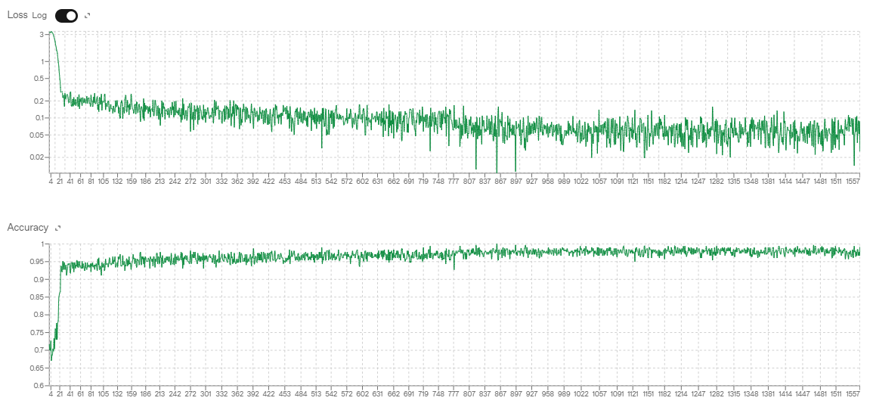

S1.3.4 Training data specification
The ICD-10 subcategory pairs used to construct the description→code mapping stored in Each are of the type: {"descrição": "<Portuguese ICD-10 subcategory description>", "codigo": "<ICD-10 code>"}
We counted 12,451 description–code pairs spanning A00–Z99; codes follow the pattern (e.g., O24.9).
S1.3.5 Safety and governance
A safety audit for the fine-tuned endpoint indicates 13/13 checks passed across policy categories.
S1.3.6 Limitations specific to this fine-tune
We did not configure a validation split or an early-stopping rule; training ran for two epochs and the final checkpoint (ft:gpt-4o-mini-2024-07-18:personal:experimento-cid:BczZ76m5) was used.
The step log records batch-level loss and token accuracy only; optimizer-level diagnostics (e.g., gradients, learning-rate schedule) are not available, so we restrict interpretation to the overall downward trend in loss and the accuracy plateau.
Supervision used single-label description→code pairs; transfer to multi-label coding of free-text discharge notes may be limited, so we treat results as exploratory.

S1.4 Prompts

This section provides the verbatim prompts used for the Large Language Models. The Portuguese prompt was used for the main analysis, and a faithful English translation was used for the translation arm of the study. All models were instructed to return a structured JSON output.

S1.3.1 Portuguese Prompt (Original)

{
"role": "system",
"content": """Você é um médico especializado na determinação de códigos CID-10 (Classificação Internacional de Doenças) que atua em um hospital de saúde materna e neonatal. Ao receber uma nota clínica, identifique exclusivamente os códigos CID-10 mais associados àquela nota, sem qualquer informação ou explicação adicional. Utilize apenas diretrizes médicas reconhecidas (OMS, CDC, FDA, NICE).
Leia atentamente a nota clínica abaixo e extraia:
- 1 CID “principal” (motivo principal de internação/alta);
- 1 CID “secundário” (complicações ou comorbidades relevantes);
- Vários CIDs “terciários” (demais condições associadas).
Sua resposta deve ser UM JSON VÁLIDO no formato de exemplo:

{ "cids": [ { "cid": "O80", "tipo": "principal" }, { "cid": "O99.8", "tipo": "secundário" }, { "cid": "Z39.0", "tipo": "terciários" }, { "cid": "F53.0", "tipo": "terciários" } ] }

Nada além desse JSON — sem comentários ou campos extras. """ },
{
"role": "user", "content": "{clinical_note_text}"
}

S1.3.2 English Prompt

{
"role": "system",
"content": """You are a physician specializing in assigning ICD-10 codes (International Classification of Diseases) working in a maternal and neonatal health hospital. Upon receiving a clinical note, identify only the ICD-10 codes most relevant to that note, without any explanations or additional information. Use only recognized medical guidelines such as WHO, CDC, FDA, or NICE.
Read the clinical note below and extract.
- 1 primary ICD-10 code;
- 1 secondary ICD-10 code;
- several tertiary ICD-10 codes.
Return a VALID JSON in this format (no extra fields):

{ "icds": [ { "icd": "O80", "tipo": "primary" }, { "icd": "O99.8", "tipo": "secundary" }, { "icd": "Z39.0", "tipo": "terciary" } ] }
{
"role": "user", "content": "{clinical_note_text}"
}

S1.5 Human Validation Protocol
To assess the clinical validity of the model-proposed codes, we conducted a human validation on a subset of 315 notes. The evaluator was an experienced, board-certified obstetrician-gynecologist with residency training in Gynecology, research presentations at national and international obstetrics conferences, and ongoing subspecialty training in Gynecologic and Obstetric Ultrasound. The evaluator was blinded to the source of the codes (i.e., whether they came from the gold standard or a specific model).
For each note, the clinician was presented with the de-identified text alongside a unified list of all candidate codes (the union of gold-standard and all model-proposed codes for that note). The codes were presented in a randomized order. The reviewer's task was to mark each candidate code as "appropriate" or "not appropriate" based on whether there was sufficient evidence within the clinical note to justify its assignment. Multiple "appropriate" selections were permitted per note. A screenshot of the validation interface is provided in Figure S3.

Figure S4 — Interface used for human validation. For each obstetric discharge note, the evaluator (a board-certified obstetrician) viewed the note in a de-identified format, accompanied by a list of candidate codes (mixing gold-standard predictions and outputs from all models, presented in random order and with no source identification). The reviewer marked each code as either Appropriate or Not appropriate.
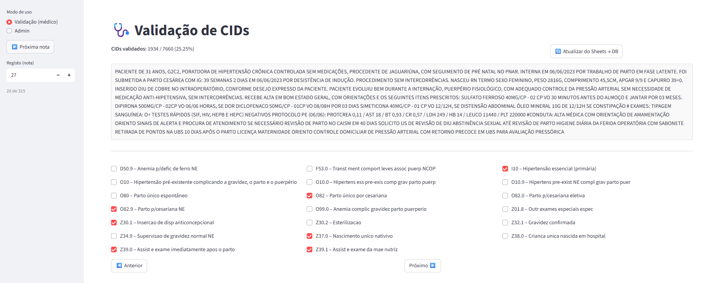

S2 Supplementary Results

S2.1 Descriptive model statistics
Table S4 summarizes per-model output characteristics across the 1,117 discharge notes in our test set. For each model, we report the mean and median number of predictions per note, the total number of distinct ICD-10 leaf codes and three-character categories predicted, and the proportion of all predicted categories accounted for by the 10 and 20 most frequent categories. These descriptive statistics provide a high-level view of each model’s coding behavior and diversity of predictions.

Table S4 — Per-model output summary.

For each model: notes (n), notes with ≥1 valid prediction (%), predictions per note (mean±SD; median [IQR]), distinct leaf codes (A00–Z99 with optional subcategory), distinct 3-character categories, and coverage of the top-10/20 categories among all predicted categories.
Model | Predictions per note — mean ± SD | Predictions per note — median [IQR] | Distinct leaf codes | Distinct 3-char categories | Top-10 category coverage | Top-20 category coverage
Sabiá-3.1 | 6.24 ± 1.89 | 6 [5–7] | 977 | 481 | 40.74% | 55.34%
Deep-Seek V-3 | 5.53 ± 1.35 | 5 [5–6] | 622 | 349 | 46.22% | 66.14%
Fine-Tuned Model | 5.68 ± 2.06 | 5 [5–6] | 523 | 241 | 55.43% | 75.54%
GPT-4o-Mini | 5.26 ± 0.99 | 5 [5–6] | 488 | 298 | 56.85% | 73.72%
GPT- 4o | 4.42 ± 1.36 | 4 [3–5] | 622 | 352 | 40.23% | 61.34%
Gemini 1.5 Flash | 4.93 ± 1.34 | 5 [4–6] | 629 | 371 | 45.70% | 67.70%

S2.2 Bootstrap Confidence Intervals — Graphical Analysis
We performed bootstrap resampling (n = 10,000 note-level resamples) to compute the empirical distribution of micro- and macro-precision, recall, and F1 scores, for both Leaf level (full ICD-10 codes) and Three-character level categories. Each histogram shows the bootstrap distribution for a given metric, with vertical lines indicating the point estimate (red) and the 95% percentile confidence interval bounds (green).

Figure S5 — Micro Precision (Leaf level)

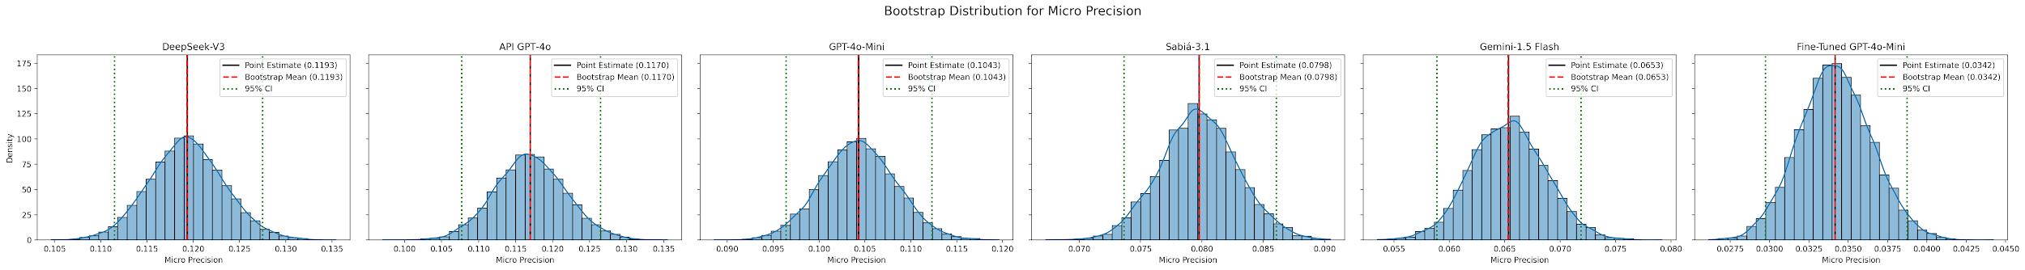

Figure S6 — Micro Precision (Three-character level)

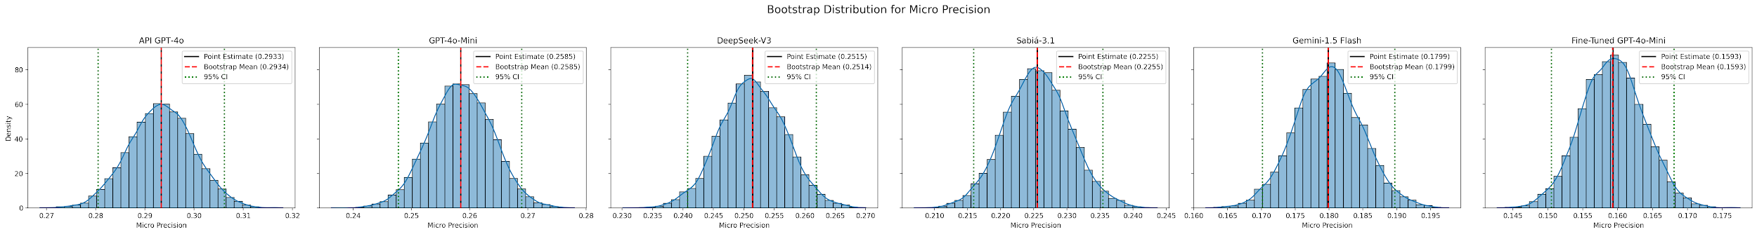

Figure S7 — Micro Precision (Three-character level)

Figure S8 — Micro Recall (Leaf level)

Figure S9 — Micro Recall (Three-character level)

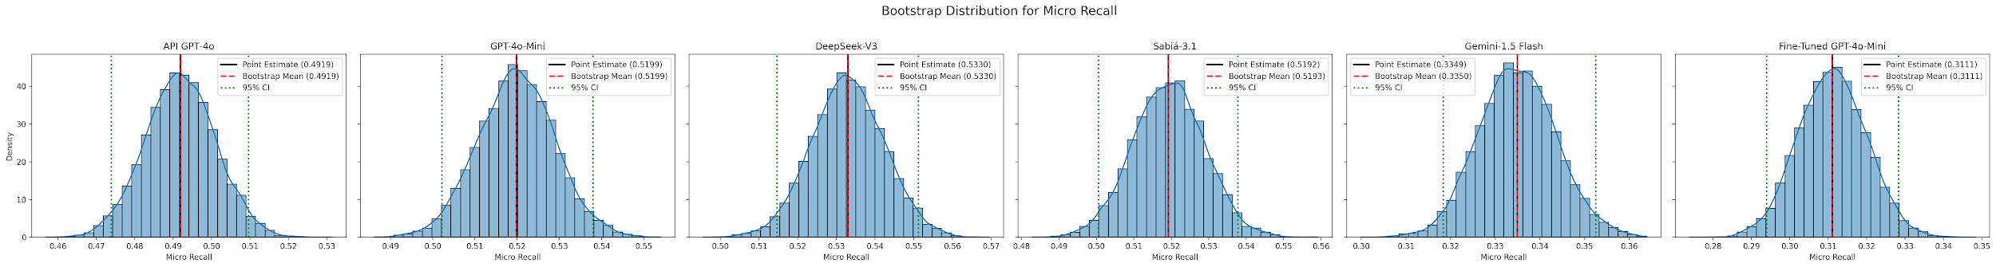

Figure S10 — Micro F1 (Leaf level)

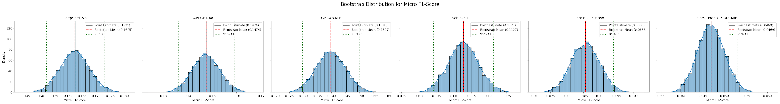

Figure S11 — Micro F1 (Three-character level)

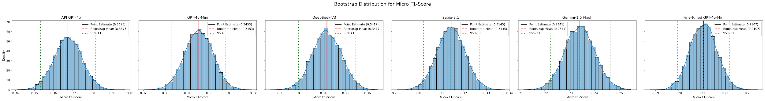

Figure S12 — Macro Precision (Leaf level)

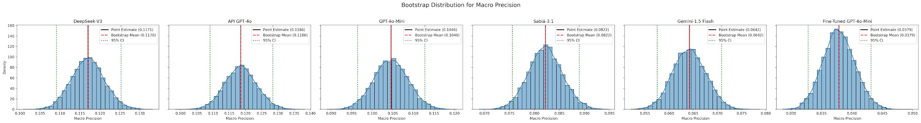

Figure S13 — Macro Precision (Three-character level)

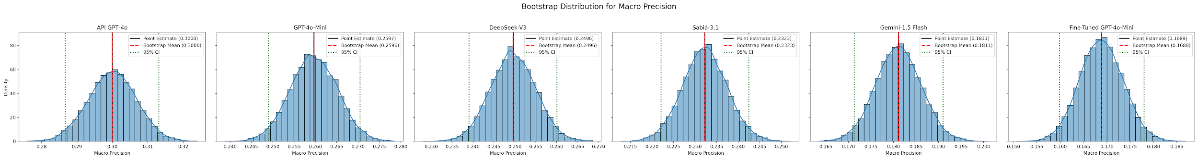

Figure S14 — Macro Recall (Leaf level)

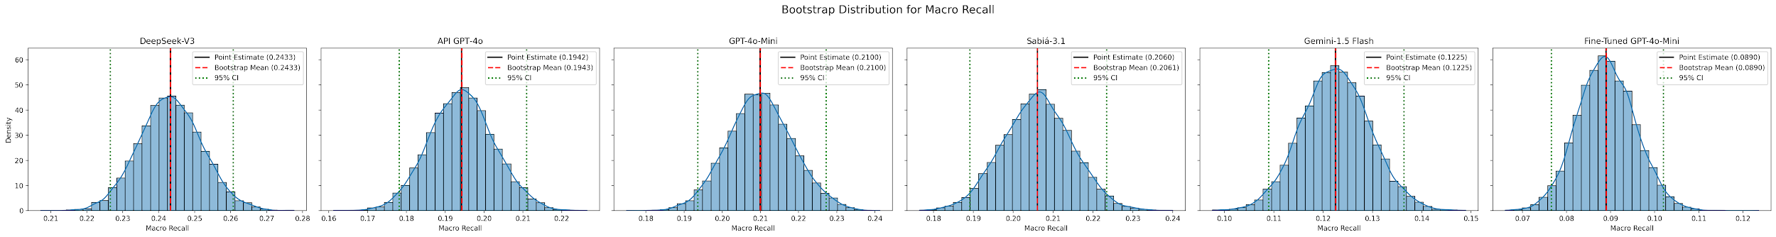

Figure S15 — Macro Recall (Three-character level)

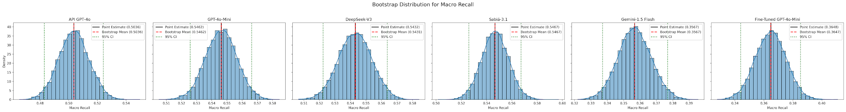

Figure S16 — Macro F1 (Leaf level)

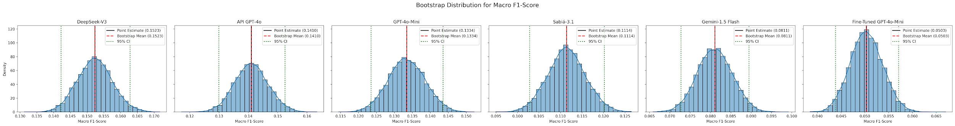

Figure S17 — Macro F1 (Three-character level)

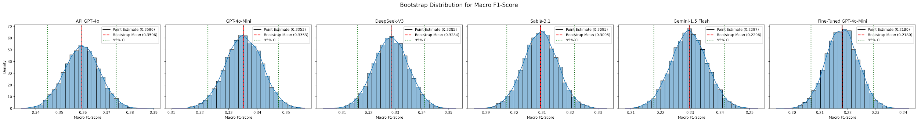

S2.3 Machine-translation engine selection (PT→EN)

We compared three translation engines, Google Translate, GPT-4o-mini, and Sabiá-3.1 and the ICD-10 pipeline identical (JSON-only prompt, same schema/regex validator). Among the three, Google Translate yielded the highest scores (e.g., leaf micro-F1 ≈ 0.127 vs 0.124 with GPT-4o-mini and 0.118 with Sabiá 3.1; 3-character micro-F1 ≈ 0.311 vs 0.303–0.306 for the others), with similarly small advantages on macro-F1. We also tested configurations that preserved versus expanded Portuguese clinical abbreviations and acronyms, observing no meaningful impact on coding performance. Differences across engines were modest, but to standardize the English-input arm we adopted Google Translate for subsequent tests.

Table S5. Machine-translation ablation with Sabiá-3.1 as the coding model. Four input conditions are compared: native Portuguese (shown elsewhere), Google Translate, GPT-4o-mini translation, and Sabiá 3.1 translation. Metrics are reported at leaf and 3-character levels (micro/macro Precision, Recall, F1).
Level | Translation | Micro |  |  | Macro
Level | Translation | Precision | Recall | F1-Score | Precision | Recall | F1-Score
Leaf Level | Google Translate API | 0.0935 | 0.1968 | 0.1268 | 0.0935 | 0.2095 | 0.2897
Leaf Level | GPT-4o-mini API | 0.0899 | 0.2002 | 0.1240 | 0.0913 | 0.2082 | 0.2831
Leaf Level | Sabia 3.1 API | 0.0857 | 0.1906 | 0.1182 | 0.0865 | 0.2028 | 0.2765
Three-character | Google Translate API | 0.2292 | 0.4821 | 0.3106 | 0.2286 | 0.5183 | 0.3810
Three-character | GPT-4o-mini API | 0,2191 | 0.4883 | 0.3025 | 0.2220 | 0.5166 | 0.3699
Three-character | Sabia 3.1 API | 0,2216 | 0.4928 | 0.3057 | 0.2235 | 0.5219 | 0.3709

S2.3 Hierarchical Coding Performance
In addition to computing set-level metrics on the flattened outputs, we evaluated the correctness of codes in each semantic role specified by the model’s instruction: ‘primary’ (main reason for admission/discharge) and ‘secondary’ (relevant comorbidities/complications). Precision was calculated separately for each role, at both the three-character and leaf levels. This role-specific evaluation is exploratory, as the reference standard does not explicitly assign gold codes to these roles.
When considering role-specific precision, GPT-4o-mini achieved the highest primary precision at the three-character level (0.6625), while GPT-4o obtained the highest secondary precision (0.3115). Leaf-level precision was consistently lower across roles (≤0.2426). These results indicate that models tend to assign more correct codes to the primary role than to secondary roles, which may reflect both model limitations and the lack of explicit role mapping in the gold standard.
Role-specific evaluation suggests that LLMs are better at assigning correct codes to the primary role than to the secondary role. This may be due to the clearer signal for the main diagnosis in discharge notes, compared to secondary diagnoses which often require nuanced interpretation of comorbidities. However, since our gold standard lacks explicit role labels, these results should be interpreted as indicative rather than definitive

Table S6. Hierarchical Coding Performance — Precision for Primary and Secondary Codes.
Precision of model-assigned primary and secondary codes against the gold standard. The analysis evaluates how accurately models identify the hierarchical role of a code, a distinct task from a code's mere presence in the note. Note that for some models, the precision in identifying the primary code (e.g., 0.66 for GPT-4o-mini) is substantially higher than their overall score for code extraction, highlighting a potential strength in identifying the main diagnosis.
Model | Primary |  | Secondary
Model | Three-Character | Leaf Level. | Three-Character | Leaf Level.
DeepSeek-V3 | 0.5237 | 0.2426 | 0.3008 | 0.1119
GPT-4o | 0.5255 | 0.1629 | 0.3115 | 0.1235
GPT-4o-mini | 0.6625 | 0.2301 | 0.2793 | 0.1262
Sabiá-3.1 | 0.5157 | 0.1970 | 0.2963 | 0.0895
Gemini-1.5 Flash | 0.2927 | 0.0618 | 0.2247 | 0.0555
Fine-Tuned GPT-4o-mini | 0.4575 | 0.1173 | 0.1656 | 0.0295

