Multi-scale Synergistic Effects Enhanced Hierarchically Structured Polycrystalline Diamond for Exceptional Hardness and Toughness
Shuailing Ma^{a,}†, Yunfeng She^{a,}†, Min Lian^{a,}*, Xiao Maª, Shuo Yangª, Xingbin Zhaoª, Cun You^{b}, Pinwen Zhu^{b}, Tian Cui^{a,}*
a. School of Physical Science and Technology & Institute of High-Pressure Physics, Ningbo University, Ningbo 315211, China
b. Synergetic Extreme Condition High-Pressure Science Center, State Key Laboratory of Superhard Materials, College of Physics, Jilin University, Changchun 130012, China

Email: lianmin@nbu.edu.cn; cuitian@nbu.edu.cn
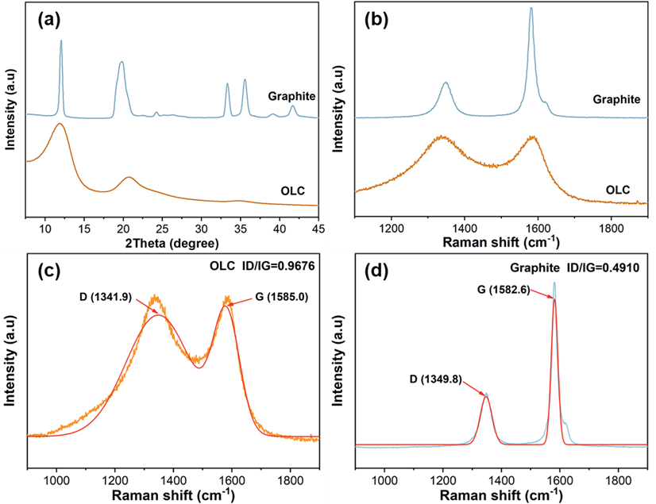
Fig. S1 (a) XRD characterization of OLC and graphite raw materials; (b-d) Raman characterization of OLC and graphite raw materials and their fitting curves.
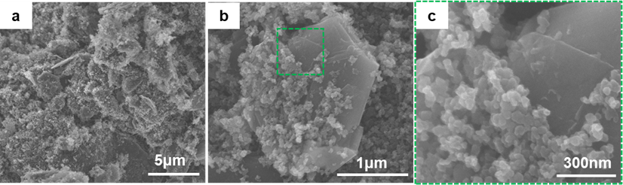
Fig. S2 (a-b) SEM shows the surface morphology of OLC and graphite raw materials after mixing evenly. (c) Local enlarged view of the tight bonding of raw materials after being evenly mixed

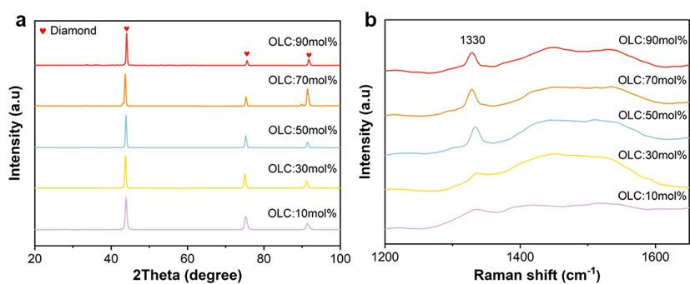
Fig. S3 (a) XRD characterization of samples with different OLC and Graphite molar ratios; (b) Raman characterization of OLC and Graphite samples with different molar ratios.
Table S1. The precursor, number of HPHT runs, the grain size, hardness and fracture toughness of synthesized samples.
Run number. | Name | OLC / Graphite | Synthesis condition (P / GPa, T / ℃) | Grain size (nm) | Hardness (GPa) | Fracture toughness (MPa∙m^{0.5})
NBU-204 | HSPD-10 | 1:9 | 15 – 2000 | --- | 121.0 | 7.8
NBU-199 | HSPD-30 | 3:7 | 15 – 2000 | 30 – 80 and 300 – 400 | 124.1 | 10.9
NBU-193 | HSPD-50 | 1:1 | 15 – 2000 | 30 – 70 and 300 – 400 | 133.2 | 11.5
NBU-188 | HSPD-70 | 7:3 | 15 – 2000 | 40 – 80 and 350 – 450 | 146.0 | 14.1
NBU-202 | HSPD-90 | 9:1 | 15 – 2000 | --- | 116.9 | 10.4

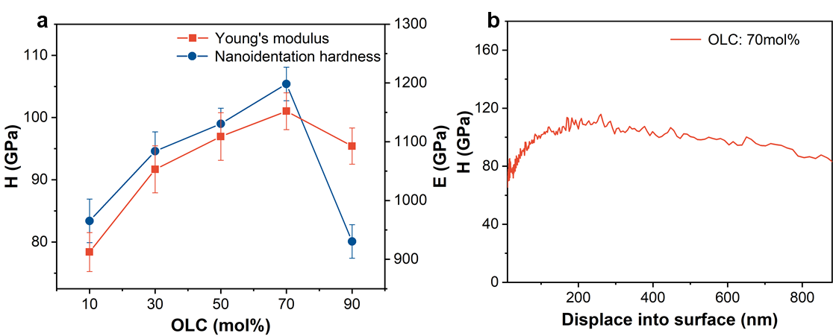
Fig. S4 (a) Characterize nanoindentation hardness (H) and Young's modulus (E) of OLC and graphite samples with different molar ratios; (b) Continuous stiffness test curves for sample nanoindentation containing 70 mol% OLC.

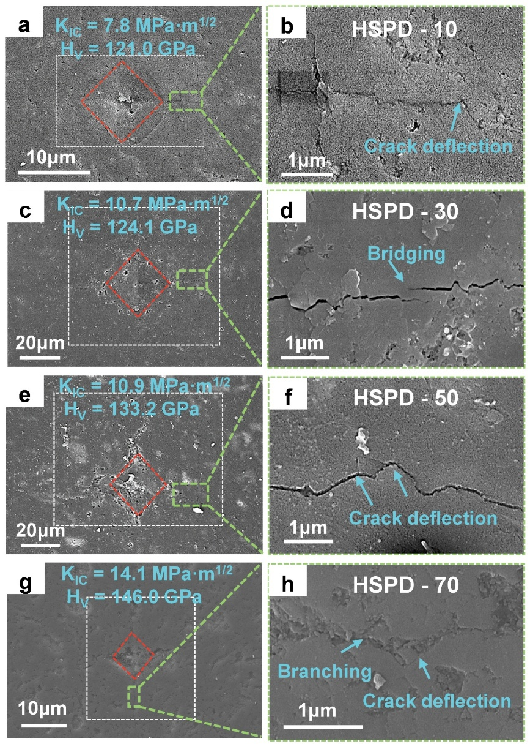
Fig. S5. Scanning-electron micrographs of indents produced at 19.6 N, together with higher-magnification views of the radial cracks used for toughness evaluation for (a, b) 30 mol % OLC, (c, d) 50 mol % OLC, (e, f) 70 mol % OLC.
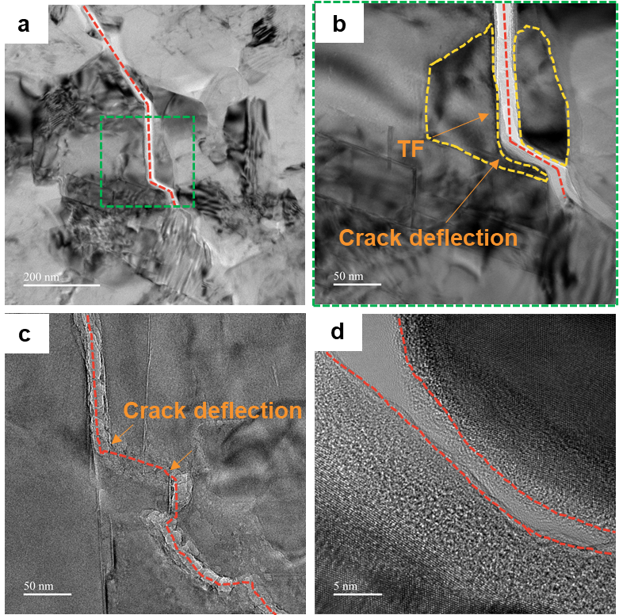
Fig. S6. TEM shows some additional descriptions of supplemental toughening mechanisms for samples containing 70 mol% OLC
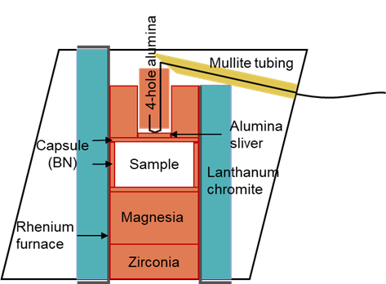
Fig. S7 Standard 10/5 assembly drawing.

