The pH Effects on SARS-CoV and SARS-CoV-2 Spike Proteins in the Process of Binding to hACE2

Yixin Xie¹, Wenhan Guo¹, Alan Lopez-Hernadez¹, Shaolei Teng², Lin Li^{1,3*}

¹ Computational Science Program, University of Texas at El Paso, El Paso, TX.
² Department of Biology, Howard University, Washington, D.C.
³ Department of Physics, University of Texas at El Paso, El Paso, TX.

*Correspondence:
Lin Li: lli5@utep.edu
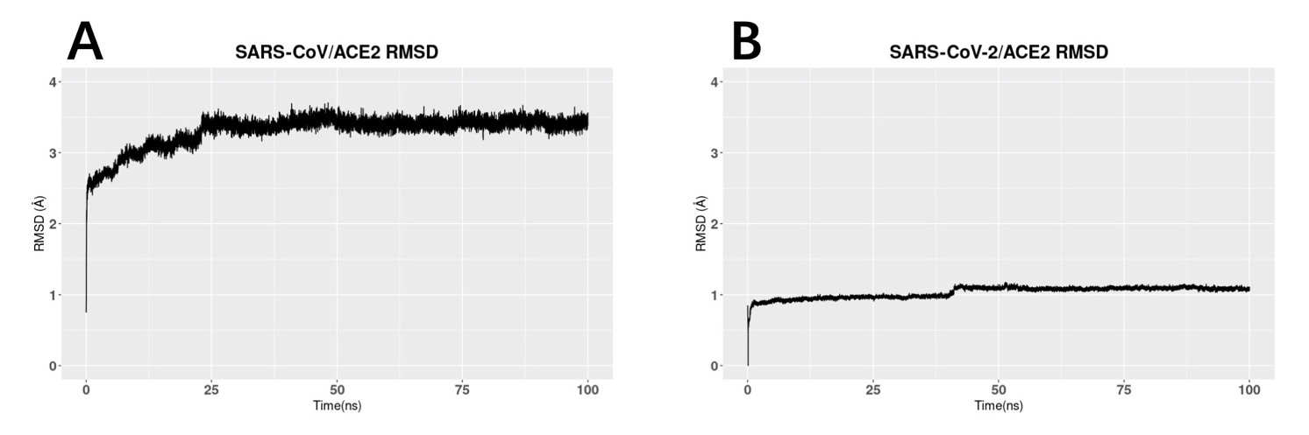

Figure S1. RMSD comparison of SARS-CoV/ACE2 and SARS-CoV-2/ACE2 complex structure
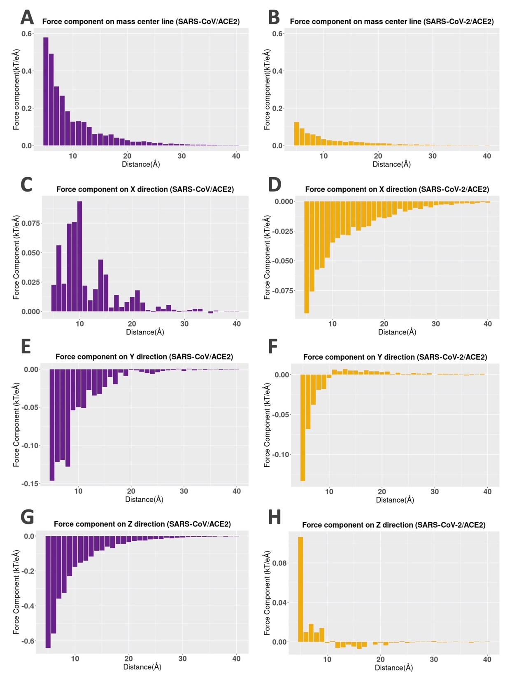
Figure S2. (A-B) The binding forces of SARS-CoV/hACE2 and SARS-CoV-2/hACE2 complexes (C-H) X,Y,Z components of electrostatic binding forces. The mass center line was set as the X axis.

Movies:
Movie1: SARS-CoV electrostatic surface
Movie2: SARS-CoV-2 electrostatic surface
Movie3: hACE2 electrostatic surface
Movie4: SARS-CoV RBD / hACE2 complex simulation
Movie5: SARS-CoV-2 RBD / hACE2 complex simulation

Software applied:
Delphi:
http://compbio.clemson.edu/delphi
DelphiForce:
http://compbio.clemson.edu/delphi-force/
DelphiPKa:
http://compbio.clemson.edu/pka_webserver/
NAMD:
https://www.ks.uiuc.edu/Research/namd/
R Studio:
https://www.rstudio.com/
Chimera:
https://www.cgl.ucsf.edu/chimera/

