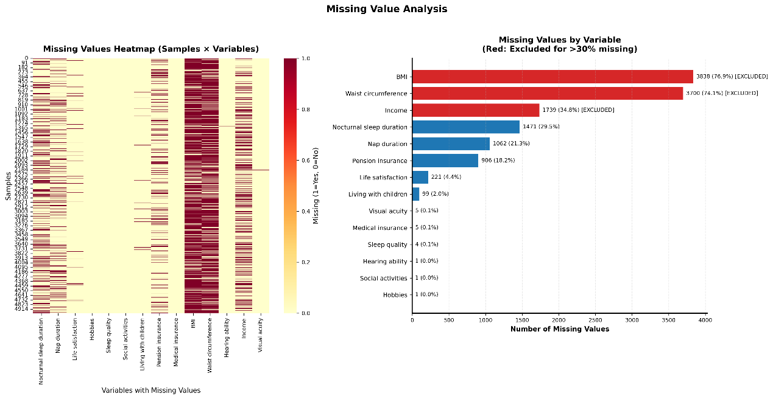
FigureS1. Missing-data pattern in the analytical sample (N = 4,991).
Upper panel: sample-by-variable heatmap; red bands indicate variables excluded a priori because >30 % of values were absent (BMI, waist circumference, income).
Lower panel: frequency of missing values among the 36 retained predictors. Nap duration exhibited the highest missingness (29.5 %), followed by pension insurance (21.3 %); all other variables had <5 % missing values.
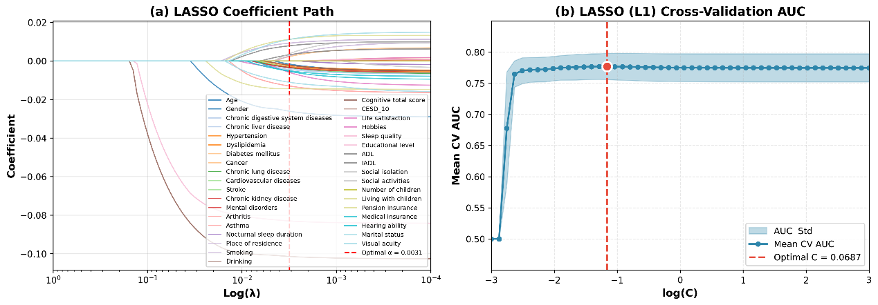
Figure S2
LASSO regression results for [specify target outcome, e.g., incident depressive symptoms].(a) LASSO Coefficient Path: Trajectories of regression coefficients for all candidate predictors (e.g., demographics, chronic conditions, cognitive function) across decreasing log(λ)
(regularization parameter). The vertical dashed red line denotes the cross-validated optimal α=0.0031; coefficients shrink toward zero with stronger regularization, with some predictors penalized to 0 (feature selection).
(b) LASSO Cross-Validation AUC: Mean cross-validated area under the curve (AUC; solid blue line) and its standard deviation (light blue shade) across log(C) (inverse regularization parameter). The vertical dashed red line marks the optimal C=0.0687 (maximizing AUC), corresponding to the regularization parameter in (a).

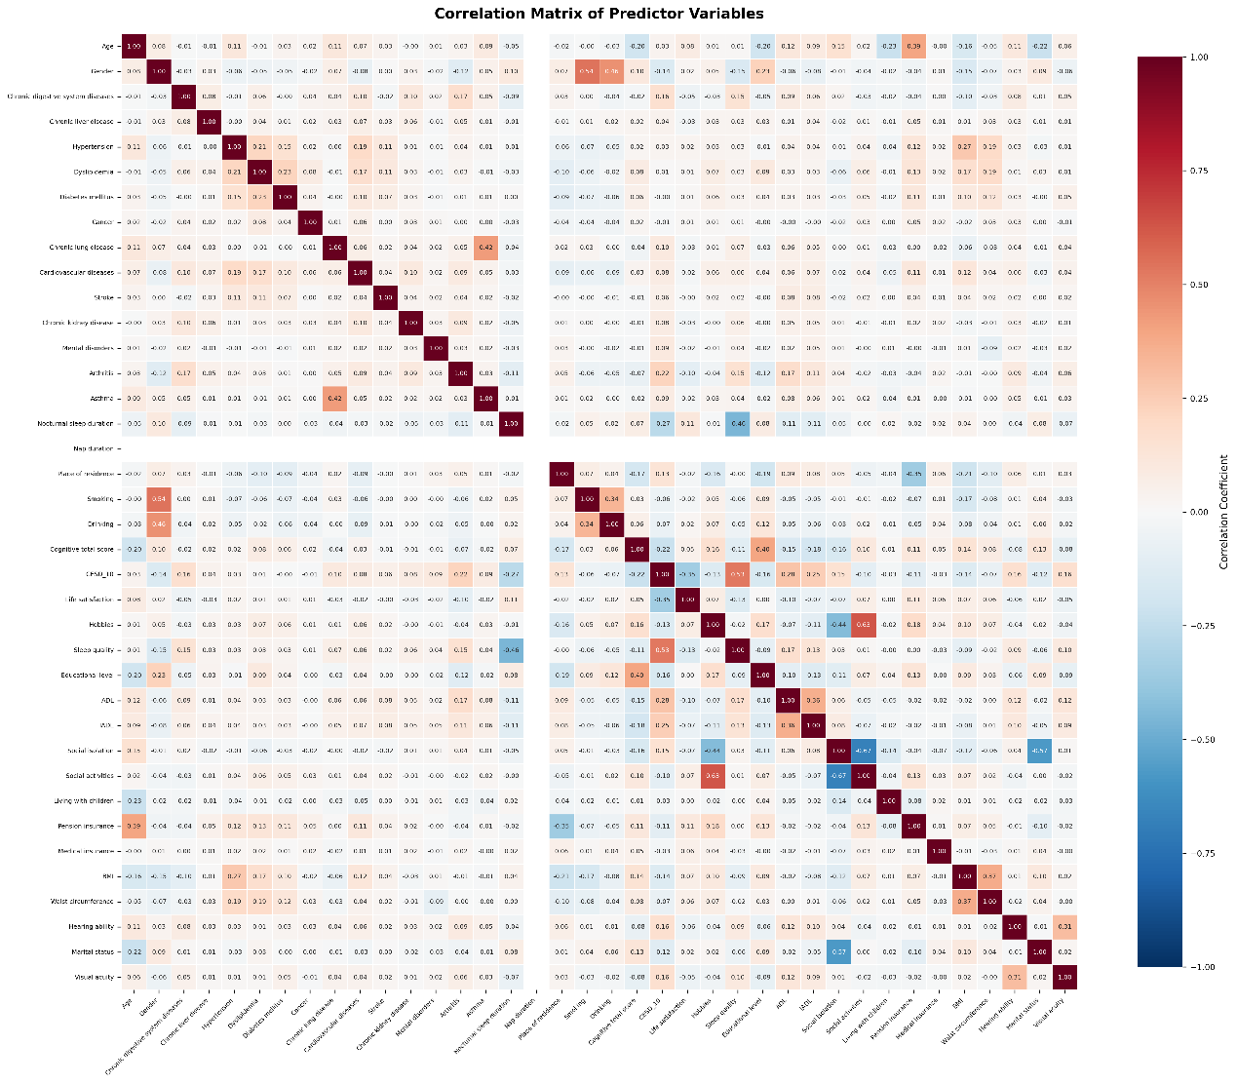
Figure S3. Pearson correlation matrix of the nine final predictors.
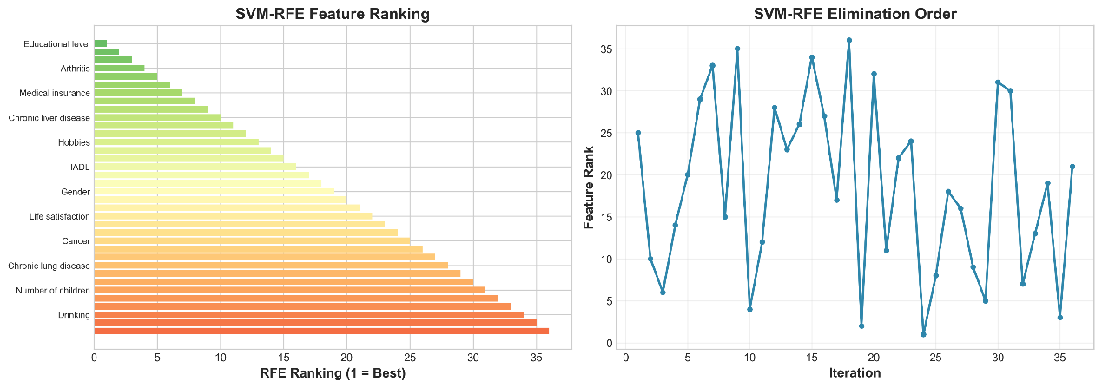
Figure S4
SVM-RFE feature selection results for [target outcome, e.g., depressive symptom risk].(a) SVM-RFE Feature Ranking: Bar plot displays the SVM-RFE ranking of candidate predictors (1 = most contributory to model performance). The color gradient (from green to red) corresponds to ranking priority (higher priority = greener).(b) SVM-RFE Elimination Order: Line plot illustrates dynamic changes in feature rankings across SVM-RFE elimination iterations. The x-axis denotes iteration steps, and the y-axis denotes the current ranking of each feature, reflecting how feature importance shifts during the stepwise elimination process.

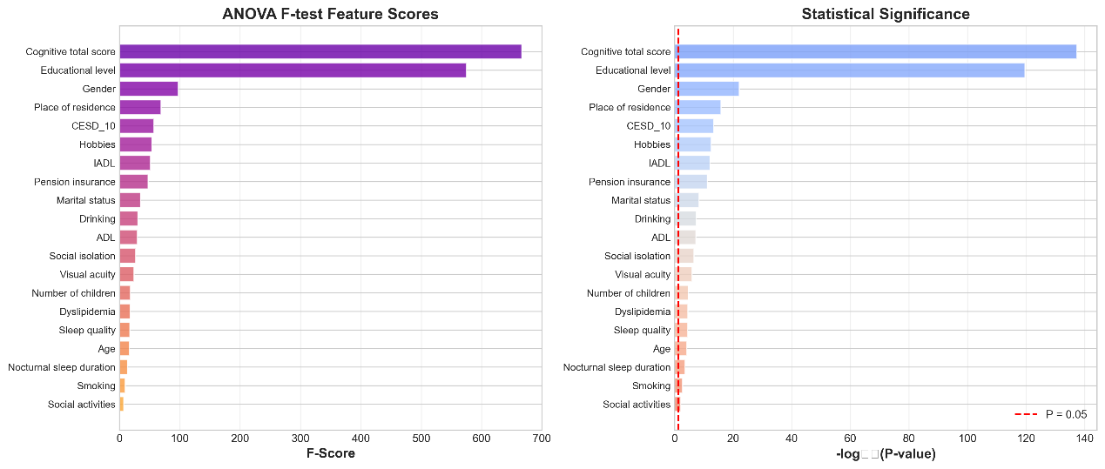
FigureS5
ANOVA F-test results for assessing the association between candidate predictors and [target outcome, e.g., depressive symptoms].
(a) ANOVA F-test Feature Scores: Bar plot displays the F-score (reflecting the strength of group difference association) for each candidate predictor. Higher F-scores indicate a stronger association between the predictor and the target outcome.
(b) Statistical Significance: Bar plot presents the (a transformed measure of statistical significance, with higher values indicating stronger significance) for each predictor. The vertical dashed red line denotes the conventional significance threshold (); predictors to the left of this line reach statistical significance.

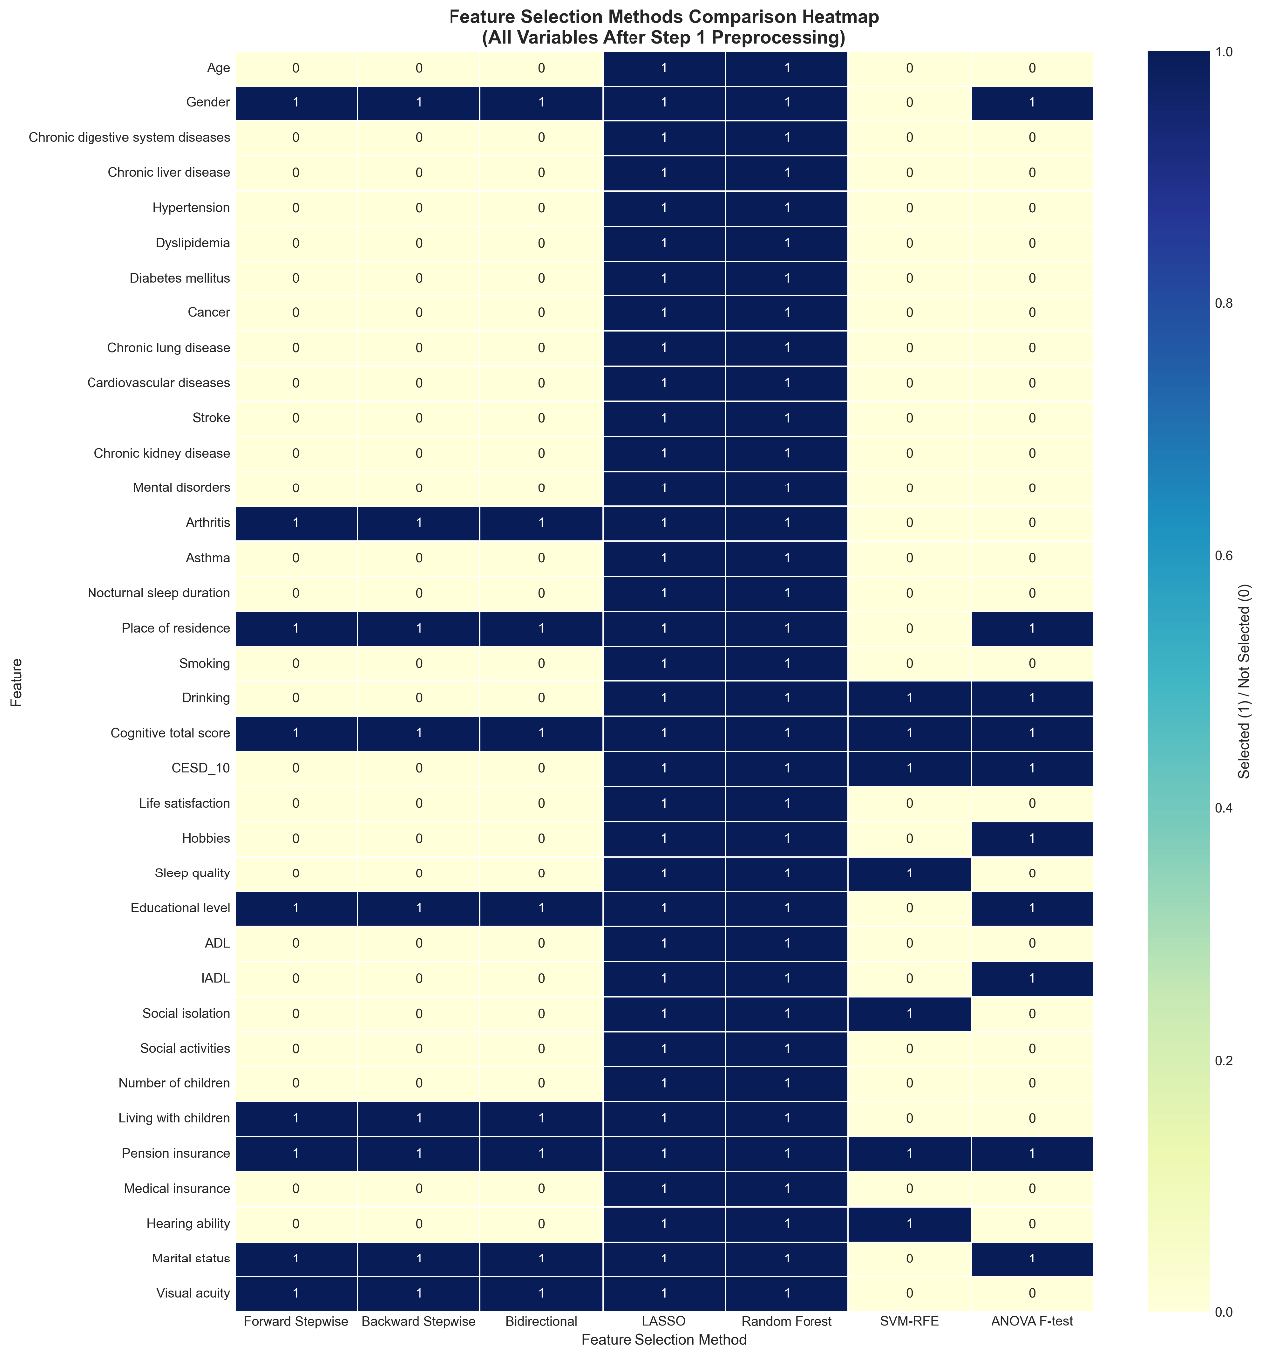
Figure S6
Heatmap comparing feature selection results across multiple methods (for preprocessed variables).
Structure: Rows represent candidate features; columns represent feature selection methods (e.g., Forward Stepwise, LASSO, Random Forest).
Color encoding: The color intensity indicates whether a feature was selected (1 = dark color) or not selected (0 = light color) by the corresponding method.
Purpose: This heatmap illustrates the consistency (or discrepancy) in feature selection results across different methods, highlighting features frequently selected by multiple approache

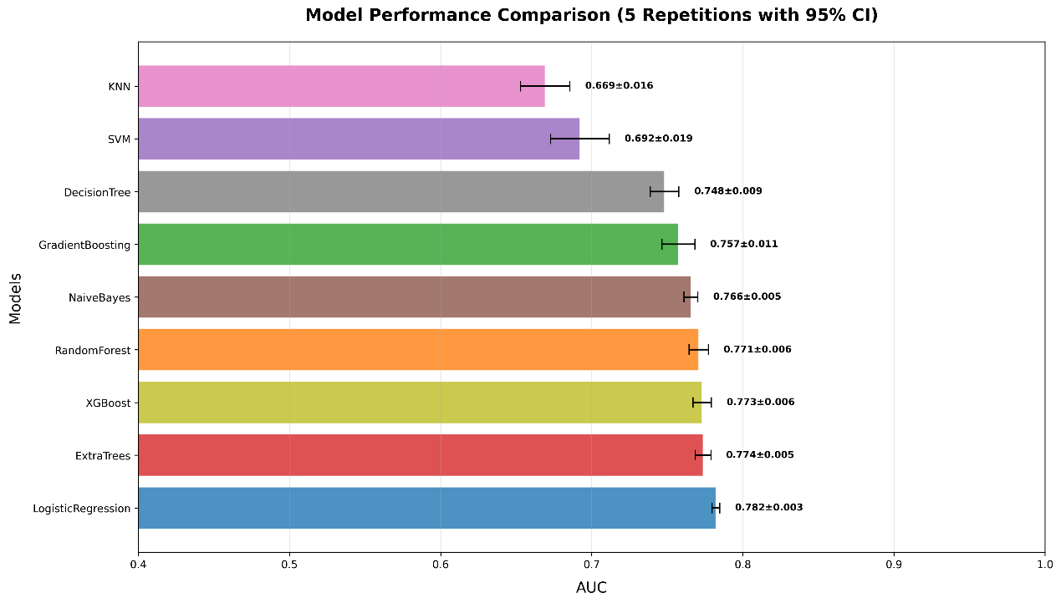
Figure S7 Legend
Bar plot depicting the training-set AUC performance (mean ± standard deviation, 95% confidence intervals) of 9 predictive models (including KNN, SVM, and Logistic Regression) across 5 independent repetitions; AUC values range from 0.669 (KNN) to 0.782 (Logistic Regression)
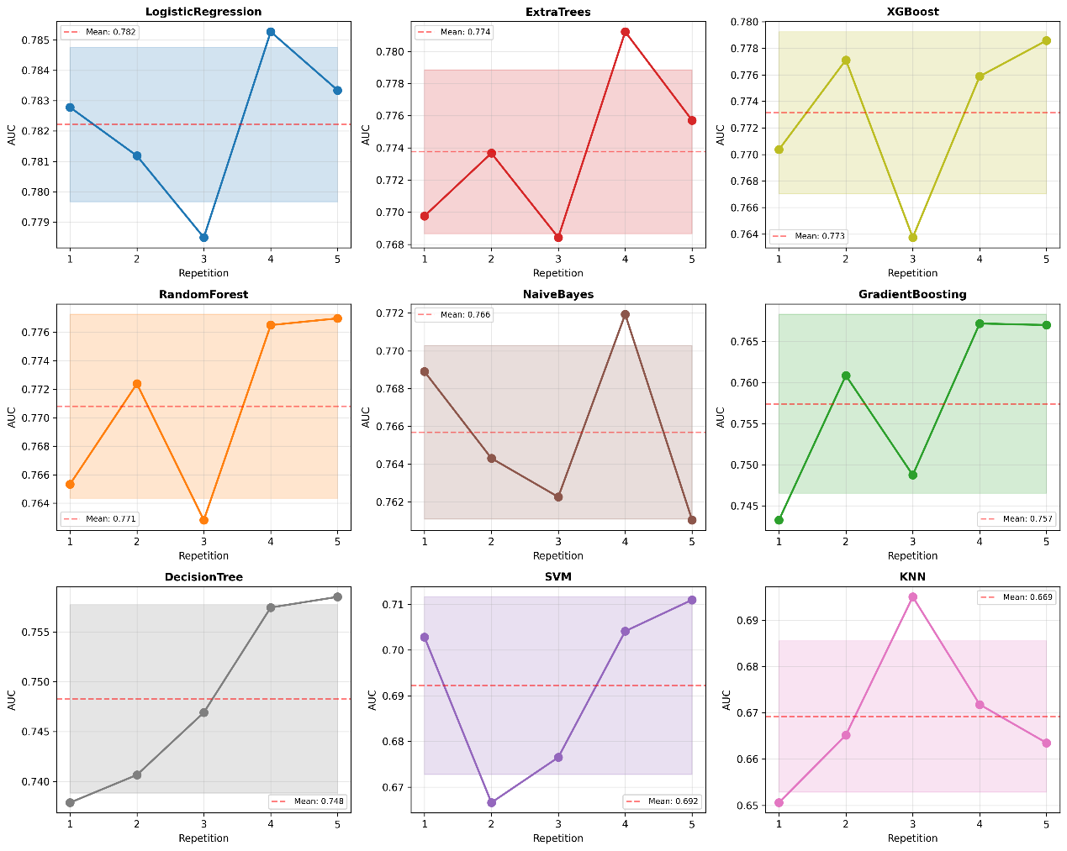
Figure S8 Legend
Line plots showing AUC values for each predictive model across 5 independent training repetitions on the training dataset, depicting per-repetition AUC variation.

