Methods
In vitro cell culture
Peripheral blood mononuclear cells (PBMCs) were isolated from a healthy donor's buffy coat (Transfusion and Tissue Department University Hospital Brno) using Histopaque-1077 (Merck, 10771) according to the manufacturer’s manual. Isolated PBMCs were cultured in complete OpTmizer medium (Gibco, A1048501) supplemented with 10% FBS (Gibco, A1048501), 1% L-glutamine (Biosera, XC-T1715/100), 1% Penicilin-Streptomycin (Biosera, XC-A4122/100), and 2 ng/mL IL-2 (Merck, SRP3085-50UG) at 37 °C in humidified atmosphere with 5% CO₂.
BCCs SK-BR-3 were obtained from the American Type Culture Collection (ATTC). Prior to use, the cell line was authenticated and the cell identity was confirmed (STR loci amplification PowerPlex® 16 HS System, Promega; fragment analysis was done on an ABI3730xl, Life Technologies; data were analyzed with GeneMarker HID. Software, Softgenetics). SK-BR-3 cells were maintained in Dulbecco’s Modified Eagle Medium High Glucose (Biosera, LM-D1111/500) supplemented with 10% FBS, and 1% Penicilin-Streptomycin at 37 °C in humidified atmosphere with 5% CO₂.
For co-culture experiments cancer cells were seeded and cultured for 24 h until fully adhered. Activated PBMCs (4 µg/mL Phytohemagglutinin (Merck, L2646); 24 h) were added to cancer cell culture in ratio 2:1. Co-cultures were treated with ERS modulators: TUDCA (Merck, 580549-5GM), tunicamycin (Tun; Merck, T7765), or their combination. For TUDCA the working concentration used was 1 mM, for Tun treatment, the working concentration used was 0.5 μM. These treatments were combined with targeted anti-cancer therapy in vitro: anti-HER2 monoclonal antibody Herceptin (Her; trastuzumabum; Roche, EU/1/00/145/002) and anti-PD-L1 monoclonal antibody Tecentriq (Tec; atezolizumabum; Roche, EU/1/17/1220/001). The used working concentration for Her was 20 µg/mL and for Tec 10 µg/mL.
Cell viability assay
Cell metabolic activity was assessed using colorimetric MTT assay. Cancer cells were seeded at 1500 cells/well in technical triplicates in 96-well plates and cultured for 24 h until fully adhered. Subsequently, activated PBMCs were added in a final volume of 200 µL. Cells were treated as listed in Co-culture experiments. Viability/metabolic activity assessment was performed using MTT Reagent 3-(4,5-Dimethylthiazol-2-yl)-2,5-Diphenyltetrazolium Bromide (Merck, M2128-1G) at concentration of 0.5 mg/mL directly to the culture media for 3 h. Actively respiring cells convert the water-soluble MTT to an insoluble formazan. The formazan was then solubilized using DMSO (Serva, 2038502) and its concentration was determined by absorbance measurement at 595 nm using a microplate reader Infinite M1000 PRO (Tecan).
Scratch wound healing assay
Cell migration was assessed using a scratch wound assay. SK-BR-3 cells were seeded on an IncuCyte Imagelock 96-Well Microplate (Sartorius, BA-04857) at density 80,000 cells/well in technical tetraplicates and allowed to grow to 90% confluence. Then, a scratch was mechanically performed using IncuCyte 96-Well Woundmaker Tool (Sartorius, BA-04858). After scratching, the wells were washed with PBS and cells were treated as listed in Co-culture experiments and PBMCs were added. PBMCs were pre-stained using CellTracker Deep Red Dye (ThermoFisher Scientific, C34565) according to the manufacturer’s manual. Cell co-cultures were placed into live-cell imaging system IncuCyte (Sartorius, Germany) and imaged at 4 × magnification once per hour for 24 h.
RT-qPCR
Total RNA was isolated using phenol-chloroform isolation (RNA blue (TopBio, R013), 1-Bromo-3-Chloropropane (Merck, B9673), Isopropanol, 75% Ethanol, PCR H₂O). RNA samples were transcribed into cDNA using the High Capacity cDNA Reverse transcription Kit (Thermo Fisher Scientific, 4368814). The amplification reactions were carried out in a final volume of 10 µL using Luna Universal qPCR Master Mix (New England Biolabs, M3003X). All reactions were performed in technical triplicates and change in gene expression was calculated using the comparative threshold cycle 2^{−ΔΔCT} method with ACTB as a housekeeping gene. The amplifications were performed on LightCycler Instrument QuantStudio 5 (Applied Biosystems). All primers were synthesized by Generi Biotech.
SDS-PAGE and Western blotting
For western blot analysis, cell lysates were harvested into 100 µL of NET buffer (150M NaCl, 1% NP-40, 50 mM Tris pH 8.0, 50 mM NaF, 5 mM EDTA pH 8.0, in 100 ml H₂O). Following protein quantification using Bradford Assay (Bio-Rad, 5000006), lysates were stabilized in CSB medium (Glycerol, 1 M Tris pH 6.8, Bromphenol Blue, 1 M Tris pH 6.8, SDS, β-merkaptoethanol) and incubated at 95 °C for 10 min. 10 µg of proteins were loaded to 10% polyacrylamide gel, and resolved by SDS-PAGE, following electrotransfer onto PVDF membrane Immobilon-P (Merck, IPVH00010). Membranes were blocked with 5% BSA (Serva, cat. n. 11930.04), and incubated with primary antibodies overnight (Suppl. Table 1). Protein containing membranes were washed with 0.1% Tween-20 solution, incubated with HRP-conjugated secondary antibodies (Suppl. Table 1), washed, and ECL reagent (Cytiva, GERPN2106) was applied to enhance signal visualization. Signal was detected using G:BOX (Syngene). β-Actin was used as a loading control.
Immunofluorescence staining of in vitro co-cultures
For immunofluorescence staining, cells were seeded on 8 Well Chamber (Ibidi, 80841) and treated as listed in Co-culture experiments. Following the experiment, cells were fixed with 4% paraformaldehyde (PFA; Carl Roth, R67334). Triton 0.1% solution was used to permeabilize cells and 3% BSA solution for saturating excess protein-binding sites. Cells were stained with primary and secondary antibodies. For visualization of actin filaments, cells were stained with AlexaFluor® 647 conjugated Phalloidin. Cell nuclei were counterstained with DAPI (4′,6-Diamidino-2-phenylindole dihydrochloride; Suppl. Table 2). Stained cells were mounted in Roti-Mount FluorCare (Carl Roth, R.HP19.1). Images were acquired using Eclipse Ti-E microscope (Nikon) with a 20× magnification.
Patient enrollment and assessment of clinical outcomes
Retrospective patient-based analyses were conducted using tumor tissue and intraoperative serum samples from adult patients with HER2-positive BC treated with anti-HER2 therapy in combination with chemotherapy. All treatment procedures were performed according to institutional standards of care and in alignment with the relevant international guidelines. The study was approved by the Institutional Ethical Committee of MMCI (approval No. 2022/1680/MOU), and all participants provided informed consent for the use of their data for research purposes. In addition, a control cohort (CTR) consisting of 15 serum samples from healthy female donors (median age 60 years) was included for MALDI-TOF MS analysis.
Patients were stratified according to the occurrence of early failure, defined as recurrence or death within 36 months from the initiation of anti-HER2 therapy, to patients with early failure (EF) and patients without early failure (non-EF). Event-free survival (EFS) was defined as the time from the initiation of anti-HER2 therapy to the first documented recurrence or death from any cause. Overall survival (OS) was defined as the time from diagnosis to death from any cause. Patients alive at the time of analysis were censored at the date of last follow-up. Survival probabilities for OS and EFS were calculated using the Kaplan-Meier method and compared using the log-rank test.
Histological tissue slide preparation, tumor tissue Immunofluorescence staining and microscopy
Formalin-Fixed Paraffin-Embedded (FFPE) tumor tissue samples from patients with HER2-positive BC were processed into 5-μm-thick transverse sections. Sections were placed at 56 °C overnight, followed by deparaffinization and rehydration using xylene and ethanol. Antigen retrieval was performed using Dako Tris/EDTA pH9 buffer (Agilent Technologies, S2367) at 98 °C for 30 min, followed by 30 min cooling at room temperature. Sections were incubated with 10% BSA. Sections were incubated overnight at 4 °C in primary antibodies diluted in 0.05% Tween-20/PBS solution. After thorough washing in PBS, sections were incubated with the secondary antibodies diluted in 0.05% Tween-20 solution for 2 h protected from light, followed by DAPI counterstaining for 5 min in the dark. Tumor tissue sections were mounted using Roti-Mount FluorCare. Staining was imaged with AxioImager.Z2 (Zeiss), at 40× magnification. Images obtained from patient-driven samples, containing separate channels for individual signals, were exported as 16-bit jpeg files and processed for image analysis.
Matrix-assisted laser desorption/ionization time-of-flight mass spectrometry MALDI-TOF MS Serum analysis
MALDI-TOF MS sample preparation and analysis: Trifluoroacetic acid (TFA), Sinapic acid (SA), Ferulic acid (FA), trifluoroacetic acid (TFA), and Acetonitrile (ACN), were purchased from either Sigma-Aldrich (Steinheim, Germany) or Penta (Prague, Czech Republic). MALDI MS calibration mixture ProMix1 was purchased from LaserBio Labs (Valbonne, France). The protein extraction protocol is based on a previously published procedure [1, 2]. Briefly, proteins from human serum (25 μL) were extracted in 50 μL of ACN using an ultrasonication bath (15 min, 25 °C). Following a 5 min centrifugation at 14,500 rpm, the organic layer was removed, and 50 μL of 50% ACN supplemented with 0.1% TFA was added to the protein pellet. After 15 min of ultrasonication and 5 min of centrifugation, the protein extract (supernatant) was collected. Finally, the extract was mixed with SA-FA matrix (1:1, v/v). 20 mg SA and 6.6 mg of FA were dissolved in 1 mL of matrix solvent (50% ACN with 2.5% TFA). Five technical replicates of each sample (2 μL) were spotted on MALDI metal target plate as described previously [3]. MALDI-TOF MS measurements were conducted on a MALDI-7090™ MALDI TOF-TOF mass spectrometer (Shimadzu, Japan) with a 2 kHz ultra-fast solid-state UV laser (Nd-YAG: 355 nm). Mass spectra were acquired in the linear positive ion mode in the mass range of 2–20 kDa; pulse extraction 12.5 kDa; 1 kHz, 100 μm. Each spectrum was averaged from 5 profiles of 1000 shots and externally calibrated with ProMix1 (2.8–17 kDa) with a mass error of ± 200 mDa. Subsequently, the mass spectra were then subjected to pre-processing and multivariate statistical analysis using an in-house R script, as previously described [4]. The final data matrix consists of 44 features (detected m/z signals) and 36 samples (15 CTR, 9 EF, 12 non-EF). The conditions for MALDI-TOF MS measurement were systematically optimized for peripheral blood serum by selecting the optimal matrix composition, laser energy, and sample volume in order to achieve the highest possible robustness (data not shown). Samples were obtained by Biobank at Masaryk Memorial Cancer Institute, a coordinator of LRI BBMRI.cz; supported by the project BBMRI.cz no. LM2023033.
Statistical analyses
The experimental data were statistically processed using R statistical software version 4.3.1 (R Core Team, 2023) (https://www.r-project.org). All experiments were conducted in at least three biological replicates.
Cell viability assay, Scratch wound healing assay, RT-qPCR: Prior to statistical analyses, outliers were detected using a robust z-score method (threshold |z| > 3.5) and excluded from further comparisons. Pairwise comparisons between groups were performed using Dunn’s test. Raw p-values were subsequently adjusted for multiple comparisons using the false discovery rate (FDR) method (Benjamini–Hochberg procedure).
Immunofluorescence staining of in vitro co-cultures: For each sample, images acquired in up to four fluorescence channels (cell nuclei referred as DAPI and three evaluated signals) were loaded, converted to grayscale, and normalized.
Cell segmentation was performed using the DAPI channel as a nuclear marker. To remove background noise and improve contrast, images were smoothed by convolution with a circular brush filter, followed by background correction through subtraction of the filtered image. A global threshold was derived from the mean intensity and standard deviations, and binary masks were refined using morphological operations (opening and hull filling). Unusual objects with a small area were removed to exclude artifacts. For other channels, analogous preprocessing was applied only with a different threshold factor and exclusion of artifacts.
Masks from all fluorescence channels were combined to estimate the overall tissue area, followed by segmentation using the propagate function to delineate individual cells within the tissue mask. Each cell was then characterized by the occurrence and intensity of the signal in the evaluated channels. Subsequently, the images were characterized by two attributes: (1) Occurrence, defined as the proportion of cells with the detected signal relative to all cells within the frame, and within specific environments (e.g., immune cells) as the proportion of cells restricted to the corresponding area; and (2) Relative intensity, defined as the ratio of the average intensity of the evaluated signal to the average intensity of the reference signal (cell nuclei). From each sample, at least 10 images were acquiredand combined into a single composite image object, which was then analyzed using standard methods. Based on immunofluorescence labeling, the number and type of TILs, and ERS levels in TIME were evaluated. The Mann–Whitney test and Fisher’s exact test were used to assess the statistical significance of differences between groups. All data processing and statistical analyses of clinical samples were conducted using R. Specifically, functions from the EBImage library [5] were utilized for image data analysis and the calculation of derived attributes.
For cell viability assay, scratch wound healing assay, RT-qPCR, MALDI-TOF MS, and immunofluorescence staining of in vitro co-cultures significance threshold was set as follow: (*p<0.05, **p<0.01, ***p<0.001). P-values are reported both with () and without () FDR correction due to the exploratory nature of the study, the limited sample size, and to allow balanced interpretation of statistical and biological relevance.
Tumor tissue Immunofluorescence: The statistical evaluation described in section “Immunofluorescence staining of in vitro co-cultures” was further applied for tumor tissue. 20 images were performed for biological replication.
MALDI-TOF MS Serum analysis: Unsupervised Principal Component Analysis (PCA) and the supervised Partial Least Squares – Discrimination Analysis (PLS-DA) and Orthogonal PLS-DA (OPLS-DA) were conducted using R. Score plots of the first and second components are shown. (O)PLS-DA separates samples based on the known classes and can be used for prediction. The number of orthogonal components was optimized based on the R2Y (goodness-of-fit), Q2Y (model predictability via cross-validation), and RMSEE (Root Mean Squared Error of Estimation). To classify samples into clinical groups, five supervised Machine Learning (ML) algorithms were applied: Decision Tree (DT), Random Forest (RF), k-Nearest Neighbors (k-NN), PLS-DA, and Artificial Neural Network (ANN) algorithms tuned by applying a 5×repeated 5-fold leave-one-out Cross-Validation (CV). Acccuracy of ML models is accompanied by 95% Wilson confidence intervals (CI). Overfitting was evaluated through variable reduction using the non-parametric Wilcoxon rank-sum test and permutation test (100 iterations with randomized class labels). For individual m/z variables, statistical significance was calculated using the Wilcoxon test.

Antibody | Mol. Weight of Protein | Host animal | Manufacturer, cat. no. | Dilution
β-Actin | 45 kDa | Mouse | Cell Signaling Technology (CST), #3700S | 1:10000ª
BiP | 78 kDa | Rabbit | CST, #3177S | 1:1000ª
CHOP | 27 kDa | Mouse | CST, #2895S | 1.500ª
PERK | 140 kDa | Rabbit | CST, #3192S | 1:1000ª
XBP1s | 60 kDa | Rabbit | CST, #40435S | 1:500ª
IRE1α | 130 kDa | Rabbit | CST, #3294S | 1:1000ª
TUSC3 | 40 kDa | Rabbit | Abcam, ab230520 | 1:500ª
FOXP3 | 45 kDa | Rabbit | CST, #12632S | 1:1000ª
CD3ε | 23 kDa | Rabbit | CST, #85061S | 1:1000ª
CD4 | 55 kDa | Rabbit | Zeta, Z2420RL | 1:1000ª
CD8α | 29 kDa | Rabbit | CST, #85336S | 1:1000ª
CD28 | 25 kDa | Rabbit | Abcam, ab243228 | 1:200ª
PD-1 | 52-65 kDa | Rabbit | CST, #86163S | 1:500ª
PD-L1 | 40-50 kDa | Rabbit | CST, #13684S | 1:500ª
HER2 | 185 kDa | Rabbit | CST, #2165S | 1:500ª
Anti-mouse IgG, HRP-linked Antibody |  | Horse | CST, #7076S | 1:3000^{b}
Anti-rabbit IgG, HRP-linked Antibody |  | Goat | CST, #7074S | 1:3000^{b}

Suppl. Table 1.: Antibodies for Western Blot; ª primary antibodies diluted in 5 % BSA in PBS + 0.1 % Tween 20; ^{b} secondary antibodies diluted in 5 % milk in PBS + 0.1 % Tween 20

Antibody | Host animal | Manufacturer, cat. no. | Dilution
BiP | Rabbit | CST, #3177S | 1:500
CHOP | Mouse | Sony, 5343510 | 1:200
CD3 | Rat | Biorad, MCA1477 | 1:500
CD4 | Rabbit | Zeta, Z2420RL | 1:500
CD8 | Mouse | Biorad, MCA1817 | 1:500
Phalloidin |  | Abcam, ab176761 | 1:2000
DAPI |  | Merck, MBD0015 | 1:1000
Anti-rabbit IgG (H+L) Highly Cross-Adsorbed Secondary Antibody, Alexa Fluor 488 | Goat | Invitrogen, A11034 | 1:2000
Anti-Mouse IgG (H+L) Cross-Adsorbed Secondary Antibody, Alexa Fluor 568 | Goat | Invitrogen, A11004 | 1:2000
Anti-Rat IgG (H+L) Highly Cross-Adsorbed Secondary Antibody, Alexa Fluor 647 | Donkey | Invitrogen, A48272 | 1:2000

Suppl. Table 2.: Antibodies for Immunofluorescence staining; for in vitro cultures diluted in 3 % BSA + PBS; for tissue samples diluted in PBS + 0.05 % Tween 20; DAPI diluted in PBS
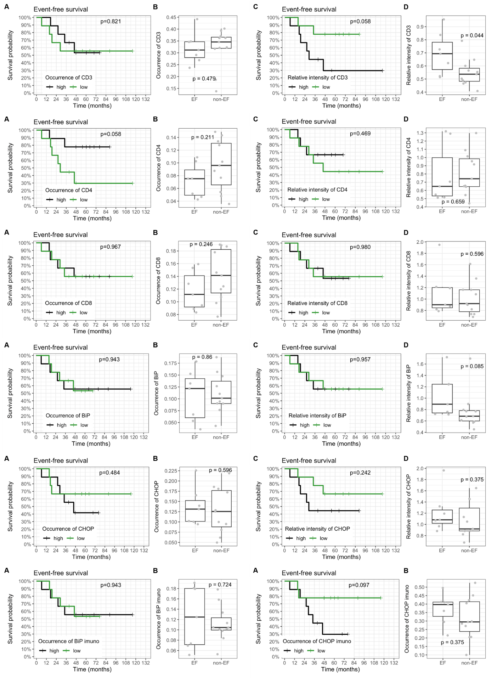
Suppl. Figure 1: Image-based analysis of UPR- and immune-related markers in HER2-positive BC tumor tissues.
Tumor sections were stained using immunofluorescence for BiP, CHOP, CD3, CD4, and CD8, and analyzed by automated cell segmentation and quantitative image processing. Two image-derived parameters were evaluated: occurrence (proportion of positive cells) and relative intensity (signal intensity ratio to nuclei). Both relative intensity and occurrence are relevant for UPR markers evaluation, whereas in terms of immune infiltration only signal occurrence is conclusive. BiP immuno and CHOP immuno (the last row of graphs) indicate occurrence of BiP and CHOP in the vicinity of CD3+ TILs, reflecting UPR activity within T-cell–rich regions.
(A) Kaplan–Meier curves showing EFS according to marker occurrence.
(B) Quantified occurrence of BiP, CHOP, and immune markers across patient subgroups (EF, non-EF).
(C) Kaplan–Meier curves for EFS based on relative intensity.
(D) Quantified relative intensity of evaluated markers in EF and non-EF groups.

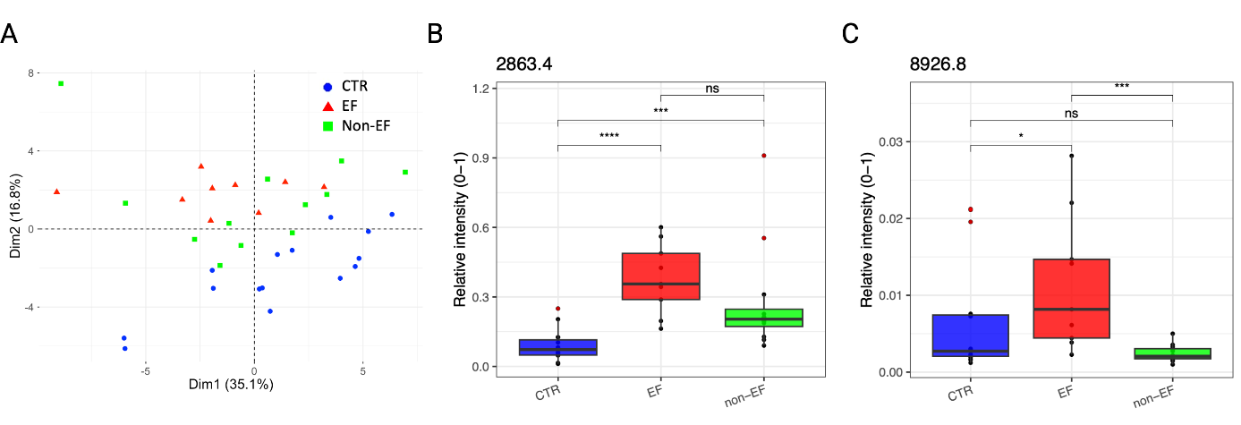
Suppl. Figure 2:
(A) PCA score plot of evaluated samples.
(B, C) Relative intensity of the two most important signals (2863.4 Da and 8926.8 Da) contributing to the RF-based model. Significant differences are shown between CTR, EF, and non-EF groups.

List of abbreviations
ACN Acetonitrile
ANN Artificial Neural Network
ATF4 Activation Transcription Factor 4
ATF6 Activation Transcription Factor 6
BC Breast Cancer
BCCs Breast Cancer Cells
BIP Binding Immunoglobuline Protein
CD Cluster of Differentiation
CHOP C/EBP Homologous Protein
CSB Complete Sample Buffer
CTLA-4 Cytotoxic T lymphocyte-associated protein-4
CTR Control
CV Cross-validation
DAPI 4′,6-Diamidino-2-phenylindole dihydrochloride
DCs Dendritic Cells
DMSO Dimethyl Sulfoxide
DT Decision TreeECM
EM Extracellular Matrix
EF patients with early failure
EFS Event-free survival
EMT Epithelial to Mesenchymal Transition
ER Estrogen Receptor
ERS Endoplasmic Reticulum Stress
FA Ferulic Acid
FDR False Discovery Rate
FFPE Formalin-Fixed Paraffin-Embedded
FOXP3 Forkhead Box P3
Her Herceptin
HER2 Human Epidermal Growth Factor Receptor 2
ICI Immune Checkpoint Inhibitor
IFNγ Interferon Gamma
IRE1α Inositol-Requiring Enzyme 1 α
k-NN k-Nearest Neighbors
MALDI-TOF MS Matrix-Assisted Laser Desorption/Ionization – Time-of-Flight Mass Spectrometry
MDSCs Myeloid-Derived Suppressor Cells
MMCI Masaryk Memorial Cancer Institute
ML Machine Learning
Non-EF Patients without early failure
OS Overall Survival
(O)PLS-DA Orthogonal Partial Least Square – Discrimination Analysis
PBMCs Peripheral Blood Mononuclear Cells
PCA Principal Component Analysis
PD-1 Programmed Death 1
PD-L1 Programmed Death-Ligand 1
PERK Protein Kinase R-like ER Kinase
PFA Paraformaldehyde
PR Progesterone Receptor
PVDF Polyvinylidene Difluoride
RF Random Forest
RIDd Regulated IRE1 Dependent Decay
ROS Reactive Oxygen Species
SA Sinapic Acid
SD Standard Deviation
Tec Tecentriq
TERS Transmissible Endoplasmic Reticulum Stress
TFA Trifluoroacetic Acid
TILs Tumor Infiltrating Lymphocytes
TIME Tumor Immune Microenvironment
TNBC Triple Negative Breast Cancer
Tregs Regulatory T cells
TUDCA Tauroursodeoxycholic Acid
Tun Tunicamycin
UPR Unfolded Protein Response
XBP1 X-box Binding Protein 1

Supplementary references
1. Pecinka, L., et al., Improved Screening of Monoclonal Gammopathy Patients by MALDI-TOF Mass Spectrometry. J Am Soc Mass Spectrom, 2023. 34(12): p. 2646-2653.
2. Vlachova, M., et al., Liquid biopsy of peripheral blood using mass spectrometry detects primary extramedullary disease in multiple myeloma patients. Sci Rep, 2024. 14(1): p. 18777.
3. Mandal, G., et al., Matrix enrichment by black phosphorus improves ionization and reproducibility of mass spectrometry of intact cells, peptides, and amino acids. Sci Rep, 2022. 12(1): p. 1175.
4. Pecinka, L., et al., Intact cell mass spectrometry coupled with machine learning reveals minute changes induced by single gene silencing. Heliyon, 2024. 10(9): p. e29936.
5. Pau, G., et al., EBImage--an R package for image processing with applications to cellular phenotypes. Bioinformatics, 2010. 26(7): p. 979-81.

