Cu-Fe Oxide Nanozymes with Enhanced Peroxidase-like Activity for Sensitive H₂O₂ Colorimetric Detection
Pengfei Jiang^{1, #}, Yifan Hao^{1, #}, Mingxi Jia², Cun Liu^{1,*}

¹College of Chemistry and Chemical Engineering, Xinjiang Agricultural University, 311 East Nongda Road, Urumqi 830052, China.
²College of Food Science and Pharmacy, Xinjiang Agricultural University, China. 311 East Nongda Road, Urumqi 830052, China.

# These authors contributed equally to this work.

* Corresponding Author
*E-mail: liucun0910@163.com
Fig. S1. SEM images of (a) Cu₂FeO_{x} (b) CuFeO_{x} (c) CuFe₂O_{x}.

Fig. S2. Energy-dispersive X-ray (EDX) spectroscopy of (a, b) Cu₂FeO_{x}, (c, d) CuFeO_{x}, (e, f) CuFe₂O_{x}.

Fig. S3. UV-Vis absorption spectra of TMB oxides in the presence and absence of CuFeO_{x}, Cu_{x}O, and Fe₂O₃.

Fig. S4. Effect of Cu-Fe oxide nanozyme dosage on the catalytic oxidation of TMB for H₂O₂ detection. (a) UV-Vis absorption spectra obtained at different Cu-Fe oxide nanozyme dosages. (b) Comparison of the absorbance at 652 nm extracted from the spectra in (a).

Fig. S5. Effect of solution pH on the catalytic oxidation of TMB for H₂O₂ detection. (a) UV-Vis absorption spectra obtained at different pH values. (b) Comparison of the absorbance at 652 nm extracted from the spectra in (a).

Fig. S6. Effect of reaction temperature on the catalytic oxidation of TMB for H₂O₂ detection. (a) UV-Vis absorption spectra obtained at different temperatures. (b) Comparison of the absorbance at 652 nm extracted from the spectra in (a).

Fig. S7. (a) UV-Vis absorption spectra obtained at various H₂O₂ concentrations for Cu_{x}O. (b) Corresponding absorbance values at 652 nm as a function of H₂O₂ concentration, with the linear fitting curves shown as insets.

Fig. S8. (a) UV-Vis absorption spectra obtained at various H₂O₂ concentrations for Fe₂O₃. (b) Corresponding absorbance values at 652 nm as a function of H₂O₂ concentration, with the linear fitting curves shown as insets.

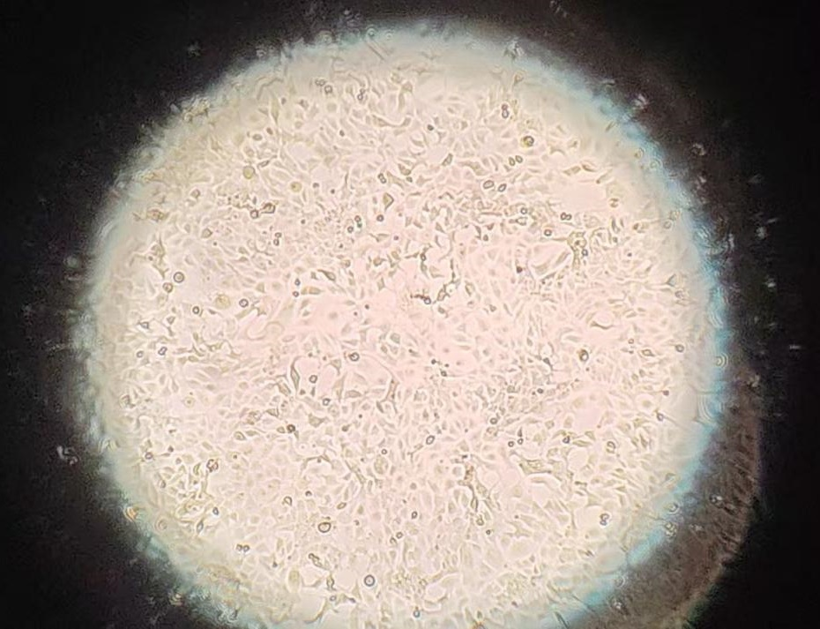
Fig. S9. Light microscopic observation of HCC827 cell.

Fig. S10. UV-Vis absorption spectra of Cu₂FeO_{x} in two systems: “nanozyme + TMB + standard H₂O₂” system and “nanozyme + TMB + AA-stimulated HCC827 cell” system.

Table S1. ICP-OES data of Cu-Fe oxides with different molar ratios.

Sample | Test components | Sample element content  W (%) | Cu : Fe  molar ratio
Cu₂FeO_{x} | Cu | 51.8824 | 1.96 : 1
Cu₂FeO_{x} | Fe | 23.2633 | 1.96 : 1
CuFeO_{x} | Cu | 41.2708 | 1.03 : 1
CuFeO_{x} | Fe | 35.2516 | 1.03 : 1
CuFe₂O_{x} | Cu | 23.6357 | 0.52 : 1
CuFe₂O_{x} | Fe | 40.3440 | 0.52 : 1

Table S2. Comparison of enzymatic kinetic parameters for three Cu-Fe oxide nanozymes.

Sample | K_{m} (mM) | V_{max}*10⁻⁸ (Ms⁻¹)
Cu₂FeO_{x} | 1.85401 | 1.08055
CuFeO_{x} | 2.28712 | 0.99709
CuFe₂O_{x} | 1.93308 | 1.04619

Table S3. Analytical parameters of H₂O₂ detection in previous papers

Materials | Linear range | LOD | references
TreHOAuC | 0-20 μM | 0.5 μM | [1]
CdV₂O₆ nanorods | 50-100 μM | 36.5 μM | [2]
Fe₃O₄ @COFs | 0.1-4 mM | 2.6 μM | [3]
InCe_{x} | 10–100 mM | 5 mM | [4]
CuBTC@PW₁₂ | 0.01-1.0 mM | 2.67μM | [5]
Fe_{1.5}-N-GDY | 100-800 μM | 52.96 μM | [6]
Cu₂O–CuO/O–g-C₃N₄ | 2.5–250 µM | 1 µM | [7]
FeS_{x}/SiO₂ | 1.0 μM-100 μM | 0.2 μM | [8]
AuNCs/Fe-MIL | 5-1000 μM | 2.78 μM | [9]
Cu₂FeO_{x} | 10-200μM | 0.572 μM | This work
CuFeO_{x} | 10-200μM | 0.636 μM | This work
CuFe₂O_{x} | 10-200μM | 0.591 μM | This work

References
[1] Y. Liu, F. Wang, Y. Liu, L. Cao, H. Hu, X. Yao, J. Zheng, H. Liu, A label-free plasmonic nanosensor driven by horseradish peroxidase-assisted tetramethylbenzidine redox catalysis for colorimetric sensing H₂O₂ and cholesterol, Sensors and Actuators B: Chemical, 389 (2023) 133893. https:/doi.org/10.1016/j.snb.2023.133893
[2] Y. Liu, P. Hao, L. Wang, G. Li, G. Fan, T. Wu, X. Zhu, Q. Liu, N,N-dicarboxymethyl Perylene-diimide-modified CdV₂O₆ Nanorods for Colorimetric Sensing of H₂O₂ and Pyrogallol, Microchimica Acta, 190 (2023) 270. https://doi.org/10.1007/s00604-023-05846-4
[3] L. Tian, B. Zhao, J. Zhang, X. Luo, F. Wu, Magnetic covalent organic framework nanospheres with enhanced peroxidase-like activity for colorimetric detection of H₂O₂ and glucose, Colloids and Surfaces A: Physicochemical and Engineering Aspects, 666 (2023) 131309. https:/doi.org/10.1016/j.colsurfa.2023.131309
[4] B. Liu, H. Ruan, C. Li, J. Yao, B. Wei, L. Wang, S. Ban, J. Xie, Ce-doped indium oxide nanozymes with peroxidase-like activity induced by cerium–indium synergy for colourimetric detection of H₂O₂, New Journal of Chemistry, 47 (2023) 18476-18484. https://doi.org/10.1039/D3NJ02985A
[5] W. Song, P. Sun, J. Zhou, X. Han, Q. Dai, F. Chai, The fabrication of CuBTC@PW₁₂ with prominent peroxidase-mimicking activity for colorimetric detection of H₂O₂ and ascorbic acid via “on–off” switch, New Journal of Chemistry, 47 (2023) 15721-15730. https://doi.org/10.1039/D3NJ02611F
[6] J. Liu, X. Guo, H. Huang, R. Cui, D. Wang, Y. Chen, Y. Chai, J. Dong, B. Sun, Y. Lian, Enhanced Peroxidase-like Activity of Graphdiyne-Based Nanozymes by Fe and N Codoping for Colorimetric Determination of H₂O₂ and Ascorbic Acid, ACS Applied Nano Materials, 6 (2023) 22142-22151. https://doi.org/10.1021/acsanm.3c04348
[7] S. Mullakkattuthodi, B.N. Narayanan, Mesoporous Cu₂O–CuO/O–g-C₃N₄ nanocomposite with enhanced peroxidase-like activity for the colorimetric H₂O₂ sensing, Research on Chemical Intermediates, 50 (2024) 4025-4047. https://doi.org/10.1007/s11164-024-05333-2
[8] C. Gu, L. Bai, T. Hou, L. Zhang, P. Gai, F. Li, Dual-mode colorimetric and homogeneous electrochemical detection of intracellular/extracellular H₂O₂ based on FeS_{x}/SiO₂ nanoparticles with high peroxidase-like activity, Analytica Chimica Acta, 1265 (2023) 341332. https:/doi.org/10.1016/j.aca.2023.341332
[9] Y.-S. Li, Q.-Y. Lv, Z.-D. Ding, X. Song, J. Chen, H.-F. Cui, Luminescent gold nanoclusters loaded on iron metal–organic framework with enhanced peroxidase-like activity for the colorimetric/fluorescent determination of H₂O₂, Microchemical Journal, 201 (2024) 110675. https:/doi.org/10.1016/j.microc.2024.110675

