Supplementary Information
- Supplementary Table S1. Geochemical analysis of cobalt-decorated areas (EDXRF).
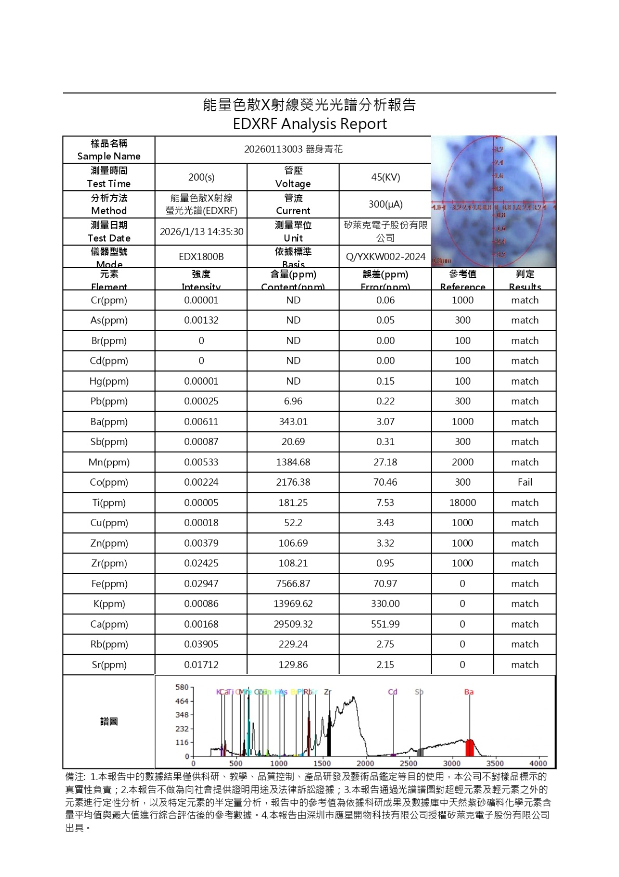
- Supplementary Table S2. Geochemical analysis of the ceramic body at the foot ring (EDXRF).
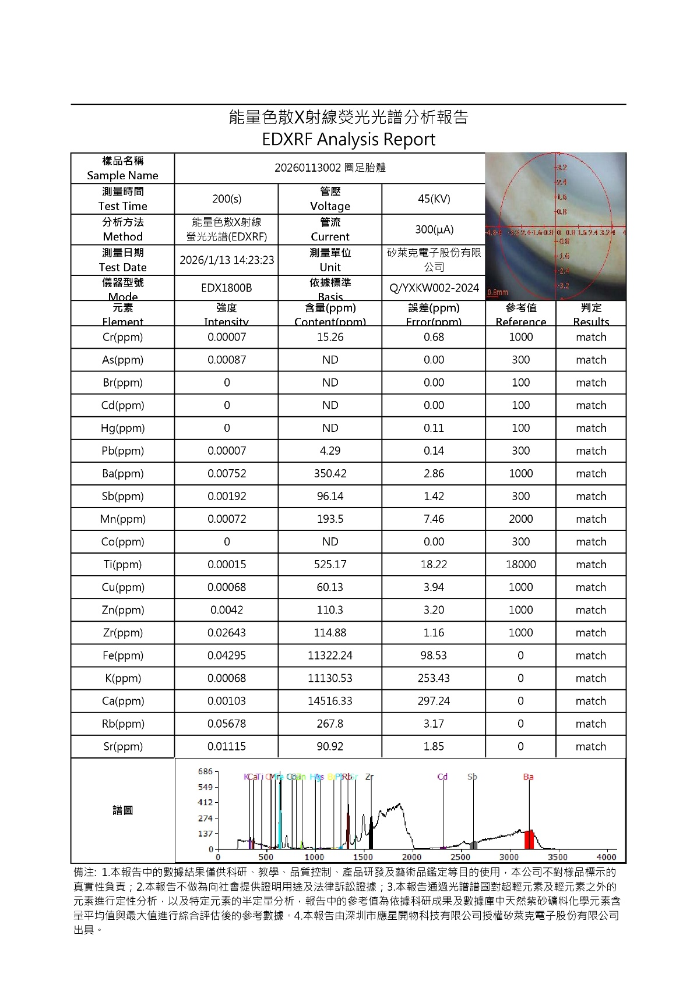

- Supplementary Table S3. Geochemical analysis of the base white glaze (EDXRF).
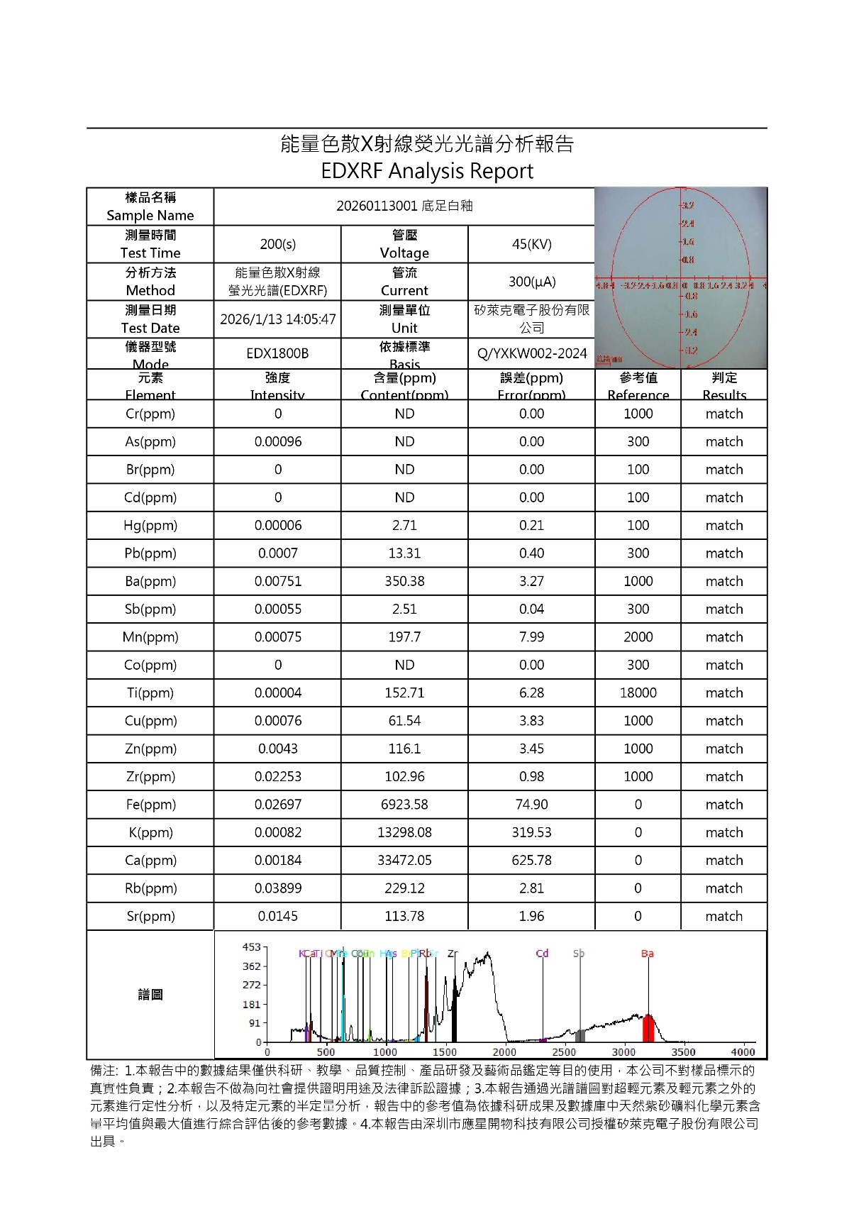

- Supplementary Fig. S1. Sub-glaze bubble distribution and boundary softening in the glaze.
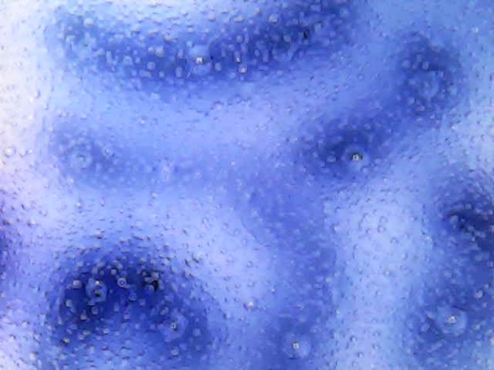
- Supplementary Fig. S2. Pigment–glaze interaction features and localized subsidence.
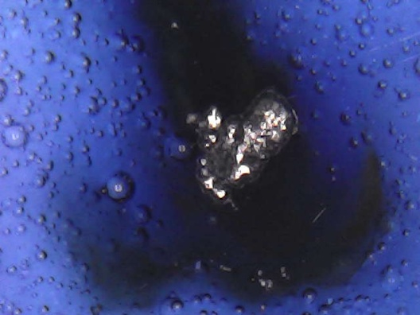
- Supplementary Fig. S3. Macroscopic views of the vessel (overall, rim, and base).
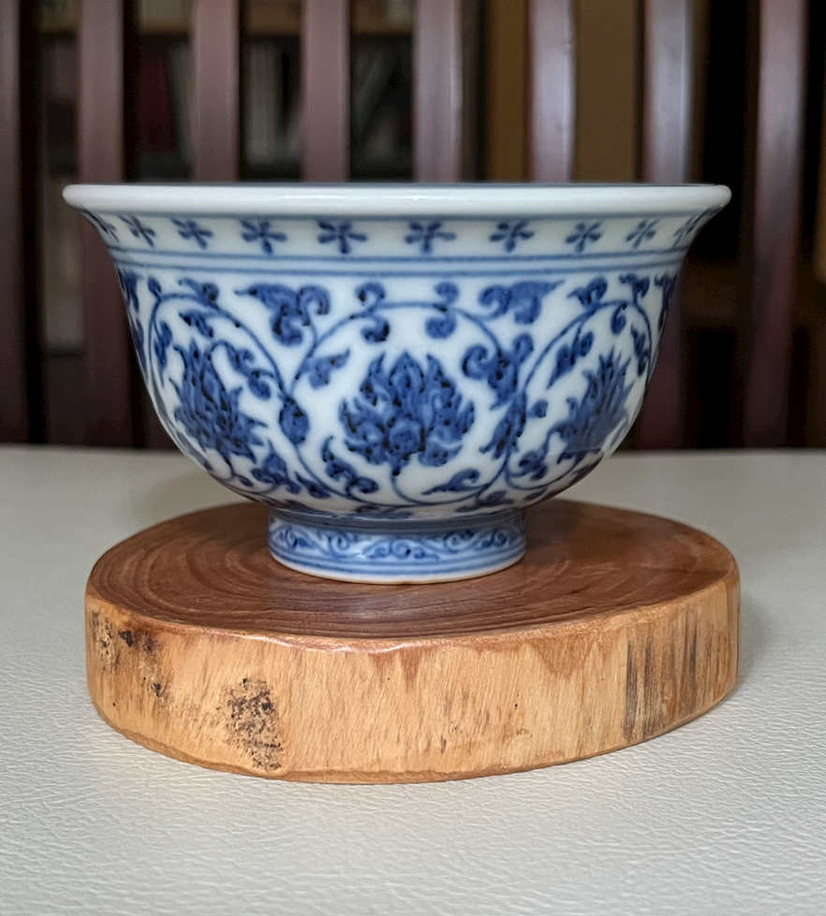 | 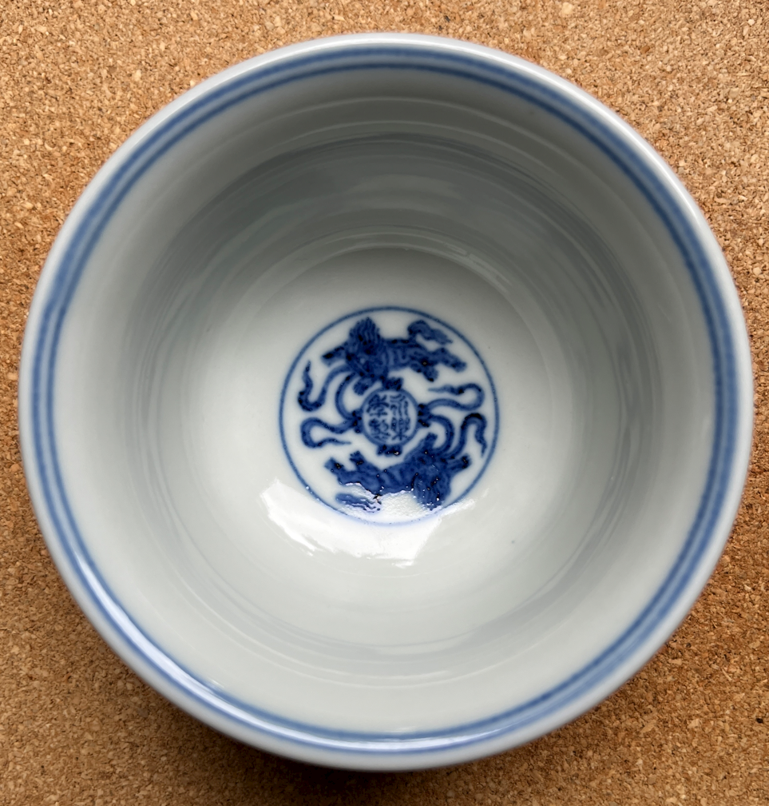 | 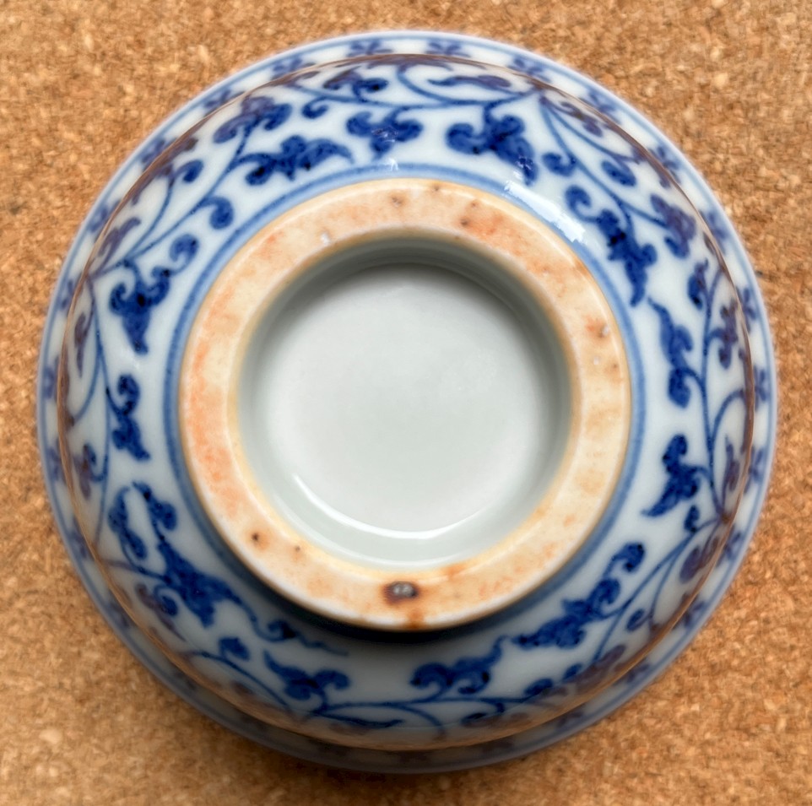
- Supplementary Fig. S4: Transmitted-light appearance of the ceramic body.
