Supplementary Information

Atomic ruthenium coordinated with chlorine and nitrogen as efficient and multifunctional electrocatalyst for overall water splitting and rechargeable zinc-air battery

Contents

Experimental Section 5
1. General material 5
2. Instruments and methods 5
3. Synthesis of Ru–Cl–N SAC 6
4. Electrochemical measurement 7
5. Zn-air battery test 8
Theoretical Section 10
Supplementary Figures and Tables 11
Supplementary Fig. S1. TGA (black) and DSC (blue) curves of CoRu-ZIF-67 measured under N₂ atmosphere with a heating rate of 5 °C/min. 11
Supplementary Fig. S2. (a) SEM and (b) TEM images of CoRu-ZIF-67, (c) XRD pattern of CoRu-ZIF-67 and the simulated ZIF-67. 12
Supplementary Fig. S3. (a) SEM, (b) TEM, (c) XRD, (d) HRTEM, (e) SAED of Co NP/Ru–Cl–N SAC. (f) Elemental mapping and line scanning of Co and Ru. 13
Supplementary Fig. S4. Fitting curve of the FT EXAFS spectrum of Ru–Cl–N SAC in R space. 14
Supplementary Fig. S5. (a) TEM and (b) XRD of RuN₄ SAC. 15
Supplementary Fig. S6. (a) K-edge XANES spectra and (b) the corresponding Fourier transform of RuN₄ SAC, Ru foil and RuO₂. (c) Fitting curve of the FT EXAFS spectrum of RuN₄ SAC in R space. 16
Supplementary Fig. S7. (a) TEM and (b) XRD pattern of Ru NP/NC. 17
Supplementary Fig. S8. (a) K-edge XANES spectra and (b) the corresponding Fourier transform of Ru NP/NC, Ru foil, RuCl₃, and RuO₂. (c) Fitting curve of the FT EXAFS spectrum of Ru NP/NC in R space. 18
Supplementary Fig. S9. (a) XPS survey and (b) Co 2p spectrum of Ru–Cl–N SAC. 19
Supplementary Fig. S10. (a) XPS survey and (b) deconvoluted Co 2p spectrum of Co NP/Ru–Cl–N SAC. 20
Supplementary Fig. S11. Polarization curve of the SCE reference electrode calibrated against RHE in H₂-saturated 1 M KOH electrolyte used for HER and OER measurements. 21
Supplementary Fig. S12. Polarization curve of the SCE reference electrode calibrated against RHE in H₂-saturated 0.1 M KOH electrolyte used for ORR measurements. 22
Supplementary Fig. S13. a, Copper UPD in 0.5 M H₂SO₄ in the (I) absence and (II-VI) presence of 5 mM CuSO₄ on Ru–Cl–N SAC. For II-VI, the electrode was polarized at 0.22, 0.23, 0.24, 0.25 and 0.26 V for 100 s to form the UPD layers, respectively. b, Copper UPD in 0.5 M H₂SO₄ in the (I, II) absence and (III) presence of 5 mM CuSO₄ on Ru–Cl–N SAC. For II and III, the electrode was polarized at 0.26 V for 100 s to form the UPD layer. c, Copper UPD in 0.5 M H₂SO₄ in the (I, II) absence and (III) presence of 5 mM CuSO₄ on Pt/C. For II-V, the electrode was polarized at 0.23, 0.24, 0.25 and 0.26 V for 100 s to form the UPD layers, respectively. d, Copper UPD in 0.5 M H₂SO₄ in the (I, II) absence and (III) presence of 5 mM CuSO₄ on Pt/C. For II and III, the electrode was polarized at 0.26 V for 100 s to form the UPD layer.. Scan rate: 10 mV s⁻¹. 23
Supplementary Fig. S14. Comparison of TOF values of the Ru–Cl–N SAC and Pt/C with other recently reported HER catalysts in alkaline condition. 25
Supplementary Fig. S15. CV curves of (a) Pt/C, (b) RuN₄ SAC, (c) Ru–Cl–N SAC and (d) NC scanning at a rate of 2, 4, 6, 8, 10 and 12 mV s⁻¹ in 1 M KOH. 26
Supplementary Fig. S16. Tafel slop of Ru–Cl–N SAC (red), RuN₄ SAC (light blue), NC (dark blue) and IrO₂ (purple). 27
Supplementary Fig. S17. Comparison of TOF values of the Ru–Cl–N SAC with other recently reported OER catalysts in alkaline condition. 28
Supplementary Fig. S18. Nyquist plots of Ru–Cl–N SAC (red), RuN₄ SAC (light blue), NC (dark blue) and IrO₂ (purple). 29
Supplementary Fig. S19. CV curves of (a) IrO₂, (b) RuN₄ SAC, (c) Ru–Cl–N SAC, (d) NC and (e) the correspoding current density difference (Δj) against scan rate plots scanning at a rate of 2, 4, 6, 8, 10 and 12 mV s⁻¹ in 1 M KOH. 30
Supplementary Fig. S20. CV curves of Ru–Cl–N SAC measured in the atmosphere of N₂ (black) and O₂ (red) under a scan rate of 50 mV s⁻¹ in 0.1 M KOH. 31
Supplementary Fig. S21. Tafel slop of Ru–Cl–N SAC (red), RuN₄ SAC (light blue), NC (dark blue) and Pt/C (purple). 32
Supplementary Fig. S22. Electron transfer number (n) and H₂O₂ yield of Ru–Cl–N SAC derived from the RRDE measurement. 33
Supplementary Fig. S23. Polarization curves of Ru–Cl–N SAC (red) and Co NP/Ru–Cl–N SAC (black) in the process of (a) HER, (b) OER and (c) ORR. 34
Supplementary Fig. S24. The structures of Co (002) 2×2 supercell. 35
Supplementary Fig. S25. The dissociation process of O₂ molecule on Co (002). 36
Supplementary Fig. S26. The free energy diagrams of OER and ORR on Co (002) at U = 0 V. 37
Supplementary Fig. S27. The free energy diagrams of HER on Co (002) and RuCl₂N₂/C at different sites. 38
Supplementary Fig. S28. (a) HER and (b) OER polarization curves of the original Ru–Cl–N SAC (red), and after addition of EDTA (black) and KSCN (blue). 39
Supplementary Fig. S29. Charge partitioning of RuN₄ SAC obtained by Hirshfeld method. Color code: C gray, N blue, Ru cyan. 40
Supplementary Fig. S30. Optical image of the overall water splitting electrolyzer cell fabricated by Ru–Cl–N SAC. 41
Supplementary Fig. S31. Open-circuit voltage (OCV) curves for the Zn-air batteries assembled by Ru–Cl–N SAC (red) and IrO₂-Pt/C (black). 42
Supplementary Table S1. The fitting parameters for the FT EXAFS spectrum of Ru foil, RuO₂, RuCl₃, Ru–Cl–N SAC, RuN₄ SAC and Ru NP/NC in R space. 43
Supplementary Table S2. Comparison of turnover frequencies (TOFs) with some of recently reported HER catalysts in alkaline condition. 44
Supplementary Table S3. The HER properties of Ru–Cl–N SAC compared with other recently-reported Ru-based HER electrocatalysts in 1 M KOH. 45
Supplementary Table S4. Comparison of turnover frequencies (TOFs) with some of recently reported OER catalysts in alkaline condition. 46
Supplementary Table S5. The OER properties of Ru–Cl–N SAC compared with other recently-reported Ru-based OER electrocatalysts in 1 M KOH. 47
Supplementary Table S6. The ORR properties of Ru–Cl–N SAC compared with other recently-reported Ru-based ORR electrocatalysts in 0.1 M KOH. 48
Supplementary Table S7. The HER (1 M KOH), OER (1 M KOH) and ORR (0.1 M KOH) properties of Ru–Cl–N SAC compared with other recently-reported trifunctional electrocatalysts. 49
Supplementary Table S8. The overall water splitting properties of Ru–Cl–N SAC compared with other recently-reported overall water splitting catalysts measured in 1 M KOH. 51
Supplementary Table S9. The Zn-air battery properties fabricated by Ru–Cl–N SAC compared with other recently-reported catalysts. 53
References 54

Experimental Section

1. General material

Cobalt nitrate hexahydrate (Co(NO₃)₂·6H₂O, ≥99%), zinc nitrate hexahydrate (Zn(NO₃)₂·6H₂O, 99%), zinc acetate (Zn(CH₃COO)₂, ≥99%), methanol (MeOH, CH₃OH, 99%), ethanol (EtOH, CH₃CH₂OH, 99.7%) and isopropanol (IPA, CH₃CH(OH)CH₃, 98%) were purchased from Sinopharm Chemical Reagent Co., Ltd., zinc foil, gas diffusion layer (GDL, YLS-30T) and hydrophilic carbon paper were purchased from Suzhou Sinero Technology Co., Ltd., ruthenium chloride (RuCl₃, ≥99%), ruthenium acetylacetonate ((CH₃CO=CHCOCH₃)₃Ru, 97%), 2-methylimidazole (C₄H₆N₂, ≥98%), iridium oxide (IrO₂, 99%), platinum on activated carbon (20wt.% Pt/C), Nafion solution (5%) and potassium hydroxide (KOH, ≥95%) were purchased from Sigma-Aldrich, and deionized (DI) water (resistivity: 18.3 MΩ·cm) were produced by an ultrapure water system (ULUPURE, UPDR-I-10T). All the chemical reagents were used as received without further treatment.

2. Instruments and methods
Field-emission scanning electron microscopy (FE-SEM) was carried out on a JEOL S4800 instrument. Transmission electron microscopy (TEM) images and element mapping analysis were exerted on a FEI Tecnai G2 F20 S-TWIN instrument. Aberration-corrected high-angle-annular-dark-field scanning transmission electron microscopy (AC-HAADF-STEM) was performed on Themis Z/ORION70-4M, X-ray synchrotron radiation was acquired on the B14W beamline in Shanghai Synchrotron Radiation Facility. Raman spectrum was recorded on a Renishaw-invia instrument. Powder X-ray diffraction (XRD) were carried out on a Rigaku D/max-2200PC diffractometer (Japan) with Cu Kα radiation (λ = 0.15418 nm). The thermogravimetry analysis-differential scanning calorimetry (TGA-DSC) was performed on a SETARAM LABSYS machine (LABSYS EVO, France) for the weight loss measurement. X-ray photoelectron spectroscopy (XPS) spectra were performed on the Thermo Scientific ESCALab 250Xi using 200 W monochromated Al Kα radiation. Nitrogen adsorption/desorption isotherm curves were recorded on a Quantachrome Autosorb AS-1 instrument at 77 K. HER and OER measurements were conducted on the CHI660E (Chenhua, Shanghai) instrument, and ORR tests were measured using a rotating ring-disk electrode equipped with a Pine WaveDrive20 instrument.

3. Synthesis of Ru–Cl–N SAC
9 mmol (2.619 g) of Co(NO₃)₂·6H₂O and 1 mmol (0.207 g) of RuCl₃ were dissolved in 30 mL of MeOH under sonication to form solution A, and 40 mmol (3.284 g) of 2-methylimidazole was dissolved in another 30 mL of MeOH to form solution B. Then solution B was added into solution A slowly under sonication for 10 min. The mixture was transfered to a Teflon-lined autoclave capped with a stainless steel vessel. After heating at 160 °C for 6 h, the precipate was seperated by suction filtration, and washed with MeOH several times before drying at 60 °C for 24 h. The as-obtained purple powder precursor was defined as CoRu-ZIF-67. Afterwards, 200 mg of CoRu-ZIF-67 was placed in a crucible and heated at 700 °C for 2 h with a rate of 2 °C/min under Ar atmosphere in a tube furnace. When the temperature decreased to 300 °C with a rate of 10 °C/min, it was cooled to room temperature naturally. The thus-obtained black powder, named as Co NP/Ru–Cl–N SAC, was then dispersed in 1 M of H₂SO₄ and HF under vigorously stirring for 24 h to remove the Co nanoparticles and unstable Ru sepcies. The final product was obtained by suction filtration, washing with EtOH and water each three times and drying at 60 °C for 24 h, which was defined as Ru–Cl–N SAC. For comparison, several reference samples were synthesized under similar condition. RuN₄ SAC was synthesized by using ruthenium acetylacetonate instead of RuCl₃ and Ru NP/NC was synthesized by replacing Co(NO₃)₂·6H₂O with Zn(NO₃)₂·6H₂O while keeping other condition unchanged. In the synthesis procedure of Ru NP/NC, NC can be obtained if RuCl₃ was absent.

4. Electrochemical measurement

The HER and OER properties were performed on CHI660E electrochemical workstation using a standard three-electrode system with graphtic rod, saturated calomel electrode (SCE) and glass carbon electrode (GCE) as the counter electrode, reference electrode and working electrode, respectively. The working electrode was prepared as follow: firstly, the GCE (φ = 3 mm) was polished by aluminum oxide powder with a size distribution of 1.0, 0.5 and 0.05 μm in sequence. Then 10 mg of the as-synthesized catalyst (5 mg of Pt/C or IrO₂) powder was dispersed into the a mixture of 400 μL of IPA and 16 μL of Nafion solution through ultrasonication for 1 h. Afterwards, 4 μL of the catalyst ink was dip-coated onto the surface of GCE dried at room temperature. Before the test, the SCE reference electrode was calibrated against the reversible hydrogen potential (RHE) in H₂-saturated 1 M KOH with Pt plate as the working electrode and Pt wire as the counter electrode. Thus, the potentials herein can be obtained by the equation of E(RHE) = E(SCE) + 1.059¹. The LSV curve was recorded in a N₂-saturated 1 M KOH with a scan rate of 3 mV s⁻¹. Tafel slope was obtained by plotting the LSV curve using the equation of η = a + b log j, where η refers to the overpotential, b is the Tafel slope and a denotes the intercept². The electrochemical impedance spectroscopy (EIS) were performed under open circuit potentials for all materials and the frequency range from 0.1 Hz to 100 kHz with an amplitude of 5 mV were used to carry out the experiment. The impedance data were represented by the Nyquist curve. For the double-layer capacitor (C_{dl}) data, CV curves were recorded in the non-Faradic region with scanning rate of 2, 4, 6, 8, 10 and 12 mV s⁻¹, and the C_{dl} can be obtained by plotting the current difference (Δj) against the scanning rate.

The overall water splitting was conducted on a two-electrode setup with a scan rate of 3 mV s⁻¹ under 1 M KOH. The catalyst ink was coated on the hydrophilic carbon paper with an area of 1 × 2 cm² and dried at room temperature. For comparison, a water electrolyzer cell of IrO₂ǁPt/C was also fabricated using 5 mg of IrO₂ and 5 mg of 20% Pt/C as the cathode and anode, respectively.

The ORR measurement was carried out on a rotating ring-disk electrode (RRDE) (φ = 4 mm) equipped with a Pine WaveDrive20 instrument using Pt wire and SCE as the counter electrode and reference electrode, respectively. 6 μL of the catalyst ink was dipped onto the disk surface and dried naturally. To be accurate, the SCE was also calibrated against RHE in H₂-saturated 0.1 M KOH with RRDE as the working electrode and Pt wire as the counter electrode. Thus, the potentials herein can be obtained by the equation of E(RHE) = E(SCE) + 1.0037¹. CV curves were recorded in N₂- and O₂-saturated 0.1 M KOH solution with a scan rate of 50 mV s⁻¹. LSV curves were performed under O₂-saturated 0.1 M KOH solution with a scan rate of 1600 rpm. The hydrogen peroxide yield (H₂O₂%) and the electron transfer number (n) were calculated from the current of both disk and ring electrodes using the following equation:³

$H_{2}O_{2}\%=200×\frac{I_{r}}{I_{r}+NI_{d}}$ (1)

$n=4×\frac{I_{d}}{I_{d}+\frac{I_{r}}{N}}$ (2)

where $I_{r}$ is the ring current, $I_{d}$ is the disk current, and the current collection efficiency (N) the of Pt ring is determined to be 0.38 in our system.

The anti-poisoning the catalyst was evaluated by adding 1 M of MeOH into the electrolyte during the current-time chronoamperometry test. For the investigation of the active site of the Ru–Cl–N SAC catalyst, 10 mM of KSCN and EDTA was separately added into the electrolyte under stirring for LSV measurements⁴.

5. Zn-air battery test

For the fabrication of the liquid rechargeable Zn-air battery, 18 mg of catalyst and 2 mg of conductive carbon black were firstly dispersed into a mixture of 960 μL of IPA and 40 μL of Nafion solution under ultrasonication for 1 h. Then, 50 μL of the catalyst ink was dip-coated onto the surface of GDL (1 cm²) as the cathodic air electrode and a piece of Zn plate (4.5 cm²) was used as anodic electrode. The cell was conducted in 6 M KOH with 0.2 M zinc acetate⁵. The discharge polarization curve was measured in the voltage range of 1.55 to 0.2 V with a scan rate of 5 mV s⁻¹, and the specific capacity was tested under a current density of 20 mA cm⁻². The charge-discharge cycling stability was acquired under 2 mA cm⁻² with charge-discharge interval of 10 min. For comparison, another reference cell assembly by a mixture catalyst of 5 mg IrO₂ and 5 mg 20% Pt/C as the air electrode in the similar preparation procedure.

Theoretical Section

All the spin-unrestricted density functional theory (DFT) calculations were carried out using the Dmol³ module in the Materials studio⁶. The exchange-correlation of the electron was performed by the generalized gradient approximation (GGA)⁷ method with Perdew–Burke–Ernzerhof (PBE)⁸. The van der Waals force is treated with long-range dispersion correction through Tkatchenko and Scheffler’s scheme⁹. During geometric structural optimizations, the convergence criteria were set to 10⁻⁵ Ha for the energy, 0.002 Ha/Å for the force, and 0.005 Å for the displacement. The smearing value was set to 0.005 Ha to achieve self-consistent field convergence.

The change in Gibbs free energy (ΔG) for each reaction step is given by the equation

ΔG=ΔE+ΔE_{ZPE}-TΔS+ΔG_{U} (3)

where ΔE is the reaction energy gained from the DFT calculations, ΔE_{ZPE} is the change of zero-point energy, T is the temperature (298.15 K) and ΔS is the change of entropy. ΔG_{U} = -neU, in which n is the number of transferred electrons and U is the applied potential.

The overpotential (ղ) can be calculated by the following equations:

ղ (OER)= ΔGmax/e -1.23 (4)

ղ (ORR) = ΔGmax/e +1.23 (5)

Supplementary Figures and Tables

Supplementary Fig. S1. TGA (black) and DSC (blue) curves of CoRu-ZIF-67 measured under N₂ atmosphere with a heating rate of 5 °C/min.

Supplementary Fig. S2. (a) SEM and (b) TEM images of CoRu-ZIF-67, (c) XRD pattern of CoRu-ZIF-67 and the simulated ZIF-67.

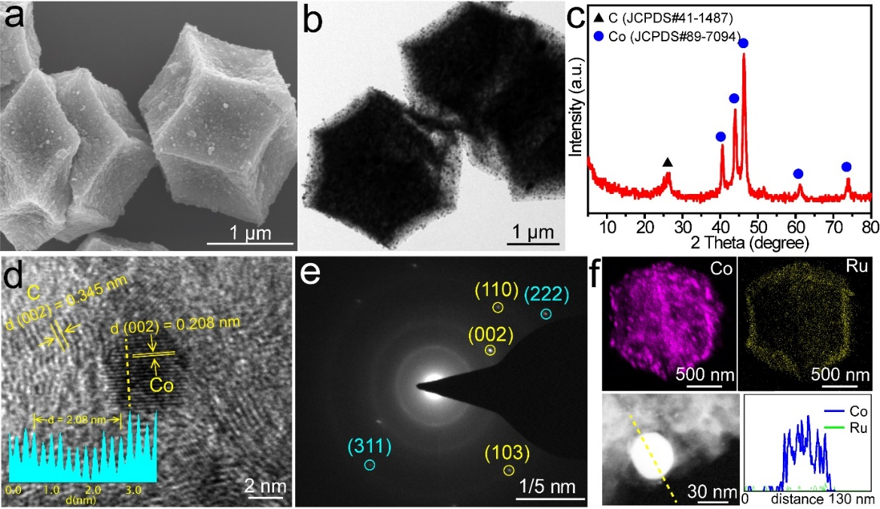

Supplementary Fig. S3. (a) SEM, (b) TEM, (c) XRD, (d) HRTEM, (e) SAED of Co NP/Ru–Cl–N SAC. (f) Elemental mapping and line scanning of Co and Ru.

From the SEM and TEM images in Supplementary Fig. S3a,b, it can be seen that the morphoogy of Co NP/Ru–Cl–N SAC remained as the CoRu-ZIF-67, but the surface become relative rough with numerous ultrasmall nanoparticle. XRD pattern and HRTEM image of Co NP/Ru–Cl–N SAC (Supplementary Fig. S3c,d) indicated that Co nanoparticles were in the form of hexagonal crystalline phase (JCPDS 89-7094) imbedded onto the carbon matrix. The SAED result further conformed the coexistence of Co nanoparticles and graphitic carbon. While the Ru was in the form of amorphous state. EDS mapping and line scanning demonstrated that Ru was uniformly dispersed on the carbon substrate and Co was nanoparticle.

Supplementary Fig. S4. Fitting curve of the FT EXAFS spectrum of Ru–Cl–N SAC in R space.

Supplementary Fig. S5. (a) TEM and (b) XRD of RuN₄ SAC.

Supplementary Fig. S6. (a) K-edge XANES spectra and (b) the corresponding Fourier transform of RuN₄ SAC, Ru foil and RuO₂. (c) Fitting curve of the FT EXAFS spectrum of RuN₄ SAC in R space.

Supplementary Fig. S6a shows the Ru K-edge X-ray adsorption near-edge structure (XANES) spectrum of RuN₄ SAC, Ru foil and RuO₂. The adsorption location of RuN₄ SAC was slightly higher than that of Ru foil and lower than that of RuO₂, indicative of a chemical state between 0 and +4. Fourier-transform (FT) k²-weighted EXAFS spectrum of Ru K edge was shown in Supplementary Fig. S6b. The dominant coordination peak located at 1.49 Å for RuN₄ SAC was assigned to Ru-O/N bond of the atomic Ru coordinated with O/N¹⁰, which was almost overlapped with the peak of RuO₂. No any peak belonging to Ru nanoparticles in RuN₄ SAC was observed in reference to Ru foil. Fitting the FT EXAFS spectrum of RuN₄ SAC in R space revealed an average coordination number (CN) of 4.9 ± 0.6 for Ru-N (Supplementary Fig.S6c and Table S1), leading to a chemical formula of RuN₄.

Supplementary Fig. S7. (a) TEM and (b) XRD pattern of Ru NP/NC.

Supplementary Fig. S8. (a) K-edge XANES spectra and (b) the corresponding Fourier transform of Ru NP/NC, Ru foil, RuCl₃, and RuO₂. (c) Fitting curve of the FT EXAFS spectrum of Ru NP/NC in R space.

Supplementary Fig. S8a shows the Ru K-edge XANES spectrum of Ru NP/NC, Ru foil, RuCl₃, and RuO₂. The adsorption location of Ru NP/NC was slightly higher than that of Ru foil and lower than that of RuCl₃, indicative of a chemical state between 0 and +3. FT-EXAFS spectrum of Ru K edge was shown in Supplementary Fig. S8b. The only one dominant coordination peak located at 2.30 Å for Ru NP/NC was assigned to Ru-Ru bond of the Ru nanoparticle⁴, which was almost overlapped with the peak of Ru foil. Fitting the FT EXAFS spectrum of Ru NP/NC in R space revealed an average coordination number (CN) of 12 ± 0.3 for Ru-Ru with a bond length of 2.66 Å (Supplementary Fig.S6c and Table S1).

Supplementary Fig. S9. (a) XPS survey and (b) Co 2p spectrum of Ru–Cl–N SAC.

Supplementary Fig. S10. (a) XPS survey and (b) deconvoluted Co 2p spectrum of Co NP/Ru–Cl–N SAC.

The XPS survey of Co NP/Ru–Cl–N SAC disclosed that the sample included Co, Ru, C, N, O and Cl element (Supplementary Fig. S10a). From the high-resolution XPS of Co 2p spectrum (Supplementary Fig. S10b), it can be seen that the binding energy of Co 2p_{3/2} located at 778.34, 780.57 and 785.60 eV and Co 2p_{1/2} located at 793.24, 796.13 and 803.48 eV, corresponding to the Co³⁺, Co²⁺ and satellite¹¹, respectively. This result evidently demonstrated the existence of Co in the sample of Co NP/Ru–Cl–N SAC before acid washing.

Supplementary Fig. S11. Polarization curve of the SCE reference electrode calibrated against RHE in H₂-saturated 1 M KOH electrolyte used for HER and OER measurements.

Supplementary Fig. S12. Polarization curve of the SCE reference electrode calibrated against RHE in H₂-saturated 0.1 M KOH electrolyte used for ORR measurements.

Supplementary Fig. S13. a, Copper UPD in 0.5 M H₂SO₄ in the (I) absence and (II-VI) presence of 5 mM CuSO₄ on Ru–Cl–N SAC. For II-VI, the electrode was polarized at 0.22, 0.23, 0.24, 0.25 and 0.26 V for 100 s to form the UPD layers, respectively. b, Copper UPD in 0.5 M H₂SO₄ in the (I, II) absence and (III) presence of 5 mM CuSO₄ on Ru–Cl–N SAC. For II and III, the electrode was polarized at 0.26 V for 100 s to form the UPD layer. c, Copper UPD in 0.5 M H₂SO₄ in the (I, II) absence and (III) presence of 5 mM CuSO₄ on Pt/C. For II-V, the electrode was polarized at 0.23, 0.24, 0.25 and 0.26 V for 100 s to form the UPD layers, respectively. d, Copper UPD in 0.5 M H₂SO₄ in the (I, II) absence and (III) presence of 5 mM CuSO₄ on Pt/C. For II and III, the electrode was polarized at 0.26 V for 100 s to form the UPD layer.. Scan rate: 10 mV s⁻¹.

Active site measurement:

The active site was assessed by the underpotential deposition of copper (Cu-UPD) method, which has been widely used for determine the corresponding active sites^{12,13}. In this manner, the number of active site (n) can be obtained by the UPD copper stripping charge (Q_{Cu}, Cu_{UPD} → Cu²⁺ + 2e⁻) with the following equation:
n = Q_{Cu}/2F
where F is the Faraday constant (96485 C mol⁻¹).

Calculation of the turnover frequency (TOF):

The TOF (s⁻¹) can be estimated by the following equation:
TOF = I/(2nF) for HER and TOF = I/(4nF) for OER
Where I is the current (A) during the linear scaning process, F is the Faraday constant (96485 C mol⁻¹), n is the number of active sits (mol). The factor 1/2 (1/4) are based on the consideration that two (four) electrons transfered to form one hydrogen (oxygen) molecule in the HER (OER) process.

Supplementary Fig. S14. Comparison of TOF values of the Ru–Cl–N SAC and Pt/C with other recently reported HER catalysts in alkaline condition.

Supplementary Fig. S15. CV curves of (a) Pt/C, (b) RuN₄ SAC, (c) Ru–Cl–N SAC and (d) NC scanning at a rate of 2, 4, 6, 8, 10 and 12 mV s⁻¹ in 1 M KOH.

Supplementary Fig. S16. Tafel slop of Ru–Cl–N SAC (red), RuN₄ SAC (light blue), NC (dark blue) and IrO₂ (purple).

Supplementary Fig. S17. Comparison of TOF values of the Ru–Cl–N SAC with other recently reported OER catalysts in alkaline condition.

Supplementary Fig. S18. Nyquist plots of Ru–Cl–N SAC (red), RuN₄ SAC (light blue), NC (dark blue) and IrO₂ (purple).

Supplementary Fig. S19. CV curves of (a) IrO₂, (b) RuN₄ SAC, (c) Ru–Cl–N SAC, (d) NC and (e) the correspoding current density difference (Δj) against scan rate plots scanning at a rate of 2, 4, 6, 8, 10 and 12 mV s⁻¹ in 1 M KOH.

Supplementary Fig. S20. CV curves of Ru–Cl–N SAC measured in the atmosphere of N₂ (black) and O₂ (red) under a scan rate of 50 mV s⁻¹ in 0.1 M KOH.

Supplementary Fig. S21. Tafel slop of Ru–Cl–N SAC (red), RuN₄ SAC (light blue), NC (dark blue) and Pt/C (purple).

Supplementary Fig. S22. Electron transfer number (n) and H₂O₂ yield of Ru–Cl–N SAC derived from the RRDE measurement.

Supplementary Fig. S23. Polarization curves of Ru–Cl–N SAC (red) and Co NP/Ru–Cl–N SAC (black) in the process of (a) HER, (b) OER and (c) ORR.

Supplementary Fig. S24. The structures of Co (002) 2×2 supercell.

Supplementary Fig. S25. The dissociation process of O₂ molecule on Co (002).

To further verify our experimental results, we performed DFT calculations to compare catalytic activities on Co (002) for comparison relative to RuCl₂N₂/C. First, the optimal adsorption site of the oxidation intermediate was tested on the Co (002). We found that the O=O bond in the Co (002) system is prone to break to form two O atoms. As shown in Supplementary Fig. S25, when a gaseous O₂ molecule approaches Co (002), only the activation barrier of 0.98 eV needs to be overcome to cause the O=O bond to break and form two O atoms. Because of this, it becomes very difficult to generate O₂ molecules on the Co (002) system. The adsorption free energies of oxygen-containing species uncover the origin of catalytic activities.

Supplementary Fig. S26. The free energy diagrams of OER and ORR on Co (002) at U = 0 V.

The OER and ORR catalytic performance on Co (002) was evaluated by the change in free energies of each reaction step (Supplementary Fig. S26). The results show that OER is indeed more difficult due to the larger overpotential (4.86 eV) on Co (002), while the ORR process only requires an overpotential of 1.96 eV. In contrast, the overpotentials of OER and ORR are both reduced on RuCl₂N₂/C. Moreover, the overpotentials of OER and ORR are basically the same (1.07 eV vs. 1.06 eV) on RuCl₂N₂/C (Fig. 4 in the main text), which indicates the potential of RuCl₂N₂/C as a dual-functional catalyst.

Supplementary Fig. S27. The free energy diagrams of HER on Co (002) and RuCl₂N₂/C at different sites.

The HER on Co (002) and RuCl₂N₂/C at different sites as shown in Supplementary Fig. S27. The most stable free energy of H adsorption is -0.27 eV on Co (002) and 0.10 eV on RuCl₂N₂/C, respectively.

Supplementary Fig. S28. (a) HER and (b) OER polarization curves of the original Ru–Cl–N SAC (red), and after addition of EDTA (black) and KSCN (blue).

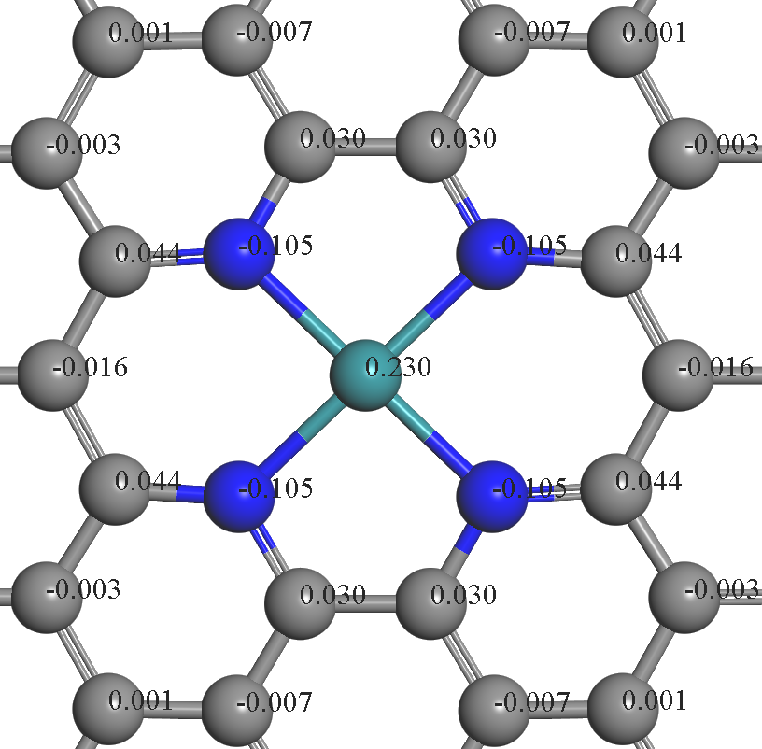

Supplementary Fig. S29. Charge partitioning of RuN₄ SAC obtained by Hirshfeld method. Color code: C gray, N blue, Ru cyan.

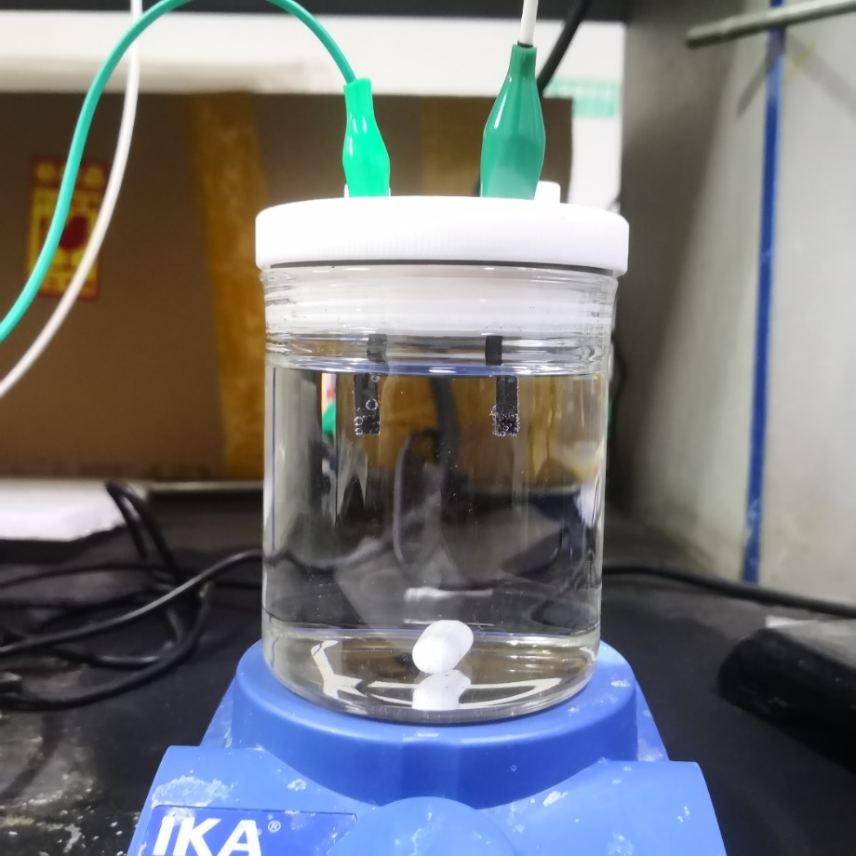

Supplementary Fig. S30. Optical image of the overall water splitting electrolyzer cell fabricated by Ru–Cl–N SAC.

Supplementary Fig. S31. Open-circuit voltage (OCV) curves for the Zn-air batteries assembled by Ru–Cl–N SAC (red) and IrO₂-Pt/C (black).

Supplementary Table S1. The fitting parameters for the FT EXAFS spectrum of Ru foil, RuO₂, RuCl₃, Ru–Cl–N SAC, RuN₄ SAC and Ru NP/NC in R space.
Sample | Shell | CNª | R^{b}  (Å) | σ^{2 c}  (×10⁻³Å²) | ΔE^{d}  (eV) | R factor
Ru foil | Ru-Ru | 12 | 2.71 ± 0.01 | -- | -- | --
RuO₂ | Ru-O | 6 | 2.01 ± 0.01 | -- | -- | --
RuCl₃ | Ru-Cl | 6 | 2.35 ± 0.02 | -- | -- | --
Ru–Cl–N SAC | Ru-N | 2.0 ± 0.02 | 2.06 ± 0.01 | 9.9 | 3.6 ± 2.0 | 0.59%
Ru–Cl–N SAC | Ru-Cl | 2.6 ± 0.02 | 2.38 ± 0.02 | 3.0 | 15.3 ± 1.0 | 0.59%
Ru–Cl–N SAC | Ru-Ru | 2.9 ± 0.02 | 2.65 ± 0.01 | 3.0 | -15 ± 1.3 | 0.59%
RuN₄ SAC | Ru-N | 4.9 ± 0.6 | 2.10 ± 0.02 | 7.1 | 1.4 ± 3.0 | 1.85%
Ru NP/NC | Ru-Ru | 12 ± 0.3 | 2.66 ± 0.02 | 5.3 | -15.2 + 1.2 | 0.37%

ªCN: coordination numbers; ^{b}R: bond distance; ^{c}σ²: Debye-Waller factors; ^{d} ΔE₀: the inner potential correction. R factor: goodness of fit. Ѕ₀² was set to 0.82, according to the experimental EXAFS fit of Ru foil reference by fixing CN as the known crystallographic value; δ: percentage.

Supplementary Table S2. Comparison of turnover frequencies (TOFs) with some of recently reported HER catalysts in alkaline condition.

No. | Catalyst | Overpotential  (V) | TOF per  active site  (H₂ s⁻¹) | reference
1 | Ru–Cl–N SAC | 0.025 | 0.66 | This work
2 | Pt/C | 0.025 | 0.32 | This work
3 | Ru@MWCNT | 0.025 | 0.4 | Nat. Commun. 2020, 11, 1278.
4 | Ru@GnP | 0.1 | 0.145 | Adv. Mater. 2018, 30, 1803676.
5 | Ru@C₄N-900 | 0.025 | 0.65 | ACS Appl. Mater. Interfaces 2019, 11, 19176−19182.
6 | Ru/C | 0.04 | 0.18 | Adv. Energy Mater. 2018, 8, 1801698.
7 | 2.20 wt % Ru SAs–Ni₂P | 0.125 | 1 | Nano Energy.2021, 80, 105467.
8 | Ru-NBC-2 | 0.1 | 0.83 | Appl. Catal. B-Environ. 2021, 285.119795.
9 | Ru-MoS₂/CC | 0.169 | 0.2 | Appl. Catal. B-Environ. 2019, 249, 91-97.
10 | Ru/NG-750 | 0.1 | 0.35 | ACS Appl. Mater. Interfaces 2017, 9, 3785-3791.
11 | Ru/MeOH/THF | 0.1 | 0.87 | Chem. Commun. 2017, 53, 11713.
12 | Ru_{SA+NP}/DC | 0.03 | 0.17 | Adv. Sci. 2021, 8, 2004516.

Supplementary Table S3. The HER properties of Ru–Cl–N SAC compared with other recently-reported Ru-based HER electrocatalysts in 1 M KOH.
No. | Catalyst | η₁₀ (mV) | Tafel slope  (mV dec⁻¹) | reference
1 | Ru–Cl–N SAC | 12 | 23.9 | This work
2 | Ru-NC-700 | 47 | 14 | Nat. Commun. 2019, 10, 631.
3 | Ru_{0.10}@2H-MoS₂ | 51 | 64.9 | Appl. Catal. B-Environ.  2021, 298, 120490
4 | Ru/Co₃O₄ NWs | 30.98 | 69.75 | Nano Energy 2021, 85,105940.
5 | Ru/Co₄N-CoF₂ | 53 | 144.1 | Chem. Eng. J. 2021, 414, 128865.
6 | CoRu_{0.5}/CQDs | 18 | 38.5 | Angew. Chem. Int. Ed. 2021, 60, 3290-3298.
7 | Ru/Co@OG | 13 | 22.8 | Angew. Chem. Int. Ed. 2021, 60, 2-9.
8 | Ru@WNO-C | 24 | 39.7 | Nano Energy 2021, 80, 105531.
9 | Ru@Co/N-CNTs-2 | 48 | 45 | ACS Sustainable Chem. Eng. 2020, 8, 24, 9136-9144.
10 | Ru NCs/BNG | 14 | 28.9 | Nano Energy 2020, 68, 104301.
11 | Pd–Ru@NG | 28 | 73 | Chem. Commun. 2019, 55, 13928.
12 | Ru/C-H₂O/CH₃CH₂OH | 53 | 36.2 | Appl. Catal. B-Environ. 2019, 258, 117952.
13 | Ru/NC-0.01 | 17 | 32 | J. Mater. Chem. A 2019, 7, 18072-18080.
14 | SA-Ru-MoS₂ | 76 | 21 | Small Methods 2019, 1900653.
15 | SA-Ru/Ru NPs/PC | 33 | 31.8 | J. Mater. Chem. A, 2019,7, 19531-19538
16 | Ru/CoO | 55 | 70 | J. Energy Chem. 2019, 37, 143-147.
17 | Ru@NG | 20.3 | 26 | J. Mater. Chem. A, 2018, 6, 13859-13866.

Supplementary Table S4. Comparison of turnover frequencies (TOFs) with some of recently reported OER catalysts in alkaline condition.

No. | Catalyst | Overpotential  (V) | TOF per  active site  (H₂ s⁻¹) | reference
1 | Ru–Cl–N SAC | 0.3 | 0.271 | This work
2 | CoNi hydroxide UNSs | 0.38 | 0.16 | Nano Res. 2016, 9, 1856–1865.
3 | Ni₃S₂ | 0.35 | 0.021 | Chem. Eng. J. 2021, 411, 128488.
4 | Vo-CoOOH | 0.3 | 0.04 | Nano Energy 2017, 42, 98-105.
5 | P─Ni_{0.75}Fe_{0.25}Se₂ | 0.5 | 0.18 | Adv. Sci. 2021, 2101775
6 | Ni_{0.5}Fe_{0.5}@COF-SO₃ | 0.3 | 0.14 | Inorg. Chem. 2020, 59, 4995−5003.
7 | Ni_{1.5}Fe_{0.5}P/CF  nanosheet | 0.3 | 0.014 | Nano Energy, 2017, 34, 472.
8 | CoNiP ultrathin nanosheet | 0.3 | 0.028 | Energy Environ. Sci., 2017, 10, 893.
9 | CoFe₂O₄/C | 0.3 | 0.0915 | Adv. Mater. 2017, 29, 1604437
10 | 3DIO-LaCoO₃-x | 0.5 | 0.21 | J. Power Sources 2020, 478, 228748
11 | NiCoP/GO nanoparticle | 0.3 | 0.047 | Adv. Funct. Mater., 2016, 26, 6785
12 | NiCo-UMOFNs nanosheet | 0.3 | 0.18 | Nat. Energy, 2016, 1, 16184.

Supplementary Table S5. The OER properties of Ru–Cl–N SAC compared with other recently-reported Ru-based OER electrocatalysts in 1 M KOH.
No. | Catalyst | η₁₀ (mV) | reference
1 | CoRu/NC | 233 | This work
2 | Co₃O₄-Ru₁ | 249 | Nano Today 2020, 34, 100955.
3 | (Ru-Co)O_{x}-350 | 265 | Chem. Eng. J. 2021, 420, 129805.
4 | LFRO-H-O | 380 | Chem. Eng. J. 2021, 418, 129422.
5 | Ca₂FeRuO₆ | 400 | ACS Appl. Energy Mater. 2021, 4, 1323-1334.
6 | Ru-0.3 | 280 | Appl. Surf. Sci. 2021, 544, 148897.
7 | Ru-CoMo/CFP | 237 | Appl. Surf. Sci. 2021, 541, 148518.
8 | NP-Ru₃ | 245 | J. Mater. Sci. Tech. 2021, 70, 197-204.
9 | RuTe₂-400 | 275 | Appl. Catal. B-Environ. 2020, 278, 119281.
10 | Ru-CoNi@NC-2 | 240 | ACS Sustainable Chem. Eng. 2019, 7, 17227-17236.
11 | Ru-N-C | 267 | Nat. Commun. 2019, 10, 4849.
12 | CoRu-O/A@HNC-2 | 253* | ACS Appl. Mater. Interfaces 2020, 12, 51437-51447.
13 | 5.0V-LRO | 330* | Energy Environ. Sci. 2020, 13, 2167.
* data measured in 0.1 M KOH solution.

Supplementary Table S6. The ORR properties of Ru–Cl–N SAC compared with other recently-reported Ru-based ORR electrocatalysts in 0.1 M KOH.
No. | Catalyst | E_{1/2}  (V vs. RHE) | reference
1 | Ru–Cl–N SAC | 0.90 | This work
2 | Ca₂FeRuO₆ | 0.78* | ACS Appl. Energy Mater. 2021, 4, 1323-1334.
3 | a-Ru@Co/CN | 0.908* | Mater. Today Phys. 2021, 17, 100338.
4 | CoRu-O/A@HNC-2 | 0.821 | ACS Appl. Mater. Interfaces 2020, 12, 51437-51447.
5 | Ru_{0.5}/HNCS | 0.72 | Mater. Today Phys. 2021, 16, 100300.
6 | Ru_{0.95}Co_{0.05}/C | 0.839 | ACS Catal. 2020, 10, 4608-4616.
7 | Ru/MWCNT | 0.72 | Nanoscale 2019, 11, 13968.
8 | Ru-SSC | 0.824 | J. Am. Chem. Soc. 2019, 141, 19800-19806.
9 | Pd–Ru@NG | 0.80 | Chem. Commun. 2019, 55, 13928.
10 | Pb₂Ru₂O_{6.5} | ~0.82 | Energy Environ. Sci. 2017, 10, 129.
* data measured in 1 M KOH solution.

Supplementary Table S7. The HER (1 M KOH), OER (1 M KOH) and ORR (0.1 M KOH) properties of Ru–Cl–N SAC compared with other recently-reported trifunctional electrocatalysts.
No. | Catalyst | HER η₁₀ (mV) | OER η₁₀ (mV) | E_{1/2}  (V vs. RHE) | reference
1 | Ru–Cl–N SAC | 12 | 233 | 0.90 | This work
2 | Pt@CoS₂-NrGO | 390 | 235 | 0.85 | Appl. Catal. B-Environ. 2021, 297, 120405.
3 | FeCo-P-2 | 183 | 277 | 0.83 | Appl. Catal. B-Environ. 2021, 295, 120275.
4 | P,S-Co_{x}O_{y}/Cu@CuS | 116 | 280 | 0.67 | Adv. Funct. Mater. 2020, 2007822.
5 | Co₂P/CoNPC | 208 | 326 | 0.843 | Adv. Mater. 2020, 2003649.
6 | Mo₂C/Co@NC | 510 | 308 | 0.86 | Appl. Catal. B-Environ. 2021, 296, 120360.
7 | Ni@N-HCGHF | 950 | 260 | 0.875 | Adv. Mater. 2020, 2003313.
8 | ZnCo−PVP-900−acid | 270 | 420 | 0.84 | ACS Appl. Mater. Interfaces 2019, 11, 9925-9933.
9 | NiS₂ | 147 | 241 | 0.8 | J. Mater. Chem. A, 2019, 7, 23787-23793.
10 | Co@N-CNTF-2 | 220 | 350 | 0.81 | J. Mater. Chem. A, 2019, 7, 3664-3672.
11 | FeNiP/NCH | 216 | 250 | 0.75 | J. Am. Chem. Soc. 2019, 141, 7906-7916.
12 | CoP | 62.5 | 330 | 0.858 | Adv. Mater. 2018, 1705796.
13 | FeP_{x}/Fe–N–C/NPC | 75 | 325 | 0.86 | Adv. Energy Mater. 2018, 1803312.
14 | NCNT/CoFe-CoFe₂O₄ | 204 | 310 | 0.72 | ACS Appl. Mater. Interfaces 2018, 10, 46, 39828-39838.
15 | Co₃O₄/NCMTs | 210 | 350 | 0.778 | J. Mater. Chem. A 2017, 5, 20170-20179.
16 | NSCHCT1000 | 360 | 460* | 0.84 | Chem. Eng. J. 2021, 418, 129321.
17 | Co-NCNT-600 | 235* | 397* | 0.81 | J. Colloid Interface Sci. 2021, 585, 276-286.
18 | Co₄N@NC-2 | 283 | 290* | 0.84 | Appl. Catal. B-Environ. 2020, 275, 119104.
19 | FeCo/Co₂P@NPCF | 260 | 330* | 0.79 | Adv. Energy Mater. 2020, 1903854.
* data measured in 0.1 M KOH solution.

Supplementary Table S8. The overall water splitting properties of Ru–Cl–N SAC compared with other recently-reported overall water splitting catalysts measured in 1 M KOH.
Catalysts | η₁₀ (mV) |  | E (V)  @10 mA cm⁻² | References
Catalysts | HER | OER | E (V)  @10 mA cm⁻² | References
Ru–Cl–N SAC | 12 | 233 | 1.49 | This work
Ru₁/D-NiFe LDH | 18 | 189 | 1.44 | Nat. Commun. 2021, 12, 4587.
RuIrO_{x} | 13 | 250 | 1.47 | Nat. Commun. 2019, 10, 4875.
Ru/N-BP2000 | 15 | 285 | 1.53 | ChemCatChem 2019, 11, 4327–4333.
CoP NFs | 136 | 323 | 1.65 | ACS Catal. 2020, 10, 1, 412-419.
Ce-NiFe-LDH | 147 | 175 | 1.59 | Sustain. Energ. Fuels, 2020, 4, 312-323
CoMoNiS-NF | 113 | 117 | 1.54 | J. Am. Chem. Soc. 2019, 141, 10417.
RuCu NSs | 20 | 234 | 1.49 | Angew. Chem. Int. Ed. 2019, 58, 13983.
Ni₂P@NSG | 110 | 240 | 1.572 | Chem. Mater. 2021, 33, 1, 234–245
Co₂P/CoNPC | 130 | 326 | 1.64 | Adv. Mater., 2020, 32, 2003649.
Ni/Ni(OH)₂ | 77 | 270 | 1.59 | Adv. Mater. 2020, 32, 1906915.
Co@N-CS/N-HCP | 66 | 248 | 1.545 | Adv. Energy Mater.2019, 9, 1803918.
Co–Fe oxyphosphide MTs | 180 | 280 | 1.69 | Adv. Sci., 2019, 6, 1900576.
Co_{0.6}Fe_{0.4}P-1.125 | 133 | 298 | 1.57 | Chem. Sci., 2019, 10, 464-474.
Co₁–Fe₁–B–P nanochains | 173 | 225 | 1.68 | Nanoscale, 2019, 11, 7506-7512.
CVN/CC | 118 | 263 | 1.64 | Appl. Catal. B-Environ., 2019, 241, 521-527.
CoP@NPCSs | 115 | 350 | 1.643 | ACS Appl. Mater. Interfaces, 2018, 10, 44201-44208.
CoP/NCNHP | 115 | 310 | 1.64 | J. Am. Chem. Soc., 2018, 140, 7, 2610-2618.
CoSe₂/MoSe₂ | 90 | 280 | 1.67 | Energy Environ. Sci., 2016, 9, 478.
Ni₃S₂/NF | 223 | 260 | 1.76 | J. Am. Chem. Soc., 2015, 137, 14023.
NiFe LDH/NF | 210 | 240 | 1.7 | Science, 2014, 345, 1593-1596.
CP/CNTs/Co-S | 190 | 307 | 1.743 | ACS Nano, 2016, 10, 2342.
NiSe/NF | 96 | 270 (η₂₀) | 1.63 | Angew. Chem. Int. Ed. 2015, 54, 9351-9355
Co₃O₄ nanocrystals | 380 | 320 | 1.91 | Chem. Commun., 2015, 51, 8066.
Co-NC/CNT | 203 | 354 | 1.625 | J. Mater. Chem. A, 2016, 4, 16057-16063.
NiCo₂S₄ NS/CC | 181 | 240 | 1.66 | ACS Sustainable Chem. Eng., 2018, 6, 5011-5020.
Fe_{11.1%-}Ni₃S₂/Ni foam | 126 | 234 (η₅₀) | 1.60 | J. Mater. Chem. A, 2018,6, 4346-4353.

Supplementary Table S9. The Zn-air battery properties fabricated by Ru–Cl–N SAC compared with other recently-reported catalysts.
Catalysts | OCV  (V) | Power density  (mW cm⁻²) | Specific capacity  (mAh g⁻¹) | References
Ru–Cl–N SAC | 1.455 | 205 | 804.26 | This work
Pb₂Ru₂O_{6.5} | ~1.25 | 195 | N.A. | Energy Environ. Sci. 2017, 10, 129.
Pt@CoS₂-NrGO | 1.41 | 114 | 763 | Appl. Catal. B-Environ. 2021, 297, 120405.
FeCo-P-2 | 1.415 | 205 | 800 | Appl. Catal. B-Environ. 2021, 295, 120275.
P,S-Co_{x}O_{y}/Cu@CuS | 1.383 | 130 | N.A. | Adv. Funct. Mater. 2020, 2007822.
Co₂P/CoNPC | 1.425 | 116 | N.A. | Adv. Mater. 2020, 2003649.
Mo₂C/Co@NC | 1.41 | 187.9 | 691 | Appl. Catal. B-Environ. 2021, 296, 120360.
Ni@N-HCGHF | 1.49 | 117.1 | 706 | Adv. Mater. 2020, 2003313.
CoFe/N-GCT | 1.43 | 203 | N.A. | Angew. Chem. Int. Ed. 2018, 57, 16166-16170.
NGM-Co | 1.439 | 152 | 749.4 | Adv. Mater. 2017, 1703185.
Co@N-CNTF-2 | N.A. | 91 | N.A. | J. Mater. Chem. A, 2019, 7, 3664-3672.
FeNiP/NCH | 1.48 | 250 | N.A. | J. Am. Chem. Soc. 2019, 141, 7906-7916.
NPMC-1000 | 1.48 | 55 | 735 | Nat. Nanotech. 2015, 10, 444-452.
FeP_{x}/Fe–N–C/NPC | 1.25 | N.A. | 739 | Adv. Energy Mater. 2018, 1803312.
NCNT/CoFe-CoFe₂O₄ | 1.56 | 98 | 606 | ACS Appl. Mater. Interfaces 2018, 10, 46, 39828-39838.
N-GRW | 1.46 | 65 | 873 | Sci. Adv. 2016, 2, e1501122.
NSCHCT1000 | 1.44 | 109 | N.A. | Chem. Eng. J. 2021, 418, 129321.
NDGs-800 | 1.45 | 115.2 | 750.8 | ACS Energy Lett. 2018, 3, 1183-1191.
Co₄N@NC-2 | 1.48 | 74.3 | 769.4 | Appl. Catal. B-Environ. 2020, 275, 119104.
FeCo/Co₂P@NPCF | 1.44 | 154 | N.A. | Adv. Energy Mater. 2020, 1903854.
N.A. refers to “not available”.

References
1. Wei C, et al. Recommended practices and benchmark activity for hydrogen and oxygen electrocatalysis in water splitting and fuel cells. Adv. Mater. 31, 1806296 (2019).

2. Pan Y, et al. Core–shell ZIF-8@ZIF-67-derived CoP nanoparticle-embedded N-doped carbon nanotube hollow polyhedron for efficient overall water splitting. J. Am. Chem. Soc. 140, 2610-2618 (2018).

3. Zhao L, et al. Cascade anchoring strategy for general mass production of high-loading single-atomic metal-nitrogen catalysts. Nat. Commun. 10, 1278 (2019).

4. Lu B, et al. Ruthenium atomically dispersed in carbon outperforms platinum toward hydrogen evolution in alkaline media. Nat. Commun. 10, 631 (2019).

5. Yan L, et al. A Freestanding 3D heterostructure film stitched by MOF-derived carbon nanotube microsphere superstructure and reduced graphene oxide sheets: a superior multifunctional electrode for overall water splitting and Zn–air batteries. Adv. Mater. 32, 2003313 (2020).

6. Delley B. From molecules to solids with the DMol³ approach. J. Chem. Phys. 113, 7756-7764 (2000).

7. Grimme S. Semiempirical GGA-type density functional constructed with a long-range dispersion correction. J. Comp. Chem. 27, 1787-1799 (2006).

8. Ernzerhof M, Scuseria GE. Assessment of the Perdew–Burke–Ernzerhof exchange-correlation functional. J. Chem. Phys. 110, 5029-5036 (1999).

9. Tkatchenko A, Scheffler M. Accurate molecular Van Der Waals interactions from ground-state electron density and free-atom reference data. Phys. Rev. Lett. 102, 073005 (2009).

10. Hu X. et al. Ru single atoms on N-doped carbon by spatial confinement and ionic substitution strategies for high-performance Li–O₂ batteries. J. Am. Chem. Soc. 142, 16776-16786 (2020).

11. Feng Y. et al. Decorating CoNi layered double hydroxides nanosheet arrays with fullerene quantum dot anchored on Ni foam for efficient electrocatalytic water splitting and urea electrolysis. Chem. Eng. J. 390, 124525 (2020).

12. Kweon D. H. et al. Ruthenium anchored on carbon nanotube electrocatalyst for hydrogen production with enhanced Faradaic efficiency. Nat. Commun. 11, 1278 (2020).

13. Mahmood J. et al. An efficient and pH-universal ruthenium-based catalyst for the hydrogen evolution reaction. Nat. Nanotech. 12, 441-446 (2017).

