Supporting Information
Current and Future Distribution Models of Sweet Chestnut (Castanea sativa Mill.) in Türkiye Using a Spatially Nested Approach
Data Availability
All data sources utilized in this study are free and publicly accessible. The data generated in this study is publicly available in the Zenodo repository at https://doi.org/10.5281/zenodo.16882976 and https://github.com/ozgurhsyndgn/Phd repository.

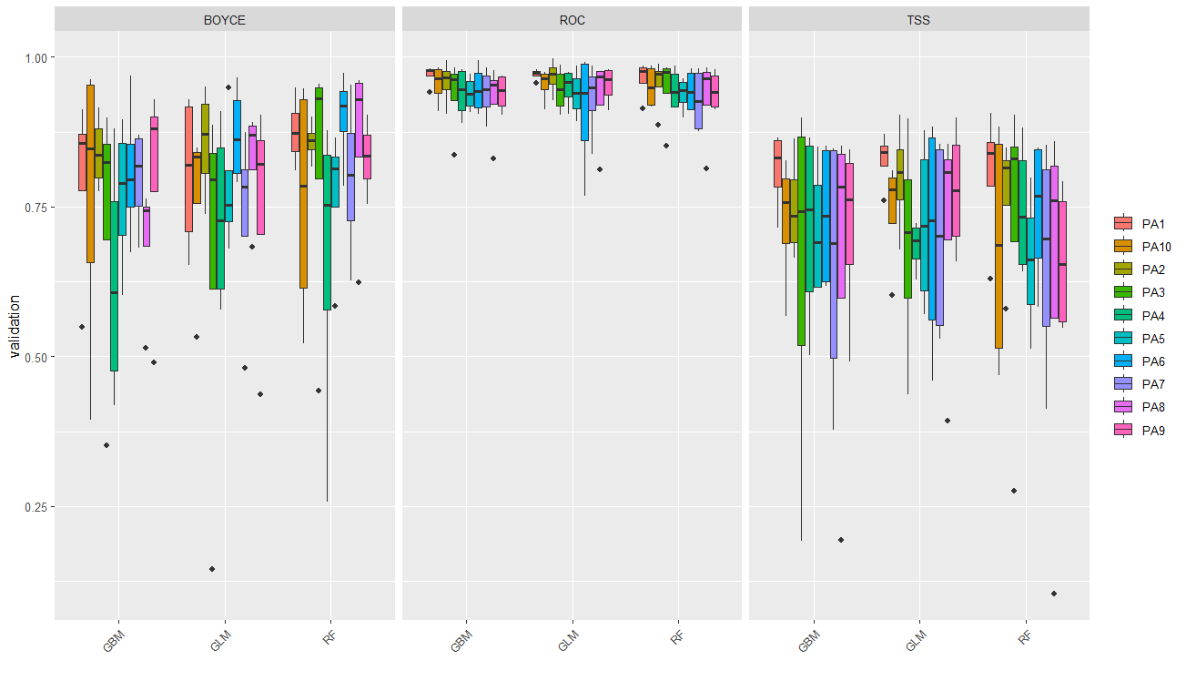
Appendix 1: Evaluation scores for each Pseudo-absence (PA) datasets.

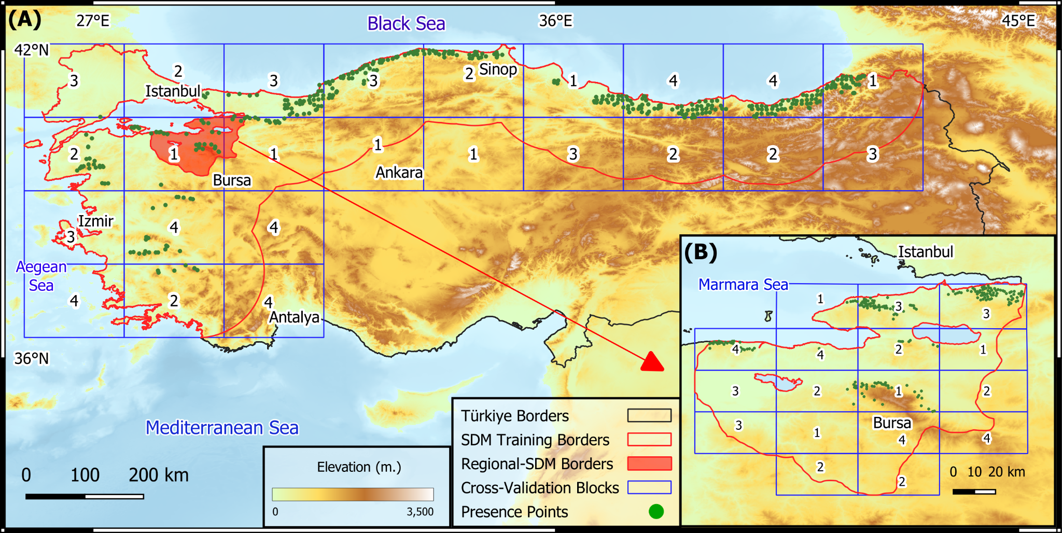
Appendix 2: Example of spatial block configuration used for cross-validation).

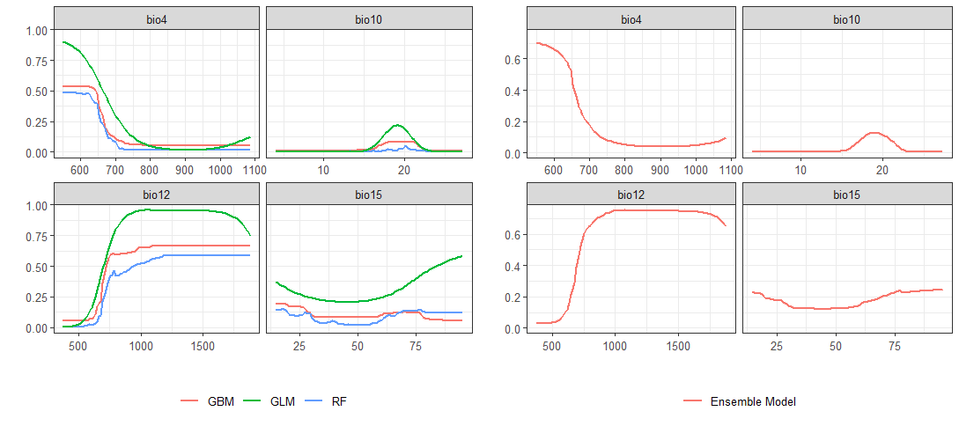
Appendix 3: Response curves of Castanea sativa to selected WorldClim 2.1 bioclimatic variables, illustrating the species' climatic preferences and tolerance ranges.

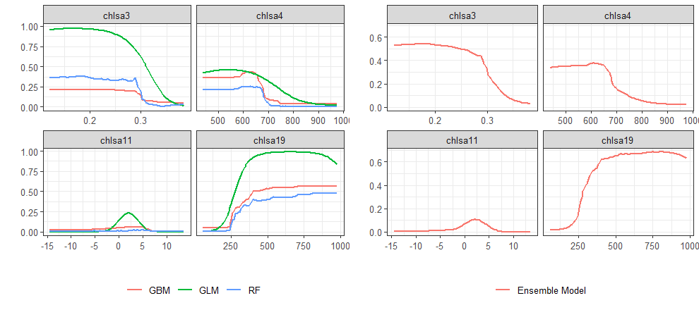
Appendix 4: Response curves of Castanea sativa to selected CHELSA2.1 bioclimatic variables, illustrating the species' climatic preferences and tolerance ranges.

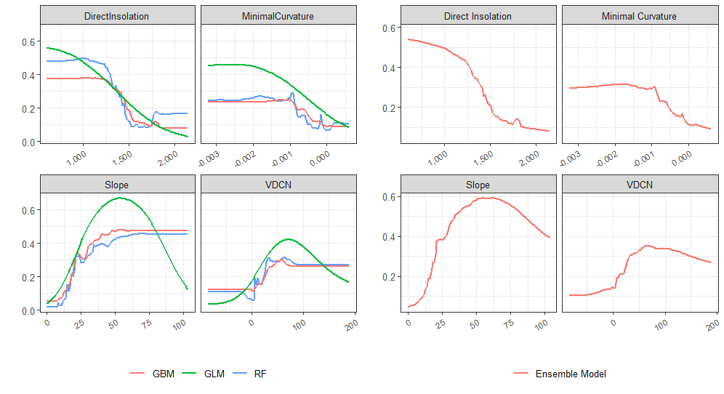
Appendix 5: Response curves of variables used in regional-scale SDMs. The curves illustrate the relationship between environmental variables (Direct Insolation, Minimal Curvature, Slope, and VDCN) and the probability of species presence, showing the results for RF, GLM, and GBM algorithms (left panels) and the combined (ensemble) model (right panels).

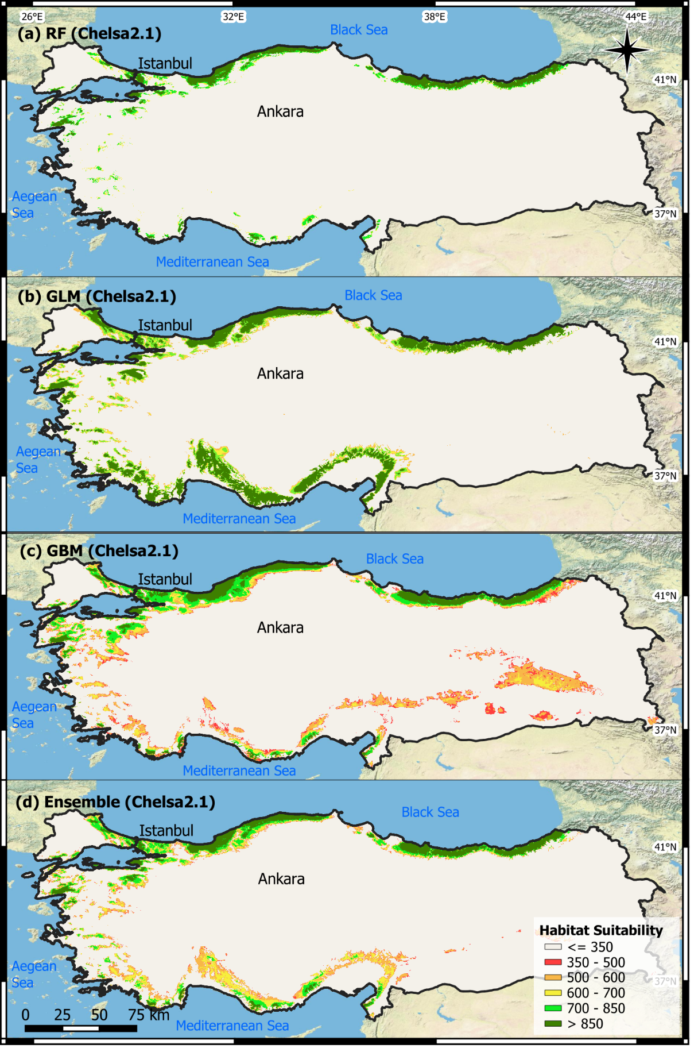
Appendix 6: Predicted current habitat suitability for Castanea sativa Mill. in Türkiye at a national scale using the CHELSA 2.1 dataset. Maps illustrate the results from three individual Species Distribution Model (SDM) algorithms (RF, GLM, GBM) and their ensemble prediction.
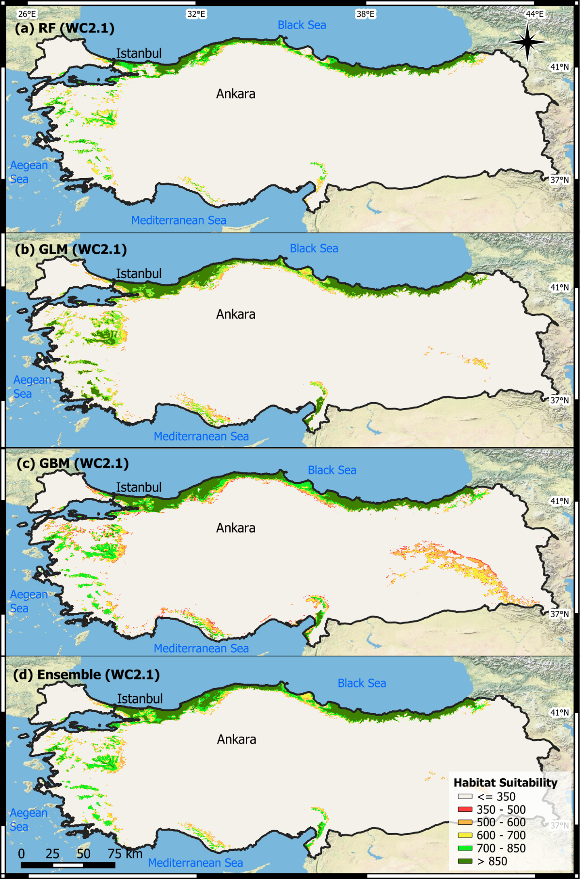
Appendix 7: Predicted current habitat suitability for Castanea sativa Mill. in Türkiye at a national scale using the WORLDCLIM 2.1 dataset. Maps illustrate the results from three individual Species Distribution Model (SDM) algorithms (RF, GLM, GBM) and their ensemble prediction.
Appendix-Table 1: Tuning parameters for each algorithm and models (bm_Tuning table).
Run | formula (GLM) | mtry (RF) | n.trees (GBM) | interaction.depth (GBM) | shrinkage (GBM) | bag.fraction (GBM)
_PA1_RUN1 | check .csv | 1 | 500 | 2 | 0.01 | 0.5
_PA1_RUN2 | check .csv | 2 | 1000 | 8 | 0.01 | 0.5
_PA1_RUN3 | check .csv | 1 | 2500 | 8 | 0.1 | 0.5
_PA1_RUN4 | check .csv | 2 | 1000 | 5 | 0.1 | 0.5
_PA2_RUN1 | check .csv | 1 | 500 | 8 | 0.1 | 0.5
_PA2_RUN2 | check .csv | 1 | 1000 | 5 | 0.01 | 0.5
_PA2_RUN3 | check .csv | 2 | 500 | 8 | 0.1 | 0.5
_PA2_RUN4 | check .csv | 1 | 1000 | 8 | 0.1 | 0.5
_PA3_RUN1 | check .csv | 2 | 2500 | 8 | 0.1 | 0.5
_PA3_RUN2 | check .csv | 2 | 2500 | 5 | 0.1 | 0.5
_PA3_RUN3 | check .csv | 3 | 2500 | 8 | 0.1 | 0.5
_PA3_RUN4 | check .csv | 1 | 2500 | 8 | 0.1 | 0.5
_PA4_RUN1 | check .csv | 1 | 2500 | 8 | 0.01 | 0.5
_PA4_RUN2 | check .csv | 4 | 2500 | 8 | 0.1 | 0.5
_PA4_RUN3 | check .csv | 1 | 2500 | 8 | 0.1 | 0.5
_PA4_RUN4 | check .csv | 1 | 2500 | 8 | 0.1 | 0.5
_PA5_RUN1 | check .csv | 2 | 2500 | 8 | 0.01 | 0.5
_PA5_RUN2 | check .csv | 1 | 500 | 8 | 0.1 | 0.5
_PA5_RUN3 | check .csv | 1 | 1000 | 8 | 0.01 | 0.5
_PA5_RUN4 | check .csv | 1 | 2500 | 2 | 0.01 | 0.5
_PA6_RUN1 | check .csv | 1 | 1000 | 5 | 0.1 | 0.5
_PA6_RUN2 | check .csv | 1 | 1000 | 8 | 0.01 | 0.5
_PA6_RUN3 | check .csv | 3 | 2500 | 8 | 0.1 | 0.5
_PA6_RUN4 | check .csv | 1 | 1000 | 2 | 0.1 | 0.5
_PA7_RUN1 | check .csv | 4 | 2500 | 5 | 0.01 | 0.5
_PA7_RUN2 | check .csv | 3 | 1000 | 8 | 0.1 | 0.5
_PA7_RUN3 | check .csv | 3 | 500 | 8 | 0.01 | 0.5
_PA7_RUN4 | check .csv | 2 | 2500 | 8 | 0.1 | 0.5
_PA8_RUN1 | check .csv | 1 | 2500 | 8 | 0.1 | 0.5
_PA8_RUN2 | check .csv | 2 | 500 | 8 | 0.1 | 0.5
_PA8_RUN3 | check .csv | 2 | 2500 | 8 | 0.01 | 0.5
_PA8_RUN4 | check .csv | 2 | 2500 | 8 | 0.01 | 0.5
_PA9_RUN1 | check .csv | 4 | 1000 | 8 | 0.01 | 0.5
_PA9_RUN2 | check .csv | 1 | 1000 | 8 | 0.01 | 0.5
_PA9_RUN3 | check .csv | 1 | 2500 | 8 | 0.1 | 0.5
_PA9_RUN4 | check .csv | 1 | 2500 | 8 | 0.1 | 0.5
_PA10_RUN1 | check .csv | 2 | 500 | 8 | 0.1 | 0.5
_PA10_RUN2 | check .csv | 2 | 1000 | 8 | 0.1 | 0.5
_PA10_RUN3 | check .csv | 1 | 2500 | 8 | 0.1 | 0.5
_PA10_RUN4 | check .csv | 1 | 1000 | 8 | 0.01 | 0.5
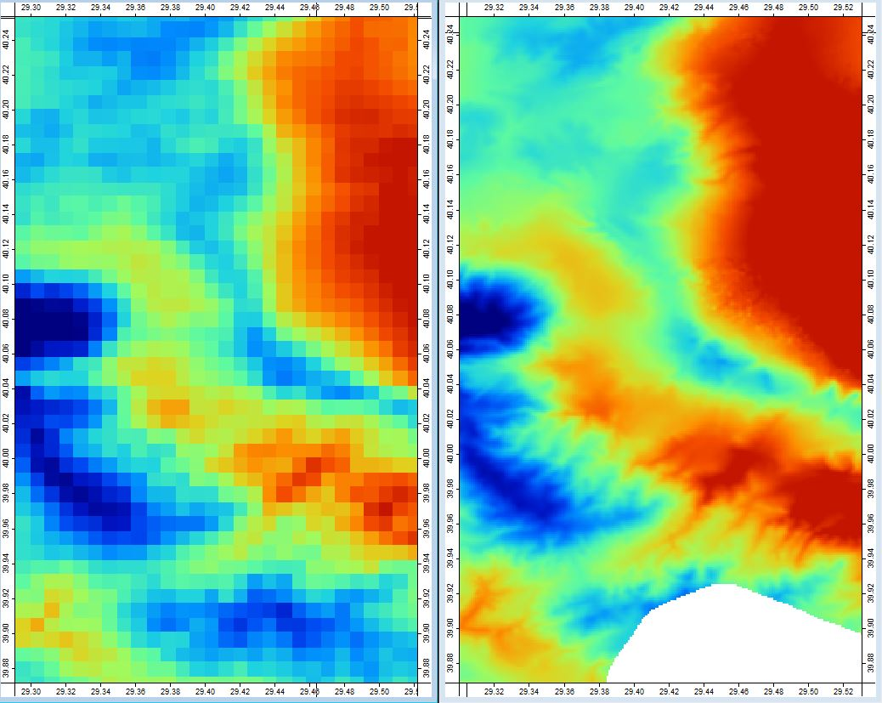
Appendix 8: Transformation of the 1km resolution bioclimatic layer (left) into a 120m high resolution layer (right) using Geographically Weighted Regression (GWR: Brunsdon et al., 1996).

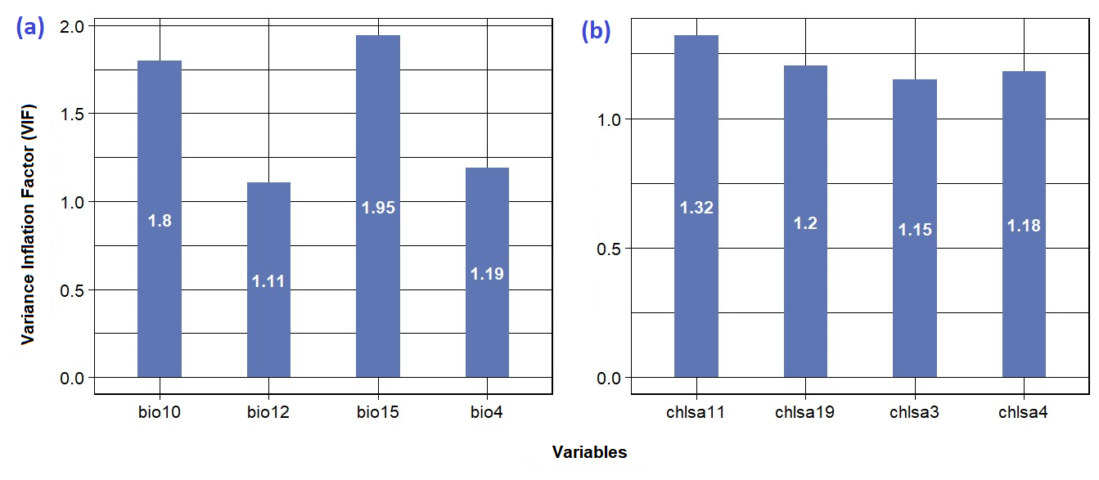
Appendix 9: VIF (Variance Inflation Factor) values for each variable used in both datasets; Worldclim 2.1 (a) and CHELSA 2.1 (b).

Appendix-Table 2: Relative Importance of Climatic Variables from CHELSA and WorldClim Datasets for Species Distribution Models using GBM, RF, and GLM Algorithms.
Algorithm | Method | Variables  (Chelsa) | Variable  Importance | Variables  (Worldclim) | Variable  Importance
GBM | Ensemble | chlsa3 | 0.041017 | bio4 | 0.184338
GBM | Ensemble | chlsa4 | 0.277449 | bio10 | 0.17936
GBM | Ensemble | chlsa9 | 0.183429 | bio12 | 0.416231
GBM | Ensemble | chlsa19 | 0.453203 | bio15 | 0.034962
GBM | Ensemble | chlsa3 | 0.038693 | bio4 | 0.18795
GBM | Ensemble | chlsa4 | 0.276955 | bio10 | 0.178423
GBM | Ensemble | chlsa9 | 0.178949 | bio12 | 0.423267
GBM | Ensemble | chlsa19 | 0.440715 | bio15 | 0.033713
RF | Ensemble | chlsa3 | 0.121624 | bio4 | 0.263777
RF | Ensemble | chlsa4 | 0.294984 | bio10 | 0.188536
RF | Ensemble | chlsa9 | 0.245393 | bio12 | 0.333635
RF | Ensemble | chlsa19 | 0.356299 | bio15 | 0.067436
RF | Ensemble | chlsa3 | 0.12808 | bio4 | 0.245233
RF | Ensemble | chlsa4 | 0.292255 | bio10 | 0.187657
RF | Ensemble | chlsa9 | 0.244833 | bio12 | 0.328789
RF | Ensemble | chlsa19 | 0.350511 | bio15 | 0.0694129
GLM | Ensemble | chlsa3 | 0.151478 | bio4 | 0.163168
GLM | Ensemble | chlsa4 | 0.34792 | bio10 | 0.419229
GLM | Ensemble | chlsa9 | 0.245987 | bio12 | 0.492332
GLM | Ensemble | chlsa19 | 0.477014 | bio15 | 0.006584
GLM | Ensemble | chlsa3 | 0.147092 | bio4 | 0.158255
GLM | Ensemble | chlsa4 | 0.334814 | bio10 | 0.439514
GLM | Ensemble | chlsa9 | 0.246793 | bio12 | 0.469204
GLM | Ensemble | chlsa19 | 0.484702 | bio15 | 0.006569

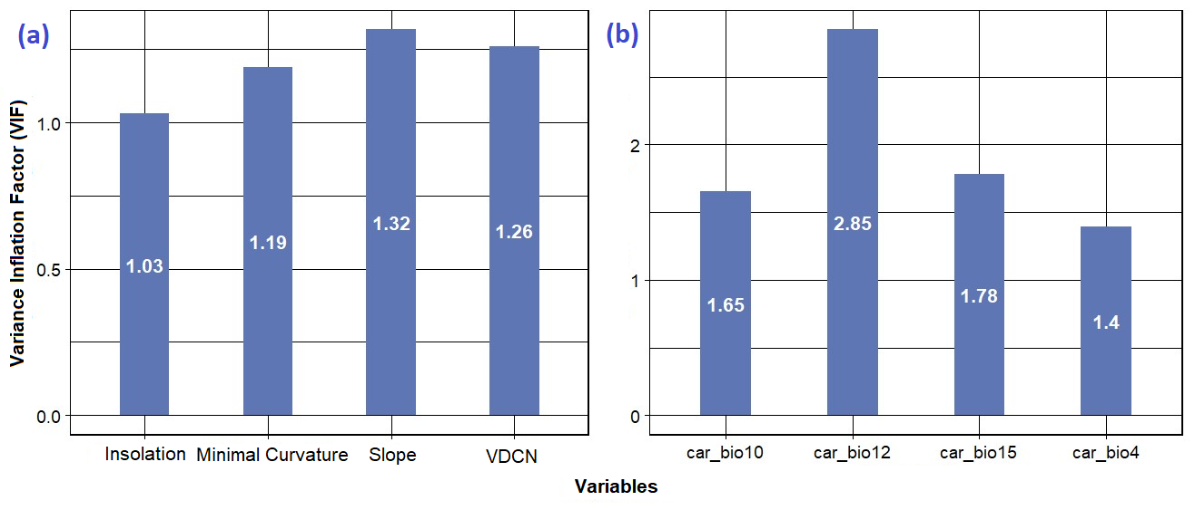
Appendix 10: VIF (Variance Inflation Factor) values for Hierarchical SDMs: Topographic SDM (left), Climatic SDM (right).
Appendix-Table 3: Relative Importance of Variables for Hierarchical SDMs for each algorithm.
Algorithm | Evaluation  Yöntemi | Variables | Variable Importance
RF | TSS | Topographic HSM Output | 0.682438
RF | TSS | Direct Insolation | 0.00460499999999997
RF | TSS | Minimal Curvature | 0.012245
RF | TSS | Slope | 0.137146
RF | TSS | Vertical Distance to Channel Networks | 0.031772
GBM | TSS | Topographic HSM Output | 0.818641
GBM | TSS | Direct Insolation | 0.000959000000000043
GBM | TSS | Minimal Curvature | 0.00175499999999995
GBM | TSS | Slope | 0.077339
GBM | TSS | Vertical Distance to Channel Networks | 0.025657
GLM | TSS | Topographic HSM Output | 0.820675
GLM | TSS | Direct Insolation | 0.00213200000000002
GLM | TSS | Minimal Curvature | 0.00107800000000002
GLM | TSS | Slope | 0.125971
GLM | TSS | Vertical Distance to Channel Networks | 0.040733

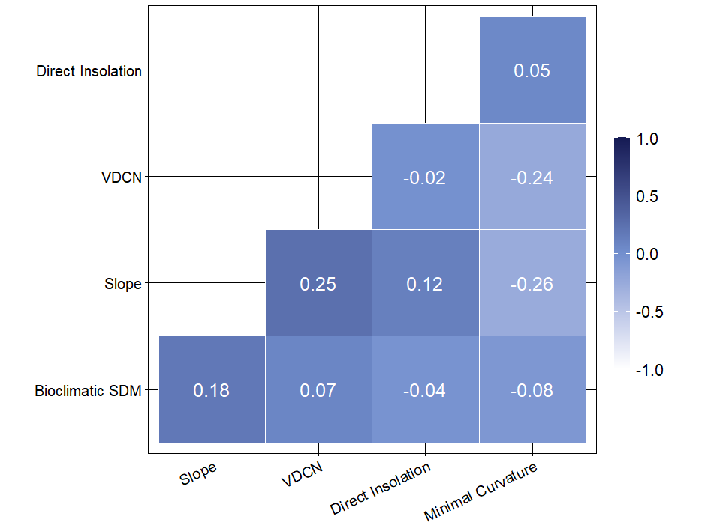
Appendix 11: Correlation values among the variables used to construct final hierarchical model at the regional scale.

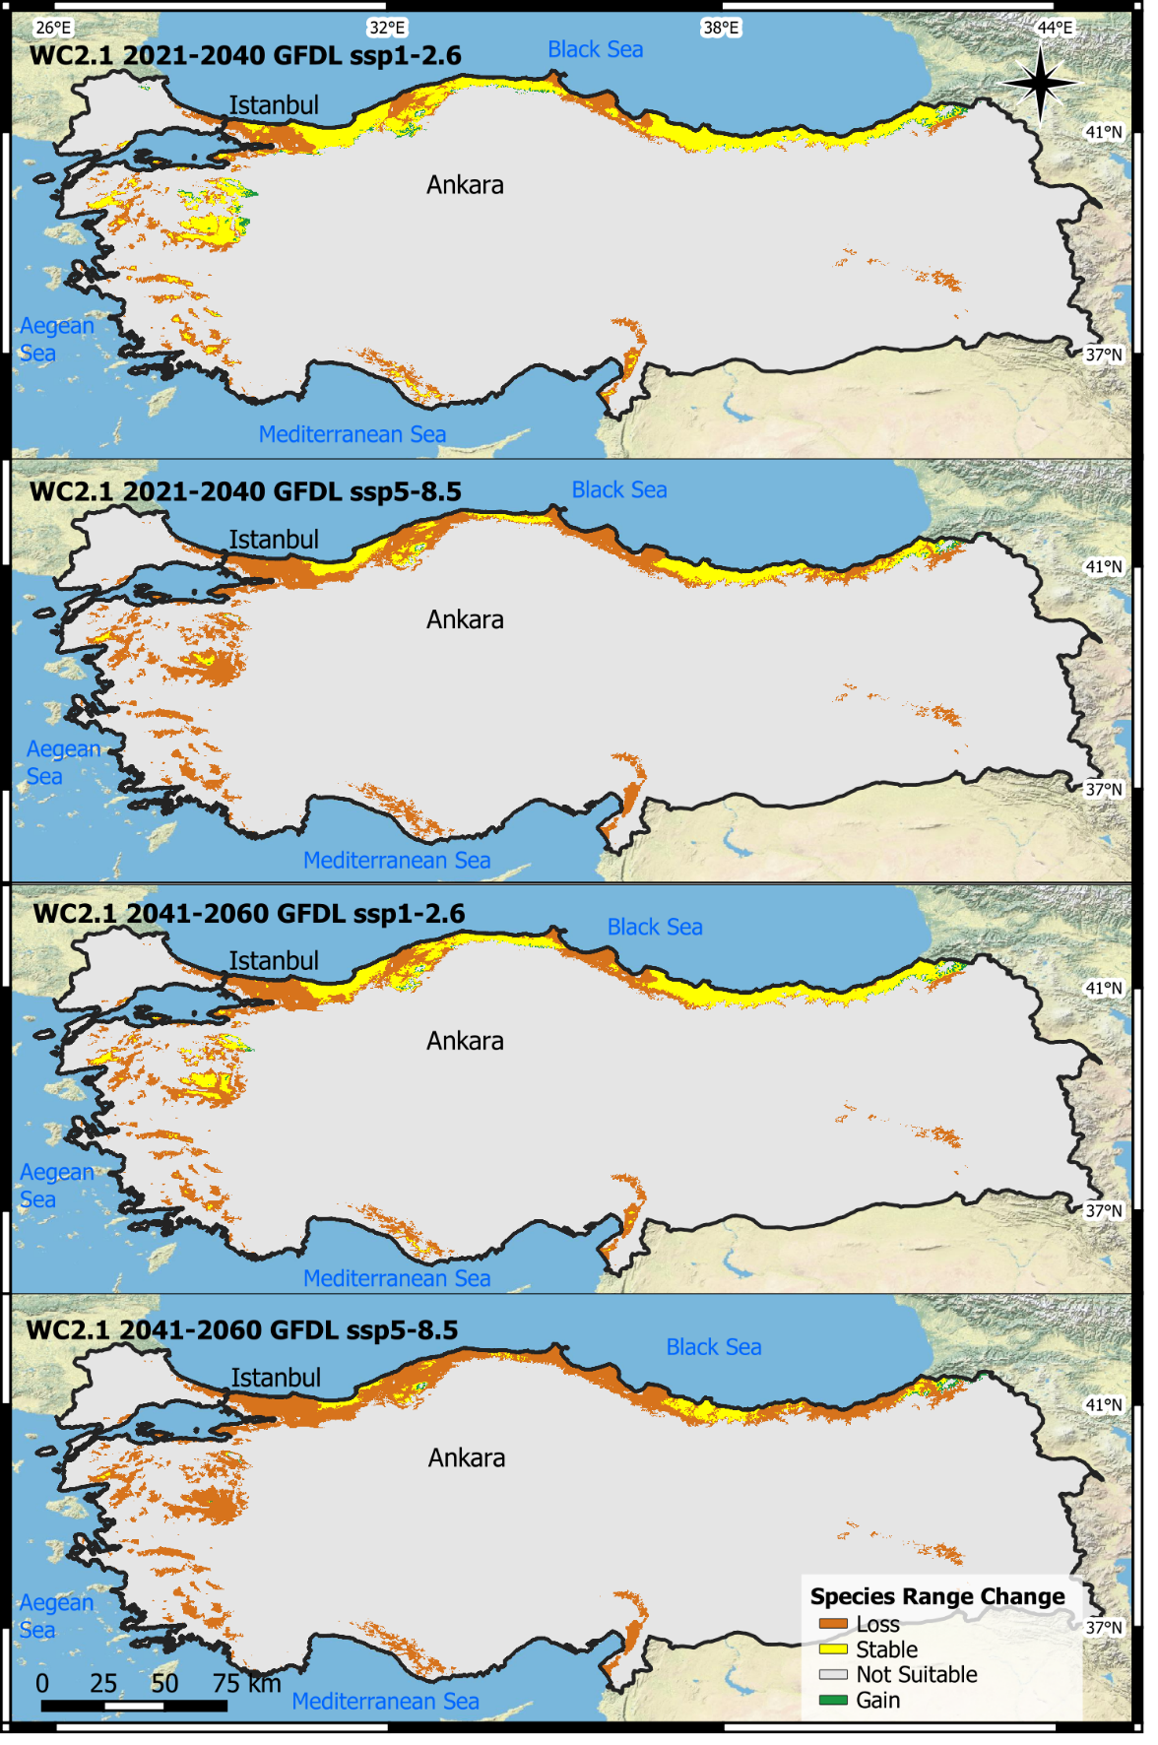
Appendix 12: Projected habitat changes for the species in Türkiye based on WorldClim 2.1 data and GFDL GCM models.

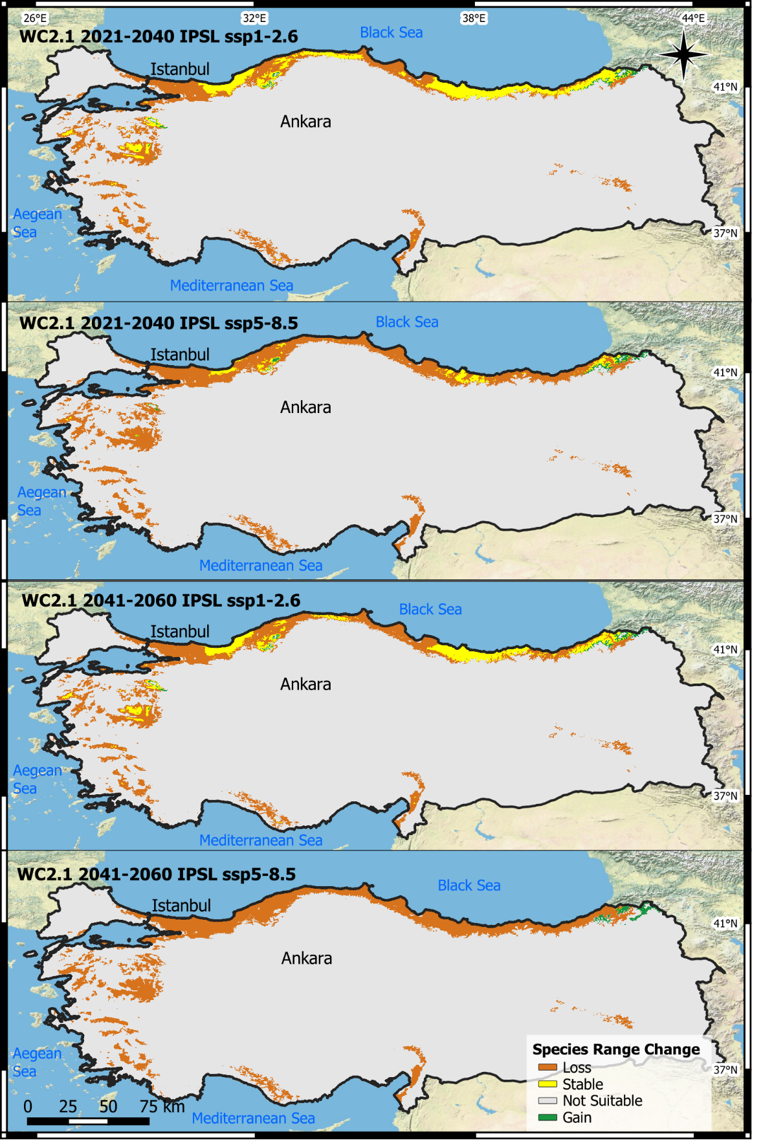
Appendix 13: Projected habitat changes for the species in Türkiye based on WorldClim 2.1 data and IPSL GCM models.
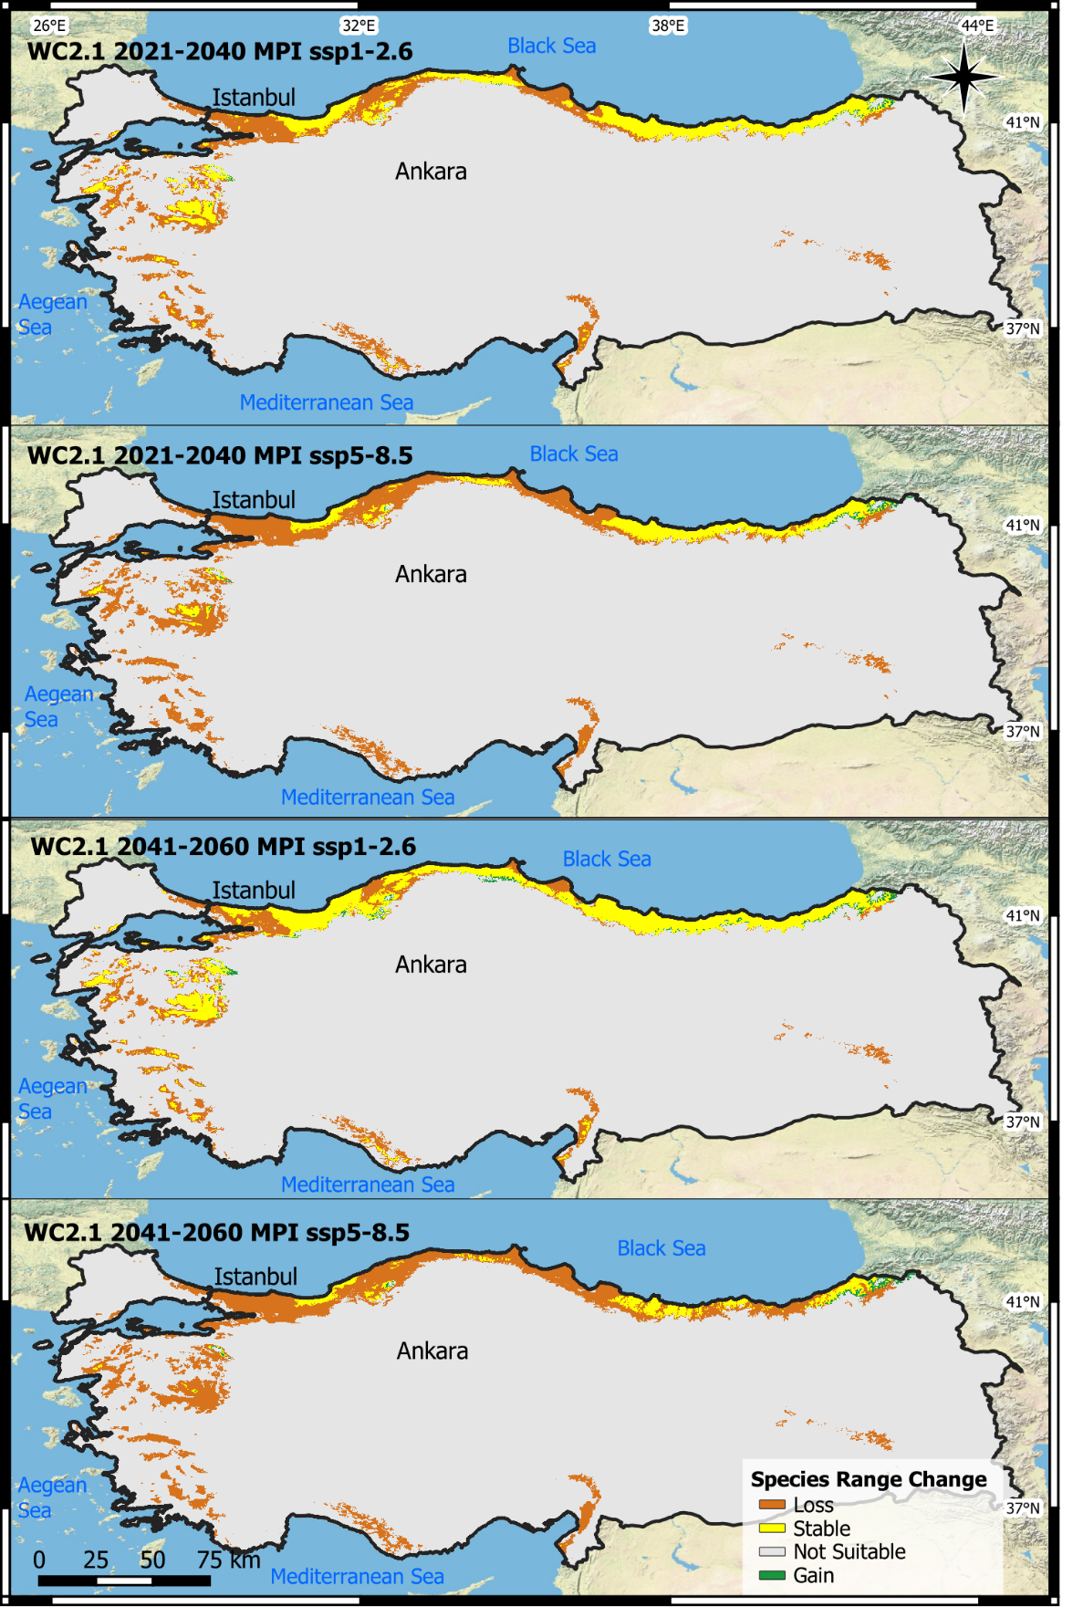
Appendix 14: Projected habitat changes for the species in Türkiye based on WorldClim 2.1 data and MPI GCM models.

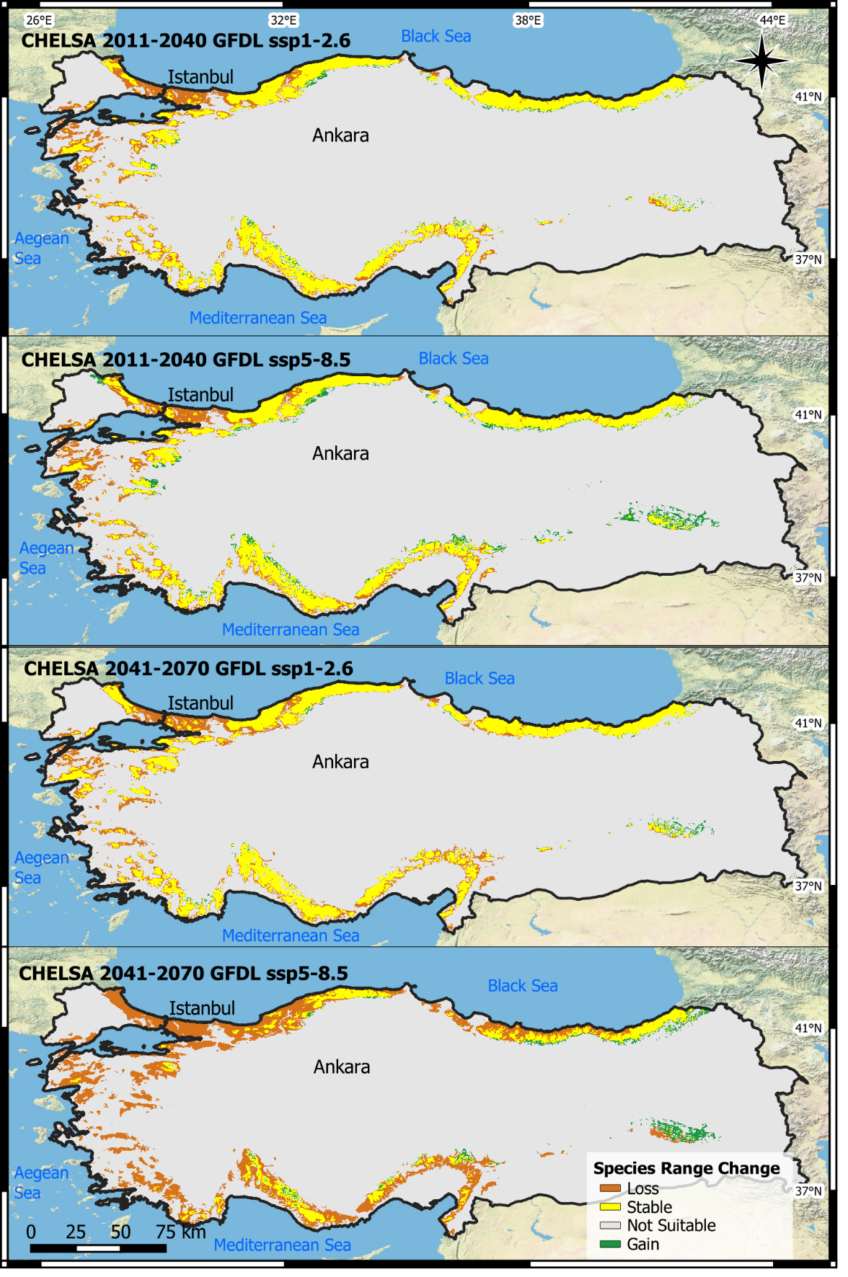
Appendix 15: Projected habitat changes for the species in Türkiye based on CHELSA 2.1 data and GFDL GCM models.

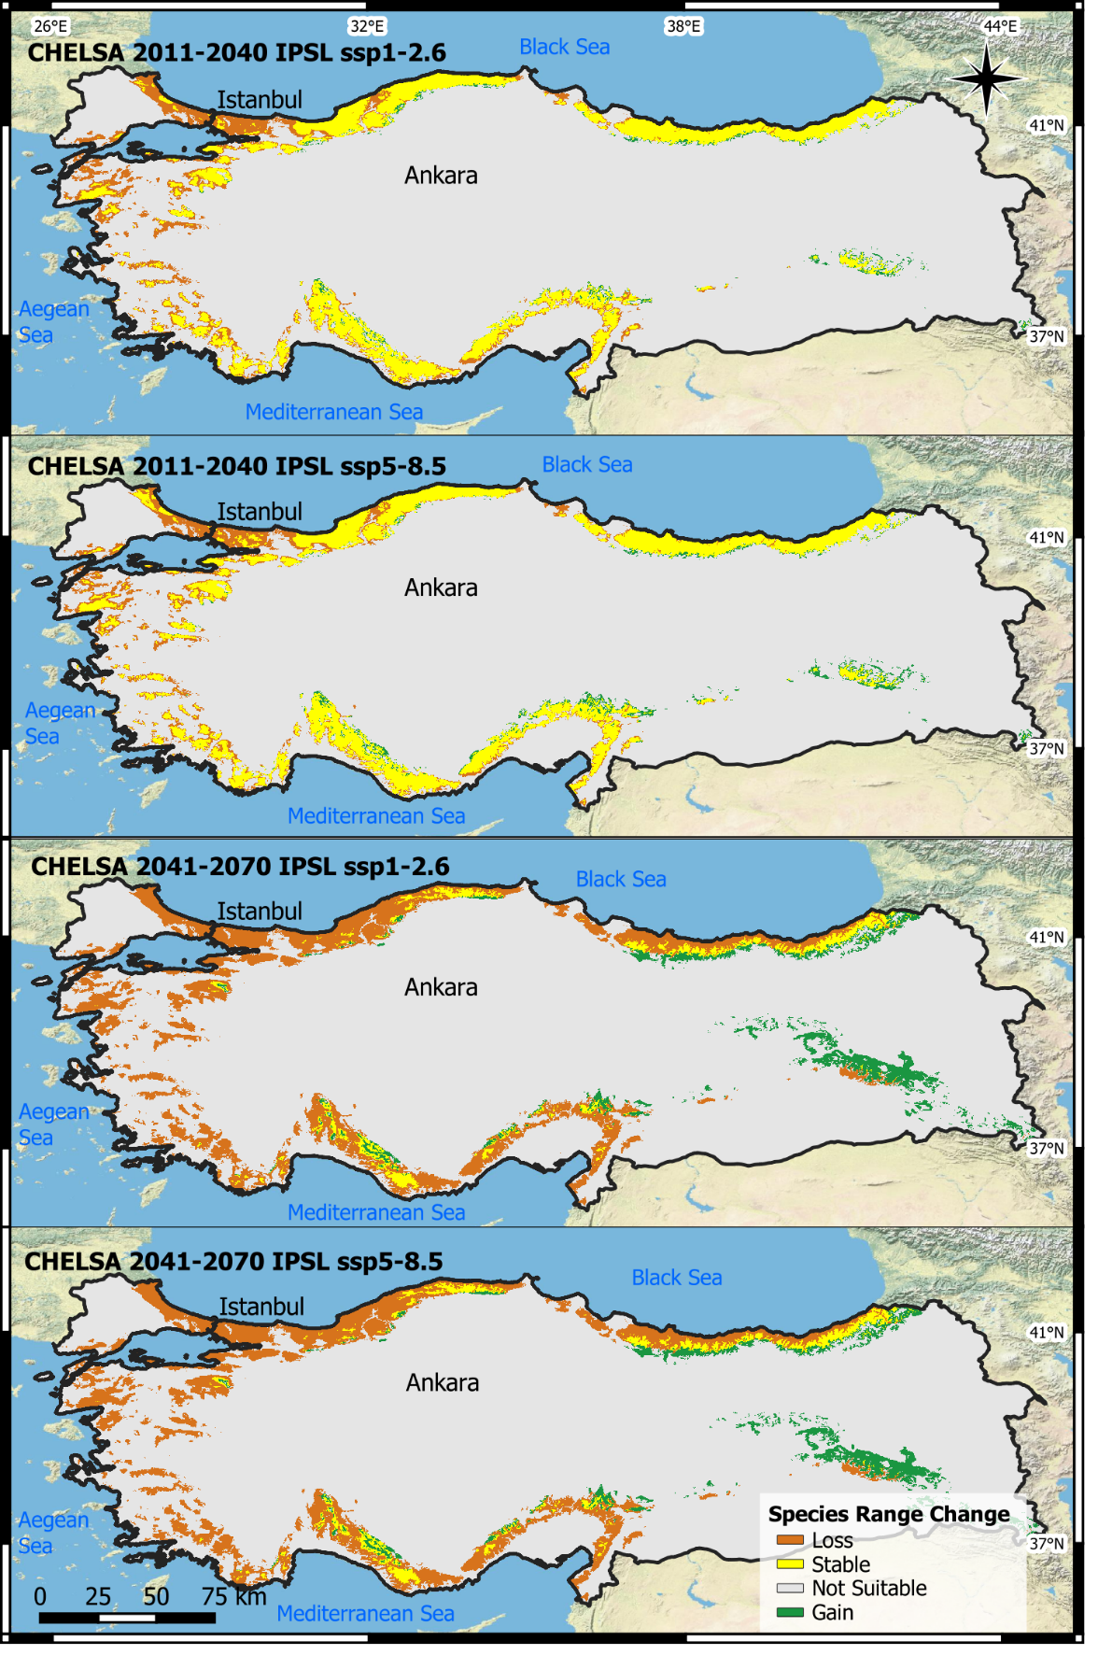
Appendix 16: Projected habitat changes for the species in Türkiye based on CHELSA 2.1 data and IPSL GCM models.

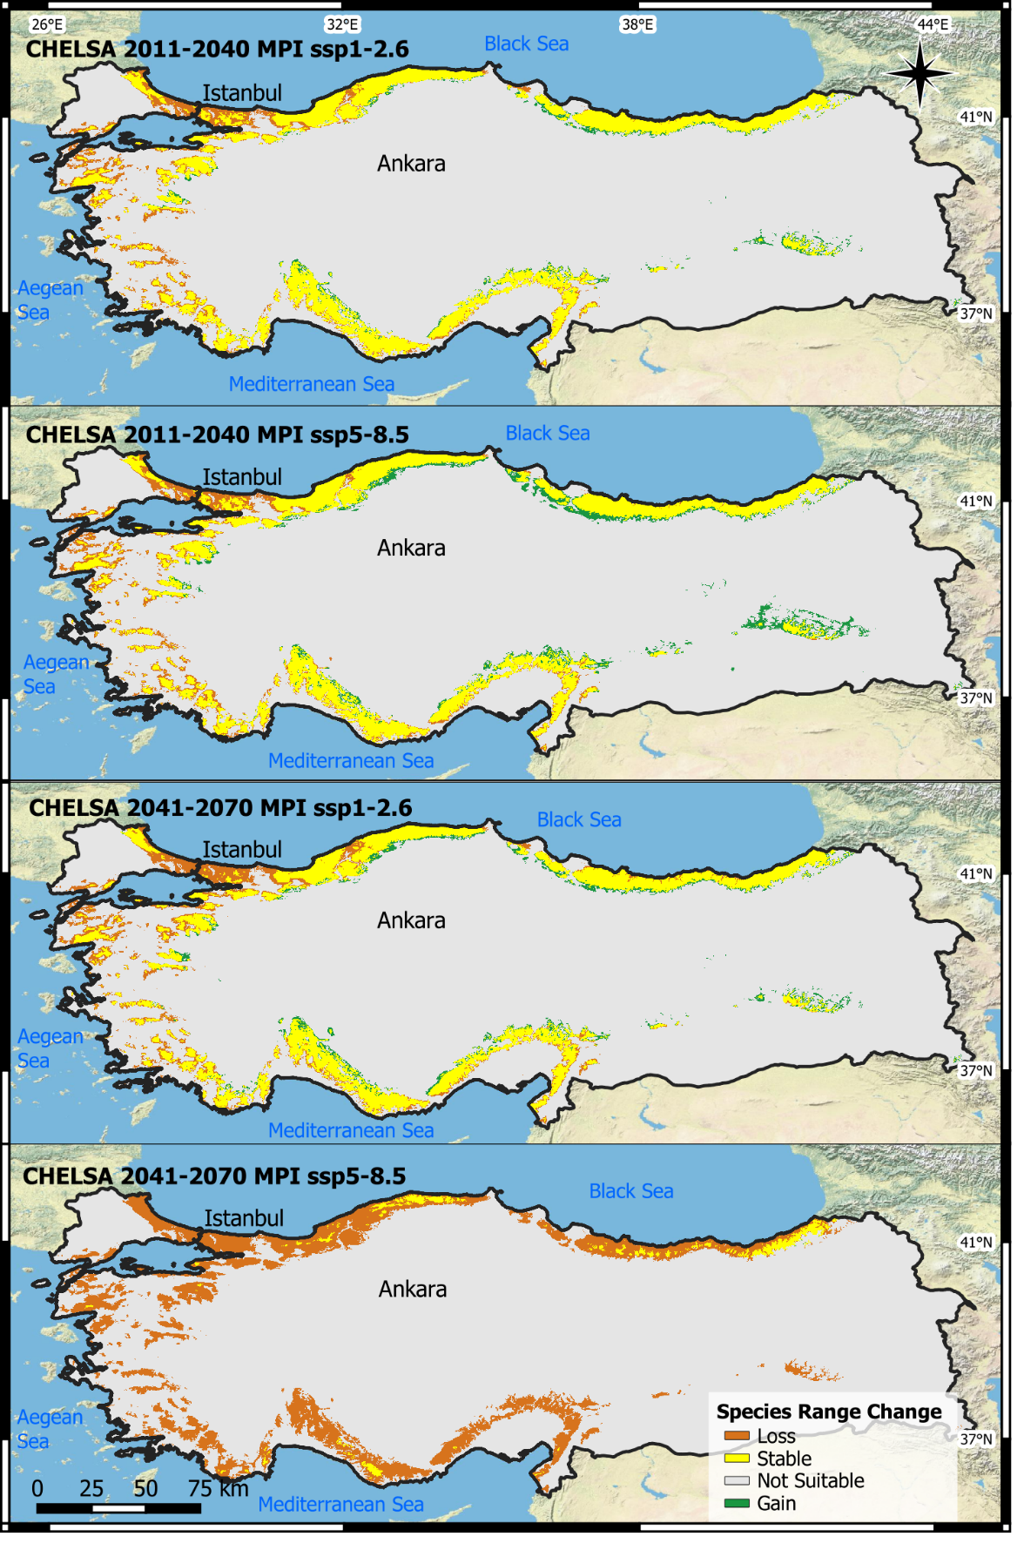
Appendix 17: Projected habitat changes for the species in Türkiye based on CHELSA 2.1 data and MPI GCM models.

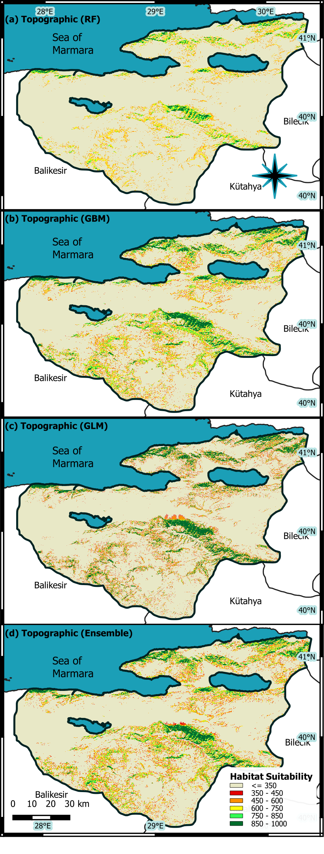
Appendix 18: Regional-scale habitat suitability models developed using topographic and hydrological variables. The models presented show results derived using the RF, GBM, and GLM algorithms, respectively, with the final panel illustrating the Ensemble Model result, which represents the average of the three algorithms.
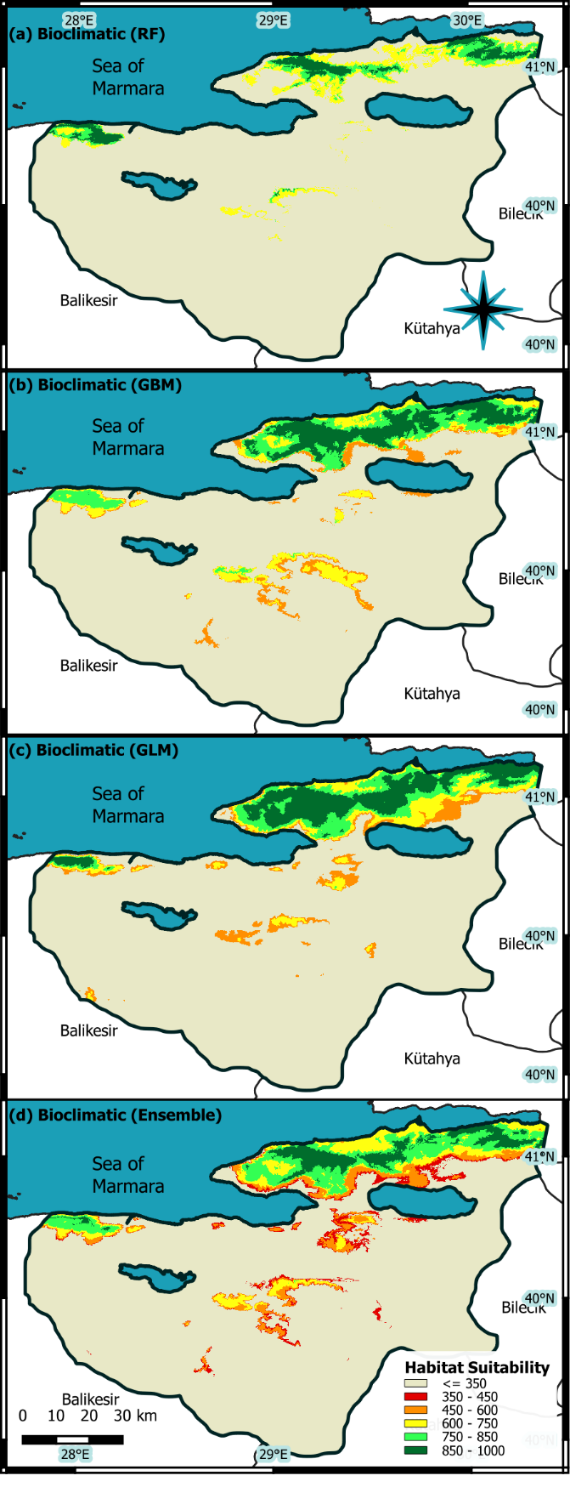
Appendix 19: Regional-scale habitat suitability models generated using bioclimate variables with enhanced resolution via the GWR method. The panels show the results derived using the RF, GBM, and GLM algorithms, respectively, with the final panel illustrating the Ensemble Model result, which represents the average prediction of the three algorithms.
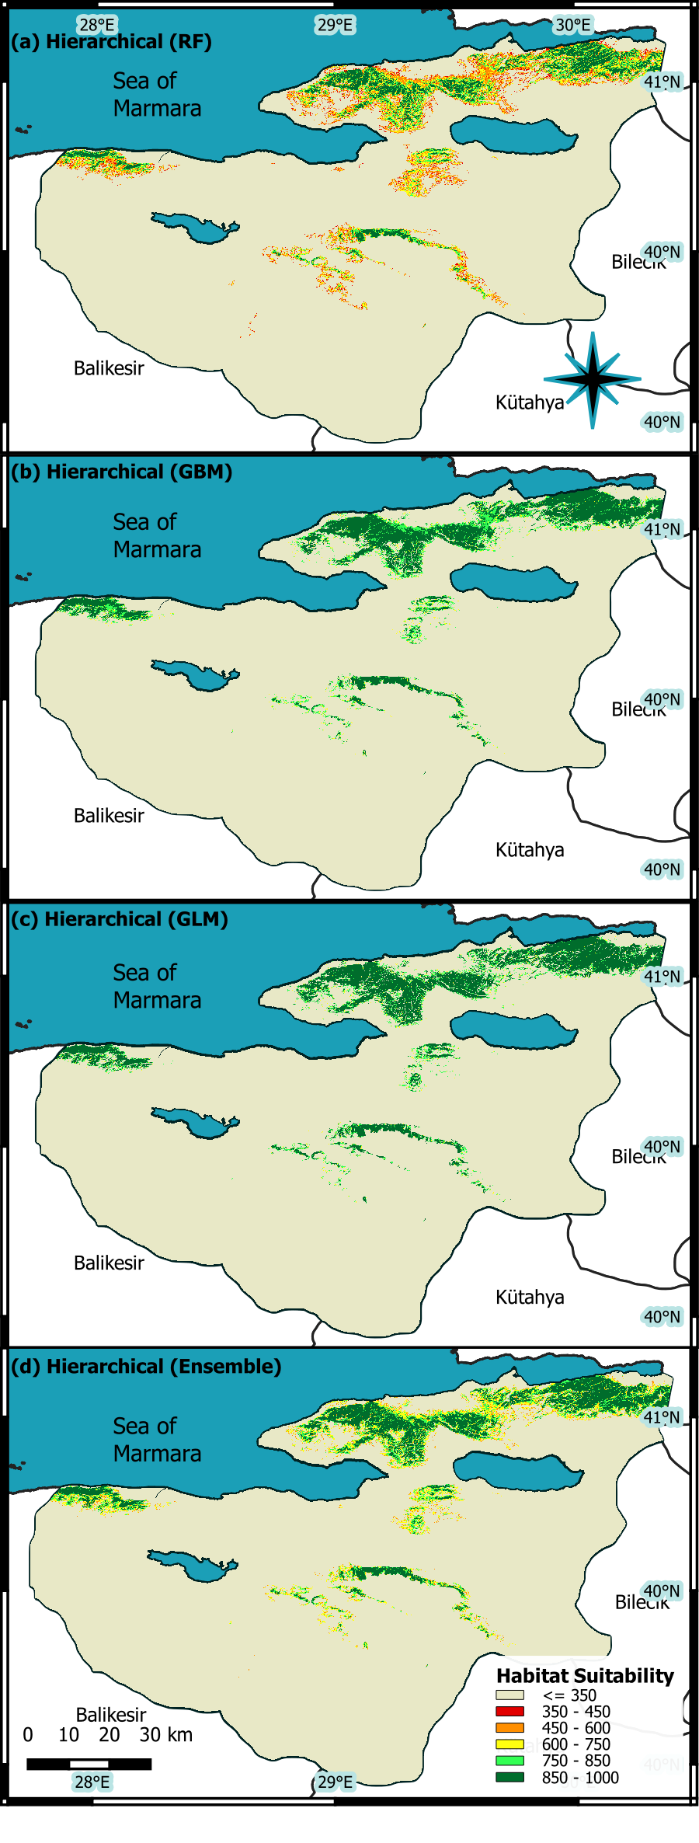
Appendix 20: Regional-scale models developed within the framework of a hierarchical approach. The models were generated using Random Forest (RF), Gradient Boosting Machines (GBM), and Generalized Linear Models (GLM) algorithms, respectively, with the final panel illustrating the Ensemble Model result, which represents the averaged prediction of the three algorithms.
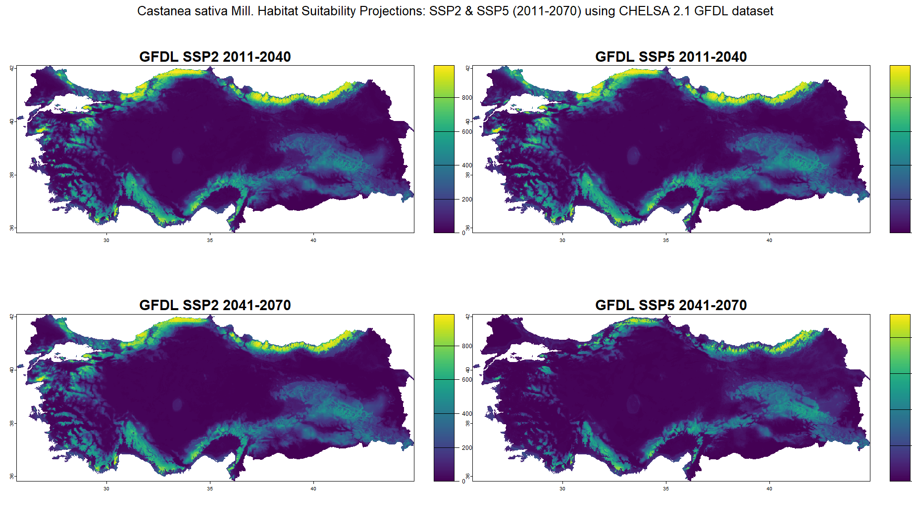
Appendix 21: Habitat suitability projections for Castanea sativa Mill. in Türkiye under SSP2 (left column) and SSP5 (right column) climate scenarios for 2 different periods: 2011–2040 and 2041–2070 using CHELSA2.1 GFDL GCM dataset.
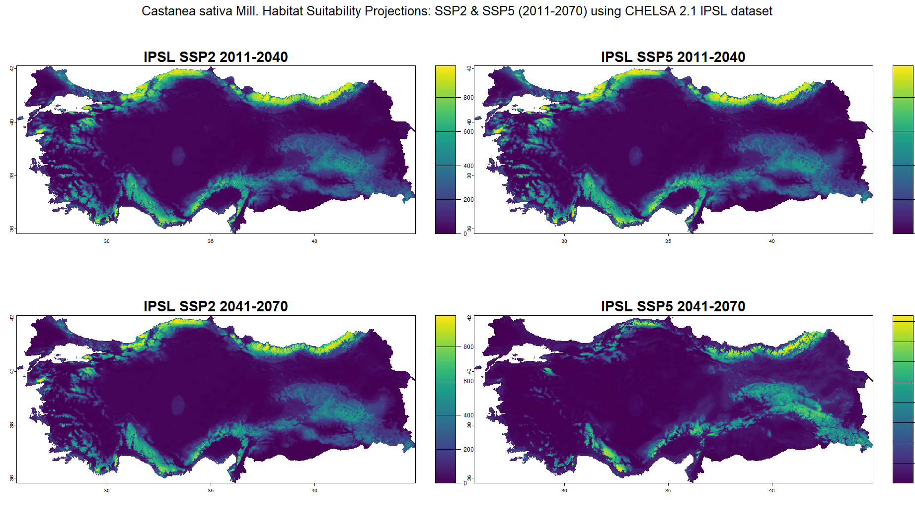
Appendix 22: Habitat suitability projections for Castanea sativa Mill. in Türkiye under SSP2 (left column) and SSP5 (right column) climate scenarios for 2 different periods: 2011–2040 and 2041–2070 using CHELSA2.1 IPSL GCM dataset.
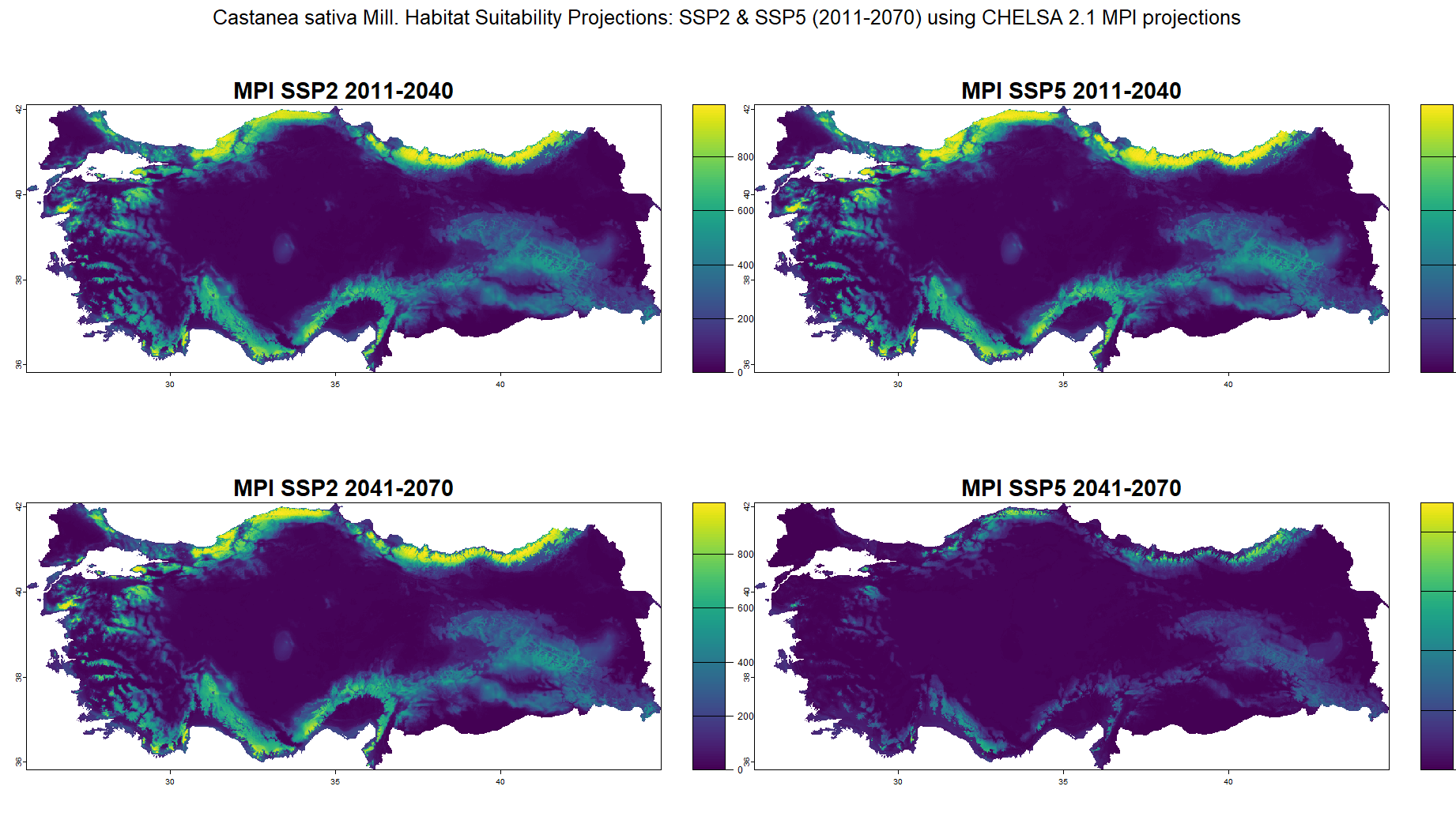
Appendix 23: Habitat suitability projections for Castanea sativa Mill. in Türkiye under SSP2 (left column) and SSP5 (right column) climate scenarios for 2 different periods: 2011–2040 and 2041–2070 using CHELSA2.1 MPI GCM dataset.
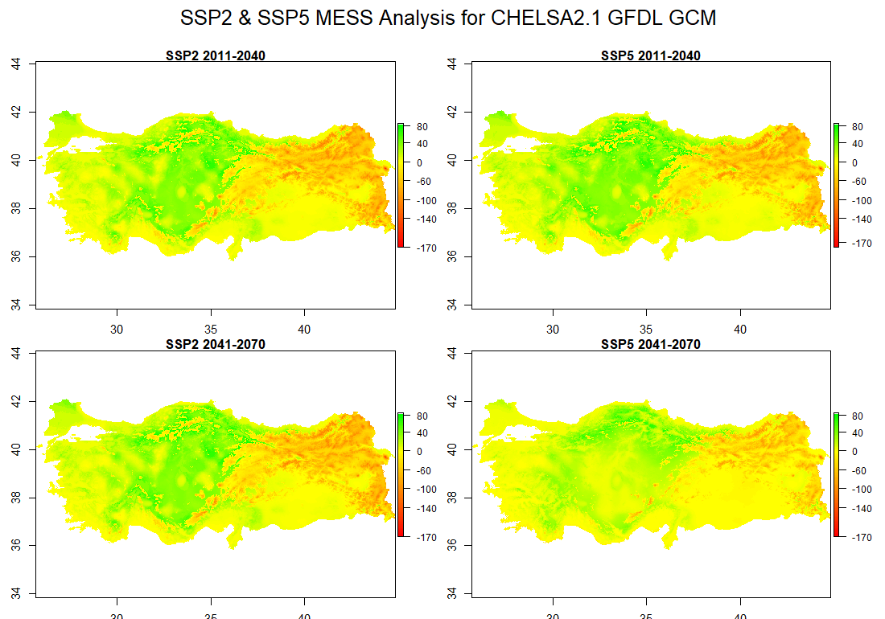
Appendix 24: MESS Analysis for CHELSA 2.1 GFDL GCMs.

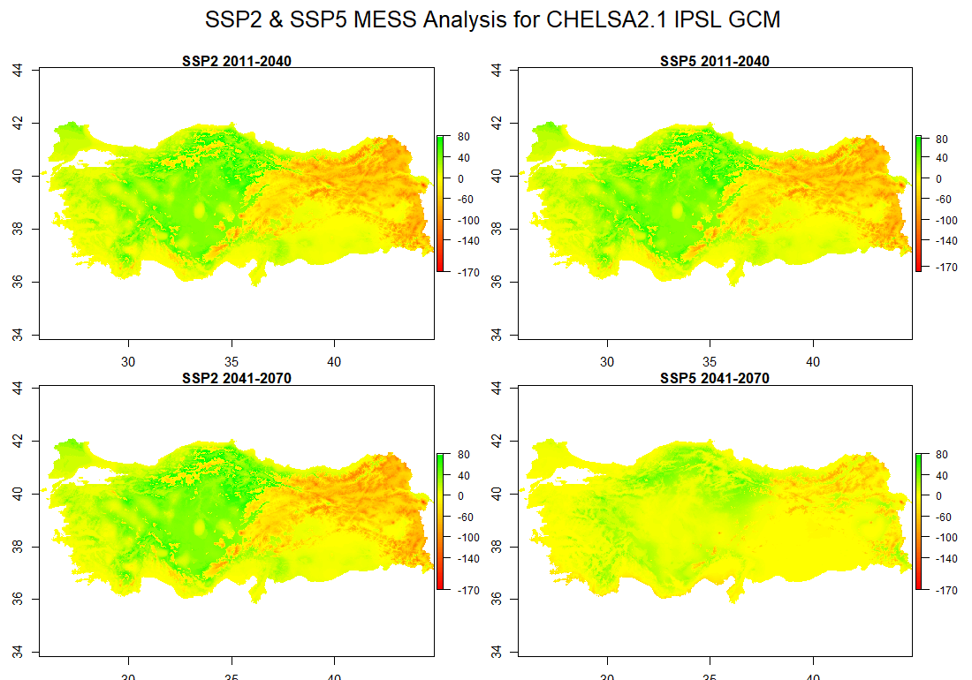
Appendix 25: MESS Analysis for CHELSA 2.1 IPSL GCMs.
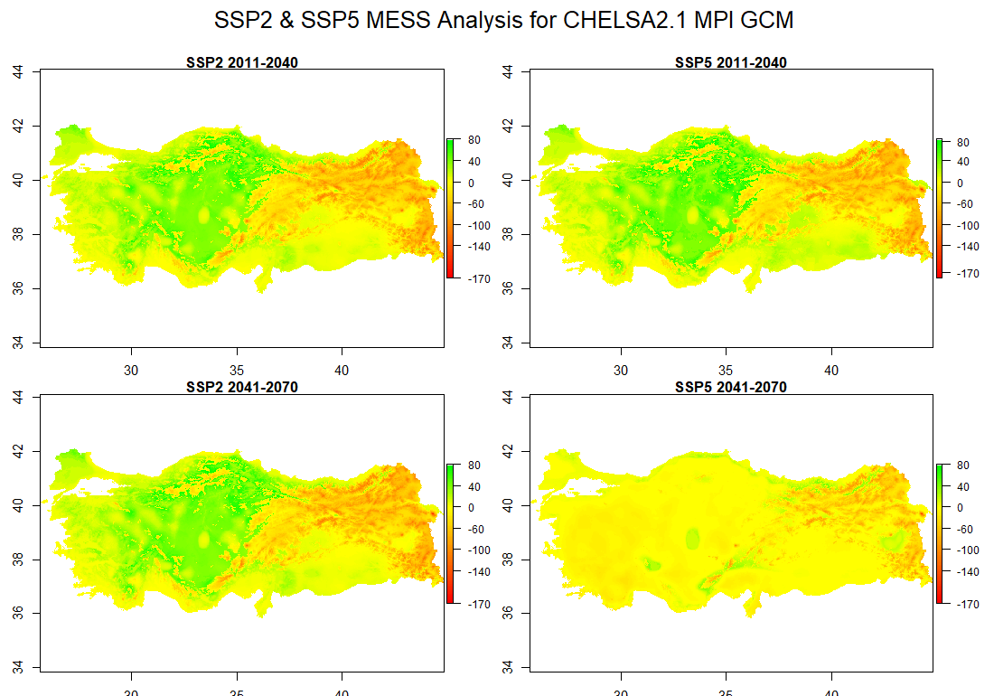
Appendix 26: MESS Analysis for CHELSA 2.1 MPI GCMs.

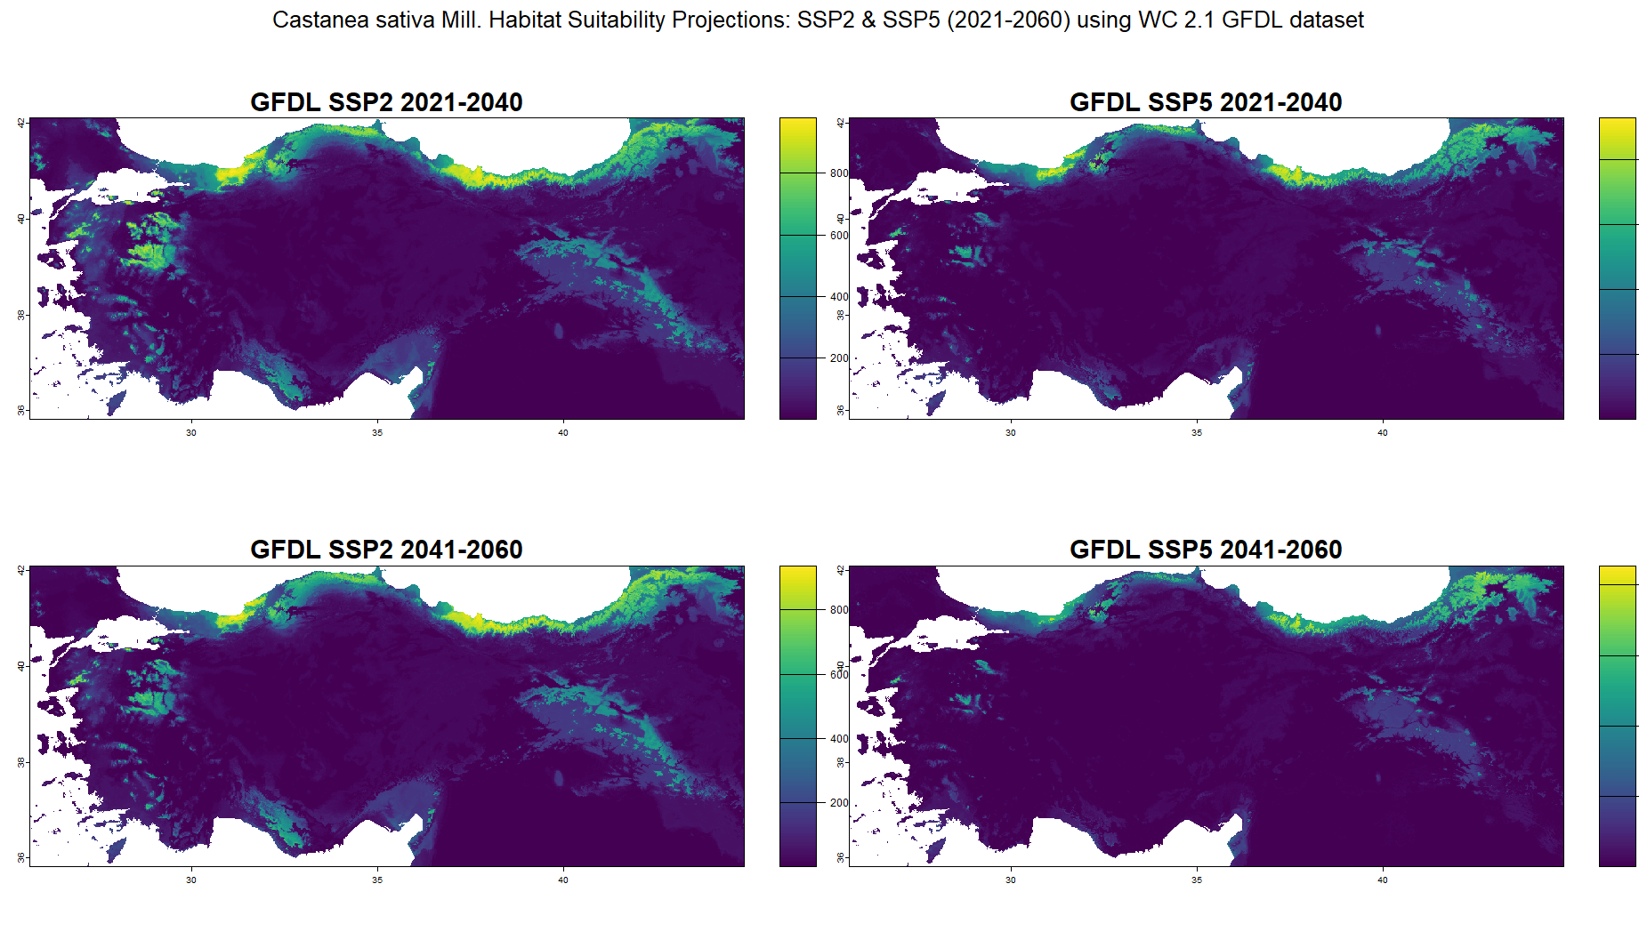
Appendix 27: Habitat suitability projections for Castanea sativa Mill. in Türkiye under SSP2 (left column) and SSP5 (right column) climate scenarios for 2 different periods: 2021–2040 and 2041–2060 using WC 2.1 GFDL GCM dataset.
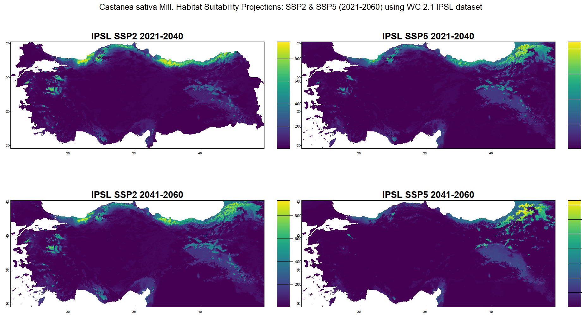
Appendix 28: Habitat suitability projections for Castanea sativa Mill. in Türkiye under SSP2 (left column) and SSP5 (right column) climate scenarios for 2 different periods: 2021–2040 and 2041–2060 using WC 2.1 GFDL GCM dataset.
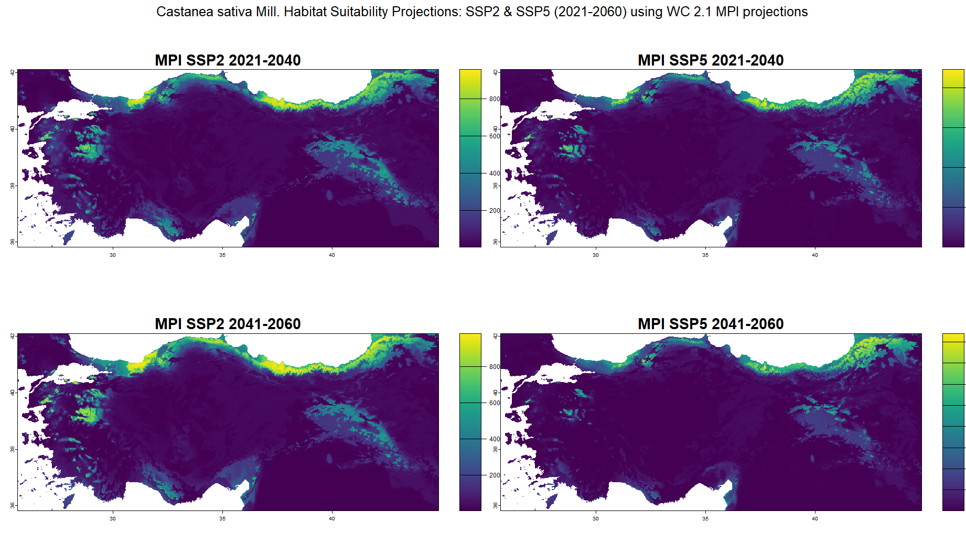
Appendix 29: Habitat suitability projections for Castanea sativa Mill. in Türkiye under SSP2 (left column) and SSP5 (right column) climate scenarios for 2 different periods: 2021–2040 and 2041–2060 using WC 2.1 MPI GCM dataset.
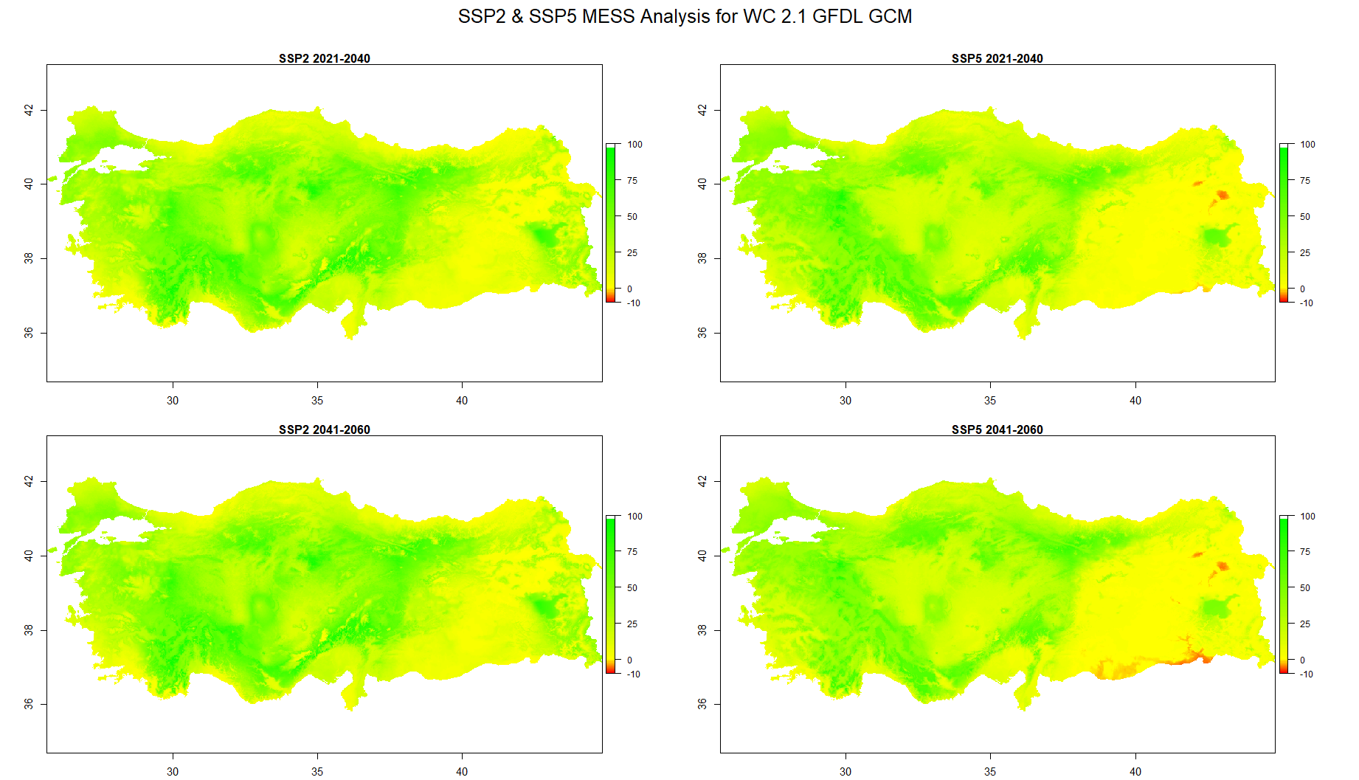
Appendix 30: MESS Analysis for WC 2.1 GFDL GCMs.
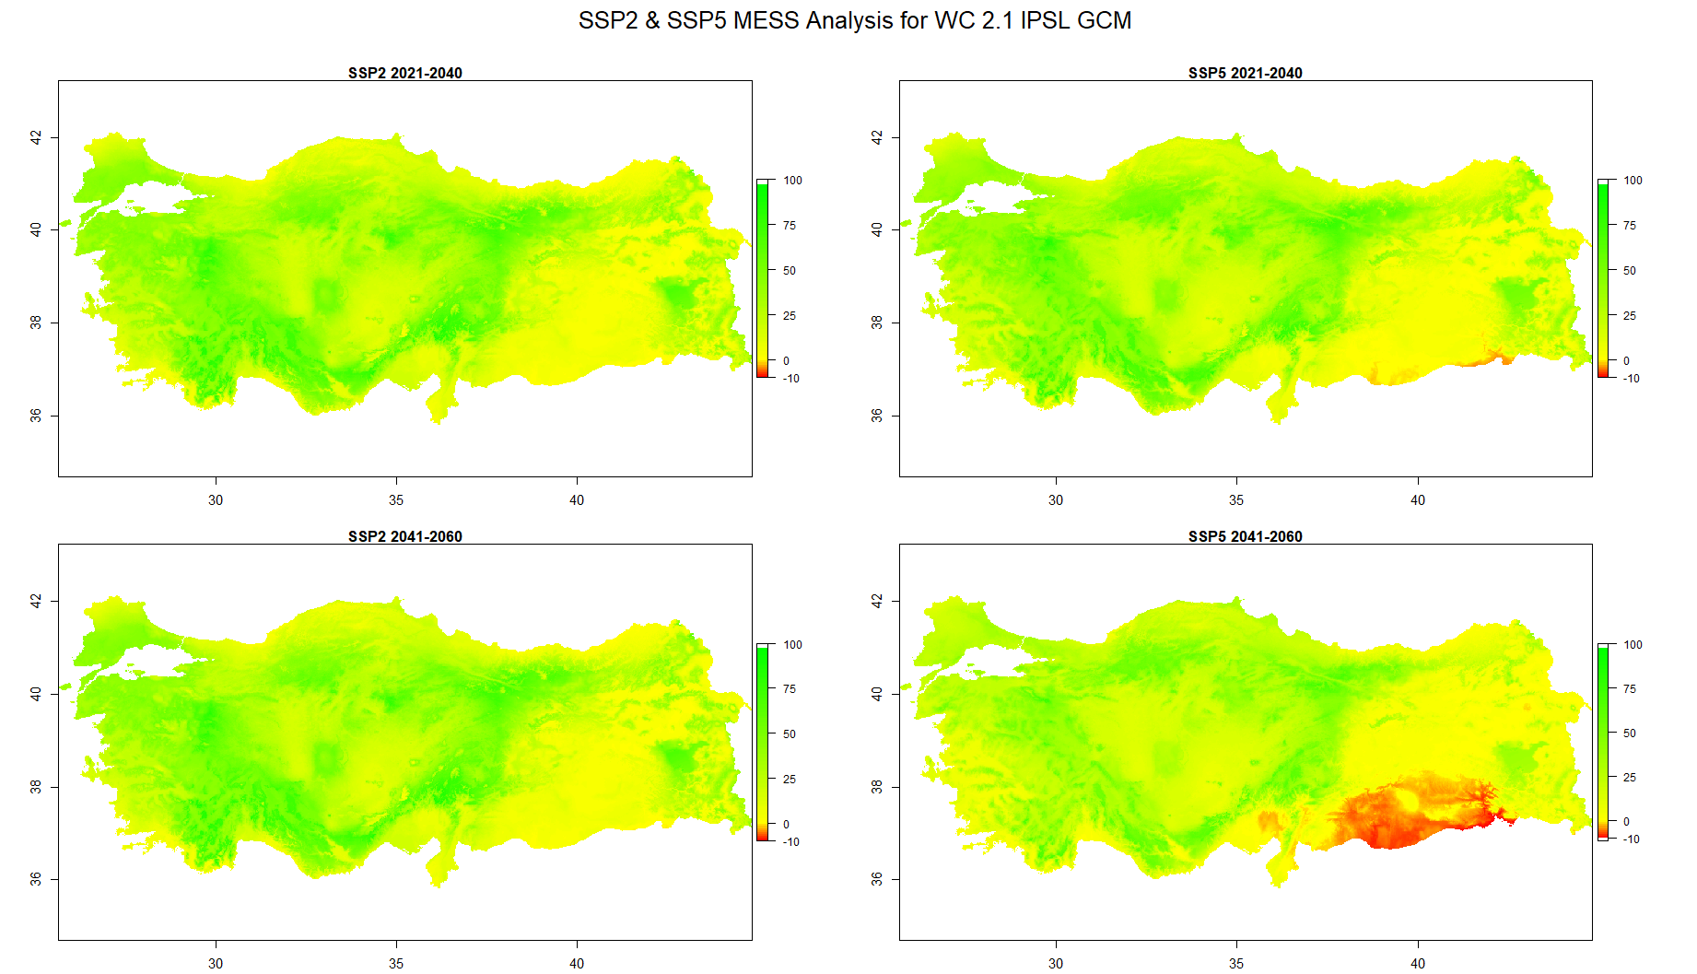
Appendix 31: MESS Analysis for CHELSA 2.1 IPSL GCMs.

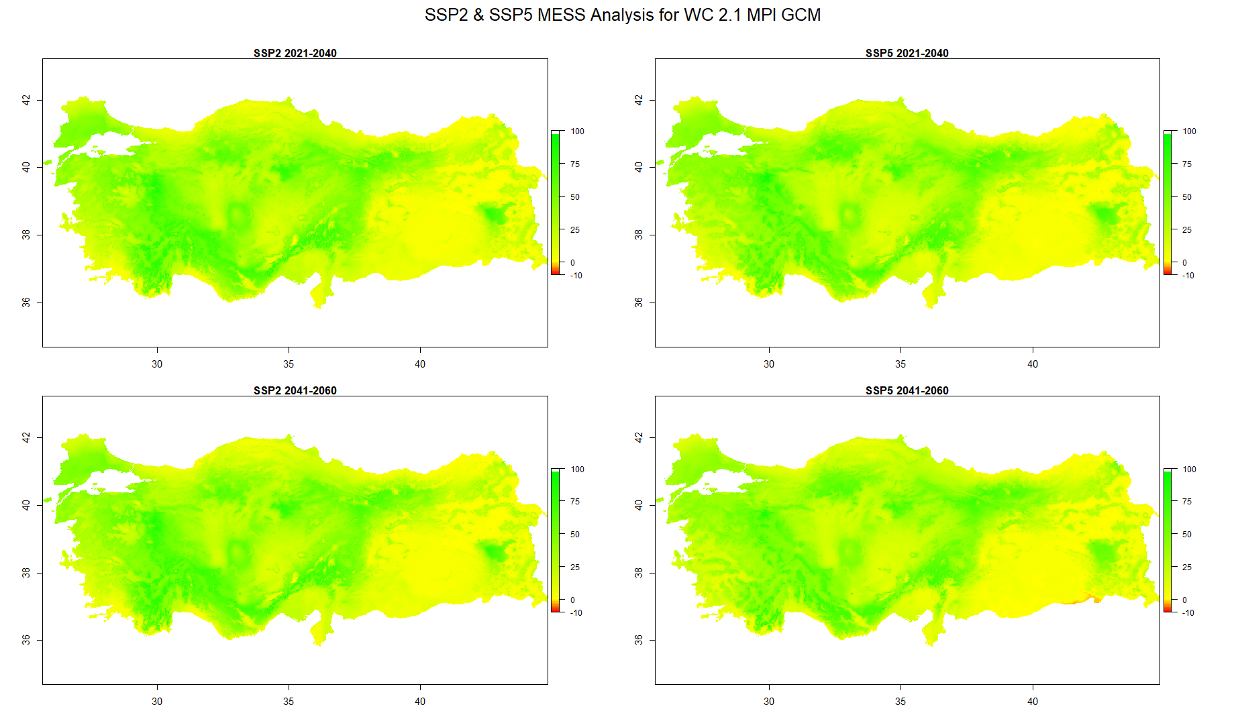
Appendix 32: MESS Analysis for CHELSA 2.1 MPI GCMs.

