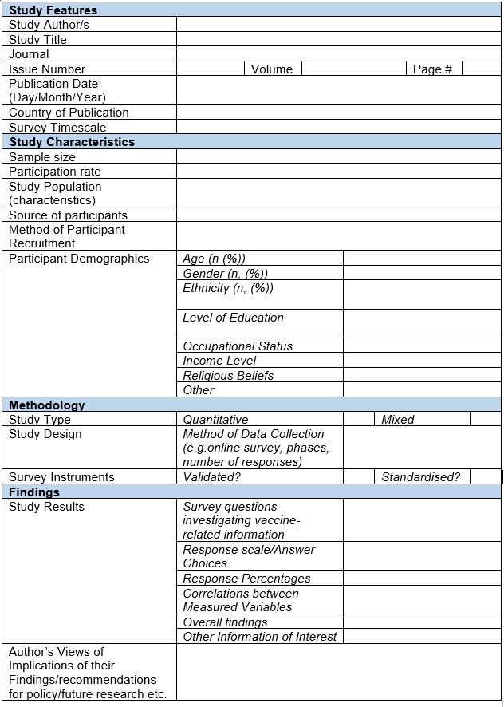
Additional File 4: Data Extraction Form. A copy of the data extraction form used to extract data from each study included in the review.

