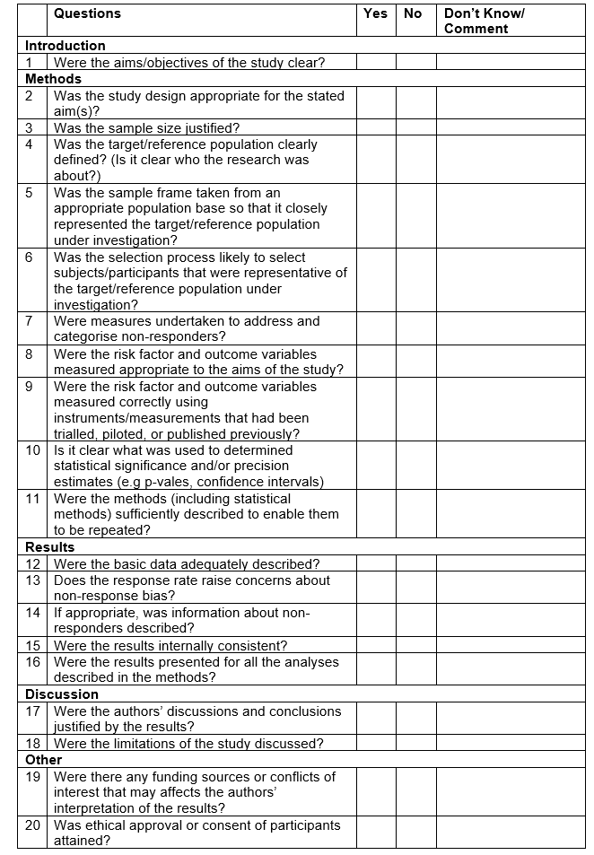
Additional File 5: AXIS Form. A copy of the AXIS form used for the assessment of bias and quality of each study included in the review.

