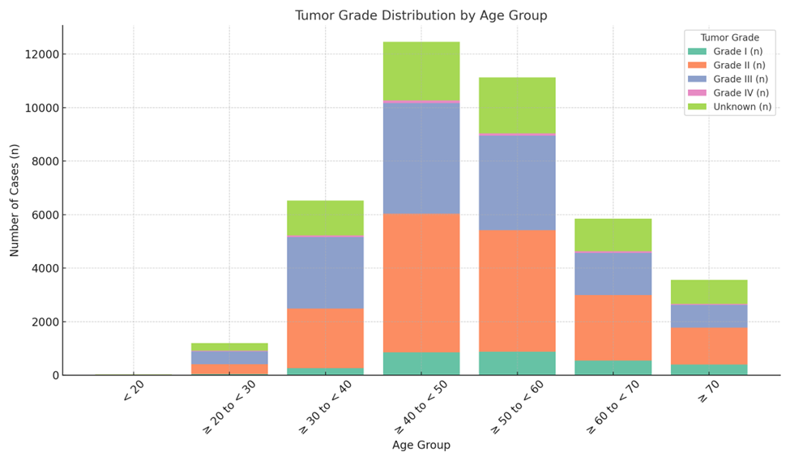 Supplementary Figure S1. Distribution of tumor grade by age group among Saudi women diagnosed with breast cancer, 2007–2022.

