Determination and comparison of triacylglycerol composition of tea (Camellia sinensis) oil and extra virgin olive oil using ¹H NMR and UV–Visible spectroscopy

Hagos Tesfay^{a,b,}*, Girma Workeneh Woyessa^{a,b,c}, Amitabha Datta^{d,}*

ª Sustainable Chemical Science and Technology, Taiwan International Graduate Program, Taiwan, ROC
^{b} Institute of Chemistry, Academia Sinica, Nankang, Taipei - 11529, Taiwa, ROC
^{c} Harc Department of Chemistry, Haramaya University, P.O. Box 138, Haramaya, Ethiopia
^{d} Department of Chemistry, National Changhua University of Education, Changhua – 50058, Taiwan, ROC

*Corresponding author. E-mail address: hagtes76@gmail.com (H. Tesfay); amitd_ju@yahoo.co.in (A. Datta)

Table S1. Assignment of signals of Tea Oil by ¹HNMR (400MHz)
Signals | Functional group |  |  | Integral values | Multiplicity | Chemical shift in [ppm]
Integral a |  | C-CH=CH-C (O, L, Ln) |  | 8.8405 | m | 5.3228
Integral b |  | CH(-C-O-CO-C-)₂ |  | 1.4116 | m | 5.2296
Integral c |  | -C-CH₂-O-CO-C |  | 2.9491 | dd | 4.2662
Integral d |  | -C-CH₂-O-CO-C |  | 2.9921 | dd | 4.1145
Integral e |  | C=C-CH₂-C=C- (L, Ln) |  | 1.0000 | t | 2.7542
Integral f |  | -CH₂-CO₂-(acyl group) |  | 9.0473 | dt | 2.2842
Integral g |  | -C-CH₂-C=C- |  | 15.8541 | m | 1.9937
Integral h |  | -OCO-CH₂-CH₂-(S, O, L, Ln) |  | 9.3066 | m | 1.5799
Integral i |  | -(CH₂)_{n}- ( S, O, Ln, ) |  | 90.1324 | m | 1.2715
Integral j |  |  | -CH₃ (Saturated, oleic and linoleic acyl group) | 13.1659 | t | 0.8534
Table S2 Assignment of signals for Tea Oil and Extra virgin olive oil by ¹H-NMR (800MHz
Signals | Functional group | Integral  Tea Oil | Integral Extra virgin  Olive Oil | Multiplicity | Chemical shift  ν[ppm]
 |  |  |  |  | Tea Oil | Olive Oil
Integral a | C-CH=CH-C (O, L, Ln) | 604.6591 | 559.8718 | m | 5.3188 | 5.2689
Integral b | CH(-C-O-CO-C-)₂ | 100.0000 | 100.0000 | m | 5.2398 | 5.1939
Integral c | -C-CH₂-O-CO-C | 202.2609 | 201.9361 | dd | 4.2795 | 4.2333
Integral d | -C-CH₂-O-CO-C | 207.3650 | 206.9198 | dd | 4.1134 | 4.0675
Integral e | OH group of digly. | 1.7691 | -0.0818 | d | 3.6857 | 3.6382
Integral f | -C=C-CH₂-C=C-CH₂-C=C | 4.7689 | 3.0805 | t | 2.7786 | 2.7325
Integral g | -C=C-CH₂-C=C- | 62.9605 | 25.0211 | t | 2.7402 | 2.6950
Integral h | -C-CH₂-C=C- | 620.7392 | 603.7743 | t | 2.2904 | 2.2384
Integral i | -CH₂-CO₂-(acyl group) | 1059.5427 | 1032.0033 | m | 2.0045 | 1.9410
Integral j | -OCO-CH₂-CH₂-(S, O, L, Ln acyl group) | 616.0515 | 597.8680 | m | 1.5934 | 1.5462
Integral k | -(CH₂)_{n}- ( S, O, Ln, acyl group) | 5466.2712 | 5756.4934 | m | 1.2790 | 1.2205
Integral l | -CH₃ (linolenic acyl group) | -3.7805 | -3.2936 | - | 0.9373 | 0.8954
Integral m | -CH₃ (Saturated, oleic and linoleic acyl group) | 880.6528 | 886.1946 | t | 0.8491 | 0.8014
Where O=Oleic, S=Saturated, L=linoleic, Ln= linolenic acyl groups

Table S3. Typical levels in (%) of C₁₈ unsaturated fatty acids and saturated fatty acids in common oils.
Oil | Linoleic | Linolenic | Oleic | Saturated
Tea Oil** | 10.14 | 0.38 | 74.83 | 14.65
Extra Virgin olive Oil** | 4.14 | 0.26 | 81.06 | 14.54
Extra Virgin Olive Oil^{[22]} | 4.2 | 0.7 | 82.9 | 12.2
Extra Virgin Olive Oil^{[22]} | 4.1 | 0.5 | 84.5 | 10.9
Extra Virgin Olive Oil^{[22]} | 9.1 | 0.3 | 78.5 | 12.1
Tea (C. tenuifolia) seed oil^{[11]} | 12.2 | ND | 66.2 | 8.0
Camellia japonica ^{[12]} | 6.65 | 0.29a | 80.67 | 12.39
Olive oil^{[19]} | 6.0 | 0.7 | 81.3 | 12
Tea seed oil^{[15]} | 22.3 | 0.0 | 57.5 | 18.6
Peanut^{[16]} | 18.2 | 0.0 | 71.1 | 10.7
Cotton seed oil ^{[18]} | 49.97 | 0 | 19.24 | 0
Sunflower^{[16]} | 62.2 | 0.0 | 0 | 9.4
Rice bran^{[16]} | 33.1 | ND | ND | 22.5
Sunflower oil ^{[18]} | 12.13 | 0 | 79.22 | 0
Soybean^{[23]} | 45.0 | 13.3 | 24.1 | 17.3
Coconut^{[16]} | 1.6 | 0 | 6.2 | 92.11
** Current work, ND=not detected

Figure S1: ¹³CNMR of tea oil sample

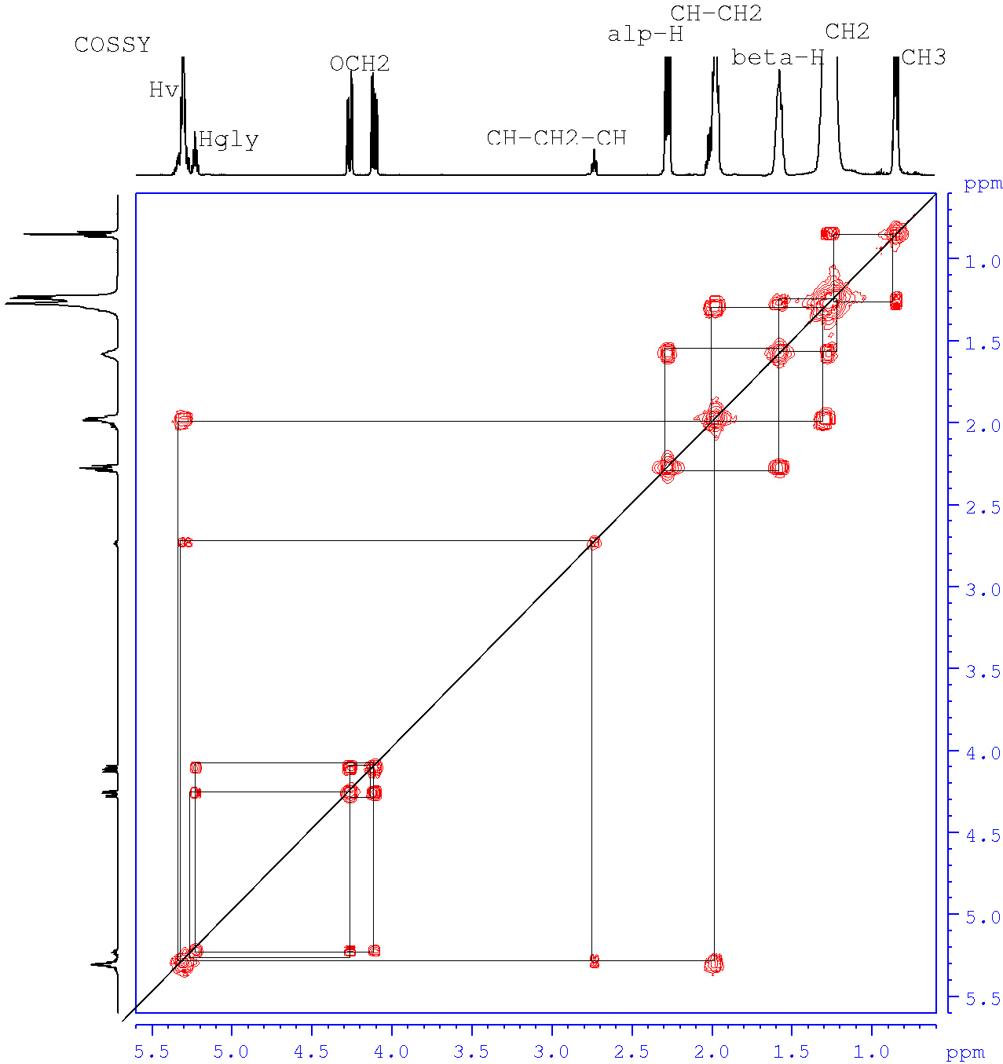

Figure S2: 2D-COSSY NMR spectrum of tea oil

