Supplementary material for
RMI2 Depletion Recovers cGAS-STING Signaling to Enhance Immunotherapy in Colorectal Cancer
Runkai Cai^{1,2,3#}, Enmin Huang^{2,3,5#}, Yina Liu^{4#}, Xiaoshuang Lyu^{1,2,3#}, Yang Fu^{1,2,3}, Fan Bai^{1,2,3}, Chenxu Guo^{1,2,3}, Ge Qin^{1,2,3}, Yuqian Xie^{1,2,3}, Jianwei Zhang^{1,2,3*}, Yanhong Deng^{1,2,3,4*} and Weixiang Zhan^{1,2,3*}

This PDF file includes:
Figures S1 to S12
Table S1 to S4

Figures and figure legends
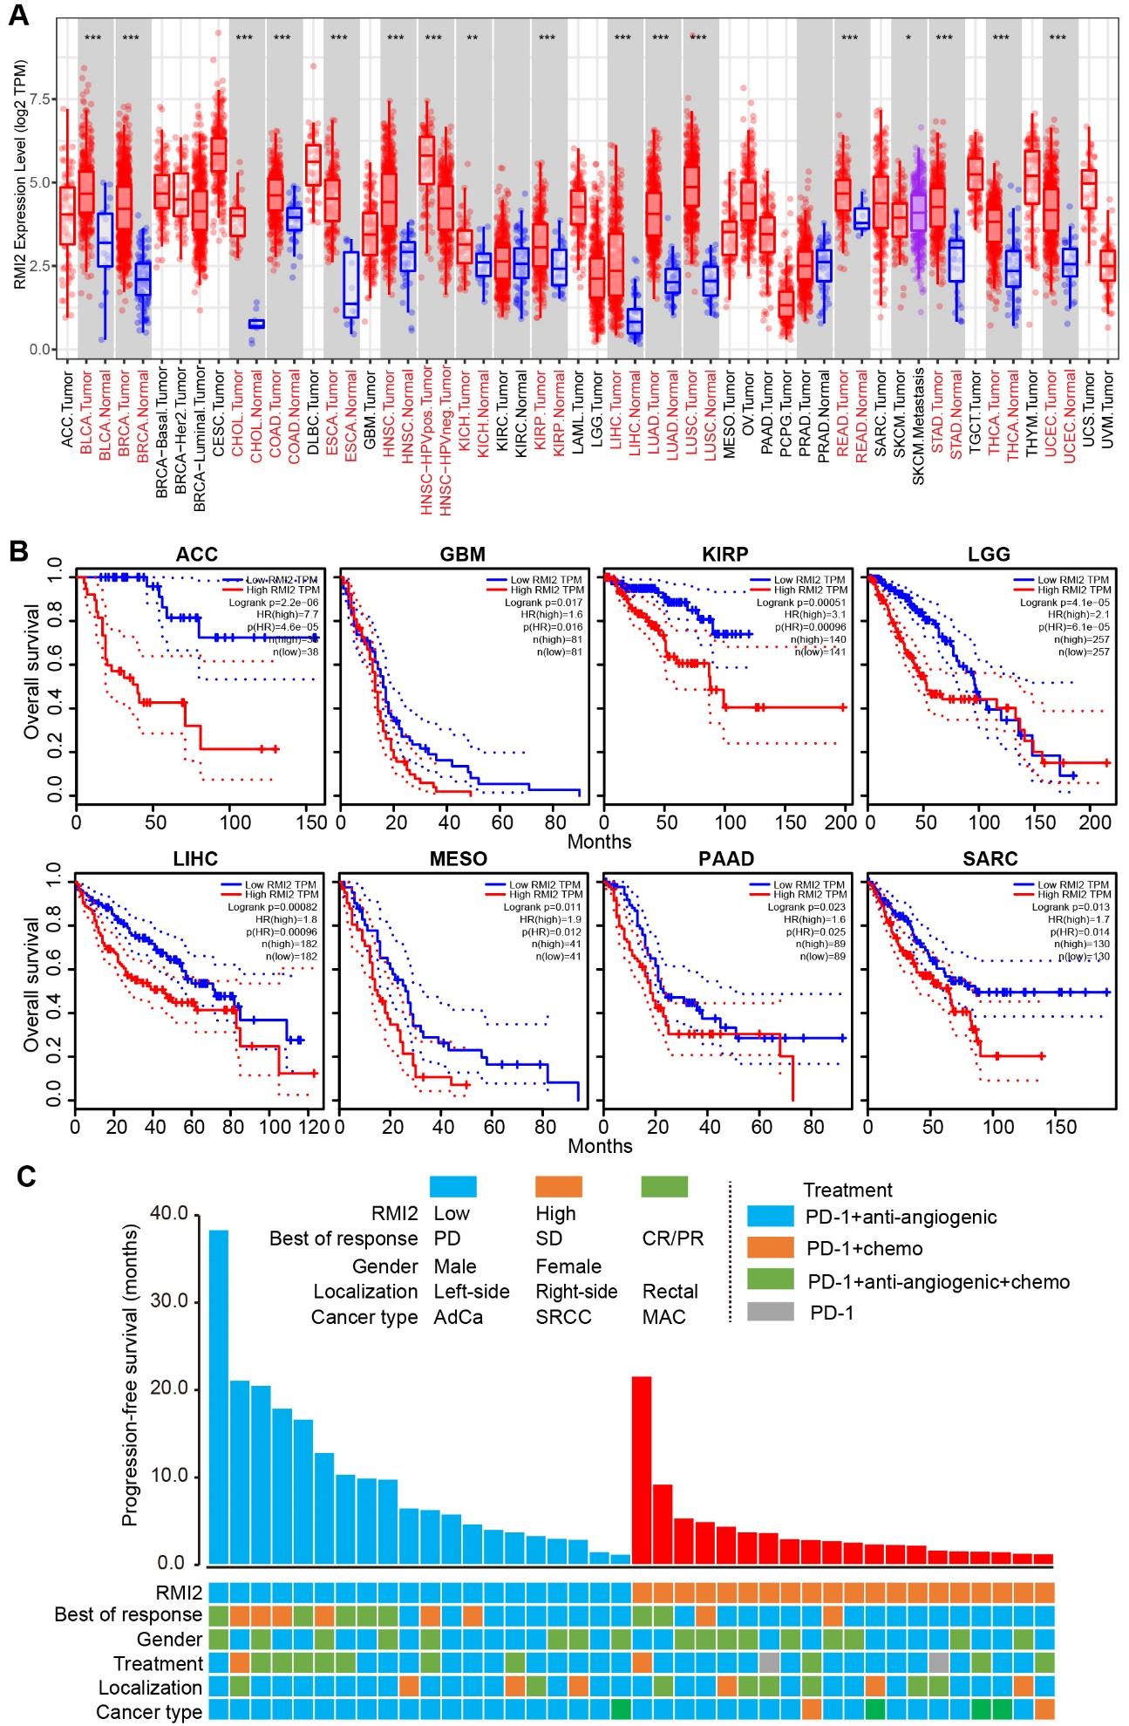
Figure S1. High RMI2 is associated with poor survival. (A) Box plots depicting RMI2 mRNA expression levels in tumor tissues versus adjacent normal tissues across The Cancer Genome Atlas (TCGA) pan-cancer cohorts were analyzed using the Wilcoxon test. The red font indicates statistically significant differences. Statistical significance is denoted as follows: *p < 0.05, **p < 0.01 and ***p < 0.001. (B) Association of RMI2 mRNA level with overall survival (OS) in ACC (Adrenocortical Carcinoma), GBM (Glioblastoma), KIRP (Kidney Renal Papillary Cell Carcinoma), LGG (Brain Lower Grade Glioma), LIHC (Liver Hepatocellular Carcinoma), MESO (Mesothelioma), PAAD (Pancreatic Adenocarcinoma), SARC (Sarcoma). (C) Individual patient PFS in the refractory MSS CRC cohort 4, along with their clinical benefit and clinicopathological characteristics.
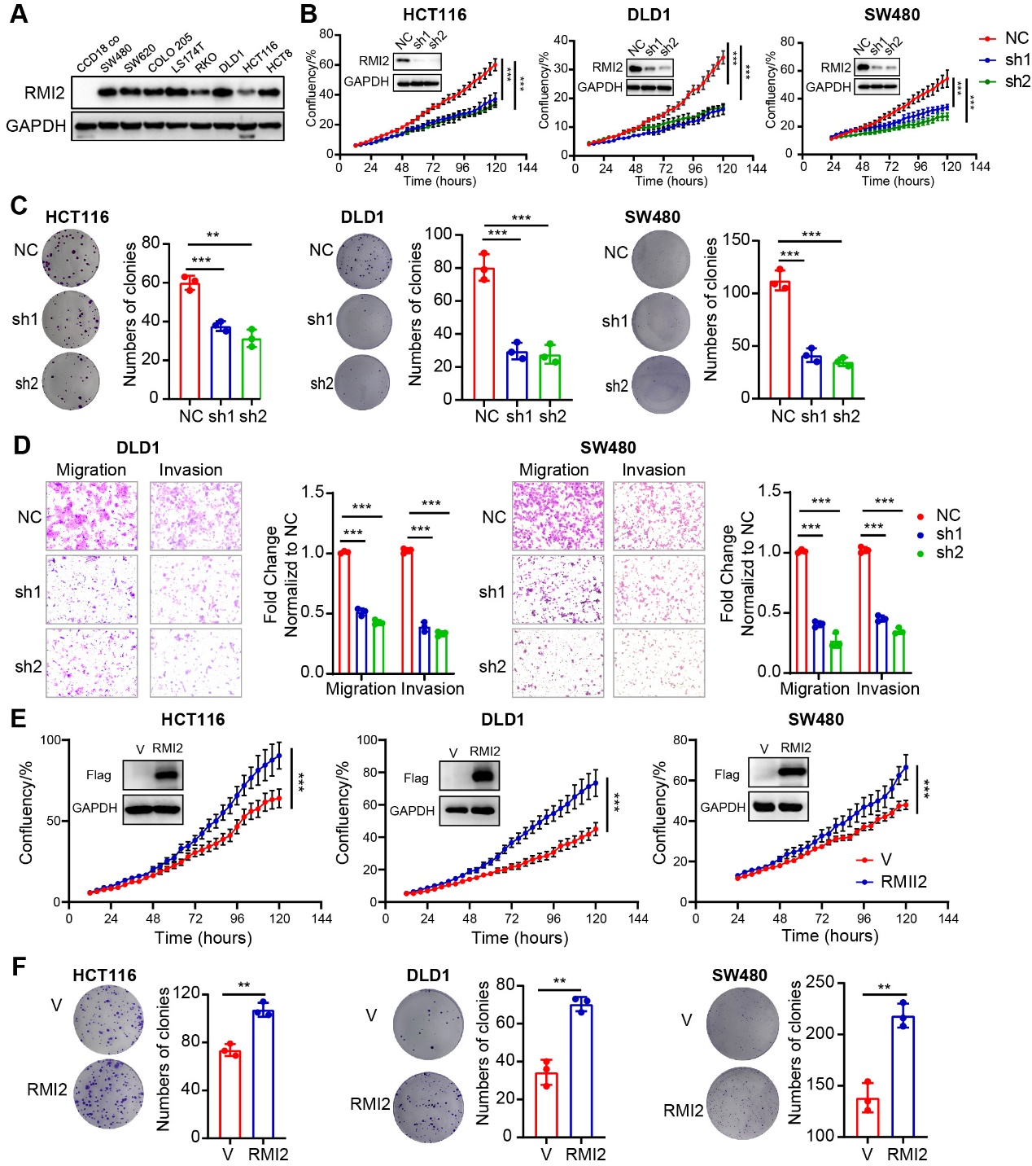
Figure S2. Depletion of RMI2 effectively suppresses tumor cell growth, migration and invasion. (A) Immunoblot of the indicated proteins in CRC cells lines. (B) Growth curves of non-targeting control (NC) and RMI2 knockdown (shRMI2) cells in HCT116, DLD1 and SW480. (C) Colony formation assay of NC and shRMI2 cells in the indicated CRC cell lines. (D) Migration and invasion of NC and shRMI2 cells in the indicated CRC cell lines. (E) Growth curves of vector and overexpression of RMI2 cells in the indicated CRC cell lines. (F) Colony formation assay of vector and overexpression of RMI2 cells in the indicated CRC cell lines. Data are presented as means ± SEM. Statistical analyses were performed using unpaired Student’s t-tests (C, D and F), and two-way ANOVA (B and E). **, P < 0.01; ***, P < 0.001.

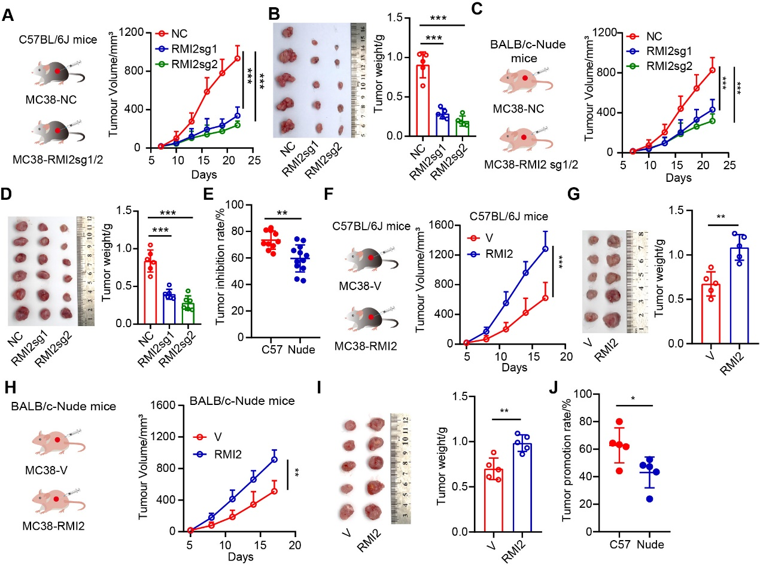
Figure S3. RMI2 promotes immune evasion in colorectal cancer. (A) The effect of RMI2 knockout on MC38 tumor growth was evaluated in C57BL/6J mice (n = 5/group). (B) Representative images of tumors (left) and tumor weight (right) for indicated groups as presented in (A). (C) The effect of RMI2 knockout on MC38 tumor growth in syngeneic BALB/c-nude mice (n = 6/group). (D) Representative images of tumors (left) and tumor weight (right) for indicated groups as presented in (C). (E) Tumor inhibition rate for RMI2 knockout MC38 cells relative to control cells after inoculation into C57BL/6J or BALB/c-nude mice, respectively. (F) The effect of overexpression of RMI2 on MC38 tumor growth was evaluated in C57BL/6J mice (n = 5/group). (G) Representative images of tumors (left) and tumor weight (right) for indicated groups as presented in (F). (H) The effect of overexpression of RMI2 on MC38 tumor growth in syngeneic BALB/c-nude mice (n = 5/group). (I) Representative images of tumors (left) and tumor weight (right) for indicated groups as presented in (C). (J) Tumor promotion rate for RMI2 overexpression in MC38 cells relative to control cells after inoculation into C57BL/6J or BALB/c-nude mice, respectively. Data are presented as means ± SEM. Statistical analyses were performed using unpaired Student’s t-tests (B, D, E, G, I and J), and two-way ANOVA (A, C, F and H). *, P < 0.05; **, P < 0.01; ***, P < 0.001.

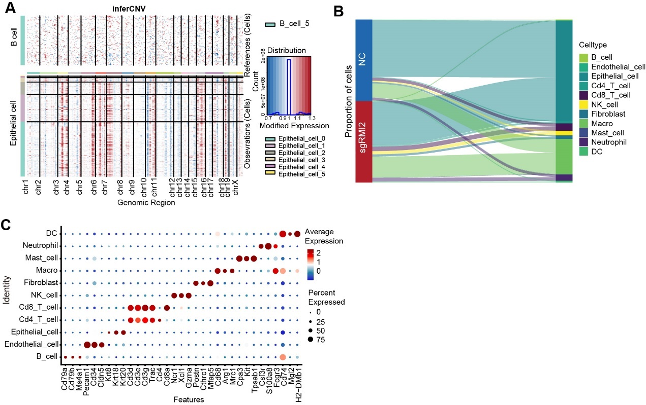
Figure S4. RMI2 modulates the immune profile and impairs T-cell and NK cell response. (A) CNV profile in cancer versus stromal cells assessed using InferCNV based on scRNA-seq. (B) Sankey diagram comparing cell distribution between sgRMI2 and NC groups. (C) Bubble plots of the marker genes expressed in the major cell types. Dot color reflects the expression level and dot size represents the percent of cells expressing marker genes in different cell types.

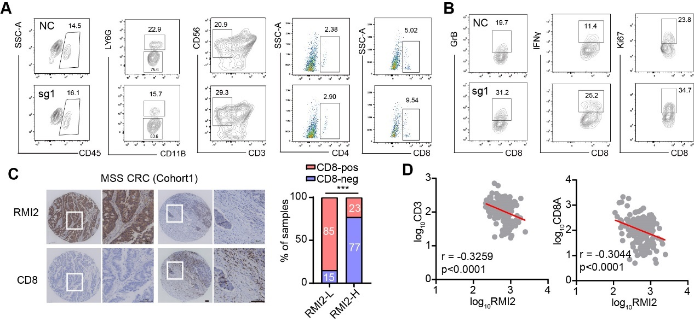
Figure S5. RMI2 deficiency promotes infiltration and activation of cytotoxic CD8⁺ T cells.
(A) Representative images of CD45⁺, Ly6G⁺ MDSC, NK, CD4 T and CD8 T cells proportion in MC38 subcutaneous tumors. (B) Representative images of GZMB⁺ CD8⁺ T cells, IFN-γ⁺ CD8⁺ T cells, and Ki67⁺ CD8⁺ T cells in MC38 subcutaneous tumors. (C) Representative images of IHC staining with RMI2 and CD8 in cohort 1. Scale bars, 100 μm. Statistics of the CD8 T cell infiltration and the expression of RMI2 in the CRC IHC cohort 1 (right). Statistical analyses were performed using Fisher’s exact test. (D) Negative correlation of RMI2 mRNA levels with that of CD3 or CD8A in CRC. Data from the Gene Expression across Normal and Tumor tissue (GENT) database. ***, P < 0.001.

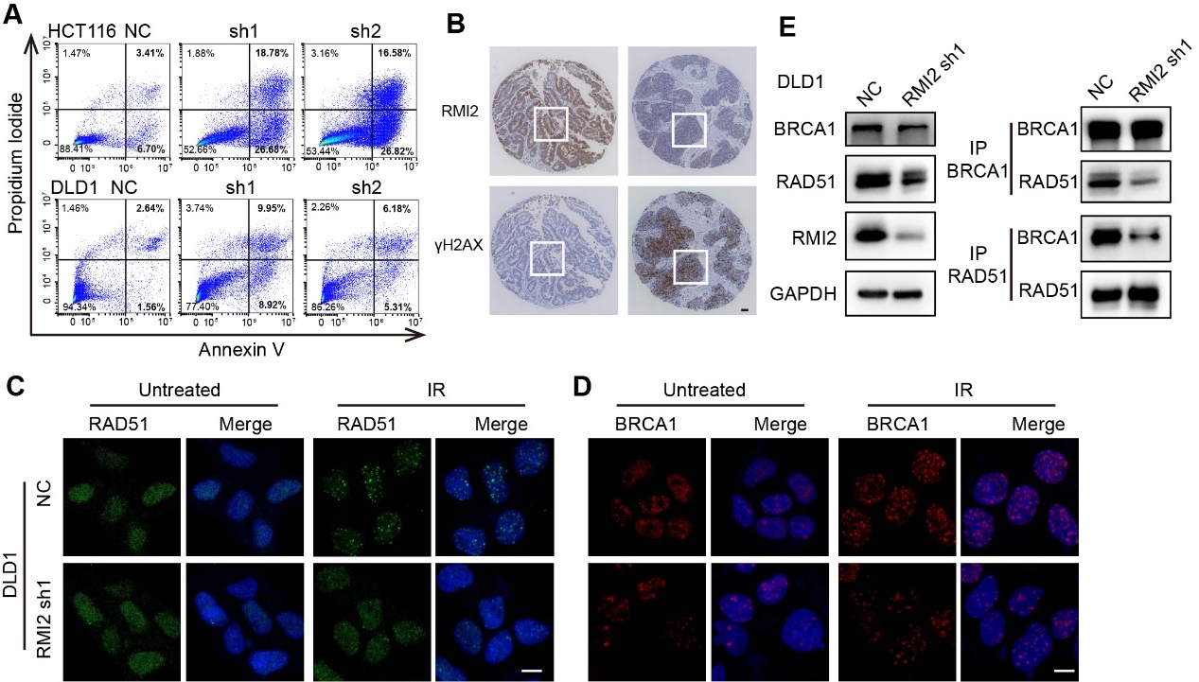
Figure S6. RMI2 depletion impairs homologous recombination.
(A) Flow cytometry analysis of apoptotic (annexin V⁺) cells in NC and shRMI2 cells in the indicated CRC cell lines. (B) Representative images of IHC staining for RMI2 and γH2AX. Scale bars, 100 µm. (C and D) Immunostaining with anti-RAD51 (C) and anti-BRCA1 (D) was performed in indicated cells. Scale bars, 15 μm. (E) RAD51 and BRCA1 were immunoprecipitated from cell lysates, followed by immunoblotting with the indicated antibodies.

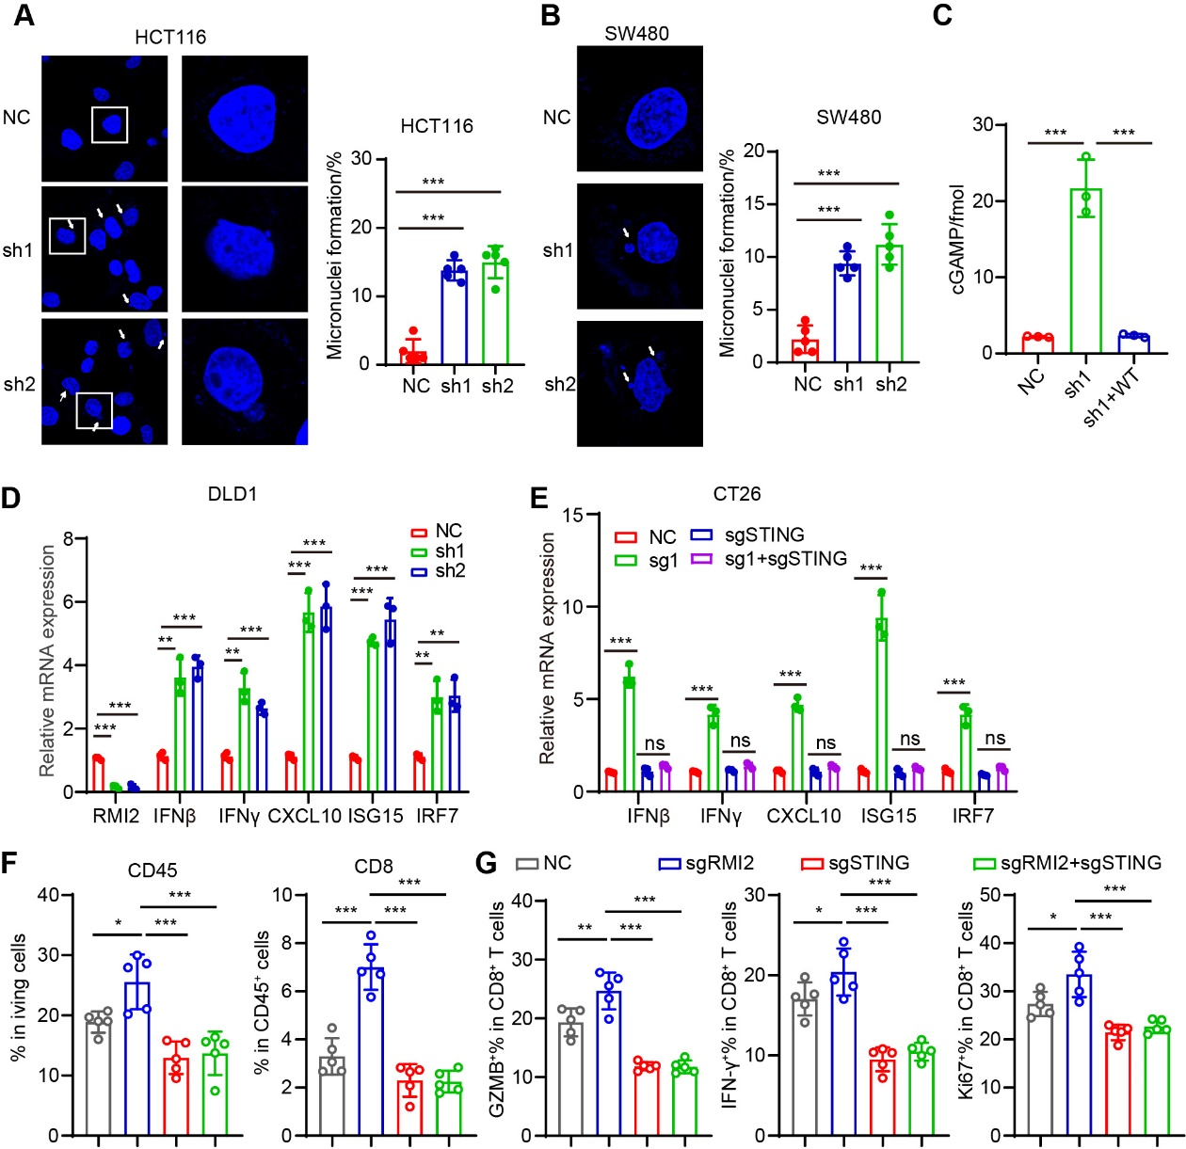
Figure S7. RMI2 deficiency augments cytosolic DNA levels and robustly activates the cGAS-STING pathway.
(A and B) Representative images and quantification of micronuclei formation in CRC cells. (C) The production of cGAMP in NC, shRMI2, and RMI2-rescued cells. (D) RT-qPCR analysis of mRNA expression levels of IFN-β, IFN-γ, ISG15, CXCL10, and IRF7 in DLD1. (E) RT-qPCR analysis of mRNA expression levels of IFN-β, IFN-γ, ISG15, CXCL10, and IRF7 in CT26. (F and G) Flow cytometric analysis of the proportions of CD45, CD8⁺ T cells (F), and GZMB⁺ CD8⁺ T cells, IFN-γ⁺ CD8⁺ T cells, and Ki67⁺ CD8⁺ T cells (G) in CT26 subcutaneous tumors (n = 5/group). Data are presented as means ± SEM. Statistical analyses were performed using unpaired Student’s t-tests (A and B), and one-way ANOVA (C-G). *, P < 0.05; **, P < 0.01; ***, P < 0.001. ns, not significant.

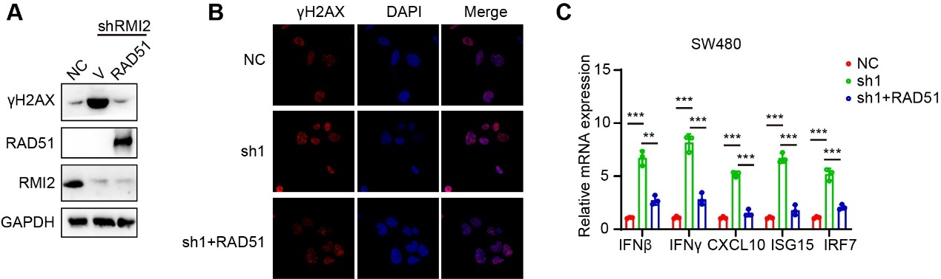
Figure S8. RMI2 depletion increases DNA damage and activates the cGAS-STING pathway, potentially mediated by RAD51.
(A) Immunoblot of the indicated proteins in NC, shRMI2, and shRMI2+RAD51 cells. (B) Representative images of γH2AX immunofluorescence staining in the indicated cells. Scale bars, 20 µm. (C) RT-qPCR analysis of mRNA expression levels of IFN-β, IFN-γ, ISG15, CXCL10, and IRF7 in the indicated cells. **, P < 0.01; ***, P < 0.001.

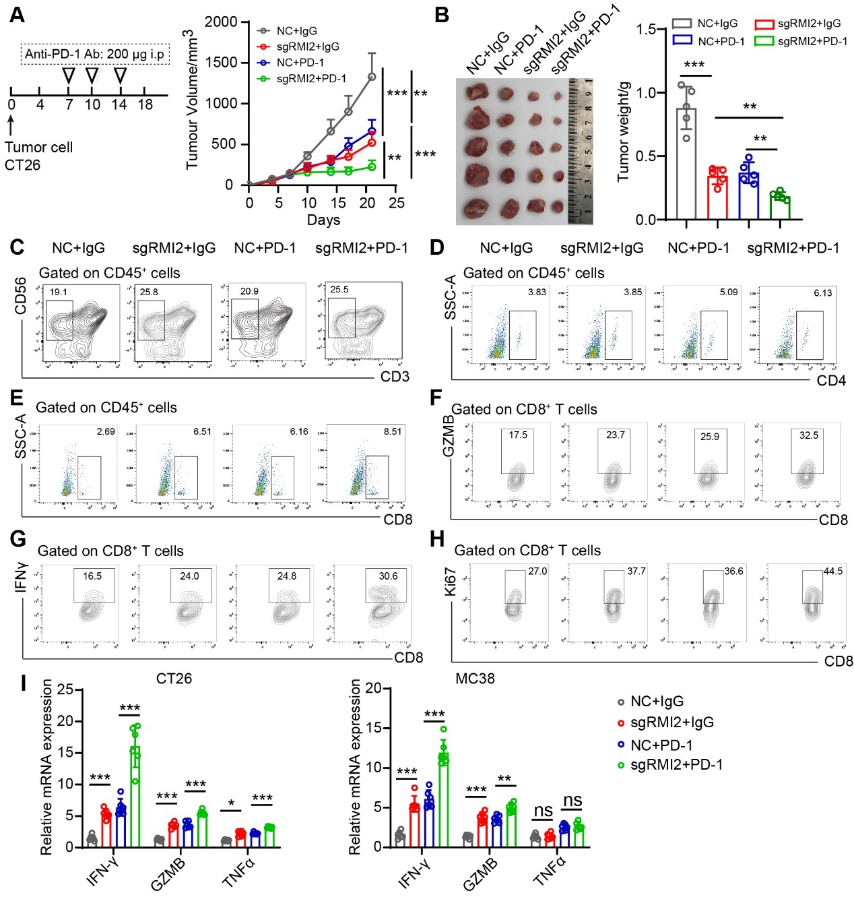
Figure S9. RMI2 deficiency enhances tumor susceptibility to anti-PD-1 therapy. (A) Tumor growth curves of CT26 subcutaneous tumors at the indicated time points (n = 5/group). (B) Representative images of tumors (left) and tumor weight (right) for the indicated groups, as shown in (A). (C-H) Representative images of NK (C), CD4⁺ (D), and CD8⁺ (E) T cells, and GZMB⁺ CD8⁺ (F), IFN-γ⁺ CD8⁺ (G), and Ki67⁺ CD8⁺ (H)T cells in MC38 subcutaneous tumors. (I) RT-qPCR analysis of mRNA expression levels of IFN-γ, GZMB, and TNFα in CT26 or MC38 xenografts. Data are presented as means ± SEM. Statistical analyses were performed using one-way ANOVA (B and I), and two-way ANOVA (A). *, P < 0.05; **, P < 0.01; ***, P < 0.001. ns, not significant.

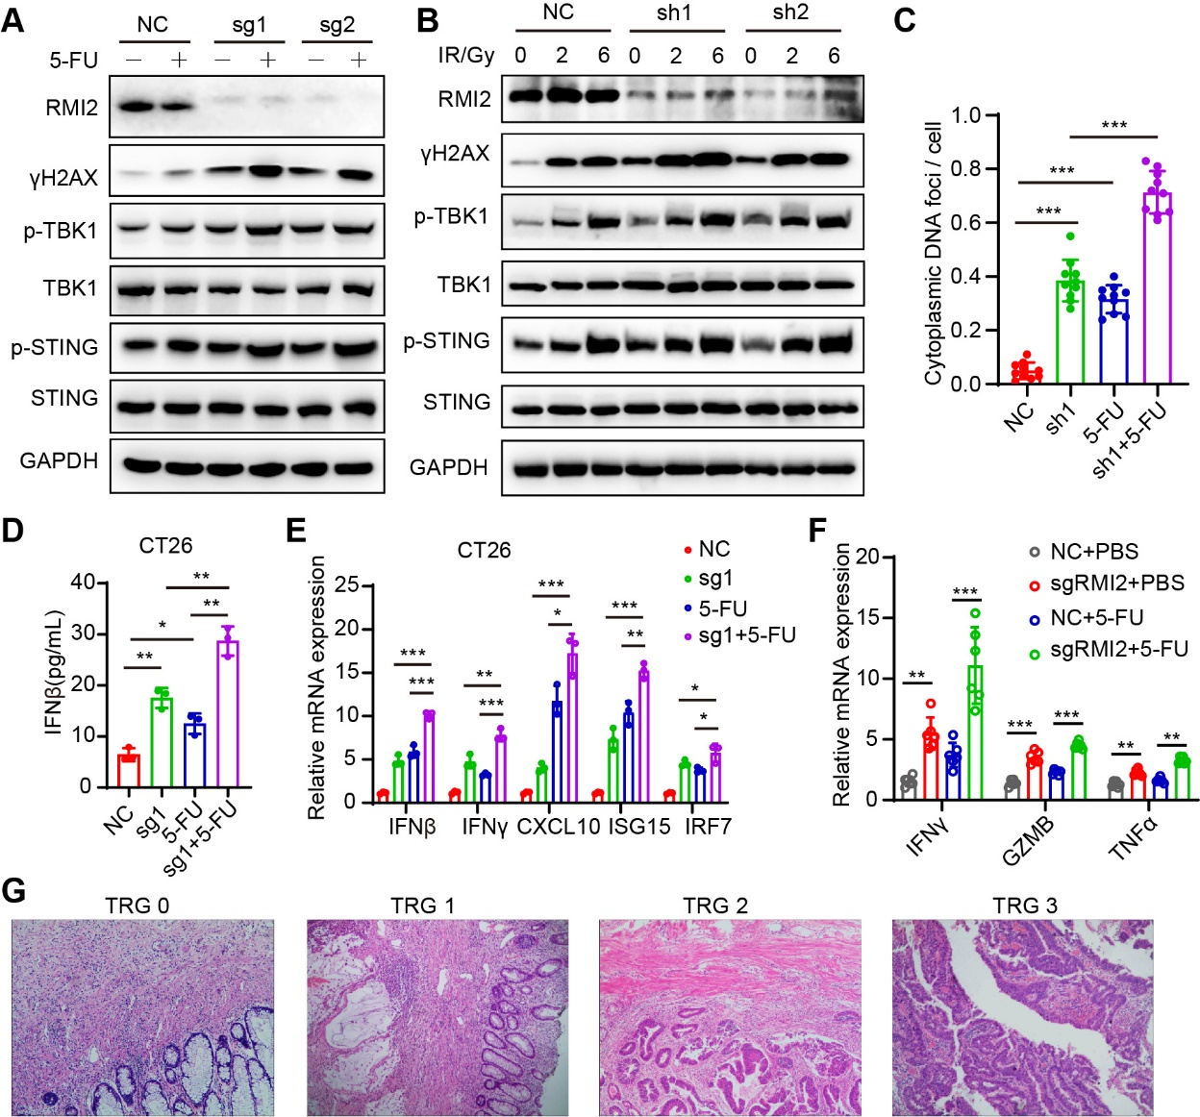
Figure S10. RMI2 deficiency sensitizes tumor cells to 5-FU.
(A) Western blot of indicated proteins in RMI2 knockout CT26 cells after 5-FU treatment. (B) Western blot of indicated proteins in RMI2 knockout CT26 cells after IR treatment. (C) Quantification of cytoplasmic DNA immunofluorescence staining in SW480 cells in figure 7C. (D) ELISA analysis of human IFN-β in conditioned media derived from CT26 cells with the indicated treatment. (E) RT-qPCR analysis of mRNA expression levels of IFN-β, IFN-γ, ISG15, CXCL10, and IRF7 in CT26 cells. (F) RT-qPCR analysis of mRNA expression levels of IFN-γ, GZMB, and TNFα in CT26 xenografts. (G) Representative HE staining images illustrate the histological changes related to tumor regression grade (TRG). Data are presented as means ± SEM. Statistical analyses were performed using one-way ANOVA (C-F). *, P < 0.05; **, P < 0.01; ***, P < 0.001.
Figure S11. A model depicting the molecular mechanisms of antitumor effects induced by RMI2 inhibition.
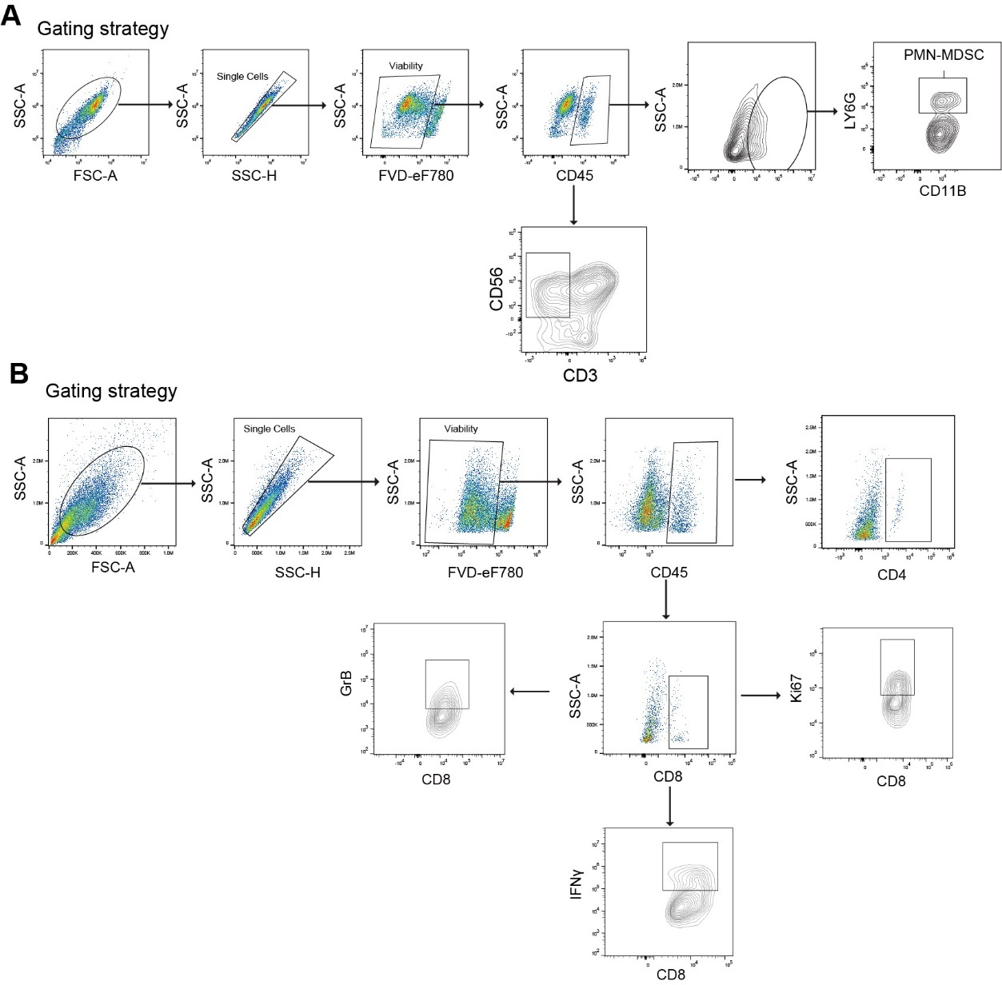

Figure S12. Representative diagram of the gating strategy. (A) Representative diagram of the gating strategy for CD56⁺ NK, Ly6G⁺ MDSC. (B) Representative diagram of the gating strategy for CD45⁺, CD4⁺, CD8⁺ T cells, and GZMB⁺, IFN-γ⁺, and Ki67⁺ CD8⁺ T cells.

Table S1. Expression of RMI2 and patient characteristic in cohort 1.
 |  | Overall | HR (95% CI) | P value
 |  | (Percentage) | HR (95% CI) | P value
Age
<60 |  | 108(47.79%) | 1.576 (0.995-2.498) | 0.053
≥60 |  | 118 (52.21%) | 1.576 (0.995-2.498) | 0.053
Gender
Male |  | 131 (57.96%) | 0.758 (0.475-1.207) | 0.243
Female |  | 95(42.04%) | 0.758 (0.475-1.207) | 0.243
Stage
I - II |  | 86 (38.05%) | 2.768 (1.594-4.807) | <0.001
III - IV |  | 140 (61.95%) | 2.768 (1.594-4.807) | <0.001
T stage
T1 - T2 |  | 48 (21.24%) | 12.893 (3.164-52.541) | <0.001
T3 - T4 |  | 178 (78.76%) | 12.893 (3.164-52.541) | <0.001
N stage
N0 |  | 95 (42.04%) | 2.578(1.533-4.336) | <0.001
N1 - N3 |  | 131 (57.96%) | 2.578(1.533-4.336) | <0.001
M stage
M0 |  | 192 (84.96%) | 2.734 (1.623-4.604) | <0.001
M1 |  | 34 (15.04%) | 2.734 (1.623-4.604) | <0.001
RMI2
High |  | 117(51.77%) | 1.856 (1.160-2.971) | 0.01
Low |  | 109(48.23%) | 1.856 (1.160-2.971) | 0.01

Table S2. Clinical characteristics of patients in cohort 2 with refractory MSS CRC.
Patient ID | Localization | Pathology types | Treatment | Best of response | PFS status | PFS (months) | RMI2
1 | Left-side | AdCa | PD-1+anti-angiogenic | PD | 1 | 2.80 | Low
2 | Left-side | MAC | PD-1+anti-angiogenic | PD | 1 | 1.30 | Low
3 | Left-side | AdCa | PD-1+anti-angiogenic | PD | 1 | 1.03 | Low
4 | Left-side | AdCa | PD-1+anti-angiogenic | PR | 1 | 9.57 | High
5 | Left-side | AdCa | PD-1+anti-angiogenic+chemo | SD | 1 | 12.40 | Low
6 | Left-side | AdCa | PD-1+anti-angiogenic+chemo | SD | 0 | 6.03 | Low
7 | Rectal | AdCa | PD-1+chemo | SD | 0 | 20.50 | Low
8 | Left-side | AdCa | PD-1+anti-angiogenic+chemo | CR | 1 | 10.00 | Low
9 | Left-side | AdCa | PD-1+anti-angiogenic | CR | 0 | 37.37 | Low
10 | Left-side | AdCa | PD-1+anti-angiogenic+chemo | CR | 1 | 16.13 | Low
11 | Left-side | AdCa | PD-1+anti-angiogenic+chemo | SD | 0 | 19.93 | Low
12 | Left-side | AdCa | PD-1+anti-angiogenic+chemo | SD | 0 | 17.37 | Low
13 | Left-side | AdCa | PD-1+anti-angiogenic | PR | 1 | 9.43 | Low
14 | Left-side | AdCa | PD-1+anti-angiogenic | SD | 1 | 4.40 | Low
15 | Left-side | AdCa | PD-1+chemo | CR | 1 | 20.97 | High
16 | Rectal | AdCa | PD-1+anti-angiogenic | PD | 1 | 3.10 | Low
17 | Rectal | AdCa | PD-1+anti-angiogenic | PD | 1 | 3.53 | High
18 | Rectal | AdCa | PD-1 | PD | 1 | 1.47 | High
19 | Right-side | AdCa | PD-1+anti-angiogenic | PD | 1 | 4.17 | High
20 | Right-side | AdCa | PD-1+anti-angiogenic | PD | 1 | 1.13 | High
21 | Left-side | AdCa | PD-1+anti-angiogenic | PD | 1 | 1.40 | High
22 | Left-side | MAC | PD-1+anti-angiogenic | PD | 1 | 1.30 | High
23 | Left-side | AdCa | PD-1+anti-angiogenic | PD | 1 | 2.73 | High
24 | Left-side | AdCa | PD-1+anti-angiogenic | PD | 1 | 3.80 | High
25 | Left-side | AdCa | PD-1+anti-angiogenic | PD | 1 | 5.07 | High
26 | Left-side | SRCC | PD-1+anti-angiogenic+chemo | PD | 1 | 1.07 | High
27 | Left-side | AdCa | PD-1+anti-angiogenic | PD | 1 | 5.53 | High
28 | Rectal | SRCC | PD-1+anti-angiogenic+chemo | PD | 1 | 2.67 | High
29 | Rectal | AdCa | PD-1 | PD | 1 | 3.47 | High
30 | Rectal | AdCa | PD-1+anti-angiogenic | PD | 1 | 2.03 | High
31 | Rectal | AdCa | PD-1+anti-angiogenic | PR | 1 | 8.87 | High
32 | Left-side | AdCa | PD-1+anti-angiogenic | SD | 1 | 4.67 | High
33 | Right-side | AdCa | PD-1+anti-angiogenic | PD | 1 | 6.20 | High
34 | Right-side | AdCa | PD-1+anti-angiogenic+chemo | PD | 1 | 3.53 | High
35 | Right-side | AdCa | PD-1+anti-angiogenic | PD | 1 | 2.70 | High
36 | Right-side | AdCa | PD-1+anti-angiogenic | SD | 1 | 2.53 | High
37 | Left-side | AdCa | PD-1+anti-angiogenic | PD | 1 | 2.37 | High
38 | Right-side | MAC | PD-1+anti-angiogenic | PD | 1 | 2.17 | High
39 | Left-side | AdCa | PD-1+anti-angiogenic | PD | 1 | 2.10 | High
40 | Left-side | MAC | PD-1+anti-angiogenic+chemo | PD | 1 | 1.37 | High
Table S3. The sequences of quantitative real-time PCR primers.
Gene | Primer
human-CXCL10-F | 5'-GTGGCATTCAAGGAGTACCTC -3'
human-CXCL10-R | 5'-TGATGGCCTTCGATTCTGGATT -3'
human-GAPDH-F | 5’-TGACTTCAACAGCGACACCC-3’
human-GAPDH-R | 5’-CTGGTGGTCCAGGGGTCTTA-3’
human-IFNB-F | 5'-ATGACCAACAAGTGTCTCCTCC-3'
human-IFNB-R | 5'-GGAATCCAAGCAAGTTGTAGCTC-3'
human-IFNG-F | 5'-TCGGTAACTGACTTGAATGTCCA-3'
human-IFNG-R | 5'-TCGCTTCCCTGTTTTAGCTGC-3'
human-IRF7-F | 5'-CCCAGCAGGTAGCATTCCC-3'
human-IRF7-R | 5'-GCAGCAGTTCCTCCGTGTAG-3'
human-ISG15-F | 5'-GCGAACTCATCTTTGCCAGTA-3'
human-ISG15-R | 5'-CCAGCATCTTCACCGTCAG-3'
human-RMI2-F | 5'-ATGCAGGGCAGGGTAGTGAT-3'
human-RMI2-R | 5'-CTTTCCTGGGACTAGACAGGG-3'
mouse-GAPDH-R | 5'-GCAGGGTAAGATAAGAAATG-3'
mouse-GAPHD-F | 5'-CAACTGCTTAGCCCCCCTGG-3'
mouse-RMI2-F | 5'-CCGCCACTCAAGGTACTGG-3'
mouse-RMI2-R | 5'-TCGTGGACAGGATTGTCAGAA-3'

Table S4. The sequences of cloning PCR used in this study.
Gene | Primer
human-sgSTING | 5'-CATATTACATCGGATATCTG-3'
human-shRMI2-1 | 5'-GCAGGAAGACAGACTGTGTAA-3’
human-shRMI2-2 | 5'-GCTTCGGACACCACTCAAACA-3’
mouse-sgRMI2 | 5'-TGTCCTGCCAGTACCTTGAG-3'
mouse-sgSTING | 5'-CTACATAACAACATGCTCAG-3'

