Supporting Information

Thermal and Mechanical Stabilities of Core-shell Microparticles Containing a Liquid Core

Fariba Malekpour Galogahi, Hongjie An, Yong Zhu, Nam-Trung Nguyen*

S1. Properties of the Core and the Shell Materials

Table S1 Physical and chemical properties of the core and the shell materials
Properties | Core material (HFE7500) | Shell material (TMPTMA)
Boiling point @ 1 atm (°C) | $${129}^{[1]}$$ | > ${200}^{[2](a)}$
Liquid density (kg.$m^{-3}$ ) | $${1614}^{[1]}$$ | $${1070}^{[2](b)}$$
Viscosity (dynamic) (cP) | - | $${40-70}^{S2(b)}$$
Viscosity (cSt) | $${0.77}^{[1]}$$ | -
Surface tension (dynes.${cm}^{-1}$) | $${16.2}^{[1]}$$ | -
Coefficient of expansion ($K^{-1}$) | $${0.00129}^{[1]}$$ | -
Young’s modulus (MPa) | - | $${300}^{[3]}$$
Tensile strength (MPa) | - | $${20-40}^{[3]}$$

S2. Preparation of the TMPTMA
The TMPTMA was prepared by mixing ethyl- 4(dimethylamino)benzoate (0.06 g), camphorquinone (0.05 g), and TMPTMA (10 g) using mechanical stirred at 600 rpm for 1 hr [4].

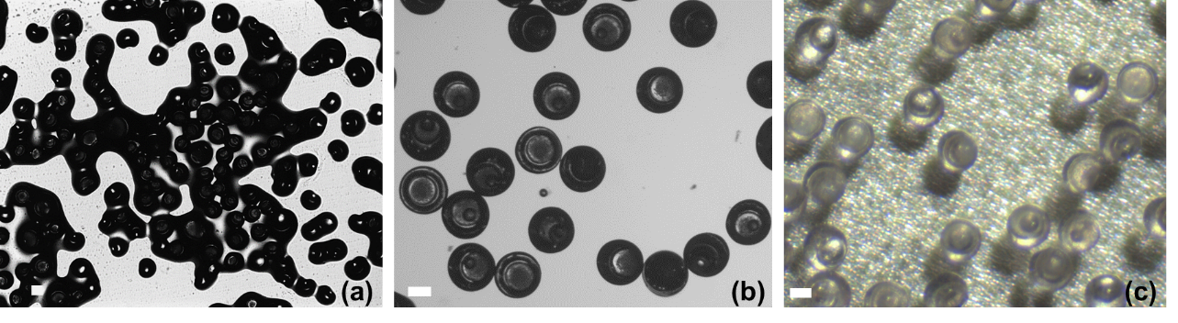
S3. Preparation of Core-Shell Particles
Figure S1. (a) Microscopic image of core-shell particles sticking to each other; (b) Microscopic image and (c) Optical image of core-shell particles after the outlet tubing was exposed to an UV light and the particles was subsequently washed with methanol, respectively. Scale bars represent 100 µm.

S4. Setups for the Investigation of the Thermal and Mechanical Behaviour of Core-Shell Microparticles
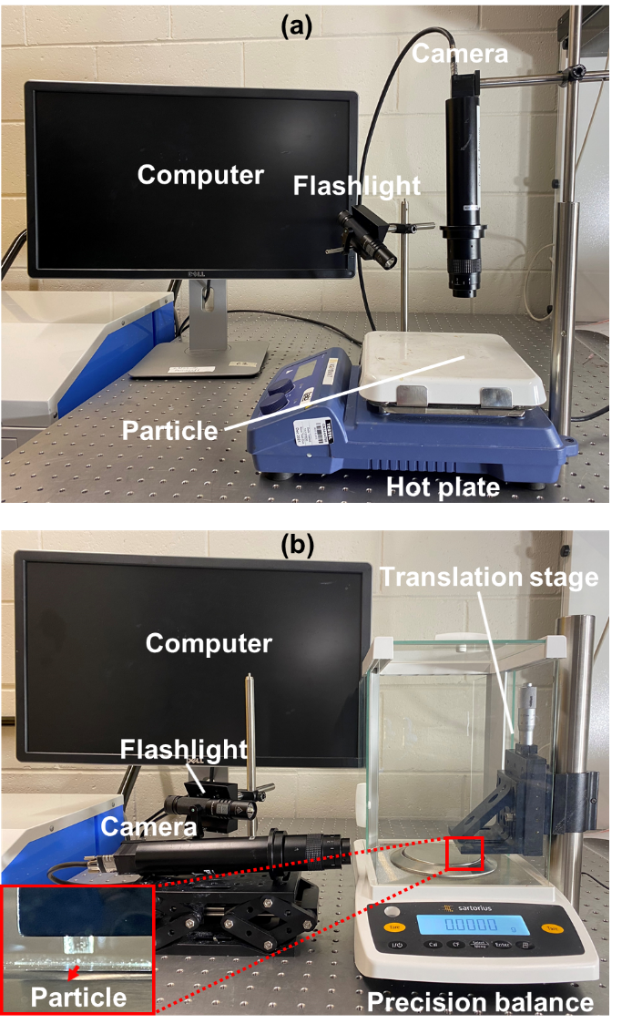
Figure S2. Experimental setup for investigating (a) the thermal behaviour and (b) mechanical behaviour of core-shell microparticles with liquid core.

S5. Supporting References

[1] The 3M Company. https://www.3m.com/3M/en_US/p/d/b40045191/, (accessed May 2021).
[2] a) The Allnex Company. https://www.palmerholland.com/getmedia/ec2be025-6f40-4c47-bcdb-c6fc13cc136c/MITM13438, (accessed: April 2020); (b) The Allnex Company. https://www.palmerholland.com/getmedia/5bedec17-8492-4a24-a7e7-d42241df20e1/MITM13438, (accessed February 2020).
[3] Vining, K.H., J.C. Scherba, A.M. Bever, M.R. Alexander, A.D. Celiz, and D.J. Mooney, Synthetic light‐curable polymeric materials provide a supportive niche for dental pulp stem cells, Advanced materials. 30 (2018) 1704486. https://doi.org/10.1002/adma.201704486.
[4] Sreejith, K.R., L. Gorgannezhad, J. Jin, C.H. Ooi, T. Takei, G. Hayase, H. Stratton, K. Lamb, M. Shiddiky, and D.V. Dao, Core-shell beads made by composite liquid marble technology as a versatile microreactor for polymerase chain reaction, Micromachines. 11 (2020) 242. https://doi.org/10.3390/mi11030242.

