Linkage groups of rice

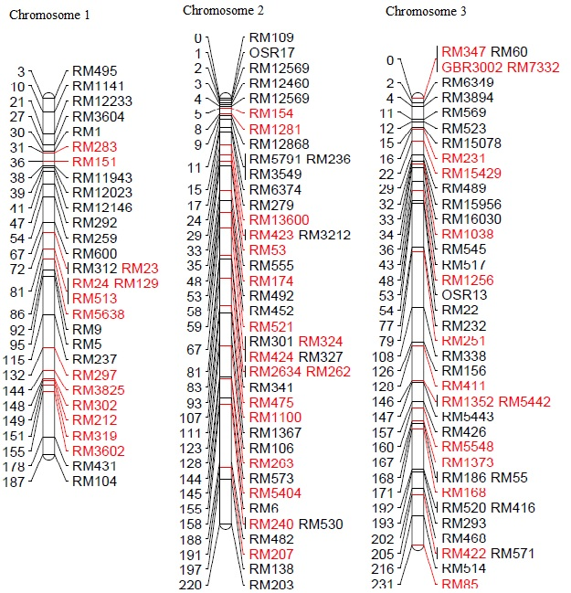

Figure S2 A. SSR Linkage group of rice genome based on parental polymorphism between all the donor and recurrent parents. Linkage group was drawn by using “Mapchart” software, SSR markers are to right and centiMorgan (cM) is to the left of the chromosomes. SSR markers and its distance (cM) based on Temnykh et al (2000) and Universal Core Genetic Map Orjuela et al (2010). The red colour indicates the polymorphic markers and the black colour indicates the monomorphic markers.

Linkage groups of rice

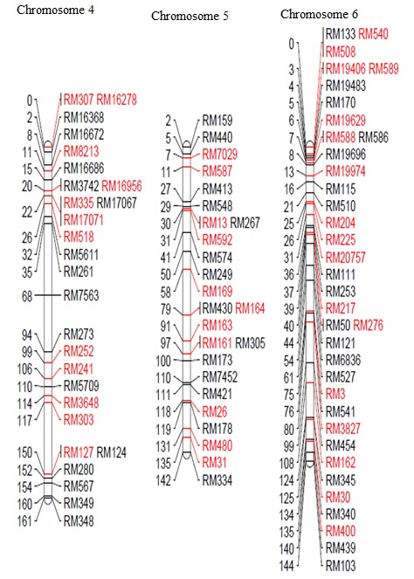

Figure S2 B. SSR Linkage group of rice genome based on parental polymorphism between all the donor and recurrent parents. Linkage group was drawn by using “Mapchart” software, SSR markers are to right and centiMorgan (cM) is to the left of the chromosomes. SSR markers and its distance (cM) based on Temnykh et al (2000) and Universal Core Genetic Map Orjuela et al (2010). The red colour indicates the polymorphic markers and the black colour indicates the monomorphic markers.

Linkage groups of rice

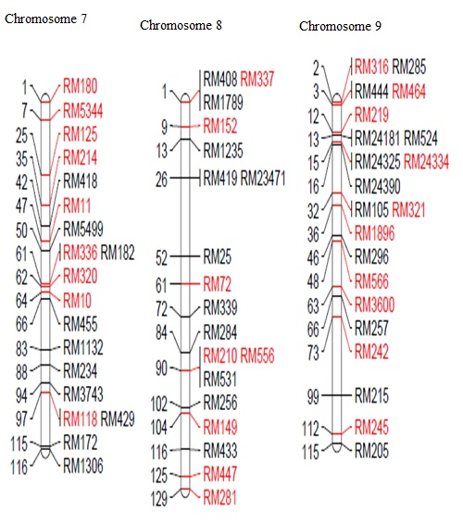

Figure S2 C. SSR Linkage group of rice genome based on parental polymorphism between all the donor and recurrent parents. Linkage group was drawn by using “Mapchart” software, SSR markers are to right and centiMorgan (cM) is to the left of the chromosomes. SSR markers and its distance (cM) based on Temnykh et al (2000) and Universal Core Genetic Map Orjuela et al (2010). The red colour indicates the polymorphic markers and the black colour indicates the monomorphic markers.

Linkage groups of rice chromosome

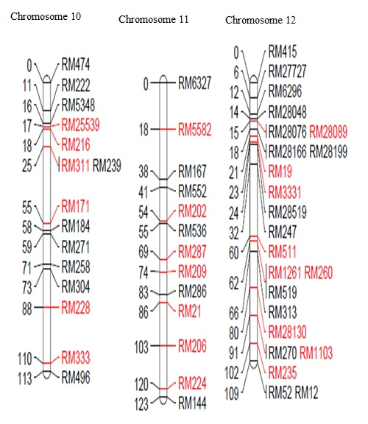

Figure S2 D. SSR Linkage group of rice genome based on parental polymorphism between all the donor and recurrent parents. Linkage group was drawn by using “Mapchart” software, SSR markers are to right and centiMorgan (cM) is to the left of the chromosomes. SSR markers and its distance (cM) based on Temnykh et al (2000) and Universal Core Genetic Map Orjuela et al (2010). The red colour indicates the polymorphic markers and the black colour indicates the monomorphic markers.

