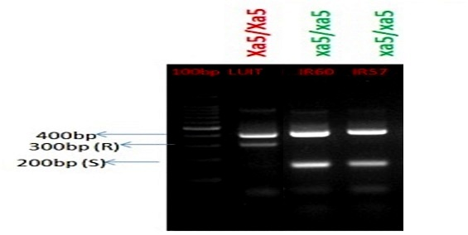

Figure S1A: Functional marker xa5 FM specific for xa5 gene, PCR amplified 1.5% agarose gel of donor parents IRBB60 (Xa4+xa5+xa13+Xa21); positive control IRBB57 ( Xa4+xa5+Xa21) and recurrent parents Luit. The gel picture constitute of resistance allele of 300bp and susceptible allele of 200bp and with a common allele of 300bp in all the rice genotype compared with M-100bp ladder.

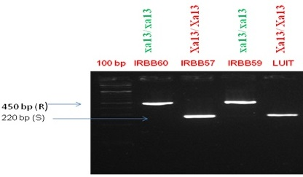
Figure S1B: Functional marker xa13 pro specific for xa13 gene, PCR amplified 1.5% agarose gel of donor parents IRBB60; positive control IRBB59 (xa5+xa13+Xa21) and Negative control IRBB57 (Xa4+xa5+Xa21) as well as recurrent parents Luit. The band size of 450 bp show resistance allele and band size of 220 bp show susceptible allele compared with M-100bp ladder.
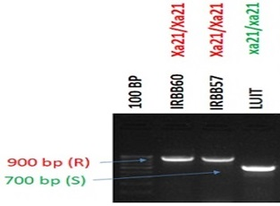
Figure S1C: Functional Marker pTA248 specific for Xa21 gene, PCR amplified 1.5% agarose gel of donor parents IRBB60 (Xa4+xa5+xa13+Xa21); positive control IRBB57 (Xa4+xa5+Xa21) and recurrent parents Luit. The band sizes of 900bp show resistance allele and 700bp show susceptible allele compared with M-100bp ladder.

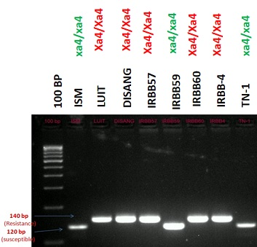

Figure S1D: STS Marker Npb181 specific for Xa4 gene, PCR amplified agarose gel of donor parents IRBB60(Xa4+xa5+xa13+Xa21), IRBB57(Xa4+xa5+Xa21), IRBB59(Xa4+xa13+Xa21) and recurrent parents Luit, Disang along with Negative control TN-1 and positive control IRBB4, M-100bp ladder, 140bp showed resistance allele and 120bp showed susceptible allele

