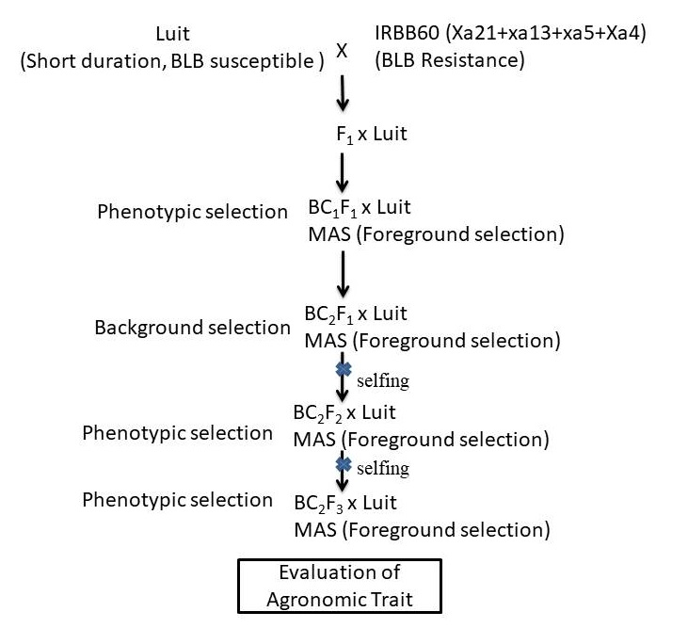
Supplementary Figure 3. Schematic representation of pyramiding three BLB resistance genes Xa21, xa13 and xa5 using marker-assisted foreground and background selection.

