Supplementary Methods:
Statistical Analysis
During preliminary analysis, an unusual association was noted between seizures and postoperative AED regimen (Table 1). It was also noted that 50% of patients with seizures had early postoperative seizures (within 7 days) and that this association was solely attributed to patients with early seizures (Supplemental Digital Content 2, Table 1). Since it is most likely that adjustments to AED regimen at discharge were made because of patients experiencing early postoperative seizures, accounting for the significant difference observed, a decision was made not to include this variable in the primary outcome multivariable analysis to avoid misinterpretation and to avoid violation to multicollinearity assumption. We instead opted to perform a post hoc analysis with early (within 7 days) and late (7 days to 6 months) postoperative seizures as secondary outcomes to account for this confounder.
REFERENCES.
1 Eseonu, C. I. et al. Awake Craniotomy Anesthesia: A Comparison of the Monitored Anesthesia Care and Asleep-Awake-Asleep Techniques. World Neurosurgery 104, 679-686, doi:10.1016/j.wneu.2017.05.053 (2017).
2 van de Schoot, R. et al. Bayesian statistics and modelling. Nat Rev Methods Primers 1, 1-26, doi:10.1038/s43586-020-00001-2 (2021).
3 Kruschke, J. K. in Doing Bayesian Data Analysis (2015).
4 Gelman, A. & Rubin, D. B. Inference from Iterative Simulation Using Multiple Sequences. Statistical Science 7, 457-472, doi:10.1214/ss/1177011136 (1992).
5 Brooks, S. P. & Gelman, A. General Methods for Monitoring Convergence of Iterative Simulations. Journal of Computational and Graphical Statistics 7, 434-455, doi:10.1080/10618600.1998.10474787 (1998).

Table S1. Fisher’s exact test showing association between early seizures and postoperative AED regimen at discharge.
P<0.000, suggesting that AED adjustments were most likely made due to early seizures. Therefore a multivariable model including AED regimen at discharge would lead to the misleading conclusion that AEDs are a significant risk factor for seizures.

AED Discharge Adjustment | Immediate Postoperative Seizures
 | No | Yes | Total
No Change to Preoperative Course | 21 | 1 | 22
 | 31.34 | 6.67 | 26.83
Monotherapy with Dose | 30 | 1 | 31
 | 44.78 | 6.67 | 37.8
Complex Adjustment (>= 2) | 16 | 13 | 29
 | 23.88 | 86.67 | 35.37
Total | 67 | 15 | 82
 | 100.00 | 100.00 | 100.00
Fisher's Exact = 0.000

Table S2. Multivariable analysis of early and late postoperative seizures with multiple imputation.
Primary Outcome: Early or Late Seizure | Odds Ratio | 95% Confidence Interval | P-value
Age
45-54 | 2.249807 | 0.4809011-10.52531 | 0.303
55-64 | 2.9566 | 0.5121818-17.06715 | 0.226
65-74 | 2.995395 | 0.49066831-18.28551 | 0.235
75 and Older | 4.262321 | 0.3909362-46.47147 | 0.234
Income
Below US Median Household Income | 0.6617115 | 0.1972109-2.220273 | 0.504
Glioma Type
High Grade Glioma | 1.036845 | 0.1663389-0.462997 | 0.969
Speech Mapping
Yes | 1.396424 | 0.2179611-8.946555 | 0.725
Motor Mapping
Yes | 0.3764431 | 0.0767521-1.846327 | 0.229
SSEP Mapping
Yes | 3.259508 | 0.6090258-17.4449 | 0.167
Anesthesia Type
Awake | 0.4159804 | 0.0795044-2.176479 | 0.299
Seizure History Preoperatively
Yes | 1.476457 | 0.3359465-6.488908 | 0.606
Seizures Intraoperatively
Yes | 2.446307 | 0.359656-16.63928 | 0.36
Extent of Resection
Gross Total Resection (GTR) | 1.360382 | 0.3742214-4.945306 | 0.64
AED Preoperative Regimen
One AED | 3.419094 | 0.4841275-24.14695 | 0.218
More than One AED | 28.45087 | 2.154688-375.6702 | 0.011

Table S3. Multivariable analysis of early postoperative seizures.
Delayed Seizure (6 Months) | Odds Ratio | 95% Confidence Interval | P-value
Age
45-54 | 0.780901 | 0.525684-11.60052 | 0.857
55-64 | 9.275596 | 0.7039888-122.2131 | 0.09
65-74 | 5.037906 | 0.434642-58.39403 | 0.196
75 and Older | 10.17435 | 0.2916871-354.8922 | 0.201
Income
Below US Median Household Income | 1.805703 | 0.2903965-11.22797 | 0.526
Glioma Type
High Grade Glioma | 1.3306009 | 0.0738129-23.10786 | 0.855
Speech Mapping
Yes | 0.261096 | 0.0107728-6.328059 | 0.409
Motor Mapping
Yes | 0.0810378 | 0.0076658-0.8566744 | 0.037
SSEP Mapping
Yes | 4.09719 | 0.2583722-64.97206 | 0.317
Anesthesia Type
Awake | 0.8400254 | 0.0652758-10.81017 | 0.894
Seizure History Preoperatively
Yes | 5.567993 | 0.3324663-93.25019 | 0.232
Seizures Intraoperatively
Yes | 1.366456 | 0.0905303-20.62517 | 0.822
Extent of Resection
Gross Total Resection (GTR) | 1.046286 | 0.1429882-7.655974 | 0.964
AED Preoperative Regimen
One AED | 0.6599849 | 0.0317657-13.71228 | 0.788
More than One AED | 31.5819 | 0.5014198-1989.184 | 0.102
AED Discharge Adjustment
Monotherapy with Dose Increase | 2.465268 | 0.2392088-25.40687 | 0.448
Complex Adjustment (>= 2 AEDs) | 0.6235748 | 0.0727162-5.34744 | 0.667

Table S4. Multivariable analysis of late postoperative seizures with multiple imputation.
Delayed Seizure (6 Months) | Odds Ratio | 95% Confidence Interval | P-value
Age
45-54 | 0.6363392 | 0.0455393-8.891821 | 0.737
55-64 | 4.14651 | 0.3471001-49.53482 | 0.26
65-74 | 2.381416 | 0.2137448-26.5323 | 0.48
75 and Older | 4.279693 | 0.1242603-147.3984 | 0.418
Income
Below US Median Household Income | 1.685954 | 0.2905109-9.784288 | 0.56
Glioma Type
High Grade Glioma | 2.575814 | 0.1447376-45.84033 | 0.519
Speech Mapping
Yes | 0.2188957 | 0.0116457-4.114436 | 0.309
Motor Mapping
Yes | 0.0880531 | 0.0083156-.9323834 | 0.044
SSEP Mapping
Yes | 2.421451 | 0.1992331-29.42998 | 0.487
Anesthesia Type
Awake | 0.4571646 | 0.0442859-4.719326 | 0.511
Seizure History Preoperatively
Yes | 4.430497 | 0.2988845-65.67521 | 0.279
Seizures Intraoperatively
Yes | 1.793502 | 0.107495-29.92371 | 0.682
Extent of Resection
Gross Total Resection (GTR) | 0.8164441 | 0.1104599-6.034595 | 0.842
AED Preoperative Regimen
One AED | 0.4758277 | 0.025932-8.731004 | 0.617
More than One AED | 12.42374 | 0.2264734-681.5337 | 0.217
AED Discharge Adjustment
Monotherapy with Dose Increase | 3.04157 | 0.3156991-29.30369 | 0.336
Complex Adjustment (>= 2 AEDs) | 0.7520421 | 0.0823631-6.866756 | 0.8

Table S5. Results of Gelman-Rubin (Rc-hat value) convergence diagnostics for each parameter assessed in the Bayesian logistic regression model.
All parameters achieve Rc-hat <1.1 and all except for two achieve Rc-hat<1.01.
Any Seizure Postoperation | Rc
Age
45-54 | 1.00098
55-64 | 1.000419
65-74 | 1.007727
75 and Older | 1.03572
Income
Below US Median Household Income | 1.000123
Glioma Type
High Grade Glioma | 1.002502
Speech Mapping
Yes | 1.001082
Motor Mapping
Yes | 1.000689
SSEP Mapping
Yes | 1.001208
Anesthesia Type
Awake | 1.000142
Seizure History Preoperatively
Yes | 1.000154
Seizures Intraoperatively
Yes | 1.002491
Extent of Resection
Gross Total Resection (GTR) | 1.000169
AED Preoperative Regimen
One AED | 1.010732
More than One AED | 1.008559

Table S6. Effective samples sizes and efficiency values for each parameter.

Any Seizure Postoperation | ESS | Corr. Time | Efficiency
Age
45-54 | 31280.22 | 5.12 | 19.55%
55-64 | 34010.17 | 4.7 | 21.26%
65-74 | 29758.27 | 5.38 | 18.60%
75 and Older | 32272.53 | 4.96 | 20.17%
Income
Below US Median Household Income | 34929 | 4.58 | 21.83%
Glioma Type
High Grade Glioma | 30425.75 | 5.26 | 19.02%
Speech Mapping
Yes | 36809.12 | 4.35 | 23.01%
Motor Mapping
Yes | 28747.47 | 5.57 | 17.97%
SSEP Mapping
Yes | 39489.19 | 4.02 | 24.91%
Anesthesia Type
Awake | 31756.88 | 5.04 | 19.85%
Seizure History Preoperatively
Yes | 31880.75 | 5.02 | 19.93%
Seizures Intraoperatively
Yes | 30025 | 5.33 | 18.77%
Extent of Resection
Gross Total Resection (GTR) | 26385.76 | 6.06 | 16.49%
AED Preoperative Regimen
One AED | 35354.04 | 4.53 | 22.10%
More than One AED | 29030.82 | 5.51 | 18.14%

Table S7. Results of Bayesian logistic regression analysis using data-derived prior on history of seizures.

Age | Odds Ratio | Std. Dev. | MSCE | HPD (95% Credible Interval)
45-54 | 4.111691 | 4.833051 | 0.24571 | 0.1273216-12.05585
55-64 | 6.597792 | 9.624157 | 0.045365 | 0.1112953-21.00375
65-74 | 6.704584 | 10.28134 | 0.466654 | 0.1115284-21.42016
75 and Older | 17.2578 | 48.46478 | 0.225268 | 0.0210846-63.48179
Income
Below US Median Household Income | 0.7730625 | 0.600104 | 0.00313 | 0.0685073-1.888104
Glioma Type
High Grade Glioma | 1.9963331 | 3.332992 | 0.015172 | 0.0215495-6.333954
Speech Mapping
Yes | 2.829299 | 4.81705 | 0.024401 | 0.0279681-9.249704
Motor Mapping
Yes | 0.4310555 | 0.4847919 | 0.002438 | 0.0109875-1.249663
SSEP Mapping
Yes | 7.11946 | 11.03436 | 0.056105 | 0.1587122-22.07964
Anesthesia Type
Awake | 0.5149751 | 0.6519952 | 0.003348 | 0.0095869-1.561326
Seizure History Preoperatively
Yes | 2.240072 | 1.653376 | 0.008816 | 0.2824738-5.355542
Seizures Intraoperatively
Yes | 5.965645 | 10.44043 | 0.050063 | 0.041815-19.85764
Extent of Resection
Gross Total Resection (GTR) | 2.002036 | 1.784618 | 0.009206 | 0.1365298-5.154861
AED Preoperative Regimen
One AED | 8.84222 | 16.93655 | 0.088693 | 0100071-29.41194
More than One AED | 211.8676 | 707.4854 | 3.33188 | 0.2417435-7772.1989

Table S8. Results of Gelman-Rubin (Rc-hat value) convergence diagnostics for each parameter assessed in the Bayesian logistic regression model with data-derived priors.
All parameters achieve Rc-hat <1.1 and all except for model constant achieved Rc-hat<1.01.
Any Seizure Postoperation | Rc
Age
45-54 | 1.002312
55-64 | 1.000325
65-74 | 1.000876
75 and Older | 1.001124
Income
Below US Median Household Income | 1.00036
Glioma Type
High Grade Glioma | 1.004733
Speech Mapping
Yes | 1.001769
Motor Mapping
Yes | 1.000403
SSEP Mapping
Yes | 1.000119
Anesthesia Type
Awake | 1.001435
Seizure History Preoperatively
Yes | 1.000108
Seizures Intraoperatively
Yes | 1.000635
Extent of Resection
Gross Total Resection (GTR) | 1.000137
AED Preoperative Regimen
One AED | 1.001365
More than One AED | 1.0006

Table S9. Effective samples sizes and efficiency values for each parameter in the model with data-derived priors.
Any Seizure Postoperation | ESS | Corr. Time | Efficiency
Age
45-54 | 35191.38 | 4.55 | 21.99%
55-64 | 34727.37 | 4.61 | 21.70%
65-74 | 36295.08 | 4.41 | 22.68%
75 and Older | 27745.44 | 5.77 | 17.34%
Income
Below US Median Household Income | 31976.42 | 5 | 19.99%
Glioma Type
High Grade Glioma | 32660.48 | 4.9 | 20.41%
Speech Mapping
Yes | 28541.13 | 5.61 | 17.84%
Motor Mapping
Yes | 31068.6 | 5.15 | 19.42%
SSEP Mapping
Yes | 28234.23 | 5.67 | 17.65%
Anesthesia Type
Awake | 31454.46 | 5.09 | 19.66%
Seizure History Preoperatively
Yes | 31143.77 | 5.14 | 19.46%
Seizures Intraoperatively
Yes | 30859.72 | 5.18 | 19.29%
Extent of Resection
Gross Total Resection (GTR) | 33223.53 | 4.82 | 20.76%
AED Preoperative Regimen
One AED | 26590.16 | 6.02 | 16.62%
More than One AED | 24613.05 | 6.5 | 15.38%

Table S10. Results of Bayesian logistic regression analysis for patients with late seizures.
Delayed Seizures (6 months) | St. Dev | MCSE | HPD (95% Credible Interval)
Age
45-54 | 1.79252 | 0.020533 | -4.263142-2.770778
55-64 | 1.751782 | 0.19744 | -02480403-6.639085
65-74 | 1.601522 | 0.01787 | -1.060231-5.230051
75 and Older | 2.498342 | 0.028974 | -1.32053-8.6-248
Income
Below US Median Household Income | 1.1147591 | 0.013018 | -1.647683-2.860381
Glioma Type
High Grade Glioma | 2.079258 | 0.22905 | -3.138789-5.047273
Speech Mapping
Yes | 2.163839 | 0.24105 | -7.124243-1.344466
Motor Mapping
Yes | 1.8339 | 0.21979 | -8.604019-1.44906
SSEP Mapping
Yes | 1.800122 | 0.20815 | -1.355116-5.657909
Anesthesia Type
Awake | 1.671988 | 0.19255 | -3.516581-3.078177
Seizure History Preoperatively
Yes | 1.937186 | 0.22194 | -0.9875708-6.531913
Seizures Intraoperatively
Yes | 2.059383 | 0.24137 | -2.925691-5.15969
Extent of Resection
Gross Total Resection (GTR) | 1.291571 | 0.01374 | -2.274461-2.81816
AED Preoperative Regimen
One AED | 2.038395 | 0.0222111 | -4.524867-3.569445
More than One AED | 2.892066 | 0.033393 | -0.1465083-11.25279
AED Discharge Adjustment
Monotherapy with dose increase | 1.501676 | 0.017353 | -1.635974-4.261358
Complex adjustment (>= 2 AEDs) | 1.439293 | 0.015484 | -3.312068-2.38396

Table S11. Results of Gelman-Rubin (Rc-hat value) convergence diagnostics for each parameter assessed in the Bayesian logistic regression model for patients with late seizures.
All parameters achieve Rc-hat <1.01.
Delayed Seizures (6 months) | Rc
Age
45-54 | 1.000537
55-64 | 1.000487
65-74 | 1.000152
75 and Older | 1.000292
Income
Below US Median Household Income | 1.000527
Glioma Type
High Grade Glioma | 1.000184
Speech Mapping
Yes | 1.000529
Motor Mapping
Yes | 1.000396
SSEP Mapping
Yes | 1.00019
Anesthesia Type
Awake | 1.000075
Seizure History Preoperatively
Yes | 1.000635
Seizures Intraoperatively
Yes | 1.000307
Extent of Resection
Gross Total Resection (GTR) | 1.000658
AED Preoperative Regimen
One AED | 1.000407
More than One AED | 1.000454
AED Discharge Adjustment
Monotherapy with dose increase | 1.000395
Complex adjustment (>= 2 AEDs) | 1.000619

Table S12. Effective sample sizes and efficiency values for each parameter in the Bayesian logistic regression model for patients with late seizures.
Delayed Seizures (6 months) | ESS | Corr. Time | Efficiency (%)
Age
45-54 | 7621.00 | 20.99 | 4.76%
55-64 | 7871.86 | 20.33 | 4.92%
65-74 | 8032.08 | 19.92 | 5.02%
75 and Older | 7435.33 | 21.52 | 4.65%
Income
Below US Median Household Income | 7771.44 | 20.59 | 4.86%
Glioma Type
High Grade Glioma | 8240.56 | 19.42 | 5.15%
Speech Mapping
Yes | 8058.06 | 19.86 | 5.04%
Motor Mapping
Yes | 6961.82 | 22.98 | 4.35%
SSEP Mapping
Yes | 7478.82 | 21.39 | 4.67%
Anesthesia Type
Awake | 7539.77 | 21.22 | 4.71%
Seizure History Preoperatively
Yes | 7618.28 | 21 | 4.76%
Seizures Intraoperatively
Yes | 7279.49 | 21.98 | 4.55%
Extent of Resection
Gross Total Resection (GTR) | 8836.47 | 18.11 | 5.52%
AED Preoperative Regimen
One AED | 8422.14 | 19 | 5.26%
More than One AED | 7500.7 | 21.33 | 4.69%
AED Discharge Adjustment
Monotherapy with dose increase | 7488.94 | 21.36 | 4.68%
Complex adjustment (>= 2 AEDs) | 8640.41 | 18.52 | 5.40%

Figure S1. E-value for sensitivity analysis of independent significant result(s) in multivariable logistic regression model for early or late seizures.
In contrast with most other sensitivity analysis approaches that focus on whether confounding of a specified strength would suffice to explain away an effect estimate, the E-value focuses on the magnitude of the confounder associations that could produce confounding bias equal to the observed association. The observed odds ratio of 28.45 could be explained away by an unmeasured confounder that was associated with both preoperative AEDs and the outcome by a risk ratio of 10.14-fold each, above and beyond the measured confounders, but weaker confounding could not do so. Also, an unmeasured confounder associated with both by an odds ratio of 2.293-fold each could explain away the lower confidence limit.
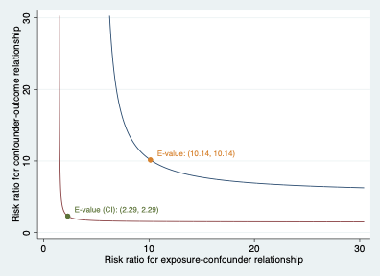

Figure S2. E-value for sensitivity analysis of independent significant result(s) in multivariable logistic regression model for late seizures.
The observed odds ratio of 0.088 could be explained away by an unmeasured confounder that was associated with both motor mapping and the outcome by a risk ratio of 6.19-fold each, above and beyond the measured confounders, but weaker confounding could not do so. Also, an unmeasured confounder associated with both by an odds ratio of 1.23-fold each could explain away the lower confidence limit.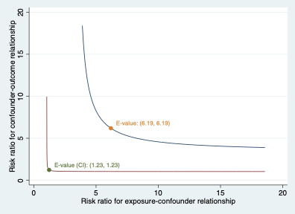

Figure S3. MCMC Random-walk Metropolis Hastings sampling model diagnostics.
Each variable in the model was assessed visually for convergence as above. Top left trace plot, top right overlay of posterior parameter histograms for all chains, bottom left shows autocorrelation plots, and bottom right shows overlay of density plots for all chains. All suggesting that the model achieved convergence and fit for valid interpretation. We used random-number seed 16 for reproducibility in our analysis.
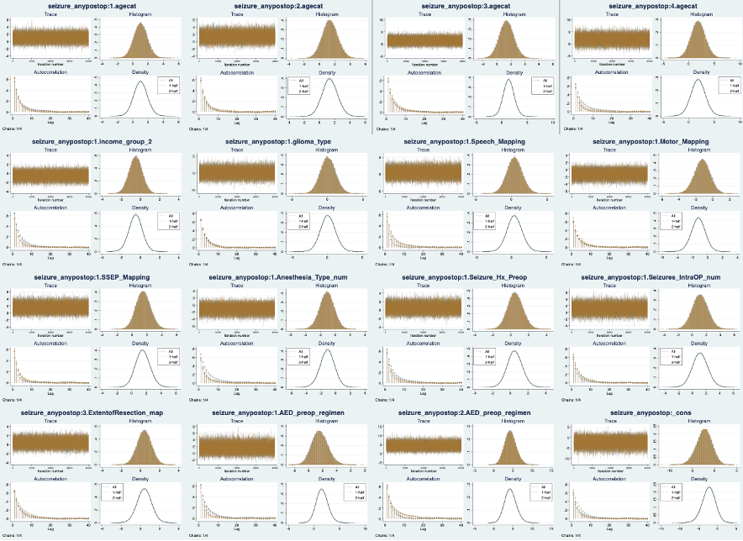

Figure S4. Results from sensitivity analysis of Bayesian logistic regression model showing the effect of different hypothetical priors and variances on the estimated posterior odds ratio of intraoperative seizures.
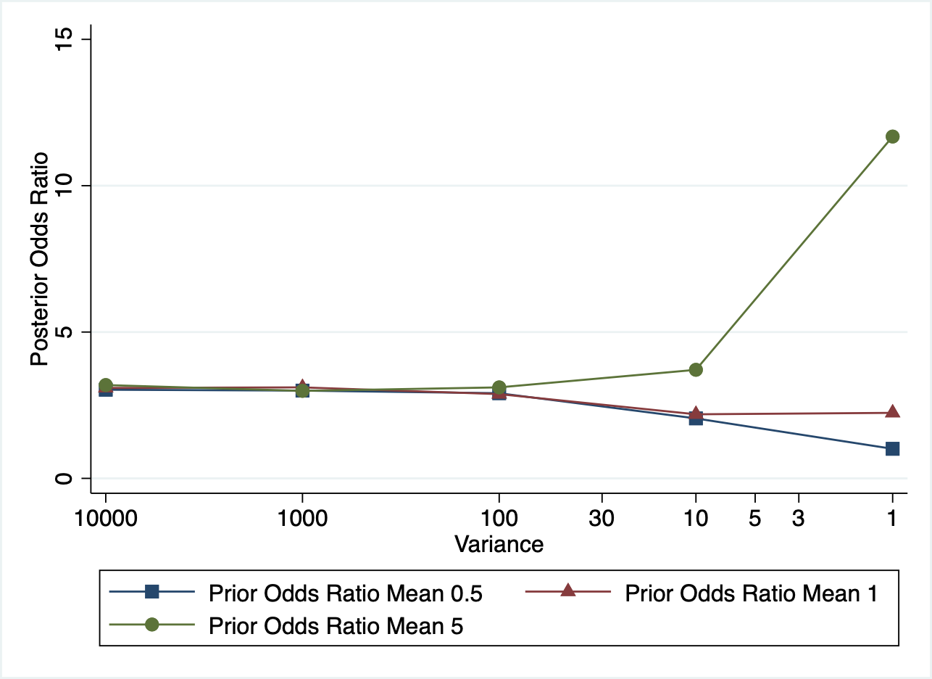

Figure S5. MCMC Random-walk Metropolis Hastings sampling model diagnostics.
Top left trace plot, top right overlay of posterior parameter histograms for all chains, bottom left shows autocorrelation plots, and bottom right shows overlay of density plots for all chains. All suggesting that the model achieved convergence and fit for valid interpretation. We used random-number seed 16 for reproducibility in our analysis.
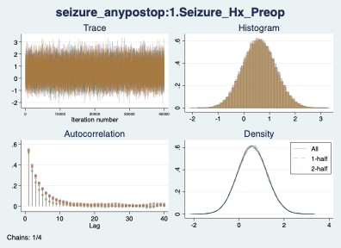

Figure S6. MCMC Random-walk Metropolis Hastings sampling model diagnostics.
Top left trace plot, top right overlay of posterior parameter histograms for all chains, bottom left shows autocorrelation plots, and bottom right shows overlay of density plots for all chains. All suggesting that the model achieved convergence and fit for valid interpretation. We used random-number seed 16 for reproducibility in our analysis.
