Supplementary materials to:

Causal association of trauma with subsequent psychiatric disorder: a Mendelian randomization study

Supplementary Table S1. Single nucleotide polymorphisms used as instrumental variables of trauma exposure.
SNP | CHR | Position | Effect allele | MAF | Beta | SE | P value
rs140746906 | 2 | 164732034 | T | 0.011868 | 0.027757 | 0.005839 | 2.00E-06
rs55984850 | 16 | 89941512 | G | 0.012702 | 0.027757 | 0.006019 | 4.00E-06
rs117659769 | 17 | 75210140 | A | 0.013785 | 0.027757 | 0.005839 | 2.00E-06
rs147967569 | 20 | 7800099 | T | 0.015396 | 0.029789 | 0.006004 | 7.00E-07
rs142592479 | 2 | 49555287 | A | 0.022664 | 0.049993 | 0.010841 | 4.00E-06
rs375555600 | 6 | 26701821 | A | 0.030823 | 0.028164 | 0.005925 | 2.00E-06
rs17676433 | 10 | 119348012 | T | 0.031546 | 0.051924 | 0.010924 | 2.00E-06
rs78289332 | 6 | 147770543 | A | 0.040944 | 0.026942 | 0.005902 | 5.00E-06
rs112201895 | 5 | 62022147 | A | 0.041983 | 0.027757 | 0.005839 | 2.00E-06
rs13336594 | 16 | 1482864 | A | 0.049853 | 0.028164 | 0.00617 | 5.00E-06
rs147542932 | 1 | 196204734 | C | 0.060584 | 0.052309 | 0.011199 | 3.00E-06
rs73207111 | 8 | 9825412 | A | 0.085517 | 0.028571 | 0.005841 | 1.00E-06
rs16972410 | 16 | 73730901 | T | 0.095067 | 0.0306 | 0.006037 | 4.00E-07
rs2405628 | 12 | 85833215 | T | 0.13682 | 0.030195 | 0.006118 | 8.00E-07
rs4978349 | 9 | 108357141 | A | 0.150774 | 0.030195 | 0.006147 | 9.00E-07
rs77660130 | 5 | 73837694 | A | 0.150851 | 0.027757 | 0.005943 | 3.00E-06
rs10068776 | 5 | 168028590 | G | 0.177928 | 0.0306 | 0.005973 | 3.00E-07
rs142356570 | 3 | 84873734 | C | 0.184137 | 0.028164 | 0.00603 | 3.00E-06
rs6466499 | 7 | 114853219 | A | 0.211549 | 0.035269 | 0.006135 | 9.00E-09
rs10507710 | 13 | 64493788 | G | 0.219206 | 0.031004 | 0.005963 | 2.00E-07
rs12682334 | 8 | 109988276 | T | 0.228081 | 0.0306 | 0.006131 | 6.00E-07
rs1957316 | 14 | 33524312 | A | 0.253271 | 0.027334 | 0.005988 | 5.00E-06
rs6959900 | 7 | 24775954 | A | 0.255694 | 0.031408 | 0.006041 | 2.00E-07
rs16896341 | 8 | 121874511 | A | 0.259425 | 0.028978 | 0.006096 | 2.00E-06
rs6445961 | 3 | 58246932 | A | 0.274879 | 0.032216 | 0.006048 | 1.00E-07
rs67526282 | 18 | 55803956 | C | 0.307985 | 0.027757 | 0.006019 | 4.00E-06
rs3754748 | 2 | 173073496 | A | 0.319136 | 0.028571 | 0.006011 | 2.00E-06
rs7650609 | 3 | 146700975 | G | 0.332888 | 0.030118 | 0.006071 | 7.00E-07
rs30266 | 5 | 104636656 | A | 0.333712 | 0.030195 | 0.006007 | 5.00E-07
rs4705007 | 5 | 156335618 | G | 0.341426 | 0.033389 | 0.00595 | 2.00E-08
rs28740872 | 14 | 98088347 | T | 0.372523 | 0.034227 | 0.005973 | 1.00E-08
rs7663401 | 4 | 105207797 | C | 0.389544 | 0.031984 | 0.006005 | 1.00E-07
rs2381473 | 2 | 143394233 | T | 0.432347 | 0.029188 | 0.005967 | 1.00E-06
rs3120637 | 15 | 79562787 | C | 0.467914 | 0.028978 | 0.005924 | 1.00E-06
rs4765074 | 12 | 126083250 | A | 0.476674 | 0.030195 | 0.00605 | 6.00E-07
rs7213514 | 17 | 29210224 | T | 0.498396 | 0.028571 | 0.006011 | 2.00E-06
rs4074990 | 1 | 73256777 | G | 0.496318 | 0.0306 | 0.006037 | 4.00E-07
rs8012767 | 14 | 46773222 | C | 0.475741 | 0.028724 | 0.006043 | 2.00E-06
rs1476535 | 7 | 114430980 | T | 0.455045 | 0.039017 | 0.006033 | 1.00E-10
rs314280 | 6 | 104952962 | G | 0.454928 | 0.027757 | 0.006081 | 5.00E-06
rs7231178 | 18 | 53227371 | A | 0.447228 | 0.027757 | 0.006019 | 4.00E-06
rs12614303 | 2 | 124289603 | C | 0.445558 | 0.029653 | 0.006037 | 9.00E-07
rs870427 | 10 | 132226387 | A | 0.443471 | 0.03105 | 0.00606 | 3.00E-07
rs2410949 | 5 | 107119024 | C | 0.426549 | 0.029789 | 0.006036 | 8.00E-07
rs4312987 | 6 | 53720234 | T | 0.407516 | 0.053078 | 0.011166 | 2.00E-06
rs3896224 | 10 | 104708095 | A | 0.401562 | 0.03105 | 0.00606 | 3.00E-07
rs10468608 | 17 | 21283048 | C | 0.372056 | 0.051587 | 0.011301 | 5.00E-06
rs861078 | 2 | 205687254 | T | 0.348552 | 0.028164 | 0.006108 | 4.00E-06
rs10968265 | 9 | 28002525 | A | 0.335715 | 0.029188 | 0.006141 | 2.00E-06
rs6227 | 15 | 90882002 | C | 0.33537 | 0.033858 | 0.006033 | 2.00E-08
rs283015 | 4 | 16727694 | C | 0.335315 | 0.028724 | 0.006043 | 2.00E-06
rs524562 | 3 | 153172818 | T | 0.317927 | 0.028724 | 0.006043 | 2.00E-06
rs4682660 | 3 | 134300524 | G | 0.296487 | 0.028724 | 0.006043 | 2.00E-06
rs1390496 | 1 | 187307421 | G | 0.256433 | 0.051538 | 0.01129 | 5.00E-06
rs7661756 | 4 | 96176288 | C | 0.244418 | 0.029188 | 0.006141 | 2.00E-06
rs66664020 | 6 | 17012781 | A | 0.235577 | 0.032452 | 0.006046 | 8.00E-08
rs11671136 | 19 | 29804726 | G | 0.234783 | 0.02826 | 0.006128 | 4.00E-06
rs60311435 | 14 | 78061571 | C | 0.196824 | 0.02826 | 0.006128 | 4.00E-06
rs74514008 | 6 | 107721176 | G | 0.14779 | 0.030584 | 0.006034 | 4.00E-07
rs62453434 | 7 | 39241130 | G | 0.122096 | 0.028724 | 0.006043 | 2.00E-06
rs4714735 | 6 | 44057962 | G | 0.118103 | 0.027797 | 0.005951 | 3.00E-06
rs1832877 | 9 | 29048442 | G | 0.111636 | 0.032452 | 0.006092 | 1.00E-07
rs111749255 | 14 | 35328673 | G | 0.080008 | 0.03105 | 0.005972 | 2.00E-07
rs79385087 | 16 | 60603143 | C | 0.05279 | 0.033389 | 0.006025 | 3.00E-08
rs35099409 | 8 | 28876569 | T | 0.048859 | 0.051098 | 0.011194 | 5.00E-06
rs35412563 | 22 | 19174844 | G | 0.04642 | 0.029653 | 0.006008 | 8.00E-07
rs13214628 | 6 | 132741777 | G | 0.026933 | 0.054531 | 0.011148 | 1.00E-06
rs138567168 | 11 | 35778692 | C | 0.018859 | 0.05061 | 0.011087 | 5.00E-06
rs73176142 | 3 | 171542960 | C | 0.017988 | 0.052076 | 0.011149 | 3.00E-06
rs113522753 | 16 | 71898534 | A | 0.017549 | 0.027797 | 0.006028 | 4.00E-06
rs77377992 | 14 | 78547099 | G | 0.01299 | 0.027797 | 0.005951 | 3.00E-06
rs139193462 | 19 | 15277406 | G | 0.009741 | 0.028724 | 0.006043 | 2.00E-06
rs182013377 | 10 | 64731271 | A | 0.006931 | 0.027797 | 0.005848 | 2.00E-06
CHR: Chromosome, MAF: Minor allele frequency; SNP: Single nucleotide polymorphism.
Supplementary Table S2. Other Mendelian randomization estimates between trauma exposure and psychiatric disease risk based on Gene ATLAS.
Outcome | Method | SNPs (N) | OR | LCI | UCI | P value
Psychiatric disorder | MR Egger | 66 | 0.99 | 0.96 | 1.02 | 0.38
 | Weighted median | 66 | 1.02 | 1.01 | 1.02 | 3.25E-04
 | Simple mode | 66 | 1.02 | 1.00 | 1.04 | 0.08
 | Weighted mode | 66 | 1.02 | 1.00 | 1.04 | 0.02
Mood disorder | MR Egger | 66 | 1.00 | 0.98 | 1.01 | 0.73
 | Weighted median | 66 | 1.01 | 1.00 | 1.01 | 0.02
 | Simple mode | 66 | 1.01 | 1.00 | 1.02 | 0.14
 | Weighted mode | 66 | 1.01 | 1.00 | 1.02 | 0.07
Depression | MR Egger | 66 | 0.99 | 0.96 | 1.02 | 0.50
 | Weighted median | 66 | 1.01 | 1.01 | 1.02 | 7.06E-04
 | Simple mode | 66 | 1.01 | 1.00 | 1.03 | 0.08
 | Weighted mode | 66 | 1.01 | 1.00 | 1.03 | 0.08
Bipolar disorder | MR Egger | 66 | 1.00 | 1.00 | 1.01 | 0.48
 | Weighted median | 66 | 1.00 | 1.00 | 1.00 | 0.17
 | Simple mode | 66 | 1.00 | 1.00 | 1.01 | 0.22
 | Weighted mode | 66 | 1.00 | 1.00 | 1.00 | 0.22
Sleep disorder | MR Egger | 66 | 1.00 | 0.99 | 1.01 | 0.95
 | Weighted median | 66 | 1.00 | 1.00 | 1.01 | 0.36
 | Simple mode | 66 | 1.00 | 1.00 | 1.01 | 0.32
 | Weighted mode | 66 | 1.00 | 1.00 | 1.01 | 0.46
Schizophrenia | MR Egger | 66 | 1.00 | 1.00 | 1.01 | 0.68
 | Weighted median | 66 | 1.00 | 1.00 | 1.00 | 0.15
 | Simple mode | 66 | 1.00 | 1.00 | 1.00 | 0.31
 | Weighted mode | 66 | 1.00 | 1.00 | 1.00 | 0.42
OR: Odds ratio; LCI: Lower confidence interval; SNP: Single nucleotide polymorphism; UCI; upper confidence interval.
Supplementary Table S3. Other Mendelian randomization estimates between trauma exposure and psychiatric disease risk based on MR Base.
Outcome | Method | SNPs (N) | OR | LCI | UCI | P value
Psychiatric disorder | MR Egger | 49 | 0.65 | 0.05 | 8.31 | 0.74
 | Weighted median | 49 | 0.71 | 0.34 | 1.49 | 0.36
 | Simple mode | 49 | 0.26 | 0.05 | 1.26 | 0.09
 | Weighted mode | 49 | 1.87 | 0.48 | 7.21 | 0.36
Mood disorder | MR Egger | 49 | 0.79 | 0.31 | 2.02 | 0.63
 | Weighted median | 49 | 1.36 | 1.06 | 1.75 | 0.01
 | Simple mode | 49 | 1.47 | 0.87 | 2.48 | 0.15
 | Weighted mode | 49 | 1.44 | 0.91 | 2.26 | 0.12
Depression | MR Egger | 49 | 0.91 | 0.71 | 1.18 | 0.48
 | Weighted median | 49 | 1.07 | 1.00 | 1.14 | 0.04
 | Simple mode | 49 | 1.09 | 0.93 | 1.28 | 0.27
 | Weighted mode | 49 | 1.03 | 0.92 | 1.14 | 0.60
Bipolar disorder | MR Egger | 66 | 0.63 | 0.26 | 1.52 | 0.30
 | Weighted median | 66 | 1.14 | 0.91 | 1.43 | 0.24
 | Simple mode | 66 | 0.88 | 0.53 | 1.46 | 0.63
 | Weighted mode | 66 | 1.06 | 0.70 | 1.61 | 0.78
Sleep disorder | MR Egger | 49 | 1.06 | 0.31 | 3.69 | 0.92
 | Weighted median | 49 | 0.97 | 0.68 | 1.36 | 0.84
 | Simple mode | 49 | 1.41 | 0.68 | 2.95 | 0.36
 | Weighted mode | 49 | 1.00 | 1.62 | 0.62 | 1.00
Schizophrenia | MR Egger | 66 | 0.56 | 0.22 | 1.45 | 0.24
 | Weighted median | 66 | 1.42 | 1.16 | 1.74 | 7.34E-04
 | Simple mode | 66 | 1.12 | 0.69 | 1.83 | 0.64
 | Weighted mode | 66 | 1.91 | 1.11 | 3.30 | 0.02
Anxiety disorders | MR Egger | 49 | 0.90 | 0.24 | 3.37 | 0.88
 | Weighted median | 49 | 1.28 | 0.88 | 1.85 | 0.20
 | Simple mode | 49 | 1.84 | 0.85 | 4.00 | 0.12
 | Weighted mode | 49 | 1.66 | 0.82 | 3.37 | 0.16
Eating disorder | MR Egger | 49 | 0.31 | 0.01 | 9.04 | 0.50
 | Weighted median | 49 | 1.35 | 0.55 | 3.31 | 0.51
 | Simple mode | 49 | 2.29 | 0.46 | 11.25 | 0.31
 | Weighted mode | 49 | 1.34 | 0.35 | 5.14 | 0.67
PTSD | MR Egger | 49 | 10.88 | 0.13 | 882.65 | 0.29
 | Weighted median | 49 | 0.57 | 0.18 | 1.82 | 0.34
 | Simple mode | 49 | 0.36 | 0.04 | 3.76 | 0.40
 | Weighted mode | 49 | 0.47 | 0.05 | 4.90 | 0.53
LCI: Lower confidence interval; OR: Odds ratio; PTSD: Post-traumatic stress disorder; SNP: Single nucleotide polymorphism; UCI; upper confidence interval.
Supplementary Figure S1. Funnel plots, scatter plots and leave-one-out plots of the genetic causal associations between trauma and mood disorder in UK Biobank. (A) funnel plots; (B) scatter plots; (C) leave-one-out plots.
(A)
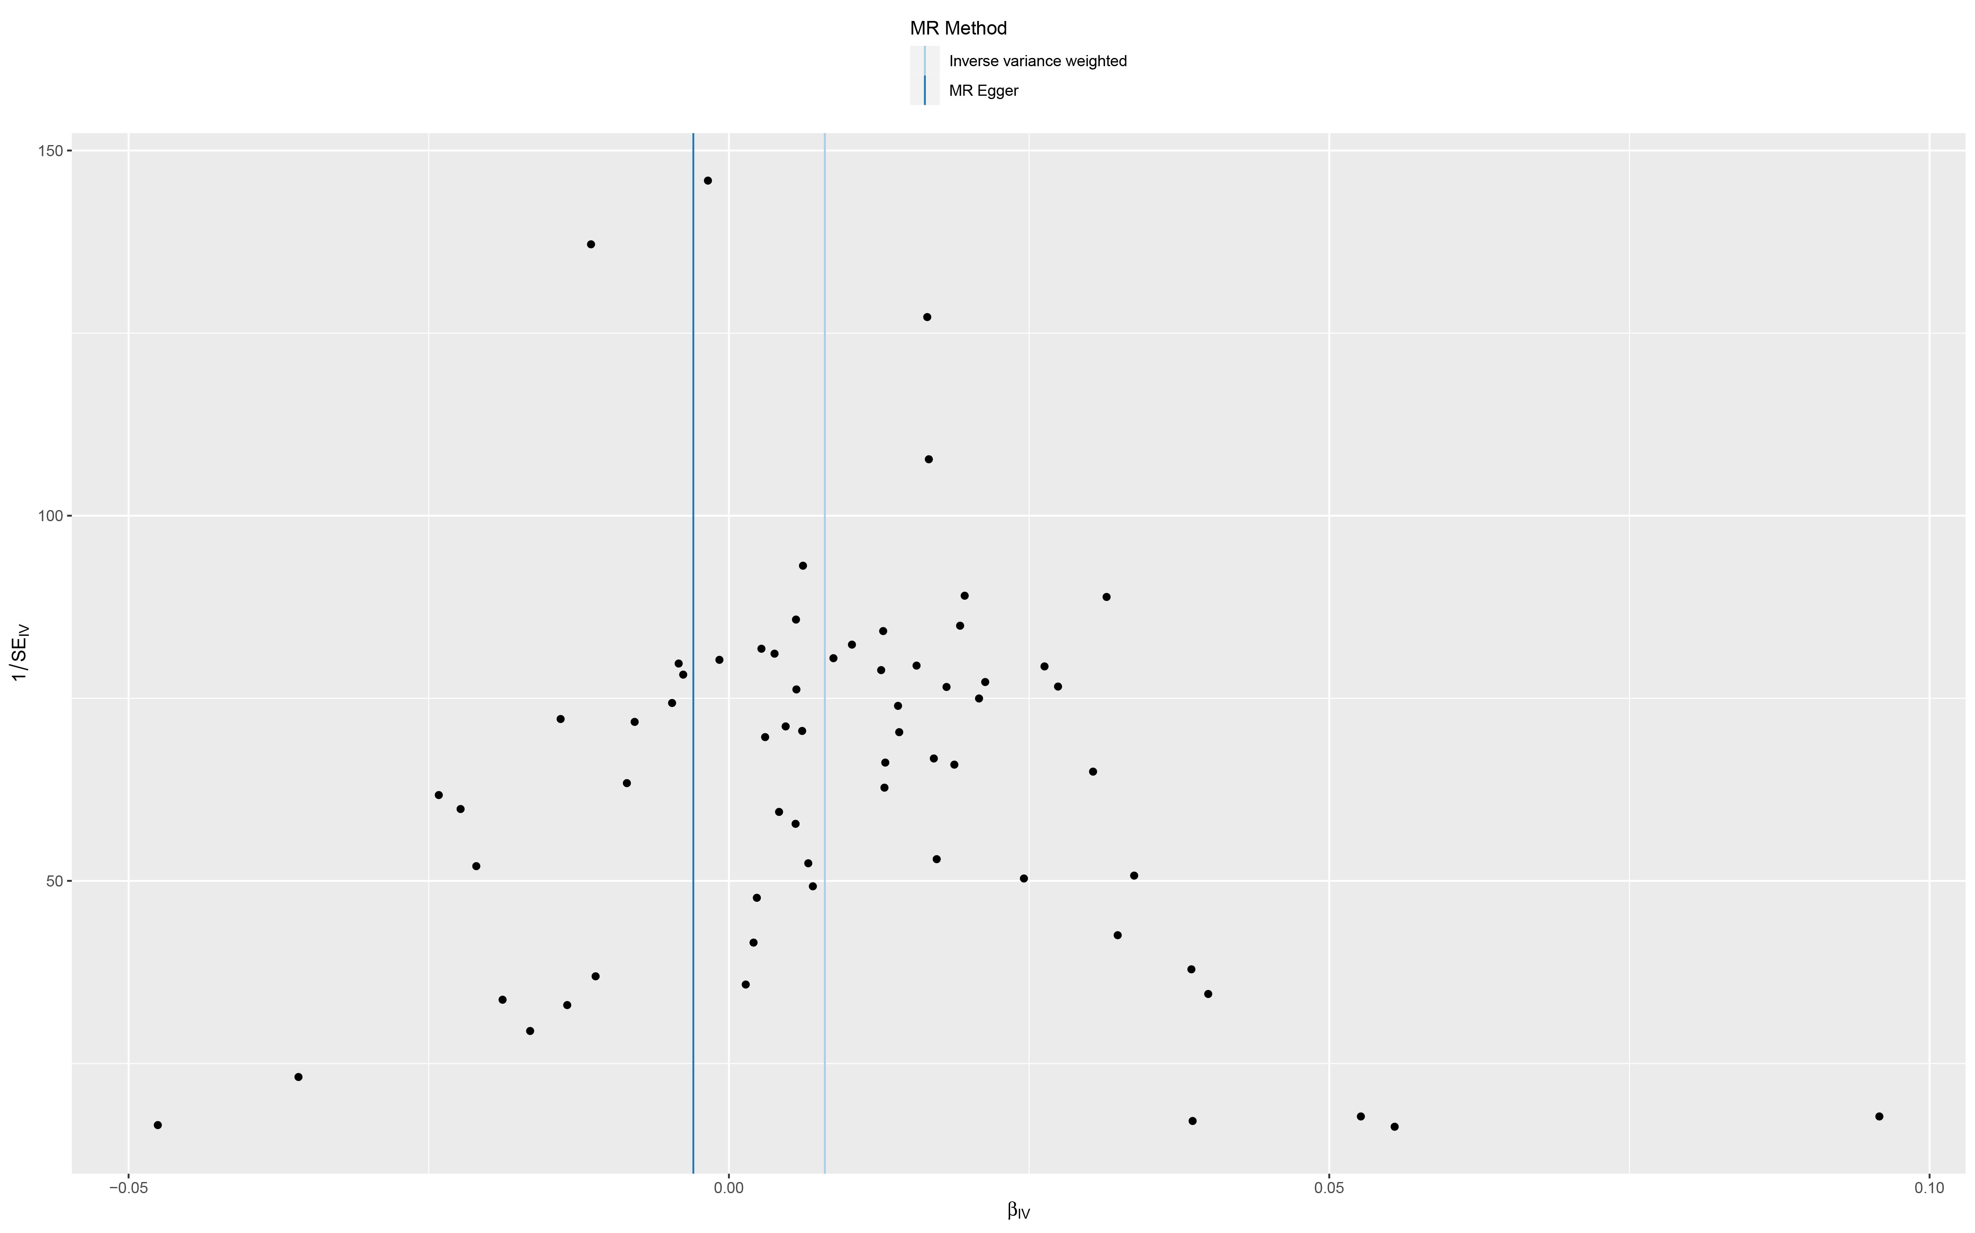
(B)
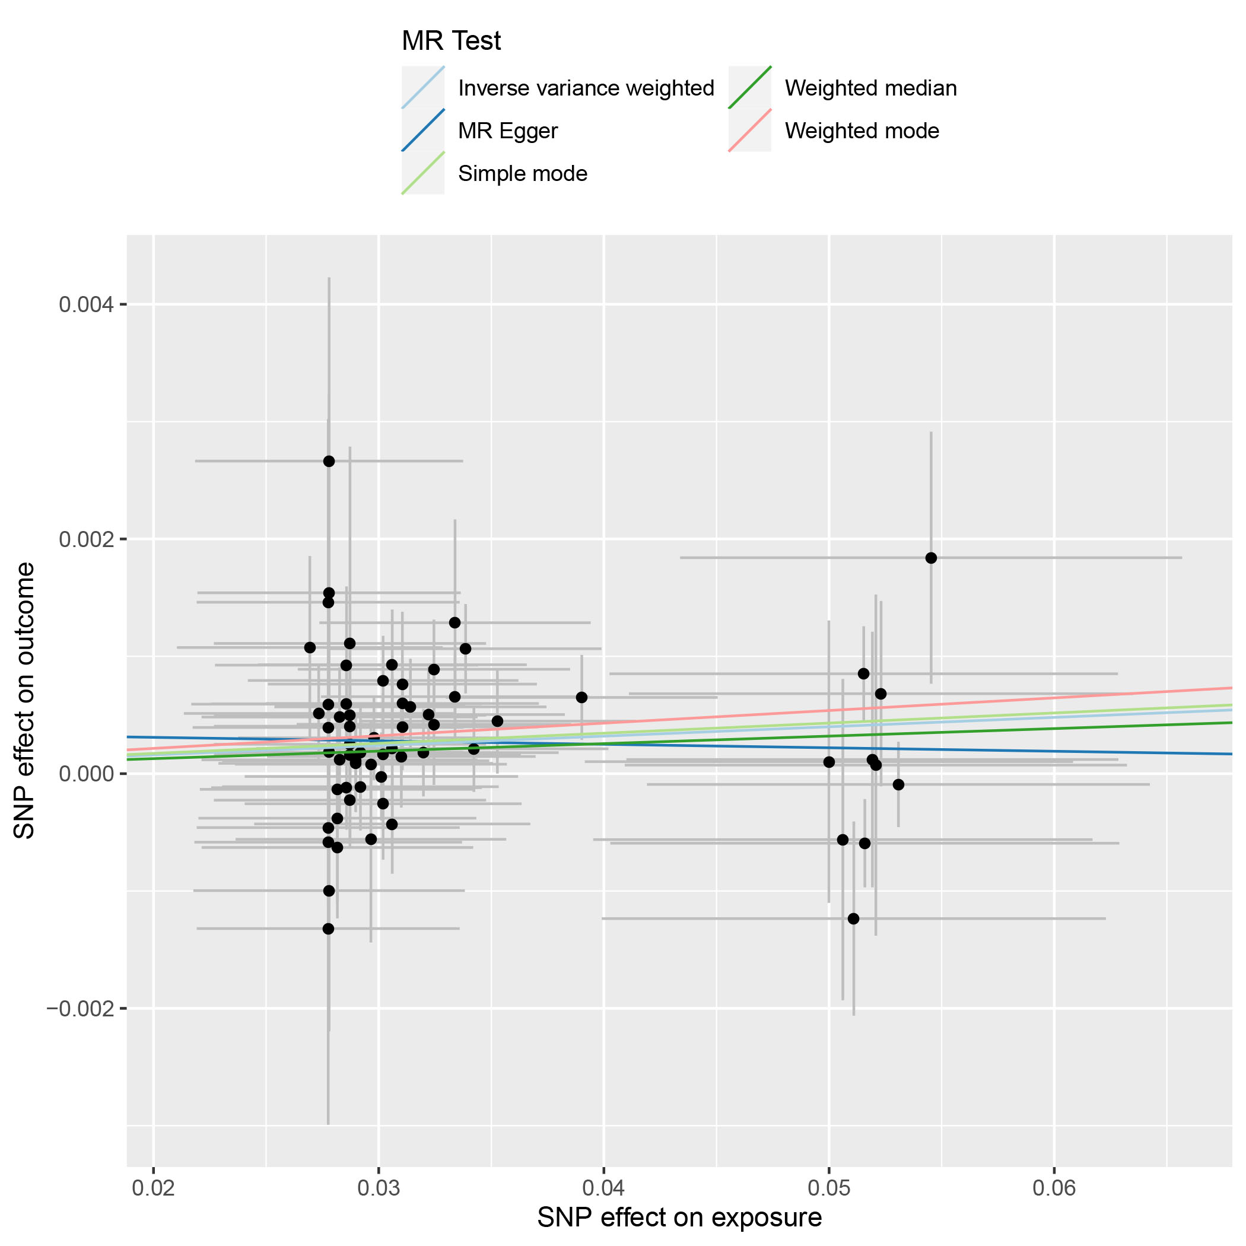
(C)

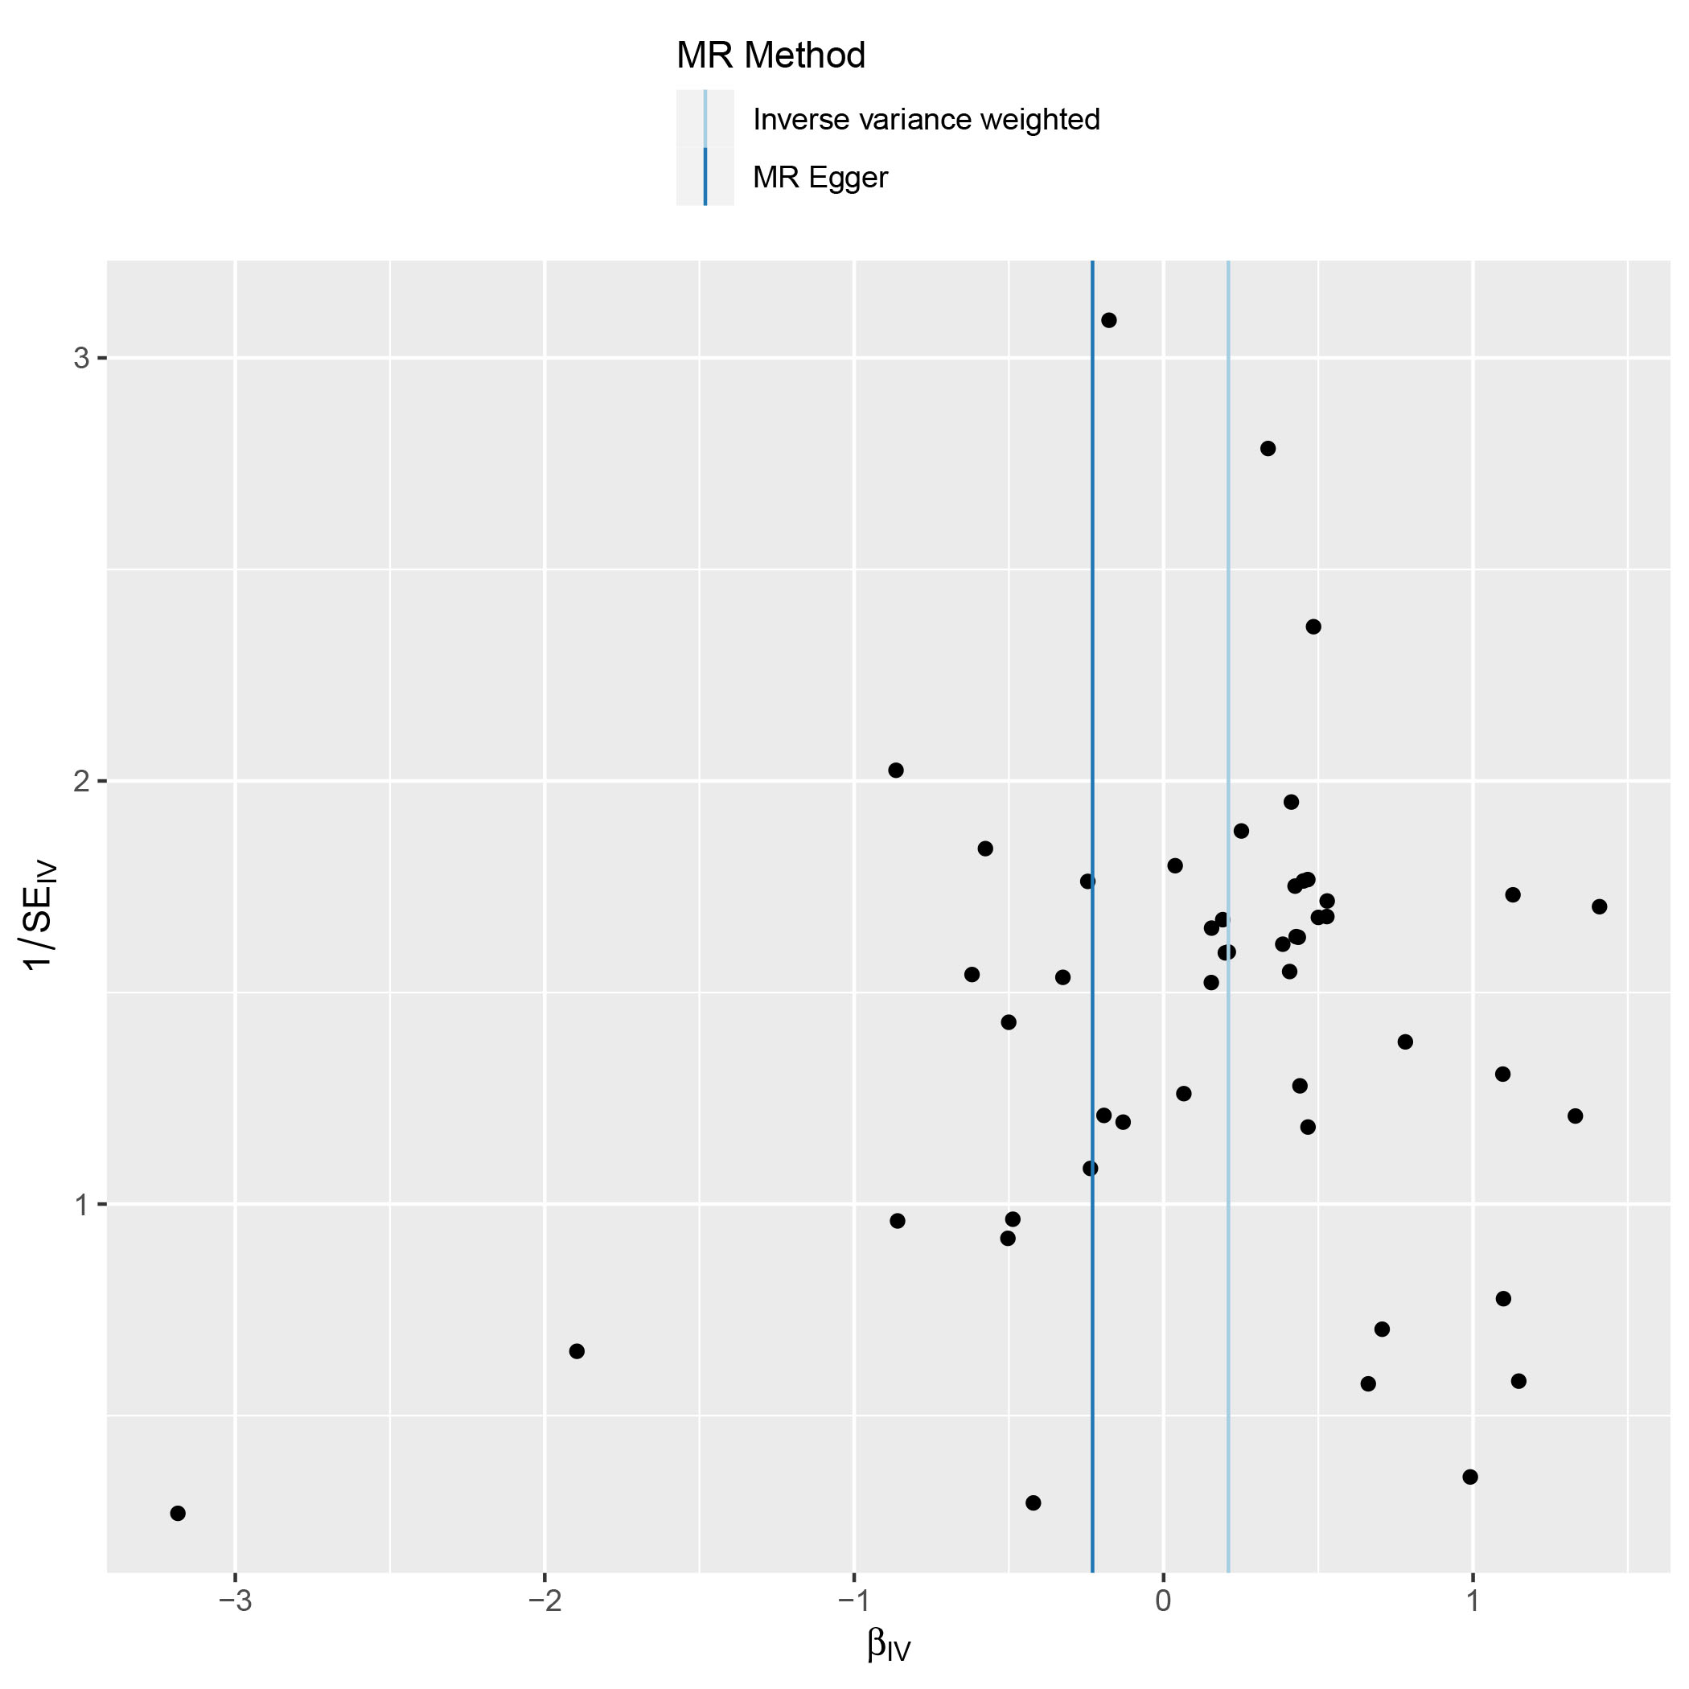
Supplementary Figure S2. Funnel plots, scatter plots and leave-one-out plots of the genetic causal associations between trauma and bipolar disorder in UK Biobank. (A) funnel plots; (B) scatter plots; (C) leave-one-out plots.
(A)
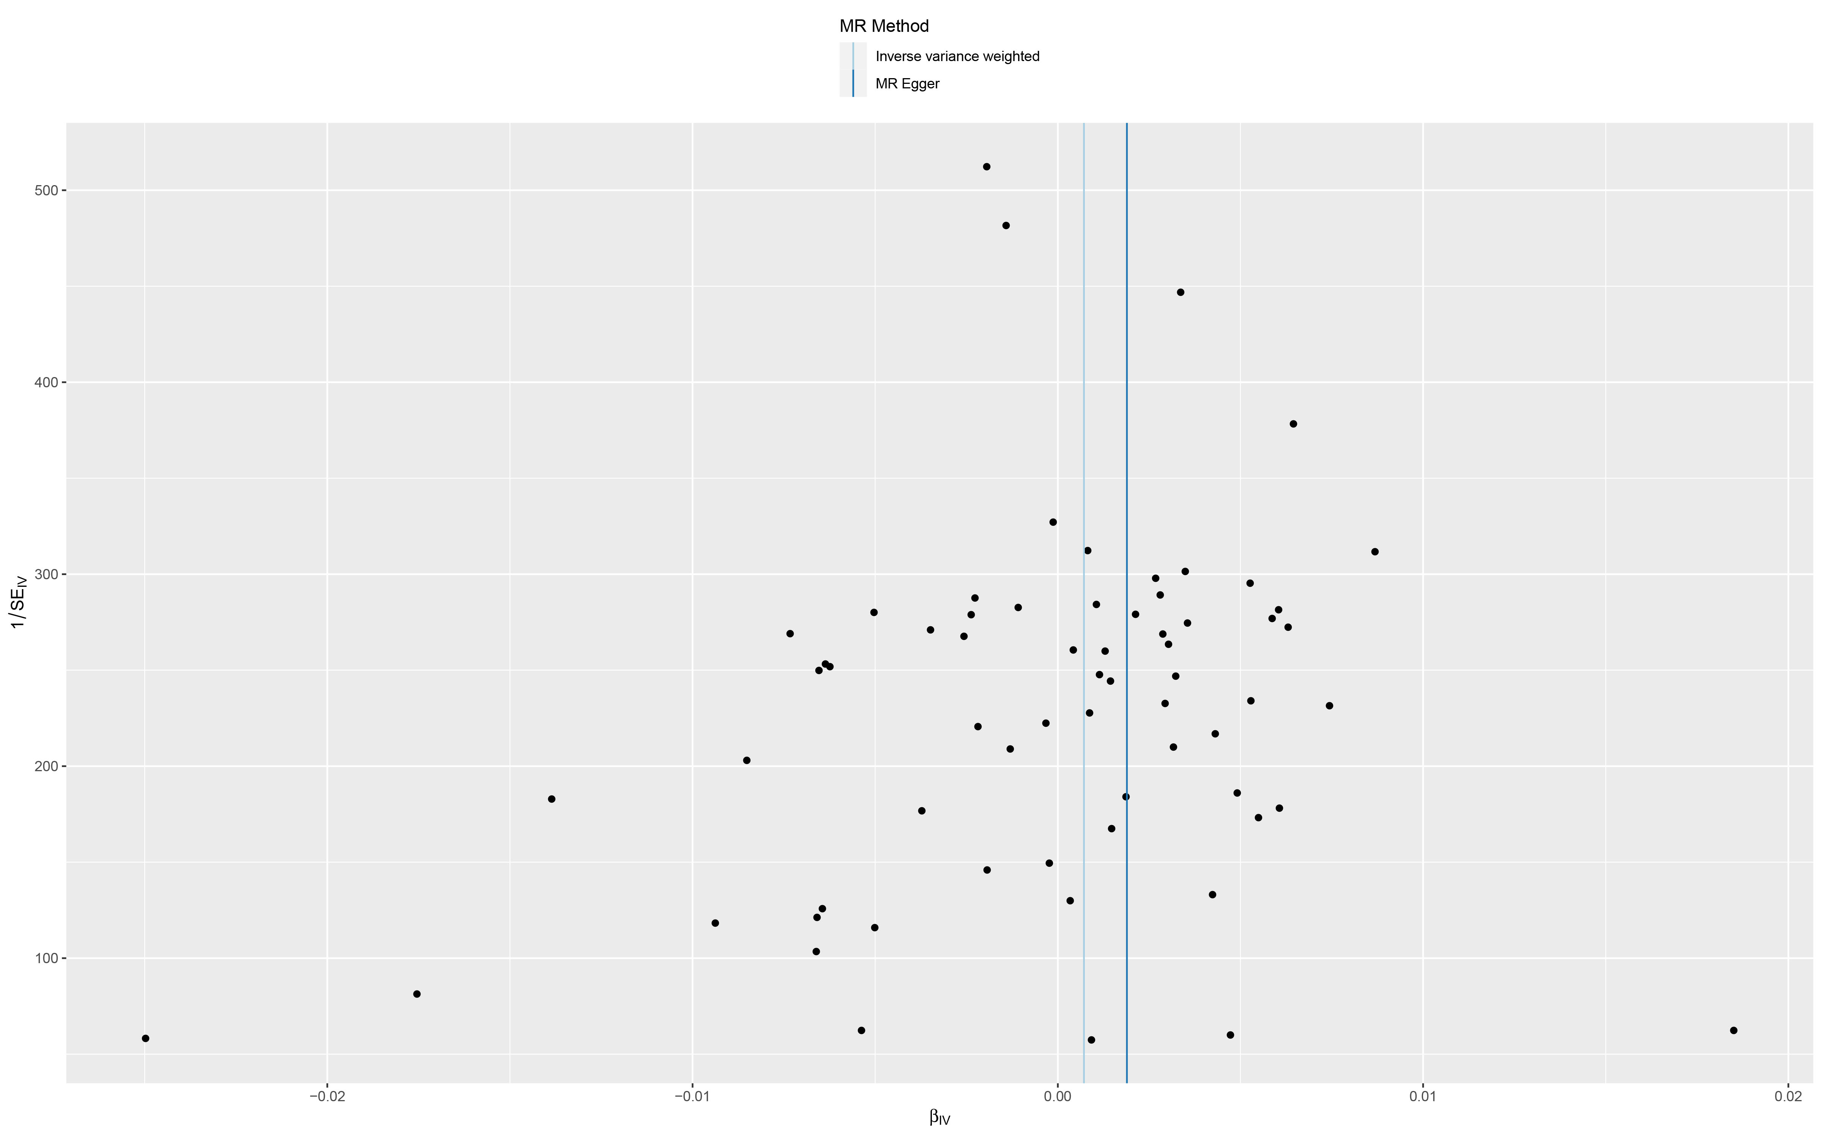
(B)
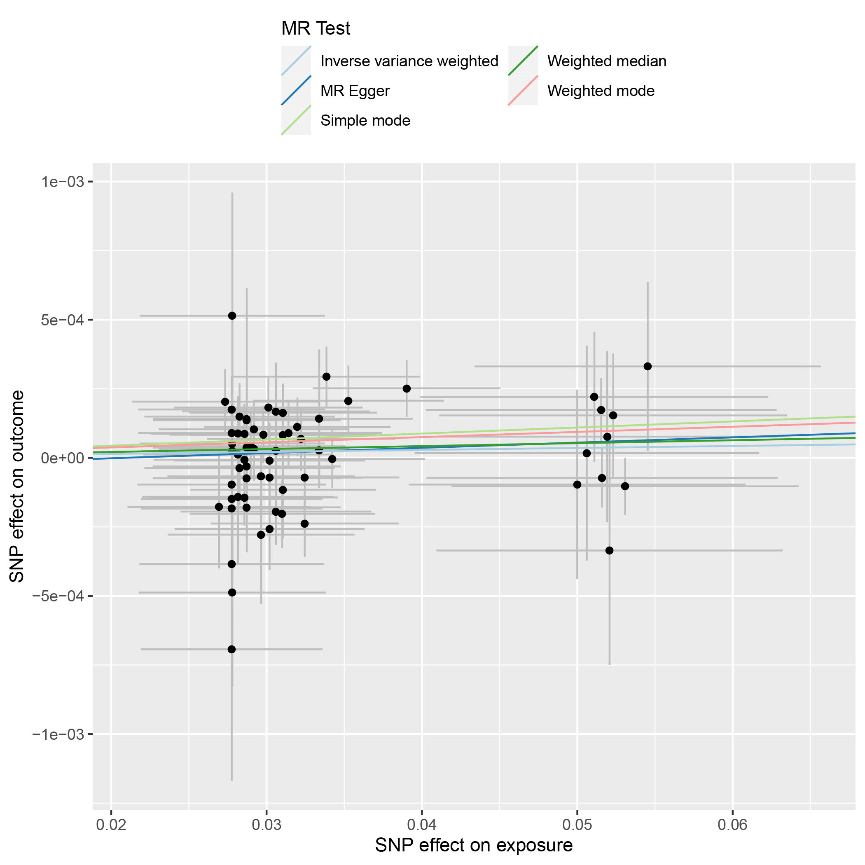
(C)
Supplementary Figure S3. Funnel plots, scatter plots and leave-one-out plots of the genetic causal associations between trauma and depression in UK Biobank. (A) funnel plots; (B) scatter plots; (C) leave-one-out plots.
(A)
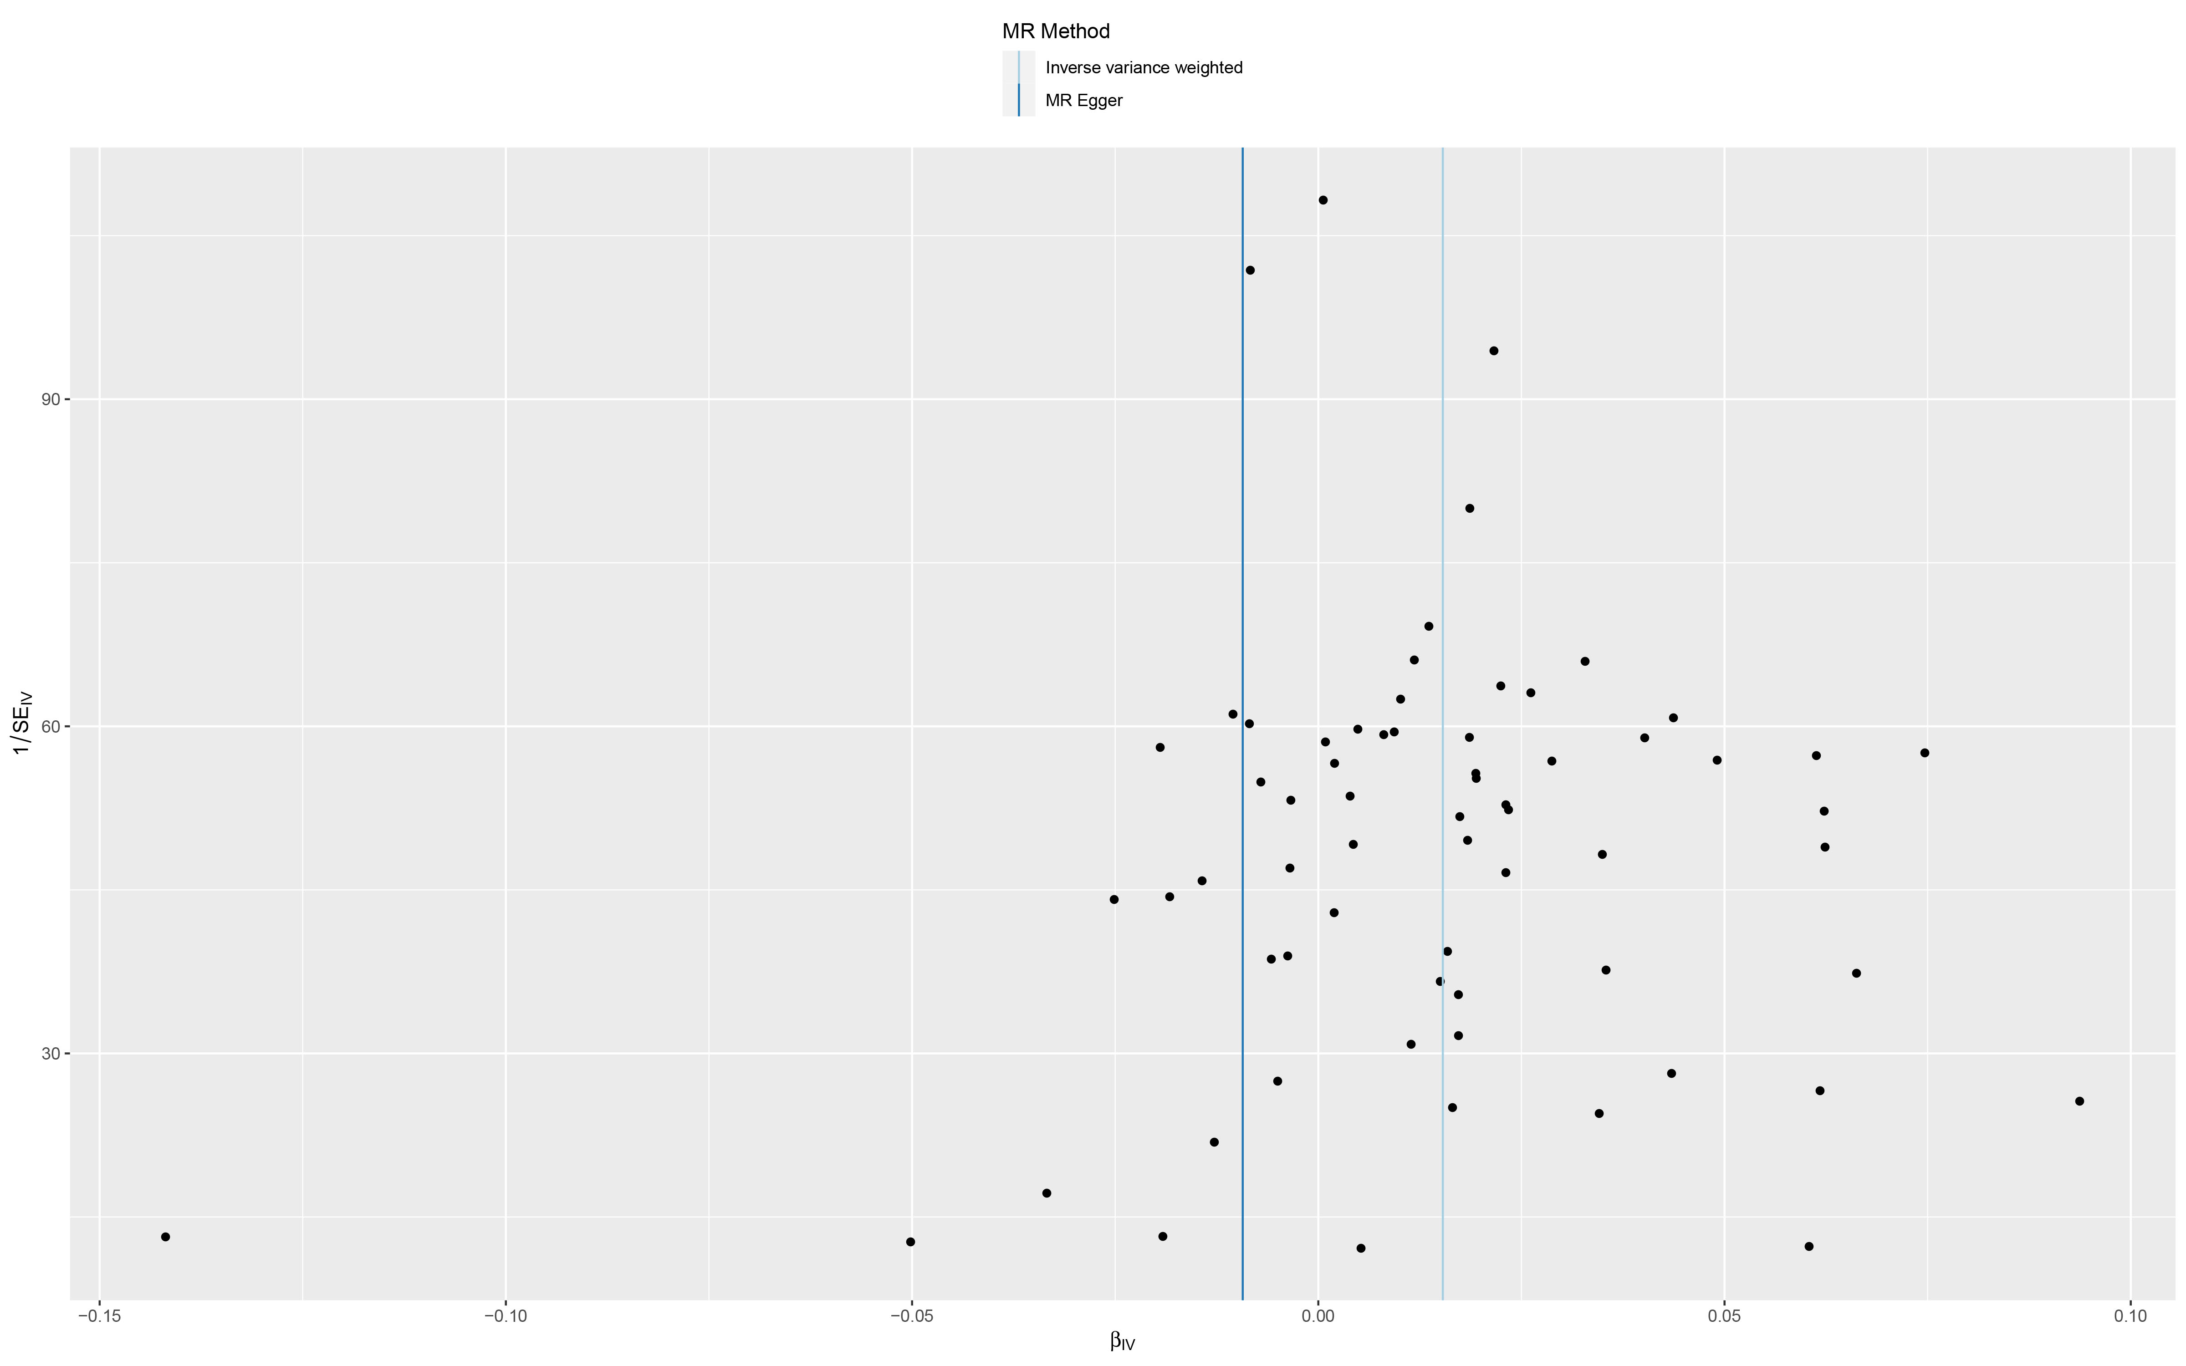
(B)
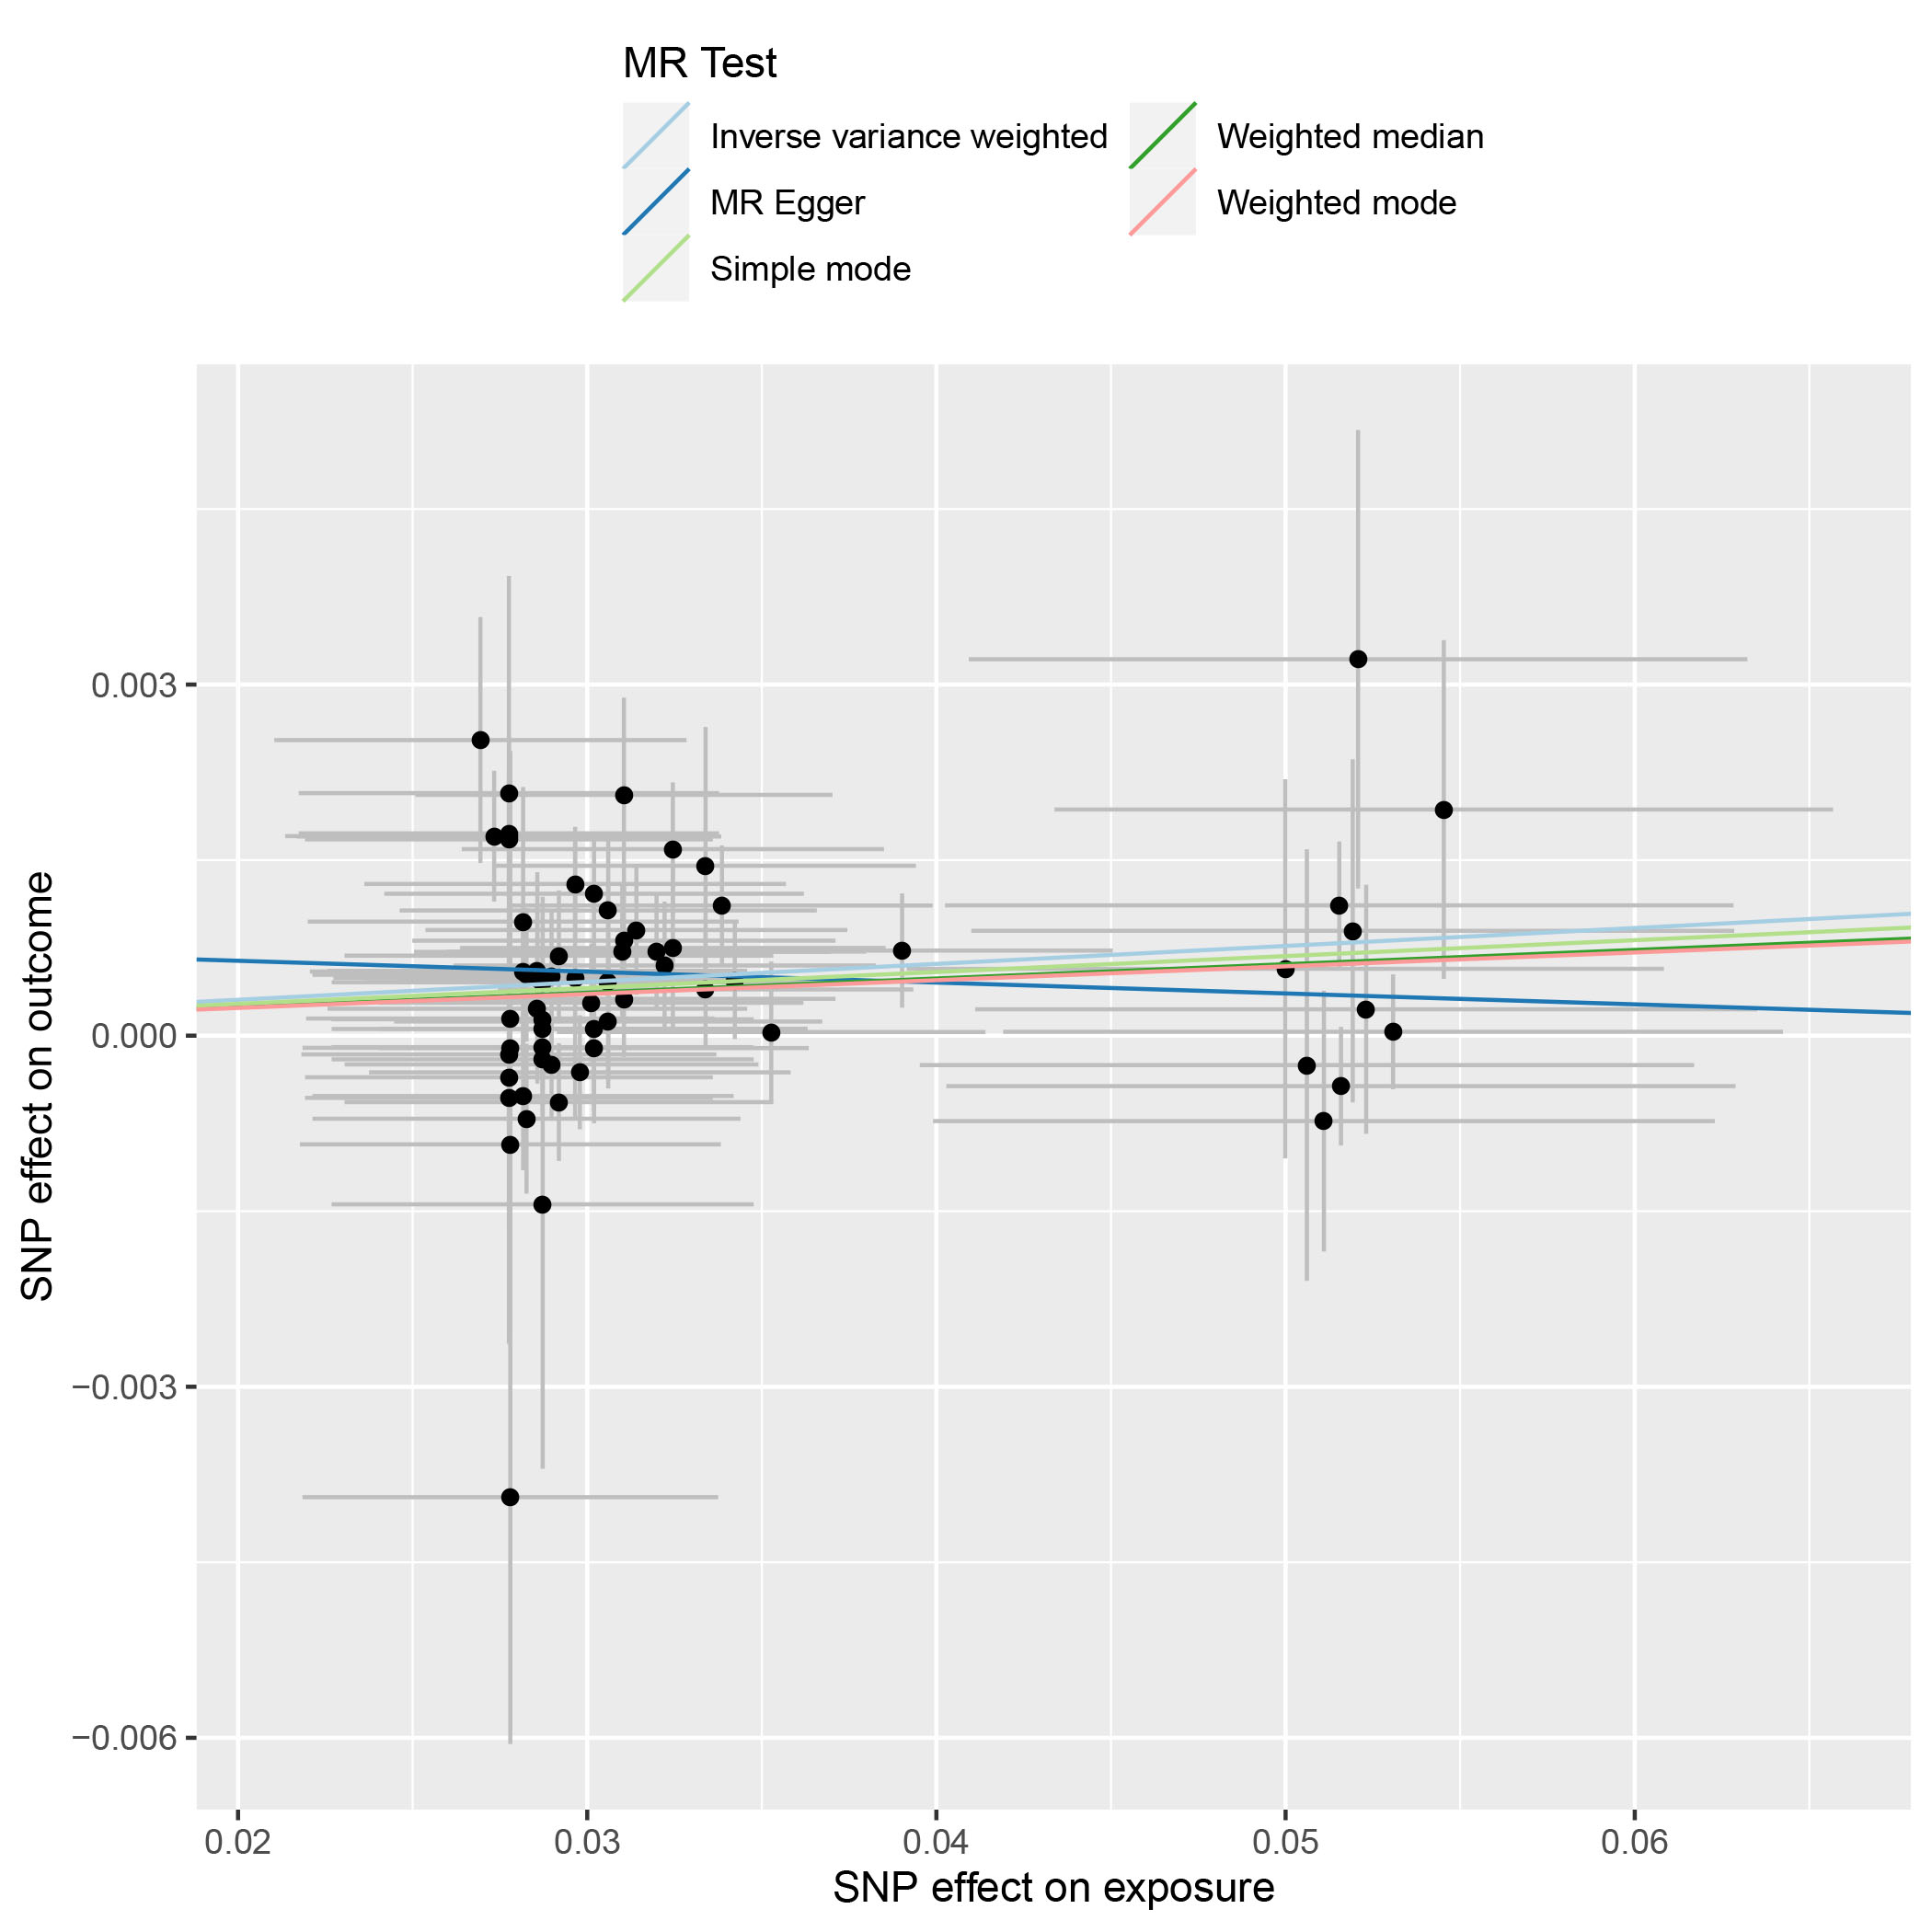
(C)
Supplementary Figure S4. Funnel plots, scatter plots and leave-one-out plots of the genetic causal associations between trauma and mood disorder in MR Base. (A) funnel plots; (B) scatter plots; (C) leave-one-out plots.
(A)
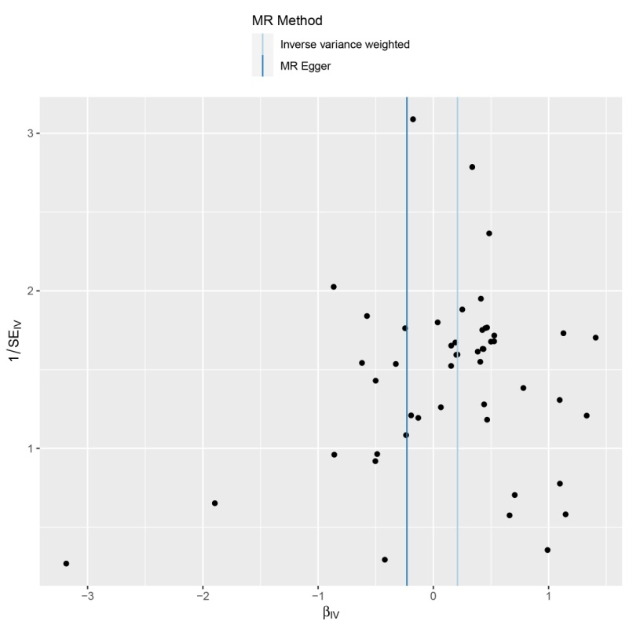
(B)
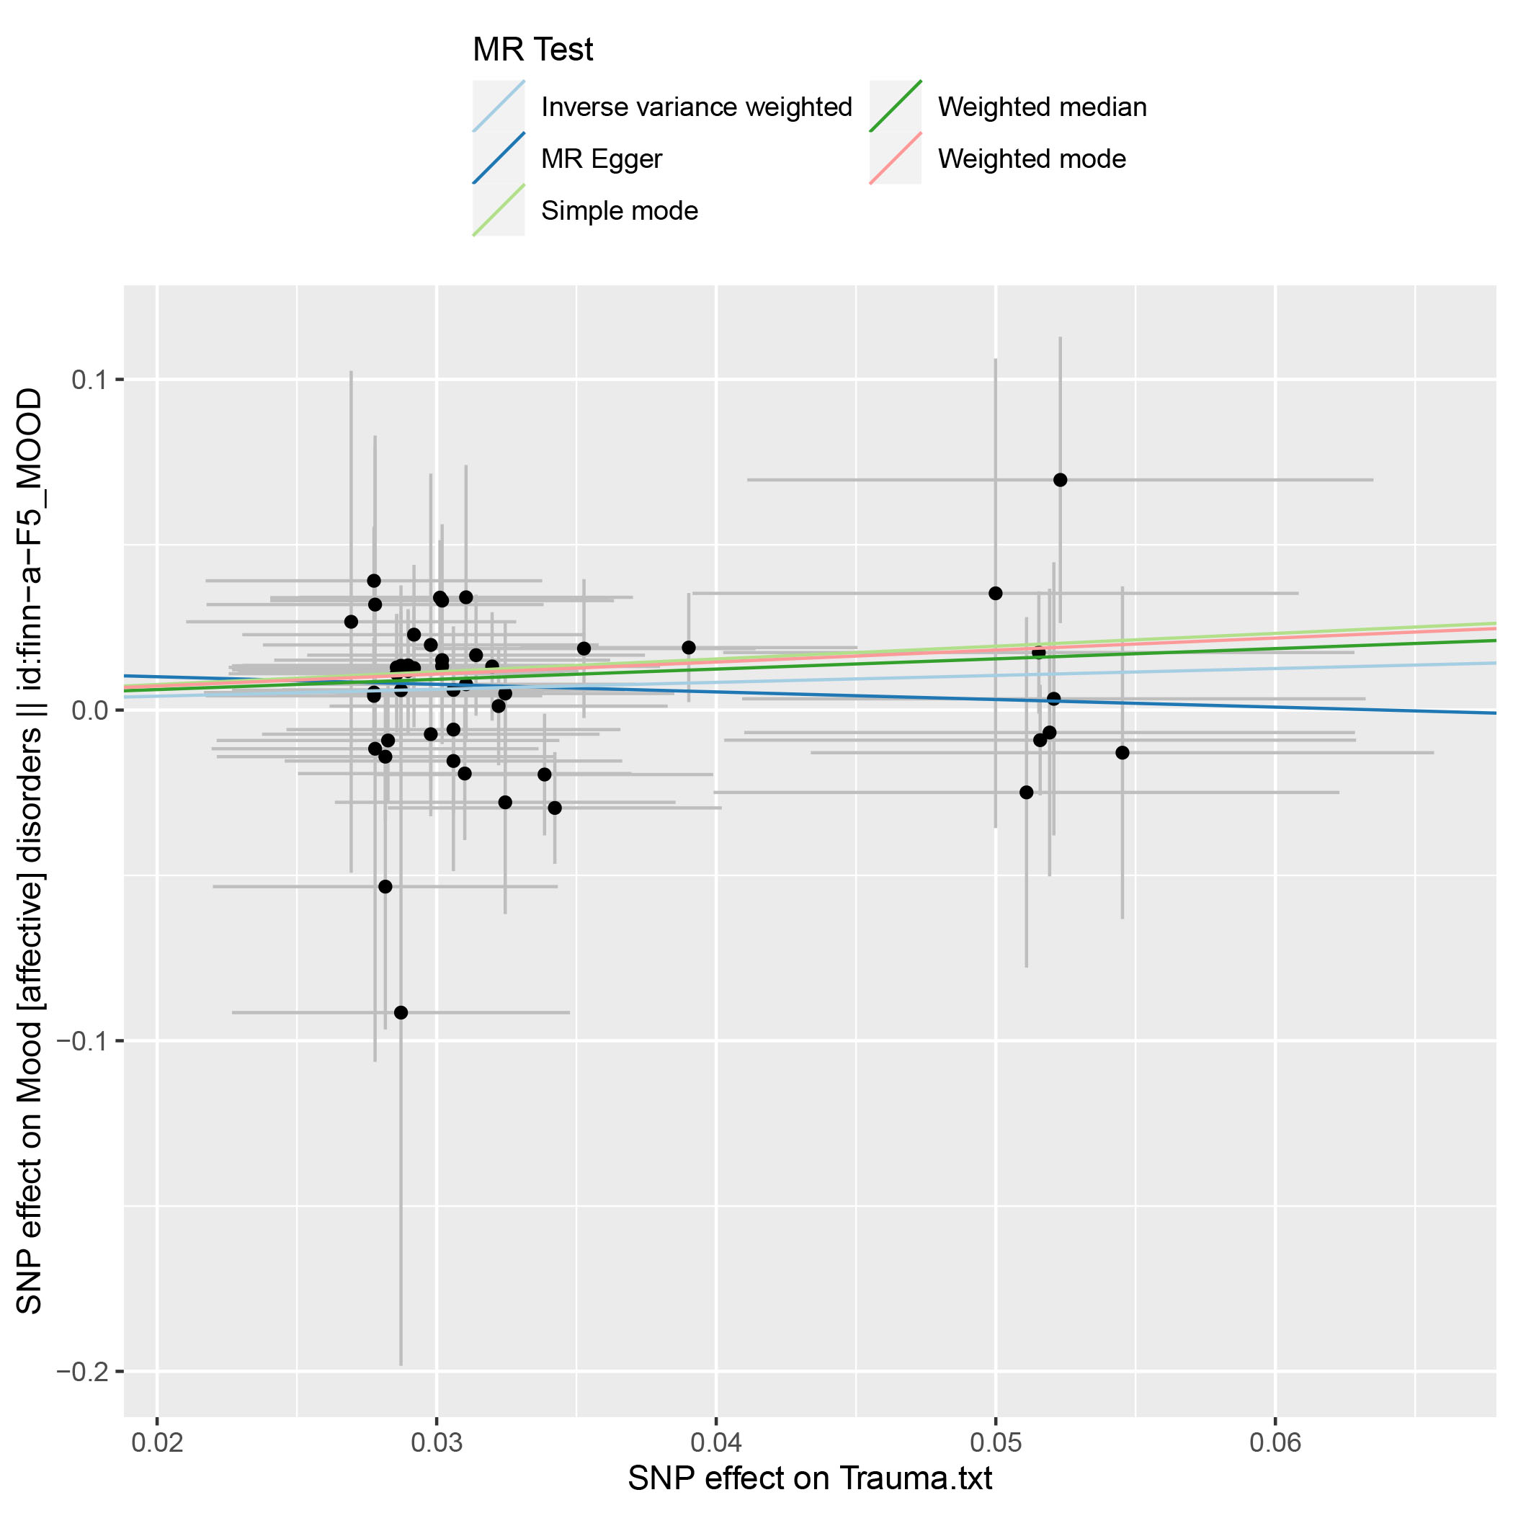
(C)

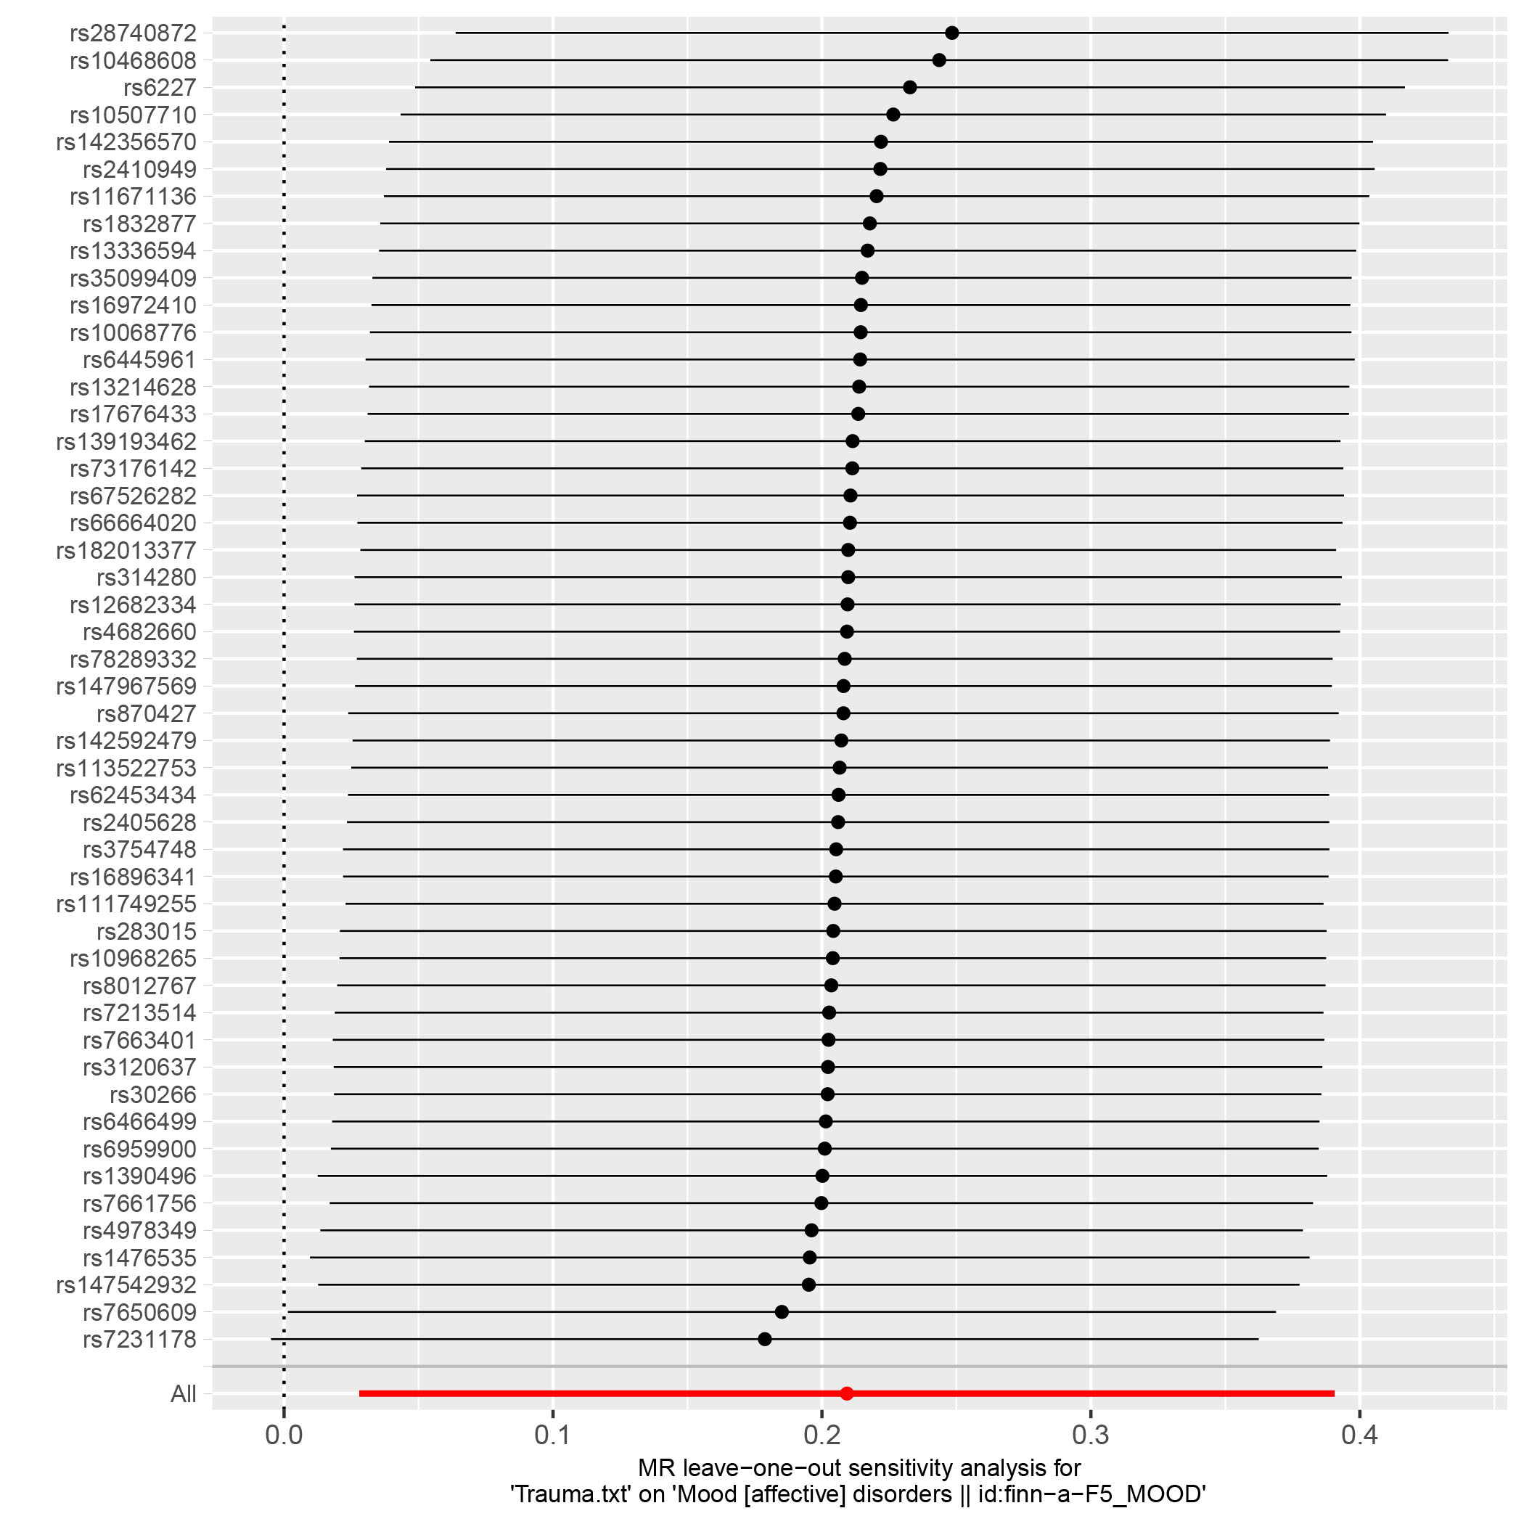
Supplementary Figure S5. Funnel plots, scatter plots and leave-one-out plots of the genetic causal associations between trauma and bipolar disorder in MR Base. (A) funnel plots; (B) scatter plots; (C) leave-one-out plots.
(A)
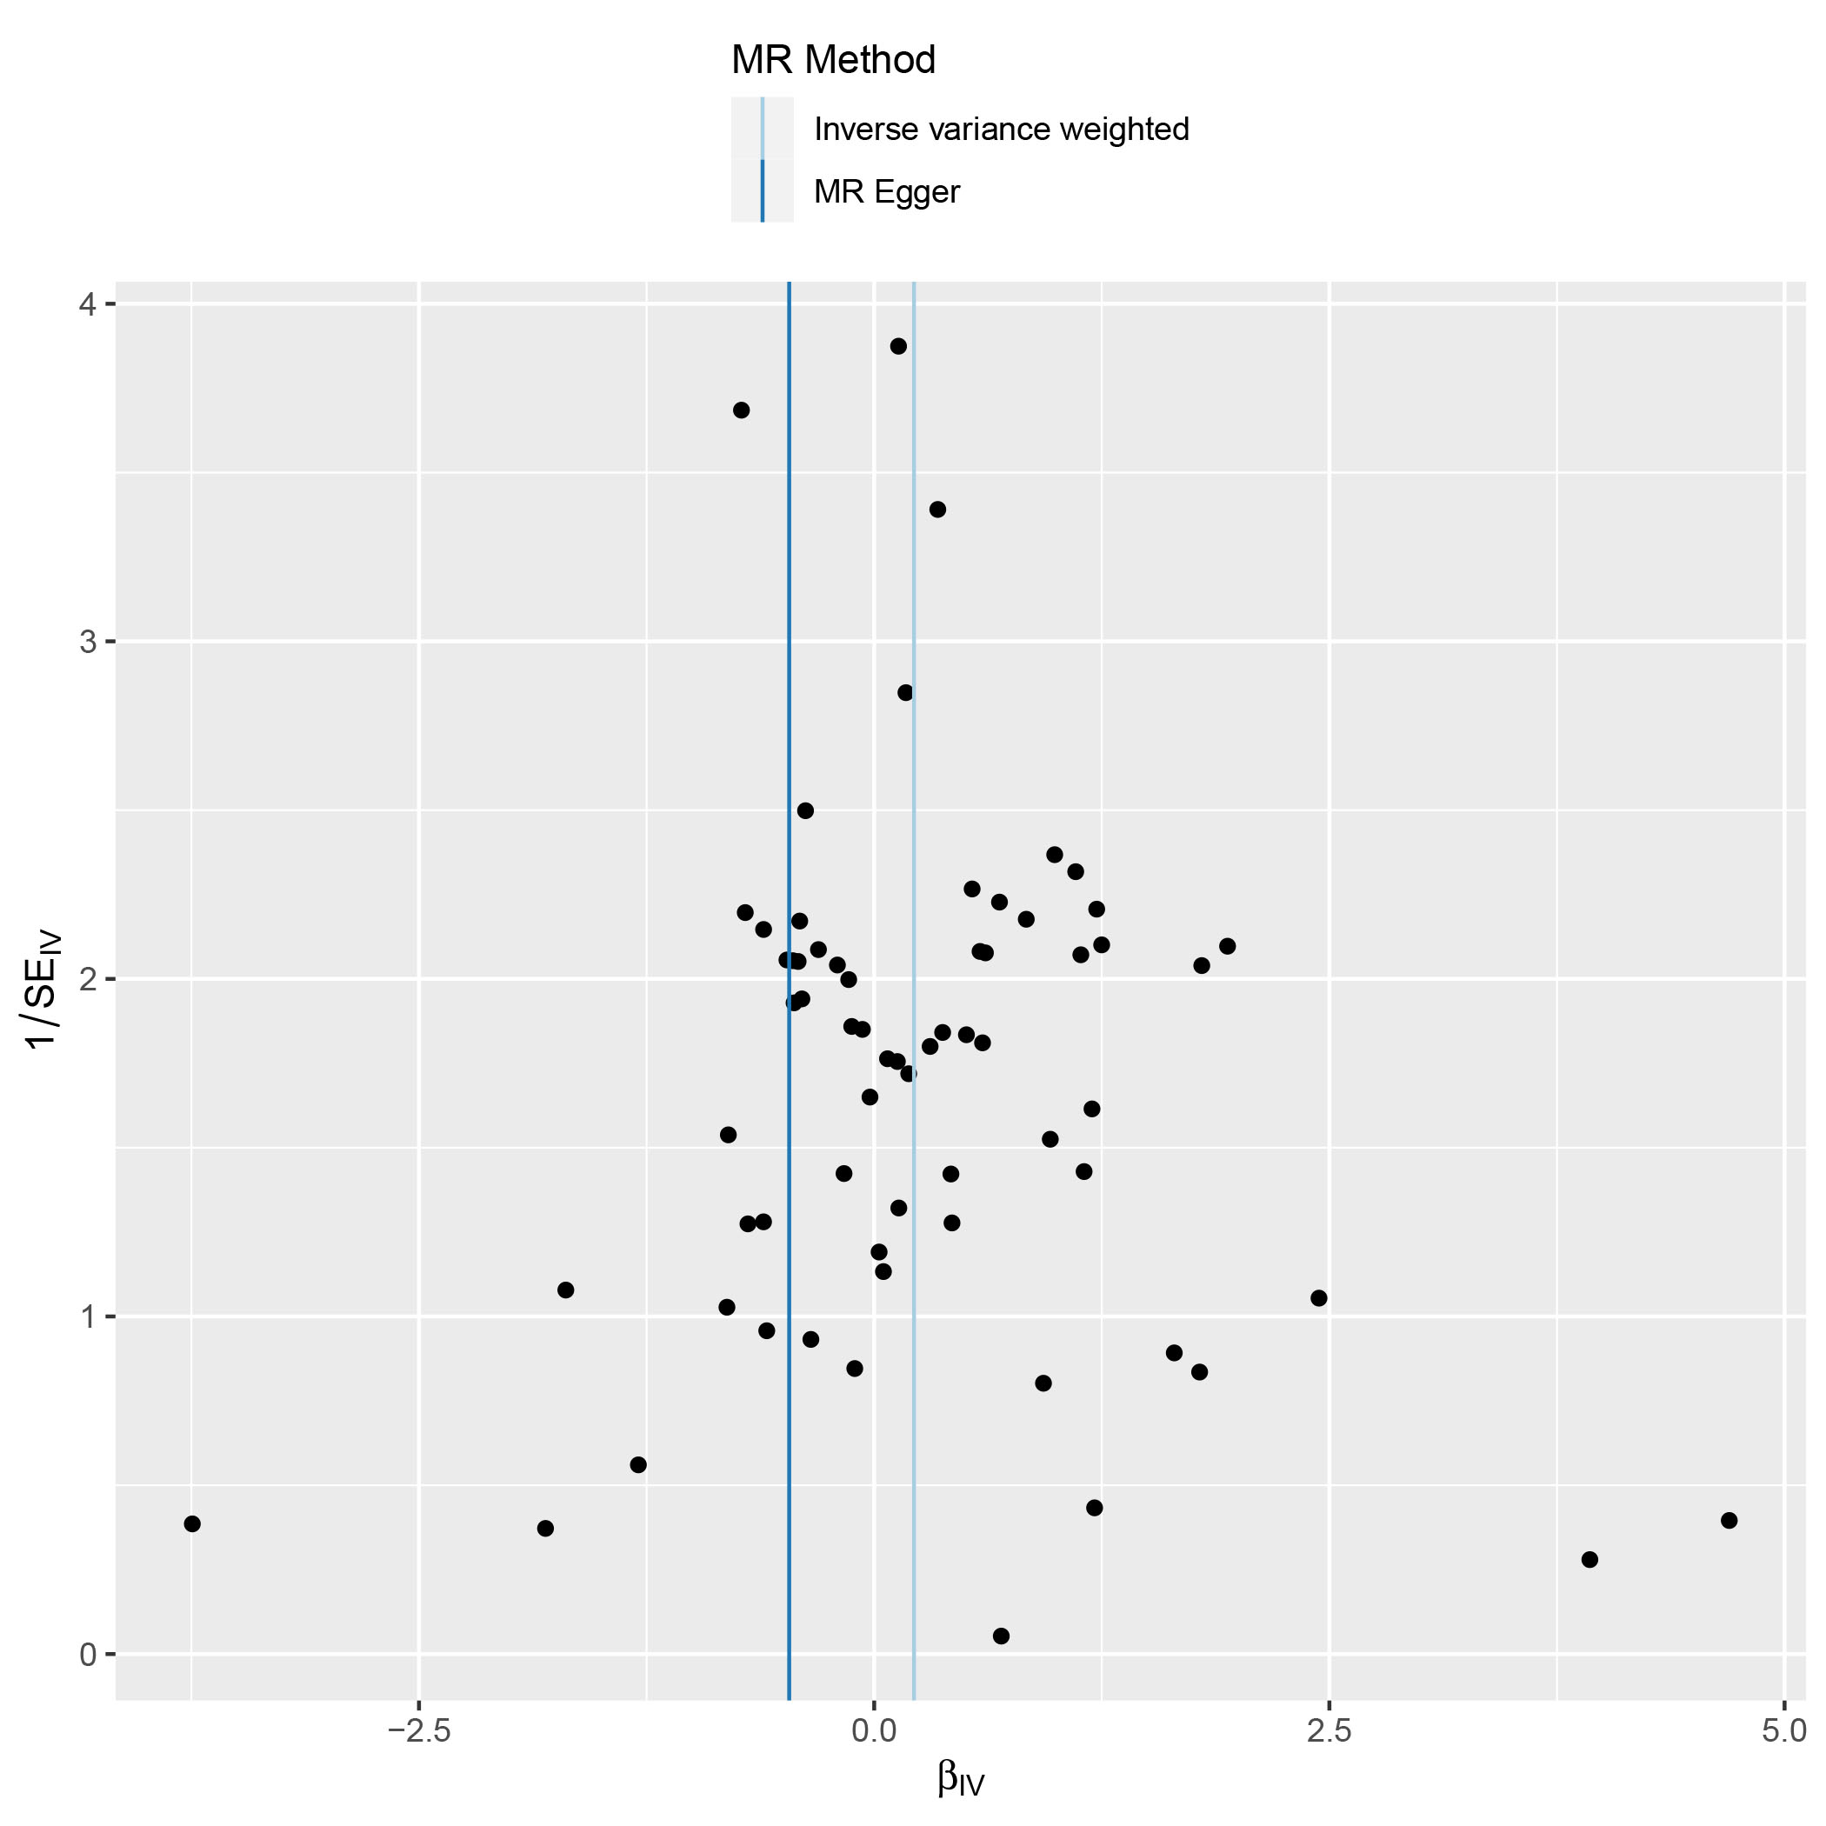
(B)
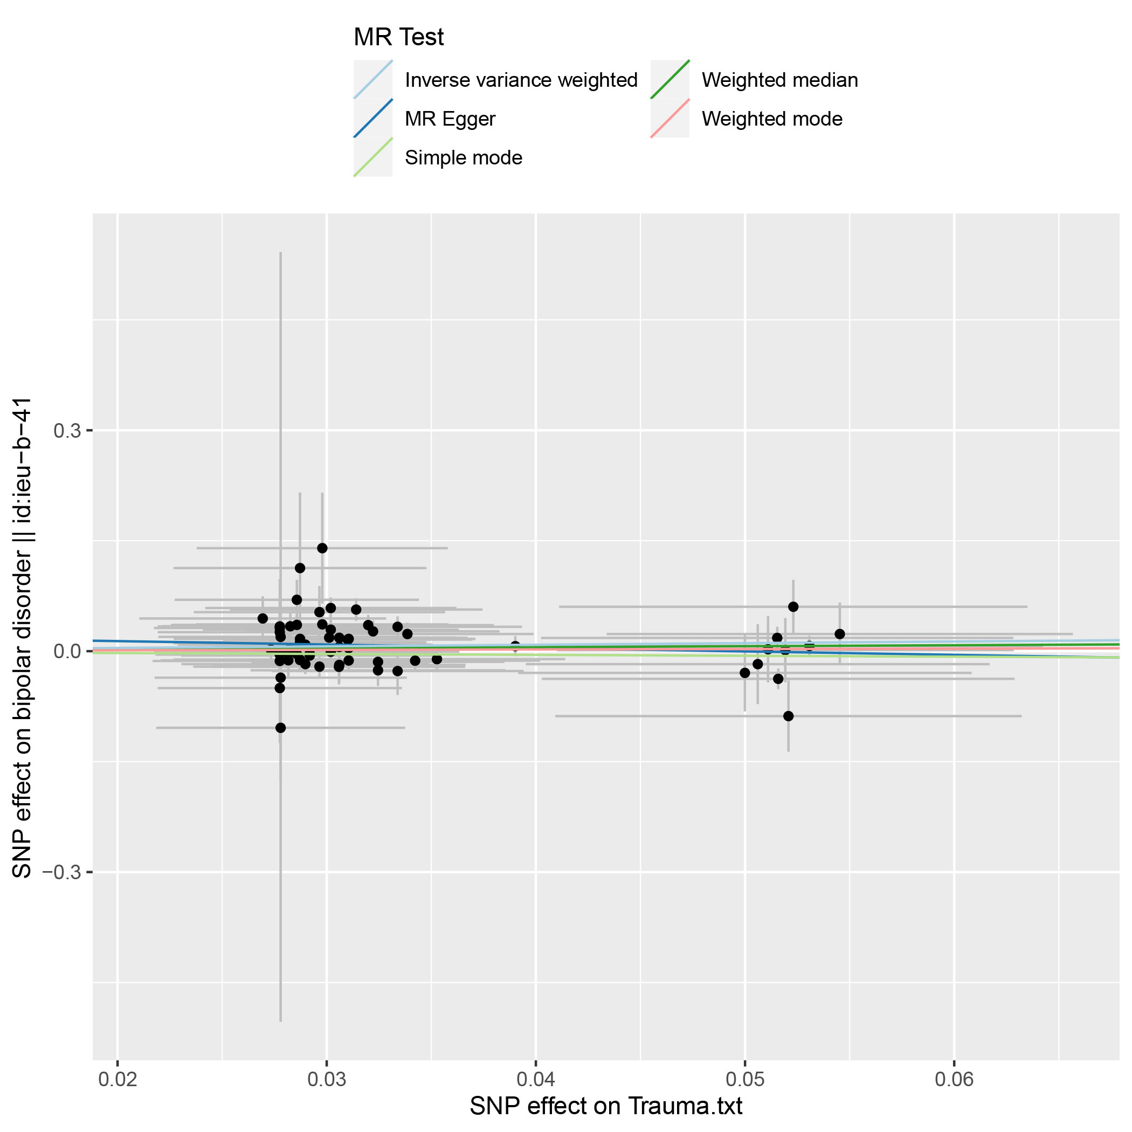
(C)
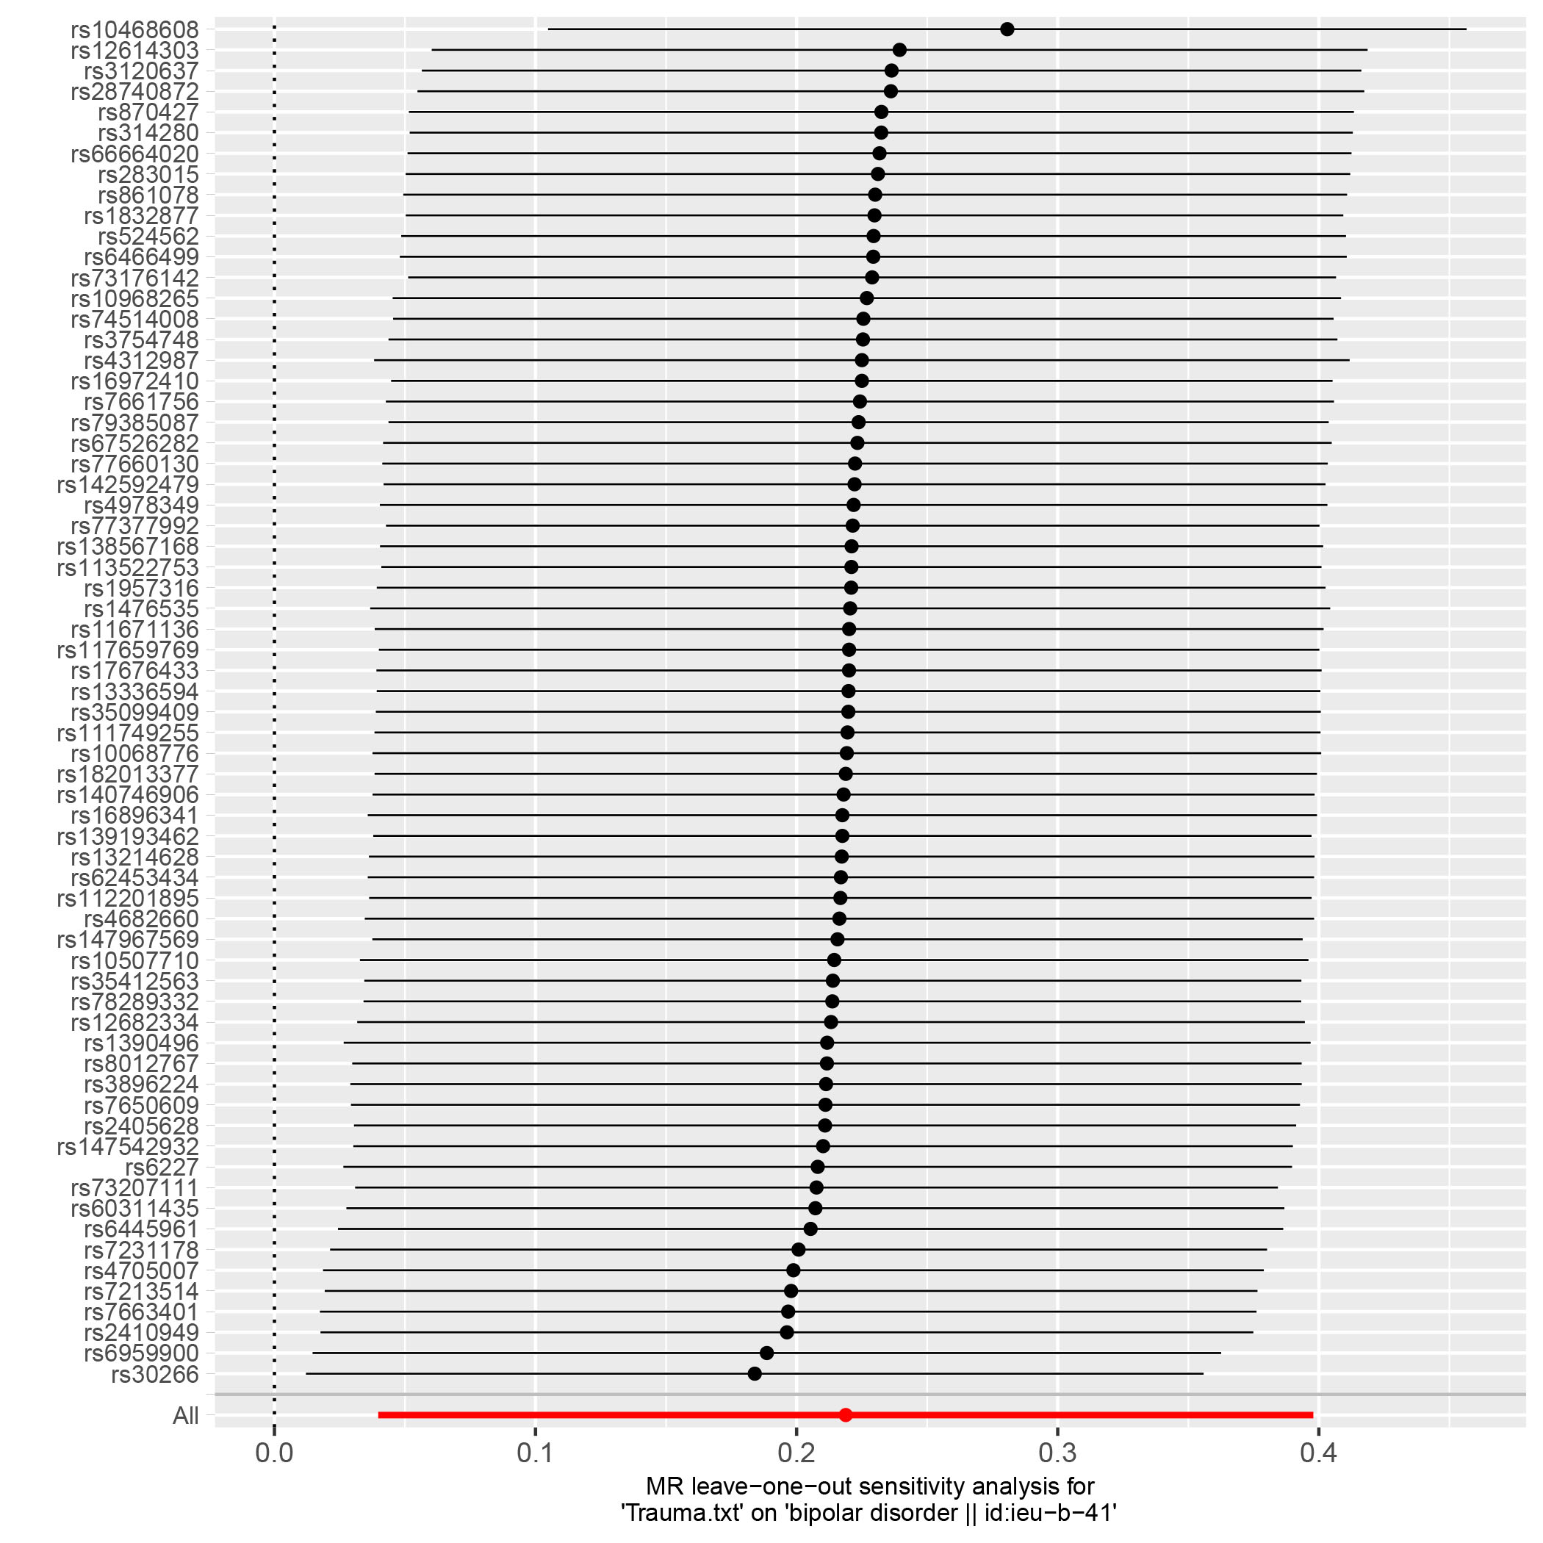

Supplementary Figure S6. Funnel plots, scatter plots and leave-one-out plots of the genetic causal associations between trauma and depression in MR Base. (A) funnel plots; (B) scatter plots; (C) leave-one-out plots.
(A)
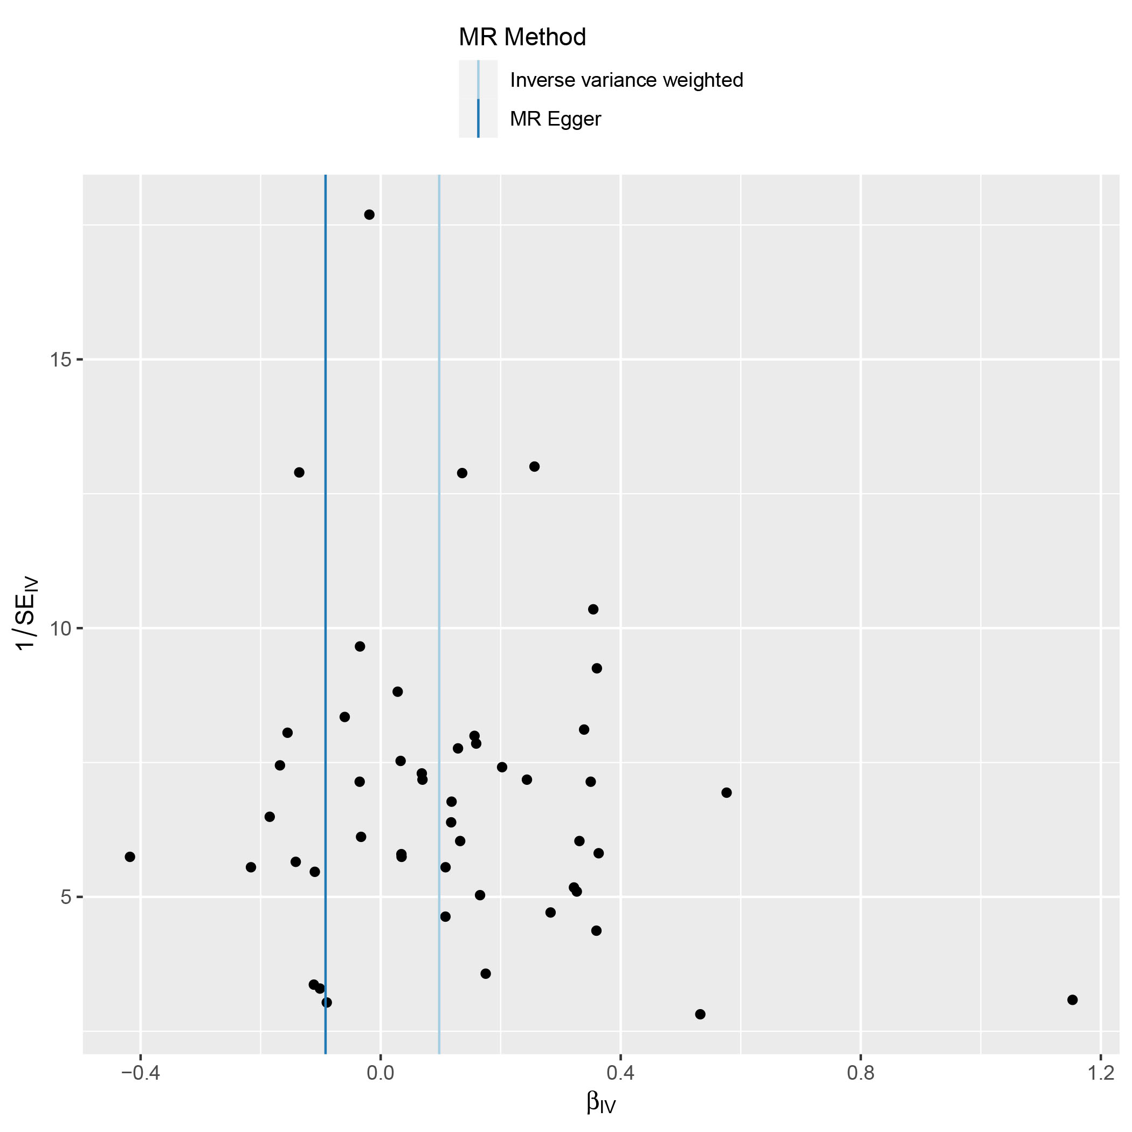
(B)
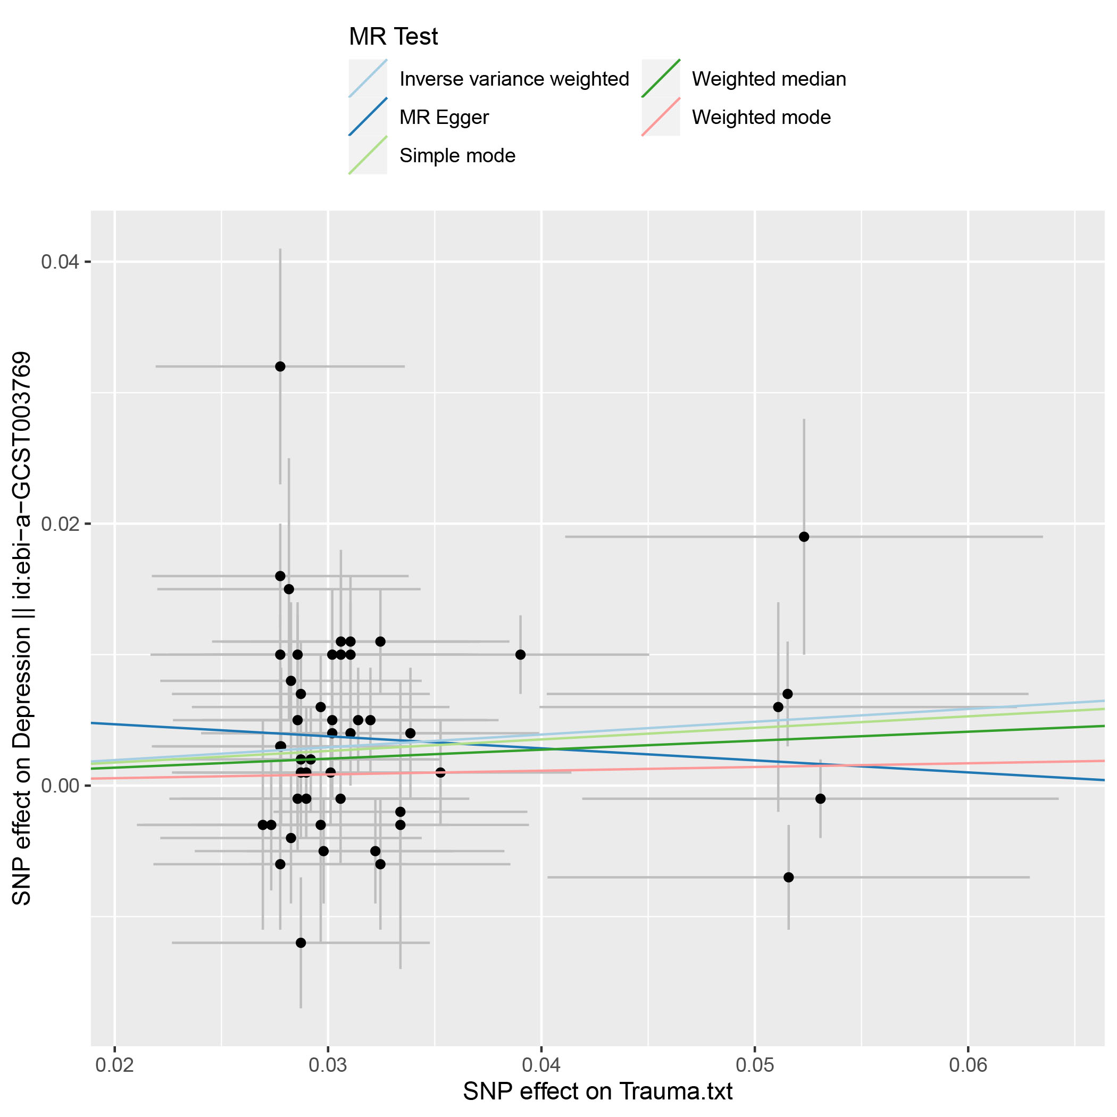
(C)
