Supplementary Information for
Optical Multi-Imaging-Casting Accelerator for Fully Parallel Universal Convolution Computing
Guoqing Ma^{1,2,3}, JunJie Yu^{1,2,4,*}, Rongwei Zhu^{1,2,5}, Changhe Zhou^{1,2,6,*}
Laboratory of Information Optics and Optoelectronic Technology, Shanghai Institute of Optics and Fine Mechanics, Chinese Academy of Sciences, P.O. Box 800-211, Shanghai 201800, China
2 Center of Materials Science and Optoelectronic Engineering, University of Chinese Academy of Sciences, Beijing 100049, China
³ e-mail: gqma@siom.ac.cn
⁴ e-mail: Junjiey@siom.ac.cn
⁵ e-mail: rwzhu@siom.ac.cn
⁶ e-mail: chazhou@mail.shcnc.ac.cn
*Corresponding authors: Junjie Yu, Changhe Zhou
Outline:
Note 1: Principle details of OMica accelerator
Note 2: Experimental setup
Note 3: Optical implementation for OMica accelerator
Note 4: Configuration of the CNN
Note 5: Optimization and manufacturing of even DG
Note 6: Experimental results for the convolution of large-scale and high-bit matrices
6.1 The 3 × 3 1-bit and 20×20 1-bit matrix convolutions
6.2 Two 10 × 10 8-bit matrix convolution results
6.3 Two 20 × 20 8-bit matrix convolution results
6.4 Two 180 × 224 8-bit large matrix convolution results
Note 7: Further discussion on alignment error
Note 1. Principle details of the OMica accelerator
As illustrated in the main text (Fig. 1), the basic idea of the proposed optical multi-imaging-casting architecture involves the original optical shadow-casting scheme [1, 2]. Owing to the difference in the angular spectrum, the kernel-sliding process is automatically realized in parallel, and the accumulation is performed by utilizing the effect of the lens. Here, an even DG is employed to generate different angular spectra, a result the diffractive angles for different orders of the DG splitter being intrinsically different [3, 4]. As shown in Fig. S1, multiple images of the kernel A are generated, and each image corresponds to one diffraction order propagating along its own angular orientation. Moreover, the replicated images are projected onto the same plane of matrix B, and there is a lateral shift between two adjacent images corresponding to two adjacent diffraction orders. By carefully tuning the distance between the plane of the kernel and that of the DG, the lateral shift can be made equal to the sliding step. In this case, the distance satisfies
$d_{0}=\frac{s}{tan}=\frac{n∆}{tan}$ , (S1)
where s = n∆ is the sliding step, ∆ is the physical size of the matrix unit, and n is an integer. When two SLMs are aligned, the image of kernel A corresponding to the 0th order should be aligned with matrix B. Therefore, there is a ∆/2 lateral shift between the image of A corresponding to the 1st order and B. In our experiment, an even DG was employed to avoid the influence of unmodulated light. Then, two SLMs should be realigned by moving the kernel A when the even DG is inserted, as shown in Fig. S1(b). After realignment, each image of Kernel A corresponds to one sliding step, and the entire kernel sliding is performed simultaneously.
In our scheme, two convolution matrix object-image planes overlap on the same plane, effectively avoiding diffraction errors introduced by field propagation. Thus, it is evident that the alignment error is a key factor in achieving high precision when the OMica is used for universal matrix convolution computing. In our proof-of-concept experiment, the alignment error was approximately 10 μm, and each matrix unit for both kernels A and B was 54 × 8 = 432 μm for 20 × 20 matrices. Such a large alignment error is due to manual transitional stages, and the alignment error can be drastically reduced when piezoactuators with resolutions in the subnanometer range are used. In this case, the scale of the matrix to be computed is increased drastically, and the computing precision can be further improved. Therefore, the OMica architecture enables a new paradigm for a universal convolution accelerator with full parallelism and sufficiently high precision.

Fig. S1. | Schematic of the OMica architecture using even DG: (a) before realignment; (b) after realignment.
Note 2. Experimental setup
Fig. S2 shows a proof-of-concept experimental system based on the OMica architecture, and Fig. S3 shows the photographs of the actual experimental setup. This system is aimed at accelerating universal matrix convolution, especially for large-scale matrix convolution, with sufficiently high precision. Two large-scale matrices, A and B, are assumed to be two matrices to be convolved, and they are loaded onto two modulators, SLM₁ and SLM₂, respectively. The convolution matrix C is detected by sCMOS₁. In our proof-of-concept experiment, a large-scale DG is used for the realization of parallel sliding of the convolution kernel A on the input matrix B, where the distance between the DG and SLM₁ can be adjusted to change the sliding stride by matching d₀ and the angle θ between two adjacent diffraction orders, as expressed by Eq. (S1). Before alignment, the DG was removed, and the monitoring camera was placed in the focal plane of L₉. During the alignment process, some specially designed patterns shown in Fig. S4 are used. Then, the DG is inserted before SLM₁, and the distance between DG and SLM₁ should be adjusted carefully to make the lateral shift of the image correspond to the 0th order with respect to matrix B equal s/2. As discussed above, realignment is needed for such even DGs by moving the SLM₁ at a distance of s/2. In our experiment, the image corresponding to (+1st, +1st) overlaps with matrix B after realignment. We can then confirm this alignment by placing one tunable iris on the focal plane of L₆ to allow only one order to pass through the iris aperture at a time. Noticeably, the window slides along the moving direction when the iris is moved to allow different orders to pass through the aperture in sequence. Here, as an example, one rectangular array of 8 × 8 square blocks [Fig. S5(a)] and one rectangular array of eight circle blocks [Fig. S5(b)] are loaded onto SLM₂ and SLM₁, respectively. As shown in Fig. S5(c), kernel A markedly slides on matrix B. In this case, the iris moves from left to right, and the diffraction orders of (+1st, +1st), (−1st, +1st), (−3rd, +1st), (−5th, +1st), (−7th, +1st), (−9th, +1st), (−11th, +1st), and (−13th, +1st) are passed through the iris aperture in sequence. Because of the cut-off effect of the square aperture located on the conjugating plane of SLM₂, we can observe that eight columns of the rectangular array of circle blocks are changed decrementally to one. Meanwhile, if all the circle blocks loaded on SLM₁ are aligned with the square blocks loaded on SLM₂, the alignment between the two matrices is achieved.
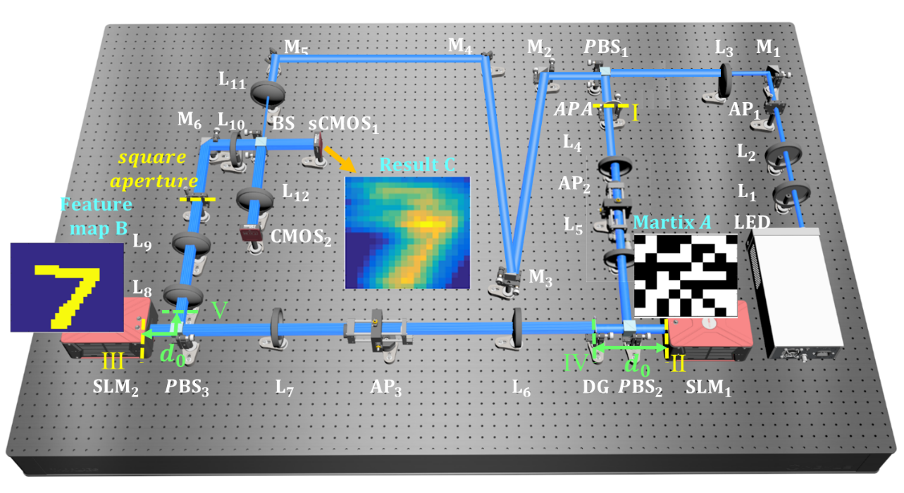
Fig. S2. | Schematic of the optical convolution experimental system of the OMica. LED is a light-emitting diode; M_{1–6} are reflective aluminum mirrors; AP_{1,2,3} denote aperture pinholes; L_{1–5} are convergent lenses; L₆, L₇, and L₁₀ are Fourier transform lenses; PBS_{1,2,3} are cube polarization beam splitters; SLM₁ and SLM₂ are reflected liquid crystal spatial light modulations; APA denotes the aperture array; DG is Dammann grating; BS denotes a nonpolarizing beam splitter; sCMOS₁ denotes a scientific complementary metal–oxide–semiconductor camera for detection; CMOS₂ is a complementary metal–oxide–semiconductor camera for monitoring. Among these, I, II, III and the plane of the square aperture are one group object–image conjugate planes, IV and V are another group object–image conjugate planes, the plane V is the image plane of the DG; d₀ is the characteristic distance, which is adjusted to match the physical size of the matrix unit of matrix B to the sliding stride.
Fig. S3. | Photographs of the optical convolution experiment system. (a) The whole optical system; (b) the SLM mounted onto a 4D manual stage for loading kernel A; (c) the SLM mounted onto a 4D manual stage for loading matrix B; and (d) enlarged part of the sCMOS detector and the monitoring CMOS camera.
As pointed out above, when the large-scale DG splitter is placed in front of matrix A, the object–image conjugating relationships between the I, II, and III planes (see Fig. S2) still hold. Thus, the multiple images of the kernel are all projected onto the matrix B plane, and each diffraction order corresponds to one image of the kernel. The multiple kernel sliding is parallel and simultaneously realized when the lateral shift between adjacent kernel images is equal to the matrix unit of B. This is the physical mechanism of the massive parallelism of the OMica architecture. In addition, the object–image conjugating relationship between two SLMs enables a reduction in the physical size of the matrix pixels. Even for commercial optical imaging systems, it is easy to achieve high-quality imaging of matrix pixels as small as 10 μm. Therefore, this makes the OMica architecture capable of achieving ultrahigh computing power and low energy consumption, and it is possible to realize a highly integrated miniature optical convolution computer. Moreover, the high order of the large-scale beam splitter can be completely filtered out by the square aperture without any influence on the calculation results, and the light efficiency of the beam splitter can be improved further by using multilevel phase elements.
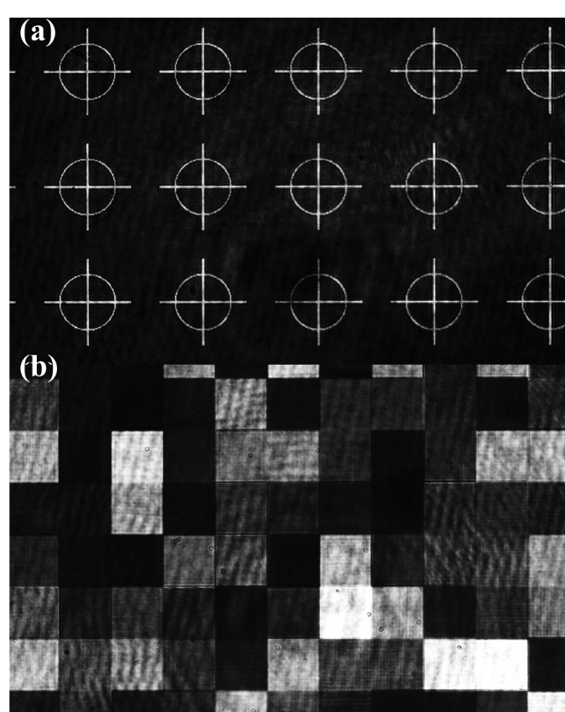
Fig. S4 | Typical patterns loaded onto two SLMs for alignment. (a) Alignment pattern; and (b) square array pattern.

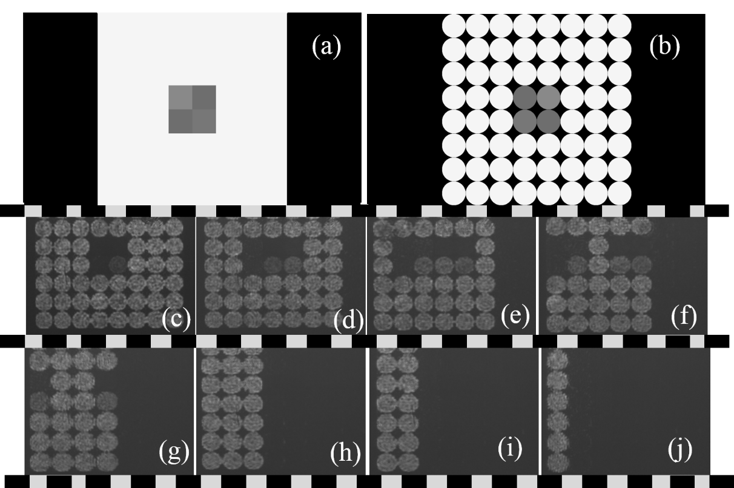
Fig. S5. | Experimental results for demonstration of kernel sliding. (a) and (b) are images loaded onto two SLMs, respectively. (c) – (j) are the images captured by the monitoring CMOS camera when the iris is moving from left to right, allowing only one diffraction order to pass through its aperture in sequence.

Fig. S6(c) is a typical intensity map of the convolution matrix captured on the sCMOS₁ camera when loading matrices A and B, which are two 10 × 10 matrices, as shown in Fig. S6 (a, b). In general, a 19 × 19 full convolution result of two 10 × 10 matrices can be obtained by tailoring the image within the red box. In addition, one can obtain the convolution result of the same size by intercepting the image within the yellow box. In addition, the light spot outside the region of the spot array in the yellow circle is the focus spot directly from the LED source, which can be used to monitor the energy fluctuation of the light source.
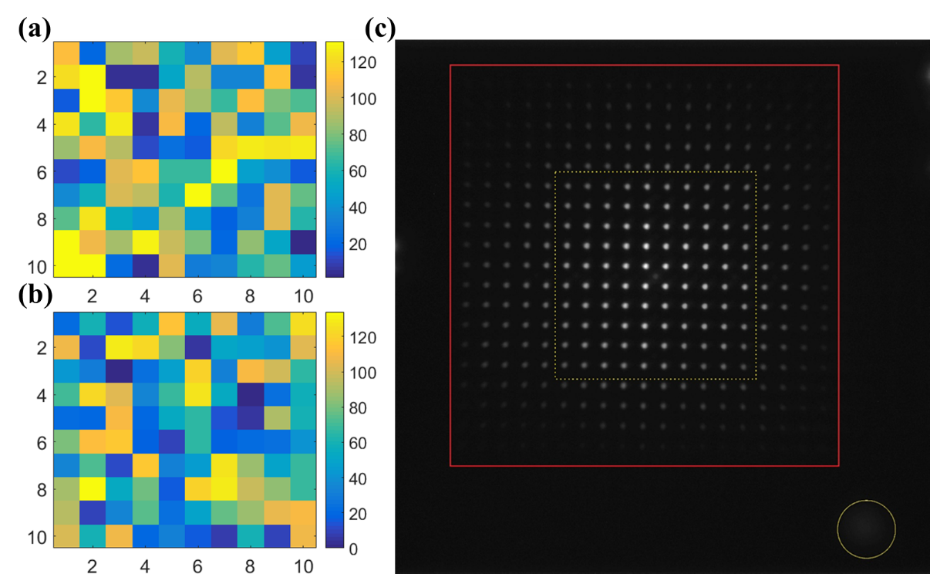
Fig. S6. | Typical images of the matrices loaded onto two SLMs and the intensity map captured by the sCMOS₁ camera. (a) Matrix A, (b) matrix B, and (c) intensity map denoting the convolutional matrix C.

Note 3: Optical implementation for OMica accelerator
In principle, the OMica hardware proposed here can be used to accelerate universal matrix convolution, and the computed results can be transferred to any other platform. The entire procedure for the implementation of this optical hardware is as follows.
(1) Align the optical axis centers of all optical components to the same horizontal line, and ensure that the light is incident perpendicular to the surface of all optical elements, while the square aperture, lens L₁₂, APA, and DG are removed.
(2) Load a full matrix with 255 Gy value on SLM₁ and a target pattern on SLM₂, and place the CMOS₂ monitor camera on the back focal plane of lens L₉. The axial position of SLM₂ is adjusted until the alignment pattern is clearly imaged on the detected plane of CMOS₂ (Fig. S4(a)), and adjust the axial locations of lenses L₈ and L₉ to an imaging magnification of M₂ = 2.
(3) Insert lens L₁₂ and adjust its position along the optical axis to make images of both SLM₁ and SLM₂ clear on the detection plane of the monitor camera.
(4) Load the target pattern on SLM₁ and a full 255 Gy matrix on SLM₂; the image of the alignment pattern is observed on CMOS₂ (Fig. S4(a)). By adjusting the axial positions of lenses L₄, L₅, L₆, and L₇, the pattern can be clearly imaged, and the imaging magnification is approximately M₁ = 2.
(5) Load two square array pattern patterns onto SLM₁ and SLM₂, and adjust the translational position along the X and Y directions and rotation around the optical axis of any of the two SLMs driven by two manual 4D stages (linear X-Y-Z and rotary) to overlap the images of the two matrices using the CMOS₂ monitor camera (Fig. S4(b)).
(6) Insert the square aperture on the focal plane, and adjusting its position. The square aperture should be clear imaged and aligned with the two matrices of SLM₁ and SLM₂.
(7) Insert the APA and adjust its position to align it with the two SLMs, as well as the square aperture.
(8) Load two matrices of the same size as that to be calculated (for example, for 20 × 20 matrices, each matrix unit is joined by a 54 × 54 pixels in the liquid display of SLMs), where there is a misalignment by half of the matrix unit (27 pixels) between these matrices along both the X and Y directions. The 4D stage is adjusted to overlap two images of these matrices using the CMOS₂ monitor camera.
(9) The DG after SLM₁ is inserted and its axial position is adjusted to roughly satisfy the relationship described in Eq. (S1).
(10) An additional tunable iris mounted on a 3D translational stage is inserted on the confocal planes of L₆ and L₇. First, let the zeroth order of the DG pass through the iris, and other higher orders be truncated. Then, the X and Y positions of the iris are adjusted, and the first order corresponding to (+1st, +1st) passes through it, and other orders are truncated. Next, the iris is moved linearly from left to right, or up to down, to make each diffractive order pass through in sequence. Note that each diffraction order corresponds to a kernel sliding step. Thus, one can dynamically observe the process of translational sliding of the convolution window when moving the iris (Fig. S5). Care must be taken to finely adjust the axial distance to ensure that the images of the two matrices overlap in each sliding step.
(11) The optical convolution accelerator function commences when the above iris is moved. Notably, the light power from the LED should be adjusted by tuning its driving current to ensure that the maximum value of the detected convolution result does not exceed the dynamic range of the camera before detection.
For a CNN in our principle-of-concept experiment, the OMica engine is only used for acceleration of operations involving matrix convolution, and it is only used for inference. Nonlinear activation, average pooling, and full-connection operations are executed using traditional electrical hardware. For comparison, we chose the above 1000 samples from the MNIST test set for blind-testing with our optical hardware, and these 1000 images were shuffled like in the training process. After BNN training, 10 convolution kernels are encoded into 10 high-bit matrices and 1 low-bit matrix, according to the principle of negative encoding in Fig. 1(b). Interestingly, because the elements of the kernels are −1 or +1, their low-bit matrices are identical, and their values are all 1. In addition, the first high-bit matrix and the low-bit matrix are identical after encoding, and thus the computing amount does not increase compared to in the original BNN. First, one of the 1000 test samples was loaded onto SLM₂, and the above 10 encoded kernels were loaded onto SLM₁ in sequence. Next, another input sample was loaded onto SLM₂, and the 10 kernels were loaded onto SLM₁ in sequence after the convolution of the input image with all 10 kernels was executed by the optical hardware. Next, the spot array denoting the convolution results is captured on the focal plane of focusing lens L₁₀ by the sCMOS₁ camera when the light passes through the system once. Finally, the convolution result matrix can be obtained after data processing, and these results are transferred to the electrical hardware for the next steps for interference.

Note 4. Configuration of the CNN
The configuration of the CNN model used in our experiment for the recognition of handwritten digits in the MNIST dataset is shown in Fig. S7. It can be seen that this CNN network contains five layers: a convolutional layer, pooling layer, nonlinear activation layer, and two fully connected layers. To obtain a higher recognition rate and prevent overfitting, we set the learning rate to 0.05 and the training batch size to 50. The number of epochs was set to four to avoid overfitting. Ten 9 × 9 convolution kernels with binary element values of −1 or +1 were used, and the activation function was the ReLU function for the first layer. Owing to its simple derivative formation, the training speed of the ReLU function is faster than that of the sigmoid and tanh functions when the kernel weights are trained based on the backpropagation algorithm. Furthermore, because the derivative is not zero, it can effectively solve the vanishing gradient problem and further reduce overfitting. The method of the pooling layer is chosen as average pooling because all the information in the feature map can be obtained on average without losing too much key information. Because the image is processed through binarization in advance, the foreground and background information in the feature map maintain a high resolution after average pooling. The number of nodes in the first fully connected layer was 200, and the activation function was selected as the ReLU function. The number of nodes in the last fully connected layer was 10, and the activation function was selected as the sigmoid function. Because the last layer uses the sigmoid function for classification tasks, we chose the cross-entropy loss function to avoid the vanishing gradient problem. For the 60,000 training set, the total training time of the CNN network was approximately 3 min (Intel® Core™ i7-4790 CPU @ 3.60 GHz), the recognition accuracy on the 1,000 test set was 96.7%, and the recognition accuracy on the 10,000 test set was 96.3%.
Here, we divide the 60,000 training samples into two parts: the training set and the validation set; the learning curve is shown in Fig. S8. The error is defined as the difference between the true and predicted values, and the loss is the average of the errors of all samples. The loss function used in this network is the cross-entropy loss function, $H\left(p,q\right)=\sum_{i=1}^{n}{p\left(x_{i}\right)\log{\frac{1}{q\left(x_{i}\right)}}}=-\sum_{i=1}^{n}{p(x_{i})logq(x_{i})}$, where p(x) is the predicted probability, and q(x) is the experimental probability. The loss of the training set demonstrably decreases rapidly with the increase in training batches, and the decreasing trend of the loss of the validation set and the training set are almost coincident, which indicates the good fitting ability of the model.
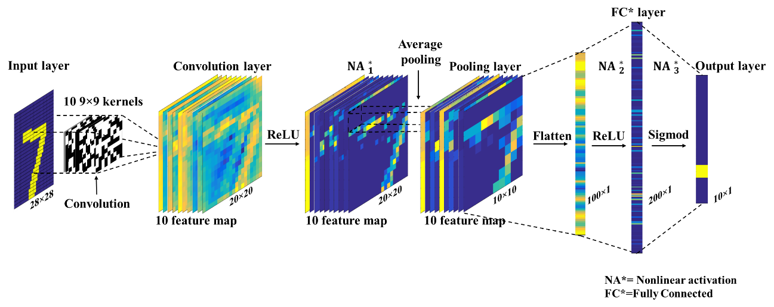
Fig. S7. | Schematic of the CNN architecture.

It can also be observed from Fig. S8 that the loss curve of the training set drops rapidly until it fluctuates slightly near a stable value. In addition, the loss of the validation set and the loss of the training set are slightly different, which indicates that the model has a certain generalization ability. The accuracy of the validation set gradually reaches a stable value as the number of samples increases, which indicates that no overfitting effect occurs in this model.
Fig. S8. | Learning curve of the CNN.

Note 5. Optimization and manufacturing of even DG
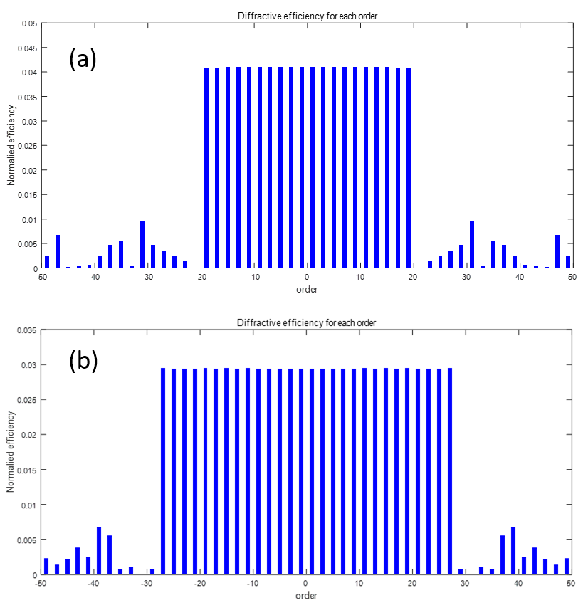
Fig. S9. | 1×20 (a) and 1×28 (b) DG beam splitting order normalized energy distribution.

A DG is a type of DOE used for beam splitting. Typically, a binary phase structure (0, π) is employed in DGs because this two-level surface-relief grating is easy to fabricate. The transitional points must then be optimized to maximize the total energy carried by some desired orders and minimize the uniformity of the intensity among these orders. Here, a simulated annealing algorithm is employed to optimize the structure of DGs.
Fig. S9 shows the normalized energy distribution of 1 × 20 and 1 × 28 DGs with diffraction order for the ideal π phase retardation. Under ideal conditions, the efficiencies of 1 × 20 and 1 × 28 one-dimensional (1D) gratings were 81.93% and 82.38%, respectively, and the energy uniformity was less than 1%. After orthogonal superposition of two crossing 1D gratings, the structure of a 2D DG can easily be obtained. The intensity distributions and diffractive angles versus diffraction orders are shown in Fig. S10 for a 20 × 28 2D DG. It can be seen that the normalized energy corresponding to each diffraction order is approximately 1.2‰ of the incident light energy (without considering the interface reflection and other losses). In addition, it can be seen from the angle distribution versus the diffraction order that the maximum diffraction angle is approximately 3.78°. This means that the paraxial condition is approximately maintained in this situation. In our experiment, the grating period was designed to be 225 μm along both directions, and the feature size was approximately 2.47 μm. Fused silica was chosen as the substrate, and the grating sample was fabricated by lithography and ion etching. The diffractive pattern in the far field is captured in the focal plane of a Fourier lens, and the intensity map is shown in Fig. S10(c). Further, the intensity distribution for this spot array was estimated by calculating the accumulation of intensity around the centroid for each spot. The results indicate that the uniformity of the fabricated 20 × 28 DG was approximately 5%. After calibration, this level of uniformity had almost no negative effect on the final computed results.
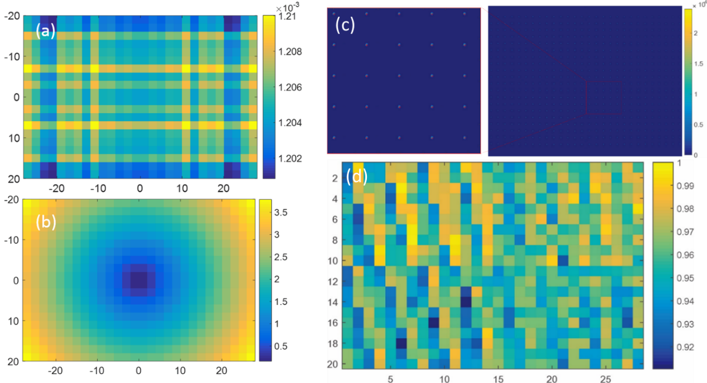
Fig. S10. | Intensity and angle distribution of 20 × 28 2D DGs. (a) The simulation result of intensity distribution versus different orders; (b) the simulation result of diffraction angle versus diffraction order; (c) the intensity map of the spot array captured in the experiment (the red cross represents the centroid); (d) the experimental results of normalized intensity distribution versus diffraction order.
In addition, a large-scale, 180 × 224 DG was designed and fabricated in our experiment. The experimental intensity detected using a CMOS camera is shown in Fig. S11(a). The intensity of the zeroth diffraction order is very strong owing to its high sensitivity, and this strong zeroth order affects the surrounding orders. Fig. S11(b) shows the intensity distribution of the local spot array in the yellow box, and Fig. S11(c) shows the experimental results of the normalized intensity distribution versus diffraction orders. The performance of this large-scale DG can be further improved by optimizing the fabrication technique. In particular, the strong zeroth order will be decreased if the etching error is reduced by optimizing the fabrication technique.
Fig. S11 | Intensity distribution of 180 × 224 2D DG. (a) The intensity map of the spot array captured in the experiment, (b) local enlarged details of spot array within the yellow box, and (c) the normalized intensity distribution versus diffraction orders corresponding to (b).

Note 6. Experimental results of the convolution of large-scale and high-bit matrices
In the main paper, it was shown that the convolution can be calculated in a hybrid analog–digital coding framework. In this section, some examples of analog convolution computing are demonstrated, including 10 × 10, 20 × 20 8-bit gray-scale matrices, and 180 × 224 8-bit gray-scale matrices.
6.1 Convolution results for 3×3 1-bit and 20×20 1-bit matrices
Fig. S12 (groups 1–5) shows the experimental results of matrix convolution of five groups of kernel A (3 × 3 1-bit) and matrix B (20 × 20, 1-bit) compared with the theoretical results. The five groups of A and B are randomly generated using either 0 or 1 for each element. It is shown that the absolute errors for the five groups of matrices are mostly lower than 0.5. Evidently, 100% of the absolute error is lower than 0.5 for groups 2–5, and only 0.75% of that is larger than 0.5 for group 1 (the largest error is 0.562). This means that 100% accuracy for most cases can be achieved after digitalization.
No. 1
No. 2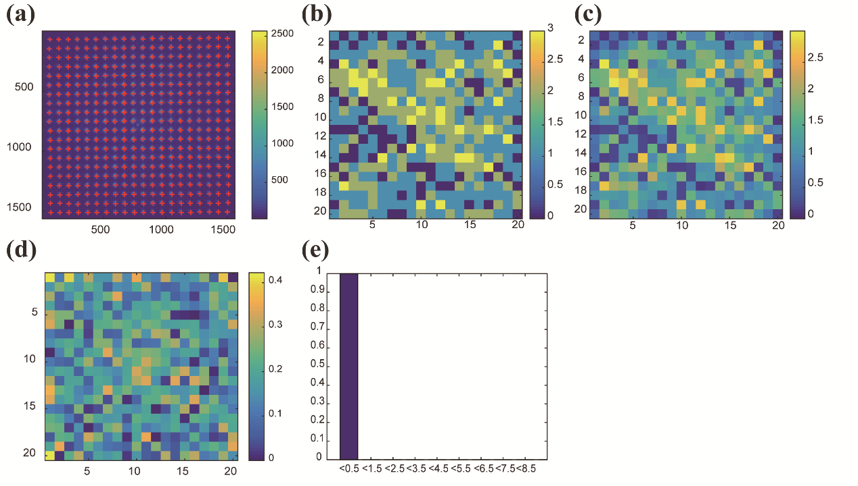
No. 3
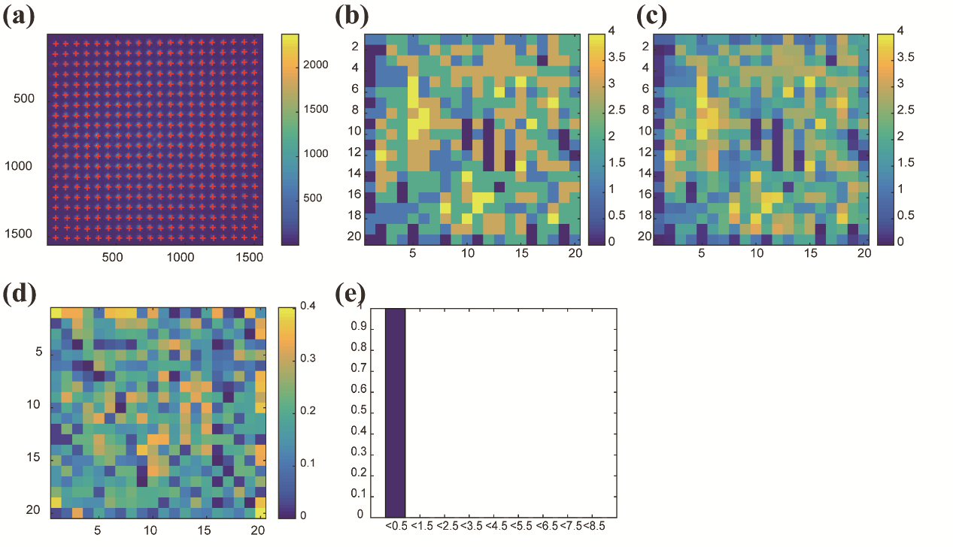
No. 4
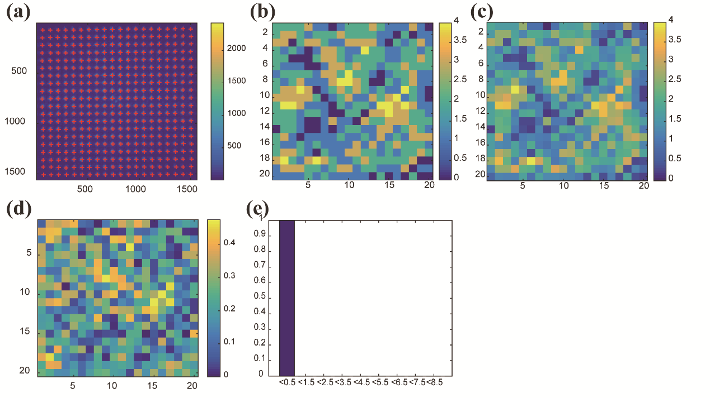
No. 5
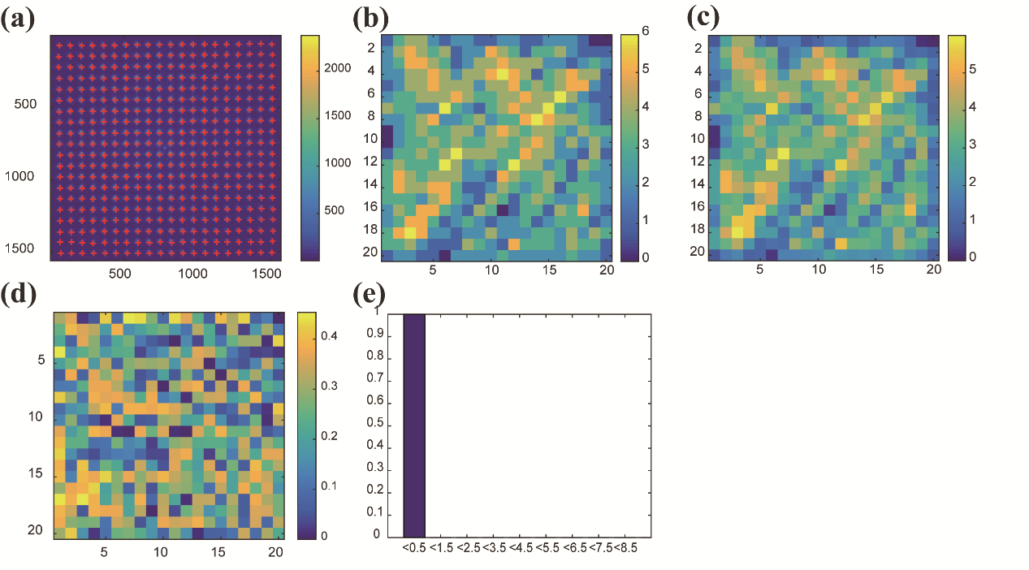
Fig. S12. | Experimental convolution results for five groups of 3 × 3 1-bit and 20 × 20 1-bit matrices. (a) The light intensity distribution, (b) theoretical convolution values, (c) experimental convolution values, (d) absolute error distribution, and (e) distribution histogram of the error proportion.

6.2 Convolution results for two 10×10 8-bit matrices
As shown in Fig. S13 (Nos. 1–5), two 10 × 10 8-bit matrices, A and B, were loaded onto two SLMs. Each element of these five groups of matrices A and B is randomly generated between 110 and 245 Gy values. The final result, shown in Fig. S13(c), is the full 2D convolution with a size of 19 × 19, which is computed in the analog framework by the optical hardware. The relative error is defined as er = | C_{exp} − C_{theo} | / (| C_{max} − C_{min} | / 256), as shown in Fig. S13(d), where C_{exp} is the experimental convolution, C_{theo} is the theoretical convolution, C_{max} is the maximum value of the theoretical convolution, and C_{min} is the minimum value of the theoretical convolution. It is shown that the mean of the relative error values are 0.424, 0.322, 0.336, 0.358, and 0.288, and the maximum values are 2.258, 2.078, 1.396, 1.376, and 1.314, respectively, which means that a precision above 7 bits (very close to 8bit) is achieved for the optical hardware.

No. 1
No. 2
No. 3
No. 4
No. 5

Fig. S13. | Experimental convolution results for five groups of two 10 × 10 8-bit matrices. (a) The light intensity distribution, (b) theoretical convolution values, (c) experimental convolution values, (d) absolute error distribution, and (e) distribution histogram of the error proportion.

6.3 Convolution results for two 20 × 20 8-bit matrices
Furthermore, in Fig. S14 (Nos. 1–5), two 20 × 20 8-bit matrices, A and B, were loaded onto two SLMs, and the final result, shown in Fig. S14(c), of the same convolution with a size of 20 × 20 is computed in the analog framework. It is shown that the overall tendency of the convolution matrices is consistent for all five groups of matrices. Quantitatively, the mean values of the relative error are 0.39, 0.415, 0.295, 0.354, and 0.266, and the maximum values are 1.293, 1.586, 1.207, 1.246, and 1.344, respectively. Again, for 20 × 20 8-bit matrices, a precision of close to 8 bits is achieved for the OMica accelerator.

No. 1
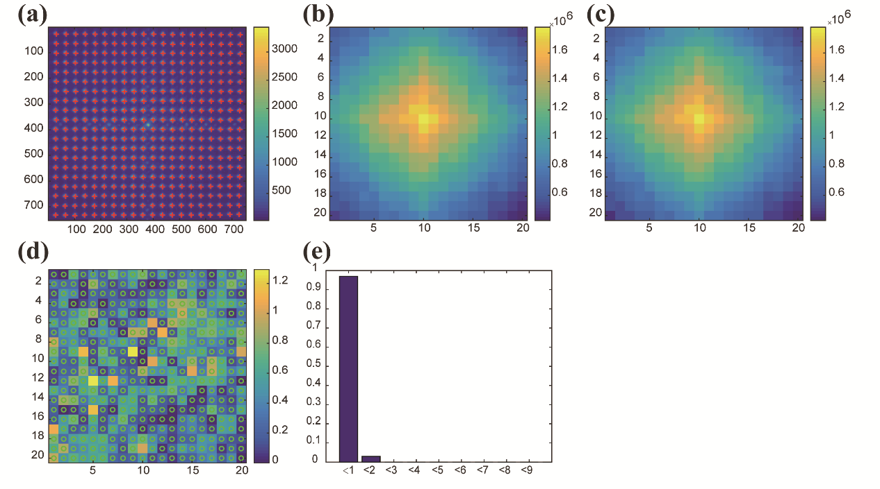
No. 2
No. 3
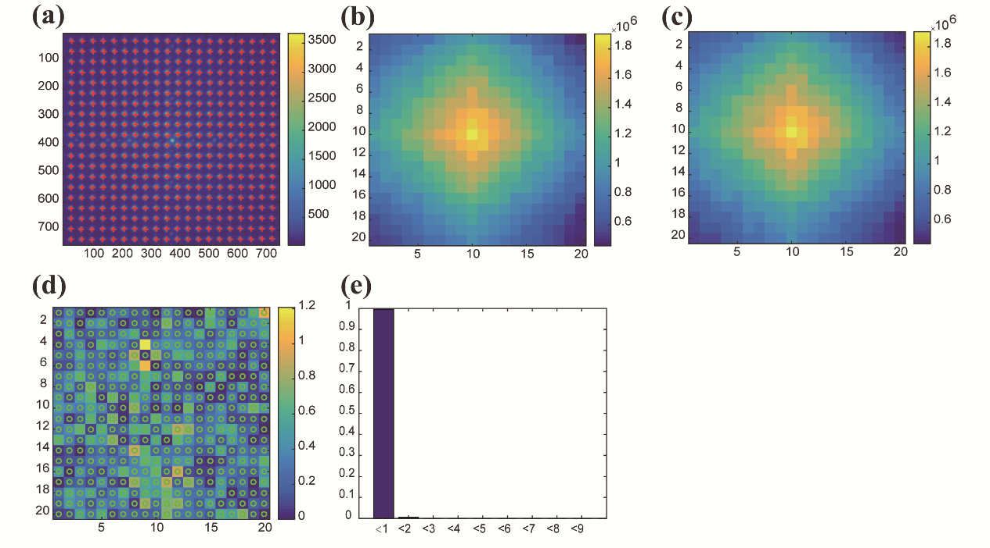
No. 4
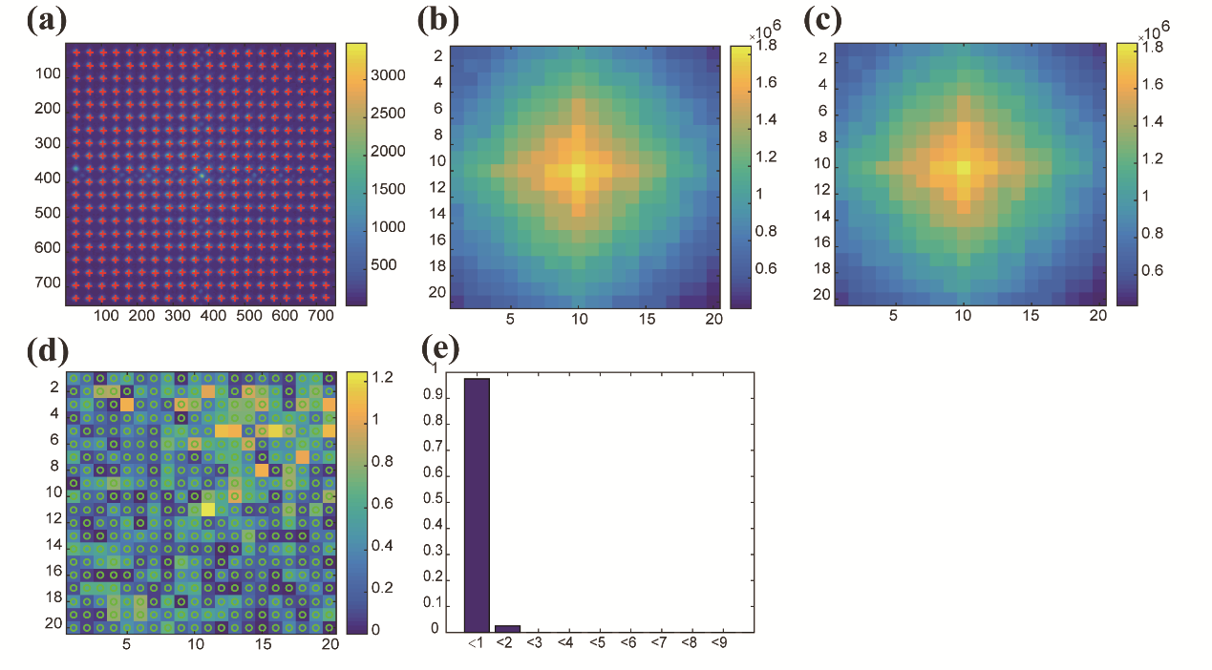
No. 5
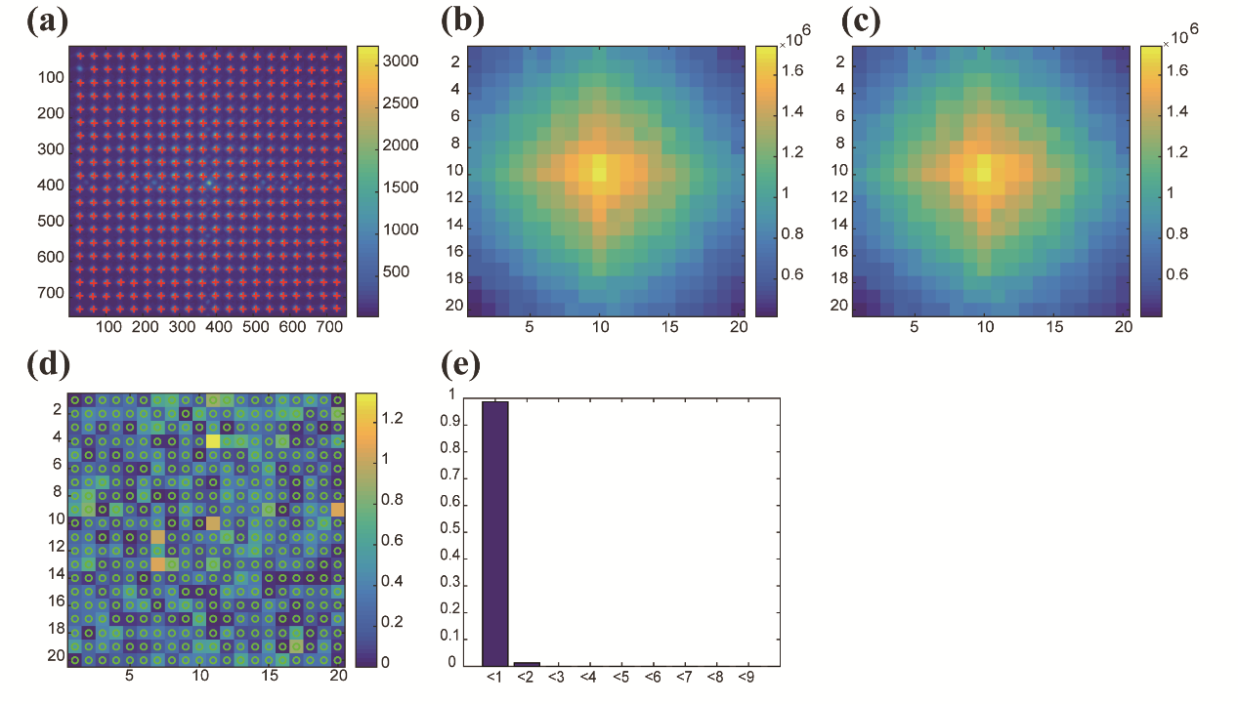
Fig. S14. | Experimental convolution results for five groups of two 20 × 20 8-bit matrices. (a) The light intensity distribution, (b) theoretical convolution values, (c) experimental convolution values, (d) absolute error distribution, and (e) distribution histogram of the error proportion.

6.4 Convolution results for two 180×224 8-bit large matrices
In principle, the OMica architecture has the potential to achieve large computing power owing to its truly parallel processing capabilities. Furthermore, the 2D convolution of two 180 × 224 matrices was also demonstrated in the analog framework. The theoretical and experimental results and the experimental detection light distribution of the 2D convolution are shown in Figs. S15 (a, b, c). The relative errors defined above are shown in Fig. S15(e). Five groups of data were computed based on the OMica hardware, and the mean errors were 10.87, 10.93, 11.12, 11.17, and 11.48, respectively. This low precision was mainly caused by the alignment error, which will be discussed in the following section. This alignment error could be dramatically decreased by using piezoactuators with resolutions in the subnanometer range. Under this condition, a matrix scale of ~200 × 200 indicates that the peak computing power reaches 3.2 × 10⁹ MAC operations when the light passes through the system once.

No. 1
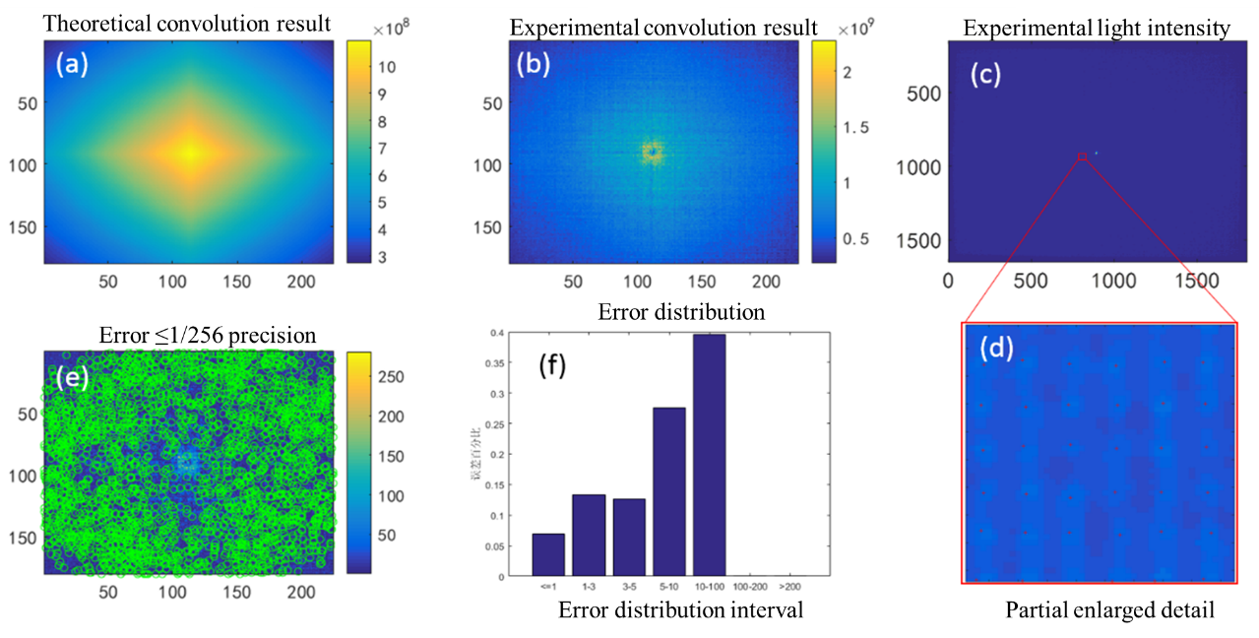
No. 2
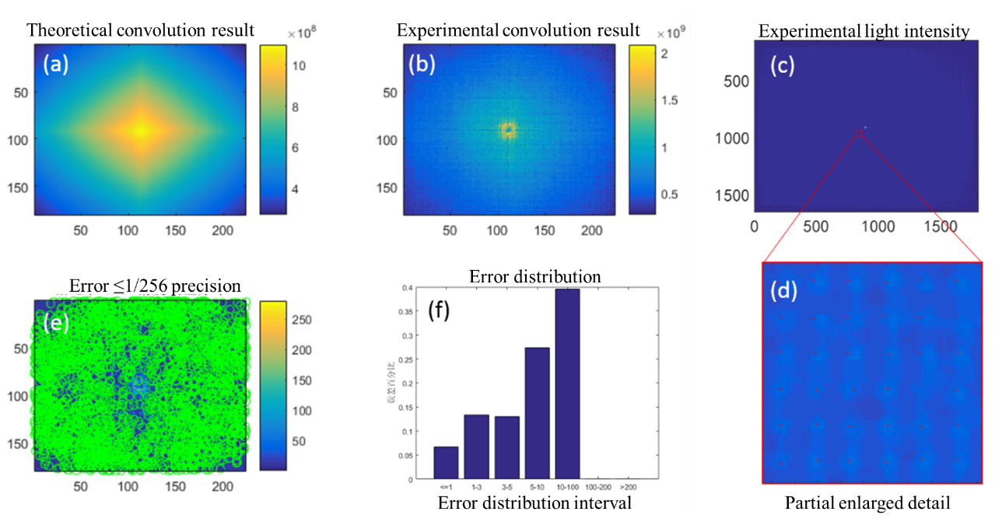
No. 3
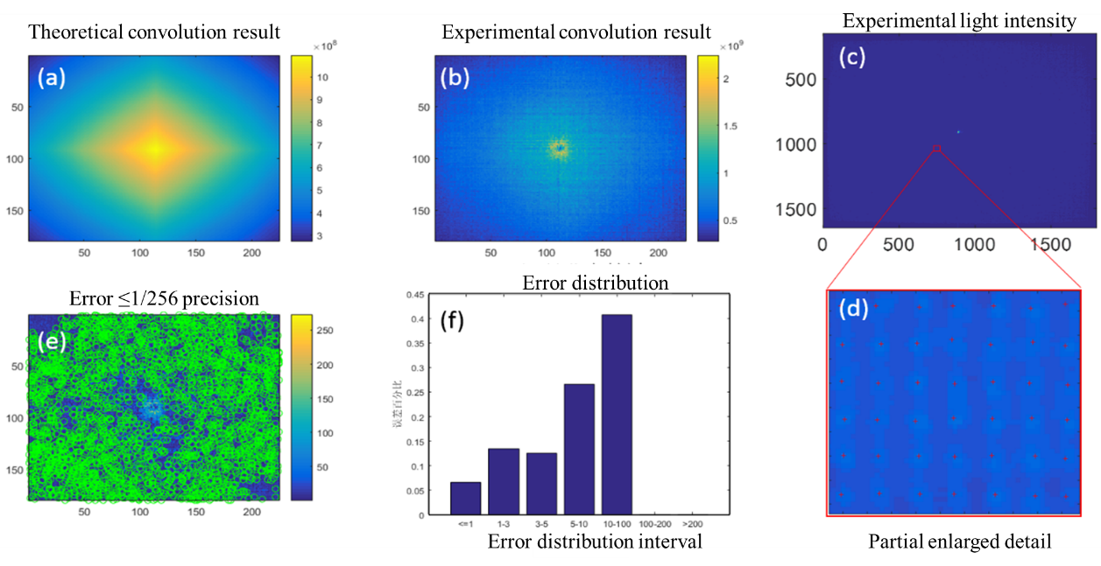
No. 4
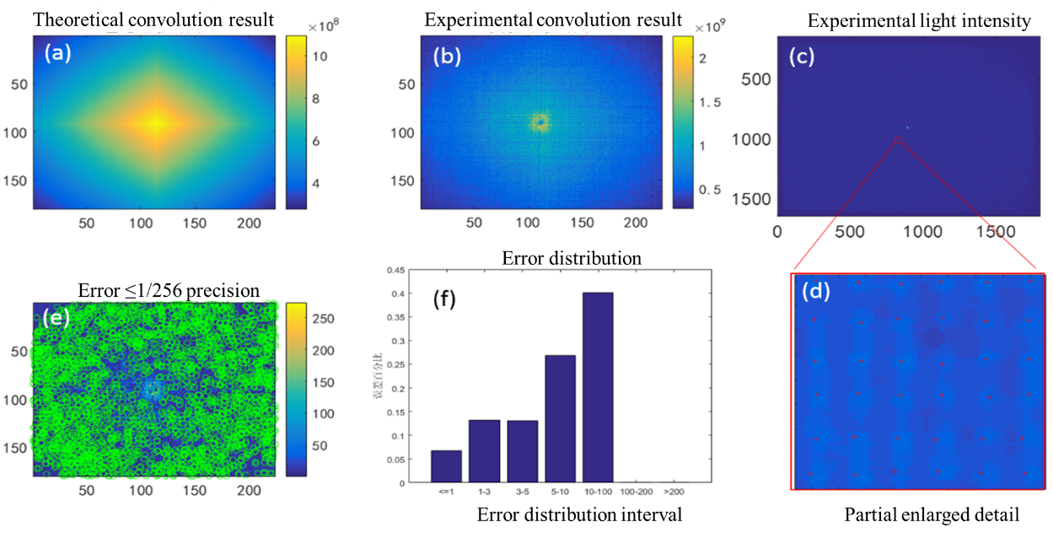
No. 5
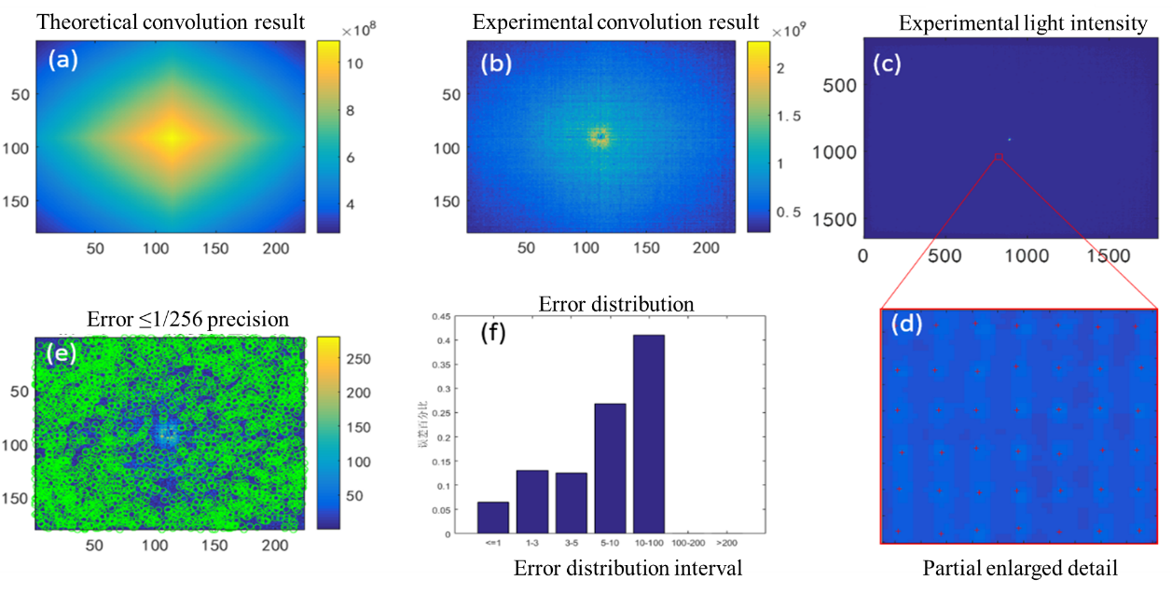

Fig. S15. | Experimental convolution results for five groups of 180 × 224 matrices. (a, b, c) The theoretical convolution results, experimental convolution results, and experimental detection light distribution, respectively, (d) the partial enlarged view of the experimental light spot on (c) (the red cross represents the centroid), (e) error distribution, where the green circle mark indicates that the relative error is less than 1, and (f) proportion of the error distribution of the convolution results distributed in different intervals.

Note 7. Further discussion of alignment error
As pointed out above, the alignment error is the main factor that affects the final computing precision. To avoid the influence of unmodulated light, such as interface reflection, an even DG is used in our experiment, where odd diffraction orders, that is, m = ±1, ±3, ±5, …, are used, and even orders m = 0, ±2, ±4, …, are missing. Strictly, the angle difference between two adjacent diffraction orders for a beam splitter is not equal, and it can be written for the m^{th} order as
$∆_{m}=\arcsin\left(\frac{m}{}\right)-arcsin\left[\frac{(m-2)}{}\right]$ , (S2)
where λ is the working wavelength, and Λ is the grating period. This equation indicates that the angle difference is dependent on the diffraction order m, and this angle difference is approximately constant when m is sufficiently low and λ<<Λ. However, for a large-scale matrix convolution, the diffraction m is sufficiently large. In this situation, the angle difference between two adjacent diffraction orders will be distinctly dependent on the diffraction order, especially for high orders.
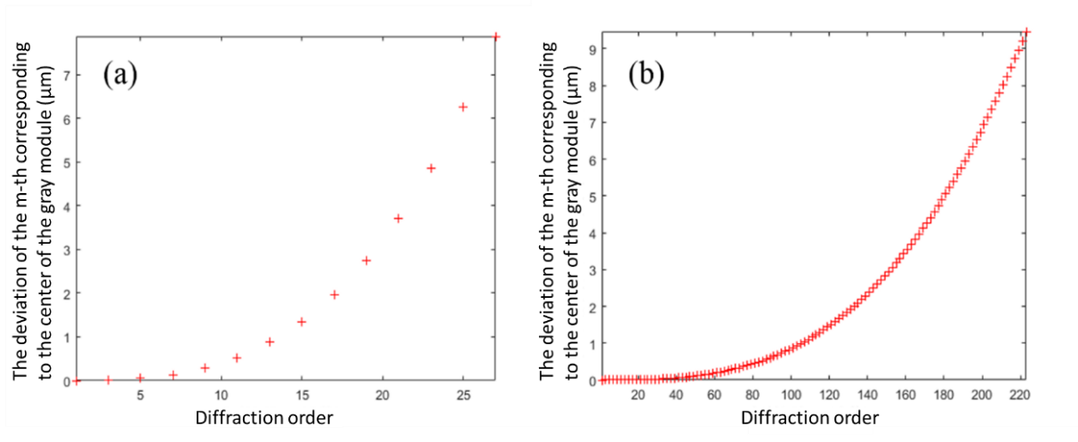
Fig. S16. | Simulation results of (a) 1 × 28 and (b) 1 × 224 DG alignment deviation at different diffraction orders.
Fig. S16 shows the simulation results of the center alignment deviation of the 1 × 28 and 1 × 224 DG at different orders. For the 20 × 28 DG used in experiment, the center deviation corresponding to the highest order (±19, ±19) is approximately 4.2 μm if the convolution of 20 × 20 matrices is ​​calculated. In this case, the matrix unit is at the scale of 432 × 432 μm, and the misalignment ratio (defined as the misalignment area divided by the total area of each matrix unit) between the image of A and matrix B is 1.93%. For 10 × 10 matrices (with a matrix unit of 864 × 864 μm) to be computed, the misalignment ratio is reduced to 0.97%. Furthermore, we can also estimate the misalignment ratio if the optical hardware is used to calculate the 180 × 224 large-scale matrix convolution. If a 180 × 224 matrix is ​​loaded, the matrix unit will reduce to 48 × 48μm. The simulation results indicate that the lateral center deviation of the image of A corresponding to the highest order (±179, ±223) is approximately 11.13 μm. In this case, the misalignment ratio will increase to as high as 41%, limiting the calculation accuracy of the 180 × 224 large-scale matrix convolution, as shown in Fig. S15.
Furthermore, the alignment error is also dependent on the magnification of these multiple images, and the image becomes larger and unclear when it is defocused. As shown in Fig. S17a, the magnification can be seen as uniform within the entire image area in the paraxial approximation. However, the ideal position of the images corresponding to high order deviates from the plane of matrix B [Fig. S17(c)], and these images are distributed on a cambered surface, rather than in a plane. If the image of the zeroth order exactly overlaps with the plane of matrix B, the images corresponding to the other high orders will deviate from this ideal axial position. Therefore, to balance the defocus effect among different orders, matrix B should be put forward with a small distance. In the following, we estimate this distance quantitatively through a simulation.
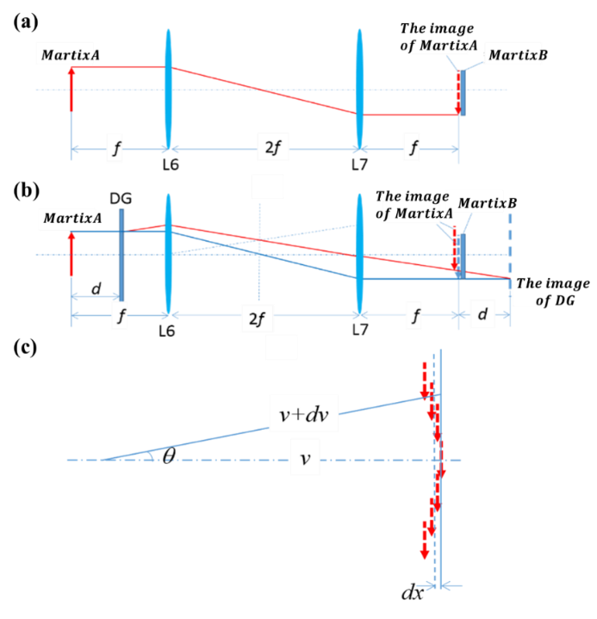
Fig. S17. | Schematic of the alignment of SLM₁ (matrix A) and SLM₂. (a) Before and (b) after adding DG, and (c) schematic of ideal image distribution corresponding to different diffraction orders of DG.
Before the DG is inserted, the image of matrix A (SLM₁) is projected onto the plane of matrix B (SLM₂), and the images of the two loaded matrices, A and B, can be clearly seen on the monitoring CMOS camera simultaneously. The ideal image distance is assumed to be v for the image corresponding to the zeroth order, and that of other higher-order image distances is v+dv, where dv is the defocus distance. If the defocus distance dv is smaller than the depth of field, the image can still be clearly imaged, and the misalignment can be omitted. This defocus distance dv corresponding to the (m^{th}, n^{th}) diffraction order can be written as
$dv=\left(\frac{1}{\sqrt{1-{\left(\frac{m}{}\right)}^{2}-{\left(\frac{n}{}\right)}^{2}}}-1\right)v.$ (S3)
The front and rear depths of the field of the imaging system can be expressed by
$u_{1}=\frac{Fu(u-f_{eff})}{{f_{eff}}^{2}+F(u-f_{eff})}$. (S4)
$u_{2}=\frac{Fu(u-f_{eff})}{{f_{eff}}^{2}-F(u-f_{eff})}.$ (S5)
where u is the object distance, F is the F number, f_{eff} is the effective focal length, and δ is the acceptable point spread function (PSF).

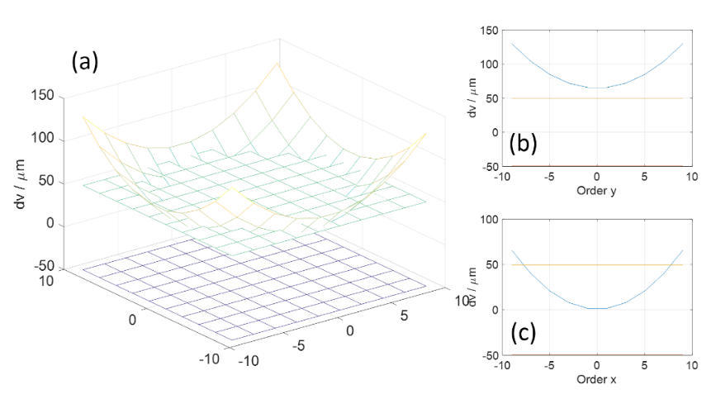
Fig. S18. | (a) Simulation results of the defocus distance versus diffraction orders compared with two planes denoting the depth of field under condition that matrix B is exactly overlapped with the image corresponding to the 0th order. (b), (c) Two profile lines along the 0th order and the 5th order, respectively.
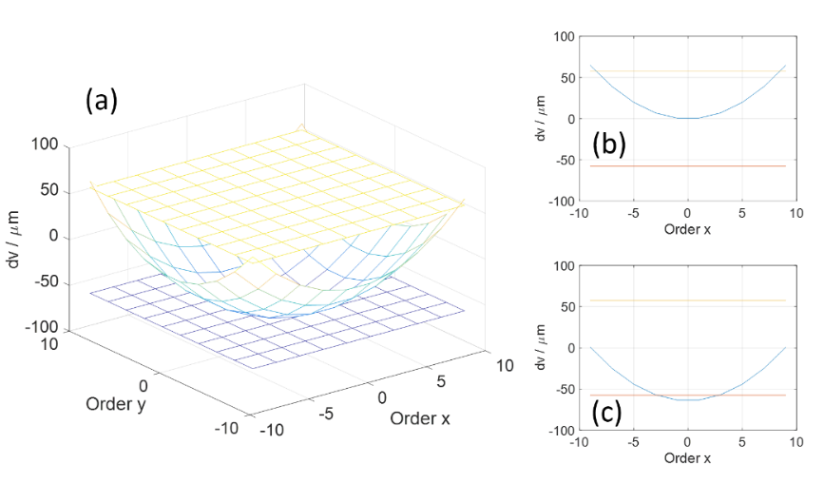
Fig. S19. | (a) Simulation results of the defocus distance versus diffraction orders compared with two planes denoting the depth of field under condition that matrix B is put forward by a distance of dz = 65 μm. (b), (c) Two profile lines along the 0th order and the 5th order, respectively.
For our proof-of-concept experimental setup, the wavelength is λ = 0.45 μm, the period of the DG is Λ = 225 μm, the object distance is u = 300 mm, and the image distance is v = 400 mm; F = 6, and f_{eff} = 171.4 mm. Assuming that the acceptable PSF is double the size of the Airy spot, that is, δ = 2λ / NA = 6.17 μm. The defocus amount versus diffraction order and the depth of field can be numerically simulated, as shown in Fig. S18, when the two images of A and B clearly overlap. It is shown that approximately half of the diffractive orders are within the depth of field (between two planes located at dv = −50 μm and 50 μm). If matrix B is put forward by a distance of dz = 65 μm, as shown in Fig. S19, most of the images corresponding to 100 orders are all within the depth of the field. In this situation, the alignment error is significantly reduced.
References:
1. Monahan, M. A., Bromley, K. & Bocker, R. P. Incoherent optical correlators. Proc. IEEE 65, 121-129 (2005).
2.Trabka E. A. & Roetling P. G. Image transformations for pattern recognition using incoherent illumination and bipolar aperture masks. J. Opt. Soc. Amer. 54, 1242-1252 (1964).
3. Dammann, H., & Klotz E. Coherent optical generation and inspection of 2-dimensional periodic structures. Opt. Acta. 24, 505-515 (1977).
4. Zhou C., & Liu L. Numerical study of Dammann array illuminators. Appl. Opt. 34, 5961-5969 (1995).

