Figur 2A Figur 2D
harpagide
harpagide
Control
Control
RR
OGD

RR
OGD

kDa
kDa
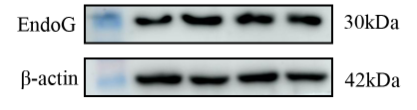
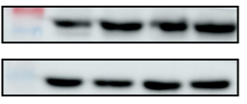
42
30
Endo G
Actin
42
67
Actin
AIF
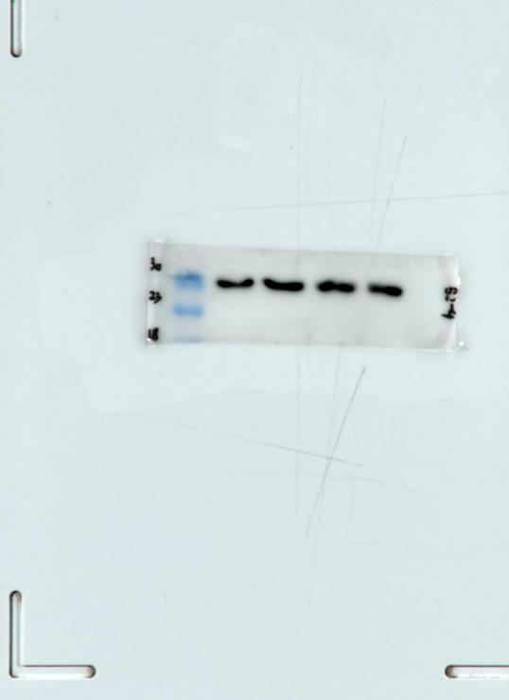
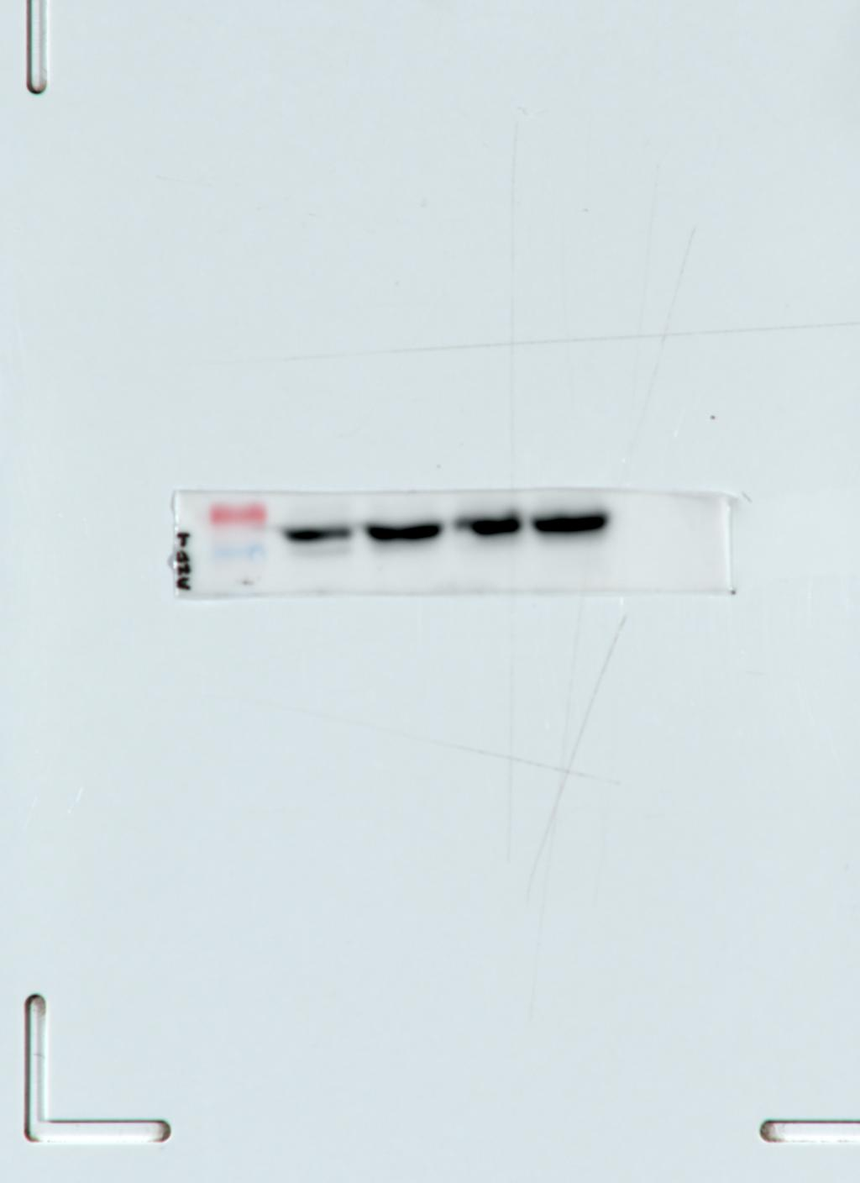

30
23
18

75
55
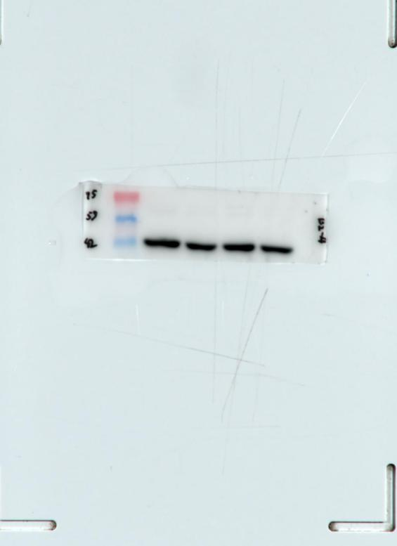
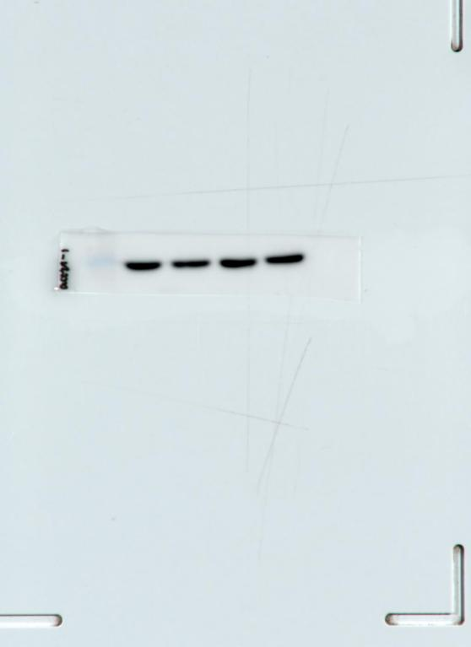

75
55
42

42
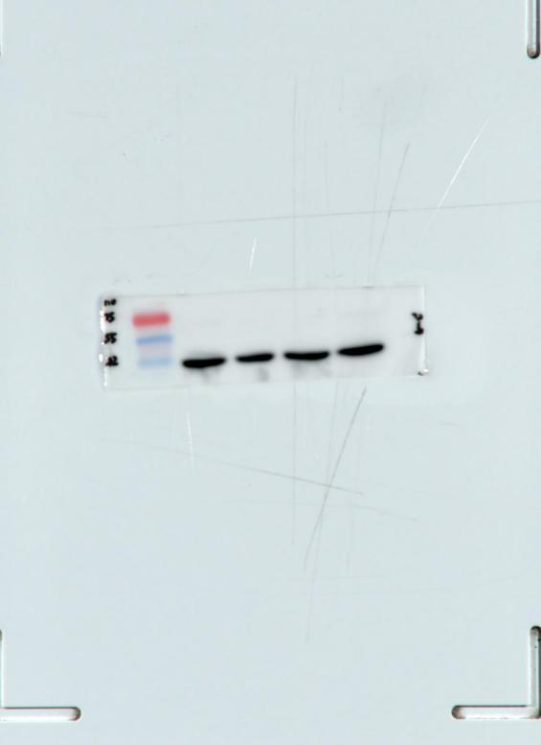
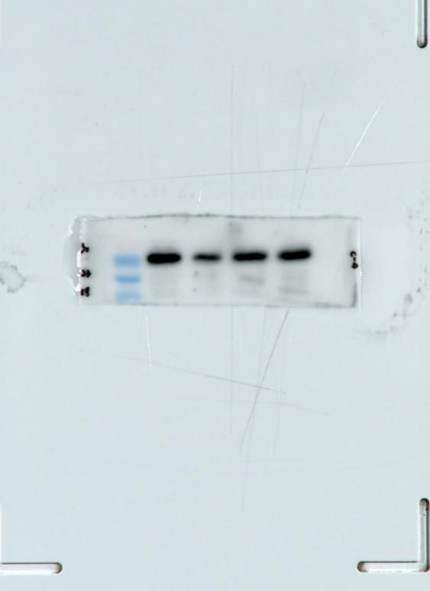
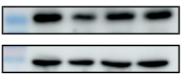
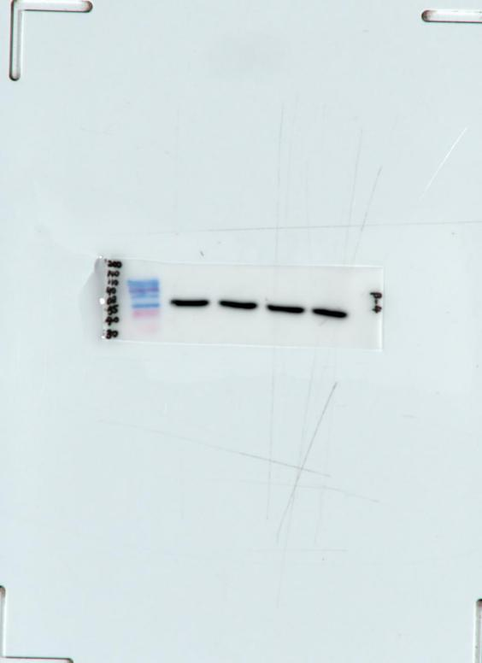
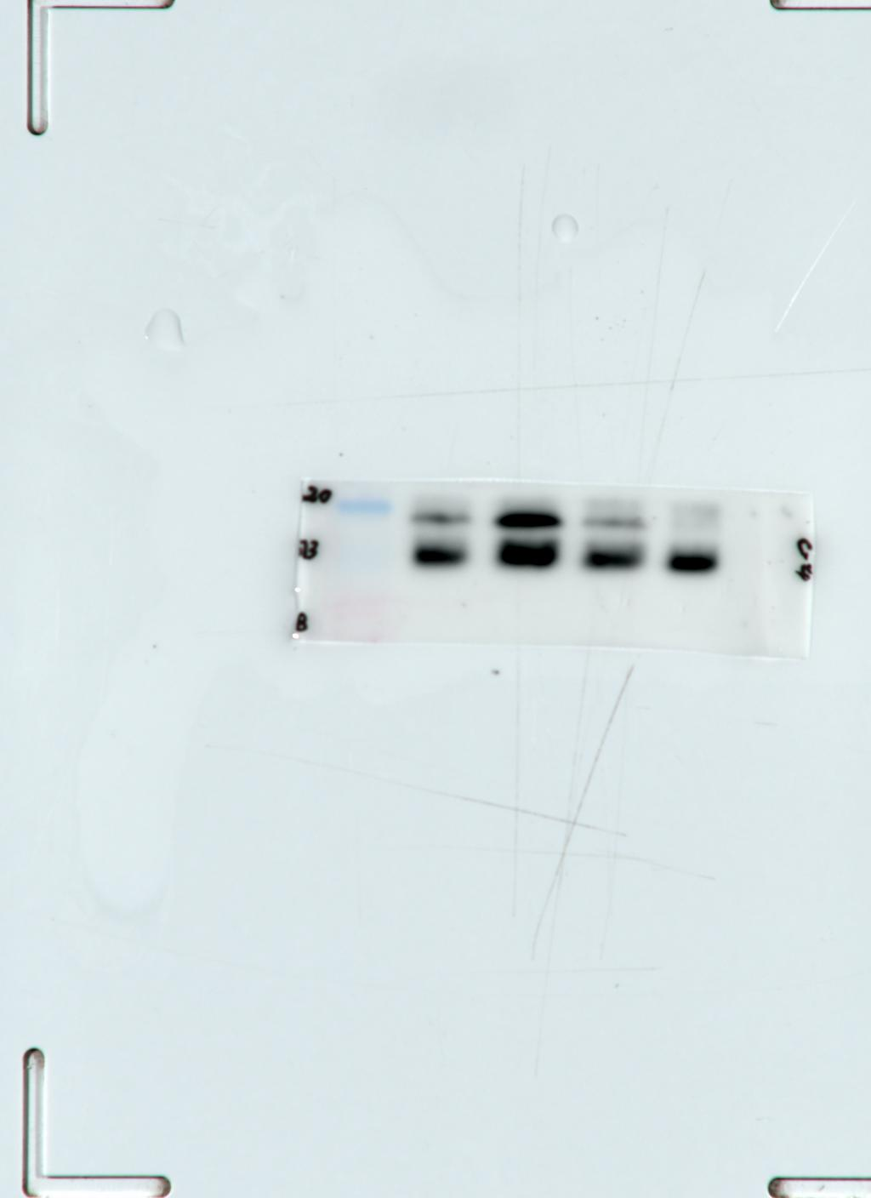
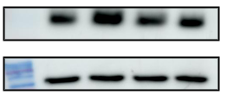
Figur 2G Figur 2J

75
55
42

30
23
18
kDa
42
35
Actin
Caspase3
Control

200
140110
75
55
42
30

23
18
10
42
harpagide
harpagide
RR
OGD

Control
RR
OGD

kDa
14
Actin
Cytc

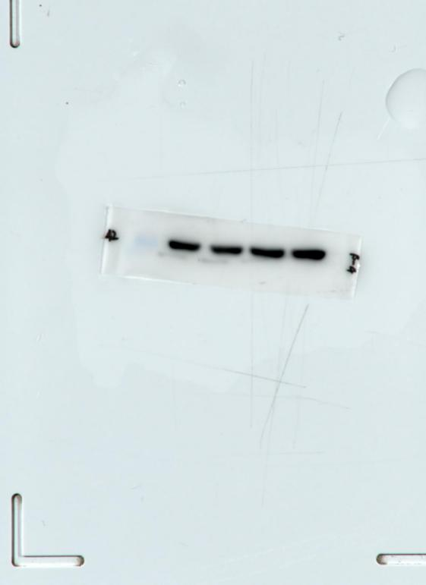
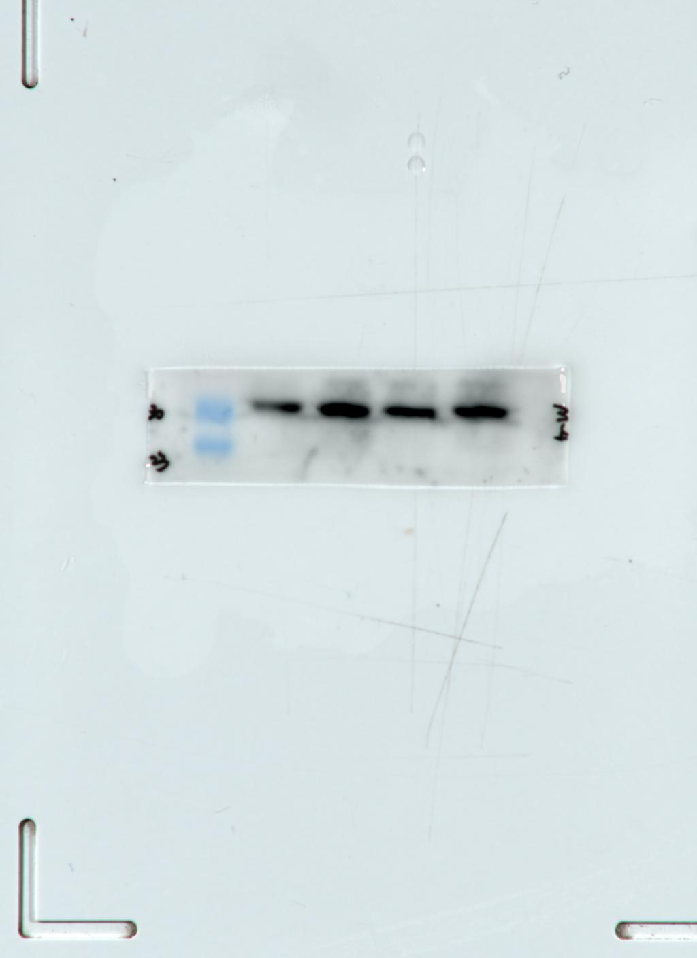
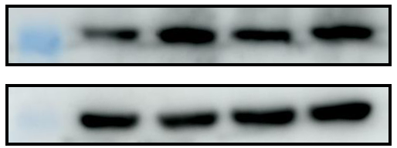
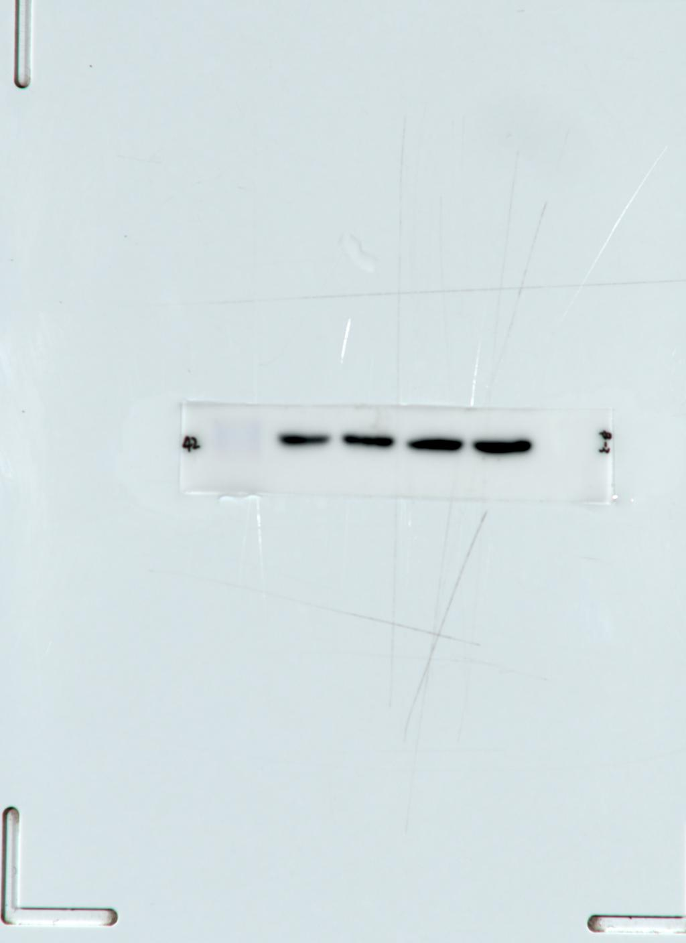
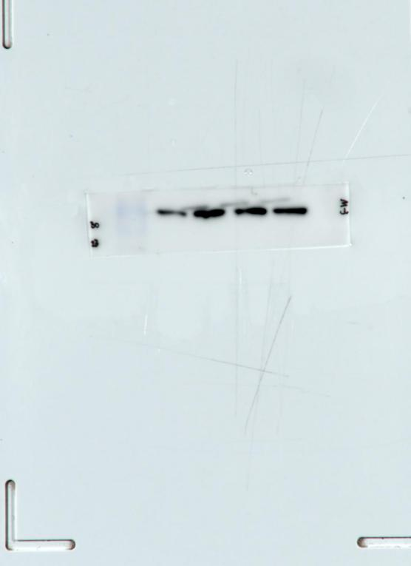
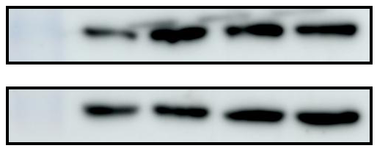
Figur 4A Figur 5G

42

30
23

42
30
23

Control
CC
OGD

kDa
30
Actin
MCU
42
harpagide
42
harpagide
Control
RR
OGD

kDa
30
Actin
MCU

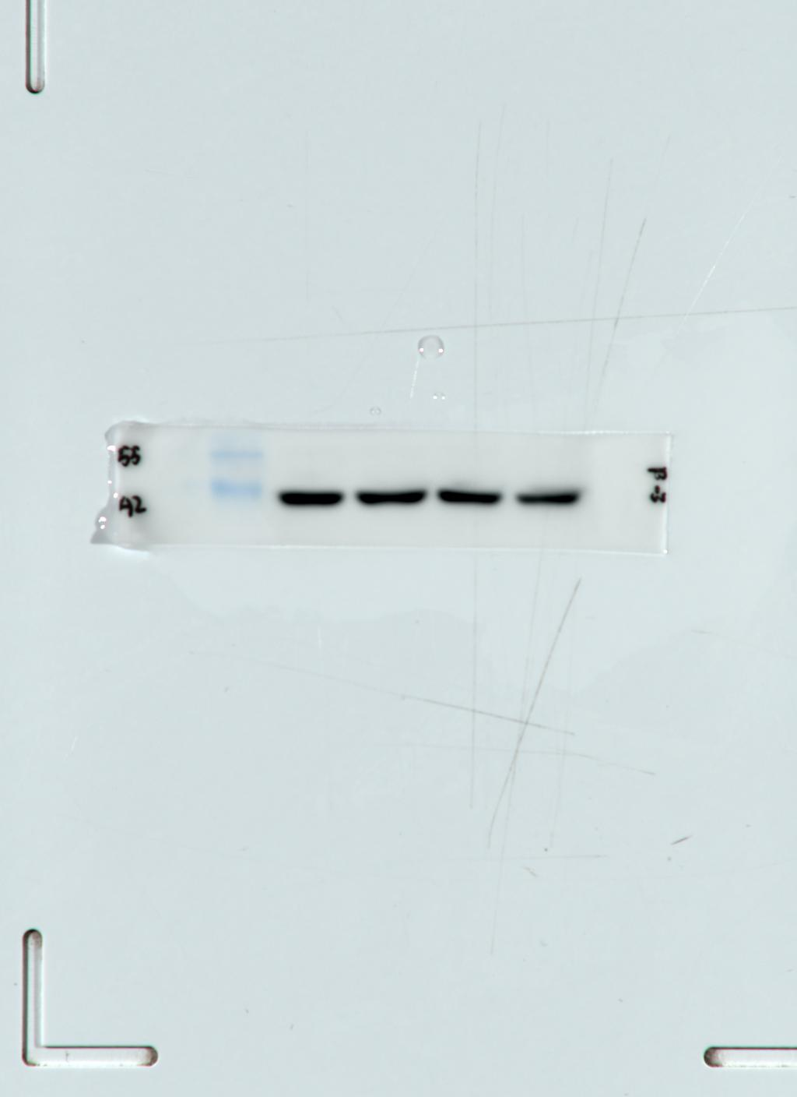
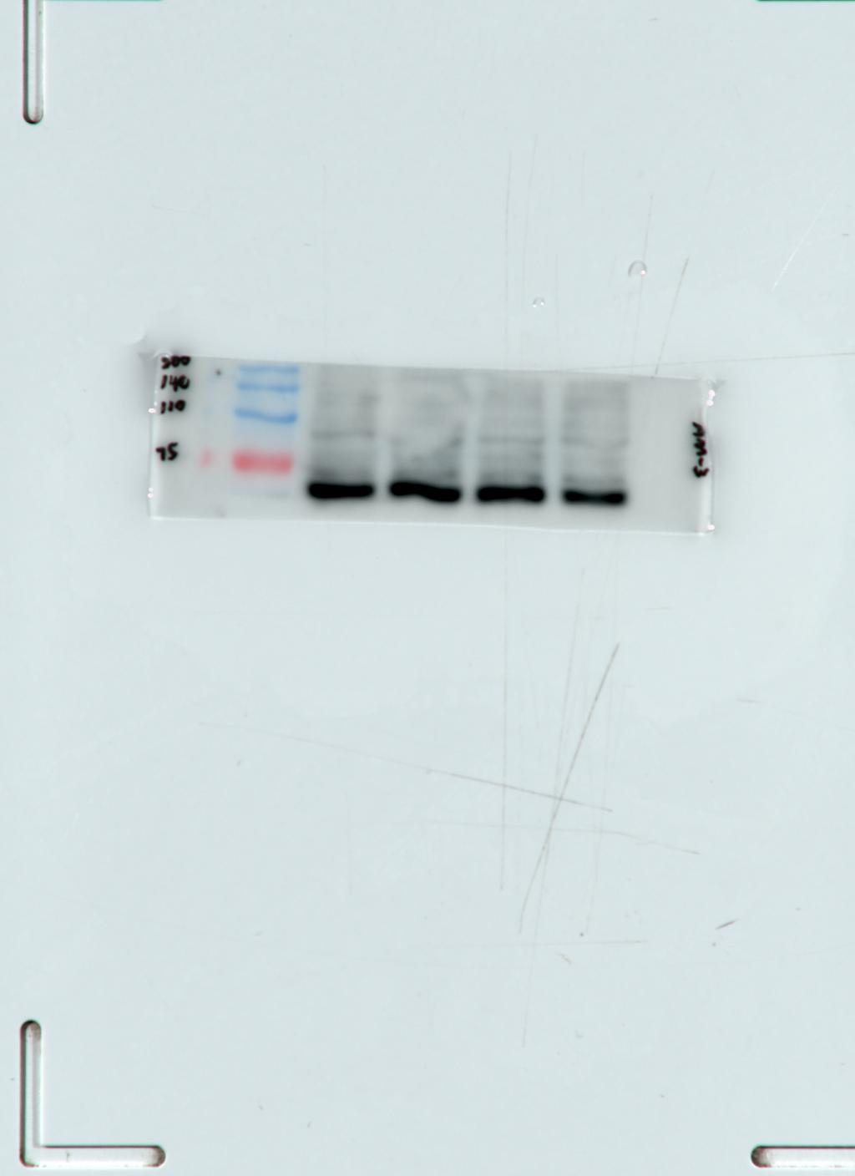
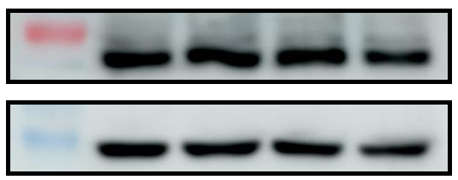
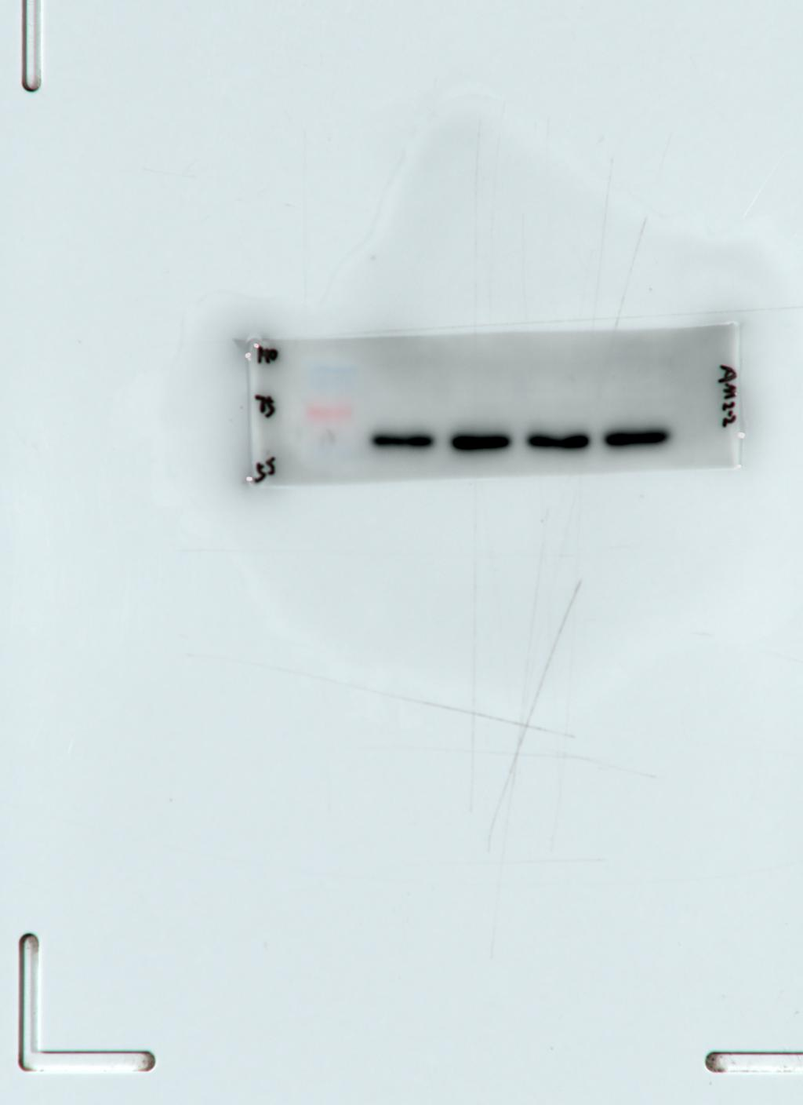
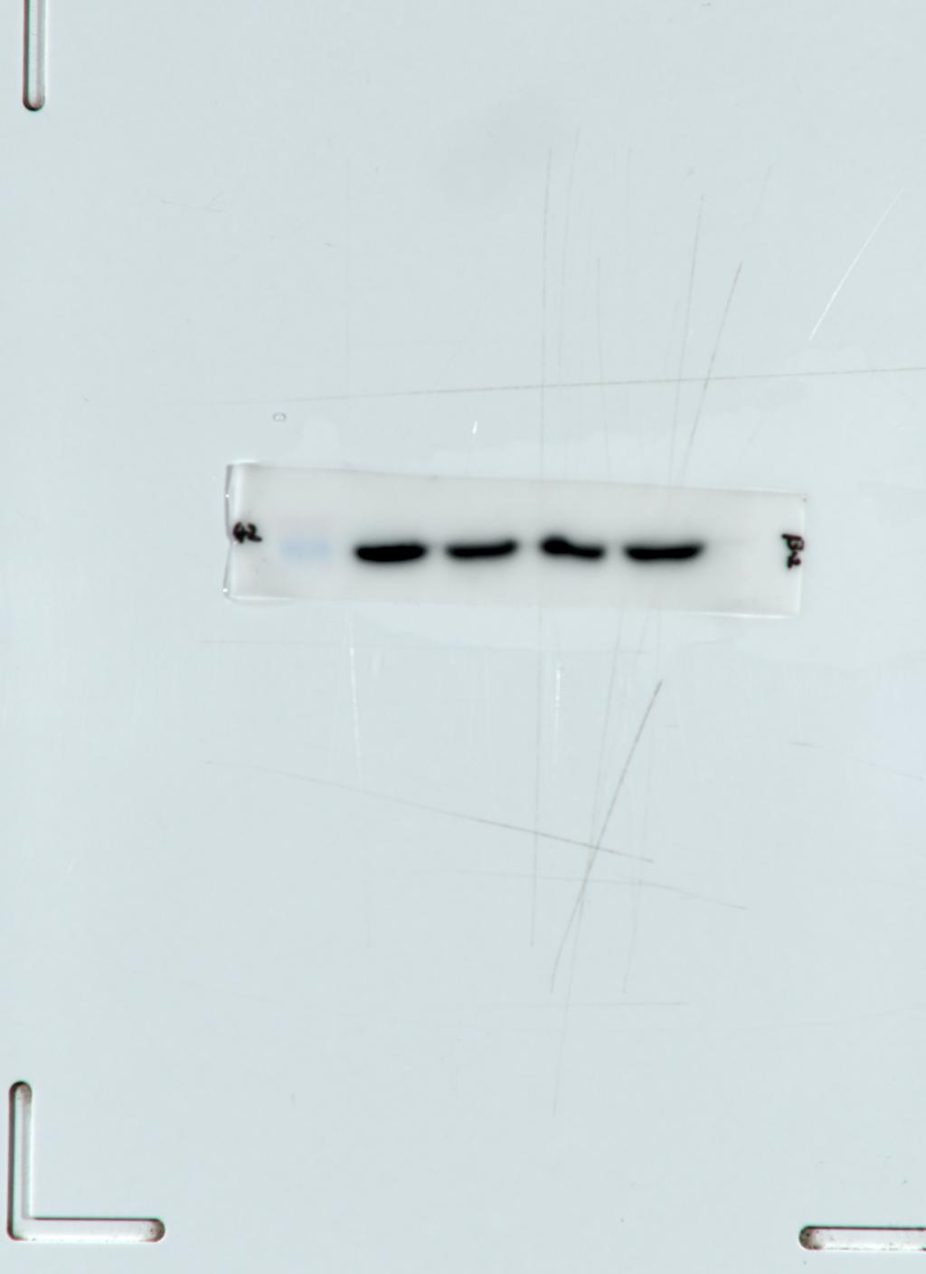
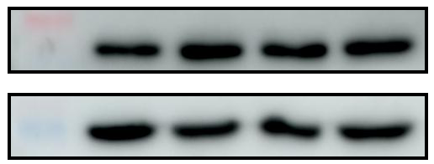
Figur 5J Figur 6B
Control
Control
OGD

CC
CC
OGD

55
42

200
140110
75

42

110
75
55

62
Actin
AMPK
kDa
62
Actin
AMPK
42
harpagide
42
harpagide
kDa

Figur 6D Figur 6F
Control
OGD

CC
55
42
30
Actin
MCU
42
harpagide
kDa
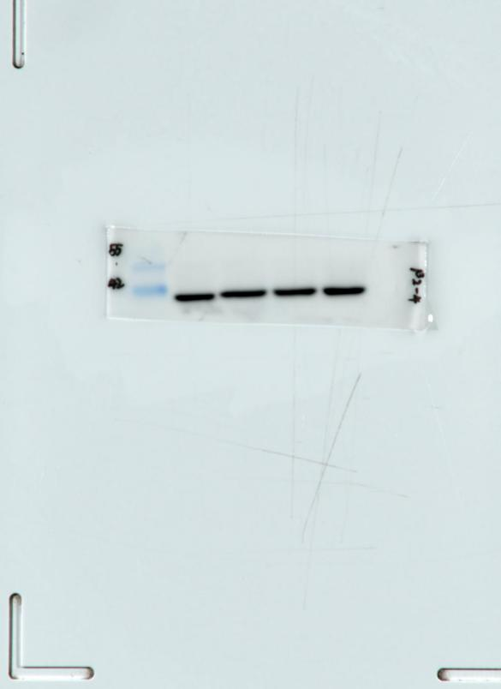
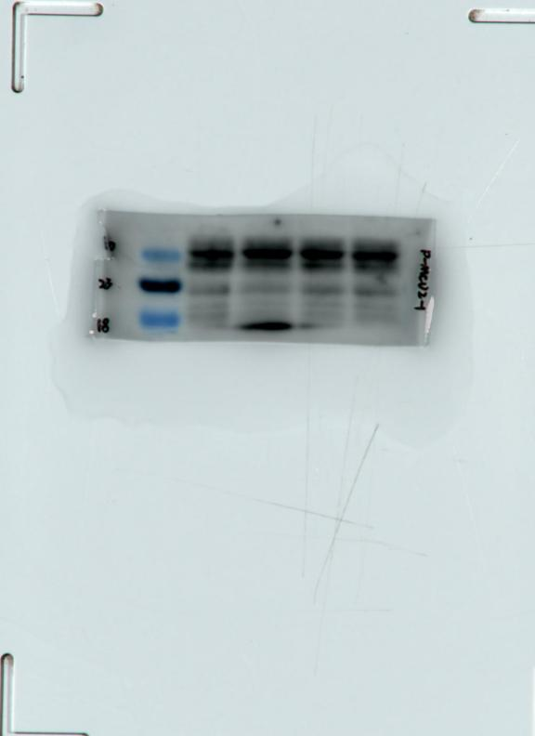
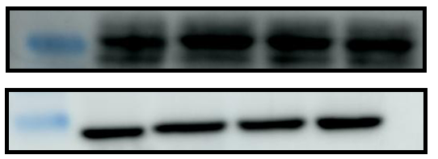
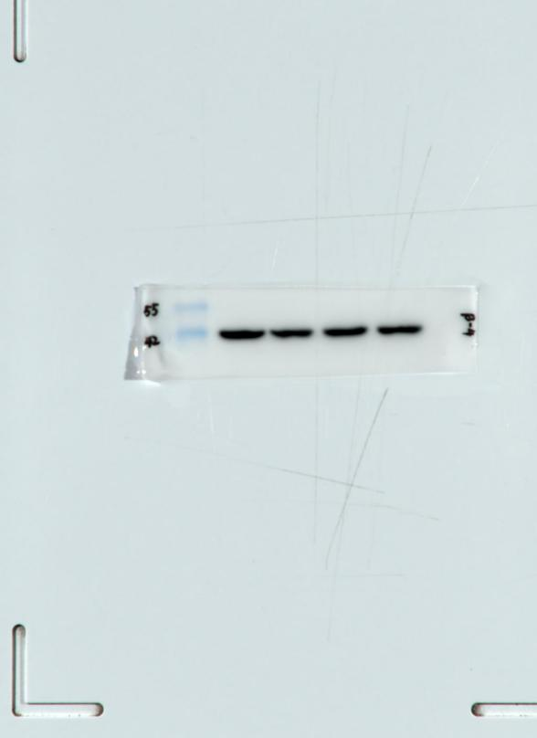
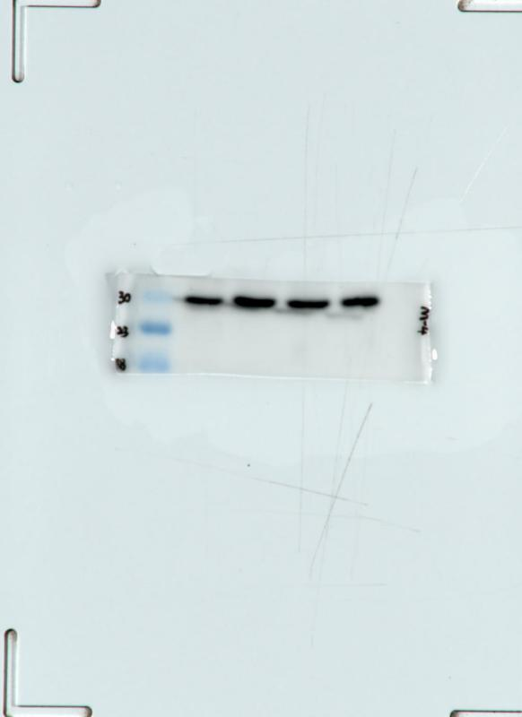
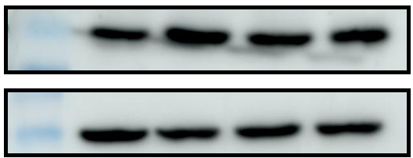

30
23
18
55
42

30
23
18
Actin
p-MCUser57
Control
OGD

harpagide
CC
kDa
42
30

