APPENDIX
Table of Contents

APPENDIX A: Descriptive evidence and measurement: additional tables and figures 1
Table A.1: Distribution of requested quotas to Netquest 1
Table A.2: Question wording 2
Table A.3: Words related to four relevant policy areas and news misinformation (benchmark) 4
Figure A.1: Affective polarization levels by plebiscite choice, runoff vote, left-right divide, rich-poor, and abortion divide by plebiscite choice (Original survey: Placebo group) 5
APPENDIX B: Additional experimental results 6
Figure B.1: Keyness analysis: Differences in feelings toward the opposite group among respondents with a plebiscite choice in the treated and control groups, by plebiscite vote 6
Figure B.2: Keyness analysis: Differences in answers to priming question by plebiscite position 7
Table B.1: Effect of plebiscite cues on agreement with ideological statements 8
Table B.2: Effect of treatment on affective polarization (manipulation checks) 9
Table B.3: Treatment effect on ideological polarization 10
Table B4: Affective polarization and the effect of cues on agreement with ideological statements (different specifications) 11
APPENDIX C: Construction of population weights 12
Table C.1: Population and unweighted sample distributions 12

APPENDIX A: Descriptive evidence and measurement: additional tables and figures

Table A.1: Distribution of requested quotas to Netquest

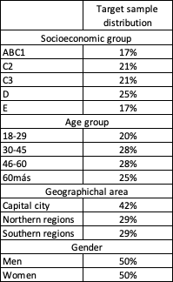

Note: Summary of quotas used to construct weights for the descriptive analysis.

Table A.2: Question wording online survey
QUESTION | CREATED  VARIABLE | QUESTION ALTERNATIVES | SURVEY
CHARACTERIZATION
Did you vote in the most recent presidential election in December 2021? | Voted Presidential | Yes  No | Both
[Voted Presidential =Yes]  Which candidate did you vote for in the second round of the December 2021 presidential election?  Gabriel Boric Font  José Antonio Kast Rist | Presidential vote choice | Yes  No | CEP survey
[Voted Presidential =Yes]  Who did you vote for? | Presidential vote choice | Gabriel Boric Font  José Antonio Kast Rist  Voted blank  Cast a null/invalid vote | Original online survey
Thinking about the exit plebiscite to be held on September 4 of this year, do you plan to vote Approve or Reject the proposed new constitution? | Plebiscite choice | Approve  Reject  I will cast a blank or null vote  Don’t know  I will probably not vote | Original online survey
On September 4, 2022, the exit plebiscite on the proposed new Constitution was held. Did you vote in that election?  Yes  No | Voted plebiscite | Yes  No | CEP survey
[Voted plebiscite=Yes]  Could you tell me which option you voted for in the September exit plebiscite? | Plebiscite choice | Approve  Reject | CEP survey

IDEOLOGICAL POLARIZATION
Where would you place yourself on the following scale where 0 represents the left and 10 represents the right: | Left–Right | 0–10 scale  0: Left  10: Right | Online  original  survey
The concepts of left and right are useful for summarizing, in a very simplified way, what people think about many issues. I would like you, please, to place yourself on a scale from 1 to 10, where 1 represents the left and 10 represents the right. | Left–Right | 1-10 scale  1: Left  10_ Right | CEP survey
Regarding taxes, where would you place yourself on a scale from 0 to 10, where 0 means that taxes should be strongly reduced and 10 means that taxes should be strongly increased? | Taxes | 0–10 scale  0: Strongly reduced  10: Strongly increased | Online  original  survey
Regarding inequality and economic growth, where would you place yourself on a scale from 0 to 10, where 0 means that the reduction of inequalities should be prioritized, even if economic growth is not generated, and 10 means that economic growth should be prioritized, even if inequality increases? | Inequality vs. Growth | 0–10 scale  0: Prioritize the reduction of inequalities  10: Prioritize economic growth | Online  original  survey
In democracies, the aspiration is for there to be public and private freedoms and for there to be public order and citizen security. In your case, which value do you give more relevance to? Where 0 is “Let there be public and private freedom” and 10 is “Let there be public order and citizen security.” | Liberty vs. Security | 0–10 scale  0: Public and private liberties  10: Public order and security | Online  original  survey
Regarding abortion, where would you place yourself on the following scale where 0 means that abortion should never be allowed and 10 means that abortion should always be allowed? | Abortion | 0–10 scale  0: Abortion never allowed  10: Abortion always allowed | Online  original  survey
Where would you place yourself on the following scale in which 0 means that the state must ensure the jobs and standard of living of the people, and 10 means individuals are responsible for their own jobs and standard of living? | Government vs. Individuals | 0–10 scale  0: State responsibility  10: Individual responsibility | Online  original  survey

AFFECTIVE POLARIZATION
Up next, some groups of people are shown. On a scale from 0 to 10, where 0 indicates that you have a very negative opinion of these people, 5 that you have neither a negative nor a positive opinion, and 10 that you have a very positive opinion about these people, what is your opinion about each group of people?
People who vote for Approve  People who vote for Reject | Plebiscite voters | 0–10 scale  0: Very negative  5 Neither positive nor negative  10: Very positive | Both
People who voted for Gabriel Boric  People who voted for José Antonio Kast | Presidential voters |  | Both
Right-wing people  Left-wing people | Left–Right |  | Both
The rich  The poor | Rich–Poor |  | Original online survey
People in favor of unrestricted abortion  People against abortion under any circumstance | Pro-choice vs. Pro-life |  | Original online survey
Using the same scale, where 0 means you strongly disagree and 10 means you strongly agree, how much do you agree with the following statements?
People who vote Approve are not only worse for politics; they are frankly bad people.  eople who vote Reject are not only worse for politics; they are frankly bad people. | Bad vs Good | 0-10 scale  0: Strongly disagree  10: Strongly agree | Original online survey
People who vote Approve are a serious threat to Chile and its people.  People who vote Reject are a serious threat to Chile and its people. | Threat | 0-10 scale  0: Strongly disagree  10: Strongly agree | Original online survey
Now thinking of a scale where 0 means they are very bad people, 5 means they are neither good nor bad people, and 10 means they are very good people, where would you place the people who voted
People who vote for Approve  People who vote for Reject | Bad vs Good | 0-10 scale  0: Very bad person  10: Very good person | CEP Survey

Table A.3: Words related to four relevant policy areas and news misinformation (benchmark)
Inequality/Growth | Abortion | Environment | Indigenous | Benchmark
inequality | abortion | environment | indigenous | news
growth | reproductive | green | mapuche | fake
taxes | abort | ecology | race | lie
unequal | right to life | earth | native people | inform
job | women rights | planet | multicultural | Information
employment | life | drought | plurinational | naivety
unemployment | women | climate | mapudungun | liars
economy |  | weather |  | deception
equality |  | environmental |  | cheat
equal |  | permissions |  | ignorance
 |  |  |  | read
 |  |  |  | true
 |  |  |  | false

Figure A.1: Affective polarization levels by plebiscite choice, runoff vote, left-right divide, rich-poor, and abortion divide by plebiscite choice (Original survey: Placebo group)
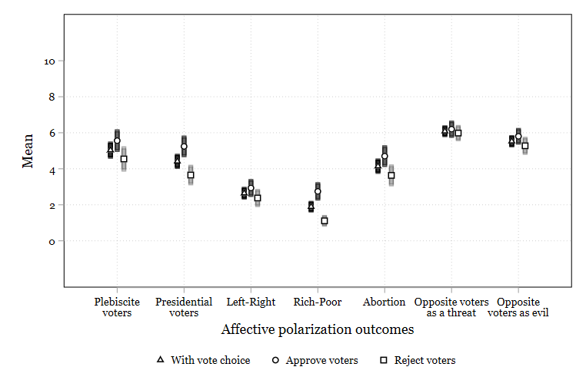
Note: Means for the placebo group using weights by population group, only for respondents with a plebiscite choice (n=661).
Source: Original online survey

APPENDIX B: Additional experimental results

Figure B.1: Keyness analysis: Differences in feelings toward the opposite group among respondents with a plebiscite choice in the treated and control groups, by plebiscite vote

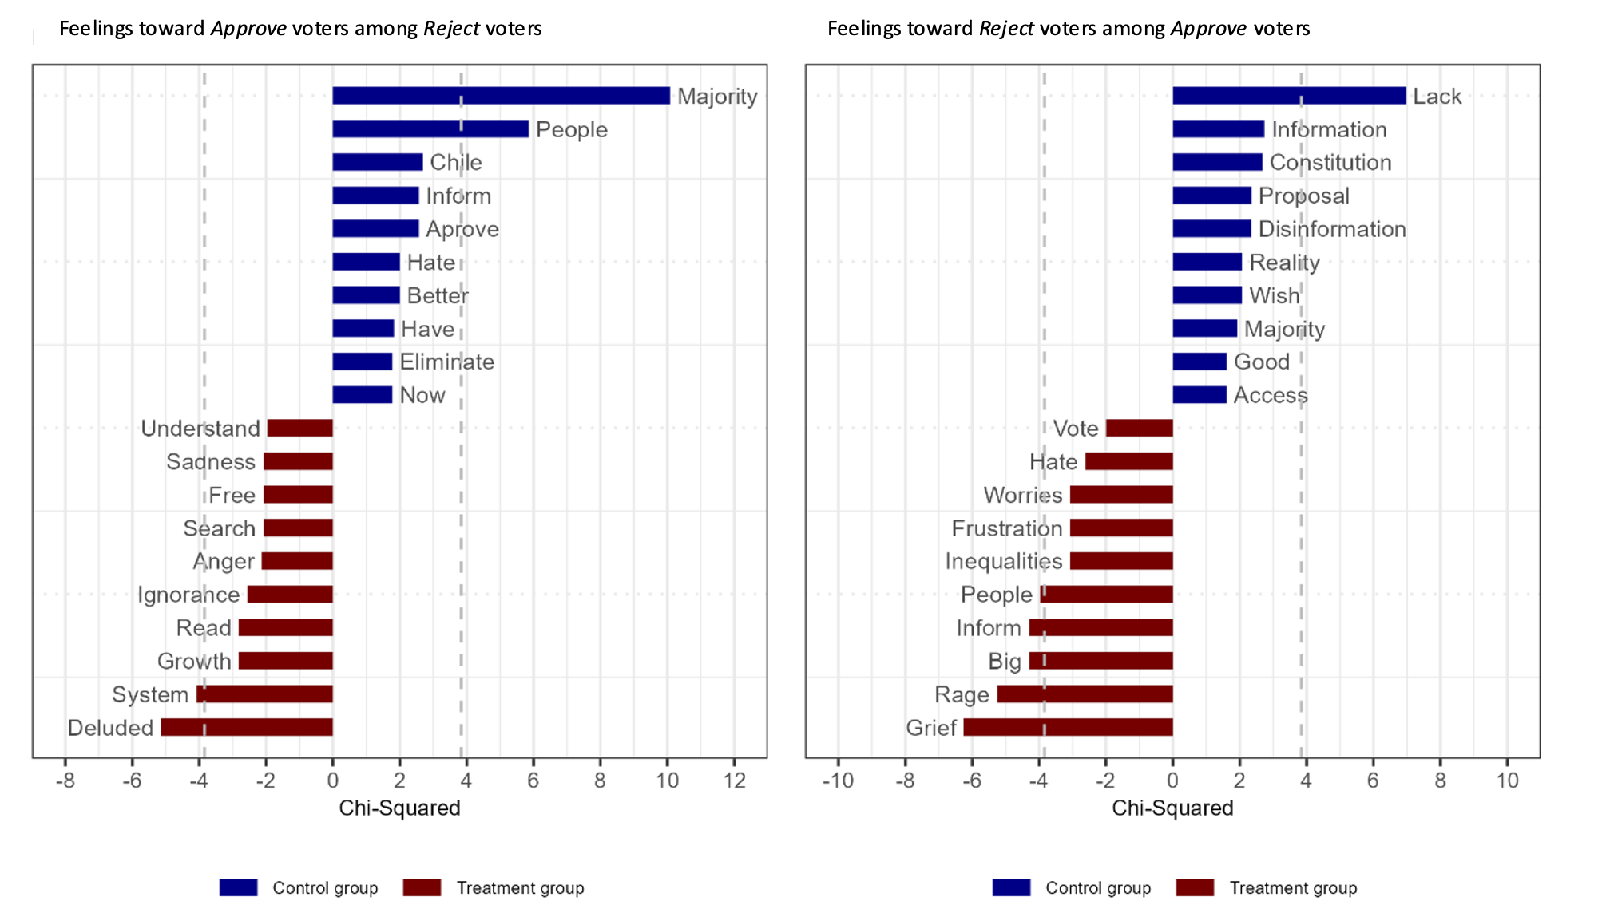

Note: Dashed lines represent 95 percent significance levels (|$χ2$| > 3.84).

Figure B.2: Keyness analysis: Differences in answers to priming question by plebiscite position

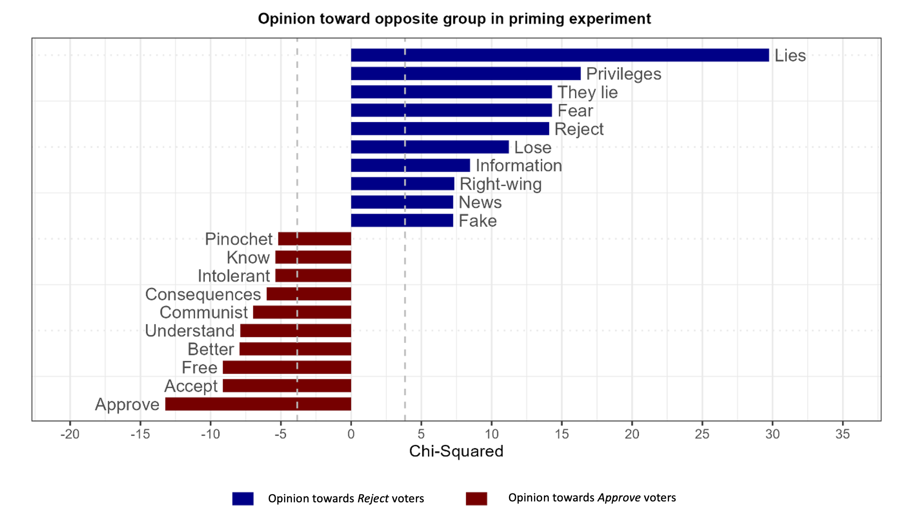
Note: Dashed lines represent 95 percent significance levels (|$χ2$| > 3.84).

Table B.1: Effect of plebiscite cues on agreement with ideological statements

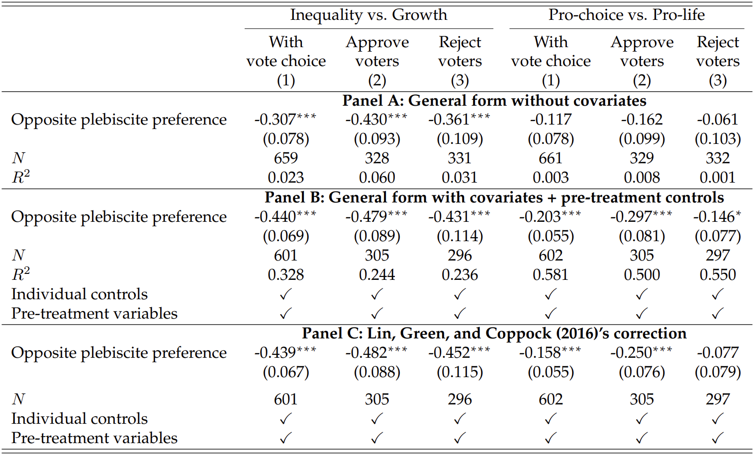
Note: Outcomes are standardized. Only respondents from the placebo group with vote preferences for the plebiscite are included. All regressions control for sociodemographic variables (age, sex, metropolitan region, education, and socioeconomic status), left–right ideology (in three groups), interest in politics, party ID, and baseline preferences for the past presidential runoff and plebiscite.
Robust standard errors are in parentheses. *p<0.10, **p<0.05, ***p<0.01

Table B.2: Effect of treatment on affective polarization (manipulation checks)

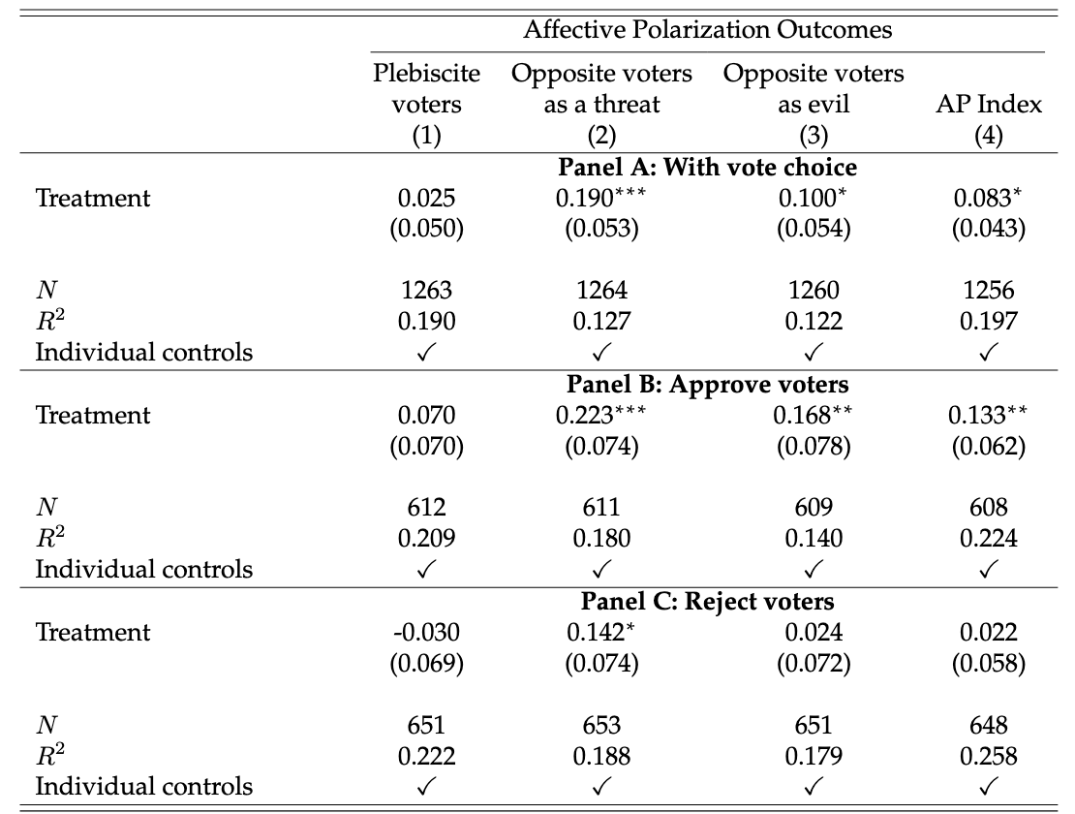

Note: OLS regressions, outcomes are standardized. All regressions control for sociodemographic variables (age, sex, metropolitan region, education, and socioeconomic status), left–right ideology (in three groups), interest in politics, party ID, and baseline preferences for the past presidential runoff and plebiscite.
Robust standard errors are in parentheses. *p<0.10, **p<0.05, ***p<0.01

Table B.3: Treatment effect on ideological polarization
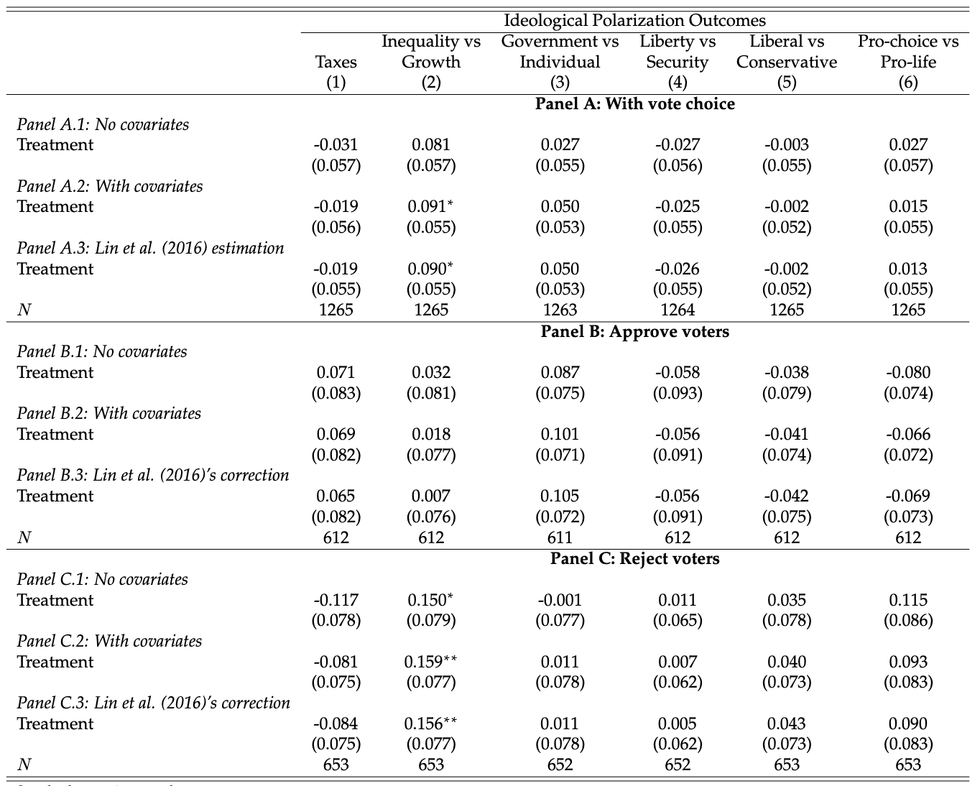
Note: OLS regressions, all control for sociodemographic variables (age, sex, region, education, and socioeconomic status), left–right ideology (in three groups), interest in politics, party ID, and baseline preferences for the past presidential runoff and plebiscite.

Table B4: Affective polarization and the effect of cues on agreement with ideological statements (different specifications)
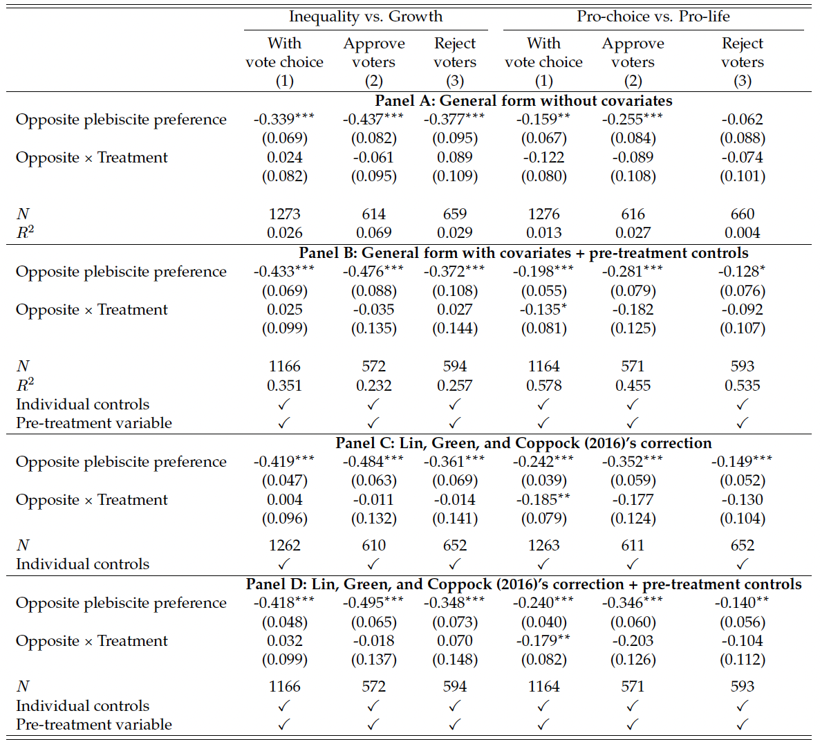
Note: Outcomes are standardized. All regressions control for sociodemographic variables (age, sex, metropolitan region, education, and socioeconomic status), left–right ideology (in three groups), interest in politics, party ID, and baseline preferences for the past presidential runoff and plebiscite.
Robust standard errors are in parentheses. *p<0.10, **p<0.05, ***p<0.01

APPENDIX C: Construction of population weights

Post-survey weights were constructed based on the population distribution obtained from the 2017 Chilean Census. Each stratum corresponds to a subgroup given by the combination of education level, age group, and gender. We identify three education categories: "less than complete secondary education," "complete secondary education," and "more than complete secondary education"; three age groups: "18-35 years old," "36-55 years old," and "over 55 years old," and two gender categories. The combination of all three variables resulted in 18 strata. For each stratum, weights were calculated as:

$$w_{i}=\frac{n*\frac{N_{i}}{∑N_{i}}}{n_{i}}$$

where
- Ni: population size in stratum i
- ni: final sample size in stratum i
- n: total sample size.

Table C.1 presents the population distribution and unweighted distribution (by construction, the weighted distribution corresponds to the population distribution).

Table C.1: Population and unweighted sample distributions
Variable | Division | Census | Survey
Education | <Secondary complete | 36.3% | 8.9%
Education | Secondary complete | 34.0% | 32.9%
Education | >Secondary complete | 29.8% | 58.3%
Age | 18–35 | 37.0% | 22.4%
Age | 36–54 | 35.4% | 41.7%
Age | >54 | 27.6% | 35.9%
Sex | Male | 48.3% | 49.0%
Sex | Female | 51.7% | 51.0%
 | N | 13,314,848 | 1,499

