Supplemental figure and table legends:

Additional file 1: Figure S1. GenomeScope plots of the genome of Cinnamomum cassia var. cassia.
Additional file 2: Figure S2. Diagram illustrating the filtering process of the whole-genome resequencing data.
Additional file 3: Figure S3. TreeMix analyses among macro, cassia-FCG and cassia-MDA.
Additional file 4: Figure S4. Genetic differentiation (F_{ST}) between Chinese and Vietnamese cinnamon in 25-kb non-overlapping sliding windows across all chromosomes.
Additional file 5: Figure S5. Demographic history of C. cassia var. cassia (Cassia-MDA) and C. cassia var. macrophyllum (macro) inferred with PSMC.
Additional file 6: Figure S6. Concentrations of three cinnamaldehyde derivatives (trans-cinnamaldehyde, 2-hydroxycinnamaldehyde, and 2-methoxycinnamaldehyde) across various tissues of C. cassia var. cassia.
Additional file 7: Figure S7. Chromosomal localization of OMTs (red line) in Cinnamomum cassia var. cassia.
Additional file 8: Table S1. Summary of the sequencing data of C. cassia var. cassia generated in the present study.
Additional file 9: Table S2. Assembly and annotation statistics of C. cassia var. cassia genome.
Additional file 10: Table S3. Details of the sample locations, Q values at K=3 in STRUCTURE (dataset D1).
Additional file 11: Table S4. Dsuite analyses did not detect any significant gene flow among cassia-FCG, cassia-MDA, and macro.
Additional file 12: Table S5. Significantly abundant volatile metabolites (relative content >1%) across five tissues in Chinese cinnamon (C. cassia var. cassia).
Additional file 13: Table S6. Concentrations (μg/mg) of three cinnamaldehyde derivatives across various tissues of two C. cassia varieties.
Additional file 14: Table S7. Experimentally verified plant OMTs used in the reconstruction of the phylogenetic tree.
Additional file 15: Table S8. A list of all primers used for CDS cloning in this study.
Supplemental Figures:
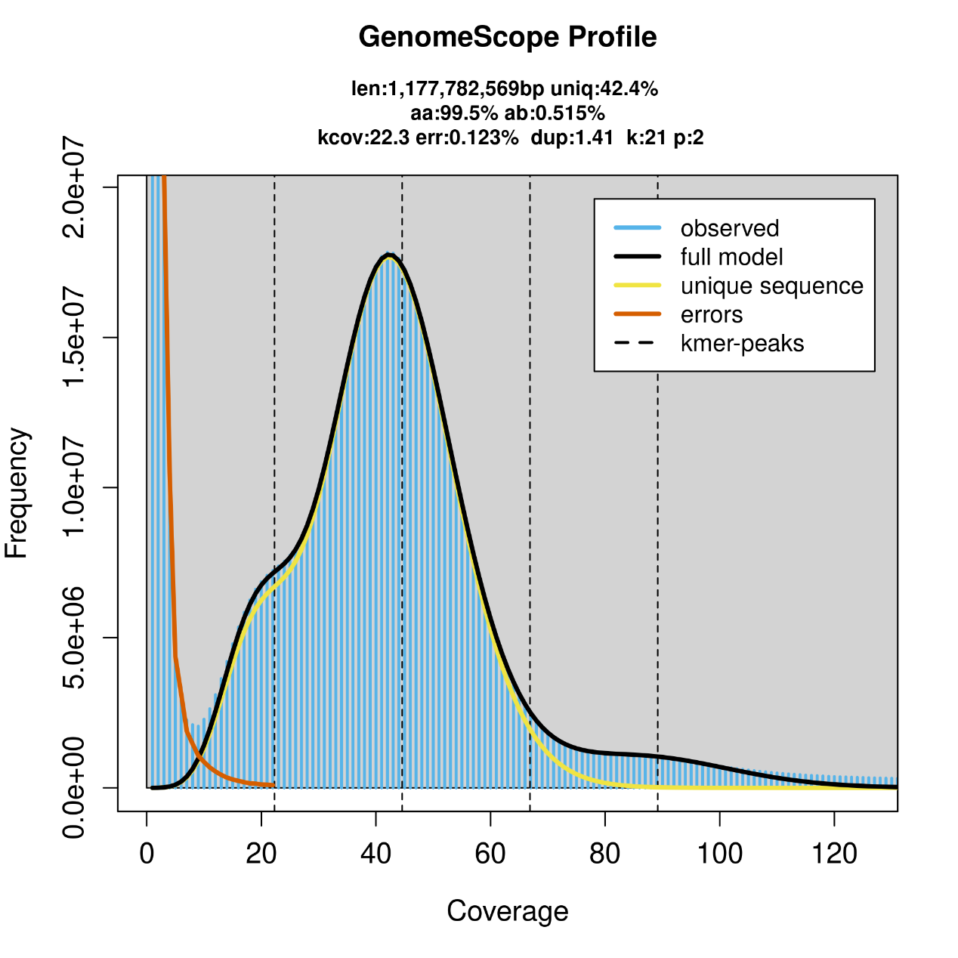
Additional file 1: Figure S1. GenomeScope plots of the genome of Cinnamomum cassia var. cassia.
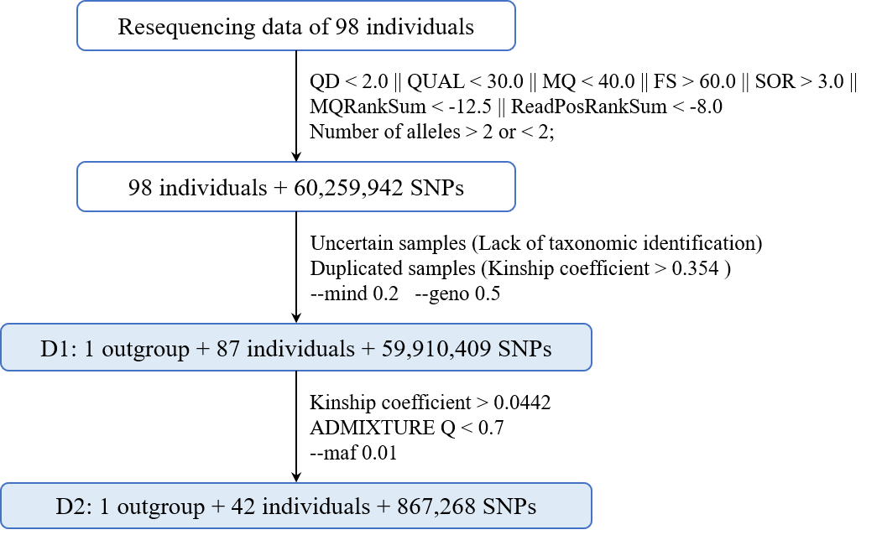
Additional file 2: Figure S2. Diagram illustrating the filtering process of the whole-genome resequencing data.

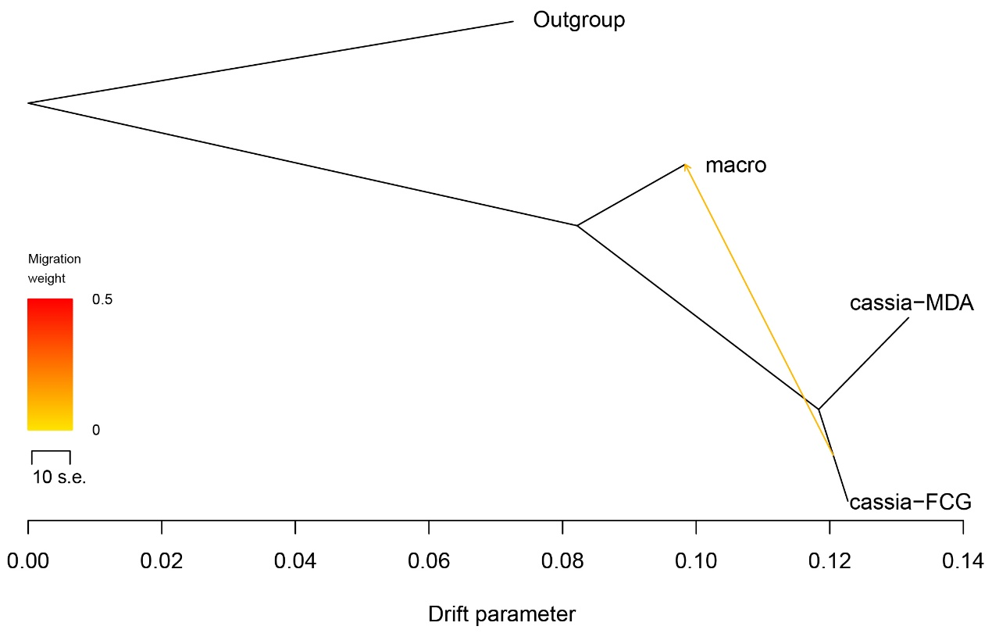
Additional file 3: Figure S3. A very weak gene flow from cassia-FCG to macro identified in the TreeMix analyses. The arrow indicates the migration direction.

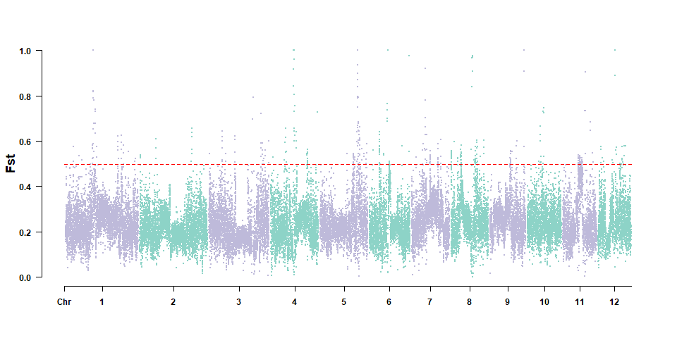
Additional file 4: Figure S4. Genetic differentiation (F_{ST}) between Chinese and Vietnamese cinnamon in 25-kb non-overlapping sliding windows across all chromosomes. Red horizontal lines represent the top 1% F_{ST} (0.499).

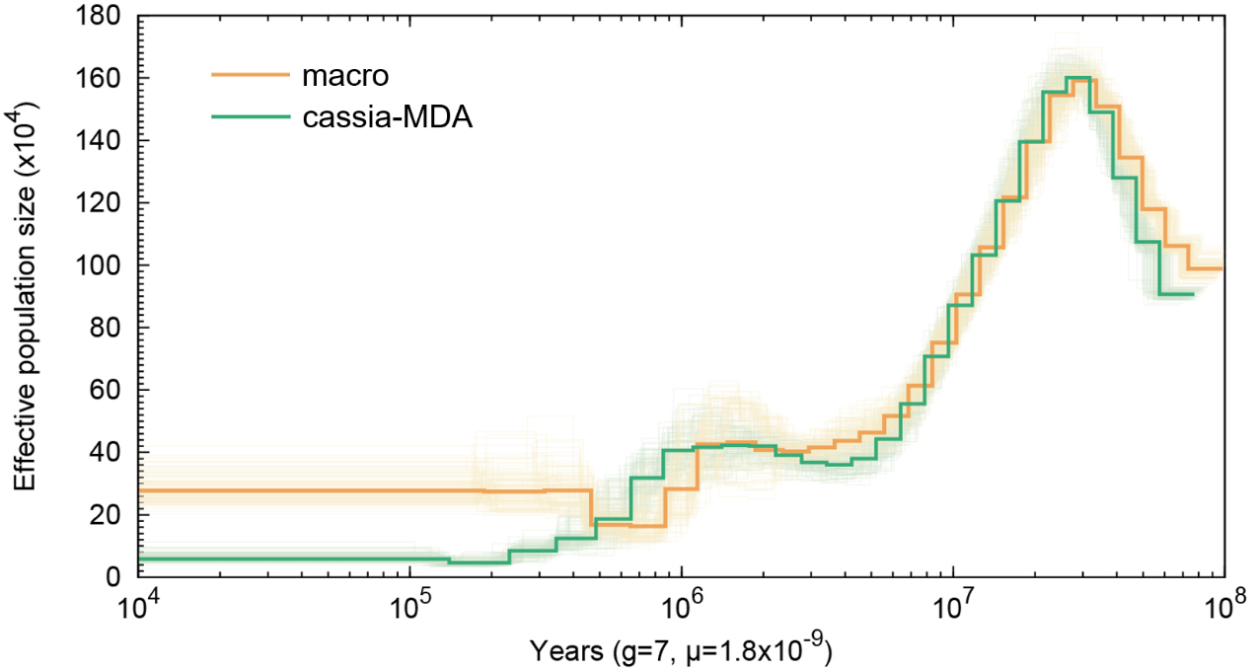
Additional file 5: Figure S5. Demographic history of C. cassia var. cassia (Cassia-MDA) and C. cassia var. macrophyllum (macro) inferred with PSMC.

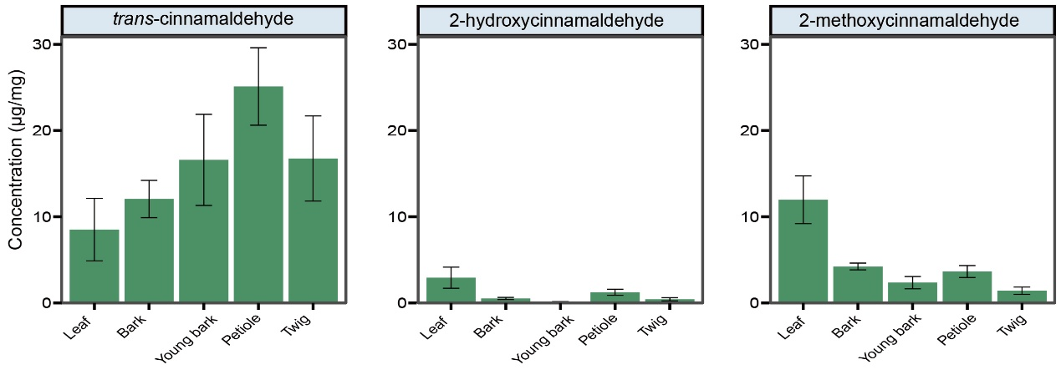
Additional file 6: Figure S6. Concentrations of three cinnamaldehyde derivatives (trans-cinnamaldehyde, 2-hydroxycinnamaldehyde, and 2-methoxycinnamaldehyde) across various tissues of C. cassia var. cassia. Original concentration data are provided in Table S6.

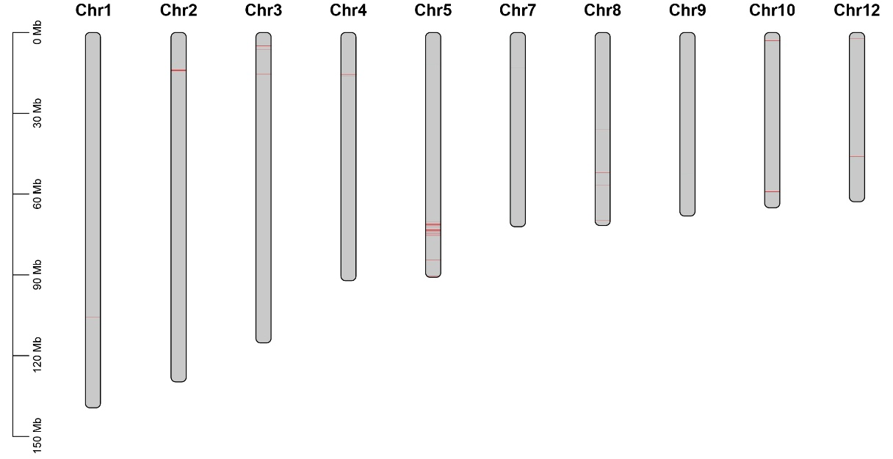
Additional file 7: Figure S7. Chromosomal localization of OMTs (red line) in C. cassia var. cassia. The scale on the left was based on megabytes (Mb). The number of chromosomes was indicated at the top of each column.

