Table 9.a. Molecular electrostatic potential map of all molecules constituting REO
Alpha-pinene  -2.637e⁻² 2.637e⁻² | Linalool  -8.006e-² 8.006e-² | Alpha-Terpineol  -6.601e⁻² 6.601e⁻² | Alpha-Terpinolene  -3.094e⁻² 3.094e⁻² | Alpha-Thujene  -2.830e⁻² 2.830e⁻² | Beta-caryophyllene  -3.138e⁻² 3.138e⁻²
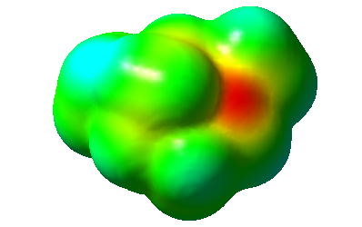 | 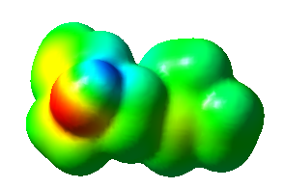 | 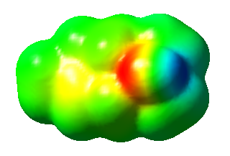 | 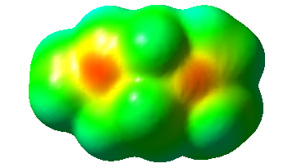 | 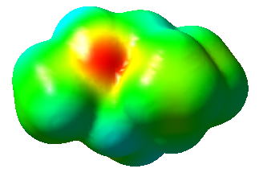 | 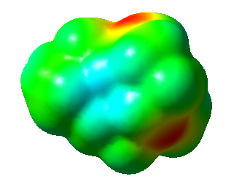
Beta-Myrcene  -3.468e⁻² 3.468e⁻² | Beta-Thujene  -2.383e⁻² 2.383e⁻² | Borneol-acetate  - 6.862e-² 6.862e-² | Eucalyptol  - 7.044e-² 7.044e⁻² | Camphene  -2.774e⁻² 2.774e⁻² | Gamma-cardinene  -2.894e⁻² 2.894e⁻²
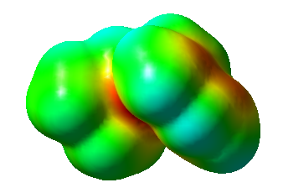 | 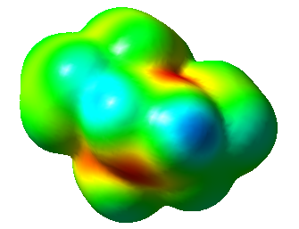 | 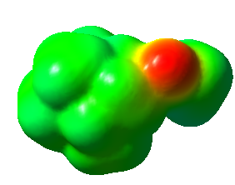 | 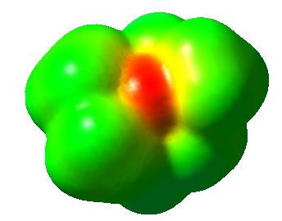 | 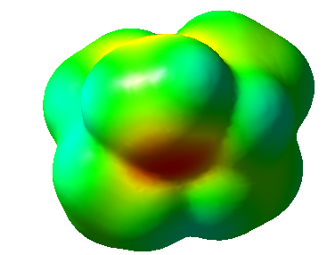 | 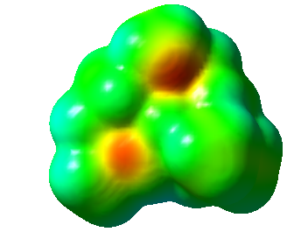
Gamma-terpinene  -2.886e⁻² 2.886e⁻² | Isoborneol  -6.887e⁻² 6.887e⁻² | Humulene  -2.915e⁻⁻² 2.915e⁻² | O-cymene  -3.889e⁻² 3.889e⁻² | Terpinene-4-ol  -6.606e⁻² 6.606e⁻² | Terpinolene  -3.094e⁻⁻² 3.094e⁻⁻²
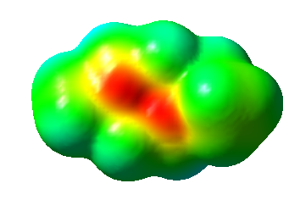 | 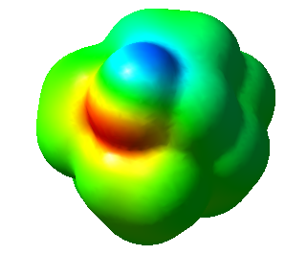 | 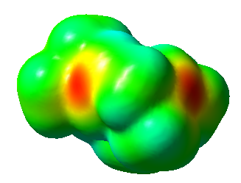 | 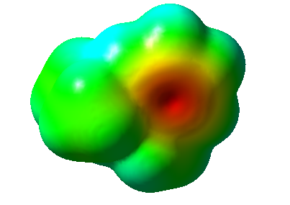 | 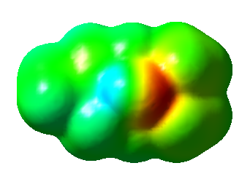 | 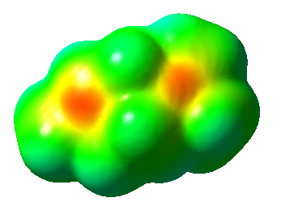
Terpineol
-6.710e⁻² 6.710e⁻²
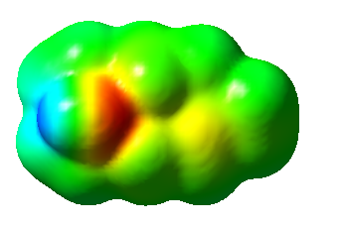

Table 9.b. Contour Surface map of all molecules constituting REO
Alpha-pinene  -2.637e⁻² 2.637e⁻² | Linalool  -8.006e-² 8.006e-² | Alpha-Terpineol  -6.601e⁻² 6.601e⁻² | Alpha-Terpinolene  -3.094e⁻² 3.094e⁻² | Alpha-Thujene  -2.830e⁻² 2.830e⁻² | Beta-caryophyllene  -3.138e⁻² 3.138e⁻²
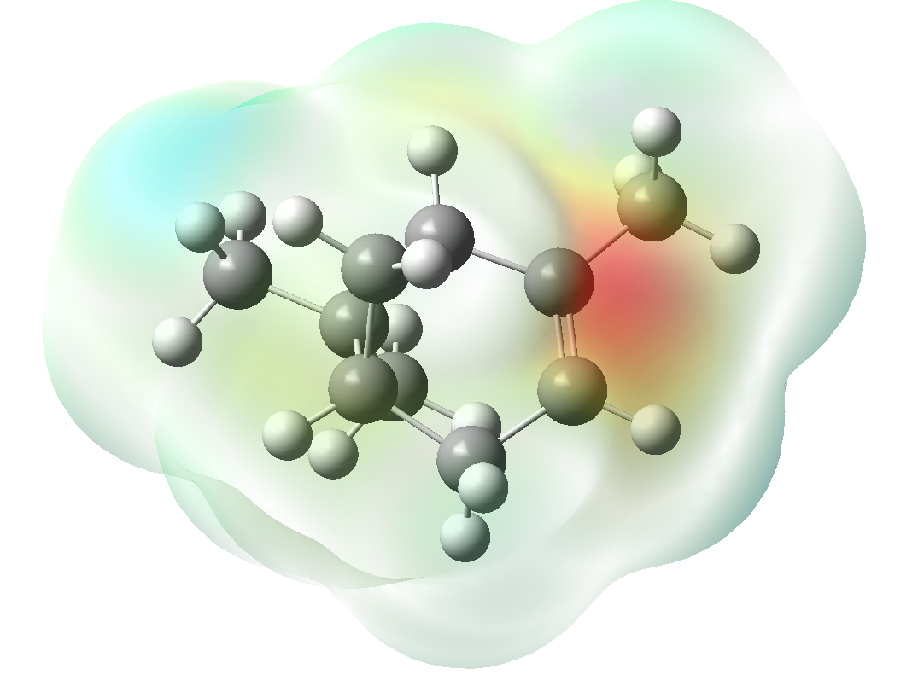 | 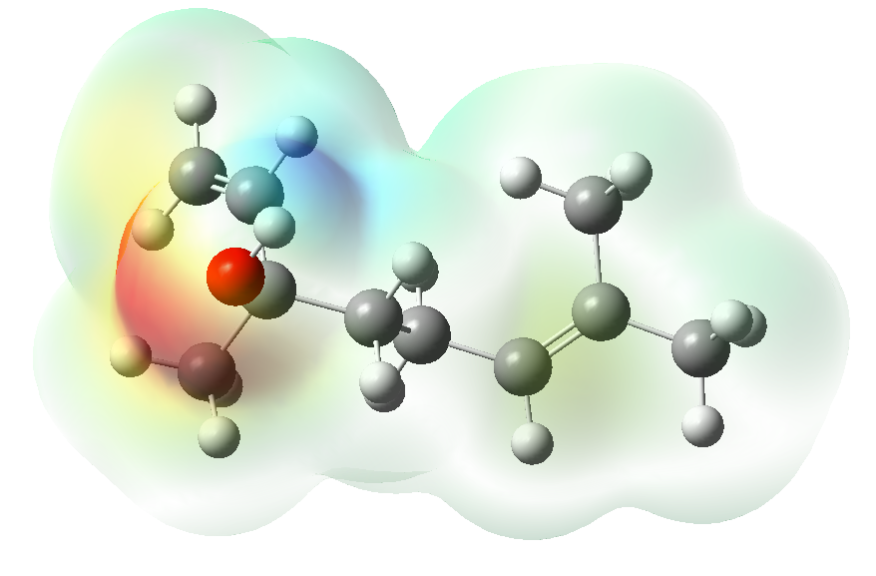 | 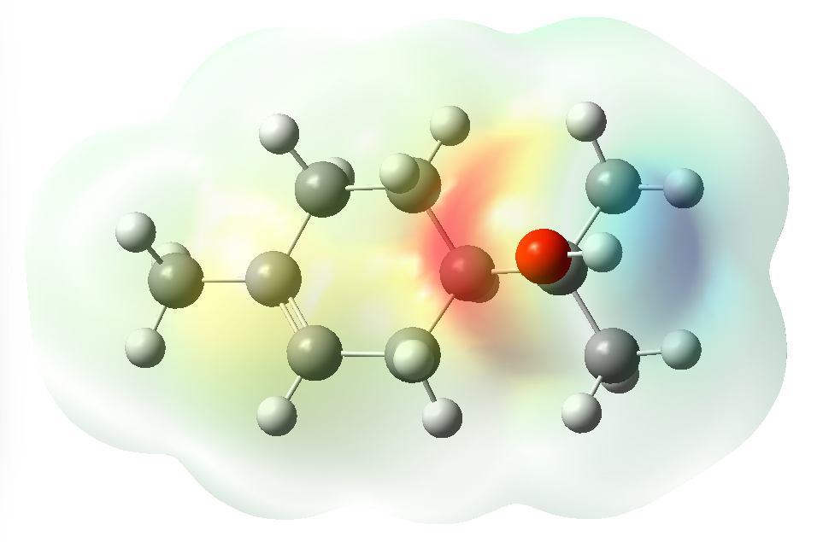 | 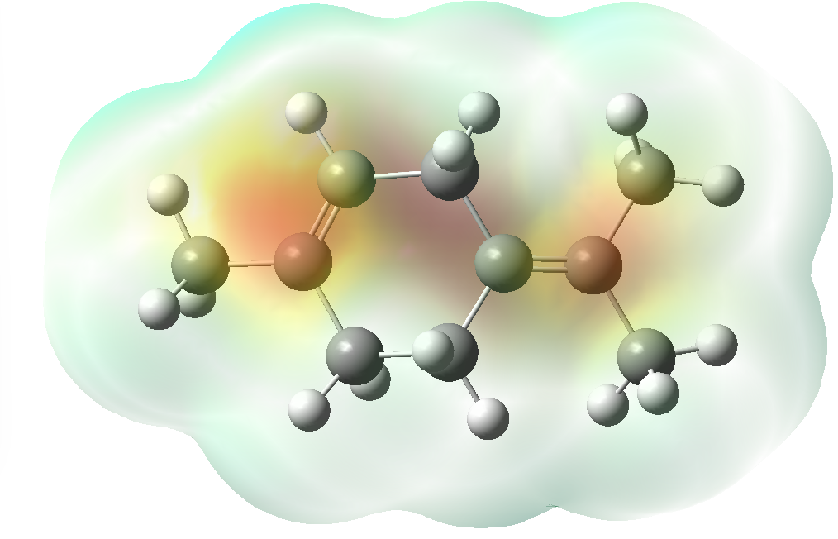 | 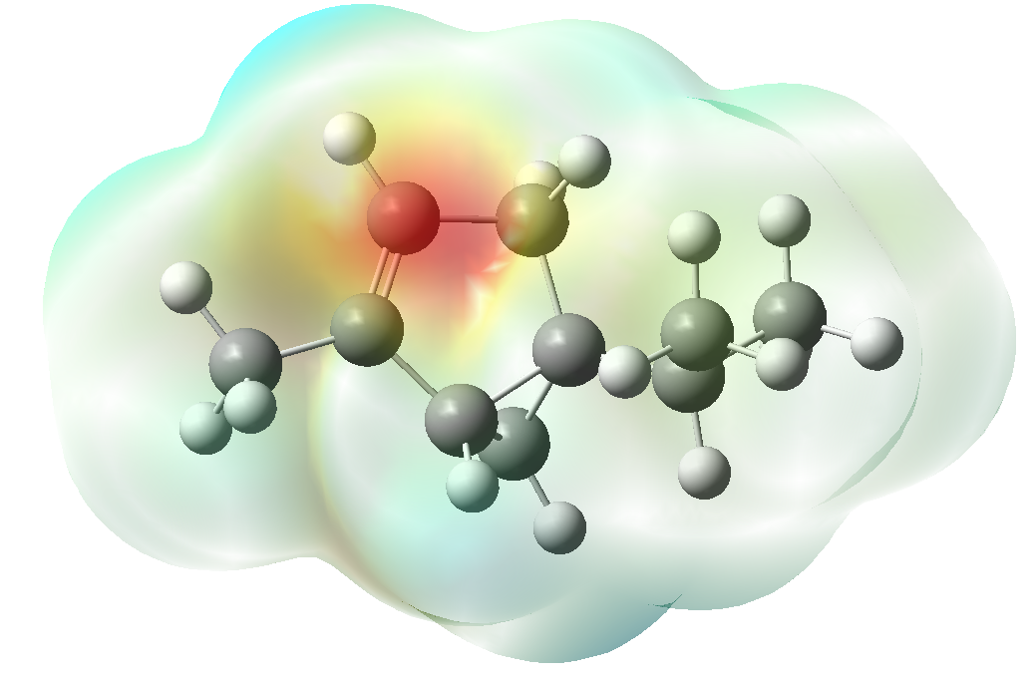 | 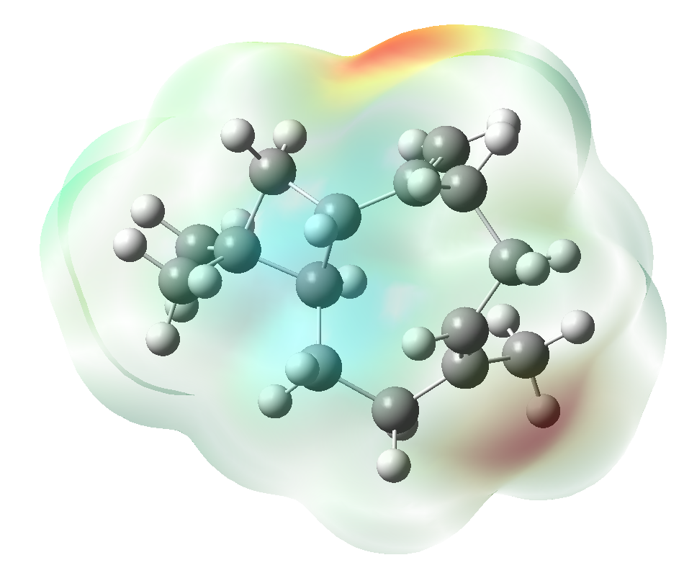
Beta-Myrcene  -3.468e⁻² 3.468e⁻² | Beta-Thujene  -2.383e⁻² 2.383e⁻² | Borneol-acetate  - 6.862e-² 6.862e-² | Eucalyptol  - 7.044e-² 7.044e⁻² | Camphene  -2.774e⁻² 2.774e⁻² | Gamma-cardinene  -2.894e⁻² 2.894e⁻²
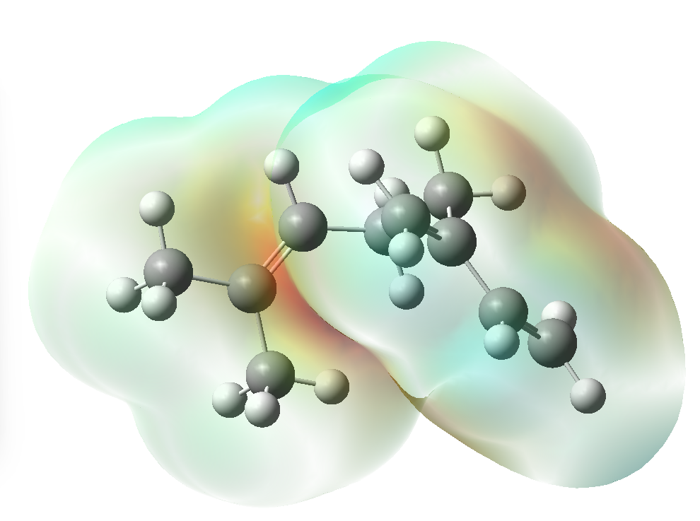 | 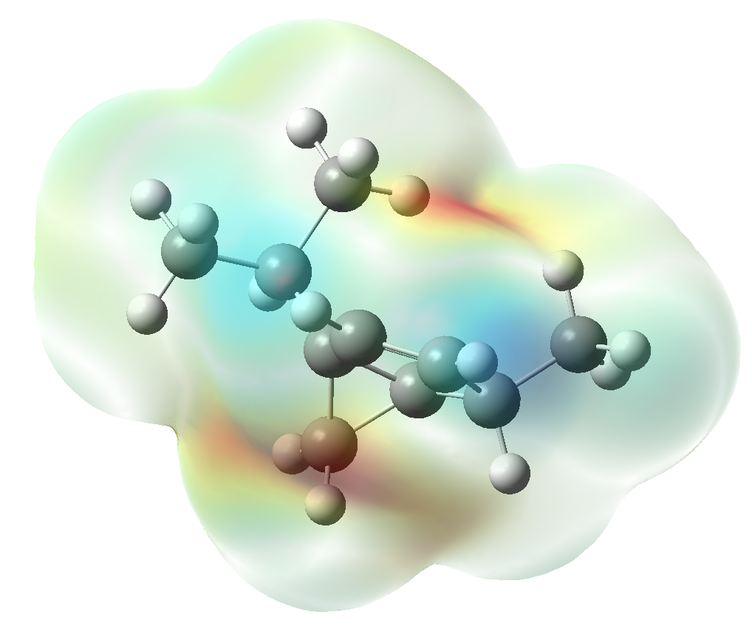 | 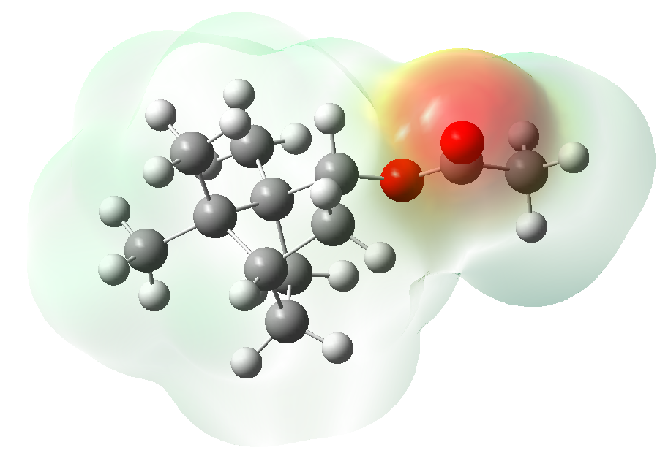 | 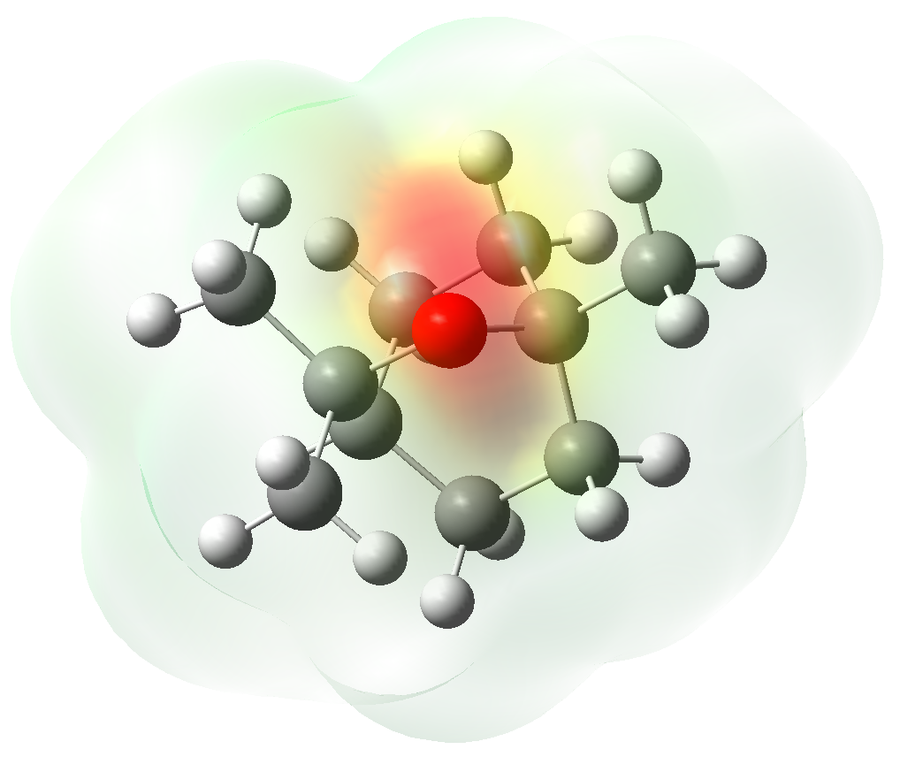 | 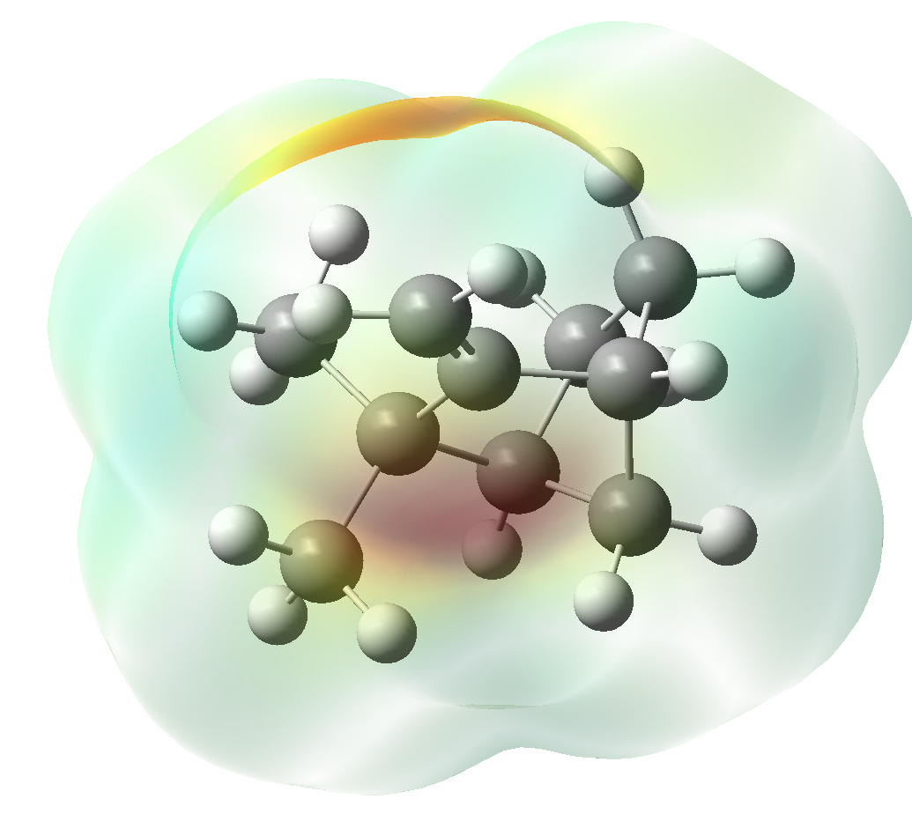 | 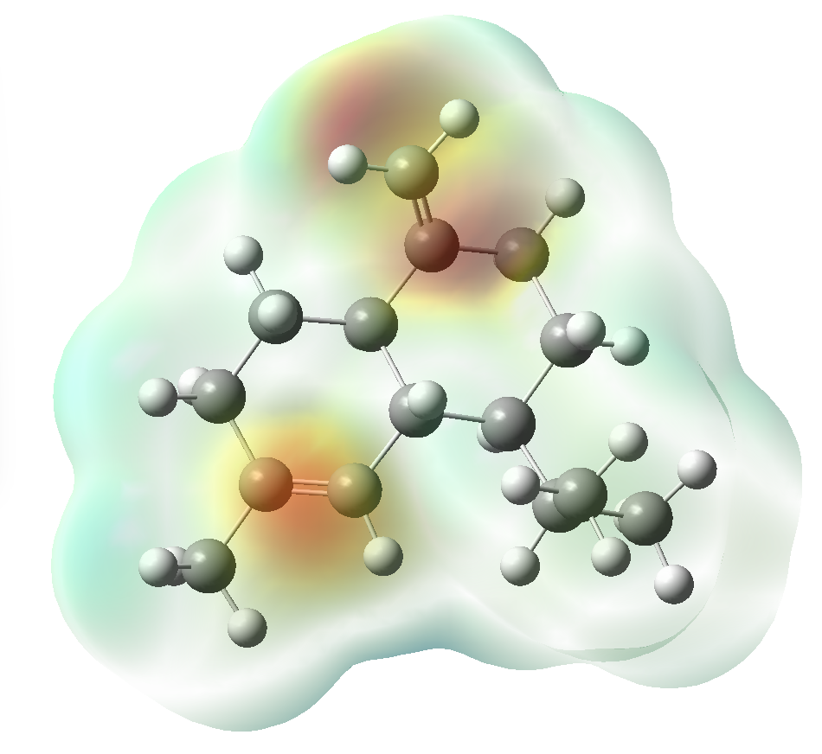
Gamma-terpinene  -2.886e⁻² 2.886e⁻² | Isoborneol  -6.887e⁻² 6.887e⁻² | Humulene  -2.915e⁻⁻² 2.915e⁻² | O-cymene  -3.889e⁻² 3.889e⁻² | Terpinene-4-ol  -6.606e⁻² 6.606e⁻² | Terpinolene  -3.094e⁻⁻² 3.094e⁻⁻²
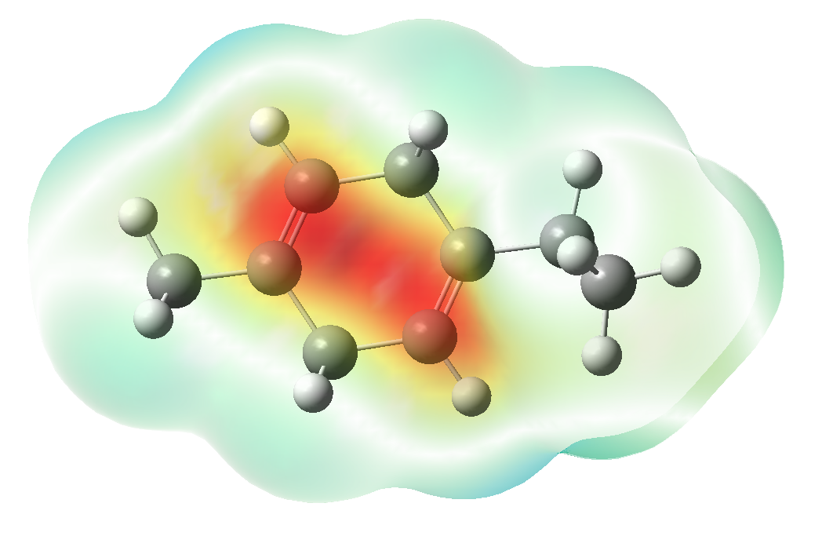 | 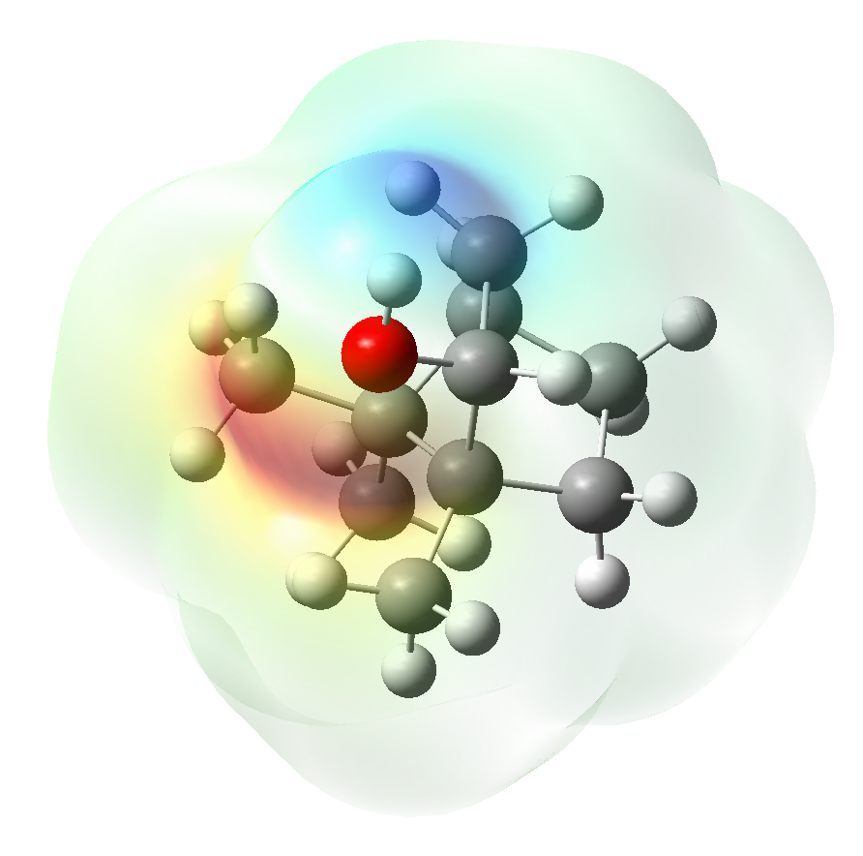 | 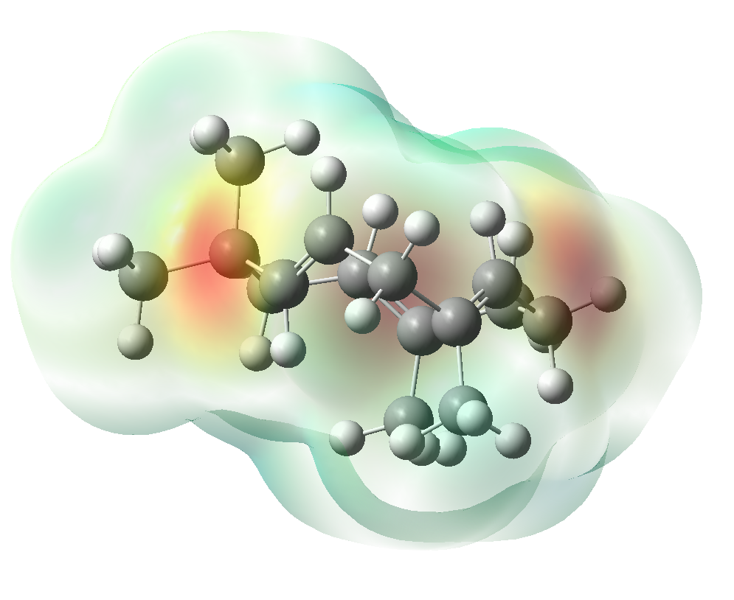 | 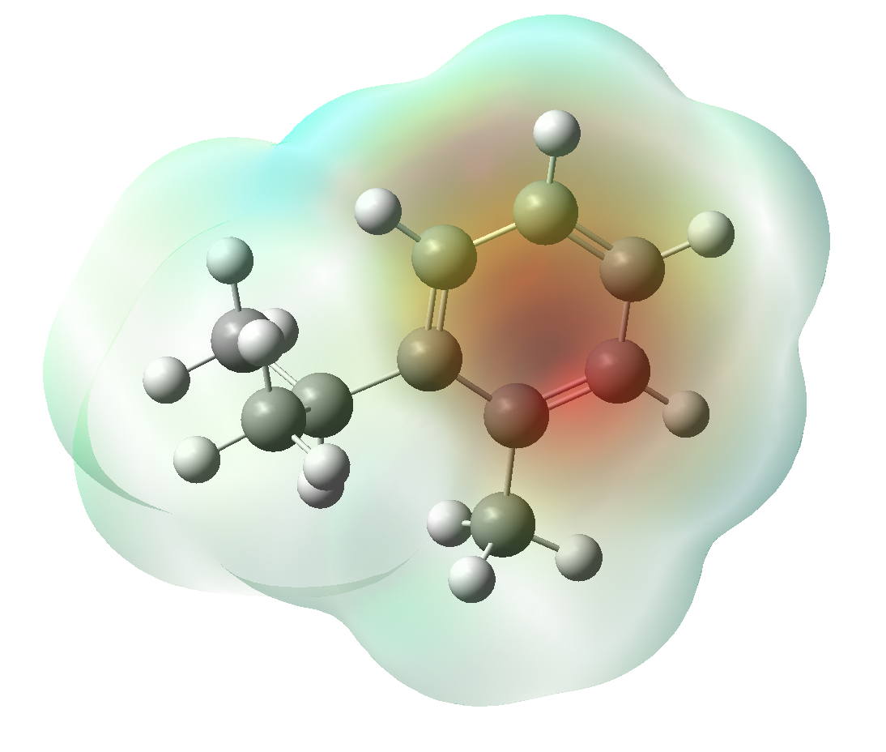 | 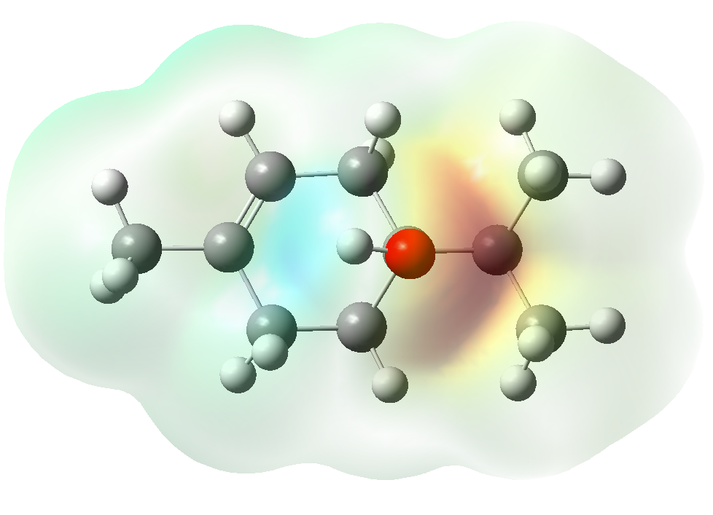 | 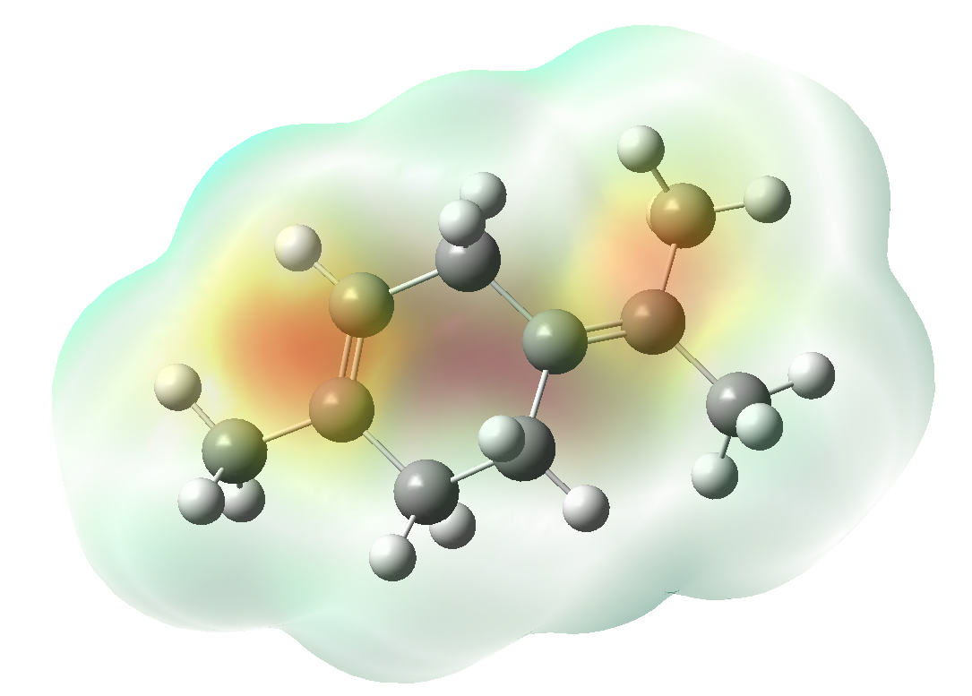
Terpineol
-6.710e⁻² 6.710e⁻²
