Supplement Figure Captions For

Klebsiella pneumoniae metabolic regulation and its application in 1,3-propanediol production

Yadong Wang¹, Jing Mu¹, Yonghong Liao¹, Yuxuan Wang¹, Xian Yin¹, Bo Xu², Fenghuan Wang^{1 *}

¹School of Light Industry, Beijing Technology and Business University, Beijing 100048, PR China
²McIntire School of Commerce, University of Virginia, Charlottesville, VA 22903, U.S.

Corresponding authors: *Fenghuan Wang, Tel.: +86-010-68985252, E-mail: wangfenghuan@th.btbu.edu.cn; Beijing Technology and Business University, No.11, Fucheng Road, Haidian District, Beijing.

Fig. S6 Verification of positive translatons. Lane M, DNA marker (bp); lane 1-7, KP-pCasKP-apr; lane 8, K. pneumoniae KP; lane 9, Plasmid pCasKP-apr.
Fig. S7 PCR amplification of upstream and downstream sequences of each target gene. Lane M, DNA marker (bp); (a) shows the PCR amplification of the upstream and downstream sequences of the ldhA gene: lane 1-3, the upstream sequences; lane4-6, the downstream sequences. (b) shows the PCR amplification of the upstream and downstream sequences of the adhE and ack: lane 1-2, the upstream sequences of adhE; lane3-4, the downstream sequences of adhE; lane5-6, the upstream sequences of ack; lane7-8, the downstream sequences of ack.
Fig. S8 dsDNA repair template. Successful overlapping dsDNA was shown at 1000bp.
Fig. S9 pSGKP-km-sgRNA plasmid identification. (a) shows the constructed pSGKP-km-sgRNA plasmid of the ldhA gene; (b) shows the constructed pSGKP-km-sgRNA plasmid of the adhE and ack gene.
Fig. S10 PCR identification of recombinant Klebsiella pneumoniae with target gene deletion. (a) shows the PCR identification of recombinant ldhA⁽⁻⁾: Lane M, DNA marker (bp); lane 1and 5, K. pneumoniae KP; lane2-4, ldhA⁽⁻⁾. (b) shows the PCR identification of recombinant ldhA⁽⁻⁾-adhE⁽⁻⁾ and ldhA⁽⁻⁾-ack⁽⁻⁾: Lane M, DNA marker (bp); Other details are marked in the picture.
Fig. S11 Recombinant Klebsiella pneumoniae with Tris-gene deletion. The PCR identification of recombinant ldhA⁽⁻⁾-adhE⁽⁻⁾-ack⁽⁻⁾.
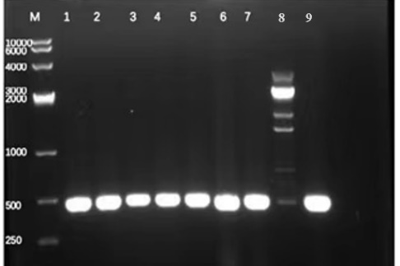
Fig. S6 Verification of positive transformants
Lane M, DNA marker (bp); lane 1-7, KP-pCasKP-apr colonies; lane 8, K. pneumoniae KP; lane 9, Plasmid pCasKP-apr.
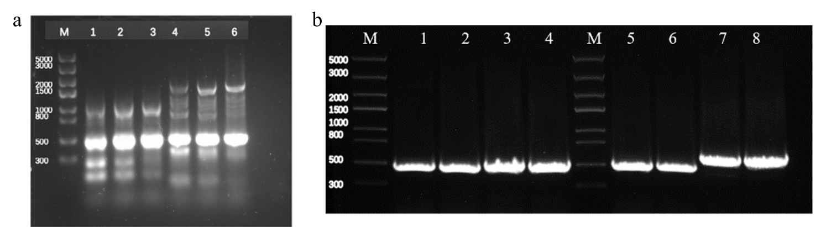
Fig. S7 PCR amplification of upstream and downstream sequences of each target gene Lane M, DNA marker (bp); (a) shows the PCR amplification of the upstream and downstream sequences of the ldhA gene: lane 1-3, the upstream sequences; lane4-6, the downstream sequences.(b) shows the PCR amplification of the upstream and downstream sequences of the adhE and ack: lane 1-2, the upstream sequences of adhE; lane3-4, the downstream sequences of adhE; lane5-6, the upstream sequences of ack; lane7-8, the downstream sequences of ack.
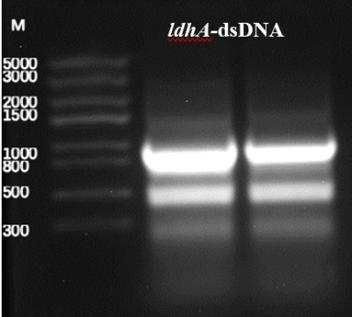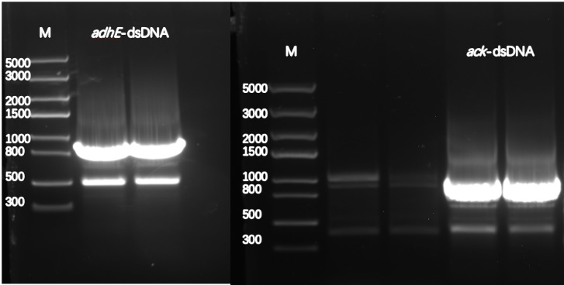
Fig. S8 DsDNA repair template
Successful overlapping dsDNA was shown at 1000bp.
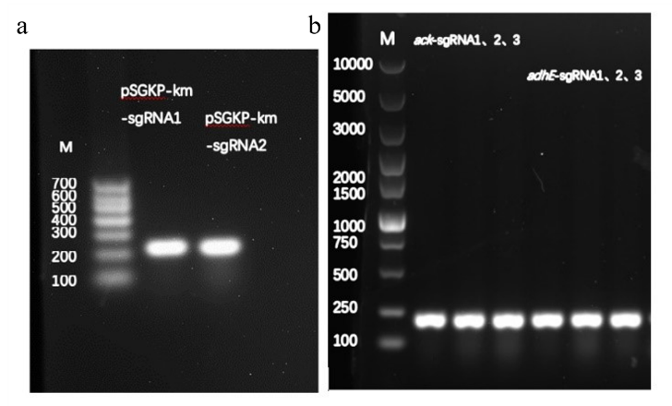
Fig. S9 pSGKP-km-sgRNA plasmid identification
(A) shows the constructed pSGKP-km-sgRNA plasmid of the ldhA gene; (B) shows the constructed pSGKP-km-sgRNA plasmid of the adhE and ack gene.
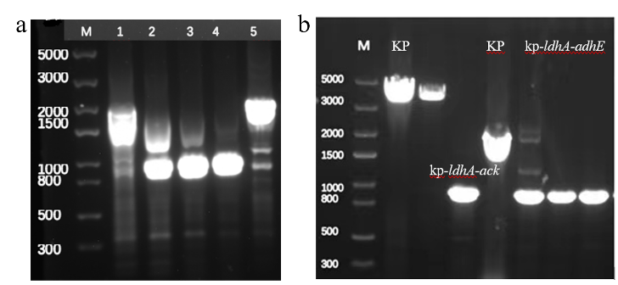
Fig. S10 PCR identification of recombinant Klebsiella pneumoniae with target gene deletion
(A) shows the PCR identification of recombinant ldhA⁽⁻⁾: Lane M, DNA marker (bp); lane 1 and 5, K. pneumoniae KP; lane 4, ldhA⁽⁻⁾. (B) shows the PCR identification of recombinant ldhA⁽⁻⁾-adhE⁽⁻⁾ and ldhA⁽⁻⁾-ack⁽⁻⁾: Lane M, DNA marker (bp); Other details are marked in the picture.

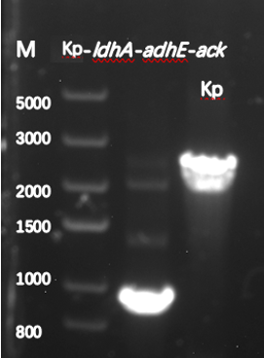
Fig. S11 Recombinant Klebsiella pneumoniae with Triple-gene deletion
The PCR identification of recombinant ldhA⁽⁻⁾-adhE⁽⁻⁾-ack^{(-).}

