Table 1 Vignette composition
Attribute |  | Level | Text element | Visual design
① | Minister | (1) Female, German name | Monika Gerber | 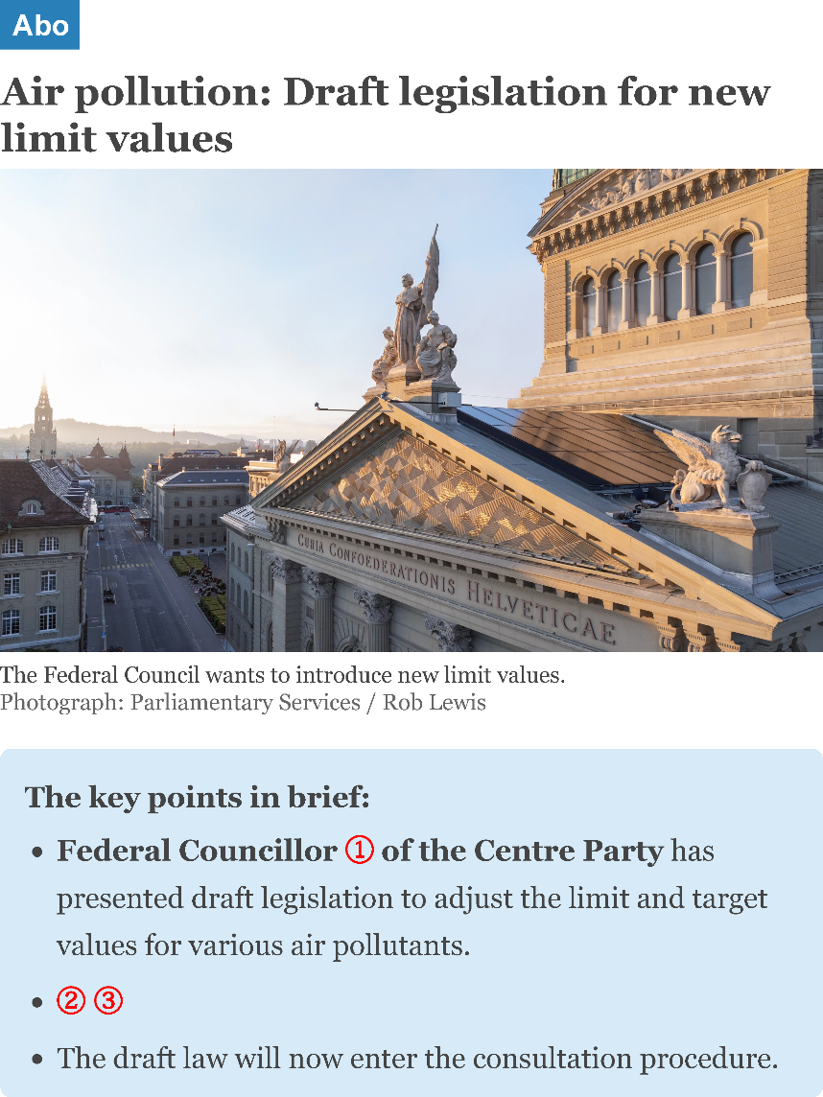
① | Minister | (2) Male, German name | Daniel Gerber
① | Minister | (3) Female, French name | Nathalie Rochat
① | Minister | (4) Male, French name | Michel Rochat
② | Disclosure | (1) Politician-controlled transparency | [He|She] explained at the press conference that the draft legislation was developed in close collaboration between the Federal Office for the Environment (FOEN) and
② | Disclosure | (2) Legally compelled disclosure | Based on the Freedom of Information Act, our newspaper was given access to numerous internal documents from the Federal Administration. They show that the draft legislation was developed in close collaboration between the Federal Office for the Environment (FOEN) and
② | Disclosure | (3) Leak | Due to a data leak in the Federal Administration, our newspaper had access to numerous internal documents. They show that the draft legislation was developed in close collaboration between the Federal Office for the Environment (FOEN) and
③ | Non-state actors | (1) Scientists | scientists from various universities.
③ | Non-state actors | (2) Environmental interest groups | representatives from various environmental associations.
③ | Non-state actors | (3) Industrial interest groups | representatives from various industrial associations.
Notes: Text elements are translated from the original German and French. The photograph in the vignette is of the Federal Palace in Bern, Switzerland.

