DATA FUSION MODELS FOR ASSESSING ADULTERATION IN BUTTER THROUGH ITS VIBRATIONAL SPECTROSCOPIC FINGERPRINT
Supplementary Information

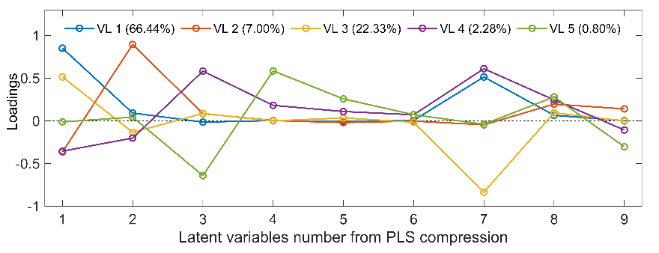
Figure 1SI. Loadings used in the model shown in Figure 5, after PLS compression procedure.
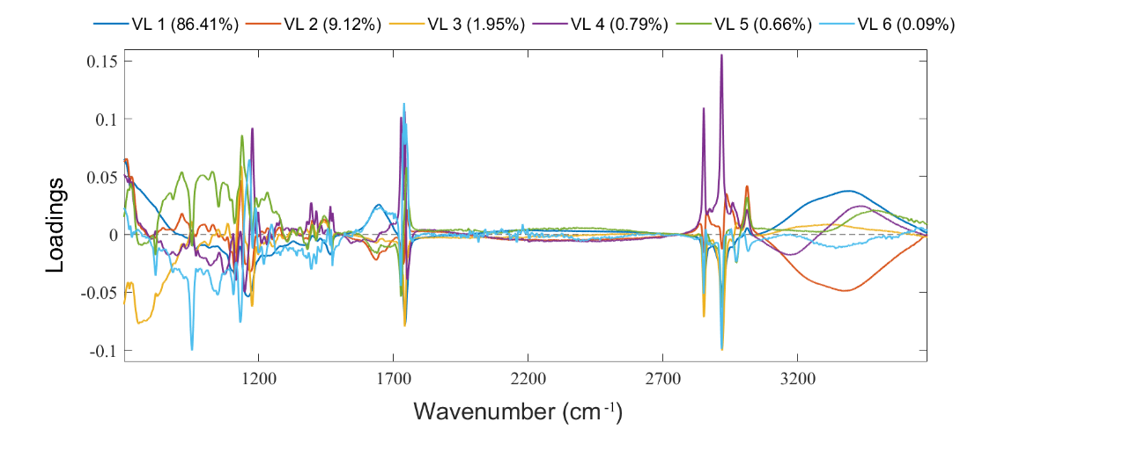
Figure 2SI. Loadings from the FT-IR dataset used in the final model shown in Figure 5, main text.
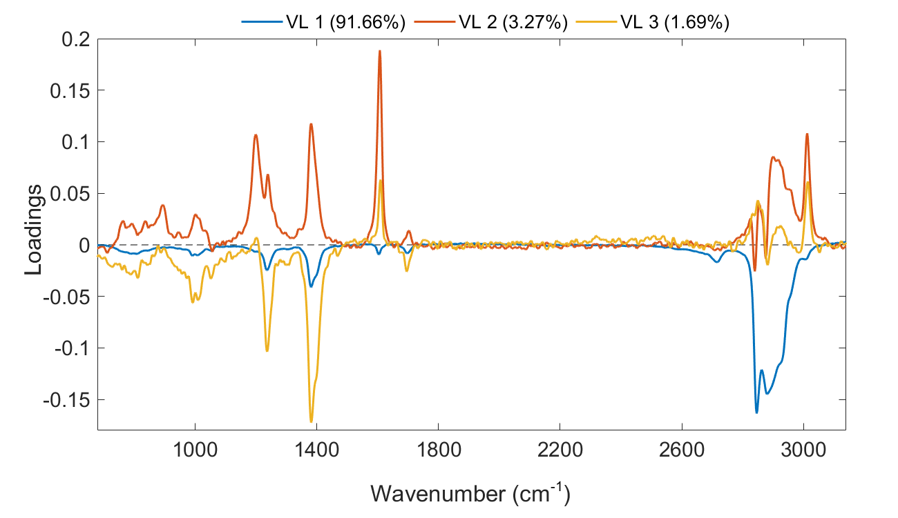
Figure 3SI. Loadings from the FT-Raman dataset used in the final model shown in Figure 5, main text.

