SUPPLEMENTAL FIGURES AND LEGENDS
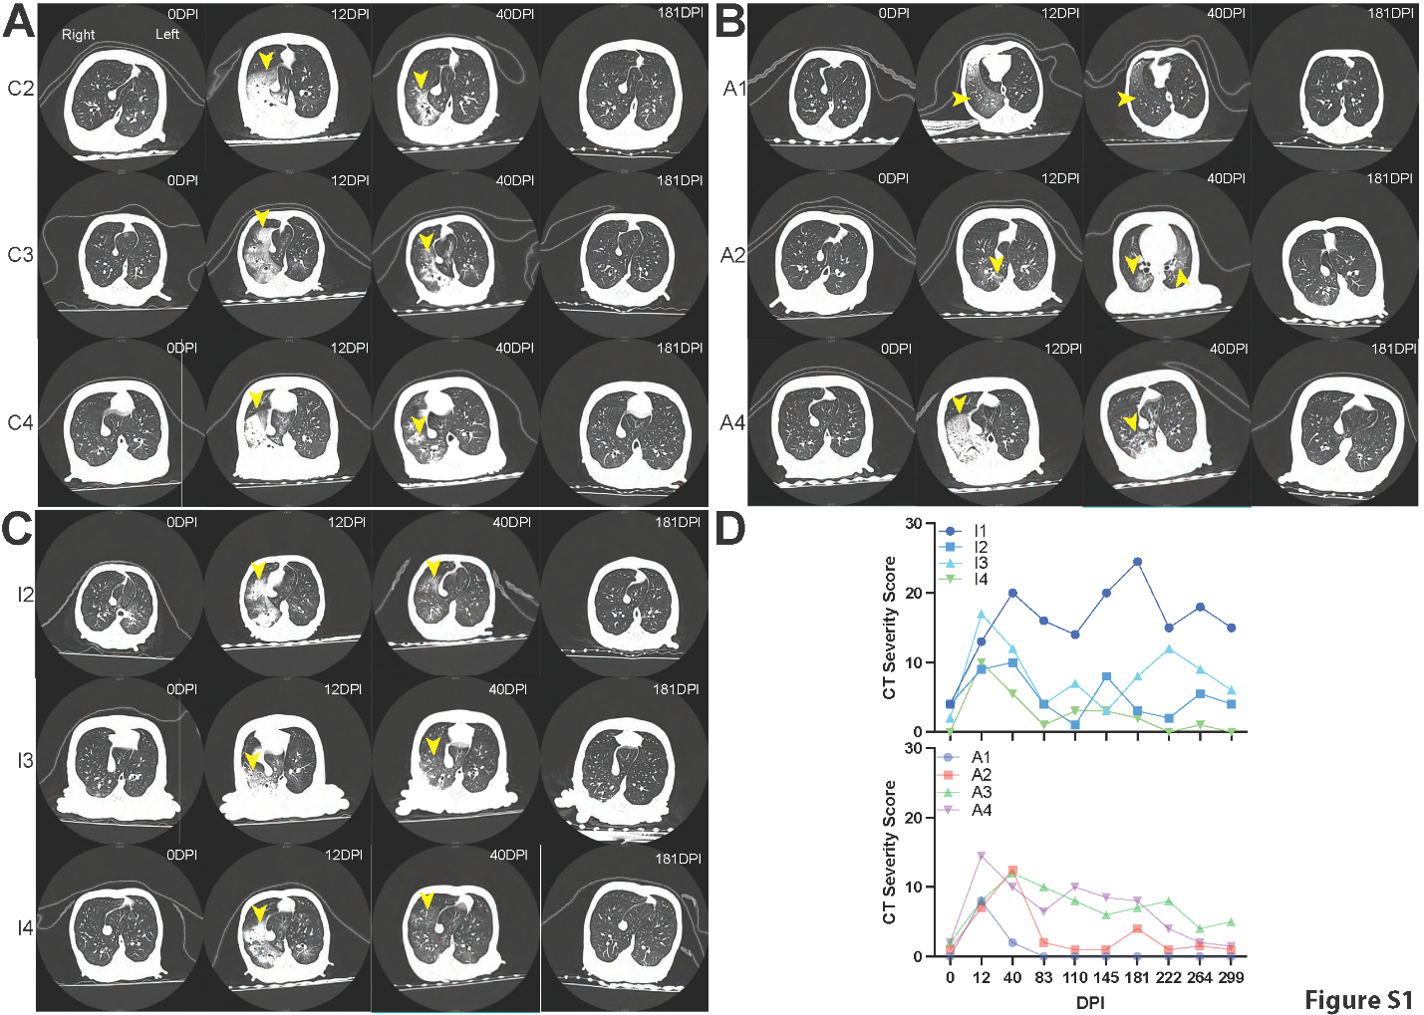
Figure S1: Representative computed tomography scans.
CT scans of the (A) control (C2, C3, and C4), (B) antibiotic (A1, A2, and A4), and (C) Inflectra (I2, I3, and I4) groups at 0, 13, 40, and 180 DPI. The yellow arrowheads note inflammation. (D) Individual CT severity scores of I1, I2, I3, and I4 (top) and A1, A2, A3, and A4 (bottom).
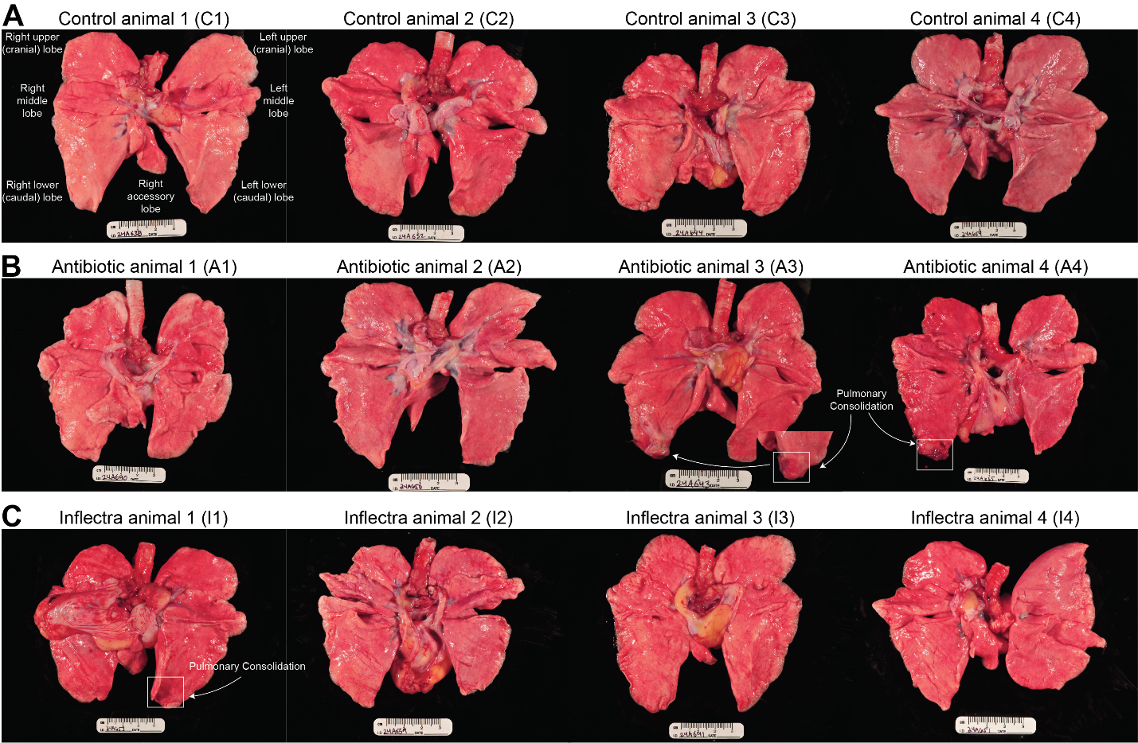
Figure S2: Gross pathology.
Gross pathology of lungs from (A) C1-C4, (B) A1-A4, and (C) I1-I4. White boxes indicate areas of pulmonary consolidation.

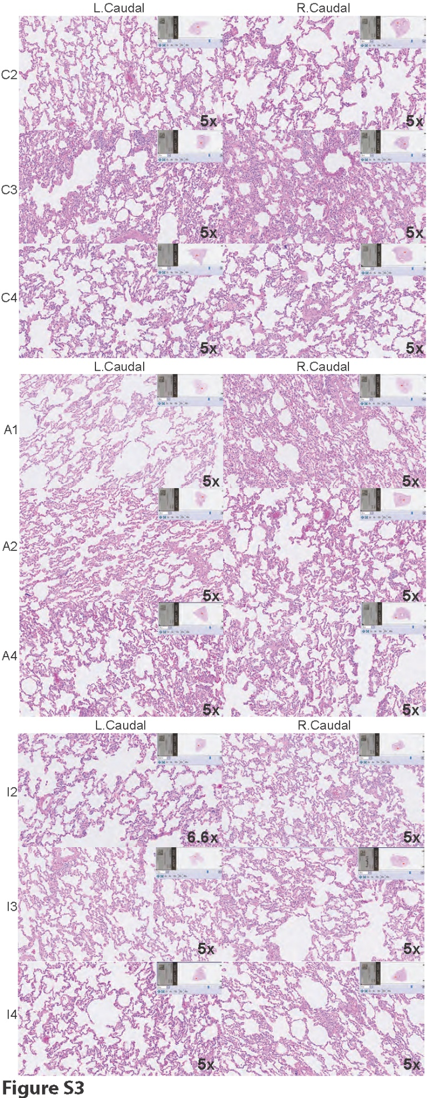
Figure S3: supplemental H&E stains.
Representative H&E stains at the indicated magnification that were acquired for the left caudal and right caudal lobes of animals C2-C4, A1, A2, A4, I2-I4.
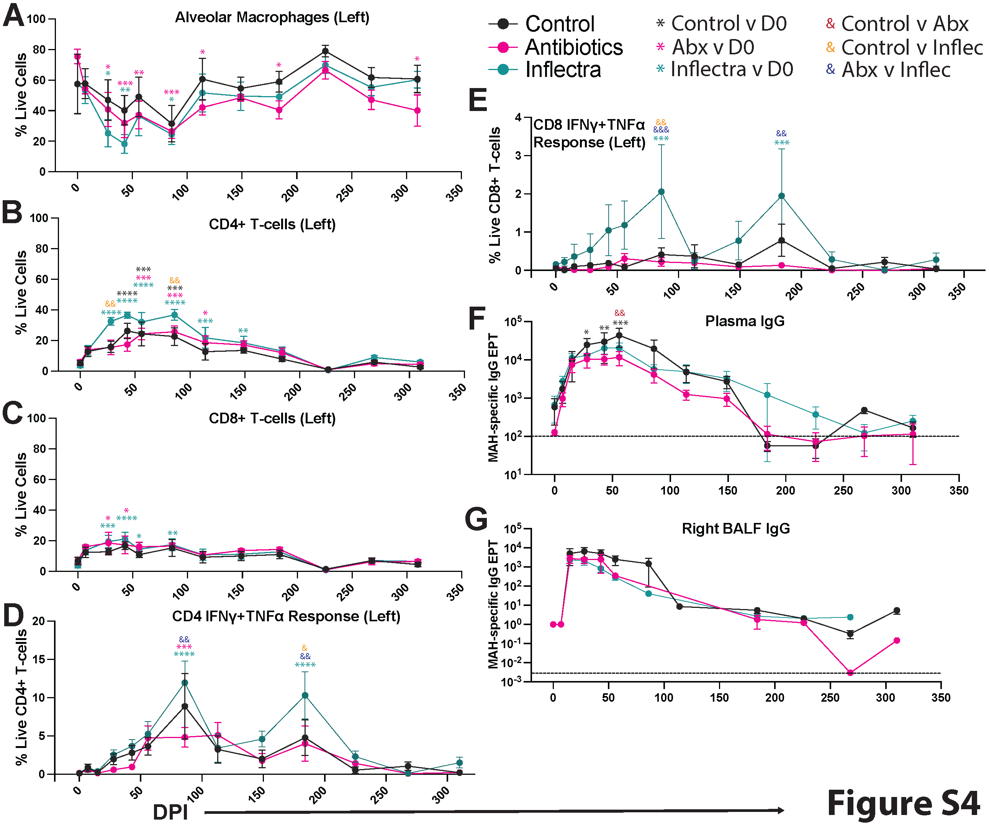
Figure S4: Immune cell influx in left lung.
BALF samples were collected from the left lungs at the indicated DPI and flow cytometry data were acquired. The relative frequency within live cells of (A) alveolar macrophages; (B) CD4+ T-cells, (C) CD8+ T cells, (D) MAH-specific IFNγ+ TNF+ CD4 T-cells, and (E) MAH-specific IFNγ+ TNF+ CD8 T-cells. The MAH-specific CD4 and CD8 T-cell response was determined by intracellular cytokine staining following stimulation with 1 mg/mL MAH lysate. The MAH-specific IgG end-point titer averages in the (F) plasma and (G) right BALF. The dashed lines represent the limit of detection. In all panels, the average and standard error of the mean for all animals in the group is shown. A 2-way ANOVA analysis was performed to compare timepoints within the experimental groups to their respective 0 DPI baseline (black, pink, or teal stars), or to compare between groups at each timepoint (red, orange, and blue ampersands). *p < 0.05, **p < 0.01, ***p < 0.001, ****p < 0.0001.
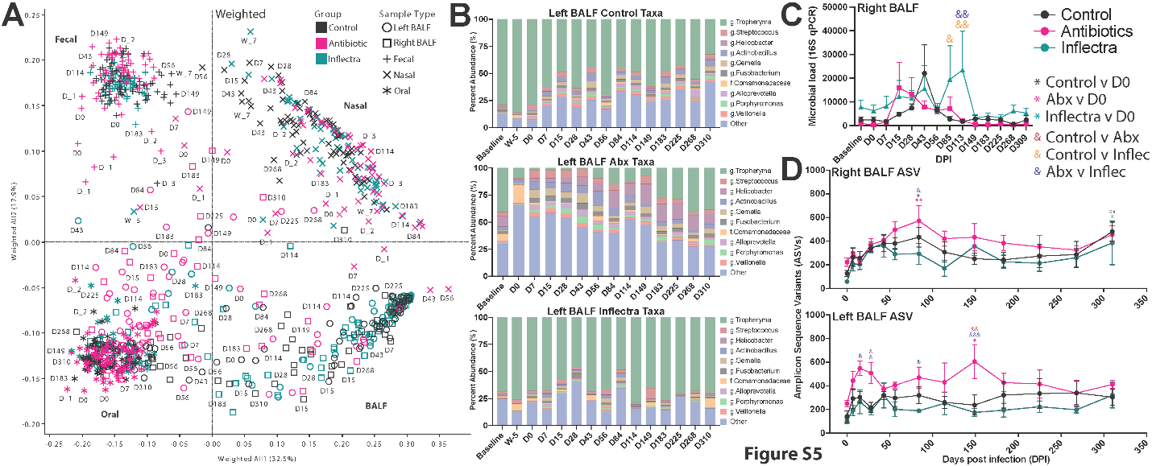
Figure S5: Microbiome profiling of the BALF.
(A) The weighted principal coordinate analysis (PCoA) plot of the left and right BALF, fecal, nasal, and oral swabs at the indicated DPI. (B) Bar plots of the dominant phyla in the left BALF of each experimental group. (C) Total bacterial load was measured in the right BALF via quantitative real-time PCR specific for the 16S rRNA gene sequence. (D) Amplicon sequence variants (ASVs) in the right and left BALF. Two-way ANOVA statistical tests were performed to evaluate within group changes compared to 0 DPI (denoted by asterisks) and between group changes at each timepoint (denoted by ampersands). *p < 0.05, **p < 0.01, ***p < 0.001, ****p < 0.0001.
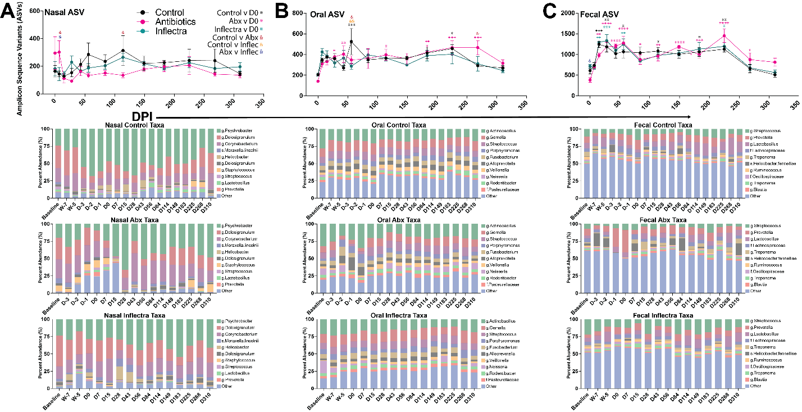
Figure S6: Microbiome profiling of the nasal, oral, and fecal swabs.
Amplicon sequence variants (ASVs) and dominant phyla in the (A) nasal, (B) oral, (C) and fecal swabs.
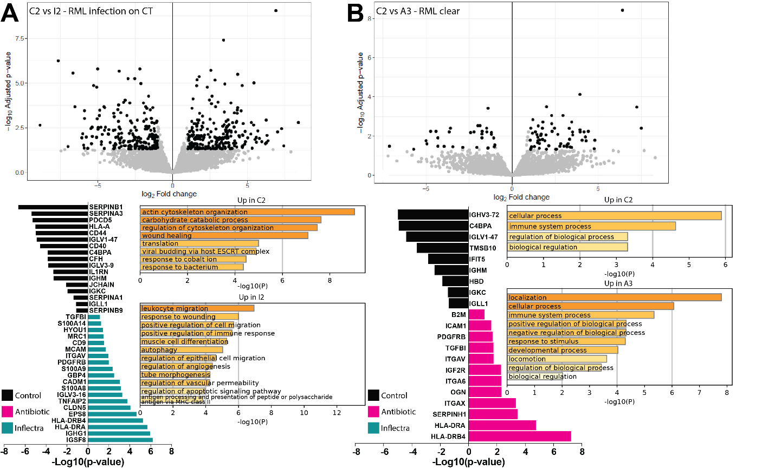
Figure S7: Additional lung proteomic comparisons.
Differentially abundant proteins and Gene Ontology (GO) enrichment bar plots in the left lower lung tissue of (A) animal C2 compared to the right middle lobe that was near an infection site of animal I1 and (C) animal C2 compared to the right middle lobe that was clear in A3.

