Supplementary Materials 2
PB1
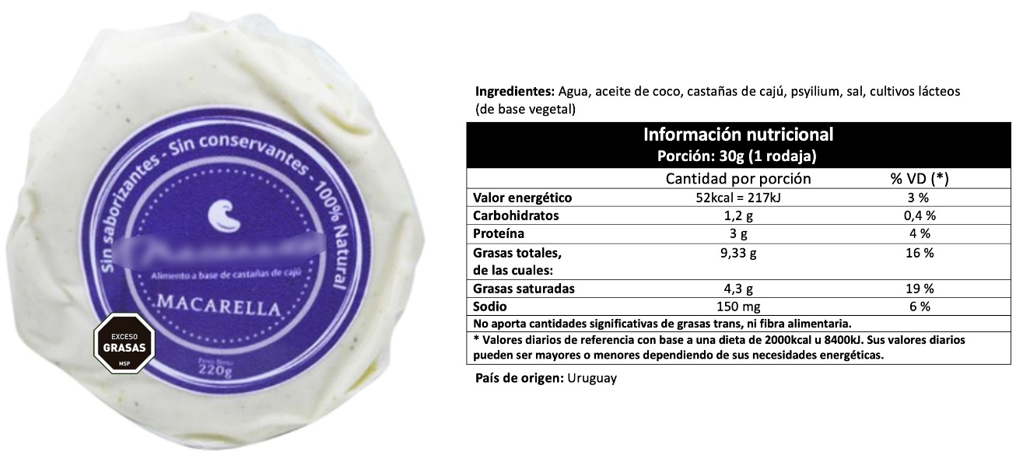

PB2

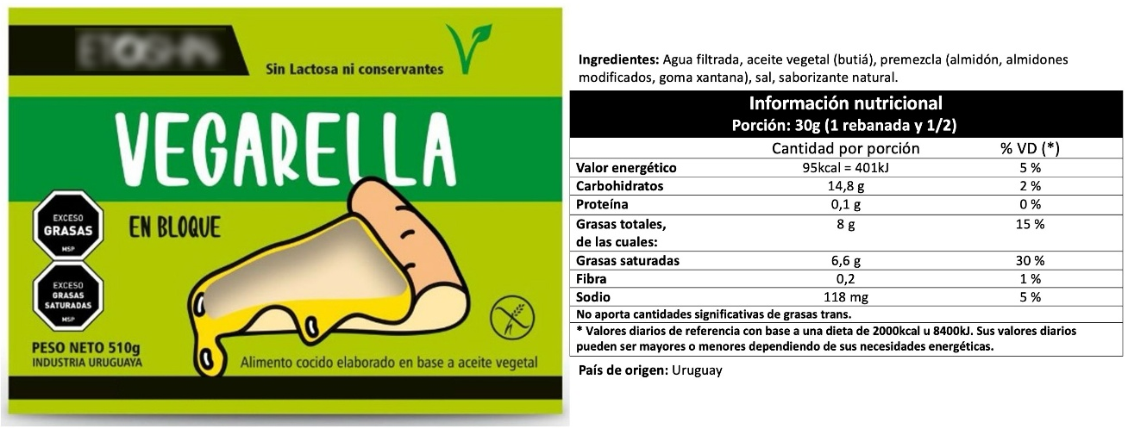

PB3
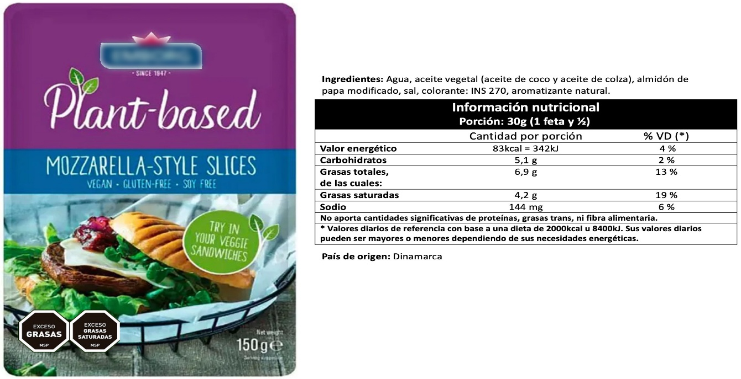

DB
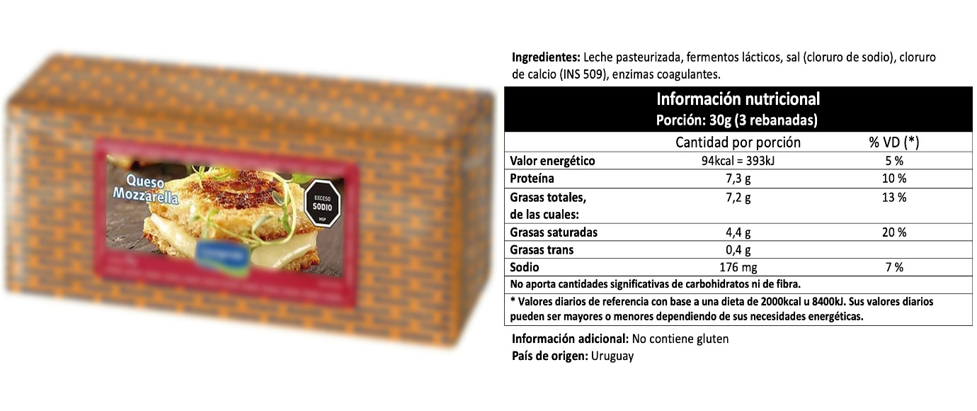

Fig. S1 Samples and information provided to the consumers in Informed and Expected Conditions.

Table S1. Proportion of citation frequency of CATA terms in blind condition
Blind condition
 | PB1 | PB2 | PB3 | DB
Oily | 7.3^{b} | 6.0^{ab} | 3.9ª | 2.8ª
Artificial flavour | 6.0^{ab} | 13.3^{c} | 10.6^{bc} | 2.6ª
Bland/mild flavour | 9.3^{c} | 7.0^{ab} | 9.2^{bc} | 3.1ª
Shiny | 0.3ª | 1.7ª | 3.5ª | 6.8^{b}
Strong aftertaste | 8.5^{b} | 8.6^{b} | 1.8ª | 2.3ª
Creamy | 10.9^{b} | 4.7ª | 1.8ª | 11.4^{b}
Smooth mouthfeel | 5.2ª | 6.3ª | 7.4ª | 18.5^{b}
Firm | 1.6ª | 8.6^{b} | 12.4^{c} | 8.5^{b}
Chewy | 2.6ª | 5.3^{ab} | 7.4^{ab} | 8.2^{b}
Bitter | 2.6^{ns} | 3.7^{ns} | 2.5^{ns} | 1.4^{ns}
Elastic | 2.6^{ab} | 2.0ª | 4.2^{ab} | 5.7^{b}
Salty | 3.9^{ab} | 3.3ª | 4.9^{ab} | 7.7^{b}
Tasteless | 3.4ª | 7.0^{ab} | 13.4^{b} | 2.6ª
Acidic | 5.4^{b} | 1.3ª | 0.4ª | 1.1ª
Cereal flavour | 0.5^{ns} | 1.7^{ns} | 2.1^{ns} | 0.3^{ns}
Rubbery | 7.0^{b} | 1.3ª | 4.6ª | 3.1ª
Gritty | 4.4^{b} | 2.3^{ab} | 1.8ª | 2.6^{ab}
Soft | 14.8^{d} | 6.6^{b} | 2.5ª | 9.7^{c}
Nutty flavour | 0.8^{ns} | 2.0^{ns} | 2.8^{ns} | 0.9^{ns}
Vegetable flavour | 3.1^{ab} | 7.3^{b} | 2.8ª | 0.9ª

Values are citation frequencies (%). Cochran’s Q test was used for inference testing. a,b,c Within the same condition, attributes with different letters in a row, are significantly different (p ≤ 0.05 -Cochran’s Q test)..

Table S2. Summary of participant characteristics (%) based on the cluster and aggregate level
 | Cluster 1 (%) | Cluster 2 (%) | Aggregate (%)
 | (n=176) | (n=60) | (n=236)
Gender
Male | 27 | 28 | 28
Female | 73 | 72 | 72
Age
18-34 | 55 | 38 | 47
35-44 | 11 | 12 | 12
45-54 | 16 | 13 | 15
>54 | 18 | 37 | 27
Family size
1 | 40 | 23 | 32
2-3 | 40 | 50 | 45
4-5 | 9 | 13 | 11
>5 | 11 | 13 | 12
Household income (UYU)
Under $45.000 | 15 | 18 | 17
Between $45000 y $90000 | 41 | 37 | 39
Between $90000 y $160000 | 22 | 32 | 27
More than $160000 | 22 | 13 | 17
Education
Incomplete secondary school | 5 | 3 | 4
Completed secondary school | 11 | 3 | 7
Incomplete university | 49 | 47 | 48
Completed university | 26 | 33 | 30
Postgraduate | 9 | 13 | 11
Residence place
Another place | 55 | 48 | 52
Montevideo | 45 | 52 | 48
*Consumption frequency
Daily | 10 | 13 | 12
Once a week | 49 | 52 | 51
Once a month | 33 | 33 | 33
More than once a week | 5 | 2 | 3
Never | 2 | 0 | 1
Diet
Omnivore | 62 | 60 | 61
low carb | 3 | 10 | 6
other | 28 | 22 | 25
Flexitarian | 2 | 3 | 3
Vegetarian | 4 | 2 | 3
Keto | 1 | 2 | 1
Food restrictions
Celiac | 2 | 0 | 1
Diabetic | 4 | 2 | 3
Lactose intolerant | 5 | 0 | 2
Other | 13 | 12 | 12
No restrictions | 76 | 87 | 81

*Consumption frequency of dairy based mozzarella cheese is shown in the table.

Table S3. Contingency table from the CATA data of the product expectation survey
 | Cluster 1 (Adopters) |  |  |  |  | Cluster 2 (Non adopters)
CATA | PB1 | PB2 | PB3 | DB | p value | PB1 | PB2 | PB3 | DB | p value
Tempting | 49 | 18 | 59 | 89 | <0.0001 | 20 | 3 | 2 | 13 | <0.0001
Unattractive | 12 | 96 | 34 | 13 | <0.0001 | 11 | 36 | 39 | 20 | <0.0001
Neat | 70 | 43 | 86 | 94 | <0.0001 | 26 | 9 | 5 | 20 | <0.0001
Artificial image | 6 | 79 | 56 | 25 | <0.0001 | 9 | 9 | 33 | 25 | <0.0001
Boring | 33 | 15 | 11 | 13 | 0.000 | 6 | 16 | 13 | 7 | 0.038
Good quality | 80 | 18 | 39 | 107 | <0.0001 | 18 | 3 | 2 | 6 | <0.0001
Healthy | 62 | 32 | 48 | 18 | <0.0001 | 7 | 9 | 4 | 1 | 0.058
Expensive | 50 | 45 | 71 | 20 | <0.0001 | 5 | 9 | 11 | 18 | 0.007
High in protein | 20 | 6 | 10 | 22 | 0.003 | 7 | 0 | 2 | 3 | 0.005
Cheap | 7 | 3 | 0 | 8 | 0.024 | 3 | 4 | 3 | 1 | 0.580
Processed | 19 | 63 | 58 | 59 | <0.0001 | 26 | 18 | 30 | 25 | 0.060
Imitation | 11 | 30 | 18 | 1 | <0.0001 | 0 | 3 | 9 | 7 | 0.005
Natural | 12 | 5 | 4 | 4 | 0.015 | 2 | 4 | 0 | 0 | 0.062
Vegan | 36 | 83 | 65 | 1 | <0.0001 | 0 | 10 | 24 | 19 | <0.0001
Excess fat | 51 | 47 | 48 | 39 | 0.319 | 19 | 19 | 25 | 23 | 0.374
Artisanal | 62 | 12 | 3 | 2 | <0.0001 | 1 | 9 | 1 | 0 | 0.000
Pleasant packaging | 38 | 18 | 53 | 41 | <0.0001 | 10 | 8 | 3 | 11 | 0.127
National | 80 | 37 | 4 | 114 | <0.0001 | 26 | 7 | 3 | 0 | <0.0001
I believe it is not nutritious | 24 | 26 | 9 | 68 | <0.0001 | 11 | 1 | 1 | 1 | <0.0001
I would never consume a product like this | 18 | 16 | 15 | 24 | 0.362 | 4 | 2 | 2 | 0 | 0.261
It is good for the environment | 0 | 7 | 28 | 13 | <0.0001 | 3 | 10 | 14 | 13 | 0.005
I could adopt this product for my regular consumption | 11 | 15 | 39 | 25 | <0.0001 | 11 | 14 | 24 | 18 | 0.008

Cochran’s Q test was used for inference testing. p value < 0.05 indicate statistically significant.

