Supplementary Information for:
The role of genetic observatory networks in the detection and forecasting of marine non-indigenous species

Justine Pagnier^{1,2*}, Tobias Andermann^{3,4}, Mats Gunnar Andersson⁵, Matthias Obst^{1,2}

*Corresponding author: Justine Pagnier, justine.pagnier@gu.se

¹Department of Marine Sciences, SciLifeLab, University of Gothenburg, Box 461, 405 30, Gothenburg, Sweden
²Gothenburg Global Biodiversity Centre (GGBC), University of Gothenburg, Box 463, 405 30, Gothenburg, Sweden
³Program in Systematic Biology, Department of Organismal Biology, Uppsala University, Norbyvägen 18D, 752 36 Uppsala, Sweden
⁴Science for Life Laboratory, Uppsala University, Uppsala, Sweden
⁵Swedish Veterinary Agency (SVA), 75189 Uppsala, Sweden

Content of this file:
- Supplementary Table 1: Spatial distribution of projected changes in mean habitat suitability across the European continental shelf under three climate scenarios.
- Supplementary Table 2: Predictor layers downloaded from Bio-Oracle.
- Supplementary Figure 1: Final predictor layers used for training the models.
- Supplementary Figure 2: Algorithm performance varies across species for AUC validation scores.
- Supplementary Figure 3: Algorithm performance varies across species for TSS validation scores.
Supplementary Files (not in this file):
- Supplementary File 1: Species list and details (.xlsx), contains two sheets (the lists of NIS detected in each monitoring program, the combined list used for GBIF and OBIS query with additional details such as native range for each species and number of models in the final ensemble model)
- Supplementary File 2: External validation data and results (.xlsx), contains three sheets (the raw unpublished data used for validation, the validation results per species and combined).
- Supplementary File 3: Future changes per ecoregions (.csv), contains suitability values for each scenario and each ecoregion (mean, median, standard deviation), the absolute and relative change values (current vs. future)
- Supplementary File 4: Tracking of occurrences/PA number pre modelling (.csv), with DOIs of the raw GBIF datasets
- Supplementary File 5: Marine Ecoregions per species (.csv), used to account for each species only in non-native regions.

SUPPLEMENTARY TABLES

Supplementary Table 1. Spatial distribution of projected changes in mean habitat suitability across the European continental shelf under three climate scenarios. Number of pixels and percentage of total study area experiencing different magnitudes of change in mean habitat suitability (averaged across 69 marine non-indigenous species) between current conditions and 2100 projections under three emission scenarios: SSP1-2.6 (low emissions), SSP2-4.5 (intermediate emissions), and SSP5-8.5 (high emissions). Changes are classified into seven categories based on difference values (ΔS = S₂₁₀₀ - Scurrent). Total study area comprises 240,294 pixels covering the European continental shelf (0-200m depth). Higher positive values indicate areas where, on average, environmental conditions become more favorable for the modeled species pool.
 | SSP1-2.6 |  | SSP2-4.5 |  | SSP5-8.5
 | Pixels | Percentage | Pixels | Percentage | Pixels | Percentage
Moderate decrease (< -0.10) | 29 | 0.01% | 0 | 0.00% | 0 | 0.00%
Slight decrease (-0.10 to -0.05) | 1754 | 0.73% | 1021 | 0.42% | 694 | 0.29%
No change (-0.05 to 0.05) | 231821 | 96.47% | 200050 | 83.25% | 98324 | 40.92%
Slight increase (0.05 to 0.10) | 6227 | 2.59% | 34171 | 14.22% | 110455 | 45.97%
Moderate increase (0.10 to 0.15) | 463 | 0.19% | 4499 | 1.87% | 22110 | 9.20%
Substantial increase (0.15 to 0.20) | 0 | 0.00% | 550 | 0.23% | 6808 | 2.83%
Major increase (> 0.20) | 0 | 0.00% | 3 | 0.00% | 1903 | 0.79%
TOTAL | 240294 | 100.00% | 240294 | 100.00% | 240294 | 100.00%

Supplementary Table 2. Final predictor layers used for training the models.
Nineteen predictors were retained after the VIF analysis. Benthic layers were generated through spatial interpolation that incorporated both geographic location and water depth derived from bathymetric data. To account for depth variation within each cell, benthic variables were calculated at three levels: minimum, mean, and maximum depth values.
Variable name | Description | Unit | Source
so_mean_depthmean | Mean salinity at mean depth | - | BioOracle v3.0
sws_mean_depthmean | Mean current velocity at mean depth | m/s | BioOracle v3.0
dfe_mean_depthmean | Mean dissolved iron concentration at mean depth | mmol.m−3 | BioOracle v3.0
o2_min_depthmean | Mean dissolved molecular oxygen concentration at mean depth | mmol.m−3 | BioOracle v3.0
ph_mean_depthmean | Mean pH at mean depth | - | BioOracle v3.0
si_mean_depthmean | Mean silicate concentration at mean depth | mmol.m−3 | BioOracle v3.0
thetao_min_depthmean | Mean temperature at mean depth | °C | BioOracle v3.0
dfe_mean_depthsurf | Mean dissolved iron concentration at surface | mmol.m−3 | BioOracle v3.0
so_mean_depthsurf | Mean salinity at surface | - | BioOracle v3.0
siconc_mean_depthsurf | Mean sea ice cover at surface | fraction | BioOracle v3.0
siconc_max_depthsurf | Maximum sea ice coverage at surface | fraction | BioOracle v3.0
sws_mean_depthsurf | Mean current velocity at surface | m/s | BioOracle v3.0
phyc_mean_depthsurf | Mean primary productivity at surface | mmol.m−3 | BioOracle v3.0
si_mean_depthsurf | Mean silicate concentration at surface | mmol.m−3 | BioOracle v3.0
ph_mean_depthsurf | Mean pH at surface | - | BioOracle v3.0
po4_mean_depthsurf | Mean phosphate concentration at surface | mmol.m−3 | BioOracle v3.0
bathymetry_mean_terrain | Bathymetry | m | BioOracle v3.0
distance_to_land | Distance to land | km | Derived from naturalearth
chl_mean_depthsurf | Mean chlorophyll concentration at surface | mmol.m−3 | BioOracle v3.0

SUPPLEMENTARY FIGURES

Supplementary Figure 1. Algorithm performance varies across species for AUC validation scores. Each panel shows the distribution of validation ROC scores across the five modeling algorithms (GAM, MARS, MAXNET, RF, XGBOOST) for a single species. The red dashed line indicates the AUC = 0.85 threshold used for model selection in ensemble construction. The color around the plot shows the number of models passing the performance threshold: green = more than 10, yellow = 5 to 9, orange = 3 to 4, red = 1 to 2.

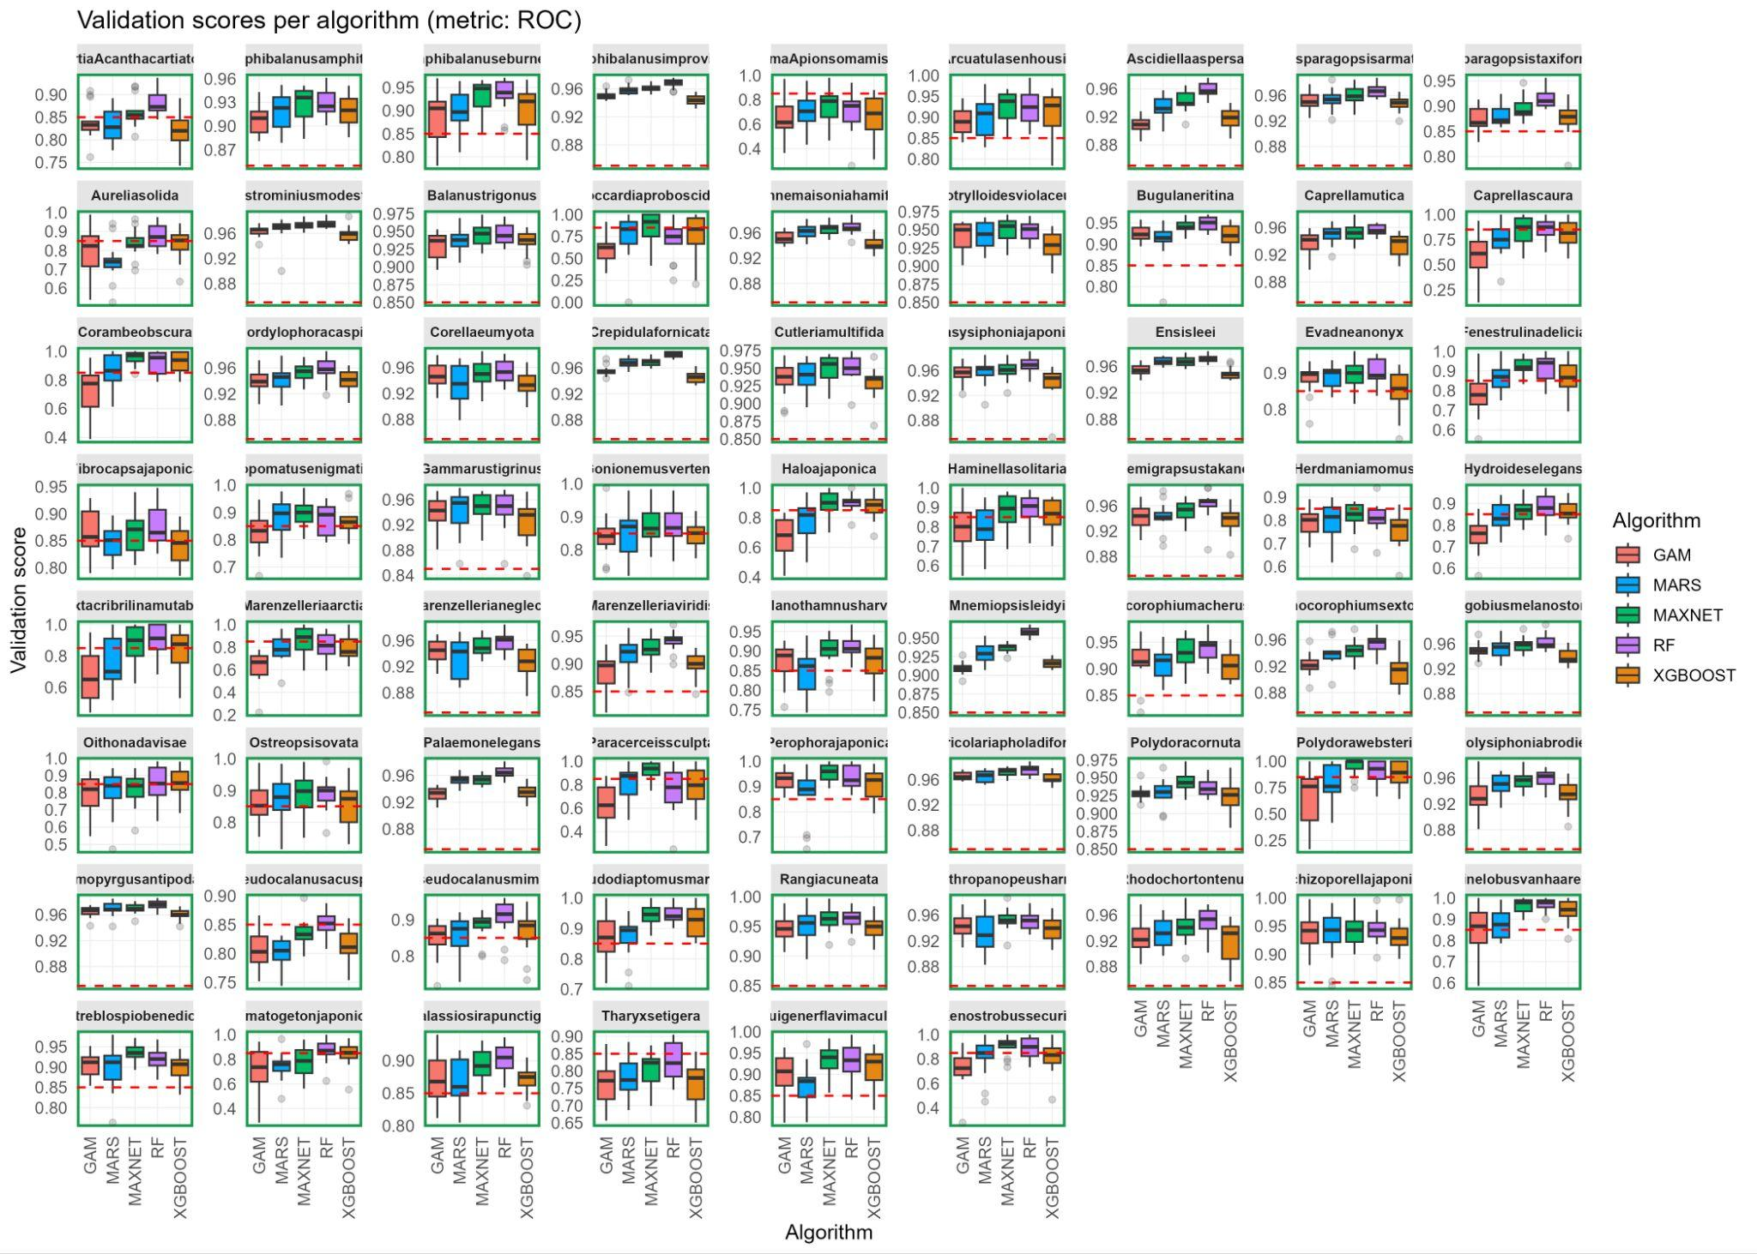

Supplementary Figure 2. Algorithm performance varies across species for TSS validation scores. Each panel shows the distribution of validation TSS scores across the five modeling algorithms (GAM, MARS, MAXNET, RF, XGBOOST) for a single species. The red dashed line indicates the TSS = 0.6 threshold used for model selection in ensemble construction. The color around the plot shows the number of models passing the performance threshold: green = more than 10, yellow = 5 to 9, orange = 3 to 4, red = 1 to 2.

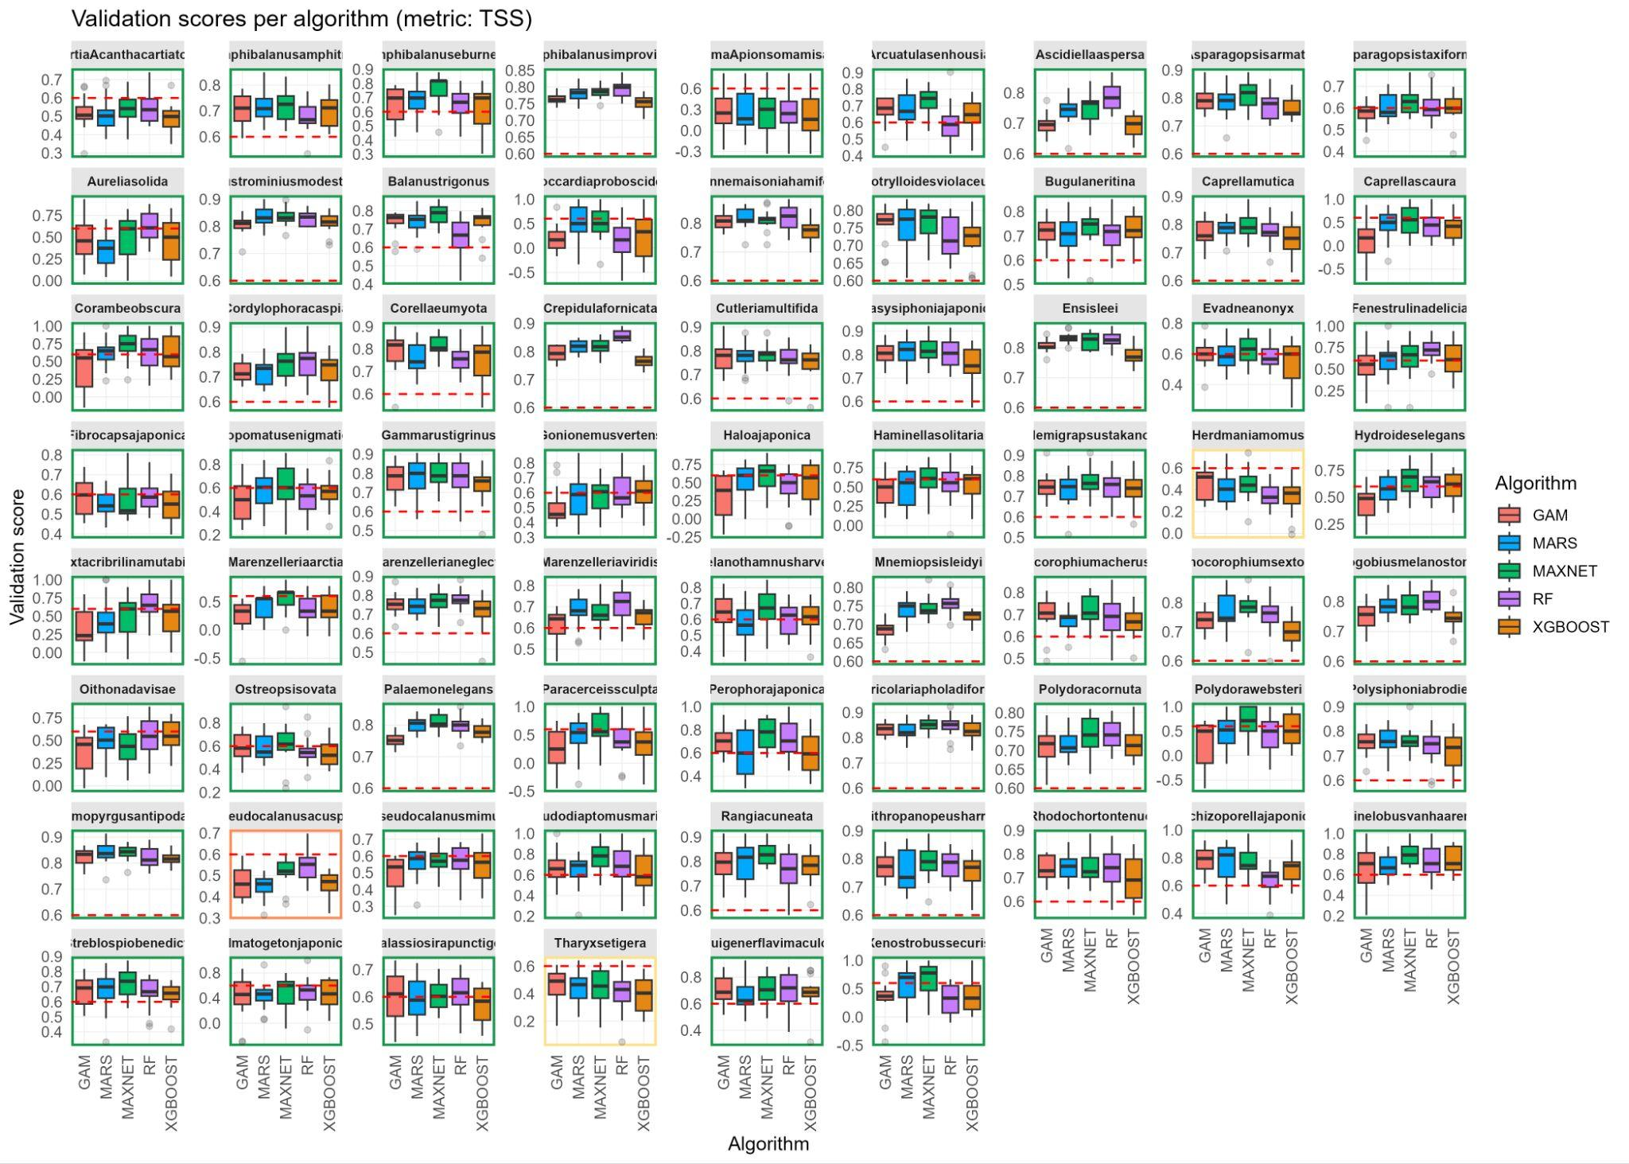

Supplementary Figure 3: Species-specific habitat suitability predictions at ARMS-MBON deployment sites across European seas. Points represent predicted suitability values (0-1 scale) at individual sampling locations, with asterisks indicating median suitability per species. Vertical dashed lines denote moderate (0.5, red) and high (0.8, brown) suitability thresholds.

