Table S1. Correlation coefficients for FLT, 2LLT and 3LT in the populations evaluated in different trials
Traits | Trials | GH19 | GH20 | FD19 | FD20 | GH21a | GH21b
FLT | GH19 | 1.00
 | GH20 | 0.91** | 1.00
 | FD19 | 0.92** | 0.91** | 1.00
 | FD20 | 0.90** | 0.99** | 0.85** | 1.00
2LLT | GH19 | 1.00
 | GH20 | 0.19** | 1.00
 | FD19 | 0.93** | 0.53** | 1.00
 | FD20 | 0.21** | 0.79** | 0.23** | 1.00
3LT | GH21a | - | - | - | - | 1.00
 | GH21b | - | - | - | - | 0.51** | 1.00
FLT flag leaf thickness, 2LLT the second last leaf thickness, 3LT 3rd leaf thickness, GH glasshouse trial, FD field trial
Note: ‘**’ refers to significant correlations at P < 0.01

Table S2. Major QTL for 3rd leaf thickness identified in the population of Morex/AWCS276
Traits | Trials | Chromosomes | Interval | LeftMarker | RightMarker | LOD | PVE (%)
3LT | GH21a | 3H | 49.2-66.9 | GBS_MST1659 | GBS_MST2112 | 3.1 | 7.5
 |  | 6H | 31.6-80.9 | GBS_MST4489 | GBS_MST3979 | 3.9 | 9.7
 | GH21b | 2H | 75.5-97.1 | GBS_MST832 | GBS_MST1324 | 4.1 | 7.3
 | BLUP | 2H | 75.5-97.1 | GBS_MST832 | GBS_MST1324 | 3.3 | 7.1
 |  | 3H | 49.2-66.9 | GBS_MST1659 | GBS_MST2112 | 3.6 | 8.5
 |  | 6H | 31.6-80.9 | GBS_MST4489 | GBS_MST3979 | 4.0 | 9.6

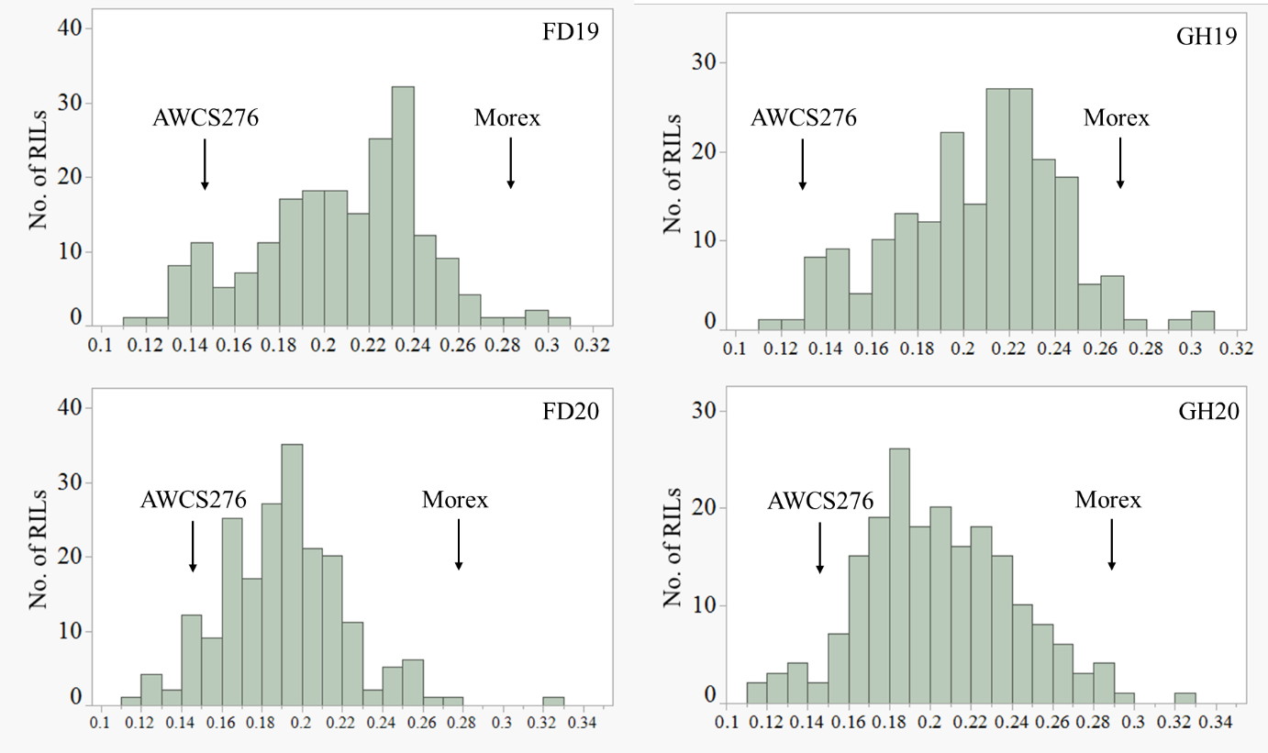
Figure S1. Frequency distributions for second last leaf thickness (2LLT) after anthesis obtained from the population of Morex/AWCS276 in different trials.
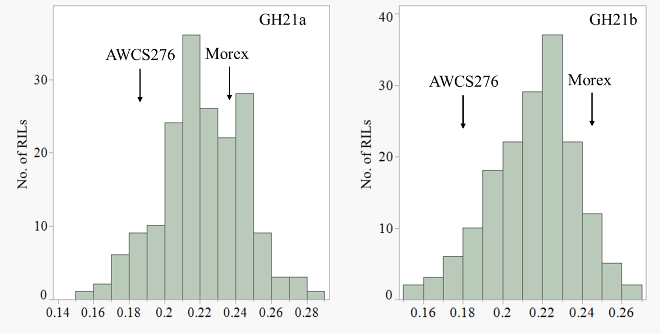
Figure S2. Frequency distributions for 3rd leaf thickness at the seedling stage obtained from the population of Morex/AWCS276 in different trials.

