Figure S1 shows the spatial distribution of p-values derived from the Mann-Kendall test applied to trends in the main hydroclimatic variables over the analysis period. Stations with statistically significant trends (p < 0.05) are shown in green, while those without significance (p > 0.05) are shown in red.
The figure allows an assessment of the statistical robustness of the results presented in the main maps. For mean, minimum, and maximum temperature, a widespread occurrence of significant signals can be observed across a substantial portion of the national territory, especially in northern regions and along the Apennines. Trends in maximum temperature appear the most statistically robust, whereas those in minimum temperature show weaker significance.
For monthly precipitation, statistical significance is more limited and spatially discontinuous. This highlights a high spatial and temporal variability of the rainfall signal, which may not be well represented by a monotonic pattern as detected by the Mann-Kendall test. The low significance observed may therefore depend on the non-monotonic or irregular nature of precipitation, rather than on the actual absence of a trend.
Similarly, for daily maximum precipitation, most stations show significant trends, with few localized exceptions mainly in Northern Italy, Sardinia, and Calabria. This behaviour suggests that, beyond local tendencies, a statistically robust variation in the frequency or intensity of extreme events can be observed at the national scale.
Overall, the p-value maps confirm a greater coherence and statistical significance of thermal signals compared to precipitation, but also reveal the presence of robust trends in extreme precipitation events.

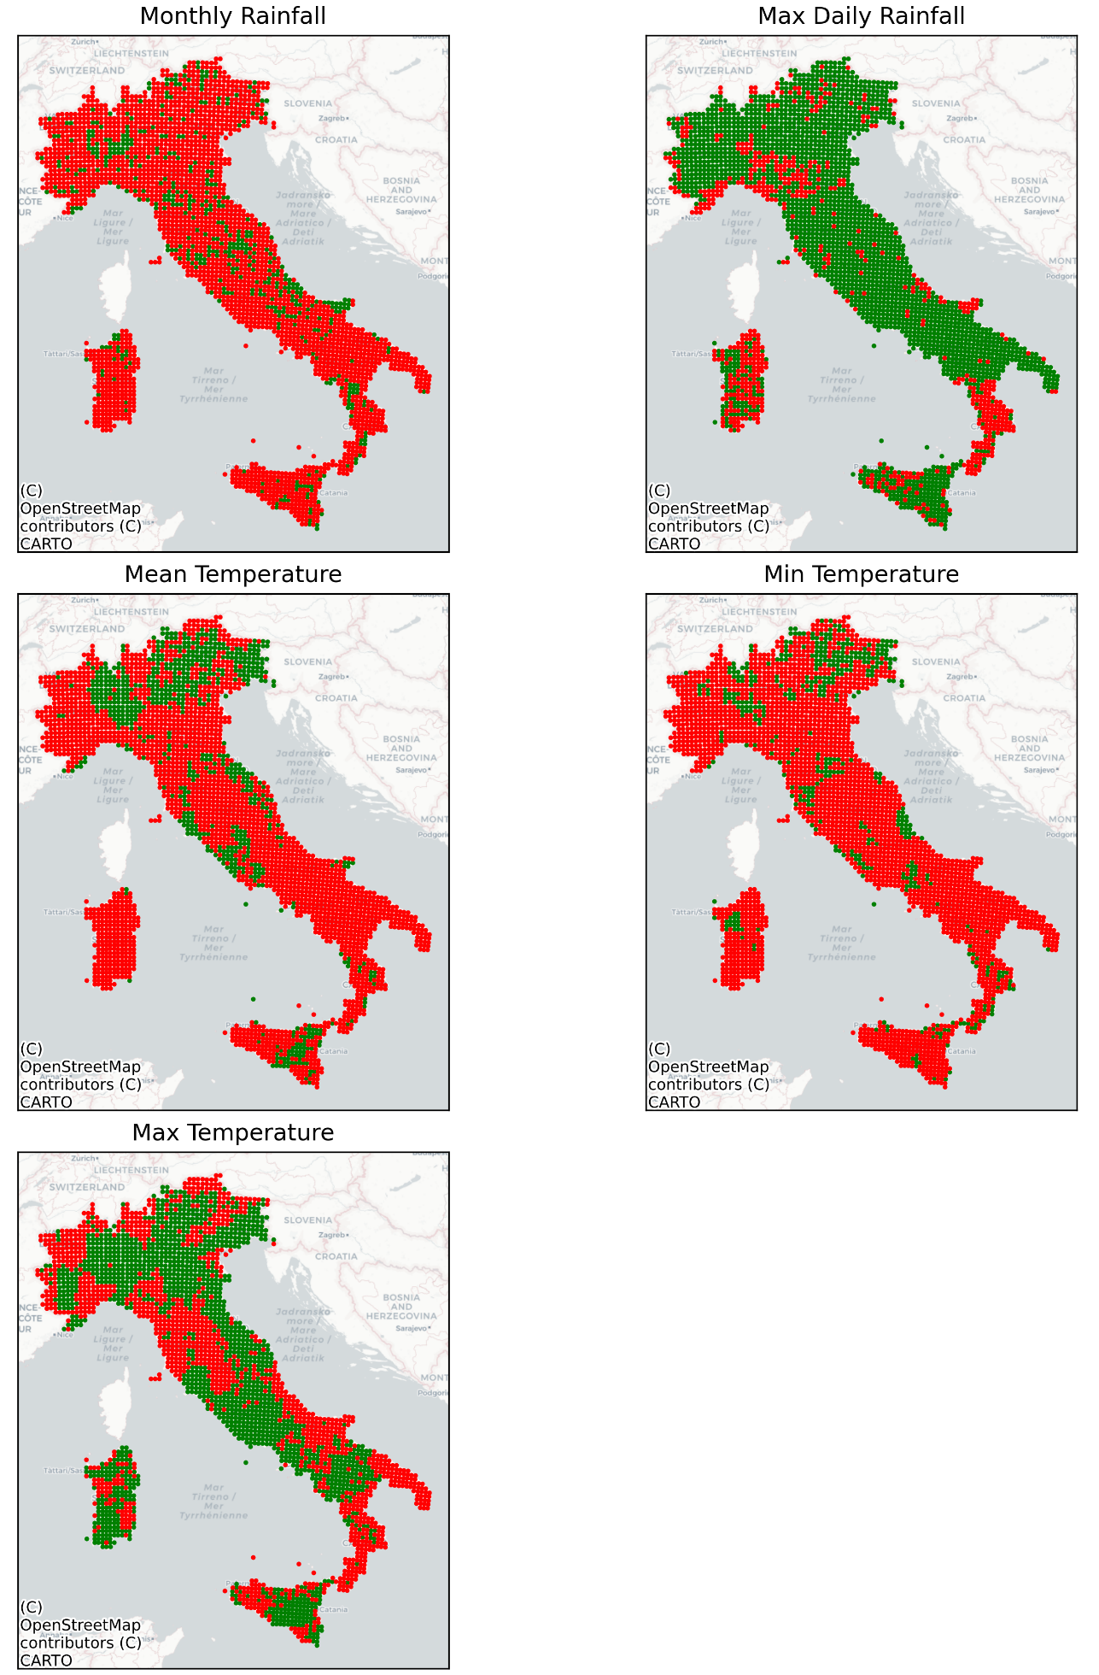
Figure S1 Spatial distribution of statistically significant trends (green, p < 0.05) and non-significant trends (red) derived from the Mann–Kendall test for monthly precipitation, maximum daily precipitation, mean temperature, minimum temperature, and maximum temperature.

