Supplementary Table 1. List of upregulated proteins in responders, with functions and associated disorders

Protein | Full Name | Location | Function | Disease (due to deficiency/dysfunction /mutation)
vWF | von Willebrand factor | Extracellular matrix | Maintenance of haemostasis, promotes adhesion of platelets to the sites of vascular injury, chaperone for coagulation factor VIII | A common hemorrhagic disorder due to defects in vWF resulting in  impaired platelet aggregation.
PROS1 | Vitamin K-dependent protein S | Secreted | Anticoagulant plasma protein, helps to prevent coagulation and stimulating fibrinolysis | A haemostatic disorder characterized by impaired regulation of blood coagulation and a tendency to recurrent venous thrombosis.
F10 | Coagulation factor X | Secreted | Converts prothrombin to thrombin in the presence of factor Va, calcium and phospholipid during blood clotting | Bleeding disorders include epistaxis (nose bleeding), gum bleeding, hematuria (blood in urine), prolonged or excessive bleeding following surgery or trauma.
LTF | Lactotransferrin | Secreted | Iron binding transport proteins, hematoma detoxification | Impaired iron transport, increased risk of infections and inflammation
ITIH3 | Inter-alpha-trypsin inhibitor heavy chain | Secreted | Act as a carrier of hyaluronan in serum or as a binding protein between hyaluronan and other matrix protein | Schizophrenia, dementia
QSOX1 | Quiescin Sulfhydryl Oxidase 1 | Golgi apparatus; Secreted | Disulfide bond formation in a variety of extracellular proteins, required for normal cell-cell adhesion and cell migration | No disorders found (No data available)
CTNNB1 | Catenin beta-1 | Intracellular | Regulation of cell adhesion, Promotes neurogenesis, Stem cell maintenance | Cancer (colorectal, skin, medulloblastoma, ovarian etc.) due to oncogenic mutations
NCAM1 | Neural cell adhesion molecule 1 | Cell membrane; secreted | A cell adhesion molecule involved in neuron- neuron adhesion, neurite fasciculation, outgrowth of neurites, etc. | Neuroendocrine carcinoma
SERPINB3 |  | Secreted | Act as a papain-like cysteine protease inhibitor to modulate the host immune response, neutrophil degranulation | No disorders found (No data available)
IGHV3-30 | Immunoglobulin heavy variable 3-30 | Cell membrane; secreted | Participate in the antigen recognition | No disorders found (No data available)

Supplementary Figure 1. Illustration of bladder anatomy and hypothesised eﬀect of
chlorophyllin (schematic)

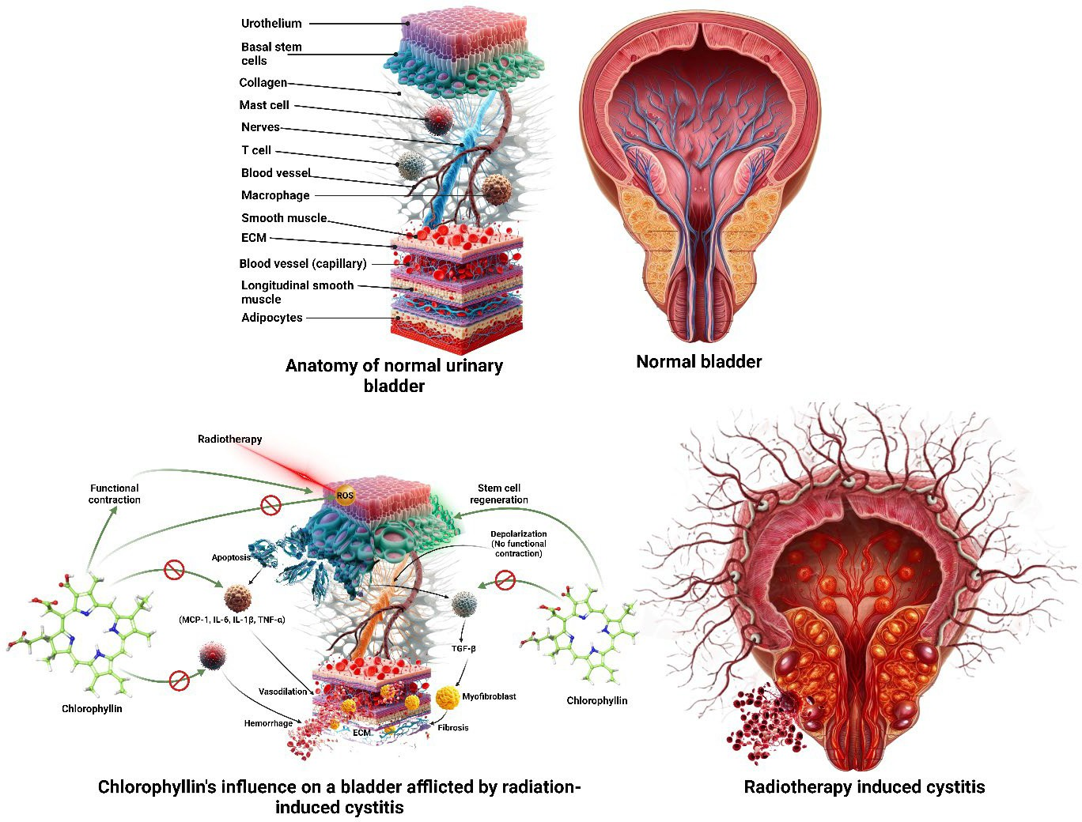

Supplementary Figure 2. Proteomics workflow
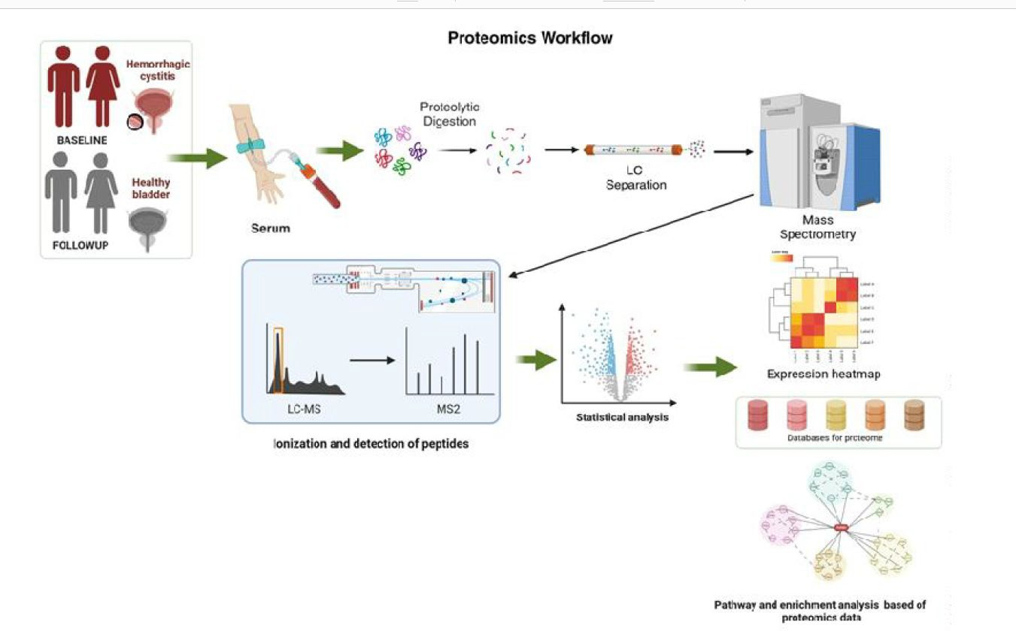

Supplementary Information on Proteomics Analysis:

Sample Preparation: Before analysis, proteins in each sample were first depleted,
followed by digestion, reduction with 5 mM TCEP, and alkylation with 50 mM
iodoacetamide. The digested samples underwent Trypsin digestion at a 1:50 ratio for
16 hours at 37°C. To remove salts, the digests were cleaned using a C18 silica
cartridge and subsequently dried using a speed vac. Finally, the dried pellet was
resuspended in buffer A, consisting of 2% acetonitrile and 0.1% formic acid.

Mass Spectrometric Analysis of Peptide Mixtures: The experiments were
conducted using an Easy-nlc-1000 system coupled with an Orbitrap Exploris mass
spectrometer. Peptide samples (1 μg) were loaded onto a 15 cm, 3.0 μm Acclaim
PepMap C18 column (Thermo Fisher Scientific) and separated using a gradient of
buffer B (80% acetonitrile, 0.1% formic acid) over 110 minutes at a flow rate of 500
nl/min. Following separation, the peptides were injected for MS analysis. MS1
spectra were acquired in the Orbitrap with specific settings, including dynamic
exclusion. MS2 spectra were collected for the top 20 peptides.

Data Processing: The acquired RAW files were processed using Proteome
Discoverer (v2.5). The database search was performed against the Uniprot Human
database with Sequest and Amanda algorithms. Specific search parameters
included precursor and fragment mass tolerances, enzyme specificity for trypsin/P,
and consideration of fixed and variable modifications. To ensure data quality, both
peptide spectrum match and protein false discovery rate were set to 0.01 FDR.

Data analysis: Depleted serum proteomics analysis approach was used to remove
highly abundant proteins, thereby enhancing the detection sensitivity for less
abundant proteins with potential prognostic or diagnostic relevance. Normalization of
protein abundance values against serum albumin levels within respective patient
groups was performed to ensure robust comparisons. Logarithmic transformation of
fold changes was computed to discern alterations in protein expression between
baseline and follow-up samples. A paired t-test was applied because baseline and
post-treatment samples were derived from the same patients. This design controls
for inter-individual variability in protein abundance and increases statistical power for
detecting within-person changes.
Patient ID-wise protein expression heatmap of Log2FC of significantly differentially
expressed proteins was generated using Python libraries ‘pandas’, seaborn’ and
‘matplotlib’ with a custom VIBGYOR colour palette. Furthermore, common proteins
exhibiting substantial upregulation (Log 2 FC &gt; 2, p &lt; 0.05) or downregulation (Log 2 FC
&gt; -2, p &lt; 0.05) among patients exhibiting positive responses to chlorophyllin
treatment were identified. The absolute and normalized log-transformed protein
abundance of these proteins at baseline and follow-up was graphically presented.
For pathway analysis and functional characterization, significantly differentially
expressed proteins were subjected to pathway mapping and enrichment analysis
using the WebGestalt platform (https://www.webgestalt.org/; 31114916; 28472511;
23703215; 15980575). Pathway overrepresentation analysis was conducted across
functional databases (KEGG, Panther, Wikipathway, and Reactome), with &39;Homo
sapiens&39; serving as the reference genome, and employing the Benjamini-Hochberg
method to control the false discovery rate (FDR &lt; 0.05). An integrated pathway
overrepresentation plot was constructed, consolidating outputs from individual
databases based on maximum enrichment ratio and minimum FDR value.
Furthermore, leveraging protein and pathway lists, a flowchart elucidating the
mechanism of action of chlorophyllin was generated using Lucidchart. Additionally,
an illustrative depiction detailing the preventive effects of chlorophyllin against
radiation-induced hemorrhagic cystitis was crafted using Biorender.

