Cadmium targeting the circadian transcription factor BMAL1 to induce osteocyte senescence contributes to osteoporosis
Gengsheng Yu^{1,2,3,#}, Xiaohui Fu^{1,2,3,#}, Dehui Zhou^{1,2,3}, Yonggang Ma^{1,2,3}, Hui Zou^{1,2,3}, Ruilong Song^{1,2,3},
Jianchun Bian^{1,2,3}, Zongping Liu^{1,2,3*}, Xishuai Tong^{1,2,3*}
¹ College of Veterinary Medicine, Yangzhou University, Yangzhou 225009, Jiangsu, China
² Joint International Research Laboratory of Agriculture and Agri-Product Safety of the Ministry of Education of China, Institute of Agricultural Science and Technology Development, Yangzhou University, Yangzhou 225009, Jiangsu, China
³ Jiangsu Co-Innovation Center for Prevention and Control of Important Animal Infectious Diseases and Zoonoses, Yangzhou 225009, Jiangsu, China

# These authors contributed equally to this work.
* Corresponding authors:
Zongping Liu, College of Veterinary Medicine, Yangzhou University. Yangzhou 225009, Jiangsu, China. Tel: +86 13605273327; E-mail: liuzongping@yzu.edu.cn.
Xishuai Tong, College of Veterinary Medicine, Yangzhou University. Yangzhou 225009, Jiangsu, China. Tel: +86 18252719601; E-mail: xstong@yzu.edu.cn
Conflict of interest: The authors declare that no conflict of interest exists.
Table of contents:
Supplementary Figures 1 to 7: Pages 2-9
Supplementary Tables 1 to 5: Pages 10-13

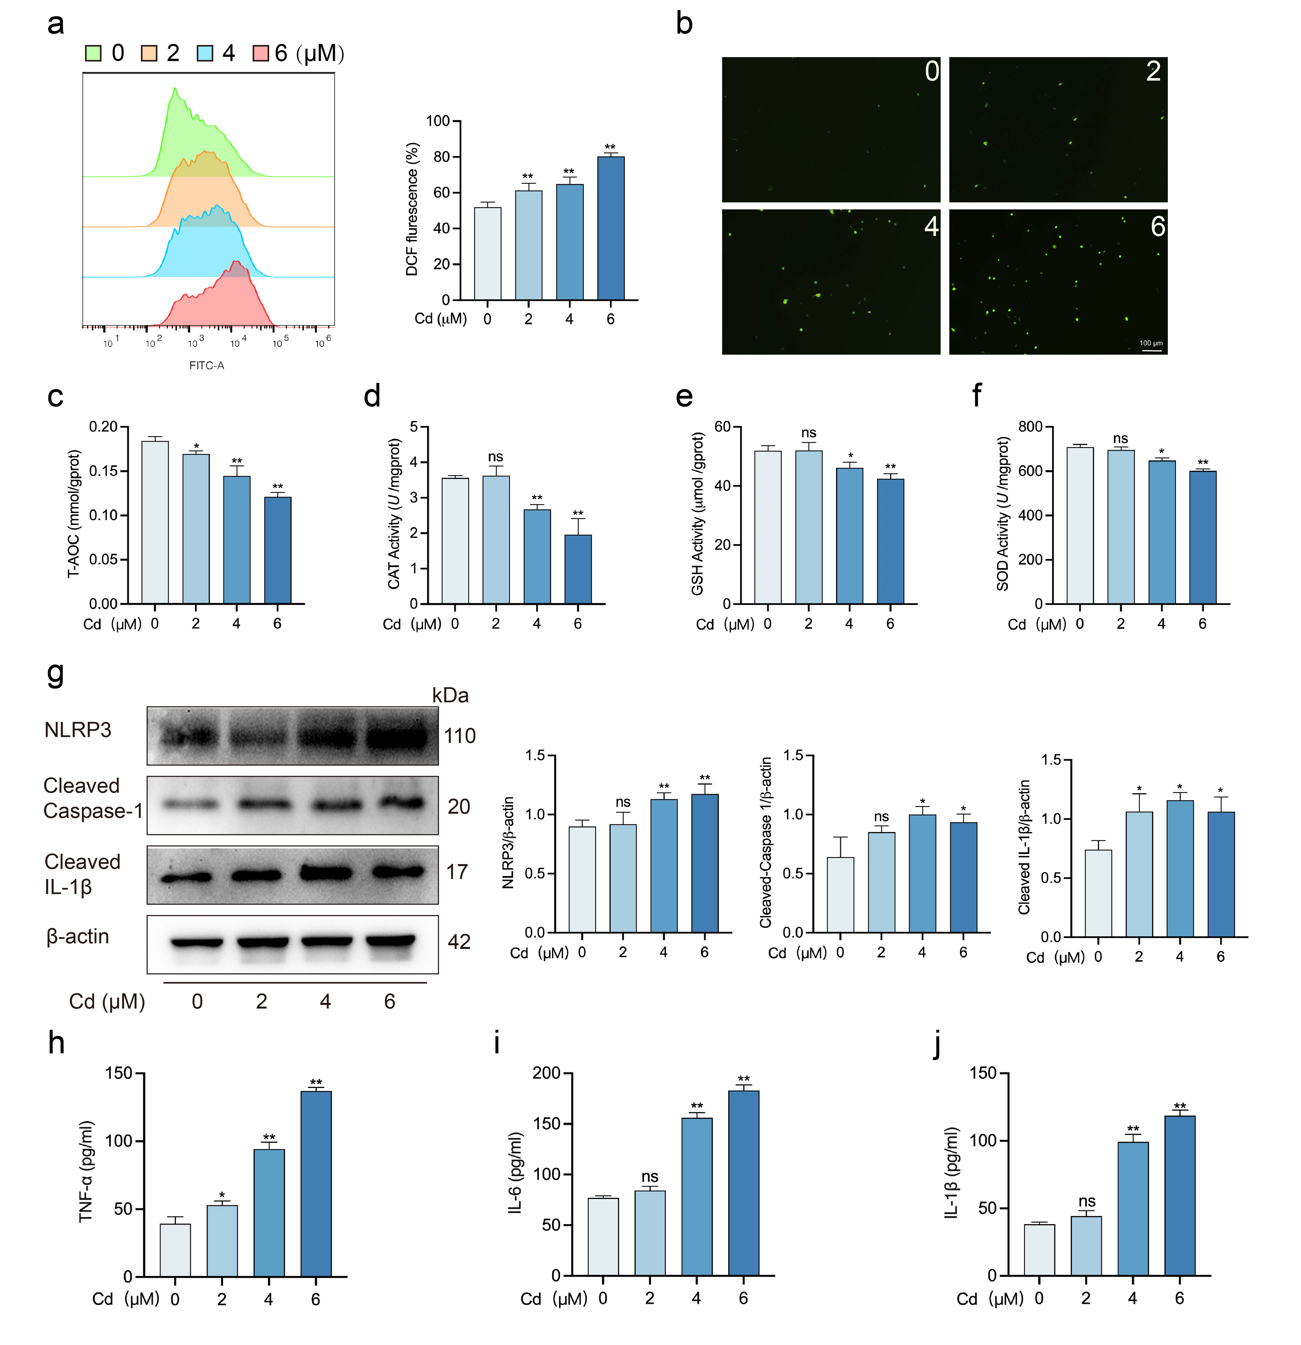
Fig. S1 Cadmium exposure induces oxidative stress and inflammation in osteocytes. MLO-Y4 cells were exposed to 0, 2, 4, and 6 μM Cd for 24 hours. a Flow cytometric analysis of ROS levels in MLO-Y4 cells (n = 3). b Representative images of ROS fluorescence intensity observed under a fluorescence microscope. c-f Measurement of total antioxidant capacity (T-AOC), catalase (CAT), glutathione (GSH), and superoxide dismutase (SOD) activity using biochemical assay kits (n = 3). g Western blot analysis and quantification of NLRP3, cleaved caspase-1, and IL-1β (n = 3). h-j Quantification of TNF-α, IL-6, and IL-1β levels in cells using ELISA kits (n = 3). Data are presented as mean ± SD; *p < 0.05, **p < 0.01 vs. 0 μM Cd; ns, not significant.

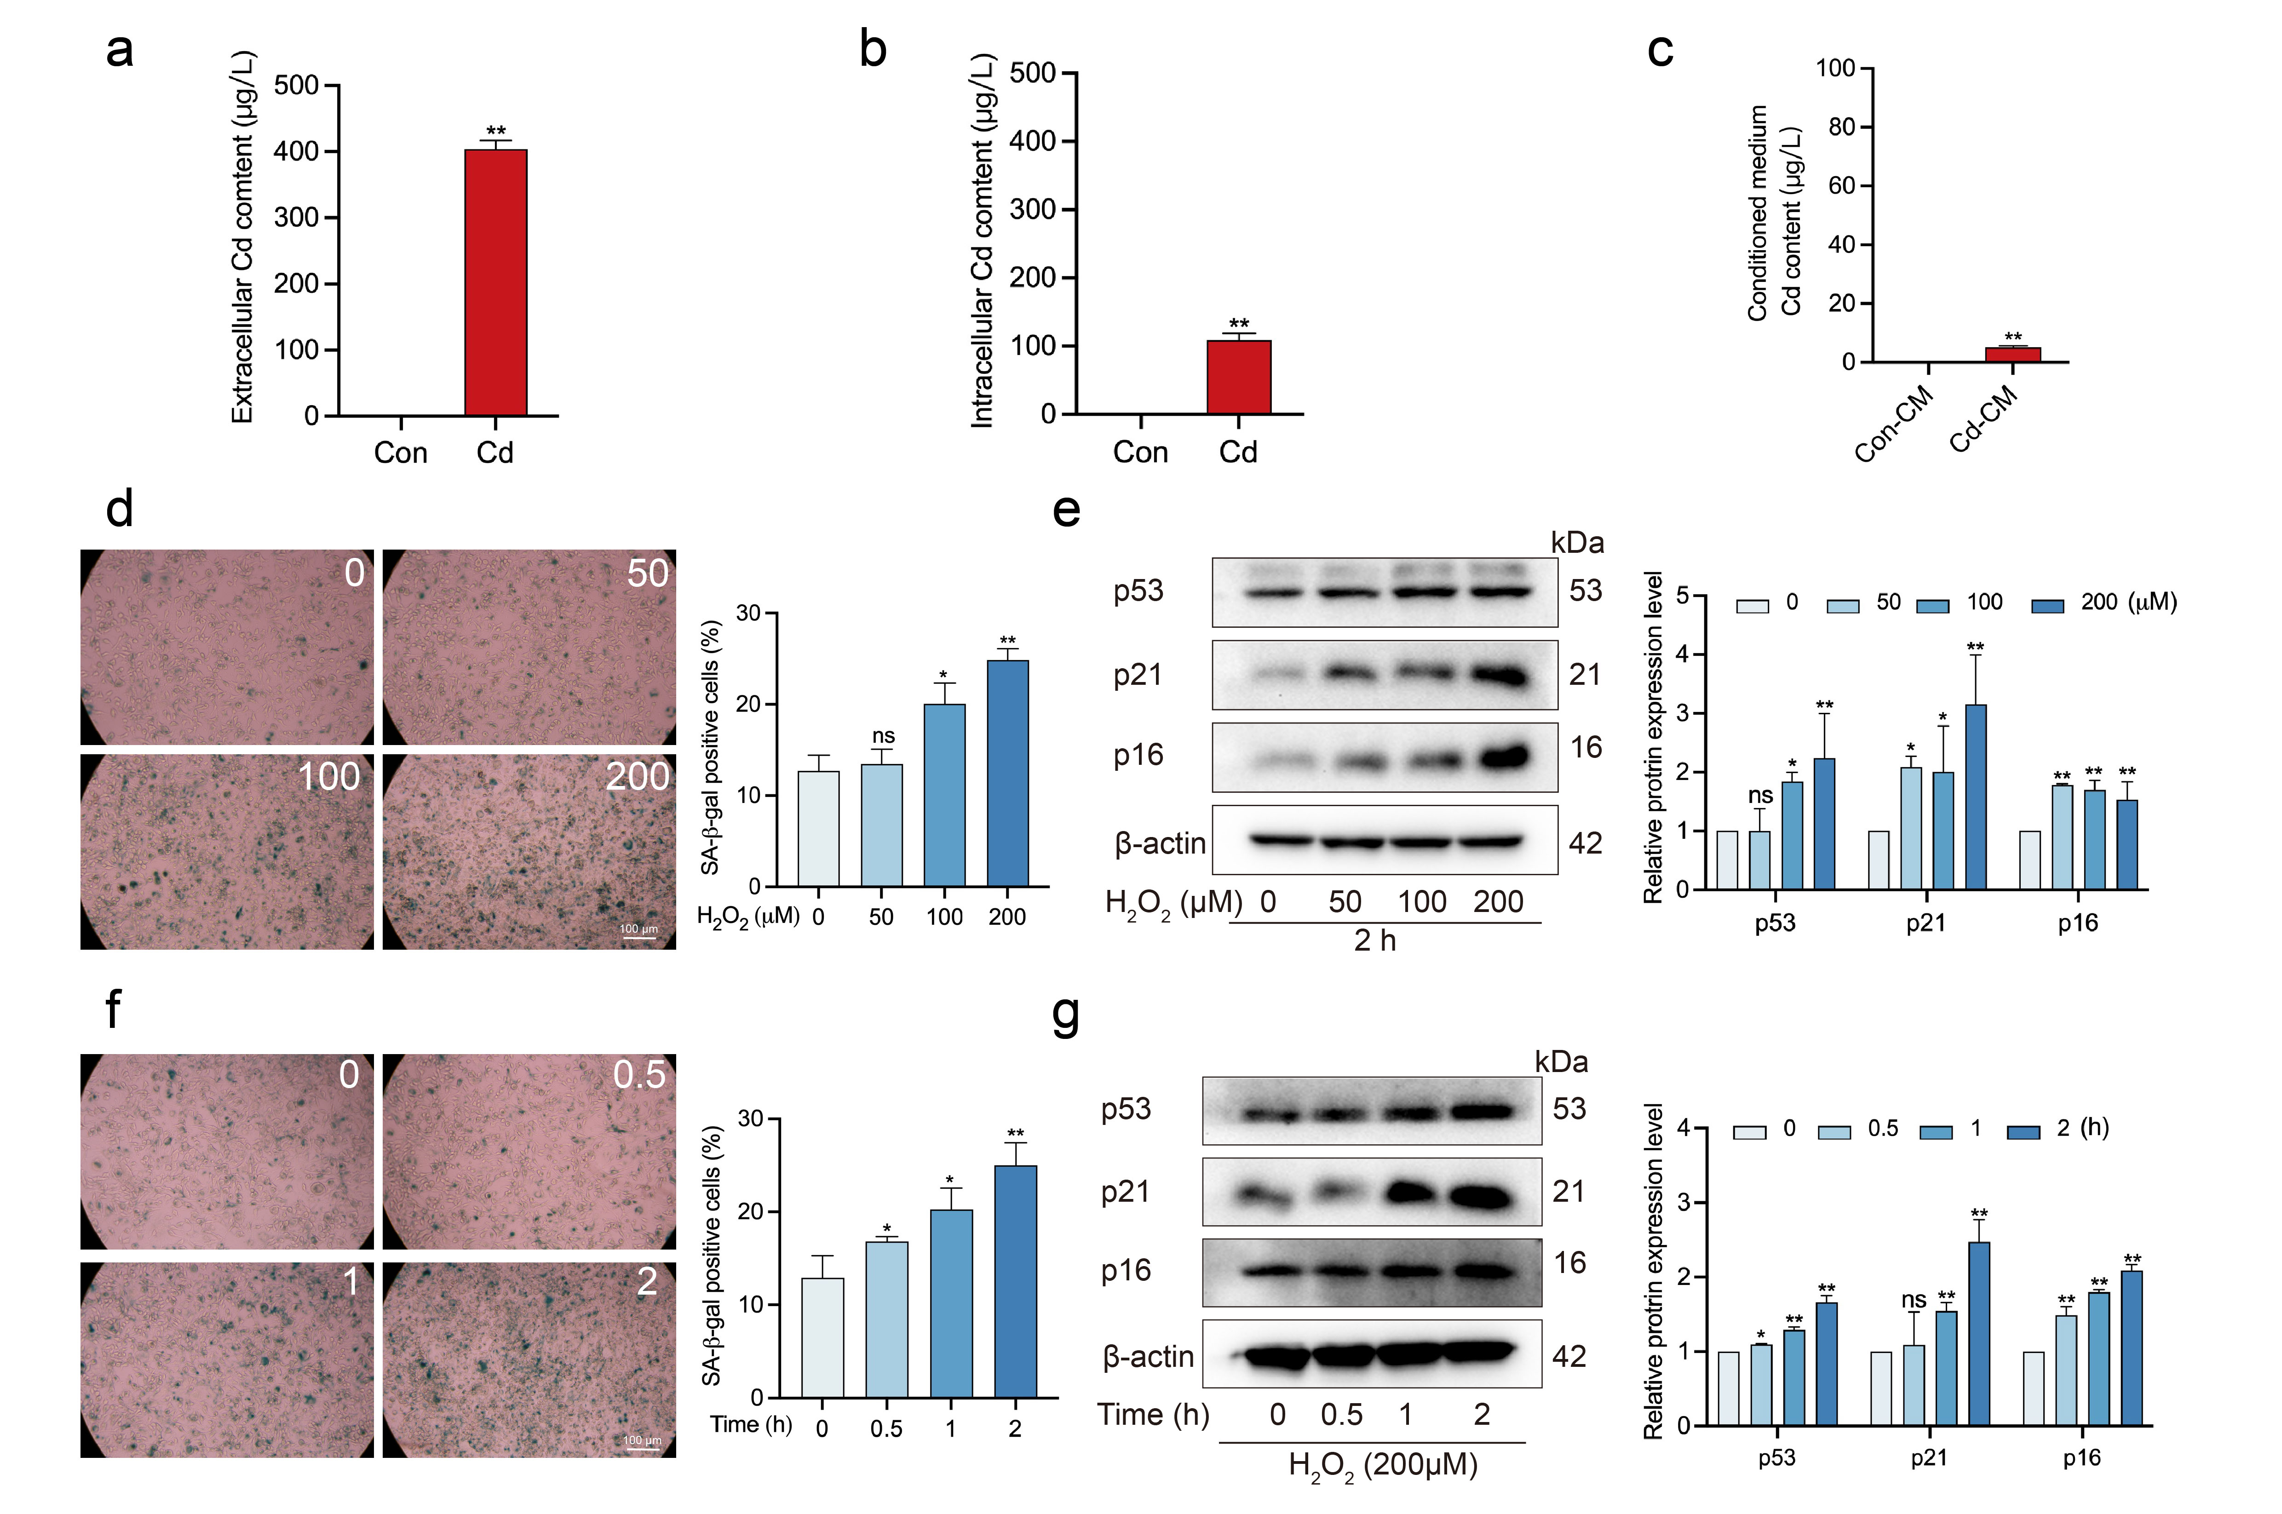
Fig. S2 Establishment of senescent osteocyte-conditioned medium. MLO-Y4 cells were exposed to 4 μM Cd for 24 hours.a Quantification of extracellular Cd levels (n = 3). b Intracellular Cd content in Con and Cd-treated MLO-Y4 cells (n = 3). c Cd levels in the CM from control and Cd-treated groups (n = 3). MLO-Y4 cells were treated with 0, 50, 100, and 200 μM hydrogen peroxide (H₂O₂) for 2 hours, followed by replacement with fresh medium and further incubation for 48 hours. d SA-β-gal staining and quantification of senescent MLO-Y4 cells (n = 3). e Western blot analysis and quantification of p53, p21, and p16 in MLO-Y4 cells (n = 3). MLO-Y4 cells were exposed to 200 μM H₂O₂ for different durations, followed by medium replacement and continued culture for 48 hours. f SA-β-gal staining and quantification of senescent MLO-Y4 cells (n = 3). g Western blot analysis and quantification of p53, p21, and p16 in MLO-Y4 cells (n = 3). Data are presented as mean ± SD; *p < 0.05, **p < 0.01 vs. Con; ns, not significant.
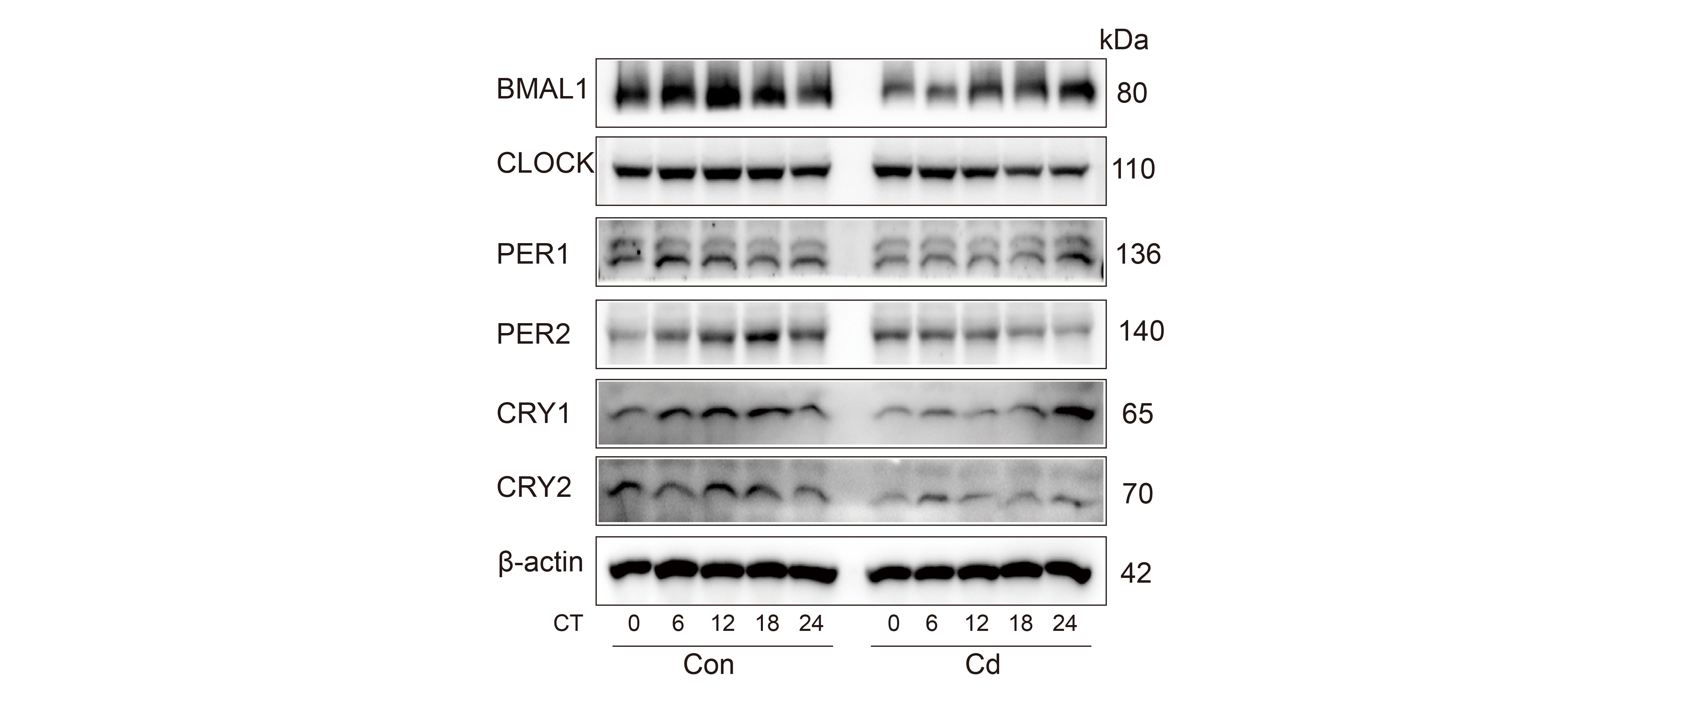
Fig. S3 Cd exposure alters the temporal patterns of core circadian clock proteins expression in cells. MLO-Y4 cells were exposed to 4 μM Cd for 24 hours. Protein levels of BMAL1, CLOCK, PER1, PER2, CRY1, and CRY2 were examined by Western blotting. β-actin was used as a loading control.

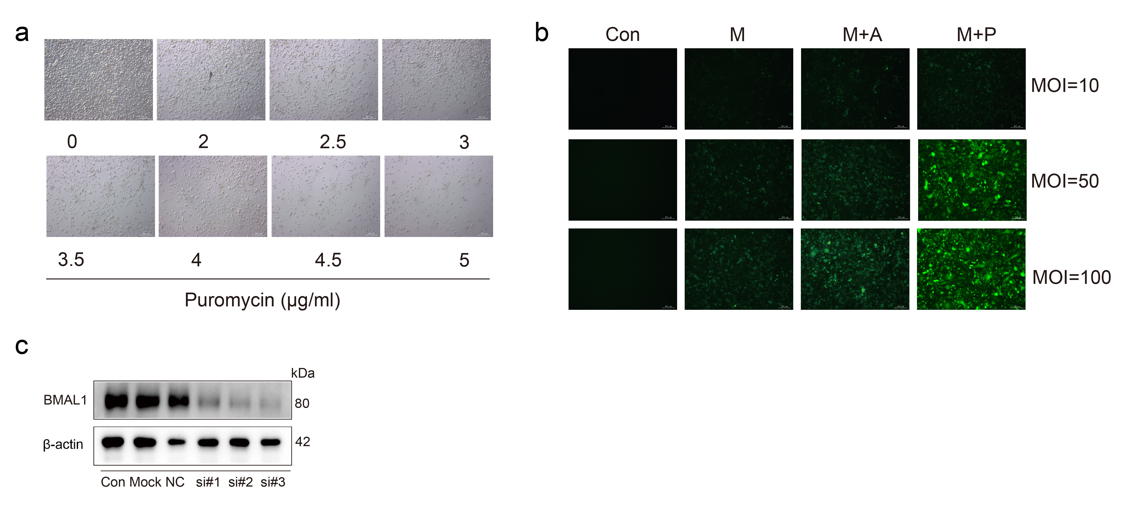
Fig. S4 Establishment of Bmal1-overexpression and Bmal1-silenced cell lines. a Puromycin kill curve. Cells were exposed to 0-5 μg/mL puromycin for 48 hours to determine the optimal dose for selection of stable transduced cells. A final concentration of 4 μg/mL puromycin was chosen for subsequent experiments. b Optimization of lentiviral transduction. Cells were infected with lentivirus for 12 hours, followed by replacement with complete medium and continued culture for 48 hours. Then, 4 μg/mL puromycin was added for 48 hours to select transduced cells. Transduction efficiency was evaluated by fluorescence microscopy. Con: untreated control; M: virus only; M+A: virus with HitransG A enhancer; M+P: virus with HitransG P enhancer. The condition M+P at MOI = 50 was selected for this study. c Screening siRNAs for Bmal1 silencing. Cells were transfected with 50 nM of three candidate siRNAs targeting Bmal1 (si#1–si#3) for 24 hours, BMAL1 protein expression was evaluated by Western blot, negative control (NC), untreated (Con) and mock-transfected (Mock). si-Bmal1#3 was selected for further experiments based on silencing efficiency.

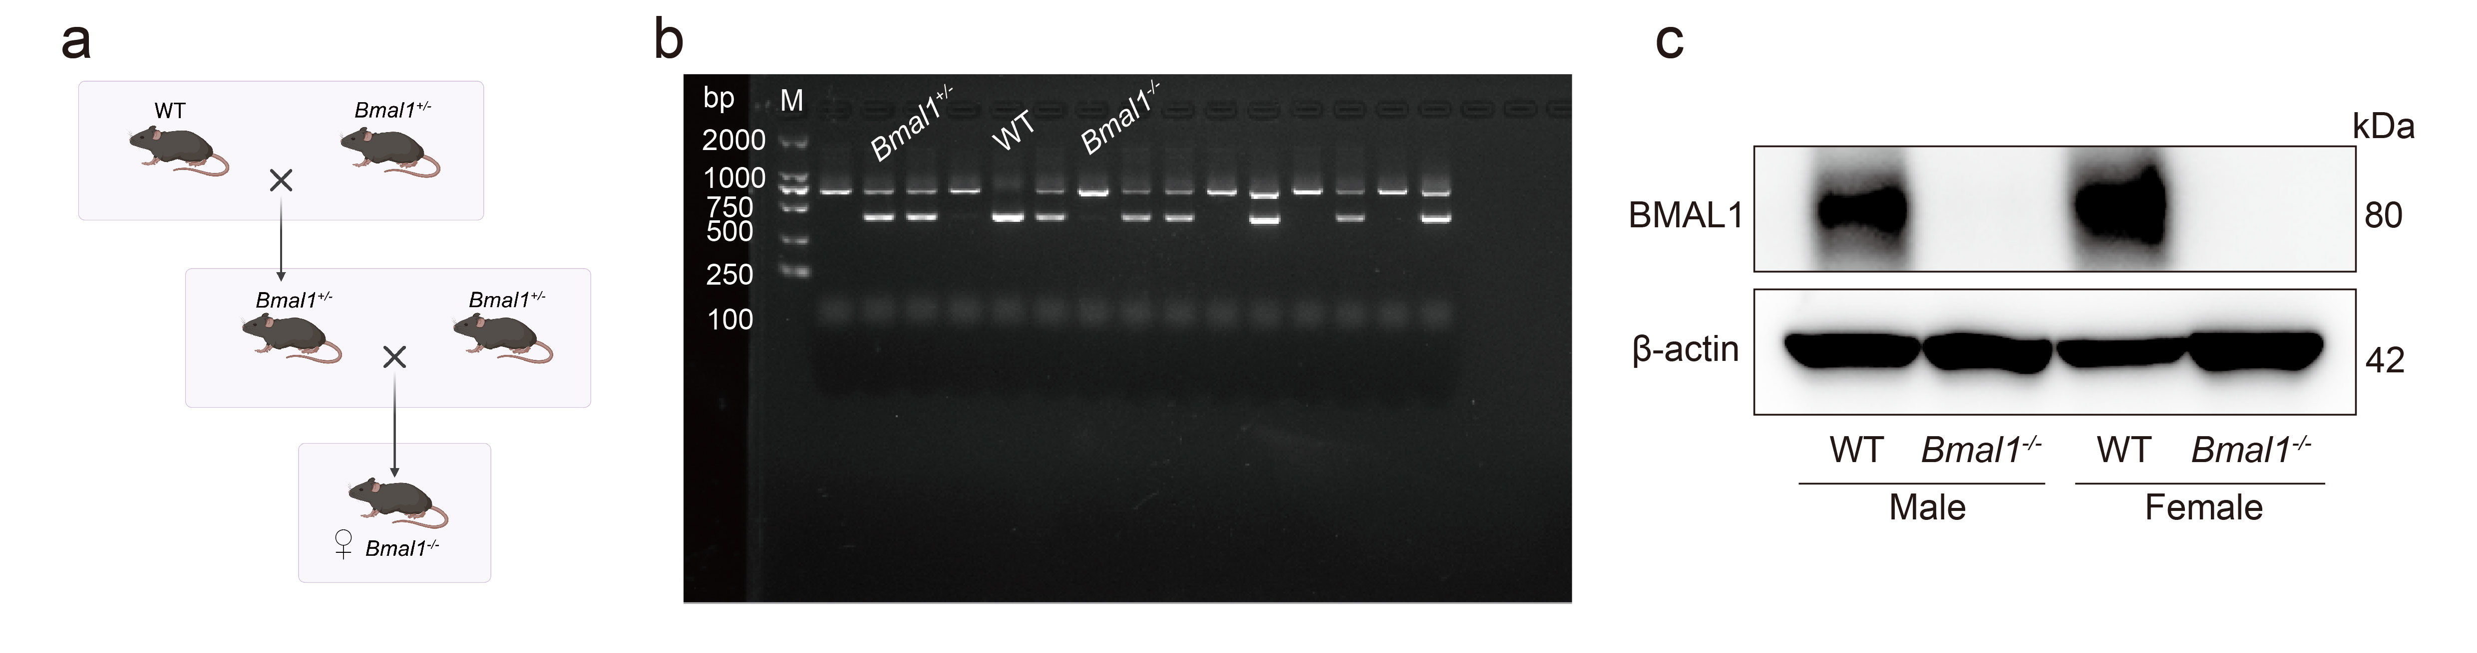
Fig. S5 Generation and validation of Bmal1–/– mice. a Breeding strategy for the generation of Bmal1 knockout (Bmal1–/–) mice. b Genotyping by PCR of tail genomic DNA: M: molecular weight marker; WT: wild–type; Bmal1^{+/–}: heterozygous; Bmal1–/–: homozygous knockout. c Western blot analysis confirming the absence of BMAL1 protein expression in bone tissue from both male and female Bmal1–/– mice.

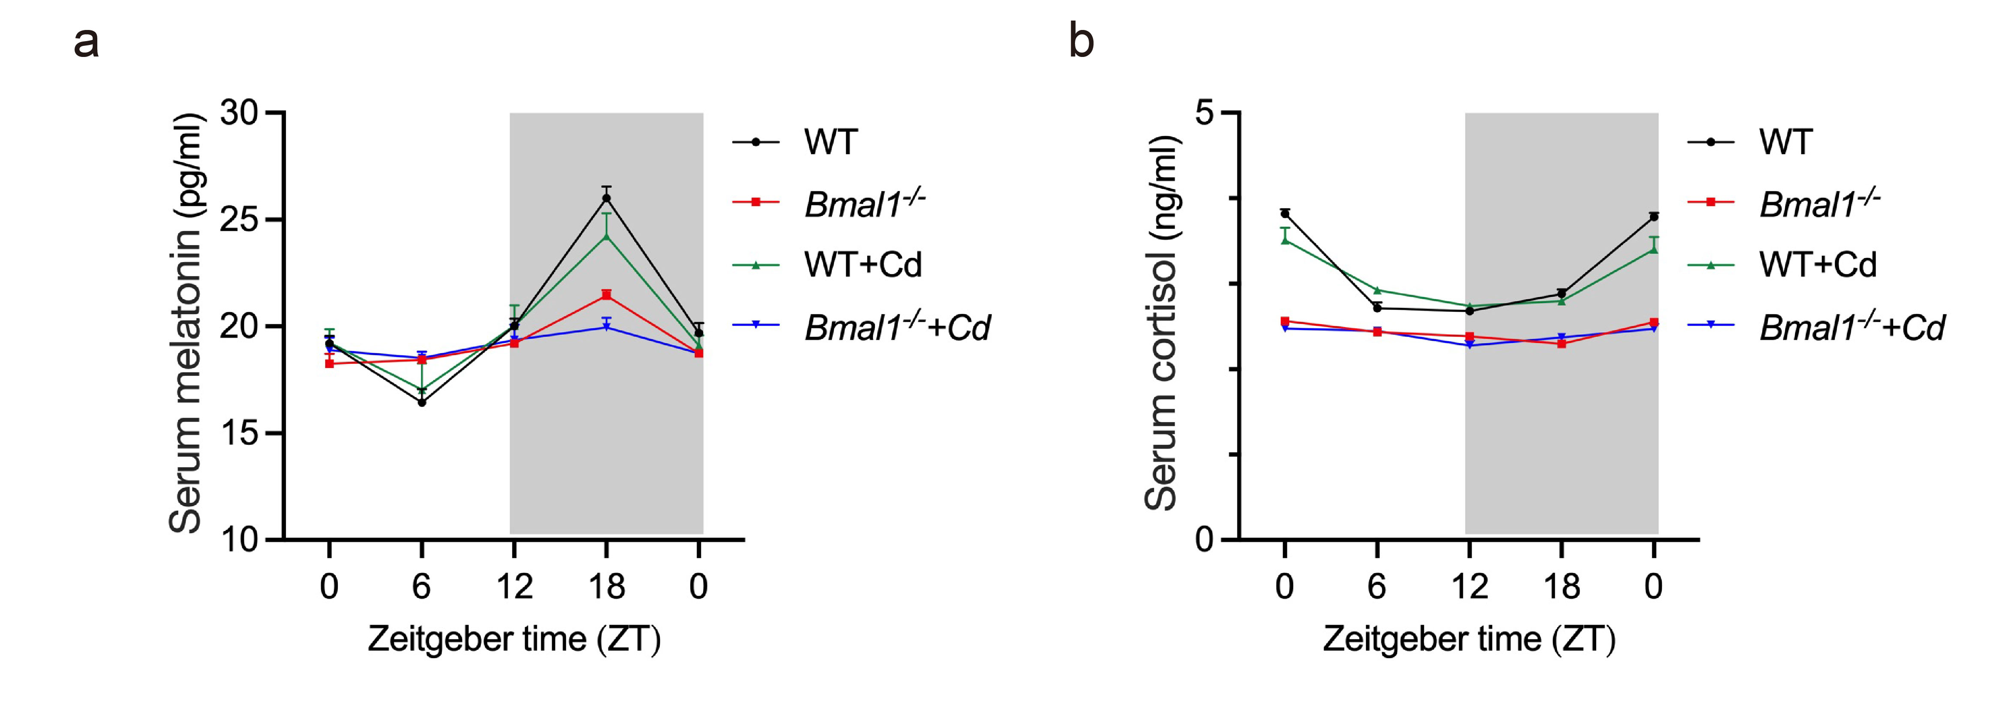
Fig. S6 Cd exposure exacerbates disruption of circadian rhythmicity in Bmal1–/– mice. a, b Serum melatonin concentrations and cortisol concentrations were measured using ELISA kits at indicated Zeitgeber times (ZT) (n = 3). Data are presented as mean ± SEM. The shaded area indicates the dark phase.

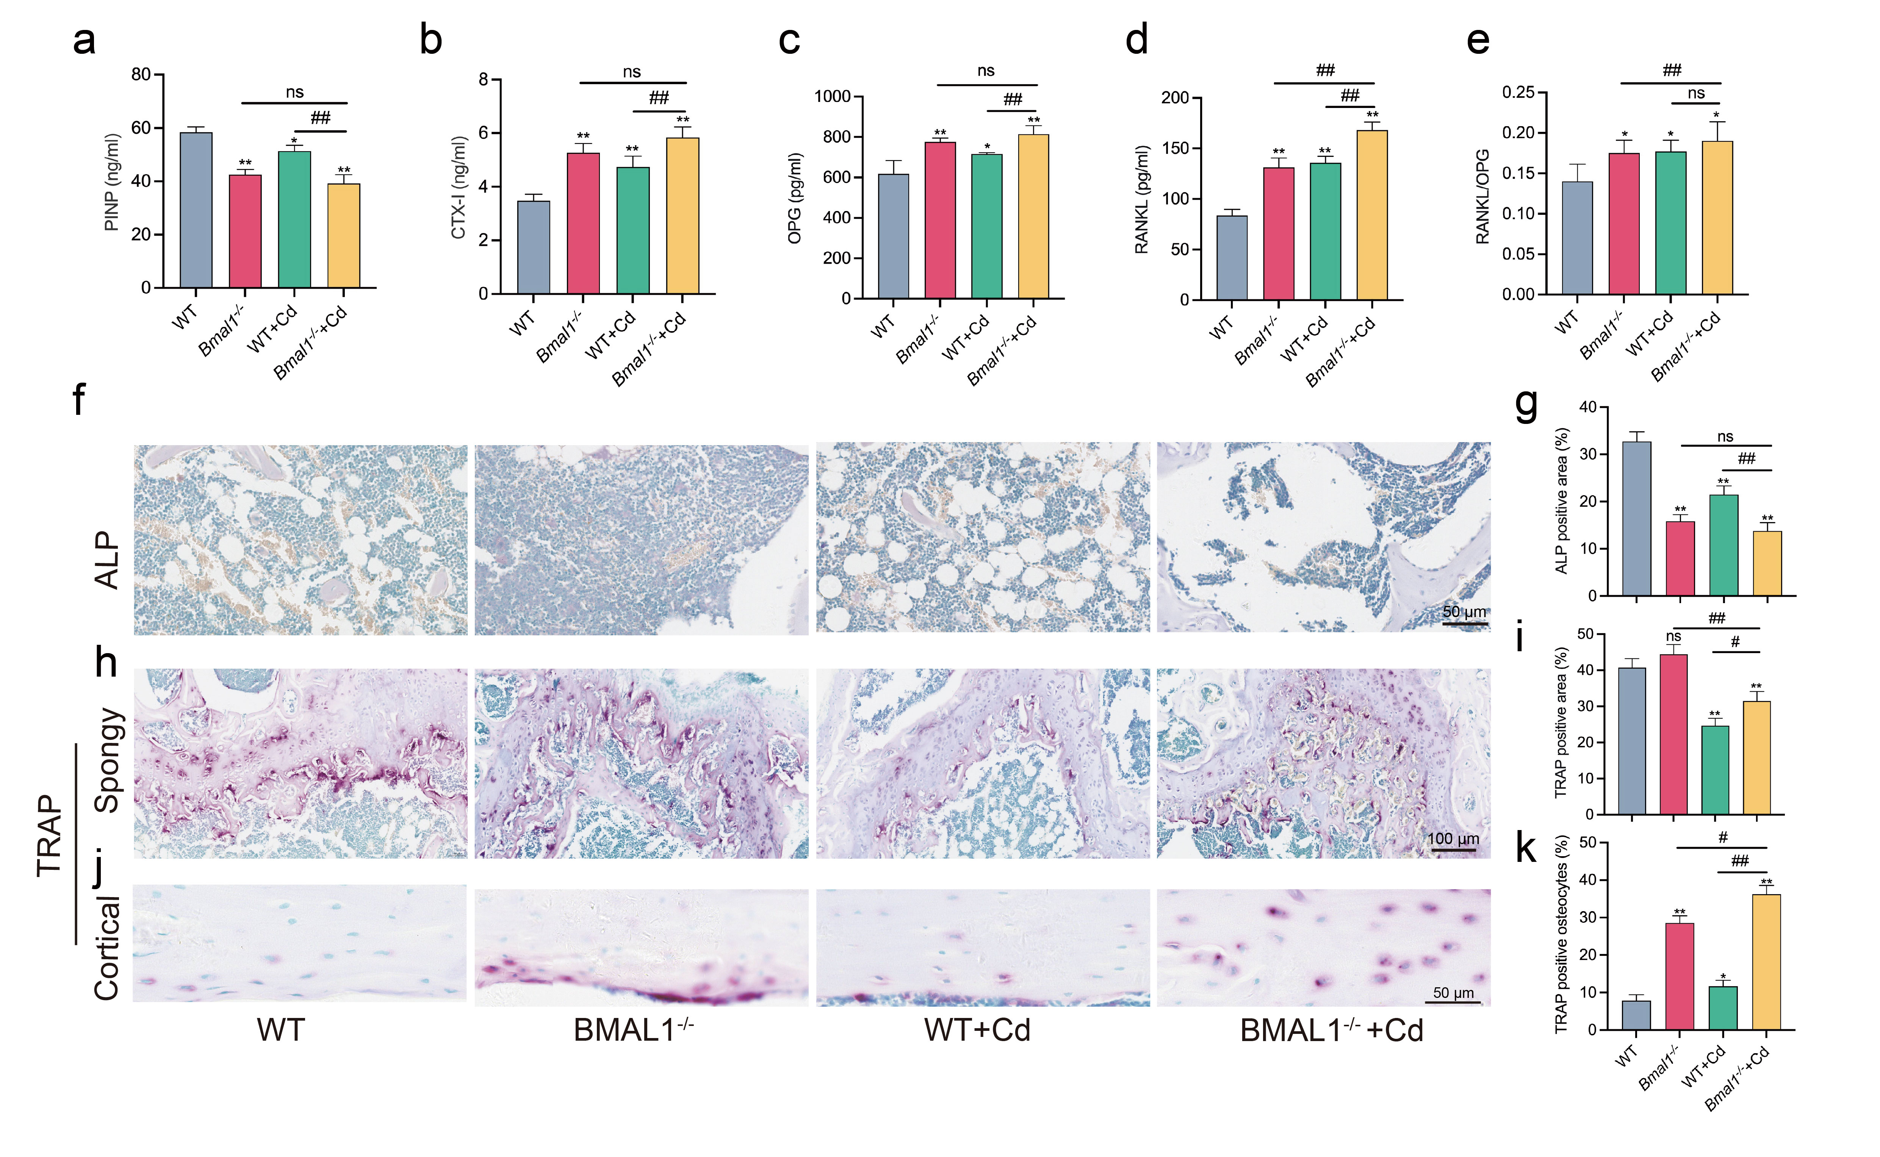
Fig. S7 Bmal1 deficiency enhances osteocyte-mediated bone resorption and aggravates bone metabolic imbalance. Bone turnover marker levels in serum were measured using ELISA kits: a procollagen type I N-terminal propeptide (PINP), b C-terminal telopeptide of type I collagen (CTX-I), c osteoprotegerin (OPG), d receptor activator of nuclear factor κB ligand (RANKL), e RANKL/OPG ratio (n = 3). f, g Representative ALP staining of bone sections and quantification of ALP-positive area (n = 3). h, i Representative TRAP staining in spongy bone and quantification of TRAP-positive area (n = 3). j, k Representative TRAP staining in cortical bone and quantification of TRAP-positive osteocytes (n = 3). Data are presented as mean ± SD. *P < 0.05, **P < 0.01 vs. WT; #P < 0.05, ##P < 0.01 vs. WT+Cd; ns, not significant.

Table S1. The chemicals and reagents information used in this study
Antibody name | Catalog number | Company name
Cadmium dichloride | 202908 | Sigma-Aldrich
Dasatinib | HY-10181 | MedChemExpress
Quercetin | HY-18085 | MedChemExpress
Melatonin | HY-B0075 | MedChemExpress
SDA-PAGE Loading Buffer | WB2001 | NCM Biotech Co., Ltd.
RIPA buffer | WB3100 | NCM Biotech Co., Ltd.
Phosphatase inhibitor | P003 | NCM Biotech Co., Ltd.
Enhanced chemiluminescence | P10300 | NCM Biotech Co., Ltd.
TRIzol Reagent | 15596018CN | Thermo Fisher Scientific Inc
BCA Protein Quantification Kit | 20201ES90 | Yeasen Biotech Co., Ltd.
Transfection Reagent | 101000046 | Polyplus
GSH assay kit | A005-1-2 | Nanjing Jiancheng Bioengineering Institute
CAT assay kit | A007-1-1 | Nanjing Jiancheng Bioengineering Institute
T-AOC assay kit | A015-2-1 | Nanjing Jiancheng Bioengineering Institute
SOD assay kit | A001-2-2 | Nanjing Jiancheng Bioengineering Institute
Mouse IL-1β ELISA KIT | ml106733 | Enzyme-inked Biotechnology Co., Ltd.
Mouse IL-6 ELISA KIT | ml063159 | Enzyme-inked Biotechnology Co., Ltd.
Genotyping assay kit | D7283S | Beyotime Biotechnology Inc.
ROS assay kit | S0033M | Beyotime Biotechnology Inc.
Cell cycle assay kit | C1052 | Beyotime Biotechnology Inc.
Apoptosis detection kit | C1062M | Beyotime Biotechnology Inc.
Alizarin Red stain kit | C0148S | Beyotime Biotechnology Inc.
SA-β-Gal stain kit | G1580 | Solarbio Science Technology Co., Ltd.
Alcian Blue stain kit | G1565 | Solarbio Science Technology Co., Ltd.
ALP stain kit | G1481 | Solarbio Science Technology Co., Ltd.
Oil Red O stain kit | G1261 | Solarbio Science Technology Co., Ltd.
TRAP stain kit | G1492 | Solarbio Science Technology Co., Ltd.

Table S2. Antibody information for western blot
Primary antibodies
Antibody name | Catalog number | Company name | Concentration
BMAL1 | 14020S | Cell Signaling Technology | 1:1000
CLOCK | 5157S | Cell Signaling Technology | 1:1000
p53 | 2524T | Cell Signaling Technology | 1:1000
γ-H2AX | 9718T | Cell Signaling Technology | 1:1000
Cyclin B1 | 4138T | Cell Signaling Technology | 1:1000
Cyclin E1 | 20808T | Cell Signaling Technology | 1:1000
CDK2 | 2546T | Cell Signaling Technology | 1:1000
CDK4 | 93597T | Cell Signaling Technology | 1:1000
Cleaved Caspase-1 | 89332S | Cell Signaling Technology | 1:1000
Cleaved IL-1β | 63124S | Cell Signaling Technology | 1:1000
SOST | 21933-1-AP | Proteintech | 1:1000
NLRP3 | 30109-1-AP | Proteintech | 1:1000
β-actin | 66009-1-Ig | Proteintech | 1:10000
DCSTAMP | A14630 | ABclonal | 1:1000
PER1 | A8449 | ABclonal | 1:1000
PER2 | A13168 | ABclonal | 1:1000
CRY1 | A13662 | ABclonal | 1:1000
CRY2 | A6891 | ABclonal | 1:1000
p21 | sc-471 | Santa Cruz | 1:500
p16 | sc-1661 | Santa Cruz | 1:500
Secondary antibodies
Antibody name | Catalog number | Company name | Concentration
Goat Anti-Mouse IgG | 115-005-003 | Jackson ImmunoResearch | 1:10000
Goat Anti-Rabbit IgG | 111-005-003 | Jackson ImmunoResearch | 1:10000
Goat Anti-Syrian Hamster IgG | 107-005-142 | Jackson ImmunoResearch | 1:10000

Table S3. Antibody information for IHC and IF
Antibodies for IHC
Antibody name | Catalog number | Company name | Concentration
SOST | 21933-1-AP | Proteintech | 1:100
p16 | sc-1661 | Santa Cruz Biotechnology, Inc. | 1:50

Antibodies for IF
Primary antibodies
Antibody name | Catalog number | Company name | Concentration
p16 | sc-1661 | Santa Cruz Biotechnology, Inc. | 1:100
γ-H2AX | 9718T | Cell Signaling Technology | 1:100

Secondary antibody
Antibody name | Catalog number | Company name | Concentration
AF488-labeled Goat Anti-Rabbit IgG (H+L) | A0423 | Beyotime Biotechnology Inc. | 1:500
Cy3-labeled Goat Anti-Mouse IgG (H+L) | A0521 | Beyotime Biotechnology Inc. | 1:500

Table S4. siRNA target sequence in this study
siRNA | siRNA target sequence
Si-Bmal1#1 | 5′-GCAAACTACAAGCCAACAT-3′
Si-Bmal1#2 | 5′-GCTCTTTCTTCTGTAGAAT-3′
Si-Bmal1#3 | 5′- CCAAGGAAGTTGAATACAT-3′

Table S5. The primer sequences for genotyping
Name | Primer
Bmal1 Forward | CCACCAAGCCCAGCAACTCA
Bmal1 WT | ATTCGGCCCCCTATCTTCTGC
Bmal1 KO | TCGCCTTCTATCGCCTTCTTGACG

