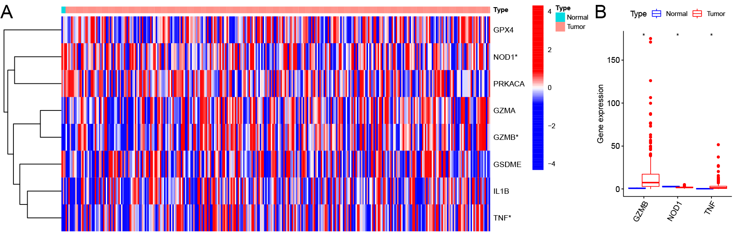
Supplementary Fig 1 Prognostic pyroptosis-related genes. (A)Heatmap. (B)Boxplot. Compared to normal cervical tissues, GZMB and TNF are highly expressed in cervical cancer tissues, while NOD1 is lowly expressed.

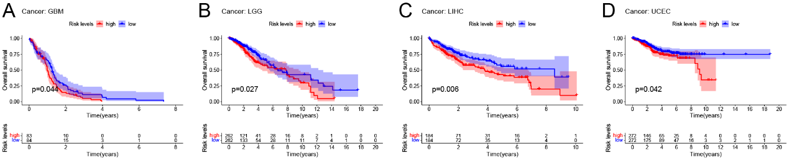
Supplementary Fig 2 The pyroptosis-related signature in other tumors. Kaplan-Meier curves showed lower overall survival rates in the high-risk group than in the low-risk group in GBM (A), LCG (B), LIHC (C), and UCEC (D) (P < 0.05). GBM, Glioblastoma multiforme. LGG, Brain Lower Grade Glioma. LIHC, Liver hepatocellular carcinoma. UCEC, Uterine Corpus Endometrial Carcinoma.

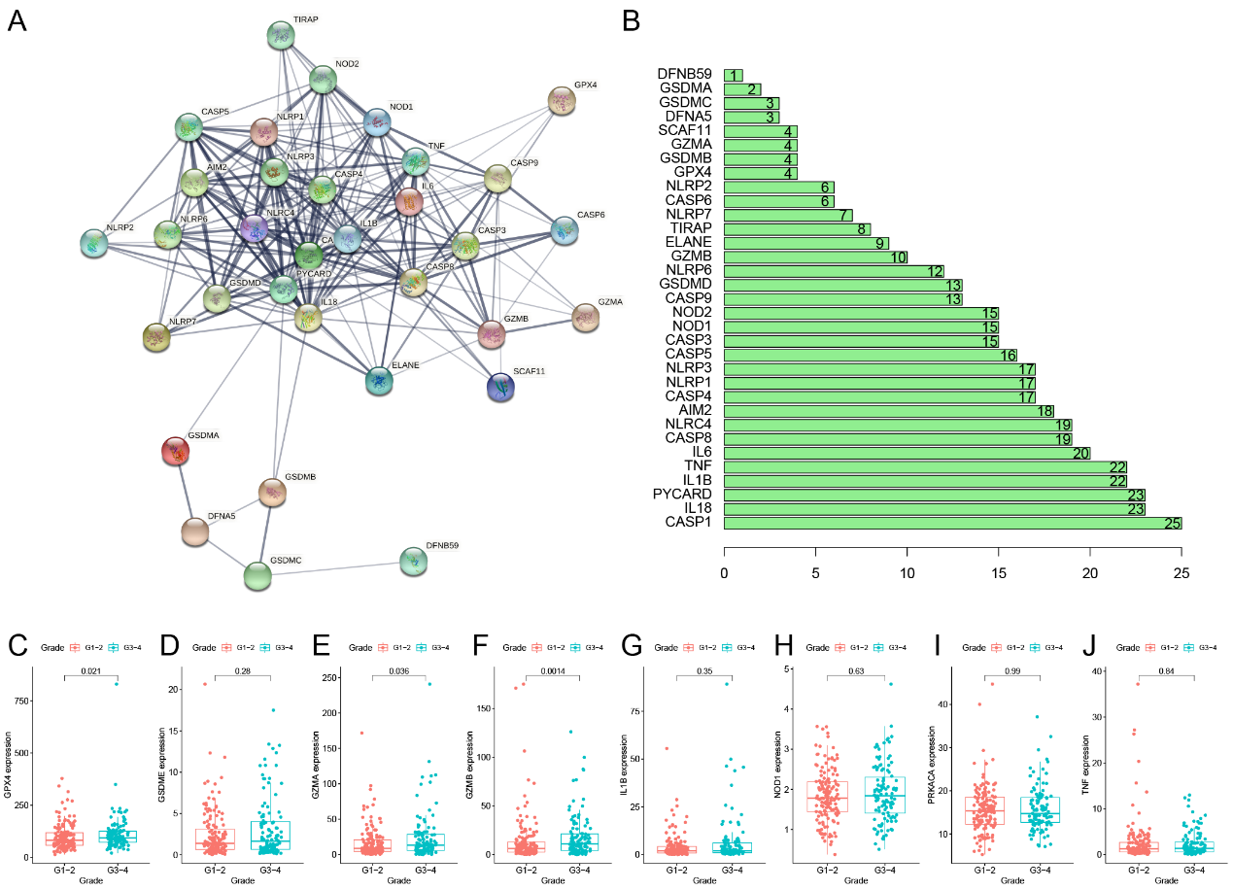
Supplementary Fig 3 Identify the core gene of the pyroptosis-related signature. (A) PPI network of the PRGs. (B) The degree of binding of PRGs. (C-J) Correlation of genes of the pyroptosis-related signature with the clinical feature Grade. The expression of GPX4, GZMA, and GZMB was significantly higher in the G3-4 group. PRGs, Pyroptosis-related genes.

