Supplementary Table 1. Summary of case demographics and experiments performed

 |  |  | Age of onset (years) | Age of death (years) | PMI  (hours) | One-colour FISH (SNCA, SOX10, aSyn) |  |  | Two-colour FISH (SNCA, Chr 7 CEP, SOX10) |  |  | γH2AX immunostaining
Donor ID | Sex | Diagnosis | Age of onset (years) | Age of death (years) | PMI  (hours) | CER | SN | PUT | CER | SN | PUT | CER | SN | PUT
SND01 | F | SND | 64 | 70 | 34.0 | X | X | X
SND02 | F | SND | 67 | 75 | 36.8 | X | X | X
SND03 | F | SND | 57 | 64 | 57.0 |  |  |  |  |  |  | X | X
SND04 | F | SND | 66 | 71 | 53.0 | X | X | X
SND05 | M | SND | 57 | 61 | 62.3 | X |  | X | X |  | X
SND06 | M | SND | 75 | 82 | 41.0 | X | X
SND07 | F | SND | 49 | 55 | 45.0 |  |  | X
SND08 | M | SND | 67 | 72 | 107.0 | X | X | X
SND09 | F | SND | 55 | 63 | 28.7 | X | X
SND10 | M | SND | 73 | 80 | 43.8 | X |  | X
SND11 | F | SND | 55 | 67 | 73.5 |  |  |  |  |  |  |  | X
SND12 | F | SND | 60 | 67 | 28.0 |  |  |  |  | X | X | X
SND13 | M | SND | 57 | 64 | 49.6 | X |  | X
SND14 | M | SND | 50 | 56 | 39.0 | X | X | X
SND15 | F | SND | 63 | 67 | 79.0 | X | X | X
Total |  |  |  |  |  | 10 | 8 | 10 | 1 | 1 | 2 | 2 | 2 | 0
OPCA01 | M | OPCA | 57 | 67 | 81.2 | X | X | X
OPCA02 | M | OPCA | 63 | 70 | 64.1 | X | X | X |  |  |  | X
OPCA03 | F | OPCA | 49 | 63 | 46.3 | X | X | X
OPCA04 | F | OPCA | 52 | 58 | 70.8 | X | X | X |  |  |  |  | X | X
OPCA05 | M | OPCA | 48 | 54 | 88.1 | X |  |  |  |  |  | X
OPCA06 | F | OPCA | 62 | 69 | 62.7 | X | X
OPCA07 | F | OPCA | 60 | 66 | 60.5 | X | X | X
OPCA08 | F | OPCA | 61 | 71 | 28.7 | X | X
OPCA09 | M | OPCA | 69 | 73 | 85.3 |  | X | X
OPCA10 | M | OPCA | 55 | 68 | 103.0 | X | X | X |  |  |  | X | X
OPCA11 | F | OPCA | 52 | 57 | 88.4 | X |  | X
OPCA12 | F | OPCA | NA | 54 | 52.0 | X | X | X |  | X | X | X
Total |  |  |  |  |  | 11 | 10 | 9 | 0 | 1 | 1 | 4 | 2 | 1
Control01 | M | Control | N/A | 69 | 168.0 |  | X | X | X
Control02 | M | Control | N/A | 73 | 47.0 |  | X |  |  |  | X
Control03 | F | Control | N/A | 57 | NA |  |  |  | X | X
Control04 | M | Control | N/A | 74 | 101.3 |  |  |  | X |  | X
Control05 | F | Control | N/A | 88 | 11.1 |  |  |  | X | X | X
Control06 | M | Control | N/A | 90 | 46.3 | X |  |  |  | X | X
Control07 | F | Control | N/A | 68 | 44.6 |  |  |  | X | X | X
Control08 | M | Control | N/A | 88 | 16.2 | X | X | X
Control09 | F | Control (dystonia) | N/A | 58 | 102.0 |  |  |  | X | X | X
Control10 | M | Control | N/A | 58 | 78.5 |  |  |  |  | X |  | X | X | X
Control11 | M | Control | N/A | 71 | 38.5 |  |  | X | X | X
Control12 | F | Control | N/A | 56 | 82.0 |  |  |  | X |  |  | X | X | X
Control13 | F | Control | N/A | 73 | 24.0 |  |  |  | X | X | X
Control14 | F | Control | N/A | 71 | 76.1 |  |  |  | X | X | X | X | X
Control15 | M | Control | N/A | 76 | 39.1 | X |  |  |  | X | X
Total |  |  |  |  |  | 3 | 3 | 3 | 10 | 10 | 9 | 3 | 3 | 2
Demographic information (sex, diagnosis, age of onset, age of death, and post-mortem interval (PMI)) is shown for all donors included in the study. The table also indicates the brain regions analysed for each experimental approach. Brain regions analysed include cerebellum (CER), substantia nigra (SN), and putamen (PUT). N/A indicates data not applicable, NA indicates data not available

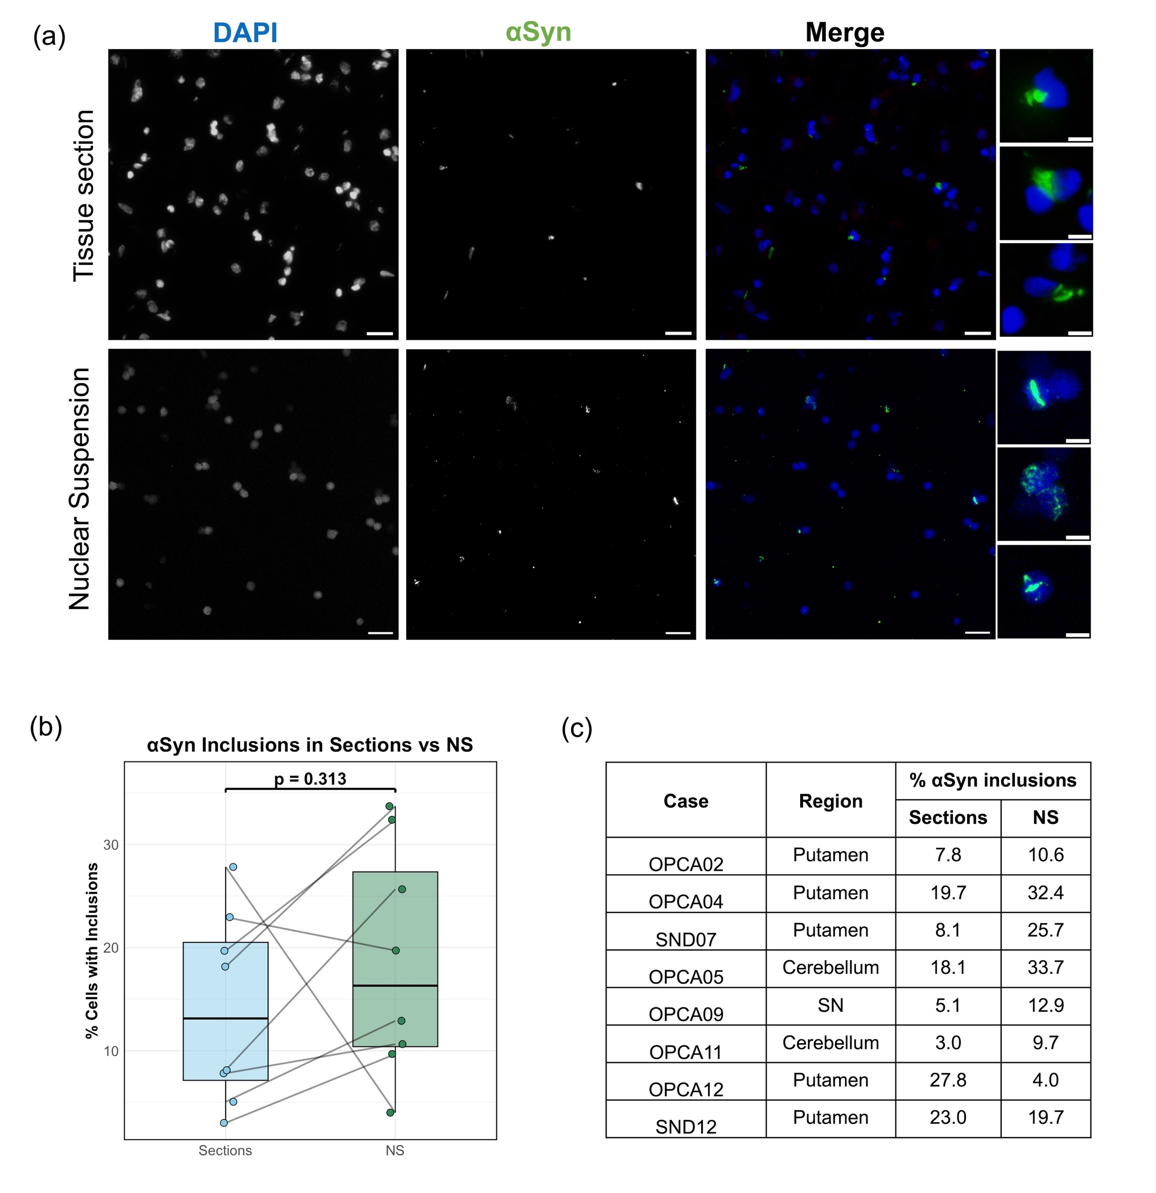

Supplementary Fig 1. Comparison of α-synuclein inclusions in tissue sections and nuclear suspensions. (a) Immunofluorescence images from an MSA-SND putamen case showing α-synuclein staining in tissue sections in the upper panel and in isolated nuclear suspensions (NS) in the lower panel. DAPI and α-synuclein (αSyn) channels are shown along with the merged view. The main scale bar represents 20 μm. Each merged image contains an inset with a scale bar of 5 μm (b) Box plots of the percentage of nuclei containing α-synuclein inclusions in tissue sections and in NS. Lines connect values from the same donor and region. P-value assessed using paired t-test. (c) Summary table presenting the percentage of α-synuclein⁺ cells for each case and region in tissue sections and in nuclear suspensions.

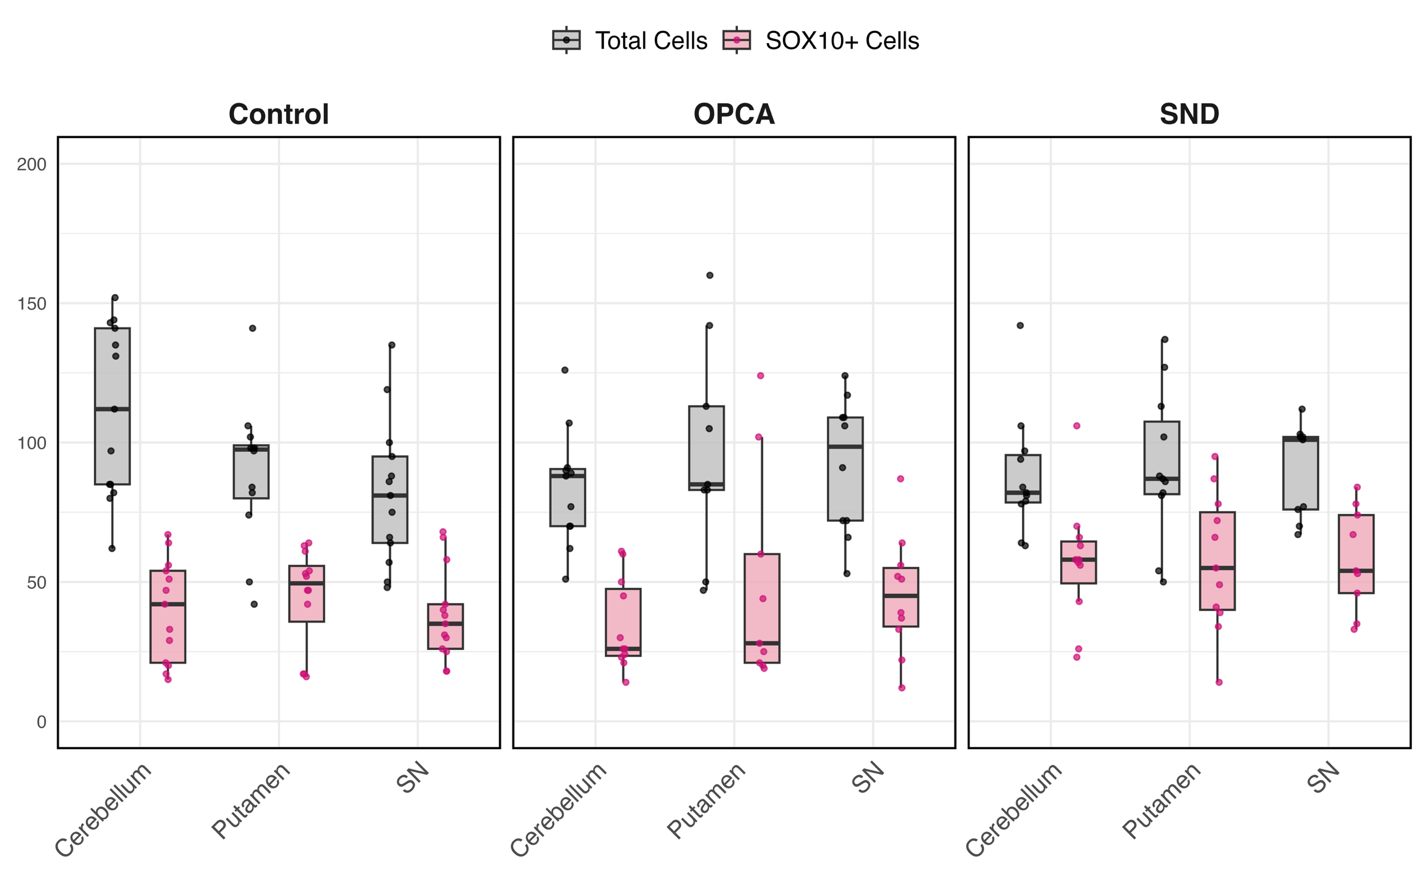
Supplementary Fig 2. Distribution of overall cell counts and SOX10+ cells across each group and region.
Supplementary Table 2. Summary of cell counts and SNCA CNVs per group and region
 |  | Cells analysed |  |  |  | Gains |  |  |  | Losses
Group | Region | Cell type | Total | Per case mean (SD) | Per case median [IQR] | Number | % | Median [IQR] | Mean (SD) | Number | % | Median [IQR] | Mean (SD)
Control | Cerebellum | SOX10+ | 516 | 39.7 (18.3) | 42 [21–54] | 14 | 2.7 | 3.0 [0–3.9] | 2.7 (2.6) | 35 | 6.8 | 6.7 [4.8–10.9] | 7.0 (4.0)
Control | Cerebellum | SOX10- | 933 | 71.7 (35.4) | 70 [46–96] | 29 | 3.1 | 3.2 [2.4–3.9] | 3.1 (1.8) | 40 | 4.3 | 4.3 [3.3–9.7] | 5.7 (3.7)
Control | Cerebellum | Overall | 1449 | 111.5 (30.8) | 112 [85–141] | 43 | 3 | 2.4 [1.6–3.7] | 2.8 (1.7) | 75 | 5.2 | 4.9 [3.5–8.2] | 5.9 (3.5)
Control | Putamen | SOX10+ | 533 | 44.4 (18) | 49.5 [35.8–55.8] | 17 | 3.2 | 2.0 [1.6–4.4] | 3 (2.6) | 34 | 6.4 | 6.4 [4.1–7.8] | 6.2 (3.7)
Control | Putamen | SOX10- | 539 | 44.9 (18) | 42.5 [34–55.5] | 17 | 3.2 | 2.3 [1.3–3.4] | 3.7 (5.4) | 52 | 9.6 | 8.8 [8.0–13.2] | 9.6 (4.5)
Control | Putamen | Overall | 1072 | 89.3 (26.1) | 97.5 [80–99] | 34 | 3.2 | 2.1 [1.7–4.6] | 3.7 (3.9) | 86 | 8 | 8.2 [7.0–10.4] | 8.2 (3)
Control | SN | SOX10+ | 495 | 38.1 (16.7) | 35 [26–42] | 12 | 2.4 | 2.4 [0–3.4] | 2.5 (3) | 40 | 8.1 | 6.5 [3.8–10.3] | 8.5 (6)
Control | SN | SOX10- | 569 | 43.8 (25.8) | 37 [24–49] | 29 | 5.1 | 4.8 [2.6–6.1] | 4.6 (3.5) | 49 | 8.6 | 9.1 [6.7–12.5] | 9.7 (5.7)
Control | SN | Overall | 1064 | 81.8 (26.1) | 81 [64–95] | 41 | 3.9 | 3.7 [1.8–5.3] | 4.1 (4.3) | 89 | 8.4 | 8.1 [6.0–11.1] | 9.4 (4.6)
MSA-SND | Cerebellum | SOX10+ | 626 | 56.9 (22.4) | 58 [49.5–64.5] | 32 | 5.1 | 3.8 [2.7–5.8] | 5.2 (4.7) | 77 | 12.3 | 13.0 [11.5–14.2] | 11.9 (3.7)
MSA-SND | Cerebellum | SOX10- | 344 | 31.3 (18.6) | 24 [21–36] | 6 | 1.7 | 0 [0–5.4] | 3.2 (6.2) | 51 | 14.8 | 14.7 [8.7–18.2] | 15.5 (9.5)
MSA-SND | Cerebellum | Overall | 970 | 88.2 (22) | 82 [78.5–95.5] | 38 | 3.9 | 2.5 [1.6–7.4] | 7.5 (5) | 128 | 13.2 | 12.7 [10.4–16.7] | 13.4 (3.2)
MSA-SND | Putamen | SOX10+ | 630 | 57.3 (24.7) | 55 [40–75] | 51 | 8.1 | 7.3 [5.6–7.9] | 8.5 (6.4) | 96 | 15.2 | 13.7 [11.9–15.3] | 14.8 (7.9)
MSA-SND | Putamen | SOX10- | 377 | 34.3 (11.1) | 35 [30.5–40] | 25 | 6.6 | 5.7 [3.0–6.4] | 6 (4.9) | 55 | 14.6 | 15.6 [8.5–20] | 15.2 (8.5)
MSA-SND | Putamen | Overall | 1007 | 91.5 (27) | 87 [81.5–107.5] | 76 | 7.5 | 6.8 [4.9–7.1] | 7.5 (5) | 151 | 15 | 14.2 [11.5–17.8] | 15.1 (6.6)
MSA-SND | SN | SOX10+ | 524 | 58.2 (18.5) | 54 [46–74] | 35 | 6.7 | 6.4 [4.5–7.5] | 7 (4.3) | 77 | 14.7 | 11.9 [11.1–15.5] | 13.8 (4.7)
MSA-SND | SN | SOX10- | 286 | 31.8 (19.4) | 24 [21–35] | 16 | 5.6 | 4.2 [0–9.5] | 5.8 (5.9) | 41 | 14.3 | 10.5 [8.3–18.2] | 12.5 (7.5)
MSA-SND | SN | Overall | 810 | 90 (17.2) | 101 [76–102] | 51 | 6.3 | 5.3 [4.9–5.9] | 6.3 (3.1) | 118 | 14.6 | 13.2 [10.4–16.7] | 14.1 (4.8)
MSA-OPCA | Cerebellum | SOX10+ | 380 | 34.5 (16.5) | 26 [23.5–47.5] | 42 | 11.1 | 8.7 [7.3–19.1] | 12.2 (8.7) | 62 | 16.3 | 15.4 [13.8–18.4] | 16.6 (4.1)
MSA-OPCA | Cerebellum | SOX10- | 541 | 49.2 (22.6) | 44 [31–66] | 47 | 8.7 | 7.9 [4.5–12.3] | 8.5 (5.5) | 55 | 10.2 | 10.9 [6.3–14.3] | 10.8 (6)
MSA-OPCA | Cerebellum | Overall | 921 | 83.7 (21.1) | 88 [70–90.5] | 89 | 9.7 | 7.9 [6.8–10.5] | 9.4 (4.5) | 117 | 12.7 | 12.9 [10.8–14.5] | 13.3 (4.3)
MSA-OPCA | Putamen | SOX10+ | 443 | 49.2 (38.9) | 28 [21–60] | 30 | 6.8 | 9.5 [3.6–11.4] | 7.9 (4.8) | 58 | 13.1 | 15.0 [10.5–15.9] | 12 (5.9)
MSA-OPCA | Putamen | SOX10- | 425 | 47.2 (19) | 41 [36–55] | 41 | 9.7 | 8.3 [4.5–13.1] | 9.2 (5.8) | 46 | 10.8 | 11.1 [9.1–12.2] | 9.9 (5)
MSA-OPCA | Putamen | Overall | 868 | 96.4 (38) | 85 [83–113] | 71 | 8.2 | 9.9 [3.6–12.4] | 8.8 (5.5) | 104 | 12 | 10.6 [9.5–14.1] | 11.3 (3.4)
MSA-OPCA | SN | SOX10+ | 453 | 45.3 (21.6) | 45 [34–55] | 37 | 8.2 | 8.4 [6.1–13.0] | 10 (6.7) | 45 | 9.9 | 8.0 [7.3–13.6] | 10.3 (5.3)
MSA-OPCA | SN | SOX10- | 466 | 46.6 (26.9) | 38 [30.5–60] | 30 | 6.5 | 4.7 [3.3–9.2] | 6.3 (4.6) | 61 | 13.1 | 14.1 [8.3–15.4] | 13.7 (6.7)
MSA-OPCA | SN | Overall | 919 | 91.9 (24.5) | 98.5 [72–109] | 67 | 7.3 | 6.3 [4.2–11.3] | 7.6 (4.2) | 106 | 11.5 | 10.4 [8.0–13.8] | 11.8 (5.1)
Values represent the total number of cells analysed and numbers/percentages of cells with SNCA CNV gains and losses, including medians [IQR] and means (SD), stratified by region and cell population.
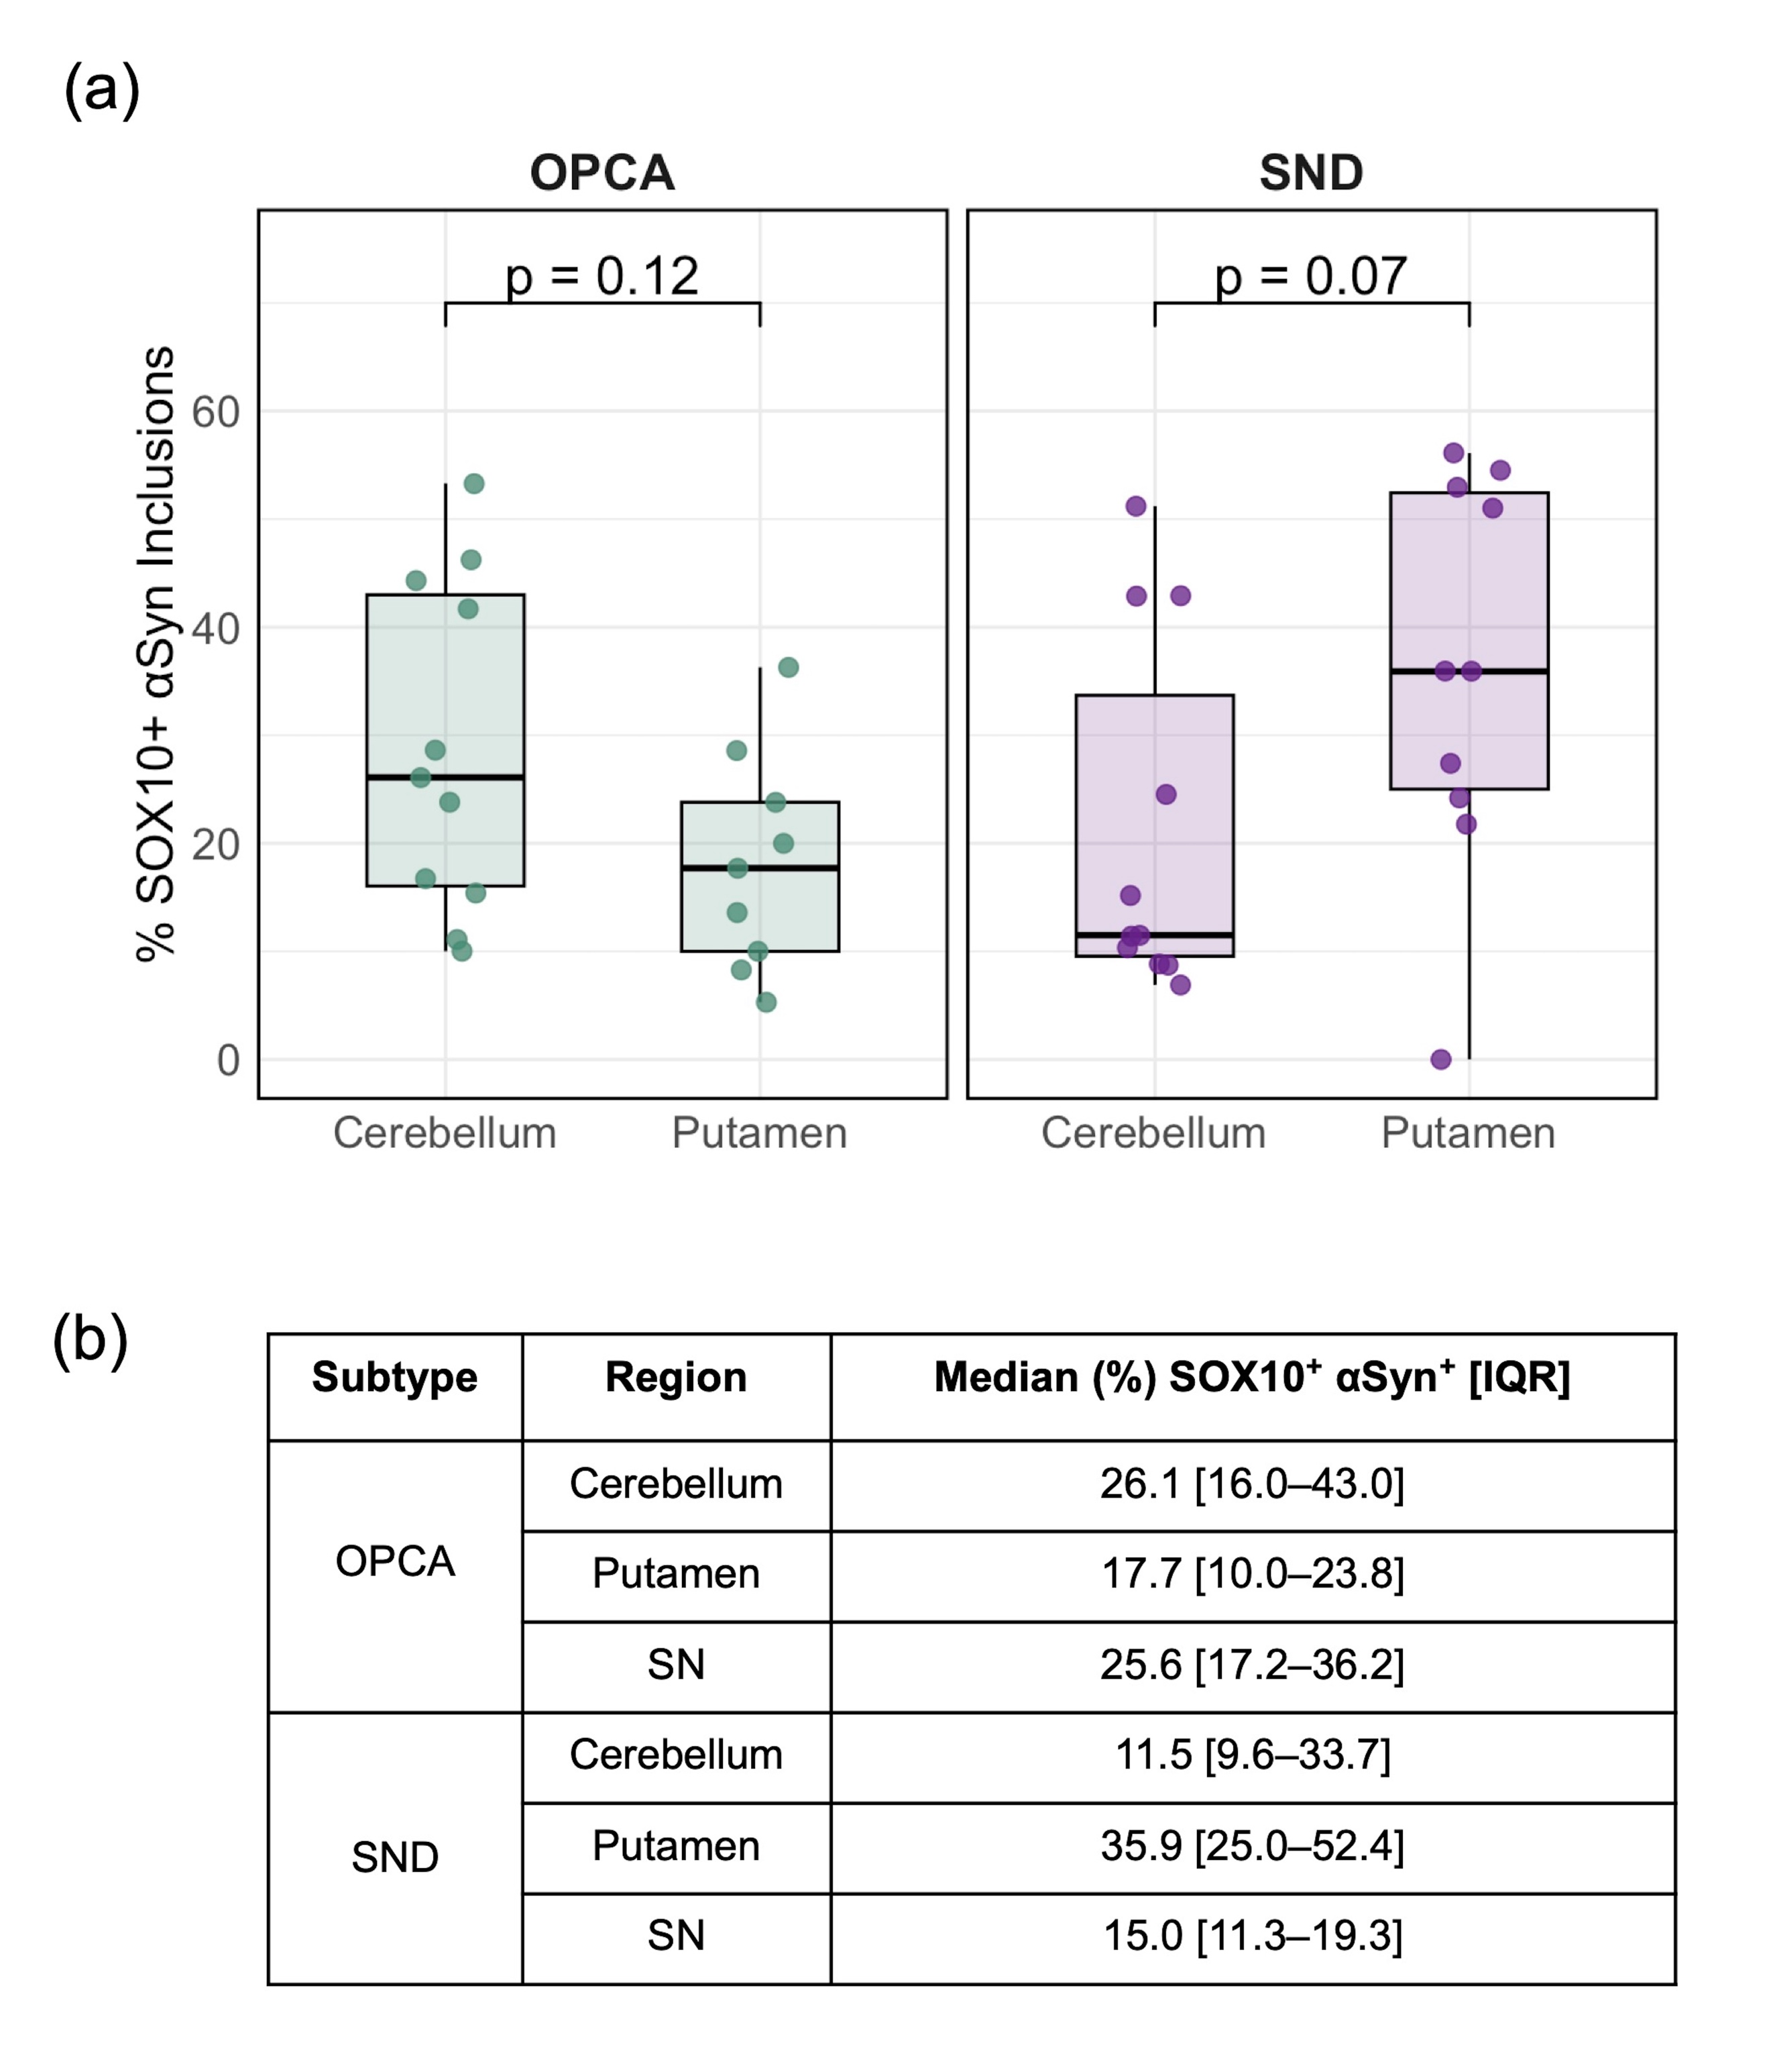

Supplementary Fig 3. Regional distribution of SOX10⁺ α-synuclein⁺ inclusions in MSA subtypes. (A) Comparison of SOX10⁺ α-synuclein⁺ cells across preferentially affected versus less affected regions in SND and OPCA. P-values were calculated using the Mann–Whitney U test. (B) Corresponding summary table of inclusion data presented as median (%) with interquartile range [IQR] for each region and MSA subtype.

Variable 1 | Variable 2 | Group | Rho | p-value
% SOX10⁺ SNCA Gains (All) | % SOX10⁻ SNCA Gains (All) | MSA | 0.50 | < 0.0001*
% SOX10⁺ SNCA Gains (All) | % SOX10⁻ SNCA Gains (All) | Control | 0.22 | 0.17
% SOX10⁺ SNCA Gains (MA) | % SOX10⁺ SNCA Gains (LA) | MSA | 0.56 | 0.02*
% SOX10⁺ SNCA Gains (CER) | % SOX10⁺ SNCA Gains (PUT) | Control | 0.35 | 0.29
% SOX10⁺ SNCA Losses (All) | % SOX10⁻ SNCA Losses (All) | MSA | -0.002 | 0.99
% SOX10⁺ SNCA Losses (All) | % SOX10⁻ SNCA Losses (All) | Control | 0.28 | 0.09
% SOX10⁺ SNCA Losses (MA) | % SOX10⁺ SNCA Losses (LA) | MSA | 0.71 | 0.002*
% SOX10⁺ SNCA Losses (CER) | % SOX10⁺ SNCA Losses (PUT) | Control | 0.24 | 0.47
% SOX10⁺ SNCA Gains (MA) | % SOX10⁺ α-synuclein inclusions (MA) | MSA | 0.49 | 0.02*
% SOX10- SNCA Gains (MA) | % SOX10⁻ α-synuclein inclusions (MA) | MSA | 0.17 | 0.44
% SOX10⁺ SNCA Losses (MA) | % SOX10⁺ α-synuclein inclusions (MA) | MSA | -0.33 | 0.14
% SOX10⁻ SNCA Losses (MA) | % SOX10⁻ α-synuclein inclusions (MA) | MSA | 0.26 | 0.25
Average %  SOX10⁺ SNCA Gains | Age of death (years) | MSA | -0.35 | 0.09
Average %  SOX10⁺ SNCA Gains | Age of death (years) | Control | -0.10 | 0.72
Average %  SOX10⁺ SNCA Gains | Age of onset (years) | MSA | -0.45 | 0.03*
Average %  SOX10⁺ SNCA Gains | Age of onset (years) | Control | N/A | N/A
Average %  SOX10⁺ SNCA Gains | PMI (hours) | MSA | 0.27 | 0.19
Average %  SOX10⁺ SNCA Gains | PMI (hours) | Control | 0.31 | 0.27
Average %  SOX10⁺ SNCA Gains | Disease duration (years) | MSA | 0.10 | 0.63
Average %  SOX10⁺ SNCA Gains | Disease duration (years) | Control | N/A | N/A
Average %  SOX10⁻ SNCA Gains | Age of death (years) | MSA | -0.12 | 0.56
Average %  SOX10⁻ SNCA Gains | Age of death (years) | Control | -0.15 | 0.57
Average %  SOX10⁻ SNCA Gains | Age of onset (years) | MSA | -0.12 | 0.58
Average %  SOX10⁻ SNCA Gains | Age of onset (years) | Control | N/A | N/A
Average %  SOX10⁻ SNCA Gains | PMI (hours) | MSA | 0.13 | 0.52
Average %  SOX10⁻ SNCA Gains | PMI (hours) | Control | 0.30 | 0.30
Average %  SOX10⁻ SNCA Gains | Disease duration (years) | MSA | 0.10 | 0.63
Average %  SOX10⁻ SNCA Gains | Disease duration (years) | Control | N/A | N/A
Average %  SOX10⁺ SNCA Losses | Age of death (years) | MSA | -0.19 | 0.36
Average %  SOX10⁺ SNCA Losses | Age of death (years) | Control | 0.30 | 0.28
Average %  SOX10⁺ SNCA Losses | Age of onset (years) | MSA | -0.06 | 0.79
Average %  SOX10⁺ SNCA Losses | Age of onset (years) | Control | N/A | N/A
Average %  SOX10⁺ SNCA Losses | PMI (hours) | MSA | -0.09 | 0.64
Average %  SOX10⁺ SNCA Losses | PMI (hours) | Control | -0.18 | 0.54
Average %  SOX10⁺ SNCA Losses | Disease duration (years) | MSA | 0.11 | 0.61
Average %  SOX10⁺ SNCA Losses | Disease duration (years) | Control | N/A | N/A
Average %  SOX10⁻ SNCA Losses | Age of death (years) | MSA | -0.04 | 0.85
Average %  SOX10⁻ SNCA Losses | Age of death (years) | Control | 0.23 | 0.41
Average %  SOX10⁻ SNCA Losses | Age of onset (years) | MSA | -0.19 | 0.36
Average %  SOX10⁻ SNCA Losses | Age of onset (years) | Control | N/A | N/A
Average %  SOX10⁻ SNCA Losses | PMI (hours) | MSA | -0.04 | 0.84
Average %  SOX10⁻ SNCA Losses | PMI (hours) | Control | -0.03 | 0.90
Average %  SOX10⁻ SNCA Losses | Disease duration (years) | MSA | 0.16 | 0.45
Average %  SOX10⁻ SNCA Losses | Disease duration (years) | Control | N/A | N/A
Supplementary Table 3. Spearman correlations between SNCA CNVs, α-synuclein inclusions, and demographic variables in MSA and control brains.

Spearman correlation coefficients (Rho) and p-values are shown for relationships between SNCA gains and losses in SOX10⁺ and SOX10⁻ cells, α-synuclein inclusions and demographic variables (age at death, age of onset, post-mortem interval [PMI]). Analyses are shown for all regions, specific brain regions (cerebellum [CER], putamen [PUT], most affected [MA], and lesser affected [LA] regions), and averages across regions. Significant correlations (p < 0.05) are indicated with an asterisk (*) and are in bold. N/A= not applicable.

Supplementary Table 4. Summary of MSA and Control demographics for γh2ax staining
Group | n | Age at death (years) |  | PMI (hours) |  | Age at disease onset (years) |  | Disease duration (years) |  | Sex (M/F)
Group | n | Mean ± SD | Median [IQR] | Mean ± SD | Median [IQR] | Mean ± SD | Median [IQR] | Mean ± SD | Median [IQR] | Sex (M/F)
Control | 3 | 61.7 ± 8.1 | 58 [57–64.5] | 78.9 ± 3.0 | 78.5 [77.3–80.3] | N/A | N/A | N/A | N/A | 1 (33.3%) / 2 (66.7%)
MSA | 8 | 62.8 ± 6.5 | 65.5 [57–67.25] | 67.1 ± 22.8 | 67.5 [55.8–77.15] | 55.7 ± 5.0 | 55 [53.5–58.5] | 8.3 ± 2.9 | 7 [6.5–9.5] | 3 (37.5%) / 5 (62.5%)
p-value |  | Mann Whitney U-test p = 1 |  | Mann Whitney U-test p = 0.18 |  | N/A |  | N/A |  | Fisher’s exact p = 1
Demographic variables are shown for control cases and MSA cases, with SND and OPCA combined. Data are presented as mean ± standard deviation (SD) and median with interquartile range (IQR), as indicated. PMI, post-mortem interval. N/A indicates not applicable.

Supplementary Table 5. Summary of donors used and regions analysed per γH2AX staining experiment
Staining Experiment | Group | Donor | Regions
SOX10 + γH2AX | Control | Control10 | Putamen, Cerebellum
SOX10 + γH2AX | Control | Control12 | Substantia Nigra
SOX10 + γH2AX | OPCA | OPCA04 | Substantia Nigra
SOX10 + γH2AX | OPCA | OPCA12 | Cerebellum
SOX10 + γH2AX | SND | SND03 | Cerebellum, Substantia Nigra
SOX10 + γH2AX | SND | SND12 | Cerebellum, Substantia Nigra
aSyn + γH2AX | Control | Control10 | Putamen, Substantia Nigra
aSyn + γH2AX | Control | Control12 | Cerebellum, Putamen
aSyn + γH2AX | Control | Control14 | Cerebellum, Substantia Nigra
aSyn + γH2AX | OPCA | OPCA10 | Cerebellum, Substantia Nigra
aSyn + γH2AX | OPCA | OPCA02 | Cerebellum
aSyn + γH2AX | OPCA | OPCA05 | Cerebellum
aSyn + γH2AX | OPCA | OPCA04 | Putamen
aSyn + γH2AX | SND | SND03 | Cerebellum
aSyn + γH2AX | SND | SND11 | Substantia Nigra
The table lists control, OPCA, and SND donors analysed by combined SOX10 or α-synuclein (aSyn) immunostaining with γH2AX, together with the brain regions examined for each donor.

