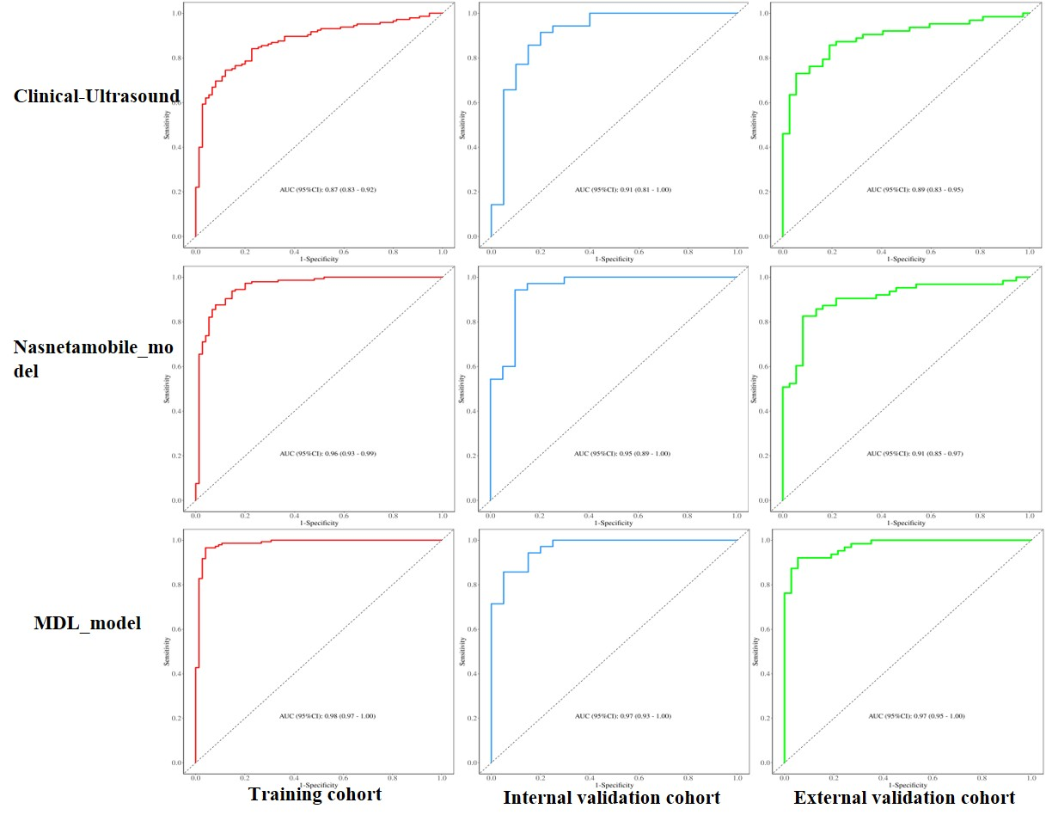
Supplementary figure S1 Comparison of ROC curves for the three diagnostic models across the training, internal validation, and external test cohorts

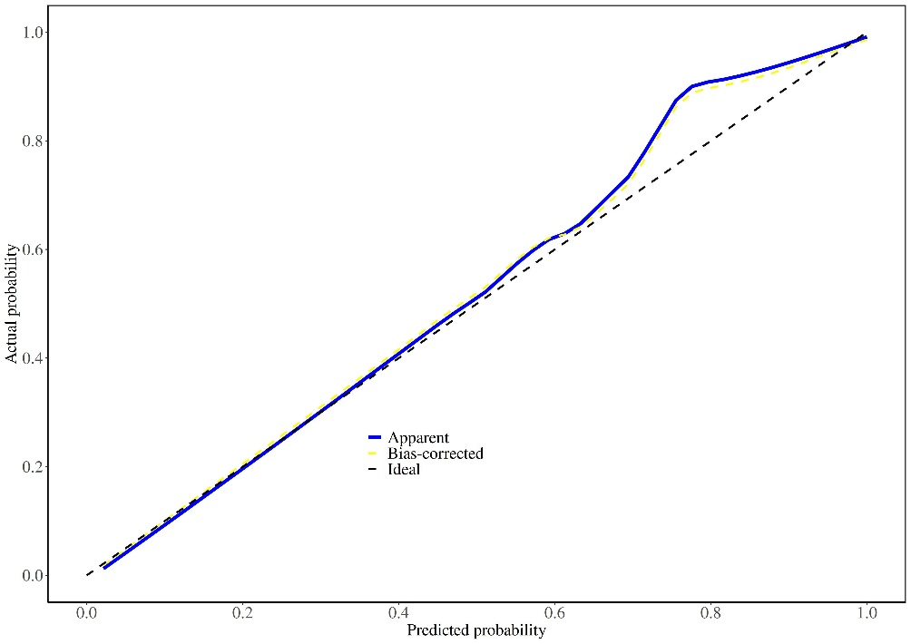
Supplementary figure S2 Calibration curve of the integrated nomogram for predicting NOA in the validation cohort.
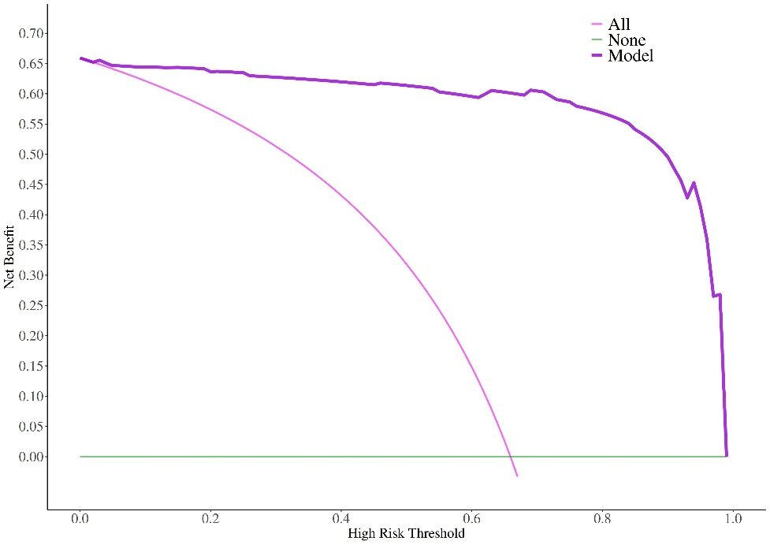

Supplementary figure S3 Decision curve analysis evaluating the clinical utility of the three diagnostic models for NOA.

Supplementary Table S1: Laboratory Findings in Normal Controls, Obstructive Azoospermia, and Non-Obstructive Azoospermia Groups
Variables | Total (n = 488) | OA (n = 131) | NOA (n = 244) | Normal  (n=113) | Statistic | P
BMI | 25.29 ± 3.72 | 24.92 ± 3.59 | 25.55 ± 3.75 | 25.13± 3.78 | -0.50a | 0.618
Age | 31.00 ± 3.92 | 31.05 ± 3.82 | 31.17 ± 3.83 | 30.58 ± 4.22 | -1.31a | 0.189
Smoking duration | 7.00  (0.00, 10.00) | 7.50  (0.00, 10.00) | 6.00  (0.00, 10.00) | 7.00  (0.00,10.00) | -0.40b | 0.686
Quantity of cigarettes  smoked | 0.50  (0.00, 1.00) | 0.50  (0.00, 1.00) | 0.50  (0.00, 2.00) | 0.50  (0.00, 1.00) | -0.60b | 0.550
Night Shift, n (%) |  |  |  |  | 0.01b | 0.912
No | 119 (24.39) | 36 (27.48) | 55 (22.54) | 28 (24.78)
Yes | 369 (75.61) | 95 (72.52) | 189 (77.46) | 85 (75.22)
High temperature, n (%) |  |  |  |  | 3.04b | 0.081
No | 447 (91.60) | 122 (93.13) | 226 (92.62) | 99 (87.61)
Yes | 41 (8.40) | 9 (6.87) | 18 (7.38) | 14 (12.39)
Radiation, n (%) |  |  |  |  | 0.00b | 1.000
No | 484 (99.18) | 130 (99.24) | 242 (99.18) | 112 (99.12)
Yes | 4 (0.82) | 1 (0.76) | 2 (0.82) | 1 (0.88)
Sedentary behavior, n (%) |  |  |  |  | 1.47b | 0.225
No | 265 (54.30) | 69 (52.67) | 129 (52.87) | 67 (59.29)
Yes | 223 (45.70) | 62 (47.33) | 115 (47.13) | 46 (40.71)
Diabetes, n (%) |  |  |  |  | - | 1.000
No | 487 (99.80) | 131 (100.00) | 243 (99.59) | 113 (100.00)
Yes | 1 (0.20) | 0 (0.00) | 1 (0.41) | 0 (0.00)
Hypertension, n (%) |  |  |  |  | 0.00b | 1.000
No | 474 (97.13) | 126 (96.18) | 238 (97.54) | 110 (97.35)
Yes | 14 (2.87) | 5 (3.82) | 6 (2.46) | 3 (2.65)
Alcohol consumption, n (%) |  |  |  |  | 89.63b | <0.001*
No | 259 (53.07) | 47 (35.88) | 108 (44.26) | 104 (92.04)
Yes | 229 (46.93) | 84 (64.12) | 136 (55.74) | 9 (7.96)
Note: n:number of patients; BMI: Body Mass Index; a: ANOVA, b: Kruskal-waills test

Supplementary table S2: Ultrasonographic and Hormonal Parameters in Azoospermia versus Healthy Controls
Variables | Total (n =388) | Azoospermia  (n =275) | Normal(n=113) | Statistic | P
Testicular volume,  M (Q₁, Q₃) | 12.57  (8.50, 15.76) | 11.70  (7.00, 15.27) | 13.60  (11.43, 16.66) | -4.29ª | <0.001*
RI, Mean ± SD | 0.63 ± 0.10 | 0.64 ± 0.11 | 0.60 ± 0.06 | -4.37^{b} | <0.001*
PSV, Mean ± SD | 7.42 ± 2.20 | 7.25 ± 2.28 | 7.83 ± 1.94 | 2.37^{b} | <0.018
EDV, Mean ± SD | 2.83 ± 0.98 | 3.07 ± 0.83 | 2.72 ± 1.01 | 3.51^{b} | <0.001*
Mean, Mean ± SD | 4.41 ± 1.52 | 4.77 ± 1.22 | 4.27 ± 1.60 | 3.39^{b} | <0.001*
SWE, M (Q₁, Q₃) | 1.65  (1.44, 1.94) | 1.59  (1.37, 1.94) | 1.75  (1.55, 1.94) | -3.14ª | 0.002*
FSH, M (Q₁, Q₃) | 7.31  (4.42, 18.48) | 11.10  (4.88, 23.71) | 5.11  (3.79, 7.46) | -7.13ª | <0.001*
LH, M (Q₁, Q₃) | 6.12  (4.20, 9.79) | 6.73  (4.20, 11.02) | 5.60  (4.30, 6.81) | -3.35ª | <0.001*
T, M (Q₁, Q₃) | 4.50  (3.16, 7.90) | 4.12  (2.79, 6.92) | 5.02  (4.02, 8.90) | -3.62ª | <0.001*
E2, M (Q₁, Q₃) | 31.00  (23.22, 41.79) | 30.80  (23.30, 42.25) | 31.40  (23.10, 41.70) | -0.33ª | 0.743
PRL, M (Q₁, Q₃) | 13.38  (9.73, 22.20) | 13.80  (9.79, 26.00) | 12.20  (9.13, 16.86) | -2.64ª | 0.008*
Note: n: number of testicular Statistic: a: Mann-Whitney test; b: t-test,
SD: standard deviation, M: Median, Q₁: 1st Quartile, Q₃: 3st Quartile

