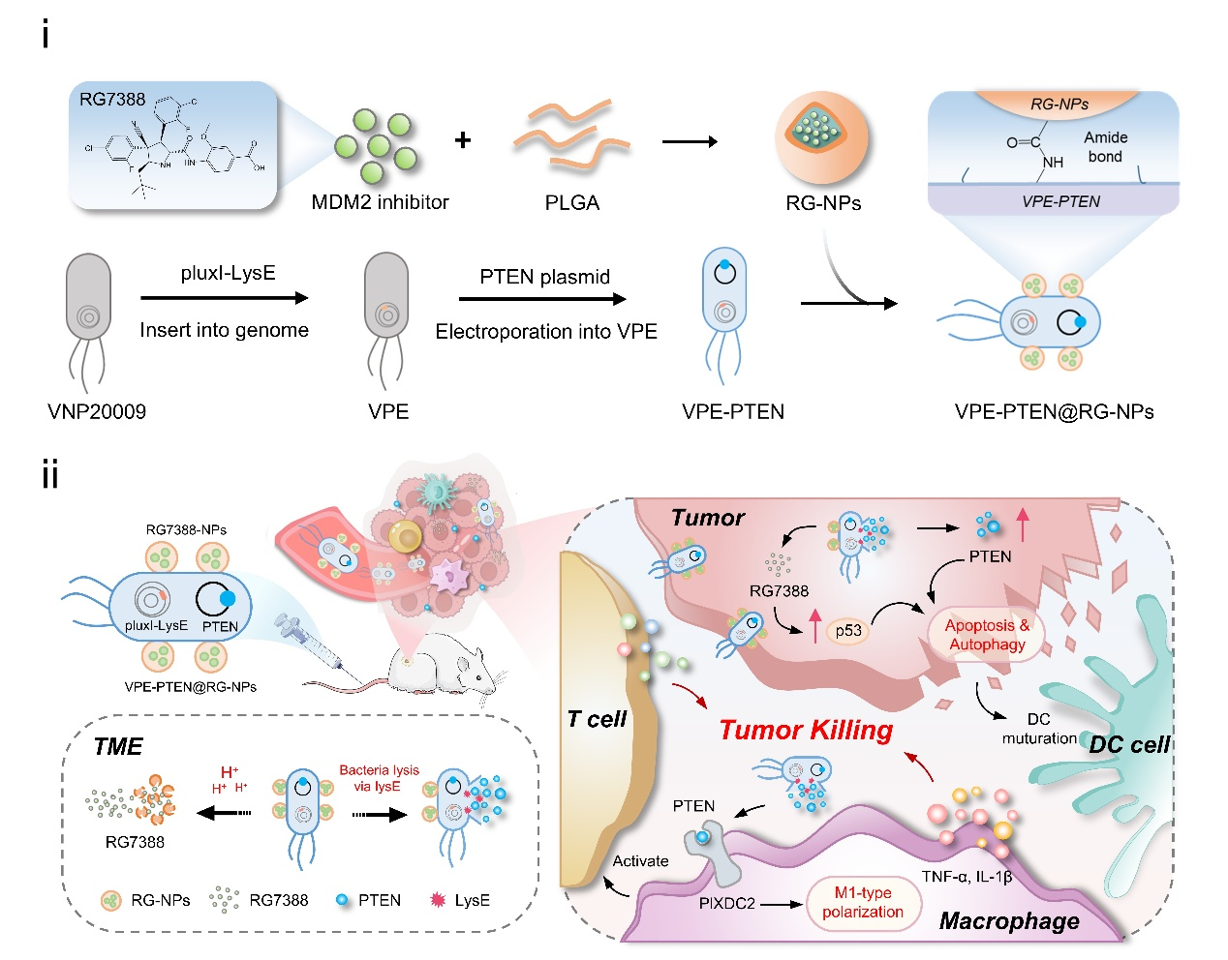
Scheme 1. Schematic illustration of the preparation process and anti-tumor mechanisms of VPE-PTEN@RG-NPs. (i) A biohybrid therapeutic platform of VPE-PTEN@RG-NPs was constructed by integrating a genetically engineered VNP strain with RG7388-loaded nanoparticles (RG-NPs). The VNP strain incorporates a QS-regulated lysis and PTEN expression system, which controls bacteria in a limited density and promotes PTEN release. (ii) Leveraging the intrinsic tumor-targeting capability and intracellular parasitism of VNP, PTEN proteins and RG7388 were efficiently delivered into tumor cells. Sustained release of RG7388 elevated intracellular p53 levels, synergizing with PTEN to restore tumor suppressor functions and induce tumor cell apoptosis and autophagy. Moreover, released PTEN promoted polarization of tumor-associated macrophages from the M2 to M1 phenotype, activating immune responses for synergized antitumor immunotherapy.

