Dual-gRNA approach with limited off-target effect corrects C9ORF72 repeat expansion in vivo

Xuejiao Piao^{1, 2, 3, 4, 5}, Dawei Meng^{1, 2, 3, 4, 5}, Xue Zhang^{1, 3, 4, 5}, Qiang Song^{1, 4}, Hailong Lv^{1, 2, 3, 4}, and Yichang Jia^{1, 3, 4, #}

¹ School of Medicine, Medical Science Building, Room D204, Tsinghua University, Beijing, China, 100084.
² School of Life Sciences, Tsinghua University
³ Peking-Tsinghua Joint Center for Life Sciences.
⁴ IDG/McGovern Institute for Brain Research at Tsinghua.
⁵ These authors contributed equally to this work.

# Corresponding author
Please address correspondence to:
Yichang Jia, Ph.D.
School of Medicine, Medical Science Building, Room D204, Tsinghua University, Beijing, 100084, P. R. China
Tel: 86-10-62781045
Email: yichangjia@tsinghua.edu.cn
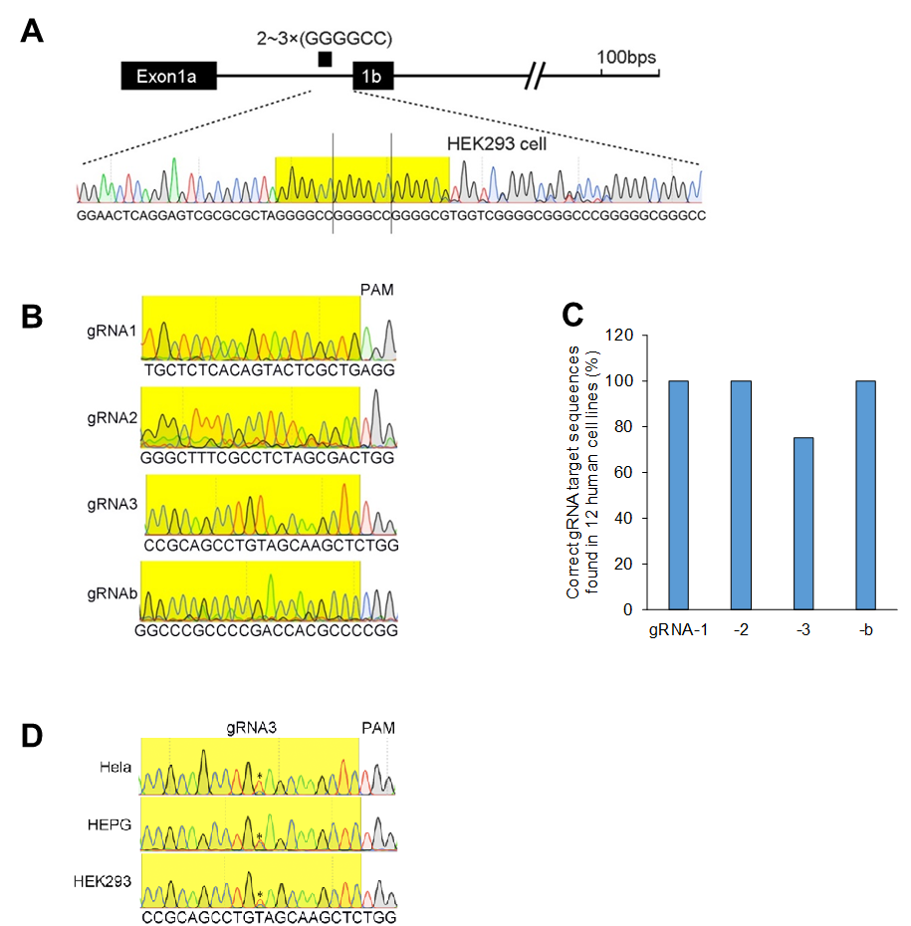
Supplementary Fig. 1. The existence of the repeat site and our gRNA target sequences in human cell lines we examined.
(A) In HEK293 cell, 2~3 GGGGCC repeats in the C9ORF72 intron. (B) The target sequences of gRNA1, gRNA2, gRNA3, and gRNAb were detected by Sanger sequencing in HEK293 cell. (C and D) No genetic variance was detected in gRNA1, 2, and b target sequences in the 12 human cell lines we examined, including BJ, HaCaT, HEK293, Hela, HEPG, Huh7.5, HUVEC, IMR-90, MRC-5, OS-732, SH-SY5Y, and U2OS cells. A SNP (asterisk in D) in gRNA3 target sequences was detected in 3 out of these 12 cell lines.

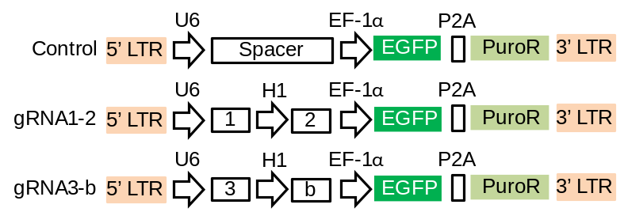
Supplementary Fig. 2. Lentiviral dual-gRNA delivery system.
The system modified from previous studies (PMID: 26493208 and 25075903). The dual gRNAs are driven by U6 and H1 promoters, separately. In control, the sequences downstream of U6 promoter are spacer sequences (PMID: 25075903).

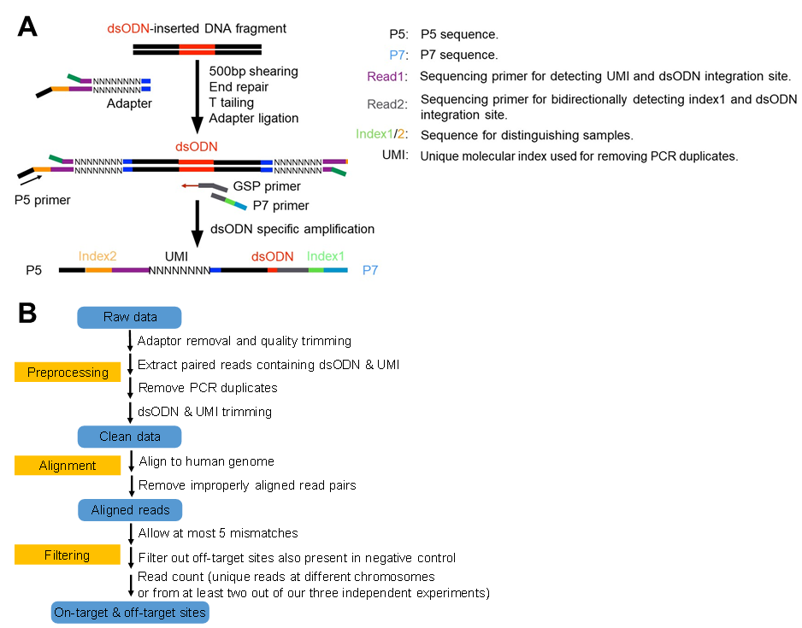
Supplementary Fig. 3. The pipeline of GUIDE-seq. (A) Schematic overview of GUIDE-seq (PMID: 24584096) with slight modification. HEK293 cells constructively expressing Cas9 were transfected with dual gRNAs together with a blunt double-stranded oligodeoxynucleotide (dsODN). Genomic DNA containing oligo tag integration sites were sheared into 500bps in length. After adaptor ligation, the resulting products were amplified by oligo tag specific amplification and applied for next-generation sequencing. UMI (unique molecular index) was used for removing the PCR duplicates and counting the numbers of unique integration sites. (B) The flow of GUIDE-seq data analysis. In brief, the raw data went through three major steps to achieve the reliable dsODN integration sites. We included off-target events that were supported by unique reads at different chromosomes or from at least two out of our three independent experiments.

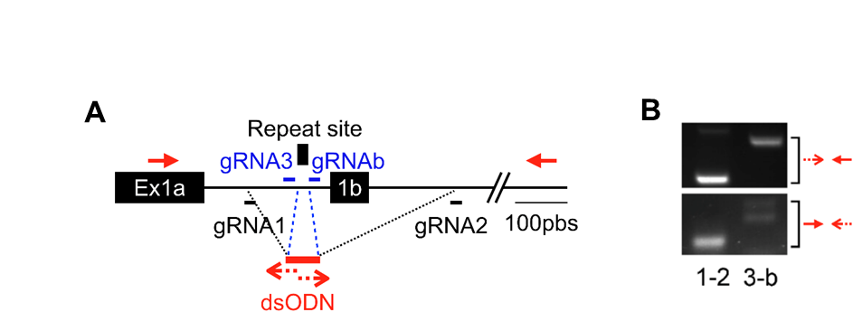
Supplementary Fig. 4. Validation of on-target integration of dsODN. (A) The primer locations for the validation. (B) The on-target integration sites were validated by genomic DNA PCR with the indicated primers (A) in HEK293 cells constructively expressing Cas9 and transfected with the gRNA1-2 or gRNA3-b together with dsODN.

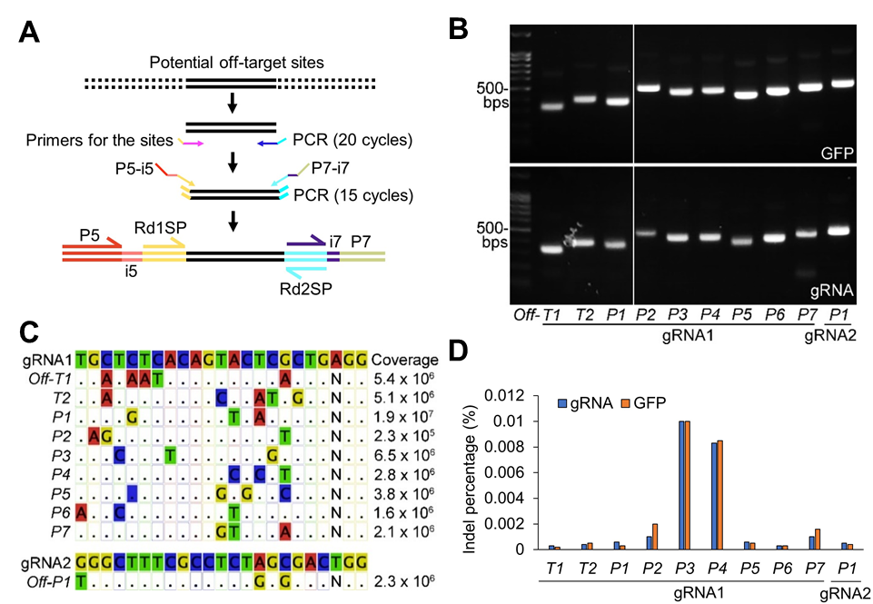
Supplementary Fig. 5. Confirmation of off-targets of gRNA1 and gRNA2. (A) Schematic overview of our off-target confirmation by targeted deep sequencing. Index 5, i5; index 7, i7; Rd1SP, Read 1 sequencing primer; Rd2SP, Read 2 sequencing primer (Illumina). (B) HEK293 cells constitutively expressing Cas9 were transfected with GFP, gRNA1, or gRNA2. The PCR amplicons of off-target sites of gRNA1 and gRNA2 identified by GUIDE-seq (Supplementary Table 2). (C) Targeted deep sequencing coverage of individual off-target sites. (D) Percentage of off-target site indels in HEK293 cells constructively expressing Cas9 and transfected with gRNA1, gRNA2 or GFP.

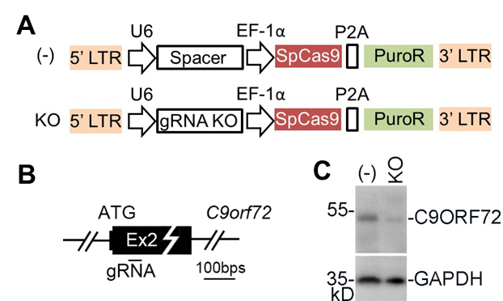
Supplementary Fig. 6. Validation of a C9ORF72 antibody. (A) For C9ORF72 antibody validation, we employed a lentiviral Crispr/Cas9-based gene knock-out (KO) system (PMID, 25075903). (B) The genome location of gRNA for C9ORF72 KO. (C) The protein lysates from the control (-) or HEK293 cells infected with lentiviral particles expressing the KO gRNA were blotted with the C9ORF72 antibody.

Supplementary Fig. 7. Deletion of repeat site and exon 1b by gRNA1-2 on C9ORF72 protein expression in U251 and SH-SY5Y cells. (A) Genomic DNA PCR for detecting the removal of repeat site and exon 1b (ΔRepeats+E1b) by gRNA1-2 in U251 and SH-SY5Y cells, respectively. The cells constitutively expressing Cas9 were infected with the lentiviral control and gRNA1-2, respectively (Supplementary Fig. 2). The band of ΔRepeats+E1b appeared in cells infected with gRNA1-2 but not control (-) due to the removal of the GC-rich region. Here we lowered high GC buffer in the PCR condition as shown in Fig. 1D. (B and C) The deletion bands (Δ) shown in (A) were applied for both forward and reverse Sanger sequencing. In b, U251; in c, SH-SY5Y. (D) Representative image of C9ORF72 immunoblot from U251 and SH-SY5Y cells infected with control (-) or gRNA1-2 lentiviral particles. TUBULIN served as loading control. (E) Relative expression of C9ORF72 (normalized to TUBULIN) shown in (D). In e, the protein lysates from at least three biological replicates and the values presented as mean ± SEM (n= 3). N.S., no statistical significance (t-test, SPSS).
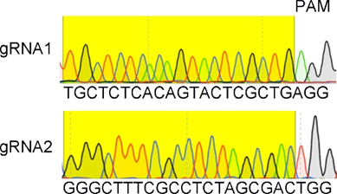
Supplementary Fig. 8. The existence of our gRNA target sequences in C9ORF72-BAC transgenic mouse. The C9ORF72-BAC transgenic mouse (C9-Tg) carries the expanded GGGGCC repeats from patient (C9-Tg mouse line 112, PMID: 26637796). The gRNA1 and gRNA2 target sequences were detected in this transgenic mouse by Sanger sequencing.

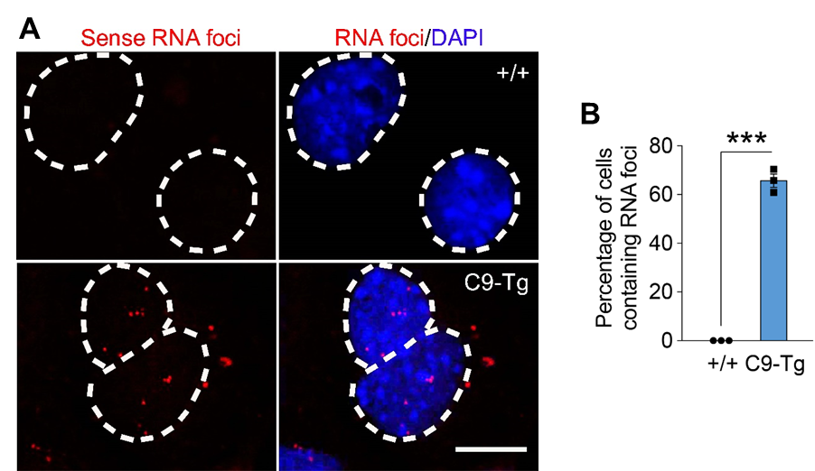
Supplementary Fig. 9. The RNA foci shown in the primary cortical cultures carrying patient repeats. (A and B) Sense RNA foci were detected in the primary cortical cultures derived from the C9ORF72-BAC transgenic (C9-Tg) mice but not in the wild type (+/+) control. In a, the dotted line circled nuclei of cultured neurons with indicated genotypes. In B, the RNA foci counts from three biological replicates and the values are presented as mean ± SEM (n = 3). ***p <0.001 (t-test, SPSS). Scale bar in (A), 10 μm.

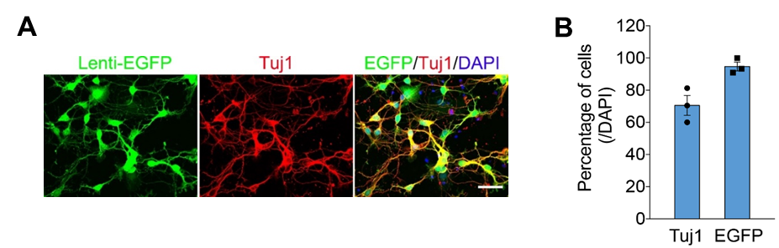
Supplementary Fig. 10. Our lentiviral infection rate in our primary cortical cultures. (A) Representative images of our primary cortical cultures (P2, 4 DIV) isolated from wild type (+/+) mouse. Tuj-1 was used as a neuronal marker. Scale bar, 20 μm. (B) The percentage of Tuj-1 and GFP-positive cells in our cultures. The values are presented as mean ± SEM (n = 3).

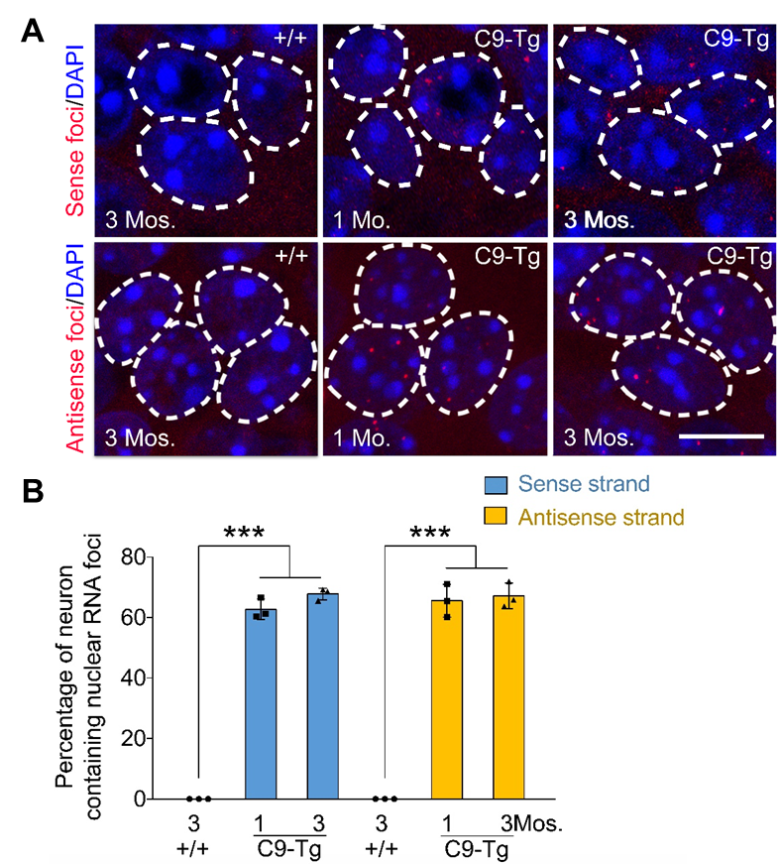
Supplementary Fig. 11. The RNA foci shown in hippocampal CA1 regions in C9-Tg mice. (a) Both sense and antisense RNA foci were detected in C9-Tg hippocampal CA1 neurons at indicated age points. The dotted line circled nuclei of CA1 neurons with indicated genotypes and ages. Mo., month. (b) Data summary of sense and antisense RNA foci detected in CA1 neurons shown in (a). The values are presented as mean ± SEM (n = 3). ***p <0.001 (ANOVA, SPSS). In (a), scale bar,10 μm.

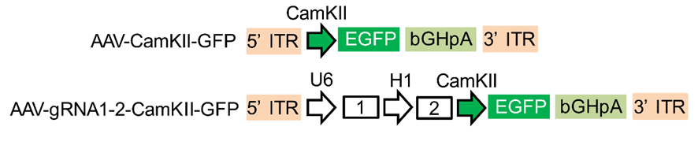
Supplementary Fig. 12. AAV-based dual-gRNA delivery system in vivo. The GFP driven by CamKII promoter is used for tracing the infected regions and neurons in vivo.

Supplementary Fig. 13. Original uncropped DNA gel for Supplementary Fig. 5B.
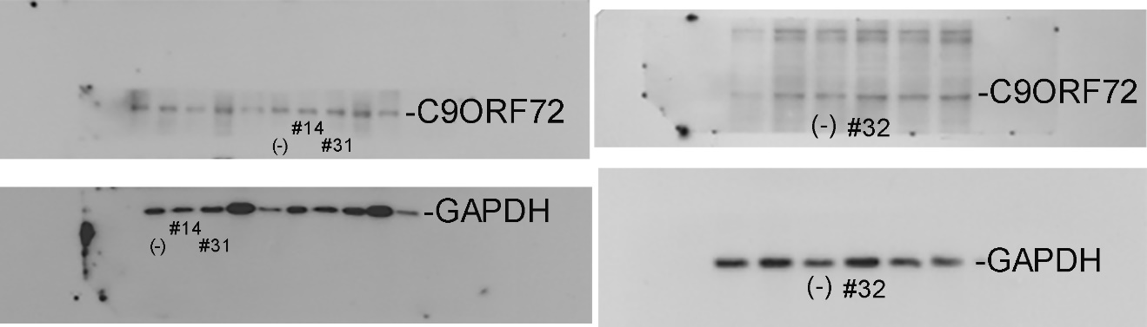Supplementary Fig. 14. Original uncropped western blot images for Fig. 3F.

