Supplementary Table S1. Collection of plant material for nodule sequencing. Collectors were Ulrike Mathesius (UM), Philippe Normand (PN), Ngiam Jia Jun (NJJ), Tiberius Jimbo (TJ). NHM, Natural History Museum.
Country | Location | Collection date | Sampling point coordinates | Genome | Collector | Host | Herbarium voucher Sweden NHM; Reg. No.
Australia | Casuarina Sands | 17/04/2021 | -35.3193 S, 148.9525 E | CcCS1 | UM | C. cunninghamiana | S25-8658
Australia | Casuarina Sands | 17/04/2021 | -35.3193 S, 148.9525 E | CcCS3 | UM | C. cunninghamiana | S25-8657
Australia | Wombeyan Caves | 30/05/2021 | -34.3038 S, 149.9721 E | CcWB2 | UM | C. cunninghamiana | S25-8656
Australia | Wombeyan Caves | 30/05/2021 | -34.3038 S, 149.9721 E | CcWB3 | UM | C. cunninghamiana | S25-8655
Australia | Molonglo | 02/05/2021 | -35.2469 S, 148.9647 E | CcMO1 | SM | C. cunninghamiana | S25-8666
Australia | Arakoon | 23/12/2021 | -30.8929 S, 153.0666 E | CgARK3 | UM | C. glauca | S25-8654
Australia | Jervis Bay | 14/06/2021 | -35.1182 S, 150.6998 E | CgJB1 | UM | C. glauca | S25-8653
Australia | Jervis Bay | 14/06/2021 | -35.1182 S, 150.6998 E | CgJB3 | UM | C. glauca | S25-8652
Australia | Kioloa | 07/03/2021 | -35.5581 S, 150.3828 E | CgKIO3 | UM | C. glauca | S25-8649
Australia | Roseville | 03/01/2022 | -33.7767 S, 151.2073 E | CgROS2 | UM | C. glauca | S25-8648
Australia | Trial Bay | 23/12/2021 | -30.8794 S, 153.0699 E | CgTRI1 | UM | C. glauca | S25-8651
Australia | Trial Bay | 23/12/2023 | -30.8794 S, 153.0699 E | CgTRI2 | UM | C. glauca | S25-8650
Singapore | Coney Island¹ | 23/11/2021 | 1.4156 S, 103.9174 E | CeCAU1 | NJJ | C. equisetifolia | S25-8642
Singapore | Coney Island¹ | 23/11/2021 | 1.4156 S, 103.9174 E | CeCAU2 | NJJ | C. equisetifolia | S25-8646
Papua New Guinea | Morobe-Bulolo | 24/07/2021 | -7.2065 S, 146.6248 E | CoBUL1 | TJ | C. oligodon | S25-8662
Papua New Guinea | Morobe-Wau | 25/07/2021 | -7.3282 S, 146.7574 E | CoWAU3 | TJ | C. oligodon | S25-8661
Papua New Guinea | Morobe-Wau | 25/07/2021 | -7.3282 S, 146.7574 E | CoWAU4 | TJ | C. oligodon | S25-8660
French Polynesia | Rurutu | 18/03/2025 | -22.4383 S, -151.3747 E | CeRuru1 | PN | C. equisetifolia | S25-8659
French Polynesia | Tahiti, Mahina | 23/03/2025 | -17.4963 S, -149.4946 E | CeTa2Mahina | PN | C. equisetifolia | S25-8665
French Polynesia | Tahiti, Moorea | 21/03/2025 | -17.4906 S, -149.9048 E | CeTa3Moorea | PN | C. equisetifolia | S25-8664
French Polynesia | Tahiti, Puna'auia | 24/03/2025 | -17.6329 S, -149.6154 E | CeTa4Puna'auia | PN | C. equisetifolia | S25-8663
¹Trees from self-sown material of unknown origin.

Supplementary Table S2. Host plant species identification based on morphological criteria. Determination based on Castle W and Andreu M (2008): Field Guide to Identify the Common Casuarina (Australian Pine) Species in Florida. University of Florida. New South Wales Flora Online, PlanNET (available at https://plantnet.rbgsyd.nsw.gov.au) and on https://edis.ifas.ufl.edu/publication/HS394.
 |  | Options based on distribution¹ |  | Description of phyllodes
Sample | Location | Casuarina species | Allocasuarina species | articles and phyllicnia | teeth | Remarks |  | Identification
 |  | C. cunninghamiana |  | articles 4–9 mm long, 0.4–0.7 mm diameter | 6-9, 0.3-0.8 mm long, traverse brown band in the middle of the teeth, white tips
 |  | C. equisetifolia |  | articles 7–13 mm long, 0.7–1.0 mm diameter | 6-10, 0.7 mm long, light green to light yellow, no traverse band
 |  | C. glauca |  | articles 8-20 mm long, 0.9-1.2 mm diameter | 12-20, brown traverse band at base
 |  | C. oligodon |  |  | 6 teeth, 0.8-1 mm long (ssp. oligodon, the one present in PNG)
 |  |  | A. littoralis | articles 4–10 mm long, 0.4–1.0 mm diameter | 6-8, 0.3-0.9 mm long
 |  |  | A. verticillata | articles 15–40 mm long | 9-13, 0.7-1.2 mm long
BUL1 | PNG forest, morobe-Bulolo | C. oligodon |  | articles 5.5 mm long | 6 teeth, 1 mm long, white at the tips | consistent with result of distribution |  | C. oligodon
WAU3 | PNG forest, Morobe-Wau | C. oligodon |  | articles 5 mm long | 6 teeth, 1 mm long, white at the tips | consistent with result of distribution |  | C. oligodon
WAU4 | PNG forest, Morobe-Wau | C. oligodon |  | articles 5.5 mm long | 6 teeth, 1.2 mm long, white at the tips | consistent with result of distribution |  | C. oligodon
CAU1 | Singapore, Coney Island | C. equisetifolia |  |  |  | based on distribution |  | C. equisetifolia
CAU2 | Singapore, Coney Island | C. equisetifolia |  |  |  | based on distribution |  | C. equisetifolia
CS1 | NSW, SC, inland Casuarina Sands | C. glauca,  C. cunninghamiana | A. littoralis,  A. verticillata | 5.5 mm, sharp white central phyllichnia ridges | 7 teeth, horizontal brown stripe in middle, white tips; 0.5 mm long |  |  | C. cunninghamiana
CS3 | NSW, SC, inland Casuarina Sands | C. glauca,  C. cunninghamiana | A. littoralis,  A. verticillata | 4.9 mm, sharp white central phyllichnia ridges | 8 teeth, horizontal brown stripe in middle, white tips; 0.6 mm long |  |  | C. cunninghamiana
WB2 | NSW, SC, inland Wombeyan Caves | C. glauca,  C. cunninghamiana | A. littoralis,  A. verticillata | 4.9 mm, sharp white central phyllichnia ridges | 8 teeth, horizontal brown stripe in middle, white tips; 0.3 mm long |  |  | C. cunninghamiana
WB3 | NSW, SC, inland Wombeyan Caves | C. glauca,  C. cunninghamiana | A. littoralis,  A. verticillata | 5 mm, sharp white central phyllichnia ridges | 8 teeth, horizontal brown stripe in middle, white tips; 0.3 mm long |  |  | C. cunninghamiana
MO1 | NSW, SC, inland Molonglo | C. glauca,  C. cunninghamiana | A. littoralis,  A. verticillata | 5.5 mm, sharp white central phyllichnia ridges | 8 teeth, white-ish with horizontal brown stripe; 0.5 mm long |  |  | C. cunninghamiana
ARK3 | NSW, SC, coast Arakoon | C. glauca,  C. cunninghamiana | A. littoralis,  A. verticillata | 11 mm x 0.9 mm, furrows visible, no central ridges | >12 teeth, light brown in young state, then light green with light brown tips, 0.5 mm long |  |  | C. glauca
JB1 | NSW, SC, coast Jervis Bay 1 | C. glauca,  C. cunninghamiana | A. littoralis,  A. verticillata | 8 mm x 0.8 mm, furrows visible, no central ridges | >12 teeth, brown in young state, later white-ish with horizontal brown stripe, 0.65 mm long |  |  | C. glauca
JB3 | NSW, SC, coast Jervis Bay 3 | C. glauca,  C. cunninghamiana | A. littoralis,  A. verticillata | 9.5 mm x 1 mm, furrows visible, no central ridges | >12 teeth, brown in young state, later white-ish with horizontal brown stripe, 0.8 mm long |  |  | C. glauca
KIO3 | NSW, SC, coast Kioloa 3 | C. glauca,  C. cunninghamiana | A. littoralis,  A. verticillata | 11 mm x 1 mm, furrows visible, no central ridges | >14 teeth, brown in young state, later white-ish with brown tips, 0.7 mm long |  |  | C. glauca
ROS2 | NSW, SC, coast Roseville 2 | C. glauca,  C. cunninghamiana | A. littoralis,  A. verticillata | 11 mm x 1 mm, furrows visible, no central ridges | >14 teeth, dark brown, 1.1 mm long |  |  | C. glauca
TRI1 | NSW, SC, coast Trial Bay 1 | C. glauca,  C. cunninghamiana | A. littoralis,  A. verticillata | 9 mm x 1 mm, furrows visible, no central ridges | >14 teeth, dark brown, 0.4 mm long |  |  | C. glauca
TRI2 | NSW, SC, coast Trial Bay 2 | C. glauca,  C. cunninghamiana | A. littoralis,  A. verticillata | 10 mm x 1 mm, furrows visible, no central ridges | >14 teeth, dark brown, 0.4 mm long |  |  | C. glauca
Ruru1 | Rurutu | C. equisetifolia |  |  |  | based on distribution |  | C. equisetifolia
Ta2Mahina | Mahina, Tahiti | C. equisetifolia |  |  |  | based on distribution |  | C. equisetifolia
Ta3Moorea | Moorea | C. equisetifolia |  |  |  | based on distribution |  | C. equisetifolia
Ta4Puna'auia | Puna'auia, Tahiti | C. equisetifolia |  |  |  | based on distribution |  | C. equisetifolia
¹https://plantnet.rbgsyd.nsw.gov.au, https://powo.science.kew.org/taxon/urn:lsid:ipni.org:names:159856-1, https://www.cabidigitallibrary.org/doi/full/10.1079/cabicompendium.16727#:~:text=Importance-,C.,%2C%20Indonesia%20(subspecies%20abbreviata)

Supplementary Table S3. Accession numbers of the MAGs in this study.
Assembly_name | Assembly acc. | Study ID | Sample ID | Contig accession
CcCS1 | GCA_977929135 | PRJEB105188 | ERS28324665 | CDWRCQ010000001-CDWRCQ010000439
CcCS3 | GCA_977927575 | PRJEB105190 | ERS28324699 | CDWRCL010000001-CDWRCL010000367
CcWB2 | GCA_977927585 | PRJEB105192 | ERS28324700 | CDWRCM010000001-CDWRCM010000336
CcWB3 | GCA_977927595 | PRJEB105193 | ERS28324794 | CDWRCK010000001-CDWRCK010000403
CcMO1 | GCA_977945845 | PRJEB105301 | ERS28330457 | CDWTMG010000001-CDWTMG010000405
CgARK3 | GCA_977947125 | PRJEB105305 | ERS28330464 | CDWTNC010000001-CDWTNC010000376
CgJB1 | GCA_977947065 | PRJEB105308 | ERS28330469 | CDWTNB010000001-CDWTNB010000292
CgJB3 | GCA_977947655 | PRJEB105309 | ERS28330471 | CDWTNW010000001-CDWTNW010000292
CgKIO3 | GCA_977946435 | PRJEB105307 | ERS28330467 | CDWTMO010000001-CDWTMO010000291
CgROS2 | GCA_977946925 | PRJEB105313 | ERS28330475 | DWTNA010000001-CDWTNA010000448
CgTRI1 | GCA_977946335 | PRJEB105310 | ERS28330473 | DWTMR010000001-CDWTMR010000409
CgTRI2 | GCA_977946315 | PRJEB105311 | ERS28330474 | CDWTML010000001-CDWTML010000372
CeCAU1 | GCA_977971845 | PRJEB105746 | ERS28378617 | CDWWXA010000001-CDWWXA010000263
CeCAU2 | GCA_977971825 | PRJEB105748 | ERS28378619 | CDWWWZ010000001-CDWWWZ010000302
CoBUL1 | GCA_978021245 | PRJEB106570 | ERS28483422 | CDXDOS010000001-CDXDOS010000368
CoWAU3 | GCA_977971855 | PRJEB105749 | ERS28378620 | CDWWXB010000001-CDWWXB010000342
CoWAU4 | GCA_977971835 | PRJEB105750 | ERS28378621 | CDWWXC010000001-CDWWXC010000363
CeRuru1 | GCA_977966315 | PRJEB105383 | ERS28338312 | CDWWEW010000001-CDWWEW010000544
CeTa2Mahina | GCA_978021235 | PRJEB106572 | ERS28485072 | CDXDOT010000001-CDXDOT010000745
CeTa3Moorea | GCA_978021225 | PRJEB106574 | ERS28485074 | CDXDOR010000001-CDXDOR010000288
CeTa4Puna'auia | GCA_978021265 | PRJEB106575 | ERS28485087 | CDXDOU010000001-CDXDOU010000798

Supplementary Table S4. Frankia casuarinae genomes from NCBI used in this study.
Accession | strain | remarks | reference
CP000249.1 | CcI3 | type strain | Normand P, Lapierre P, Tisa LS, Gogarten JP, Alloisio N, Bagnarol E, Bassi CA, Berry AM, Bickhart DM, Choisne N, Couloux A, Cournoyer B, Cruveiller S, Daubin V, Demange N, Francino MP, Goltsman E, Huang Y, Kopp OR, Labarre L, Lapidus A, Lavire C, Marechal J, Martinez M, Mastronunzio JE, Mullin BC, Niemann J, Pujic P, Rawnsley T, Rouy Z, Schenowitz C, Sellstedt A, Tavares F, Tomkins JP, Vallenet D, Valverde C, Wall LG, Wang Y, Medigue C, Benson DR (2007) Genome characteristics of facultatively symbiotic Frankia sp. strains reflect host range and host plant biogeography. Genome Res 17(1): 7-15. doi: 10.1101/gr.5798407.
NZ_AYTZ01000000 | CcI6 |  | Mansour SR, Oshone R, Hurst SG 4th, Morris K, Thomas WK, Tisa LS (2014) Draft genome sequence of Frankia sp. strain CcI6, a salt-tolerant nitrogen-fixing actinobacterium isolated from the root nodule of Casuarina cunninghamiana. Genome Announc 2(1): e01205-13. doi: 10.1128/genomeA.01205-13.
GCF_000611815.2 | Thr |  | Hurst SG 4th, Oshone R, Ghodhbane-Gtari F, Morris K, Abebe-Akele F, Thomas WK, Ktari A, Salem K, Mansour S, Gtari M, Tisa LS (2014) Draft genome sequence of Frankia sp. strain Thr, a nitrogen-fixing actinobacterium isolated from the root nodules of Casuarina cunninghamiana grown in Egypt. Genome Announc. 2014 May 22;2(3):e00493-14. doi: 10.1128/genomeA.00493-14.
GCF_001636575.1 | BR |  | D'Angelo T, Oshone R, Abebe-Akele F, Simpson S, Morris K, Thomas WK, Tisa LS (2016) Permanent draft genome sequence of Frankia sp. strain BR, a nitrogen-fixing actinobacterium isolated from the root nodules of Casuarina equisetifolia. Genome Announc 4(5): e01000-16. doi: 10.1128/genomeA.01000-16.
GCF_000733325.1 | Allo2 |  | Oshone R, Ngom M, Abebe-Akele F, Simpson S, Morris K, Sy MO, Champion A, Thomas WK, Tisa LS (2016) Permanent draft genome sequence of Frankia sp. strain Allo2, a salt-tolerant nitrogen-fixing actinobacterium isolated from the root nodules of Allocasuarina. Genome Announc 4(3): e00388-16. doi: 10.1128/genomeA.00388-16.
GCF_000733325.1 | KB5 |  | Pesce C, Swanson E, Simpson S, Morris K, Thomas WK, Tisa LS, Sellstedt A (2017) Draft genome sequence of the symbiotic Frankia sp. strain KB5 isolated from root nodules of Casuarina equisetifolia. J Genomics 5: 64-67. doi: 10.7150/jgen.20887.
GCF_001983015.1 | CcI156 |  | Mansour S, Swanson E, Pesce C, Simpson S, Morris K, Thomas WK, Tisa LS (2020) Draft genome sequences for the Frankia sp. strains CgS1, CcI156 and CgMI4, nitrogen-fixing bacteria isolated from Casuarina sp. in Egypt. J Genomics 8: 84-88. doi: 10.7150/jgen.51181.
GCF_000732115.1 | CeD |  | Ngom M, Oshone R, Hurst SG 4th, Abebe-Akele F, Simpson S, Morris K, Sy MO, Champion A, Thomas WK, Tisa LS (2016) Permanent draft genome sequence for Frankia sp. strain CeD, a nitrogen-fixing actinobacterium isolated from the root nodules of Casuarina equistifolia grown in Senegal. Genome Announc 4(2): e00265-16. doi: 10.1128/genomeA.00265-16.
GCF_000685765.2 | BMG5.23 |  | Ghodhbane-Gtari F, Hurst SG 4th, Oshone R, Morris K, Abebe-Akele F, Thomas WK, Ktari A, Salem K, Gtari M, Tisa LS (2014) Draft genome sequence of Frankia sp. strain BMG5.23, a salt-tolerant nitrogen-fixing actinobacterium isolated from the root nodules of Casuarina glauca grown in Tunisia. Genome Announc 2(3):e00520-14. doi: 10.1128/genomeA.00520-14.
GCF_001854725.1 | CgS1 |  | Mansour S, Swanson E, Pesce C, Simpson S, Morris K, Thomas WK, Tisa LS (2020) Draft genome sequences for the Frankia sp. strains CgS1, CcI156 and CgMI4, nitrogen-fixing bacteria isolated from Casuarina sp. in Egypt. J Genomics 8: 84-88. doi: 10.7150/jgen.51181.
GCF_001756285.1 | CgMI4 |  | Mansour S, Swanson E, Pesce C, Simpson S, Morris K, Thomas WK, Tisa LS (2020) Draft genome sequences for the Frankia sp. strains CgS1, CcI156 and CgMI4, nitrogen-fixing bacteria isolated from Casuarina sp. in Egypt. J Genomiscs 8: 84-88. doi: 10.7150/jgen.51181.
GCF_004405155.1 | B2 |  | Belaid K, Swanson E, Carré-Mlouka A, Hocher V, Svistoonoff S, Gully D, Simpson S, Morris K, Thomas WK, Amrani S, Tisa LS, Gherbi H (2020) Draft genome sequence of the symbiotic Frankia sp. strain B2 isolated from root nodules of Casuarina cunninghamiana found in Algeria. J Genomics 8: 11-15. doi: 10.7150/jgen.38461.
Supplementary Table S5. Functions of proteins encoded by genes found in synton-1 encoding type 1h [NiFe] hydrogenase and by synton-4 encoding type 3b [NiFe] hydrogenase.
Synton/type | Component | Function
Synton-1 (type 1h) | HupL | Large subunit of ca. 60 kDa.
Synton-1 (type 1h) | HupS | Small subunit of ca. 30 kDa .
Synton-1 (type 1h) | HypA to HypF | Maturation proteins; synthesise the NiFe(CN)₂CO catalytic cluster and insert it into HupL.
Synton-1 (type 1h) | HypA and HypB | Insert Ni²⁺ ions into HupL after Fe(CN)₂CO has been added.
Synton-1 (type 1h) | HypC-HypD complex | Delivers cyanide to iron.
Synton-1 (type 1h) | HypE and HypF | Synthesises thiocyanate.
Synton-1 (type 1h) | HupD | Maturation endopeptidase; causes a conformational change enabling enzyme activity.
Synton-4 (type 3b) | hyhB | 4Fe-4S ferredoxin, iron sulfur binding
Synton-4 (type 3b) | cNMP-BD | cyclic nucleotide-binding domain protein
Synton-4 (type 3b) | hyhG | oxidoreductase FAD/NAD(P)-binding
Synton-4 (type 3b) | hyhS | NADH ubiquinone oxidoreductase 20 kDa, small subunit
Synton-4 (type 3b) | hyhL | nickel-dependent hydrogenase, large subunit
Synton-4 (type 3b) | M52 | maturation endopeptidase

Supplementary Table S6. Amino acid sequences for the bifunctional enzyme in CeRuru1 and CeTa3Moorea.
Gene | MAG | NCBI accession | Amino acid sequence
bifunctional enzyme (isocitrate lyase + malate synthase = glyoxylate shunt) | CeRuru1 |  | MTTQATPRGALSAAQQEQTELLEQQWRTDPRWAGVRRDYGGADVVRLRGSVRERHTLAELGADRLWRLIHDEDYVHALGALTGNQAVQQ  VRAGLKAIYLSGWQVAADANLARQTYPDQSLYPVNSVPAVVRRINNALLRAGQLEVAEGTVTRDWLAPIVADAEAGFGGPLNAYELMGA  MIAAGAAGVHWEDQLASEKKCGHLGGKVLIPTKQHERTLSAARLAADVAGVPTVLIARTDAQAATLITSDVDERDRPFVTGERSSEGFY  YVRNGLAPCIQRGIAYAEYADLLWMETSEPDLEVARAFAEGVKKEAPDQLLAYNCSPSFNRPAARLPPGNPAHPRGPGLAGRRPGADLA  DRRVEITGPPNRKMAINALNSGAKVWMADFEDATAPTWANVMDGQLALKDAVAGTLSFVSPQGKWYTLGDELATIVVRPRGWHLTERHV  TLDGCPAPAALVDFGLYFFHNARALVERGAGPYFYLPKIESHHEAELWNDVFRFAQDRLGMPRGTIRATVLIETITAAFEMEEILYALR  EHSAGLNAGRWDYIFSVIKNLGDRPDFVLPDRAAVTMTVPFMRAYTELLVRTCHRRGAHAIGGMAALVPGSDPAANEQAFNRVAEDKRR  EAGDGFDGSWVAHPGLVPVCRREFDAVLGDRPHQLDRTREDVRAAAADLLAVRLTPGRVTIDGVRGNVAVAVGYL
 | CeTa3Moorea |  | MTTQATPRGALSAAQQEQTELLEQQWRTDPRWAGVRRDYGGADVVRLRGSVRERHTLAELGADRLWRLIHDEDYVHALGALTGNQAVQQ  VRAGLKAIYLSGWQVAADANLARQTYPDQSLYPVNSVPAVVRRINNALLRAGQLEVAEGTVTRDWLAPIVADAEAGFGGPLNAYELMGA  MIAAGAAGVHWEDQLASEKKCGHLGGKVLIPTKQHERTLSAARLAADVAGVPTVLIARTDAQAATLITSDVDERDRPFVTGERSSEGFY  YVRNGLAPCIQRGIAYAEYADLLWMETSEPDLEVARAFAEGVKKEAPDQLLAYNCSPSFNRPAARLPPGNPAHPRGPGLAGRRPGADLA  DRRVEITGPPNRKMAINALNSGAKVWMADFEDATAPTWANVMDGQLALKDAVAGTLSFVSPQGKWYTLGDELATIVVRPRGWHLTERHV  TLDGCPAPAALVDFGLYFFHNARALVERGAGPYFYLPKIESHHEAELWNDVFRFAQDRLGMPRGTIRATVLIETITAAFEMEEILYALR  EHSAGLNAGRWDYIFSVIKNLGDRPDFVLPDRAAVTMTVPFMRAYTELLVRTCHRRGAHAIGGMAALVPGSDPAANEQAFNRVAEDKRR  EAGDGFDGSWVAHPGLVPVCRREFDAVLGDRPHQLDRTREDVRAAAADLLAVRLTPGRVTIDGVRGNVAVAVGYLDAWLSGTGAVALNG  LMEDTATVEIARTQLWQWIRHETPVAEGGVVTADEVRAVLDEHLTALAEAGADGARIAAIQALIEEAALSDTLPTFITLGAYDRLVPPA  SGPTTSAGGCPDDAFRRPWTPAPLPVGEASAAGGSTADTTGKITPGGRSADRREAPGNTGQDRFHRRRGPGKAGMRPRFTNFPDLLDCD  GGPSSRQAPEPRPFRGPGSRE
Malate synthase | F. casuarinae CcI156 | WP_076804337.1 | MGSLDGVTVHGVSAVRTVPGLTAEQVDAVLSDNALAFVAGLHRTFAGRRAELLAARAARRAAIAAGATLDFLPQTADIRAGNWRVASPA  PGLVDRRAEITGPTDAKMLINALNSGARVFMADLEDANVPTWSNMVVGQHNLSEAVAGTLAFTSPDGRRYELDESTATLVVRPRGWHLP  ERHVTVDGEPIVAALFAGMYLVRNAHALRATGVAPYFYLPKLESHLEARLWNDVFTAAQAELGLPVGTIRATVLIETLPAAFEMEEILY  ELREHSAGLNAGRWDYMFSTIKTFASRPTEFLLPDRNGVTMTVPFLRAYTELLVSTCHRRGAHAIGGMAAFIPSRRDPEINAAALAKVR  ADKERESADGFDGSWVAHPDLVPVCTEVFDAVLGDEPNQLTRLRDDVKVGAGDLLAVRDTPGSVTAAGVRGNISVGVRYLESWLRGIGA  VGIDNLMEDAATAEISRSQIFQWIAAGVVLDDGRPVTADLVRTALAEVLDQIRLSIGAAAFDNGRWKDAAAVFEETALGETFVEFLTLP  AYERID
Malate synthase | CeRuru1 |  | MGSLDGVTVHGVSAVRTVPGLTADQVDAVLSDDALAFVAGLHRTFAGRRAELLAARAARRAAIAAGATLDFLPQTADIRARNWRVASPA  PGLVDRRAEITGPTDAKMLINALNSGARVFMADLEDANVPTWSNMVVGQHNLSEAVAGTLAFTSPDGRRYELDESTATLVVRPRGWHLP  ERHVTVDGEPIVAALFDAGMHLVRNAHALRATGVAPYFYLPKLESHLEARLWNDVFTAAQAELGLPVGTIRATVLIETLPAAFEMEEIL  YELREHSAGLNAGRWDYMFSTIKTFASRPTEFLLPDRNGVTMTVPFLRAYTELLVSTCHRRGAHAIGGMAAFIPSRRDSEINAAALAKV  RADKERESADGFDGSWVAHPDLVPVCTEVFDAVLGDEPNQLTRLRDDVKVGAGDLLAVRDTPGSVTAAGVRGNISVGVRYLESWLRGIG  AVGIDNLMEDAATAEISRSQIFQWIAAGVVLDDGRPVTADLVRTTLAEVLDQIRLSIGAAAFDNGRWKDAAAVFEETALGKTFVEFLTL  PAYERIG
Malate synthase | CeTa3Moorea |  | MSEAVAGTLAFTSPDGRRYELDESTATLVVRPRGWHLPERHVTVDGEPIVAALFDAGMHLVRNAHALRATGVAPYFYLPKLESHLEARL  WNDVFTAAQAELGLPVGTIRATVLIETLPAAFEMEEILYELREHSAGLNAGRWDYMFSTIKTFASRPTEFLLPDRNGVTMTVPFLRAYT  ELLVSTCHRRGAHAIGGMAAFIPSRRDSEINAAALAKVRADKERESADGFDGSWVAHPDLVPVCTEVFDAVLGDEPNQLTRLRDDVKVG  AGDLLAVRDTPGSVTAAGVRGNISVGVRYLESWLRGIGAVGIDNLMEDAATAEISRSQIFQWIAAGVVLDDGRPVTADLVRTTLAEVLD  QIRLSIGAAAFDNGRWKDAAAVFEETALGKTFVEFLTLPAYERIG
Isocitrate lyase | F. gtarii | WP_261575308.1 | MAETKTTVTTTAATTPANGVAQAAEELAGRWATDPRWAGIERTYGAGEVIKLRGSVLEEHTLARRGAEKLWGLLHDTDYVHALGALTGN  QAVQQVKAGLKAIYLSGWQVAADANLSGQTYPDQSLYPANSVPAVVRRINNALLRADQITWAEGVADAPDWLVPIVADAEAGFGGVLNA  FELMGAMITAGAAGVHWEDQLASEKKCGHLGGKVLIPTGQHIRTLNAARLAADVADVPSVIVARTDAQAATLITSDVDERDLPFVTGER  TAEGFYRVRDGIEPCIARGLAYAPHADLLWMETSTPDLEIAREFAEAIKAQYPDQMLAYNCSPSFNWRAHLDDATIAKFQRELGHMGYK  FQFITLAGFHALNHSMFSLAHGYAREGMTAYVDLQEREFASEADGYTATRHQREVGTGYFDLVSTAINPASDTIALRGSTEEAQFTATG  AGAGH
Isocitrate lyase | CeRuru1 |  | Individual gene not in genome
Isocitrate lyase | CeTa3Moorea |  | Individual gene not in genome
Serine hydroxymethyl-transferase | F. casuarinae CcI156 | WP_076804043.1 | MHQPIPHLAVADPELAGLVEAEATRQFSSIRLIASENYVSTAVLEASGSVLTNKYSEGYVGRRYYEGQQVIDPIETLAVDRAKALFGVE  HANVQPYSGSPANLAVYLAFAEPGDTVMGLSLPMGGHLTHGWSVSATGTWFRSVRYGVRADTGRIDLDEVRDLALAERPRIIFCGGTAI  PRTIDFPGFAAIAREVGAVLVADIAHIAGLIAGGAHPSPVGHAPVISTTTHKTLRGPRGAMLLSDAEHATAIDKAVFPGLQGGPHNHTT  AAIAVALREAAPAFRDYAHAVVANARALAEALVERGFDLVTGGTDNHLILIDLTSRDIGGKPAARALDQAGIELNYNAVPFDQRRPFDP  SGIRLGTAAITTRGLGVGHMPVLAGWIDDVVKAAVVGDTATITRVREQVTELTAAFPMPGFA
Serine hydroxymethyl-transferase | CeRuru1 |  | MAYARLVFFTTFVVFTTLGAVTTRRTGVDPVPWGGAHPLDSARSRDWRIEVELTTGERSSGTVPRAWAPPAGSDLPEVKVHQPPIPHLA  VADPELAGLVEAEAMRQFSSIRLIASENYVSTAVLEASGSVLTNKYSEGYVGRRYYEGQQVIDPIETLAVDRAKALFGVEHANVQPYSG  SPANLAVYLAFAEPGDTVMGLSLPMGGHLTHGWSVSATGTWFRSVRYGVRAGTGRIDLDEVRDLALAERPRIIFCGGTAIPRTIDFPGF  AAIAREVGAVLVADIAHIAGLIAGGAHPSPVGHAPVISTTTHKTLRGPRGAMLLSDAEHATAIDKAVFPGLQGGPHNHTTAAIAVALRE  AAAPAFRDYAHAVVANARALAEALVERGFDLVTGGTDNHLILIDLTGRDIGGKPAARALDQAGIELNYNAVPFDQRRPFDPSGIRLGTA  AITTRGLGAGHMPVLAGWIDDVVKAAVAGDTATITRVREQVTELTAAFPMPGFA
Serine hydroxymethyl-transferase | CeTa3Moorea |  | MAYARLVFFTTFVVFTTLGAVTTRRTGVDPVPWGGAHPLDSARSRDWRIEVELTTGERSSGTVPRAWAPPAGSDLPEVKVHQPPIPHLA  VADPELAGLVEAEAMRQFSSIRLIASENYVSTAVLEASGSVLTNKYSEGYVGRRYYEGQQVIDPIETLAVDRAKALFGVEHANVQPYSG  SPANLAVYLAFAEPGDTVMGLSLPMGGHLTHGWSVSATGTWFRSVRYGVRAGTGRIDLDEVRDLALAERPRIIFCGGTAIPRTIDFPGF  AAIAREVGAVLVADIAHIAGLIAGGAHPSPVGHAPVISTTTHKTLRGPRGAMLLSDAEHATAIDKAVFPGLQGGPHNHTTAAIAVALRE  AAAPAFRDYAHAVVANARALAEALVERGFDLVTGGTDNHLILIDLTGRDIGGKPAARALDQAGIELNYNAVPFDQRRPFDPSGIRLGTA  AITTRGLGAGHMPVLAGWIDDVVKAAVAGDTATITRVREQVTELTAAFPMPGFA

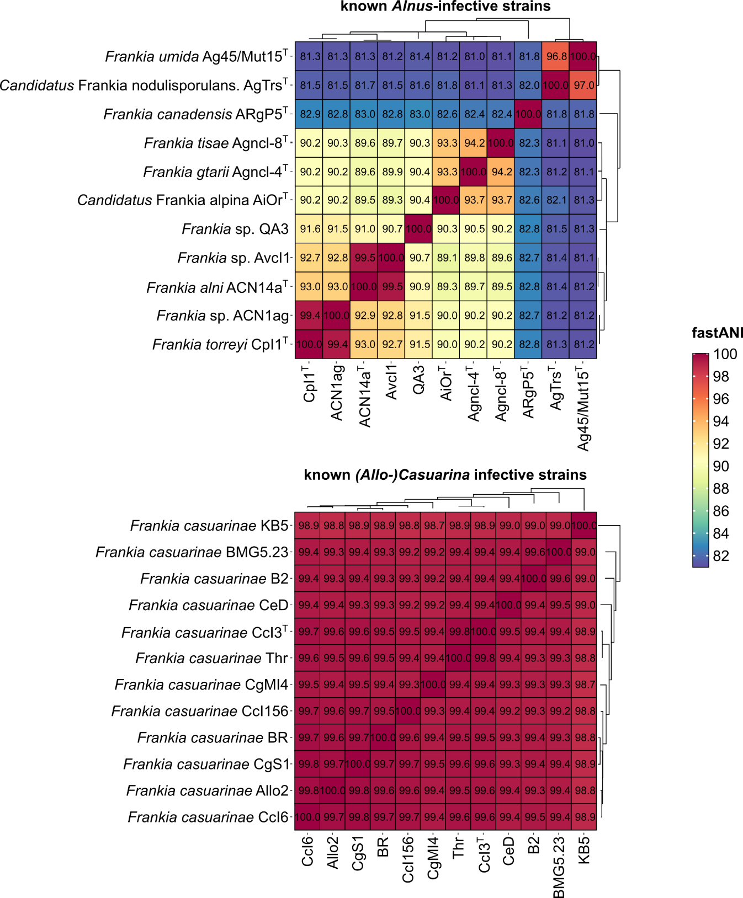
Supplementary Figure S1. Genomic diversity of alder-infective vs. (Allo-)Casuarina-infective Frankia strains. Comparison of average nucleotide identity (fastANI) matrices of the genomes of isolated alder-infective strains and (Allo-)Casuarina-infective strains. The same heat map scale was used for both matrices.
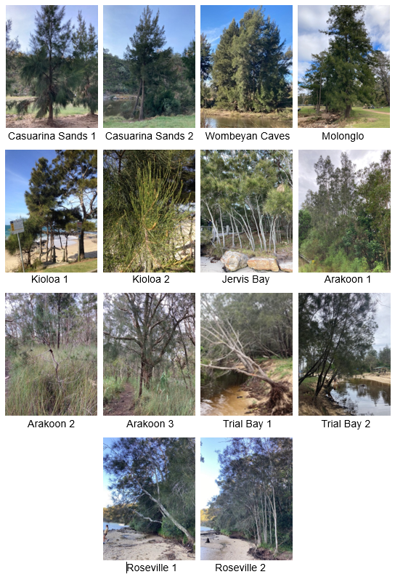
Supplementary Figure S2. Trees from where nodules were collected in this study. Nodules collected from Molonglo came from a fallen tree with roots in the air. Sampling sites in Arakoon were near a brackish lagoon, ca. 300 m from the ocean. The water bodies beside the trees in Trial Bay connect to the ocean. Trees in Roseville were both growing next to salt water.
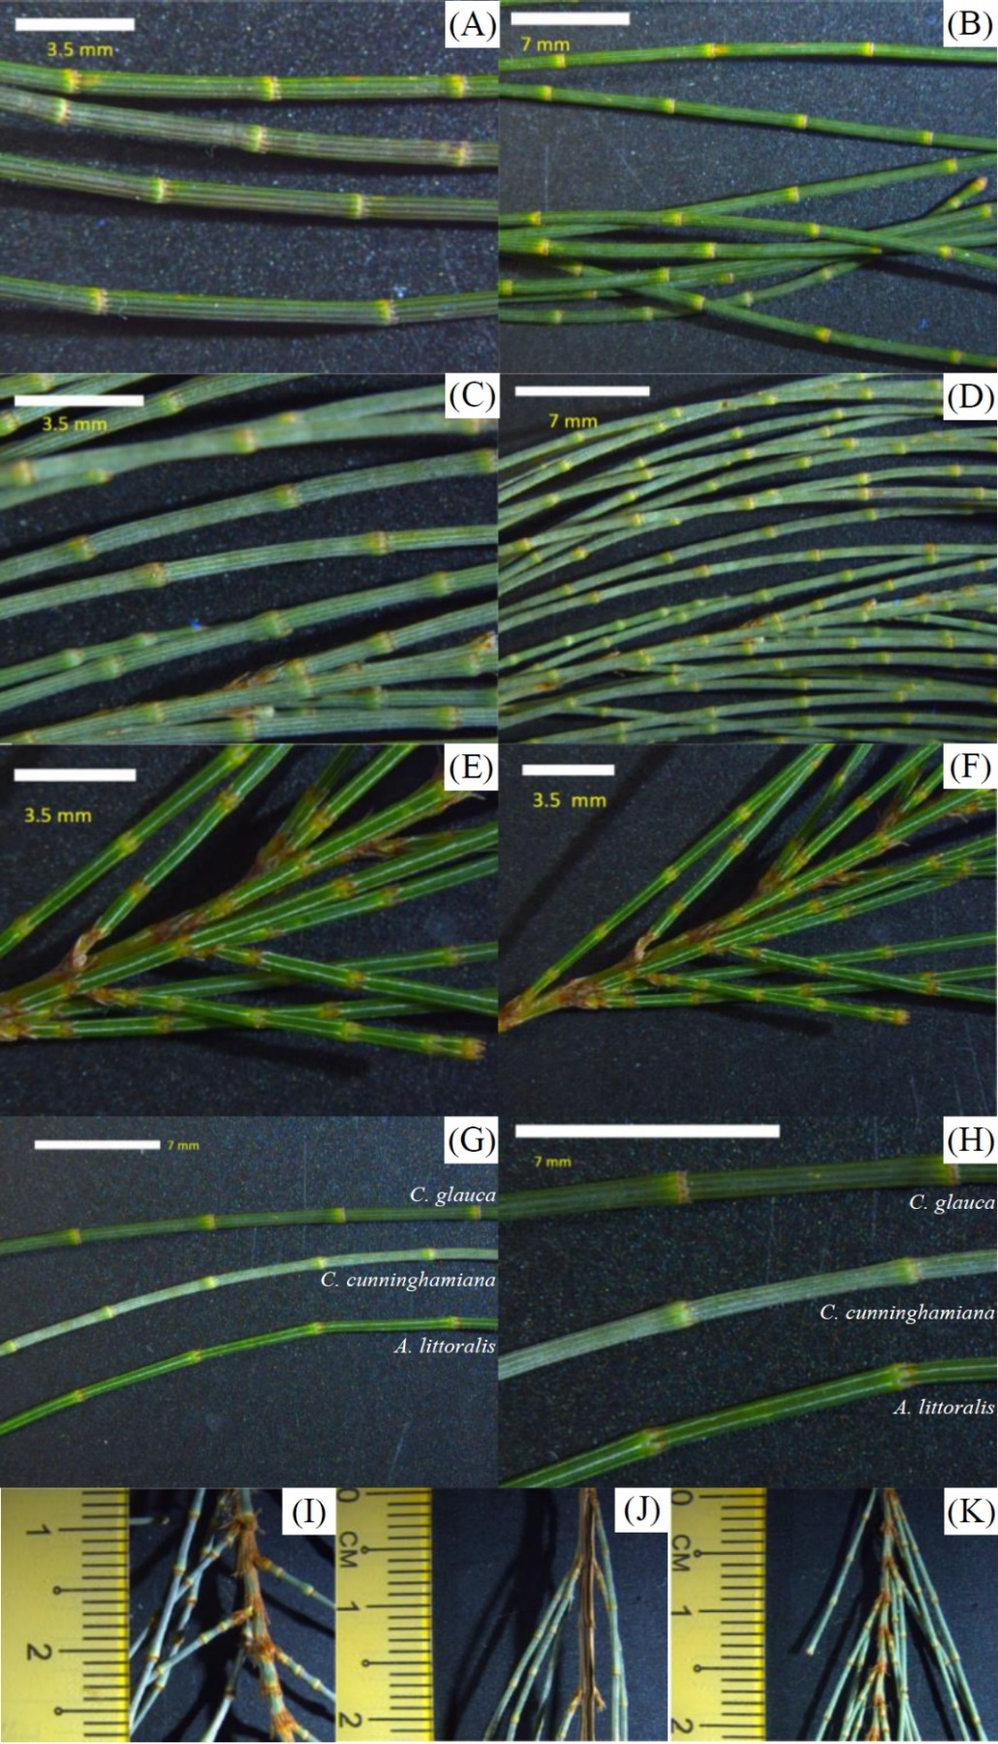
Supplementary Figure S3. Casuarina species comparison. Photosynthetic branchlets of (A-B) Casuarina glauca; (C-D) Casuarina cunninghamiana; (E-F) Allocasuarina littoralis. (G-H) Comparison of branchlets of all three species at different magnifications. (I-K) Photosynthetic branchlets of (I) C. glauca; (J) C. cunninghamiana; (K) A. littoralis. Photosynthetic branchlets of A. littoralis are thin, soft and very flexible. Branchlets of C. glauca are thick and stiff and attached at a larger angle. Furthermore, photosynthetic branchlets of C. glauca are always branching off individually, while in case of A. Littoralis and C. cunninghamiana, the branchlets branch off in pairs quite often.
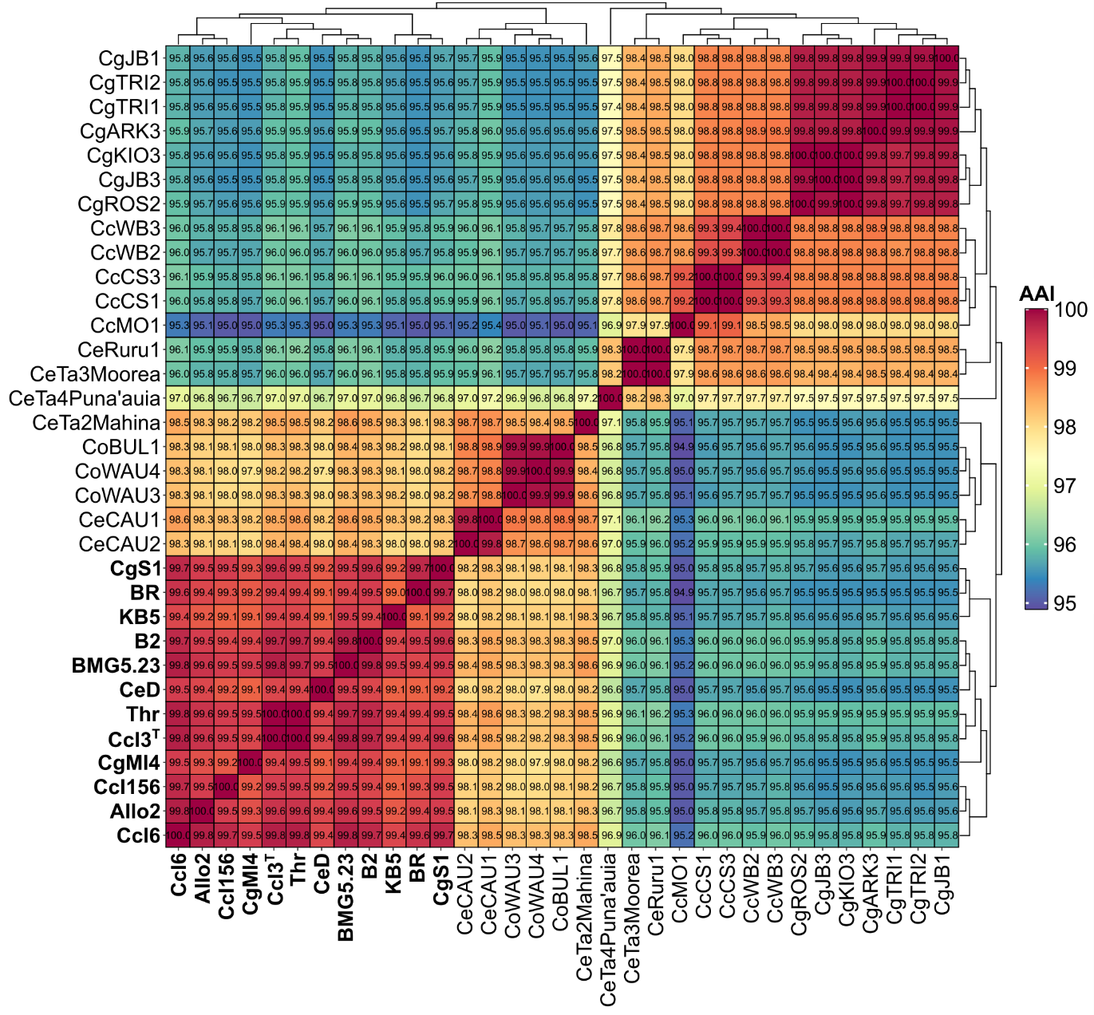
Supplementary Figure S4. Average nucleotide identity (fastAAI) matrix for the MAGs sequenced in this study, compared to the genomes of isolated Frankia casuarinae strains (labelled by bold print). The matrix suggests that the MAGs from NSW and French Polynesia (except for CeTa2Mahina) represent a species different from F. casuarinae (AAI < 96).

