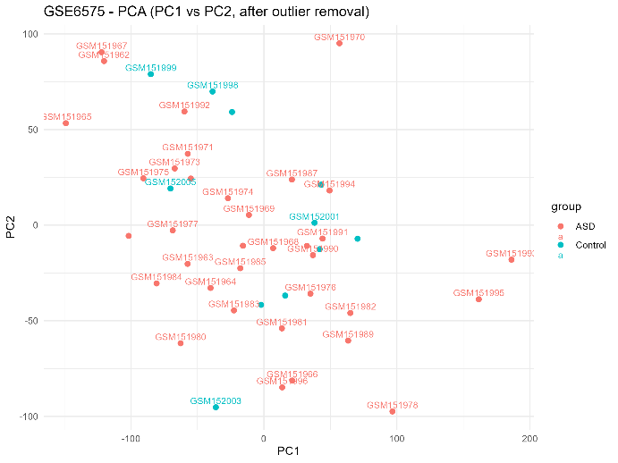 | 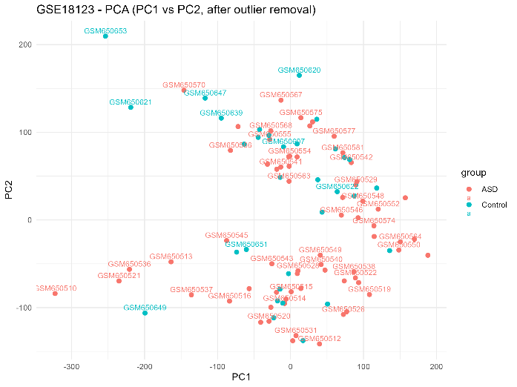
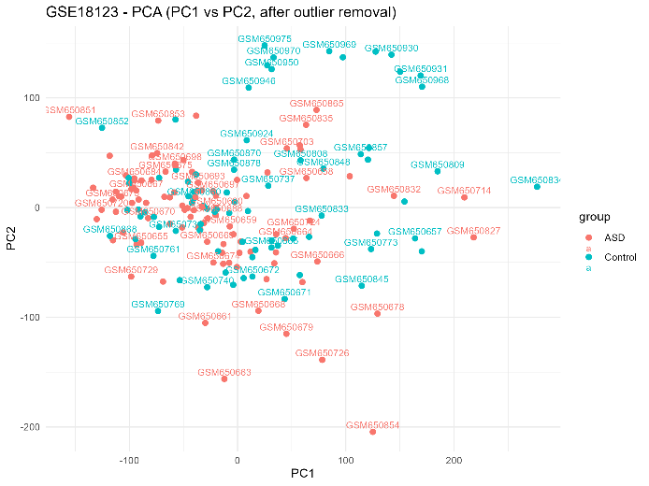 | 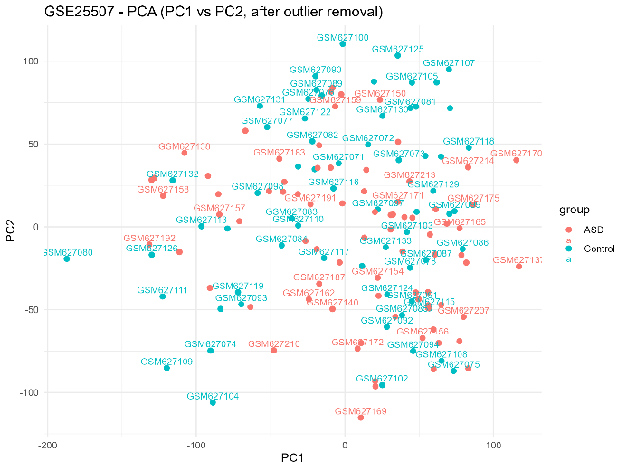
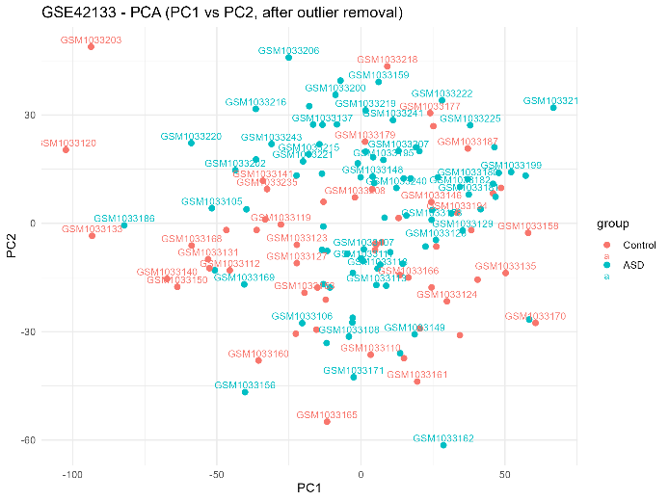 | 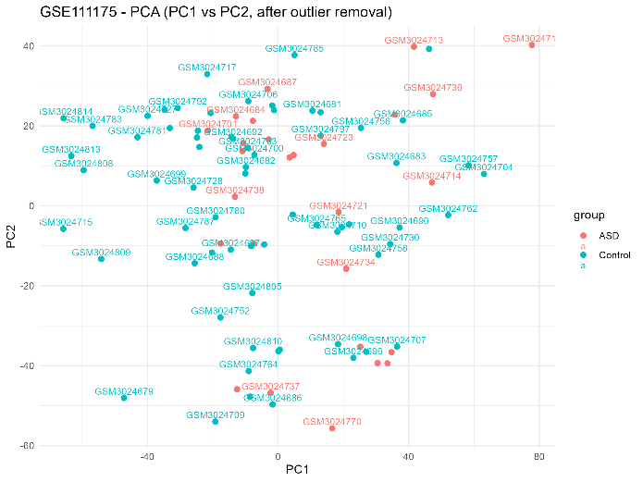

Supplementary Figure S1. Principal component analysis (PCA) of ASD transcriptomic datasets after preprocessing. PCA was performed on log2-transformed expression data for each dataset to assess sample distribution and identify potential outliers. PCA plots demonstrate overall sample structure and were used for quality control purposes. Outlier samples identified by PCA were removed prior to differential expression analysis.
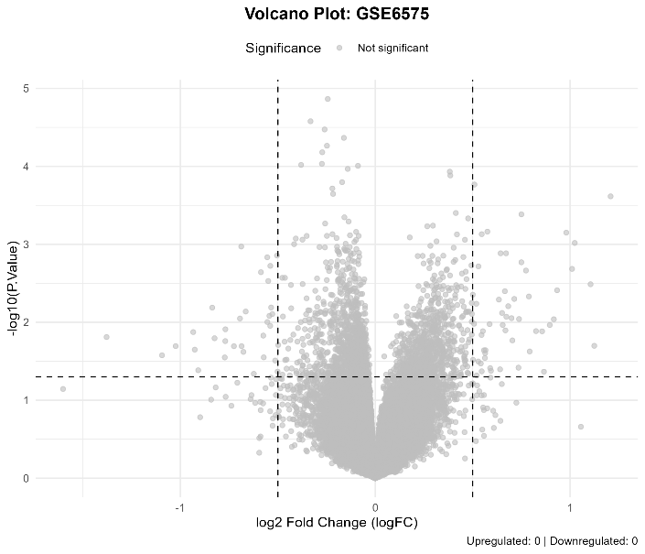 | 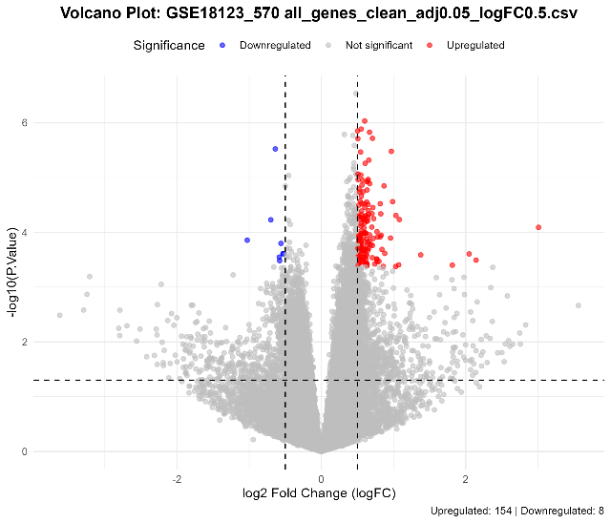
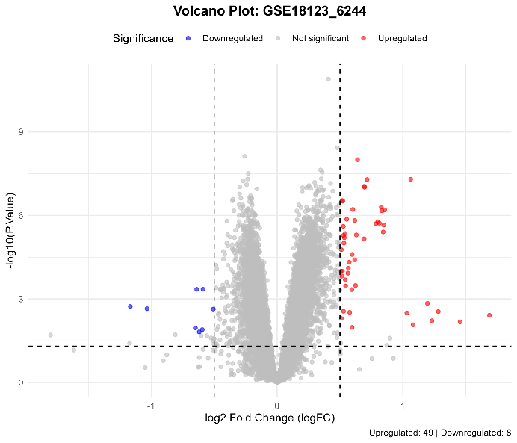 | 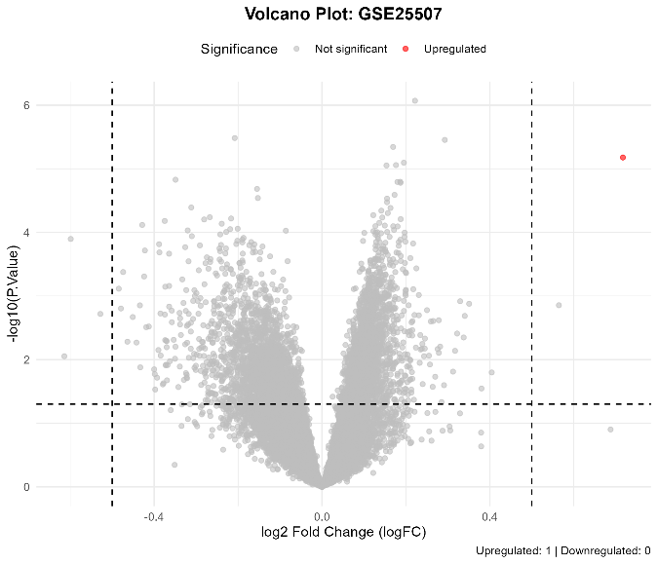
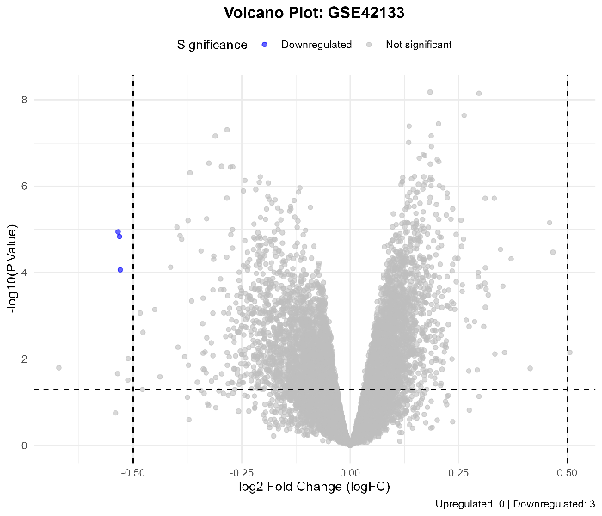 | 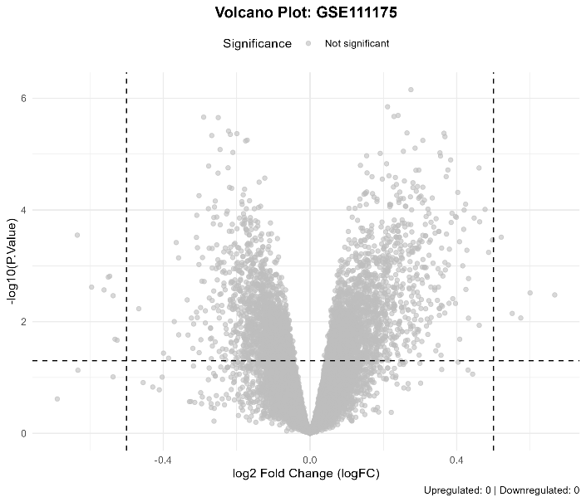

Supplementary Figure S2. Volcano plots of differential expression for individual ASD datasets. Volcano plots depict dataset-specific differential expression patterns for mRNAs and lncRNAs using adjusted p-value < 0.05 and |log2 fold change| > 0.5 as visualization thresholds. These plots are provided for descriptive purposes; dataset-level statistics were subsequently integrated using Robust Rank Aggregation (RRA) to define reproducible ASD-associated genes.

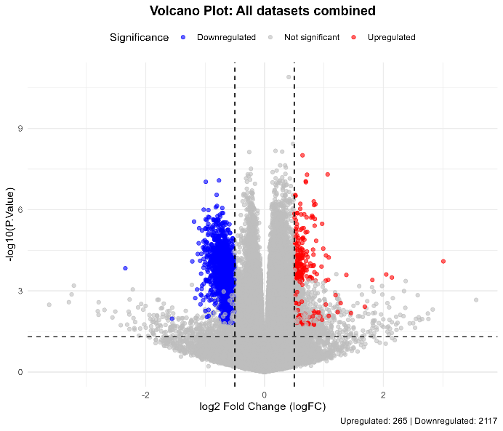 | 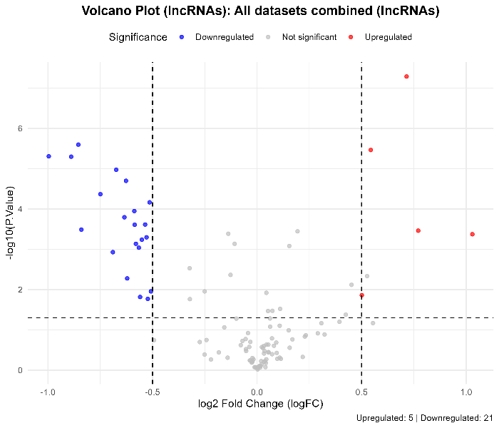

Supplementary Figure S3. Combined volcano plots summarizing differential expression patterns across pooled ASD datasets. Combined volcano plots display overall differential expression trends for mRNAs and lncRNAs obtained from pooled ASD and control samples using consistent visualization thresholds. These plots are shown for illustrative purposes only and do not define the final set of ASD-associated genes, which were determined using Robust Rank Aggregation (RRA) meta-analysis.

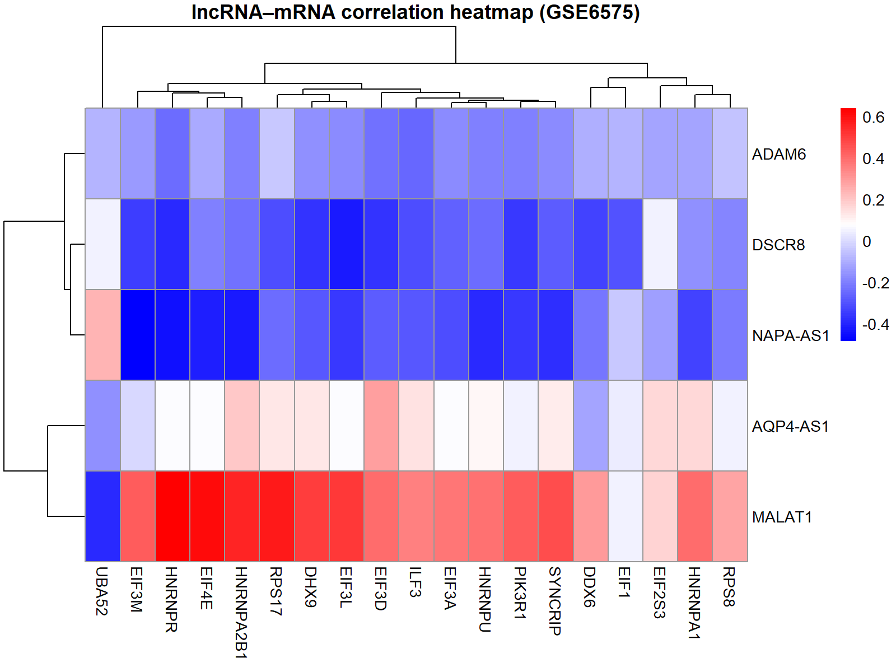
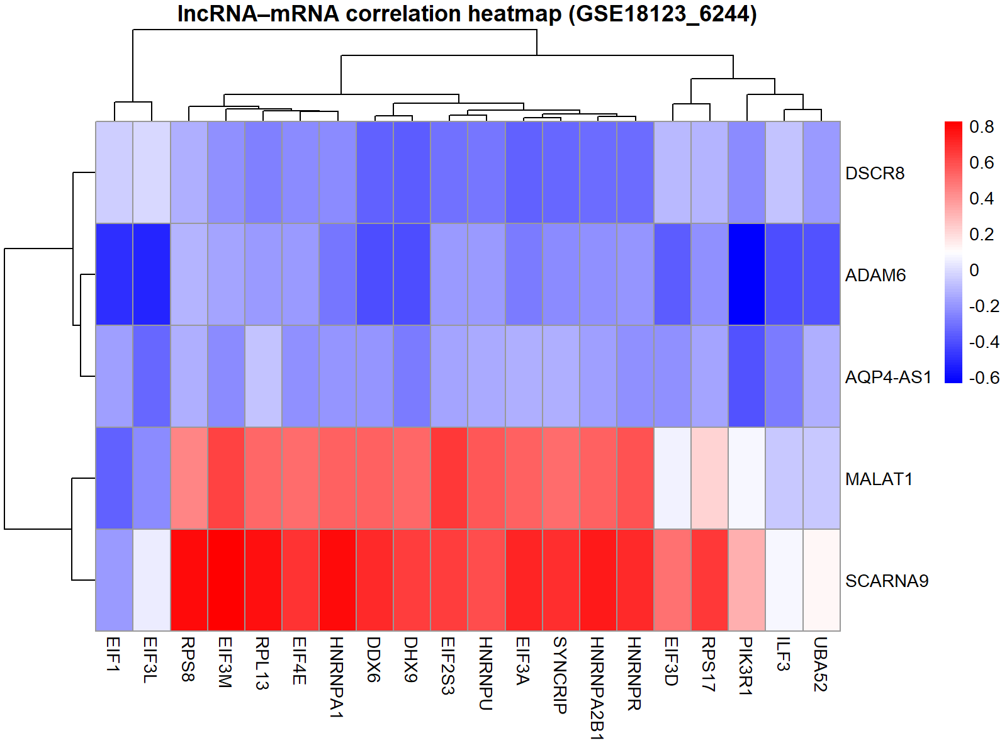
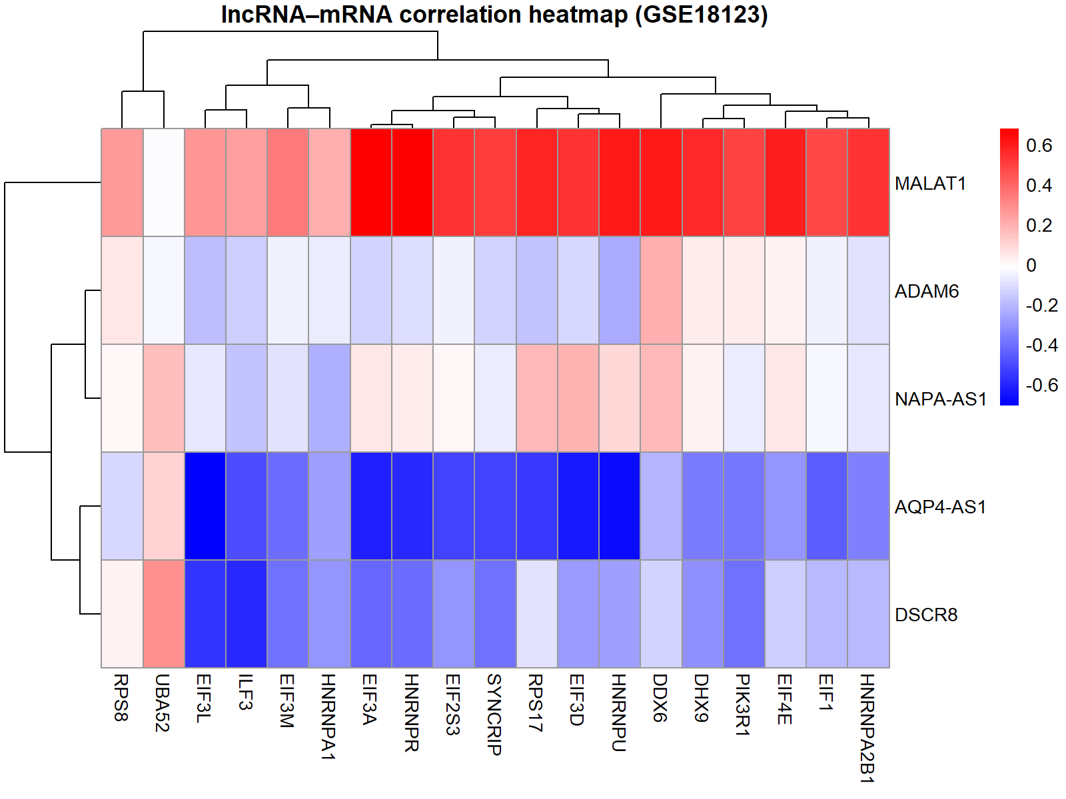
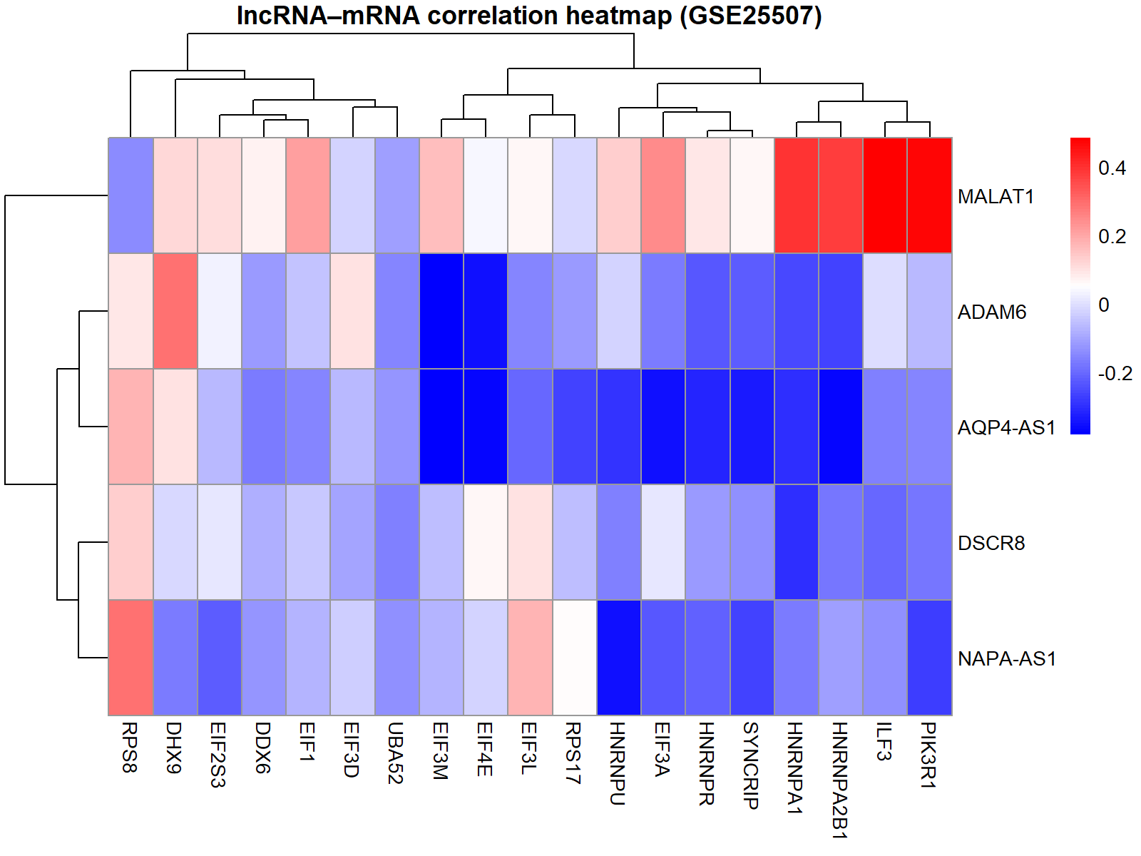
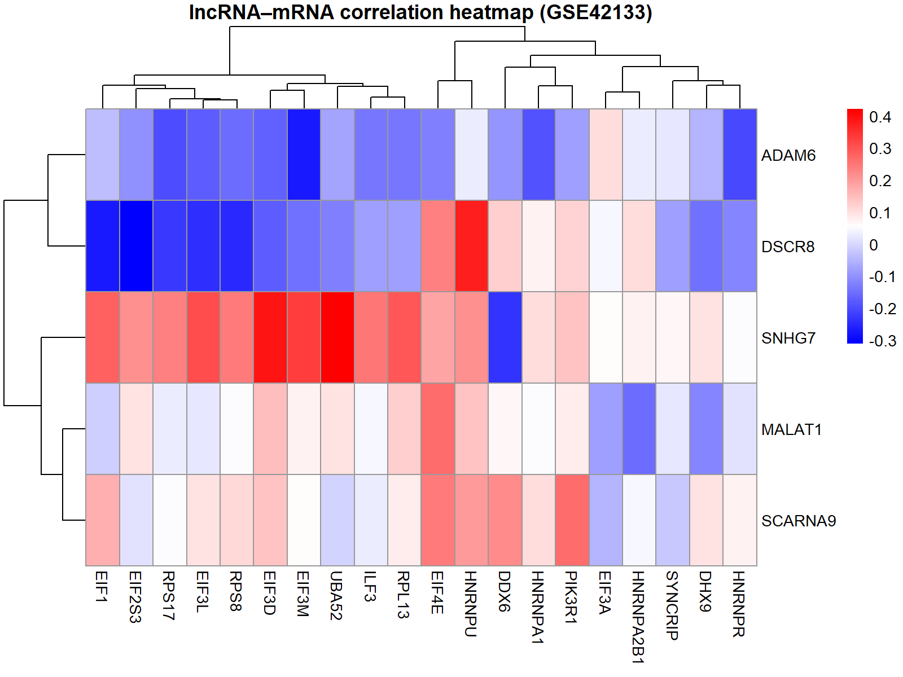
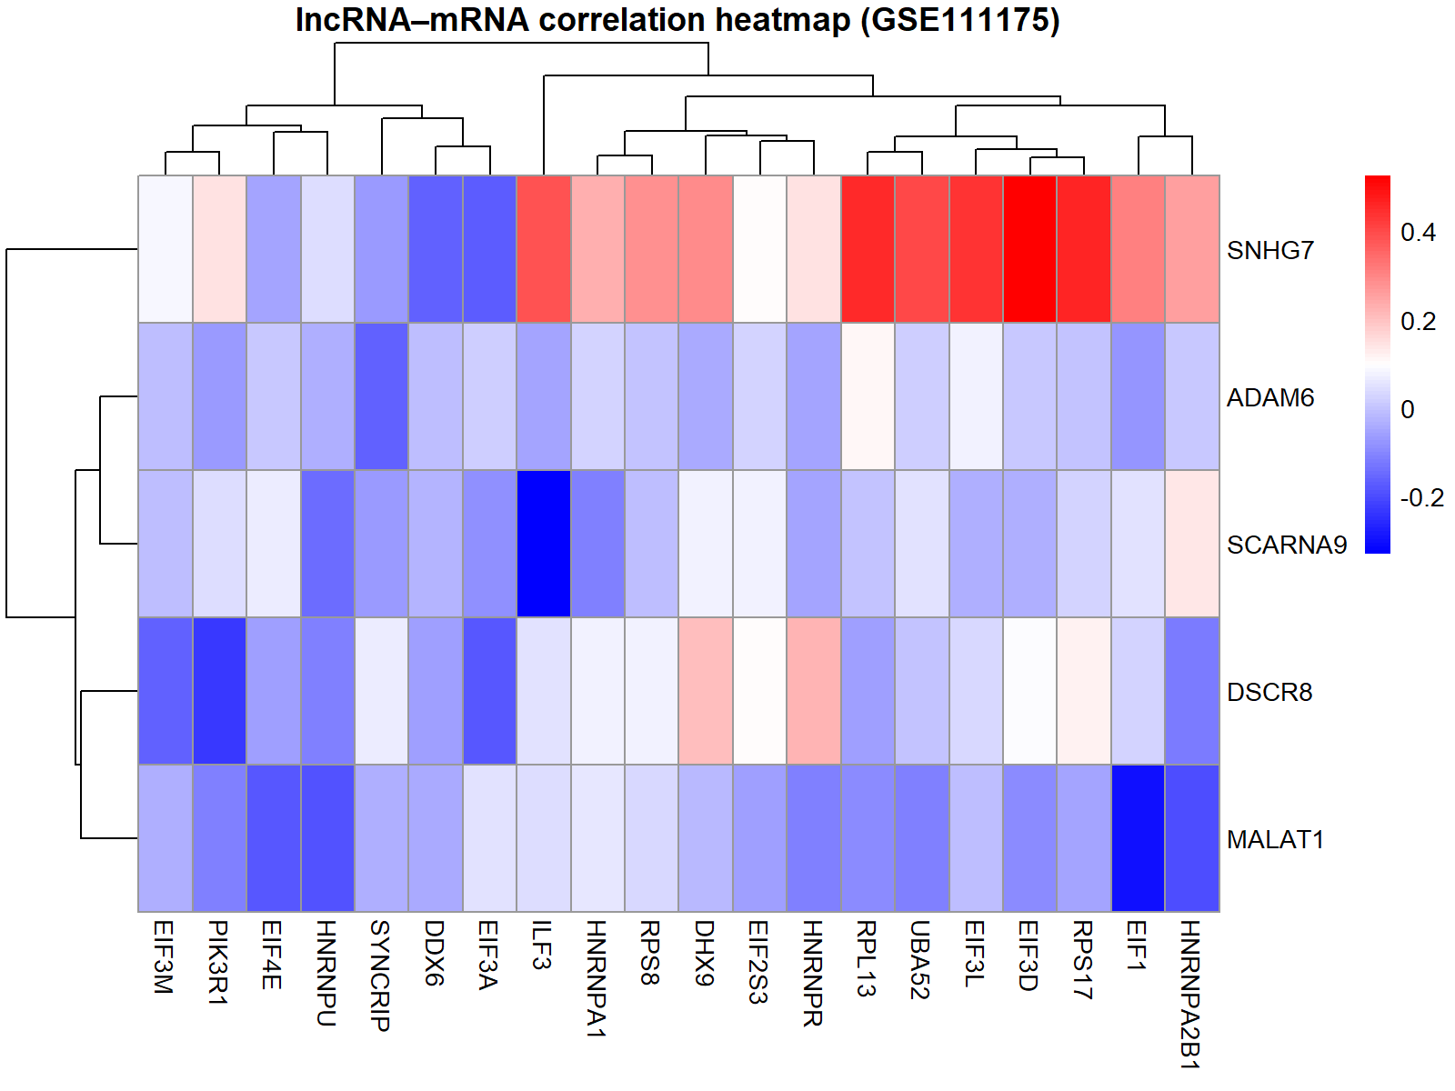

Supplementary Figure S4: Meta lncRNA–mRNA correlation heatmap across ASD datasets.

