Supplementary Tables and Figures

Contents
Table S1. Definition of outcome, exposure and covariates. 1
Table S2. Predictive performance of omic signatures to discriminate between women with and without GDM. 3
Table S3. Association between GDM-associated omic signatures and T2DM in the population with only GDM. 4
Table S4. Association between GDM-associated omic signatures and T2DM in the stepwise models in the population with and without GDM. 5
Figure S1. Waffle-plot of the percentage of women who belonged to distinct quintiles of the metabolomic signature according to the longitudinal experimental group. 6
Figure S2. Waffle-plot of the percentage of women who belonged to distinct quintiles of the proteomic signature according to the longitudinal experimental groups. 7

Table S1. Definition of outcome, exposure and covariates.
Outcome | Definition and source
Type 2 Diabetes | HES: hospital admission/episode with ICD-10 codes for non-insulin dependent diabetes (E11.0-E11.9), malnutrition-related diabetes (E12.0-E12.9), other specified diabetes (E13.0-E13.9), unspecified diabetes (E14.0-E14.9), pre-pregnancy type 1 diabetes (O24.0), pre-pregnancy type 2 diabetes (O24.1), pre-pregnancy malnutrition-related diabetes (O24.2), and pre-pregnancy unspecified diabetes (O24.3)
Exposure | Definition and source
Gestational diabetes mellitus | Any of the following:  - A self-reporting diabetes occurring only during pregnancy from the touchscreen questionnaire (ID: 4041)  - Reporting GDM during the nurse interview (ID: 20002) with code 1221 for gestational diabetes  - HES: hospital admission/episode with ICD-10 codes for diabetes mellitus arising in pregnancy (O24.4) or unspecified diabetes in pregnancy (O24.9)
Covariates | UK Biobank variable (ID), source and time point (where relevant)
Age | Age at first birth - using lowest age from:  - HES maternal age at delivery if available  - Age at first live birth (ID: 2754)  - Age at last live birth (ID: 2764)  - Age at primiparous women at birth of child (ID: 3872)
Ethnicity | Ethnic background (ID: 21000) – most recent time point available
Townsend index | Townsend index (ID: 189)
Education | Qualifications (ID: 6138) – highest qualification reported among the time points of assessment
Family history of diabetes | Family history of diabetes (ID: 20107, 20110, 20111, value 9) - present if reported in at least one time point
BMI | BMI (ID: 21001) – average from available time points
Menopause | Had menopause (ID: 2724) - present if reported in at least one time point
Parity | Live births (ID: 2734) – maximum number of live births reported among available time points
Smoking | Smoking status (ID: 20116) – latest time point available
Physical activity | Number of days/week of vigorous physical activity 10+ minutes (ID: 904) – average from available time points; Duration of vigorous activity (ID: 914) – average from available time points; Number of days/week of moderate physical activity 10+ minutes (ID: 884) – average from available time points; Duration of moderate activity (ID: 894) – average from available time points; Number of days/week walked 10+ minutes (ID: 864) –average from available time points; Duration of walks (ID: 874) – average from available time points
Fruit and vegetable intake | Sum of:  - Cooked vegetable portions per day (ID: 1289) – average from available time points  - Raw vegetable portions per day (ID: 1299) – average from available time points  - Fruit portions per day (ID: 1309) – average from available time points
Saturated fat intake | Saturated fat intake score (days/week) – sum of:  - Weekly beef intake (ID: 1369) – average from available time points  - Weekly lamb intake (ID: 1379) – average from available time points  - Weekly pork intake (ID: 1389) – average from available time points  - Weekly cheese intake (ID: 1408) – average from available time points
Alcohol intake | Alcohol weekly intake (units/week) – sum of:  - Weekly red wine intake (ID: 1568) – amount of glasses per week multiplied by 2, and taking the average from available time points  -Weekly beer and cider intake (ID: 1588) – amount of pints per week multiplied by 2.5, and taking the average from available time points  - Weekly champagne and white wine intake (ID: 1578)– amount of glasses per week multiplied by 2, and taking the average from available time points  - Weekly spirits intake (ID: 1598) – amount of measures per week multiplied by 1, and taking the average from available time points  - Weekly fortified wine intake (ID: 1608) – amount of glasses per week multiplied by 2, and taking the average from available time points  - Weekly other alcoholic drinks intake (ID: 5364) – amount of glasses per week multiplied by 1, and taking the average from available time points  - Monthly red wine intake (ID: 4407) – amount of glasses per month multiplied by 2 and divided by 4.3, and taking the average from available time points  - Monthly beer and cider intake (ID: 4429) – amount of pints per month multiplied by 2.5 and divided by 4.3, and taking the average from available time points  - Monthly champagne and white wine intake (ID: 4418) – amount of glasses per month multiplied by 2 and divided by 4.3, and taking the average from available time points  - Monthly spirits intake (ID: 4440) – amount of measures per month multiplied by 1 and divided by 4.3, and taking the average from available time points  - Monthly fortified wine intake (ID: 4451) – amount of glasses per month multiplied by 2 and divided by 4.3, and taking the average from available time points  - Monthly other alcoholic drinks intake (ID: 5364)– amount of glasses per month multiplied by 1 and divided by 4.3, and taking the average from available time points
Cholesterol lowering medication | Use of cholesterol lowering medication was defined based on self-reported medication data collected during the nurse interview. Participants were classified as users if they reported taking cholesterol lowering medication at any assessment time point. This was identified using medication variable (ID: 6153) for females, where a value of 1 indicates current use of cholesterol lowering medication.

Table S2. Predictive performance of omic signatures that discriminate between women with and without GDM.
 | Accuracy¹ | G-mean¹ | Sensitivity¹ | Specificity¹
Metabolomic signature | 0.63 (0.65) | 0.61 (0.63) | 0.58 (0.61) | 0.64 (0.65)
Proteomic signature | 0.77 (0.79) | 0.75 (0.81) | 0.75 (0.83) | 0.77 (0.79)
¹ Repeated k-fold cross-validation (whole dataset)

Table S3. Association between GDM-associated omic signatures and T2DM in the population of women with GDM.
 | N | Events | HR (95% CI)
Continuous score of metabolomic signature | 685 | 77 | 1.58 (1.13, 2.19)
Continuous score of proteomic signature | 62 | 6 | Not estimated

Table S4. Stepwise models of the association between GDM-associated omic signatures and T2DM in the population of women with and without GDM.
 | Continuous score of  metabolomic signature  HR (95% CI) | Continuous score of  proteomic signature  HR (95% CI)
Model 1  Minimally adjusted (age underlying time-covariate) | 1.69 (1.65.1.73) | 1.22 (1.15-1.31)
Model 2  Model 1 plus demographics | 2.30 (2.23-2.37) | 1.39 (1.20-1.61)
Model 3  Model 2 plus medical conditions | 1.80 (1.74-1.86) | 1.25 (1.08-1.45)
Model 4  Model 4 plus health behaviours | 1.82 (1.73-1.91) | 1.27 (1.10-1.47)

Figure S1. Sensitivity analysis illustrating the proportion of women with and without GDM, across quintiles of the metabolomic signature, who later developed or did not develop T2DM.

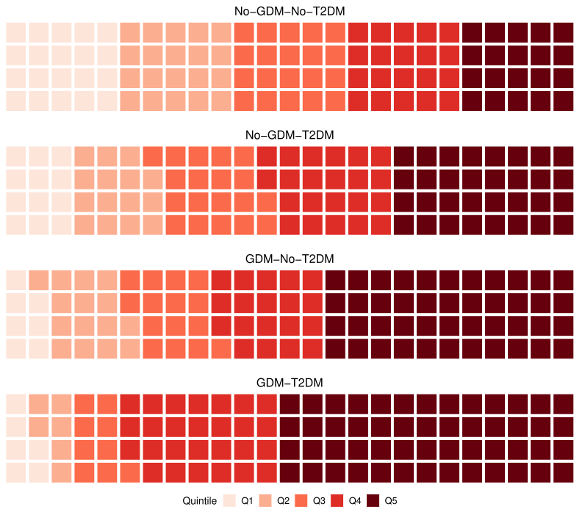
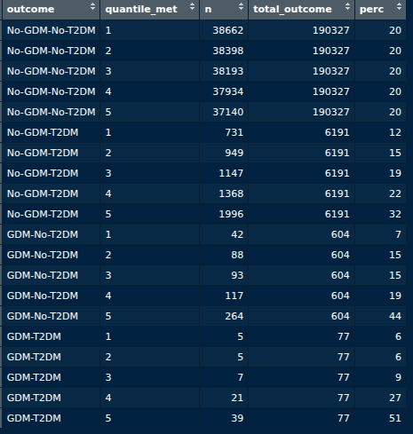

Figure S2. Sensitivity analysis illustrating the proportion of women with and without GDM, across quintiles of the proteomic signature, who later developed or did not develop T2DM.

