Supplemental Material

This appendix presents additional information

Supplement to: Identifying clinical phenotypes in extremely low birth weight infants – A machine learning approach

Corresponding author

Felipe Yu Matsushita, MD – felipe.matsushita@hc.fm.usp.br
Department of Pediatrics,
Instituto da Criança, Faculty of Medicine, University of São Paulo
Av. Dr. Enéas Carvalho de Aguiar, 647
São Paulo, São Paulo, Brazil, 05403901
ORCID: 0000-0002-5106-7497

eTable 1 and eFigure 1 – Eigenvalue, percentage of variance, and cumulative percentage of variance after FAMD
Component | Eigenvalue | Percentage of variance | Cumulative percentage of variance
Component 1 | 2.65 | 29.48 | 29.48
Component 2 | 1.10 | 12.25 | 41.73
Component 3 | 1.03 | 11.53 | 53.26
Component 4 | 0.99 | 11.05 | 64.32
Component 5 | 0.85 | 9.48 | 73.81
Component 6 | 0.77 | 8.57 | 82.38
Component 7 | 0.58 | 6.51 | 88.90
Component 8 | 0.54 | 6.04 | 94.94
Component 9 | 0.45 | 5.05 | 100

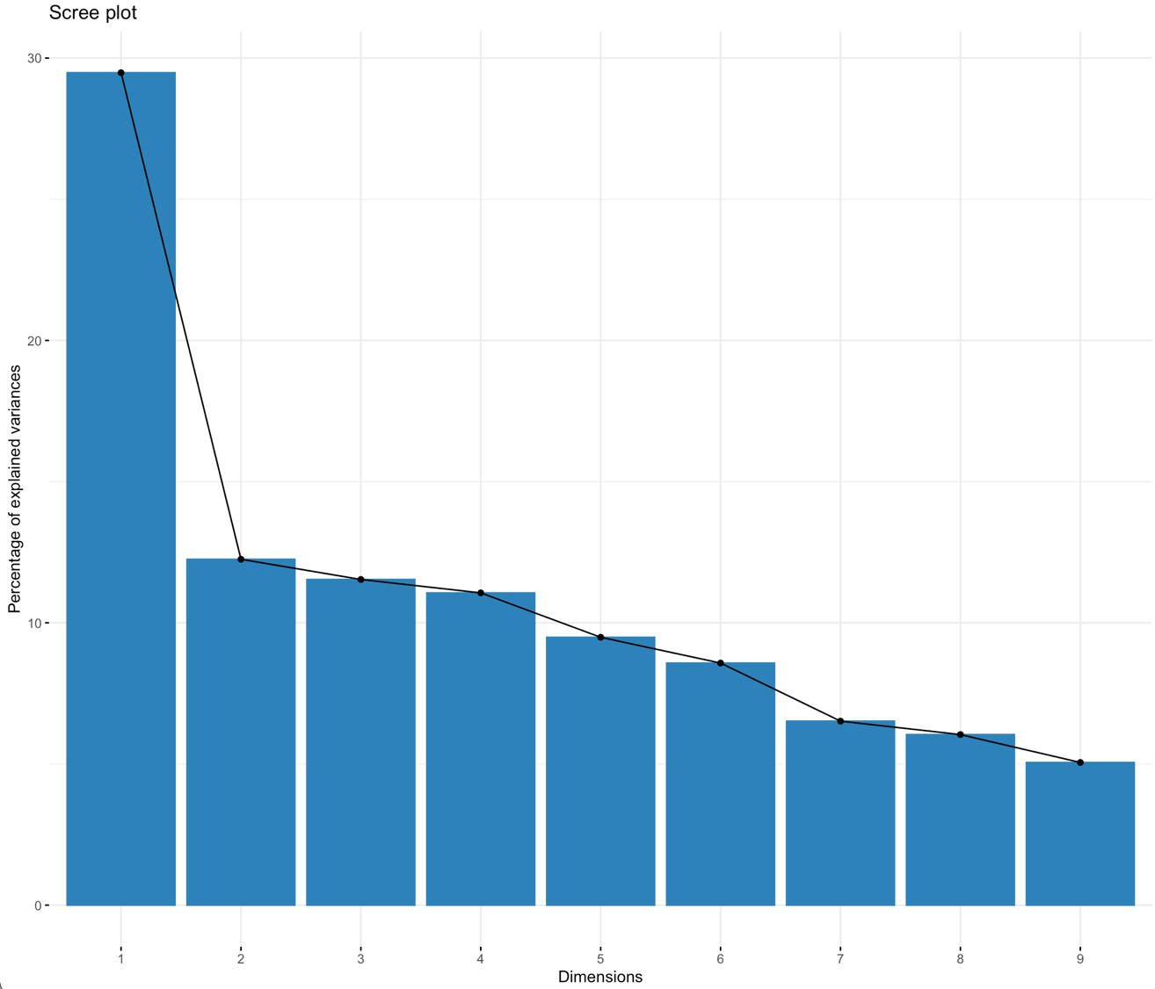

eTable 2 - Cluster stability assessment
 | Model 1 - Dimensionality reduction (FAMD) with no feature selection | Model 2 - Feature selection (gower’s distance) without dimensionality reduction | Model 3 - Feature selection with dimensionality reduction (FAMD)
Cluster stability assessment – index of stability | Cluster 1: 0.79  Cluster 2: 0.56  Cluster 3: 0.74  Cluster 4: 0.46  Cluster 5: 0.71  Cluster 6: 0.72 | Cluster 1: 0.62  Cluster 2: 0.60  Cluster 3: 0.59  Cluster 4: 0.73  Cluster 5: 0.53  Cluster 6: 0.64 | Cluster 1: 0.94  Cluster 2: 0.91  Cluster 3: 0.85  Cluster 4: 0.88  Cluster 5: 0.97  Cluster 6: 0.94

