Supplemental Materials
Supplement to: Pucher G., Kanjilal S., Kopp K., et al. (2025): Predicting Persistent Fever in Patients with Cancer Receiving Antibiotics: A Machine Learning Approach.

Table of contents
Supplemental Table 1. Data preprocessing steps 3
Supplemental Table 2. Engineered features derived from the initial covariates. 3
Supplemental Table 3. Comparison of AUC of models with and without using the forecasted fever value from the Chronos-2 forecasting model, based on 5-fold nested CV on the UME dataset. 5
Supplemental Table 4. Hyperparameter search spaces for utilized machine learning models. 6
Supplemental Table 5. Definition of antibiotic escalation strategies used for evaluation. 6
Supplemental Table 6. Performance metric per model during 5-fold nested CV over 20 trials on the UME dataset. 6
Supplemental Table 7. Performance metric per model during external validation on the BWH dataset. 7
Supplemental Table 8. Top 10 features with highest SHAP values per model and dataset. 8
Supplemental Table 9. Stratified discriminative performance per model during 5-fold nested CV over 20 trials on the UME dataset. 9
Supplemental Table 10. Stratified discriminative performance per model during external validation on the BWH dataset. 10
Supplemental Table 11. Discriminative performance per model during 5-fold nested CV over 20 trials on the UME dataset and external validation on the BWH dataset under an adapted fever definition threshold of $≥$38.3 °C. 10

Supplemental File 1. Tripod+AI Checklist. 12

Supplemental Table 1. Data preprocessing steps
Processing step | Description
Measurement errors | Body temperature: Remove data points where $x<23 °C$ or $x>47 °C$
Measurement errors | Heart rate: Remove data points where $x<20 bpm$ or $x>300 bpm$
Measurement errors | Mean arterial pressure: Remove data points where $x<20 mmHg$ or $x>200 mmHg$
Measurement errors | Hemoglobin: Remove data points where $x≤0 g/dl$ or $x>40 g/dl$
Measurement errors | Serum Creatinine: Remove data points where $x≤0 mg/dl$ or $x>80 mg/dl$
Measurement errors | Pulse Oximetry SpO₂: Remove data points where $x≤50 \%$ or $x>100 \%$
Measurement errors | Bilirubin: Remove data points where $x≤0 mg/dl$ or $x>60 mg/dl$
Measurement errors | Leukocytes: Remove data points where $x≤0 nl$ or $x>400 nl$
Measurement errors | C-reactive Protein: Remove data points where $x≤0 mg/dl$ or $x>50 mg/dl$
Duplicates | Remove redundant records where patient identifier, recorded time and recorded value are identical
Missing values | Forward-filling of the last observed values within the context window ($ω_{c}$​); remove time series if no values are included in the prediction window ($ω_{p}$​)
Scaling | Standard scaling of numerical covariates
Categorical values | One-hot encoding of categorical covariates

Supplemental Table 2. Engineered features derived from the initial covariates.
Feature | Description | Datatype
cond_hemat | One-hot encoded ICD-10 code for admission diagnosis of other hematological malignancies | boolean
cond_leuk | One-hot encoded ICD-10 code for admission diagnosis of leukemia | boolean
cond_solid | One-hot encoded ICD-10 code for admission diagnosis of solid tumors | boolean
age | Age of patient at admission | integer
elixhauser_score | Elixhauser comorbidity score based on ICD-10 codes prior to admission | float
sex_male | One-hot encoded if sex of patient is male | boolean
length_stay | Length of days from start of hospital stay to first administered antibiotic dosage | float
time_lag_1_bt_max | Highest recorded body temperature (°C) 24-48 hours after first administered antibiotic dosage | float
time_lag_2_bt_max | Highest recorded body temperature (°C) 0-24 hours after first administered antibiotic dosage | float
time_lag_1_bt_mean | Mean recorded body temperature (°C) 24-48 hours after first administered antibiotic dosage | float
time_lag_2_bt_mean | Mean recorded body temperature (°C) 0-24 hours after first administered antibiotic dosage | float
time_lag_1_krea_max | Highest recorded serum creatinine (mg/dl) 24-48 hours after first administered antibiotic dosage | float
time_lag_2_krea_max | Highest recorded serum creatinine (mg/dl) 0-24 hours after first administered antibiotic dosage | float
time_lag_1_bili_max | Highest recorded bilirubin (mg/dl) 24-48 hours after first administered antibiotic dosage | float
time_lag_2_bili_max | Highest recorded bilirubin (mg/dl) 0-24 hours after first administered antibiotic dosage | float
time_lag_1_leua_max | Highest recorded leucocytes (nl) 24-48 hours after first administered antibiotic dosage | float
time_lag_2_leua_max | Highest recorded leucocytes (nl) 0-24 hours after first administered antibiotic dosage | float
time_lag_1_hb_max  v | Highest recorded hemoglobin (g/dl) 24-48 hours after first administered antibiotic dosage | float
time_lag_2_hb_max | Highest recorded hemoglobin (g/dl) 0-24 hours after first administered antibiotic dosage | float
time_lag_1_crp_max | Highest recorded CRP (mg/dl) 24-48 hours after first administered antibiotic dosage | float
time_lag_2_crp_max | Highest recorded CRP (mg/dl) 0-24 hours after first administered antibiotic dosage | float
time_lag_1_hr_max | Highest recorded heart rate (bpm) 24-48 hours after first administered antibiotic dosage | float
time_lag_2_hr_max | Highest recorded heart rate (bpm) 0-24 hours after first administered antibiotic dosage | float
time_lag_1_map_max | Highest recorded mean arterial pressure (mmHg) 24-48 hours after first administered antibiotic dosage | float
time_lag_2_map_max | Highest recorded mean arterial pressure (mmHg) 0-24 hours after first administered antibiotic dosage | float
time_lag_1_so2_max | Highest recorded SO2 (%) 24-48 hours after first administered antibiotic dosage | float
time_lag_2_so2_max | Highest recorded SO2 (%) 0-24 hours after first administered antibiotic dosage | float
fever_variability_lag_1 | Body temperature variability 24-48 hours after first administered antibiotic dosage | float
fever_variability_lag_2 | Body temperature variability 0-24 hours after first administered antibiotic dosage | float
last_bt_fever_lag_1 | Last body temperature measurement before prediction window | float
fever_diff_lag_1 | Difference in body temperature from first to last measured value 24-48 hours after first administered antibiotic dosage | float
fever_diff_lag_2 | Difference in body temperature from first to last measured value 0-24 hours after first administered antibiotic dosage | float
fever_percent_lag_1 | Percentage of measured body temperatures over fever threshold 24-48 hours after first administered antibiotic dosage | float
fever_percent_lag_2 | Percentage of measured body temperatures over fever threshold 0-24 hours after first administered antibiotic dosage | float
fever_lag_1_evening | Highest recorded body temperature (°C) during evening hours 24-48 hours after first administered antibiotic dosage | float
fever_lag_1_afternoon | Highest recorded body temperature (°C) during afternoon hours 24-48 hours after first administered antibiotic dosage | float
fever_lag_1_morning | Highest recorded body temperature (°C) during morning hours 24-48 hours after first administered antibiotic dosage | float
fever_lag_2_night | Highest recorded body temperature (°C) during night hours 24-48 hours after first administered antibiotic dosage | float
fever_lag_2_evening | Highest recorded body temperature (°C) during evening hours 0-24 hours after first administered antibiotic dosage | float
fever_lag_2_afternoon | Highest recorded body temperature (°C) during afternoon hours 0-24 hours after first administered antibiotic dosage | float
fever_lag_2_morning | Highest recorded body temperature (°C) during morning hours 0-24 hours after first administered antibiotic dosage | float
fever_lag_2_night | Highest recorded body temperature (°C) during night hours 0-24 hours after first administered antibiotic dosage | float
fever_points_lag_1 | Number of body temperature recordings 24-48 hours after first administered antibiotic dosage | integer
fever_points_lag_2 | Number of body temperature recordings 0-24 hours after first administered antibiotic dosage | integer
fever_change_lag_1 | Change rate of measured body temperatures 24-48 hours after first administered antibiotic dosage | float
fever_change_lag_all | Change rate of measured body temperatures 0-48 hours after first administered antibiotic dosage | float
fever_range_lag_1 | Range of measured body temperatures 24-48 hours after first administered antibiotic dosage | float
fever_range_lag_2 | Range of measured body temperatures 0-24 hours after first administered antibiotic dosage | float
trend | Trend of measured body temperatures 0-48 hours after first administered antibiotic dosage | float
skewness_lag_all | Skewness of measured body temperatures 0-48 hours after first administered antibiotic dosage | float
fourier_max_magnitude | Maximum fourier transform magnitude of body temperatures 0-48 hours after first administered antibiotic dosage | float
predictions_fever_max_we | Chronos-2 based forecasted highest body temperature 48-72 hours after first administered antibiotic dosage | float

Supplemental Table 3. Comparison of AUC of models with and without using the forecasted fever value from the Chronos-2 forecasting model, based on 5-fold nested CV on the UME dataset. UME= University Medicine Essen; GLM = Generalized linear model; LR = Regularized logistic regression; RF = Random Forest; XGB = XGBoost; CB = CatBoost; TPFN = TabPFN.
Model | AUC_{95% CI}
GLM | 0.72 (CI 0.69-0.74)
GLM+Chronos-2 | 0.73 (CI 0.70-0.76)
LR | 0.73 (CI 0.70-0.76)
LR+Chronos-2 | 0.76 (CI 0.73-0.78)
RF | 0.74 (CI 0.71-0.77)
RF+Chronos-2 | 0.76 (CI 0.74-0.79)
CB | 0.77 (CI 0.74-0.80)
CB+Chronos-2 | 0.79 (CI 0.76-0.82)
XGB | 0.77 (CI 0.74-0.80)
XGB+Chronos-2 | 0.80 (CI 0.77-0.82)
TPFN | 0.79 (CI 0.76-0.81)
TPFN+Chronos-2 | 0.82 (CI 0.79-0.84)
Chronos-2 | 0.74 (CI 0.71-0.77)

Supplemental Table 4. Hyperparameter search spaces for utilized machine learning models.
Model | Hyperparameter | Range
Logistic Regression | C | {10-4, ..., 10} (log scale)
 | penalty | [l1, l2, elasticnet] (categorical)
 | l1_ratio | {0, ..., 1} (uniform)
Random Forest | n_estimators | {100, ..., 500} (integer)
 | max_depth | {5, ..., 20} (integer)
 | min_samples_split | {2, ..., 20} (integer)
 | min_samples_leaf | {2, ..., 12} (integer)
 | max_features | [sqrt, log2, None] (categorical)
 | bootstrap | [True, False] (categorical)
XGBoost | subsample | {0.5, ..., 1.0} (uniform)
 | colsample_bytree | {0.5, ..., 1.0} (uniform)
 | reg_alpha | {1e-6, …, 10} (log scale)
 | reg_lambda | {1e-6, …, 10} (log scale)
 | max_depth | {3, ..., 8} (integer)
 | learning_rate | {0.01, …, 0.3} (log scale)
 | n_estimators | {500, ..., 1000} (integer)
 | min_child_weight | {1, ..., 10} (integer)
 | gamma | {0, ..., 5} (uniform)
CatBoost | depth | {3, ..., 7} (integer)
 | iterations | {1000, ..., 2000} (integer)
 | learning_rate | {0.05, …, 0.2} (log scale)
 | l2_leaf_reg | {1e-2, …, 20} (log scale)
 | bagging_temperature | {0.0, …, 5.0} (uniform)
 | random_strength | {0.0, …, 2.0} (uniform)
 | border_count | {32, ..., 255} (integer)

Supplemental Table 5. Definition of antibiotic escalation strategies used for evaluation.
After initiation of antibiotic therapy | ATC Code | Classification
Addition of: | J01F | Macrolides, lincosamides and streptogramins
 | J01G | Aminoglycoside antibacterials
 | J01M | Quinolone antibacterials
 | J01XA | Glycopeptide antibacterials
 | J01XX08 | Linezolid
Switch to: | J01DH | Carbapenems

Supplemental Table 6. Performance metric per model during 5-fold nested CV over 20 trials on the UME dataset. UME = University Medicine Essen; GLM = Generalized linear model; LR = Regularized logistic regression; RF = Random Forest; XGB = XGBoost; CB = CatBoost; TPFN = TabPFN.
Metric | Naive | GLM | LR | RF | XGB | CB | TPFN
Discrimination
AUROC (95% CI) | 0.66 (0.62-0.69) | 0.73 (0.70-0.76) | 0.76 (0.73-0.78) | 0.76 (0.74-0.79) | 0.80 (0.77-0.82) | 0.79 (0.76-0.82) | 0.82 (0.79-  0.84)
AUPRC (95% CI) | 0.68 (0.64-0.73) | 0.76 (0.72-0.80) | 0.79 (0.75-0.82) | 0.78 (0.74-0.81) | 0.81 (0.77-0.84) | 0.81 (0.85-0.78) | 0.84 (0.81-0.87)
Calibration
Calibration intercept (95% CI) | 0.50 (0.34-0.66) | 0.14 (0.00-0.27) | 0.17 (0.03-0.30) | -0.01  (-0.16-0.13) | 0.00 (-0.15--0.15) | -0.05  (-0.20-0.09) | -0.08 (-0.23--0.07)
Calibration slope (95% CI) | 0.86 (0.65-1.08) | 0.69 (0.58-0.82) | 1.23 (1.04-1.45) | 0.86 (0.74-0.99) | 1.02 (0.90-1.17) | 0.97  (0.85-1.10) | 0.96 (0.86-1.08)
Brier score (95% CI) | 0.25 (0.24-0.26) | 0.21 (CI 0.20- 0.23) | 0.20 (0.19-0.21) | 0.20 (0.19-0.21) | 0.18 (0.17-0.20) | 0.19 (0.17-0.20) | 0.17 (0.16-0.18)
Threshold-based metrics
Sensitivity (95% CI) | 0.37 (0.33-0.41) | 0.63 (0.59-0.67) | 0.69 (0.65-0.72) | 0.66 (0.62-0.70) | 0.70 (0.66-0.73) | 0.70 (0.66-0.73) | 0.70 (0.65-0.73)
Specificity (95% CI) | 0.81  (0.78-0.85) | 0.70 (0.66-0.74) | 0.74 (0.70-0.78) | 0.71 (0.67-0.75) | 0.75 (0.71-0.79) | 0.76 (0.72-0.80) | 0.77 (0.74-0.81)
PPV (95% CI) | 0.70 (0.65-0.75) | 0.70 (0.65-0.75) | 0.76 (0.72-0.80) | 0.73 (0.69-0.77) | 0.76 (0.73-0.80) | 0.77 (0.73-0.81) | 0.79 (0.74-0.82)
NPV (95% CI) | 0.52 (0.49-0.56) | 0.52 (0.49-0.56) | 0.67 (0.63-0.71) | 0.64 (0.60-0.68) | 0.68 (0.64-0.72) | 0.68 (0.64-0.72) | 0.68 (0.64-0.72)
F1 score (95% CI) | 0.49 (0.44-0.53) | 0.68 (0.65-0.71) | 0.72 (0.69-0.75) | 0.69 (0.66-0.72) | 0.73 (0.70-0.76) | 0.73 (0.70-0.76) | 0.74 (0.70-0.77)
Accuracy (95% CI) | 0.63 (0.62-0.64) | 0.67 (0.64-0.70) | 0.71 (0.68-0.74) | 0.68 (0.65-0.71) | 0.72 (0.69-0.75) | 0.73 (0.70-0.75) | 0.74 (0.71-0.77)

Supplemental Table 7. Performance metric per model during external validation on the BWH dataset. BWH = Brigham’s and Women Hospital; GLM = Generalized linear model; LR = Regularized logistic regression; RF = Random Forest; XGB = XGBoost; CB = CatBoost; TPFN = TabPFN.
Metric | Naive | GLM | LR | RF | XGB | CB | TPFN
Discrimination
AUROC (95% CI) | 0.69 (0.68-0.70) | 0.71 (0.70-0.72) | 0.75 (0.74-0.76) | 0.75 (0.74-0.76) | 0.77 (0.76-0.78) | 0.77 (0.76-0.78) | 0.78 (0.77-  0.79)
AUPRC (95% CI) | 0.21 (CI 0.19-0.22) | 0.70 (0.68-0.72) | 0.72 (0.70-0.73) | 0.73 (0.71-0.74) | 0.76 (0.74-0.77) | 0.75 (0.74-0.77) | 0.76 (0.75-0.78)
Calibration
Calibration intercept (95% CI) | 3.28 (CI 2.99 – 3.55) | 0.20 (0.14-0.26) | -0.17 (-0.21--0.11) | -0.42  (-0.47--0.36) | -0.41 (-0.46--0.36) | -0.47  (-0.41--0.41) | -0.48 (-0.53--0.42)
Calibration slope (95% CI) | 1.90 (CI 1.75 – 2.06) | 0.34 (0.29-0.38) | 1.37 (1.23-1.49) | 0.86 (0.74-0.99) | 1.18 (1.12-1.24) | 1.26  (1.20-1.33) | 1.17 (1.11-1.23)
Brier score (95% CI) | 0.34 (CI 0.33 – 0.34) | 0.23 (CI 0.23- 0.24) | 0.21 (0.20-0.21) | 0.21 (0.21-0.22) | 0.20 (0.19-0.20) | 0.20 (0.20-0.21) | 0.20 (0.19-0.20)
Threshold-based metrics
Sensitivity (95% CI) | 0.33 (0.31-0.34) | 0.56 (0.54-0.57) | 0.66 (0.65-0.68) | 0.66 (0.64-0.67) | 0.68 (0.67-0.70) | 0.69 (0.67-0.70) | 0.69 (0.67-0.70)
Specificity (95% CI) | 0.88 (0.87-0.89) | 0.78 (0.77-0.79) | 0.72 (0.70-0.73) | 0.72 (0.70-0.73) | 0.74 (0.73-0.76) | 0.74 (0.73-0.76) | 0.76 (0.74-0.77)
PPV (95% CI) | 0.71 (0.69-0.73) | 0.69 (0.67-0.70) | 0.67 (0.66-0.69) | 0.67 (0.65-0.69) | 0.70 (0.68-0.71) | 0.70 (0.68-0.71) | 0.70 (0.69-0.72)
NPV (95% CI) | 0.60 (0.59-0.62) | 0.67 (0.66-0.68) | 0.71 (0.70-0.73) | 0.71 (0.69-0.72) | 0.73 (0.71-0.74) | 0.73 (0.72-0.74) | 0.73 (0.71-0.74)
F1 score (95% CI) | 0.45 (0.43-0.47) | 0.62 (0.60-0.63) | 0.67 (0.66-0.68) | 0.66 (0.65-0.68) | 0.69 (0.67-0.70) | 0.69 (0.68-0.70) | 0.70 (0.68-0.71)
Accuracy (95% CI) | 0.63 (0.62-0.64) | 0.68 (0.67-0.69) | 0.69 (0.68-0.70) | 0.69 (0.68-0.70) | 0.71 (0.70-0.72) | 0.71 (0.70-0.72) | 0.72 (0.71-0.73)

Supplemental Table 8. Top 10 features with highest SHAP values per model and dataset. Rank agreement through mean Spearman rank correlation and Overlap through Jaccard Index, per dataset and across models and per model and across datasest; For feature descriptions, see Supplemental Table 2. UME = University Medicine Essen; BWH = Brigham’s and Women Hospital; GLM = Generalized linear model; LR = Regularized logistic regression; RF = Random Forest; XGB = XGBoost; CB = CatBoost; TPFN = TabPFN.
Model | UME Top 10 SHAP Features | BWH Top 10 SHAP Features | Mean Spearman across datasets | Mean Jaccard across datasets
GLM | fever_change_lag_1,5.04  fever_diff_lag_1,4.80  fourier_max_magnitude,1.62  fever_points_lag_2,1.30  fever_points_lag_1,0.91  predictions_fever_max_we,0.61  time_lag_1_bt_max,0.59  time_lag_1_bt_mean,0.53  fever_variability_lag_1,0.42  trend,0.32 | fourier_max_magnitude,6.19  fever_change_lag_1,4.62  fever_diff_lag_1,4.40  fever_points_lag_2,4.36  fever_points_lag_1,2.89  time_lag_1_bt_max,0.81  predictions_fever_max_we,0.57  time_lag_1_bt_mean,0.51  time_lag_1_krea_max,0.47  fever_variability_lag_1,0.45 | 0.93 | 0.82
LR | predictions_fever_max_we,0.48  time_lag_1_bt_max,0.14  last_bt_fever_lag_1,0.12  time_lag_1_bt_mean,0.08  fever_lag_2_night,0.06  fever_range_lag_2,0.05  fever_percent_lag_1,0.04  time_lag_2_bt_max,0.04  cond_solid,0.03  fever_lag_2_evening,0.01 | predictions_fever_max_we,0.4  time_lag_1_bt_max,0.19  last_bt_fever_lag_1,0.10  time_lag_1_bt_mean,0.07  fever_lag_2_night,0.06  fever_range_lag_2,0.06  cond_solid,0.05  time_lag_2_bt_max,0.05  fever_percent_lag_1,0.05  fever_lag_2_evening,0.01 | 0.95 | 1.0
RF | predictions_fever_max_we,0.12  time_lag_1_bt_mean,0.034  time_lag_1_bt_max,0.02  fever_lag_1_morning,0.02  fever_lag_2_evening,0.01  skewness_lag_all,0.01  fever_variability_lag_2,0.01  time_lag_1_crp_max,0.01  fourier_max_magnitude,0.01  time_lag_2_map_max,0.01 | predictions_fever_max_we,0.10  time_lag_1_bt_mean,0.05  time_lag_1_bt_max,0.02  fever_lag_1_morning,0.02  fever_lag_2_evening,0.01  skewness_lag_all,0.01  time_lag_2_map_max,0.01  fourier_max_magnitude,0.01  time_lag_2_bt_max,0.01  fever_variability_lag_2,0.01 | 0.85 | 0.82
CB | predictions_fever_max_we,0.32  time_lag_1_bt_max,0.13  fever_lag_1_morning,0.09  trend,0.09  time_lag_1_bt_mean,0.09  last_bt_fever_lag_1,0.08  time_lag_2_bt_mean,0.07  fever_lag_2_night,0.06  time_lag_1_heart_rate_max,0.05  fever_percent_lag_1,0.05 | predictions_fever_max_we,0.30  time_lag_1_bt_max, 0.13  fever_lag_1_morning,0.09  time_lag_1_bt_mean,0.08  trend,0.08  fever_points_lag_1,0.08  last_bt_fever_lag_1,0.08  time_lag_2_bt_mean,0.07  time_lag_1_heart_rate_max,0.06  fever_percent_lag_1,0.06 | 0.83 | 0.82
XGB | predictions_fever_max_we,0.11  time_lag_1_bt_max,0.06  time_lag_1_bt_mean,0.04  trend,0.02  fever_lag_1_morning,0.02  time_lag_2_bt_mean,0.02  time_lag_1_map_max,0.02  time_lag_1_heart_rate_max,0.01  time_lag_1_leua_max,0.01  fever_change_lag_1,0.01 | predictions_fever_max_we,0.10  time_lag_1_bt_max,0.07  time_lag_1_bt_mean,0.04  trend,0.03  time_lag_2_bt_mean,0.03  fever_lag_1_morning,0.02  time_lag_1_map_max,0.01  time_lag_1_heart_rate_max,0.01  fever_change_lag_1,0.01  time_lag_1_leua_max,0.01 | 0.98 | 0.82
TPFN | predictions_fever_max_we,0.08  time_lag_1_bt_mean,0.03  time_lag_1_bt_max,0.02  last_bt_fever_lag_1,0.02  fever_percent_lag_1,0.01  trend,0.01  time_lag_2_bt_mean,0.01  fever_lag_1_morning,0.01  time_lag_2_bt_max,0.01  fever_lag_2_night,0.01 | predictions_fever_max_we,0.06  time_lag_1_bt_mean,0.03  time_lag_1_bt_max,0.02  last_bt_fever_lag_1,0.02  fever_percent_lag_1,0.02  fever_points_lag_1,0.01  fourier_max_magnitude,0.01  time_lag_2_bt_mean,0.01  time_lag_1_heart_rate_max,0.01  trend,0.01 | 0.66 | 0.54
Mean Spearman across models | 0.40 | 0.42
Mean Jaccard across models | 0.36 | 0.35

Supplemental Table 9. Stratified discriminative performance per model during 5-fold nested CV over 20 trials on the UME dataset. UME = University Medicine Essen; GLM = Generalized linear model; LR = Regularized logistic regression; RF = Random Forest; XGB = XGBoost; CB = CatBoost; TPFN = TabPFN.
 | AUROC (95% CI)
 | GLM | LR | RF | CB | XGB | TPFN
Female, n = 379 | 0.73 (0.68-0.78) | 0.74 (0.69-0.79) | 0.74 (0.69-0.79) | 0.78 (0.73-0.83) | 0.79 (0.74-0.84) | 0.82 (0.77-0.86)
Male, n = 608 | 0.75 (0.71-0.79) | 0.76 (0.72-0.80) | 0.77 (0.73-0.81) | 0.81 (0.77-0.84) | 0.81 (0.78-0.85) | 0.83 (0.80-0.86)
Age < 50, n = 310 | 0.80 (0.75-0.85) | 0.80 (0.75-0.85) | 0.79 (0.73-0.84) | 0.83 (0.78-0.88) | 0.84 (0.79-0.88) | 0.86 (0.82-0.90)
Age >= 50 & < 65, n = 380 | 0.72 (0.67-0.77) | 0.73 (0.68-0.78) | 0.76 (0.70-0.81) | 0.79 (0.74-0.84) | 0.79 (0.75-0.84) | 0.82 (0.77-0.86)
Age >= 65, n = 3,278 | 0.69 (0.63-0.75) | 0.70 (0.64-0.76) | 0.73 (0.68-0.79) | 0.77 (0.71-0.82) | 0.78 (0.73-0.83) | 0.79 (0.74-0.84)
Hemato. Malign., n = 503 | 0.74 (0.69-0.78) | 0.75 (0.71-0.79) | 0.76 (0.71-0.80) | 0.78 (0.74-0.82) | 0.79 (0.75-0.84) | 0.81 (0.78-0.85)
Leukemia, n = 310 | 0.73 (0.68-0.79) | 0.76 (0.70-0.81) | 0.77 (0.71-0.82) | 0.81 (0.77-0.86) | 0.82 (0.77-0.86) | 0.84 (0.79-0.88)
Solid tumor, n = 174 | 0.73 (0.65-0.80) | 0.73 (0.66-0.81) | 0.76 (0.69-0.82) | 0.81 (0.75-0.87) | 0.82 (0.76-0.88) | 0.84 (0.78-0.89)

Supplemental Table 10. Stratified discriminative performance per model during external validation on the BWH dataset. BWH = Brigham’s and Women Hospital; GLM = Generalized linear model; LR = Regularized logistic regression; RF = Random Forest; XGB = XGBoost; CB = CatBoost; TPFN = TabPFN.
 | AUROC (95% CI)
 | GLM | LR | RF | CB | XGB | TPFN
Female, n = 3,156 | 0.71 (0.70-0.73) | 0.75 (0.73-0.77) | 0.75 (0.73-0.77) | 0.77 (0.75-0.79) | 0.77 (0.75-0.78) | 0.78 (0.76-0.79)
Male, n = 4,253 | 0.71 (0.70-0.73) | 0.75 ( 0.74-0.77) | 0.75 (0.73-0.76) | 0.77 (0.76-0.79) | 0.77 (0.75-0.78) | 0.78 (0.77-0.79)
Age < 50, n = 1,478 | 0.73 (0.71-0.76) | 0.77 (0.75-0.79) | 0.77 (0.74-0.79) | 0.79 (0.76-0.81) | 0.79 (0.76-0.81) | 0.80 (0.78-0.82)
Age >= 50 & < 65, n = 2,653 | 0.71 (0.69-0.73) | 0.75 (0.73-0.77) | 0.74 (0.72-0.76) | 0.76 (0.74-0.78) | 0.76 (0.74-0.78) | 0.77 (0.75-0.78)
Age >= 65, n = 3,278 | 0.70 (0.68-0.72) | 0.75 (0.73-0.77) | 0.75 (0.73-0.76) | 0.77 (0.75-0.78) | 0.76 (0.74-0.78) | 0.77 (0.76-0.79)
Hemato. Malign., n = 1,436 | 0.70 (0.68-0.73) | 0.74 (0.71-0.76) | 0.75 (0.72-0.77) | 0.76 (0.74-0.79) | 0.75 (0.73-0.78) | 0.76 (0.74-0.79)
Leukemia, n = 1,764 | 0.73 (0.71-0.75) | 0.78 (0.76-0.80) | 0.78 (0.76-0.80) | 0.79 (0.77-0.81) | 0.79 (0.77-0.81) | 0.80 (0.78-0.82)
Solid tumor, n = 4,209 | 0.69 (0.67-0.71) | 0.74 (0.73-0.75) | 0.73 (0.71-0.74) | 0.75 (0.74-0.77) | 0.75 (0.74-0.77) | 0.76 (0.75-0.78)

Supplemental Table 11. Discriminative performance per model during 5-fold nested CV over 20 trials on the UME dataset and external validation on the BWH dataset under an adapted fever definition threshold of $≥$38.3 °C. UME = University Medicine Essen; BWH = Brigham’s and Women Hospital; GLM = Generalized linear model; LR = Regularized logistic regression; RF = Random Forest; XGB = XGBoost; CB = CatBoost; TPFN = TabPFN.
 | University Medicine Essen (UME)
 | GLM | LR | RF | CB | XGB | TPFN
AUROC (95% CI) | 0.73 (0.70-0.76) | 0.77 (0.74-0.80) | 0.77 (0.74-0.80) | 0.80 (0.77-0.82) | 0.80 (0.77-0.82) | 0.80 (0.77-  0.83)
 | Brigham’s and Women Hospital (BWH)
 | GLM | LR | RF | CB | XGB | TPFN
AUROC (95% CI) | 0.73 (0.72-0.74) | 0.77 (0.76-0.78) | 0.76 (0.75-0.77) | 0.78 (0.77-0.79) | 0.78 (0.76-0.79) | 0.79 (0.78-  0.80)

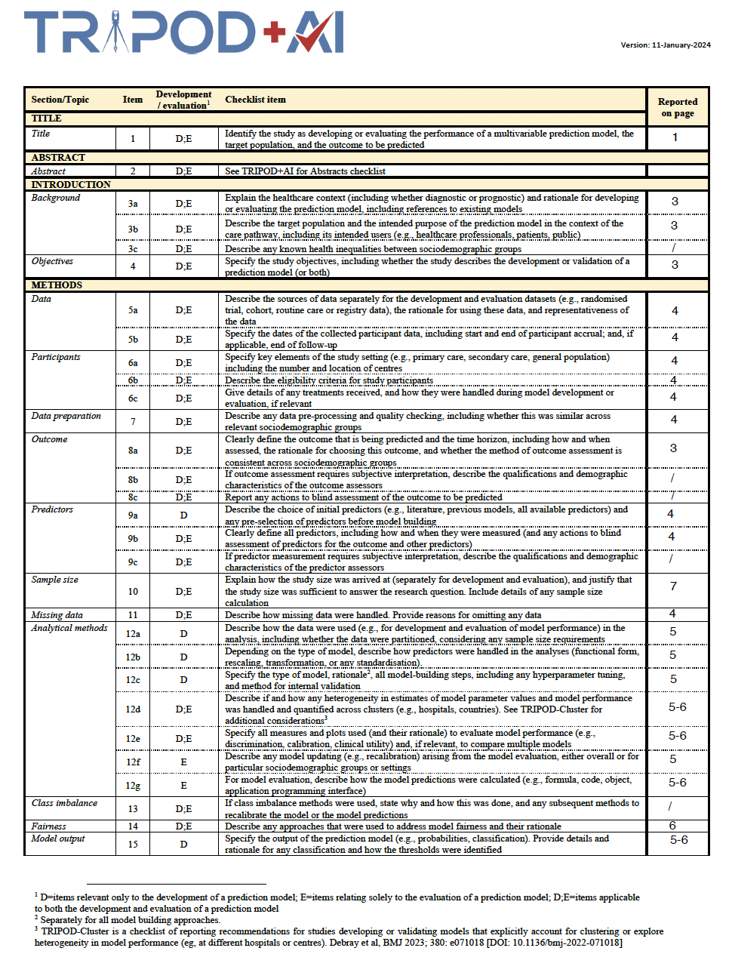
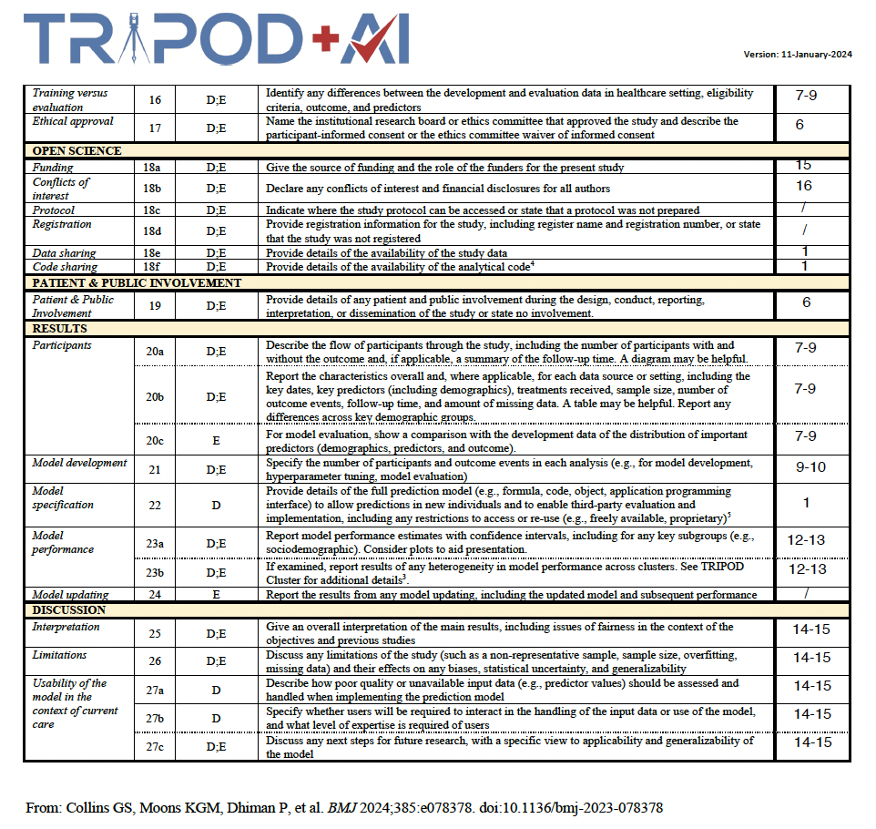
Supplemental File 1. Tripod+AI Checklist.

